**Lab – 1**

**2. WAP to divide horizontal space of screen in 3 different equal parts with different colors.**

import 'package:flutter/material.dart';  
  
class HorizontalPart_1_2 extends StatelessWidget {  
 const HorizontalPart_1_2({Key? key}) : super(key: key);  
  
 @override  
 Widget build(BuildContext context) {  
 return Scaffold(  
 appBar: AppBar(title: Text("Horizontal Parts"),),  
 body: Row(  
 children: [  
 Expanded(  
 child: Container(  
 color: Colors.*red*,  
 ),  
 ),  
 Expanded(  
 child: Container(  
 color: Colors.*blue*,  
 ),  
 ),  
 Expanded(  
 child: Container(  
 color: Colors.*green*,  
 ),  
 ),  
 ],  
 ),  
 );  
 }  
}

OutPut:

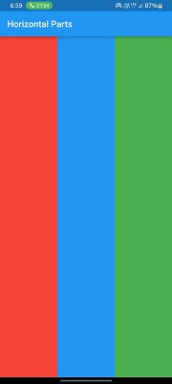

**3. WAP to divide the vertical space of the screen in 3 different equal parts with different colors.**

import 'package:flutter/material.dart';  
  
class VerticalPart_1_3 extends StatelessWidget {  
 const VerticalPart_1_3({Key? key}) : super(key: key);  
  
 @override  
 Widget build(BuildContext context) {  
 return Scaffold(  
 appBar: AppBar(title: Text("Vertical Parts"),),  
 body: Column(  
 children: [  
 Expanded(  
 child: Container(  
 color: Colors.red,  
 ),  
 ),  
 Expanded(  
 child: Container(  
 color: Colors.blue,  
 ),  
 ),  
 Expanded(  
 child: Container(  
 color: Colors.green,  
 ),  
 ),  
 ],  
 ),  
 );  
 }  
}

OutPut :

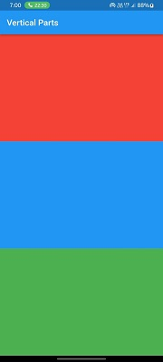

**4.1. WAP to divide the whole screen into 9 (equal size and the different size) with different colors.**

import 'package:flutter/material.dart';  
class NineParts_1_4 extends StatelessWidget {  
 @override  
 Widget build(BuildContext context) {  
 return Scaffold(  
 appBar: AppBar(  
 title: Text("Nine Parts"),  
 ),  
 body: Column(  
 children: [  
 Expanded(  
 child: Row(  
 children: [  
 Expanded(  
 child: Container(color: Colors.*green*),),  
 Expanded(  
 child: Container(color: Colors.*blue*),),  
 Expanded(  
 child: Container(color: Colors.*yellow*),),  
 ],  
 ),  
 ),  
 Expanded(  
 child: Row(  
 children: [  
 Expanded(  
 child: Container(color: Colors.*pinkAccent*),  
 ),  
 Expanded(  
 child: Container(color: Colors.*red*),  
 ),  
 Expanded(  
 child: Container(color: Colors.*purpleAccent*),  
 ),  
 ],  
 ),  
 ),  
 Expanded(  
 child: Row(  
 children: [  
 Expanded(  
 child: Container(color: Colors.*white*),  
 ),  
 Expanded(  
 child: Container(color: Colors.*black87*),  
 ),  
 Expanded(  
 child: Container(color: Colors.*cyan*),  
 ),  
 ],  
 ),  
 ),  
 ],  
 ),  
 );  
 }  
}

**OutPut :**

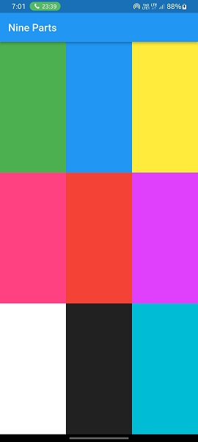

**4.2**. **WAP to divide the whole screen into 9 (equal size and the different size) with different colors.**

import 'package:flutter/material.dart';  
  
class NineParts_1_4_2 extends StatelessWidget {  
 @override  
 Widget build(BuildContext context) {  
 return Scaffold(  
 appBar: AppBar(  
 title: Text("Nine Parts Scecond"),  
 ),  
 body: Row(  
 children: [  
 //First Column  
 Expanded(  
 child: Column(  
 children: [  
 Expanded(child: Container(color: Colors.*green*),),  
 Expanded(child: Container(color: Colors.*blue*),),  
 Expanded(child: Container(color: Colors.*yellow*),),  
 ],  
 ),  
 ),  
 //Second Column  
 Expanded(  
 child: Column(  
 children: [  
 Expanded(  
 flex: 3,  
 child: Container(color: Colors.*grey*),  
 ),  
 Expanded(  
 flex: 2,  
 child: Container(color: Colors.*red*),  
 ),  
 Expanded(  
 child: Container(color: Colors.*purpleAccent*),  
 ),  
 ],  
 ),  
 ),  
 //Third Column  
 Expanded(  
 child: Column(  
 children: [  
 Expanded(child: Container(color: Colors.*white*),),  
 Expanded(flex: 3,  
 child: Container(color: Colors.*black87*),  
 ),  
 Expanded(flex: 2,  
 child: Container(color: Colors.*cyan*),  
 ),  
 ],  
 ),  
 ),  
 ],  
 ),  
 );  
 }  
}

**OutPut :**

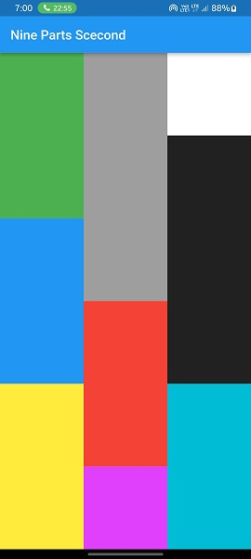

**Lab – 2**

**1.** **WAP to display “hello world” using Text widget. Change color & size of text using different properties.**

import 'package:flutter/material.dart';  
  
class TextWidgetProperties extends StatelessWidget {  
 const TextWidgetProperties({super.key});  
  
 @override  
 Widget build(BuildContext context) {  
 return Scaffold(  
 appBar: AppBar(  
 title: const Text("Text Widget Properties"),  
 ),  
 body: const Text(  
 "Hello World",  
 style: TextStyle(  
 fontSize: 20,  
 fontWeight: FontWeight.*w600*,  
 color: Colors.*purple*,  
 backgroundColor: Colors.*grey* ),  
 ),  
 );  
 }  
}

**OutPut :**

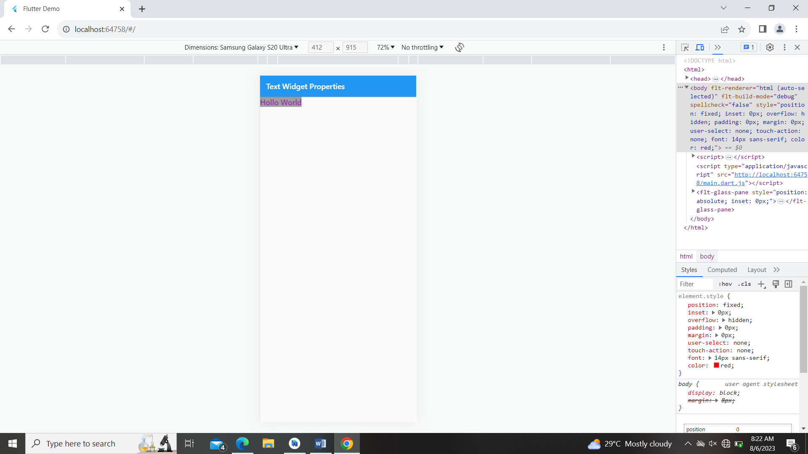

**2. WAP to create a custom Text widget with different fonts & use it.**

import 'package:flutter/material.dart';  
  
class CustomText extends StatelessWidget {  
 @override  
 Widget build(BuildContext context) {  
 return Scaffold(  
 appBar: AppBar(  
 title: Text("Custom Text Widget"),  
 ),  
 body: customText(),  
 );  
 }  
  
 Widget customText() {  
 return Center(  
 child: Text(  
 'Custom Text.',  
 style: TextStyle(  
 fontSize: 35,  
 fontWeight: FontWeight.*bold*,  
 fontFamily: 'Borel'),  
 ),  
 );  
 }  
}

**OutPut :**

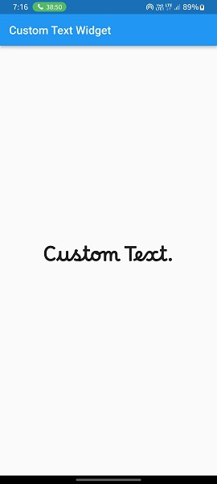

**3. WAP to use TextField and print the input value into the terminal using the controller.**

import 'package:flutter/material.dart';  
  
class PrintTextTerminal extends StatelessWidget {  
 TextEditingController nameController = TextEditingController();  
  
 @override  
 Widget build(BuildContext context) {  
 return Scaffold(  
 appBar: AppBar(  
 title: const Text("Text Form Field"),  
 ),  
 body: TextFormField(  
 controller: nameController,  
 onChanged: (value) => print(value),  
 ),  
 );  
 }  
}

**OutPut :**

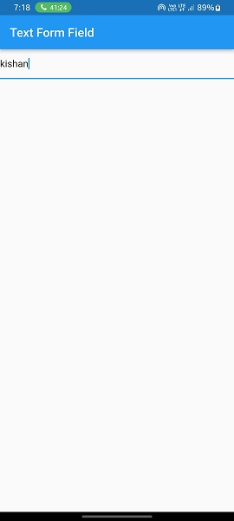

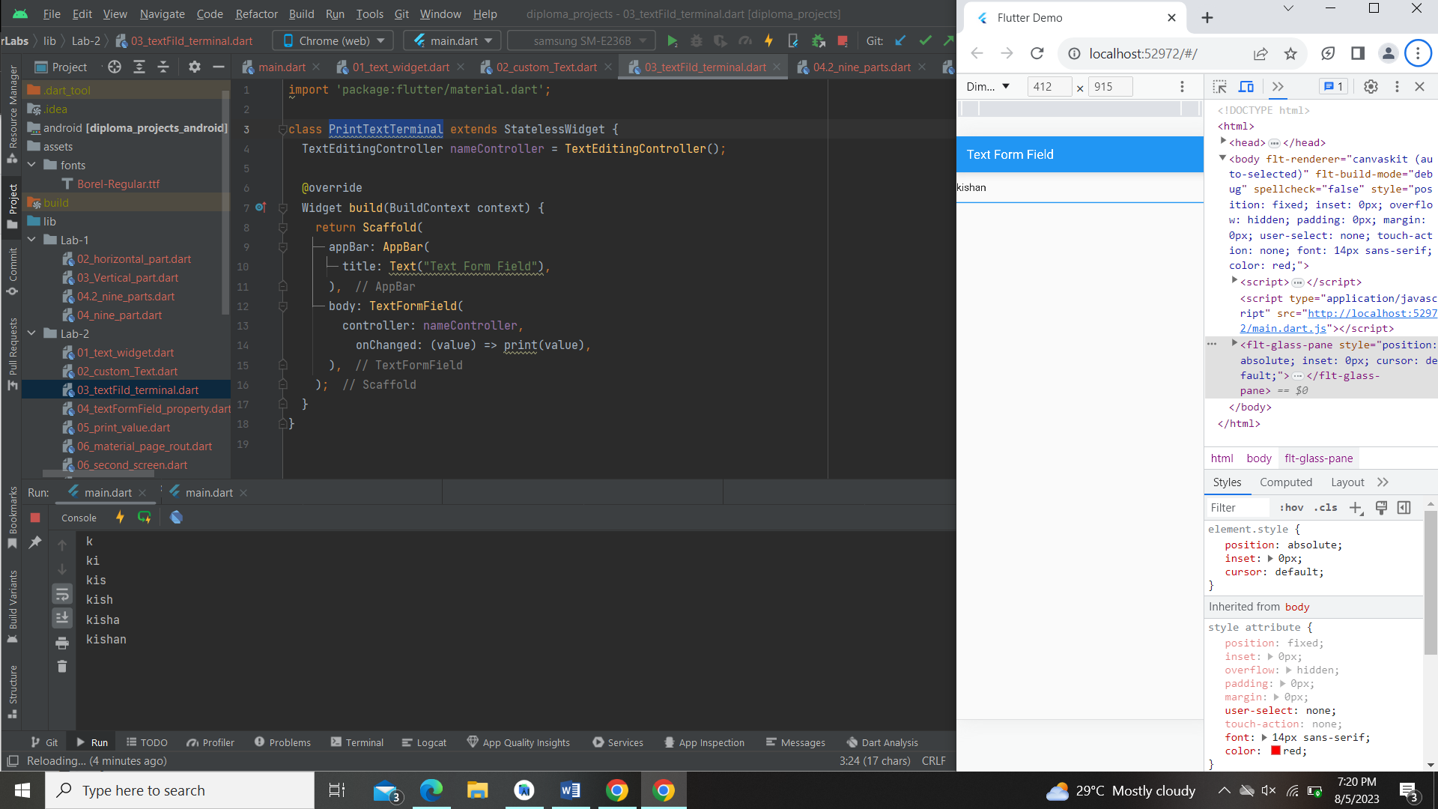

**4. WAP to use TextField & apply different borders, floating labels, hint text etc.**

import 'package:flutter/material.dart';  
  
class TextFormFieldProperty extends StatelessWidget {  
 TextEditingController nameController = TextEditingController();  
  
 @override  
 Widget build(BuildContext context) {  
 return Scaffold(  
 appBar: AppBar(  
 title: const Text("Text Form Field Properties"),  
 ),  
 body: Padding(  
 padding: const EdgeInsets.all(8.0),  
 child: TextFormField(  
 controller: nameController,  
 onChanged: (value) => print(value),  
 decoration: const InputDecoration(  
 border: OutlineInputBorder(),  
 labelText: "Enter Something"  
 ),  
 ),  
 ),  
 );  
 }  
}

**OutPut :**

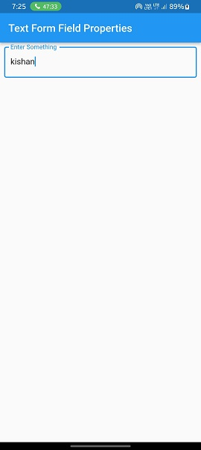

**5. WAP to print TextField value into Text widget on a click of a Button.**

import 'package:flutter/material.dart';  
  
class PrintTextFormFieldValue extends StatefulWidget {  
 @override  
 State<PrintTextFormFieldValue> createState() => _PrintTextFormFieldValueState();  
}  
  
class _PrintTextFormFieldValueState extends State<PrintTextFormFieldValue> {  
 TextEditingController controller = TextEditingController();  
  
 @override  
 Widget build(BuildContext context) {  
 return Scaffold(  
 appBar: AppBar(  
 title: const Text("Print Form Field Value"),  
 ),  
 body: Padding(  
 padding: const EdgeInsets.all(8.0),  
 child: Column(  
 children: [  
 TextFormField(  
 controller: controller,  
 decoration: const InputDecoration(  
 border: OutlineInputBorder(), labelText: "Enter Something"),  
 ),  
 ElevatedButton(  
 onPressed: () {setState(() {});},  
 child: const Text("Display")  
 ),  
  
 Text('Details: ${controller.text}')  
 ],  
 ),  
 ),  
 );  
 }  
}

**OutPut :**

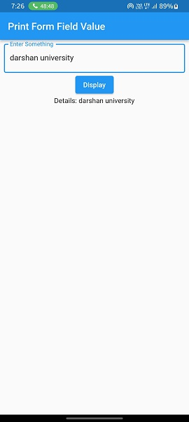

**6. WAP to do navigation between two different pages using a material page route.**

import 'package:diploma_projects/Lab-2/06_second_screen.dart';  
import 'package:flutter/material.dart';  
  
class MaterialPageRoutee extends StatefulWidget {  
 const MaterialPageRoutee({Key? key}) : super(key: key);  
 @override  
 State<MaterialPageRoutee> createState() => _MaterialPageRouteeState();  
}  
  
class _MaterialPageRouteeState extends State<MaterialPageRoutee> {  
 @override  
 Widget build(BuildContext context) {  
 return Scaffold(  
 appBar: AppBar(  
 title: const Text("First Screen"),  
 ),  
 body: Center(  
 child: ElevatedButton(  
 onPressed: () {  
 Navigator.*push*(  
 context,  
 MaterialPageRoute(  
 builder: (context) => const SecondScreen(),  
 ));  
 },  
 child: const Text("Chick to Navigate"),  
 ),  
 ),  
 );  
 }  
}

import 'package:flutter/material.dart';  
  
class SecondScreen extends StatefulWidget {  
 const SecondScreen({Key? key}) : super(key: key);  
 @override  
 State<SecondScreen> createState() => _SecondScreenState();  
}  
  
class _SecondScreenState extends State<SecondScreen> {  
 @override  
 Widget build(BuildContext context) {  
 return Scaffold(  
 appBar: AppBar(title: const Text("Second Screen"),),  
 body: Center(  
 child: ElevatedButton(  
 onPressed: () {  
 Navigator.*pop*(context);  
 },  
 child: const Text("Chick to Back"),  
 ),  
 ),  
 );  
 }  
}

**OutPut :**

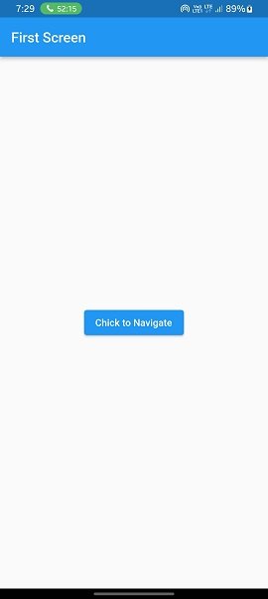 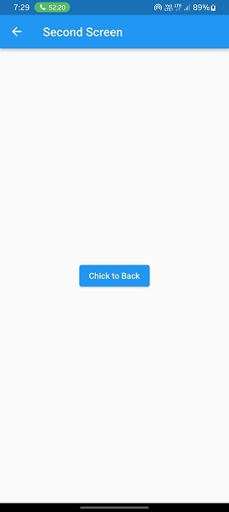

**7. WAP to do navigation between two different pages using a name route.**

void main() {  
 runApp(const MyApp());  
}  
  
class MyApp extends StatelessWidget {  
 const MyApp({super.key});  
  
 @override  
 Widget build(BuildContext context) {  
 return MaterialApp(  
 debugShowCheckedModeBanner: false,  
 title: 'Flutter Demo',  
 theme: ThemeData(  
 primarySwatch: Colors.*blue*,  
 ),  
 initialRoute: '/',  
 routes: {  
 '/' : (context) => NamedRouting(),  
 '/second': (context) => SecondScreen(),  
 },  
 );  
 }  
}

class NamedRouting extends StatefulWidget {  
 const NamedRouting({Key? key}) : super(key: key);  
  
 @override  
 State<NamedRouting> createState() => _NamedRoutingState();  
}  
  
class _NamedRoutingState extends State<NamedRouting> {  
 @override  
 Widget build(BuildContext context) {  
 return Scaffold(  
 appBar: AppBar(  
 title: Text("Named Routing First Screen"),  
 ),  
 body: Center(  
 child: ElevatedButton(  
 onPressed: () {  
 Navigator.*pushNamed*(context, '/second');  
 },  
 child: Text("Click to Navigate")),  
 ),  
 );  
 }  
}

**OutPut :**

**Same as above.**

**Lab - 3**

**1. WAP to use the bottom NavigationBar & on click display different pages.**

import 'package:diploma_projects/Lab-1/04.2_nine_parts.dart';  
import 'package:diploma_projects/Lab-1/04_nine_part.dart';  
import 'package:flutter/material.dart';  
  
class BottomNavigationBarr extends StatefulWidget {  
 const BottomNavigationBarr({Key? key}) : super(key: key);  
  
 @override  
 State<BottomNavigationBarr> createState() => _BottomNavigationBarrState();  
}  
  
class _BottomNavigationBarrState extends State<BottomNavigationBarr> {  
 int _selectedIndex = 0;  
  
 List<Widget> screens = [  
 NineParts_1_4(),  
 NineParts_1_4_2(),  
 ];  
  
 @override  
 Widget build(BuildContext context) {  
 return Scaffold(  
 body: screens[_selectedIndex],  
 bottomNavigationBar: BottomNavigationBar(  
 selectedItemColor: Colors.*deepOrange*,  
 currentIndex: _selectedIndex,  
 items: const [  
 BottomNavigationBarItem(  
 icon: Icon(Icons.*meeting_room*, ),  
 label: "Lab Programs",  
 backgroundColor: Colors.*black*,  
 ),  
 BottomNavigationBarItem(  
 icon: Icon(Icons.*phonelink_rounded*),  
 label: "Projects",  
 backgroundColor: Colors.*black*,  
 ),  
 ],  
 onTap: (value) {  
 setState(() {  
 _selectedIndex = value;  
 });  
 },  
 ),  
 );  
 }  
}

**OutPut :**

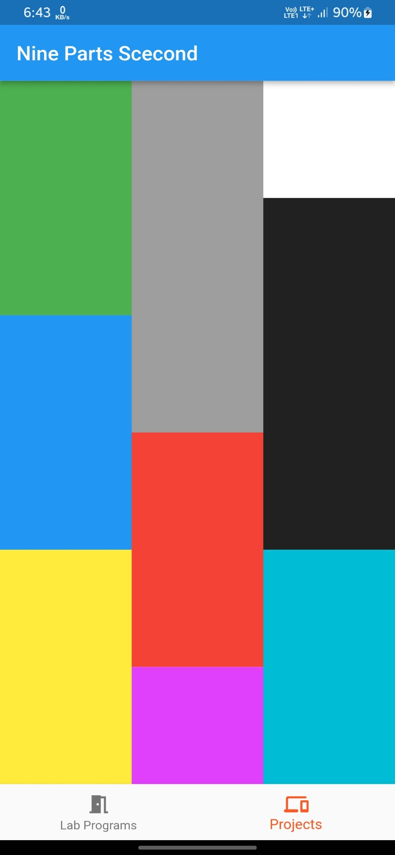

**2. WAP to create a dynamic Birthday card.**

import 'package:flutter/material.dart';  
  
class BirthdayCard extends StatefulWidget {  
 @override  
 _BirthdayCardState createState() => _BirthdayCardState();  
}  
  
class _BirthdayCardState extends State<BirthdayCard> {  
 String name = "Darshan";  
  
 void _showBirthdayCardDialog() {  
 showDialog(  
 context: context,  
 builder: (BuildContext context) {  
 return AlertDialog(  
 title: const Text("Customize Birthday Card"),  
 content: Column(  
 mainAxisSize: MainAxisSize.min,  
 children: [  
 TextField(  
 decoration: const InputDecoration(labelText: "Name"),  
 onChanged: (value) {  
 setState(() {  
 name = value;  
 });  
 },  
 ),  
 ],  
 ),  
 );  
 },  
 );  
 }  
  
 @override  
 Widget build(BuildContext context) {  
 return Scaffold(  
 appBar: AppBar(  
 title: const Text("Birthday Card"),  
 ),  
 body: Stack(  
 fit: StackFit.expand,  
 children: [  
 Image.asset(  
 "assets/images/birthday.png",  
 fit: BoxFit.fill,  
 ),  
 Center(  
 child: Column(  
 mainAxisAlignment: MainAxisAlignment.center,  
 children: [  
 Text(  
 "Happy Birthday, $name!",  
 style: const TextStyle(fontSize: 24, fontWeight: FontWeight.*bold*),  
 ),  
 Padding(  
 padding: const EdgeInsets.all(8.0),  
 child: ElevatedButton(  
 onPressed: () {  
 _showBirthdayCardDialog();  
 },  
 child: const Text("Customize"),  
 ),  
 ),  
 ],  
 ),  
 ),  
 ],  
 ),  
 );  
 }  
}

**OutPut :**

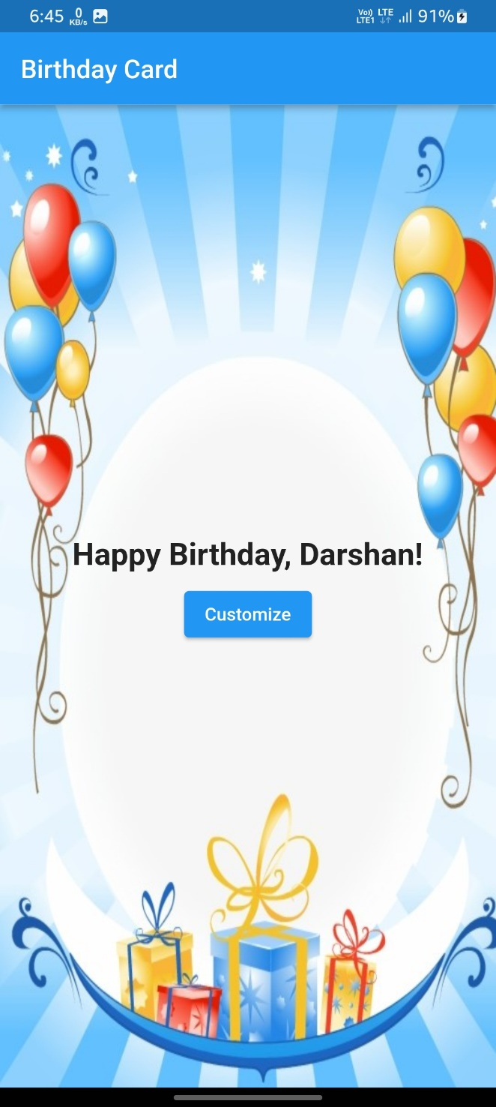

**3. WAP to create login screen login for username & password using Textfield, Button etc.**

import 'package:flutter/material.dart';  
  
class LoginScreen extends StatelessWidget {  
 @override  
 Widget build(BuildContext context) {  
 return Scaffold(  
 appBar: AppBar(  
 title: Text("Login Screen"),  
 ),  
 body: Padding(  
 padding: const EdgeInsets.all(8.0),  
 child: Column(  
 crossAxisAlignment: CrossAxisAlignment.start,  
 children: [  
 //Name Field.  
 TextFormField(  
 decoration: const InputDecoration(  
 labelText: "Name",  
 border: OutlineInputBorder(),  
 ),  
 ),  
  
 //PassWord Field  
 TextFormField(  
 obscureText: true,  
 decoration: const InputDecoration(  
 labelText: "PassWord",  
 border: OutlineInputBorder(),  
 ),  
 ),  
 Padding(  
 padding: const EdgeInsets.symmetric(vertical: 8),  
 child: ElevatedButton(  
 onPressed: () {},  
 child: const Text(  
 'Submit'  
 ),  
 ),  
 ),  
 ],  
 ),  
 ),  
 );  
 }  
}

**OutPut :**

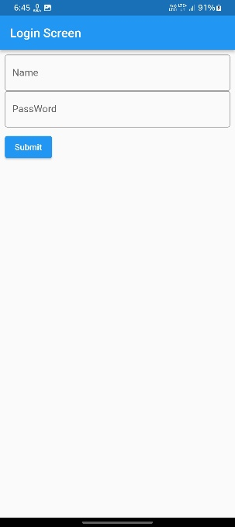

**4. WAP to do validation in the login screen. (Email Validation & Password Validation) on Button click.**

import 'package:flutter/material.dart';  
  
class LoginValidation extends StatefulWidget {  
 @override  
 State<LoginValidation> createState() => _LoginValidationState();  
}  
  
class _LoginValidationState extends State<LoginValidation> {  
 final _formKey = GlobalKey<FormState>();  
 TextEditingController passController = TextEditingController();  
  
 @override  
 Widget build(BuildContext context) {  
 return Scaffold(  
 appBar: AppBar(  
 title: const Text("LoginValidation Demo"),  
 ),  
 body: Padding(  
 padding: const EdgeInsets.all(8.0),  
 child: Form(  
 key: _formKey,  
 child: Column(  
 crossAxisAlignment: CrossAxisAlignment.start,  
 children: [  
 //Name Field.  
 Padding(  
 padding: const EdgeInsets.all(8.0),  
 child: TextFormField(  
 decoration: const InputDecoration(  
 labelText: "Name",  
 border: OutlineInputBorder(),  
 ),  
 ),  
 ),  
  
 //PassWord Field  
 Padding(  
 padding: const EdgeInsets.all(8.0),  
 child: TextFormField(  
 validator: (value) {  
 if(value!.isEmpty){  
 return "Please Enter Password";  
 } else if(!RegExp(r'(?=.*\d)(?=.*[a-z])(?=.*[A-Z])(?=.*\W)').hasMatch(value)){  
 return " Password should contain Capital, small letter & Number & Special";  
 }  
 },  
 obscureText: true,  
 decoration: const InputDecoration(  
 labelText: "PassWord",  
 border: OutlineInputBorder(),  
 ),  
 ),  
 ),  
 //Email Field  
 Padding(  
 padding: const EdgeInsets.all(8.0),  
 child: TextFormField(  
 validator: (value) {  
 if(value!.isEmpty){  
 return "Please Enter Password";  
 } else if(!RegExp(r'\S+@\S+\.\S+').hasMatch(value)){  
 return " Please Enter a Valid Email";  
 }  
 },  
 decoration: const InputDecoration(  
 labelText: "Email",  
 border: OutlineInputBorder(),  
 ),  
 ),  
 ),  
  
 Padding(  
 padding: const EdgeInsets.all(8),  
 child: ElevatedButton(  
 onPressed: () {  
 _formKey.currentState!.validate();  
 },  
 child: const Text(  
 'Submit'  
 ),  
 ),  
 ),  
 ],  
 ),  
 ),  
 ),  
 );  
 }  
}

**OutPut :**

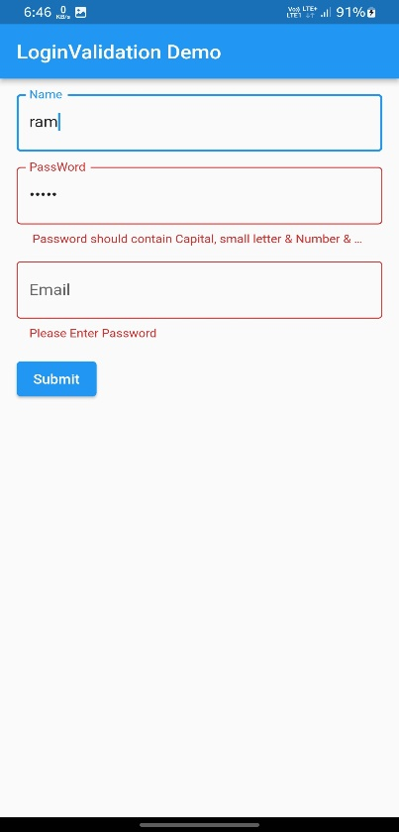

**5. WAP to create a registration screen using different widgets.**

import 'package:flutter/material.dart';  
  
class RegisterPage extends StatefulWidget {  
 @override  
 State<RegisterPage> createState() => _RegisterPage();  
}  
  
class _RegisterPage extends State<RegisterPage> {  
  
 TextEditingController nameController = TextEditingController();  
 TextEditingController cityController = TextEditingController();  
 TextEditingController ageController = TextEditingController();  
 TextEditingController emailController = TextEditingController();  
 TextEditingController passWordController = TextEditingController();  
  
 @override  
 Widget build(BuildContext context) {  
 return Scaffold(  
 appBar: AppBar(  
 title: Text("Registration Page"),  
 ),  
 body: SingleChildScrollView(  
 child: Padding(  
 padding: const EdgeInsets.all(8),  
 child: Form(  
 child: Column(  
 crossAxisAlignment: CrossAxisAlignment.start,  
 children: [  
 //First Name Field.  
 getField("Enter Name"),  
 getCard("Name", nameController),  
  
 //City Field.  
 getField("Enter City"),  
 getCard("City", cityController),  
  
 //Age Field  
 getField("Enter Age"),  
 getCard("Age", ageController),  
  
 //Email Field  
 getField("Enter Email"),  
 getCard("Email", emailController),  
  
 //PassWord Field  
 getField("Enter PassWord"),  
 Card(  
 elevation: 4,  
 child: TextFormField(  
 controller: passWordController,  
 obscureText: true,  
 decoration: const InputDecoration(  
 labelText: "PassWord",  
 border: OutlineInputBorder(),  
 ),  
 ),  
 ),  
  
 Container(  
 decoration: BoxDecoration(borderRadius: BorderRadius.circular(10), color: Colors.*blue*,),  
 padding: EdgeInsets.all(8),  
 child: TextButton(  
 onPressed: () {  
 setState(() {});  
 },  
 child: Row(  
 mainAxisAlignment: MainAxisAlignment.center,  
 children: [  
 const Text(  
 'Create an Account',  
 style: TextStyle(color: Colors.*white*,fontSize: 20),  
 ),  
 ],  
 ),  
 ),  
 ),  
 ],  
 ),  
 ),  
 ),  
 ),  
 );  
 }  
  
 Widget getField(String field) {  
 return Container(  
 margin: EdgeInsets.only(top: 12),  
 child: Text(  
 field,  
 style: TextStyle(fontWeight: FontWeight.*bold*, fontSize: 16),  
 ),  
 );  
 }  
  
 Widget getCard(String tLable, controller) {  
 return Card(  
 elevation: 4,  
 child: TextFormField(  
 controller: controller,  
 decoration: InputDecoration(  
 labelText: tLable,  
 border: OutlineInputBorder(),  
 ),  
 ),  
 );  
 }  
}

**OutPut :**

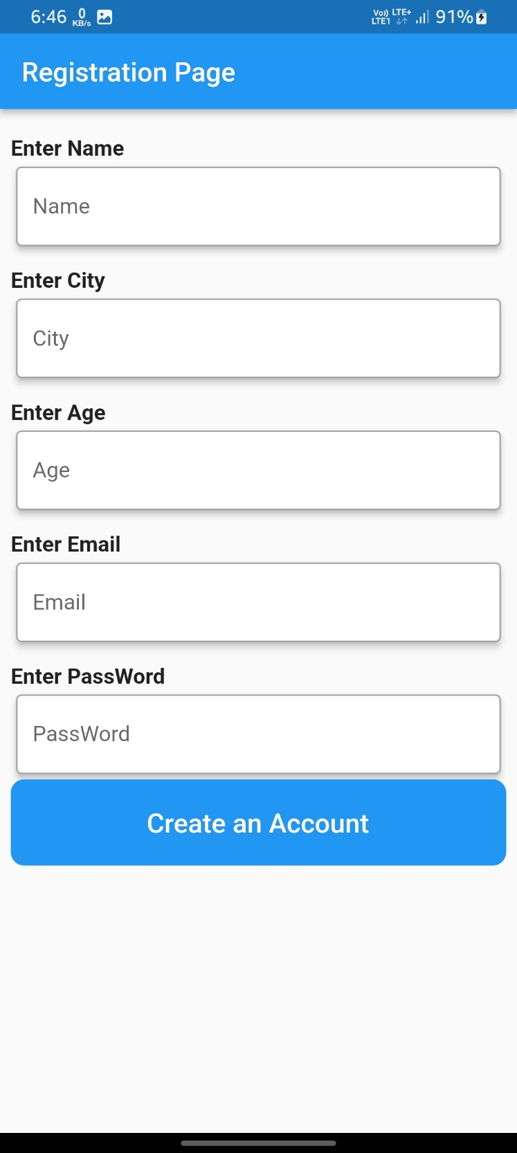

**6. WAP to do validation in the registration screen.**

import 'package:flutter/material.dart';  
  
class RegistrationValidation extends StatefulWidget {  
 @override  
 State<RegistrationValidation> createState() => _RegistrationValidation();  
}  
  
class _RegistrationValidation extends State<RegistrationValidation> {  
 final _formKey = GlobalKey<FormState>();  
 TextEditingController nameController = TextEditingController();  
 TextEditingController cityController = TextEditingController();  
 TextEditingController ageController = TextEditingController();  
 TextEditingController emailController = TextEditingController();  
 TextEditingController passWordController = TextEditingController();  
  
 @override  
 Widget build(BuildContext context) {  
 return Scaffold(  
 appBar: AppBar(  
 title: const Text("Registration Page Validation"),  
 ),  
 body: SingleChildScrollView(  
 child: Padding(  
 padding: const EdgeInsets.all(8),  
 child: Form(  
 key: _formKey,  
 child: Column(  
 crossAxisAlignment: CrossAxisAlignment.start,  
 children: [  
 //First Name Field.  
 getField("Enter Name"),  
 getCard("Name", nameController),  
  
 //City Field.  
 getField("Enter City"),  
 getCard("City", cityController),  
  
 //Age Field  
 getField("Enter Age"),  
 getCard("Age", ageController),  
  
 //Email Field  
 getField("Enter Email"),  
 getCard("Email", emailController),  
  
 //PassWord Field  
 getField("Enter PassWord"),  
 Card(  
 elevation: 4,  
 child: TextFormField(  
 validator: (value) {  
 if(value!.isEmpty){  
 return "Please Enter Password";  
 }  
 },  
 controller: passWordController,  
 obscureText: true,  
 decoration: const InputDecoration(  
 labelText: "PassWord",  
 border: OutlineInputBorder(),  
 ),  
 ),  
 ),  
  
 Container(  
 decoration: BoxDecoration(borderRadius: BorderRadius.circular(10), color: Colors.*blue*,),  
 padding: const EdgeInsets.all(8),  
 child: TextButton(  
 onPressed: () {  
 setState(() {  
 _formKey.currentState!.validate();  
 });  
 },  
 child: Row(  
 mainAxisAlignment: MainAxisAlignment.center,  
 children: const [  
 Text(  
 'Create an Account',  
 style: TextStyle(color: Colors.*white*,fontSize: 20),  
 ),  
 ],  
 ),  
 ),  
 ),  
 ],  
 ),  
 ),  
 ),  
 ),  
 );  
 }  
  
 Widget getField(String field) {  
 return Container(  
 margin: const EdgeInsets.only(top: 12),  
 child: Text(  
 field,  
 style: const TextStyle(fontWeight: FontWeight.*bold*, fontSize: 16),  
 ),  
 );  
 }  
  
 Widget getCard(String tLable, controller) {  
 return Card(  
 elevation: 4,  
 child: TextFormField(  
 validator: (value) {  
 if(value!.isEmpty){  
 return "Please Enter $tLable";  
 }  
 },  
 controller: controller,  
 decoration: InputDecoration(  
 labelText: tLable,  
 border: const OutlineInputBorder(),  
 ),  
 ),  
 );  
 }  
}

**OutPut :**

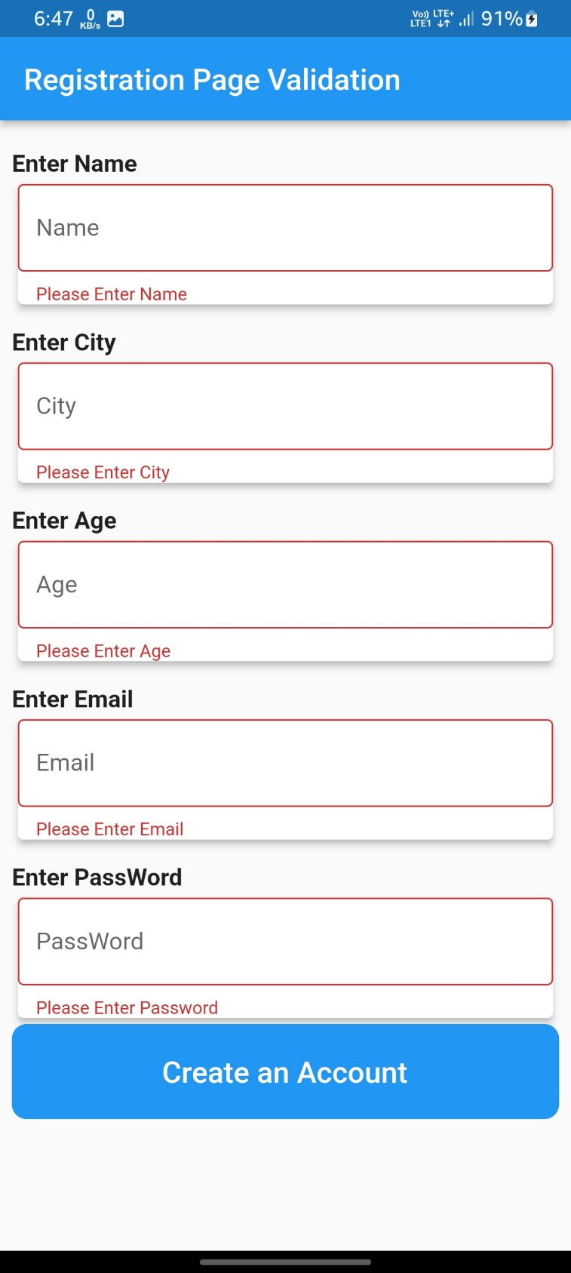

**7. WAP to Add password visibility icon in the Text field.**

import 'package:flutter/material.dart';  
  
class PasswordVisibiliity extends StatefulWidget {  
 @override  
 State<PasswordVisibiliity> createState() => _PasswordVisibilityState();  
}  
  
class _PasswordVisibilityState extends State<PasswordVisibiliity> {  
 bool isHidden = true;  
  
 @override  
 Widget build(BuildContext context) {  
 return Scaffold(  
 appBar: AppBar(  
 title: const Text("Login Screen"),  
 ),  
 body: Padding(  
 padding: const EdgeInsets.all(8.0),  
 child: Padding(  
 padding: const EdgeInsets.all(8.0),  
 child: TextFormField(  
 obscureText: isHidden,  
 decoration: InputDecoration(  
 labelText: "PassWord",  
 suffix: InkWell(  
 onTap: () {  
 setState(() {  
 isHidden = !isHidden;  
 });  
 },  
 child: const Icon( Icons.*visibility*),  
 ),  
 border: const OutlineInputBorder(),  
 ),  
 ),  
 ),  
 ),  
 );  
 }  
}

**OutPut :**

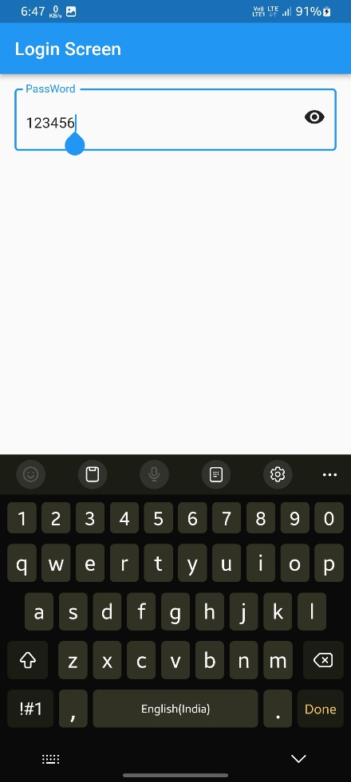 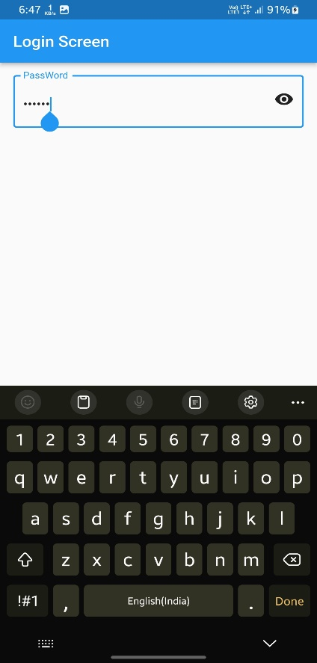

**Lab - 4**

**1. WAP to display an Image into the Image asset widget from the asset folder.**

import 'package:flutter/material.dart';  
  
class AssetsImage extends StatelessWidget {  
 @override  
 Widget build(BuildContext context) {  
 return Scaffold(  
 appBar: AppBar(  
 title: const Text("Asset Image."),  
 ),  
 body: const Image(  
 image: AssetImage('assets/images/person.jfif'),  
 ),  
 );  
 }  
}

**OutPut :**

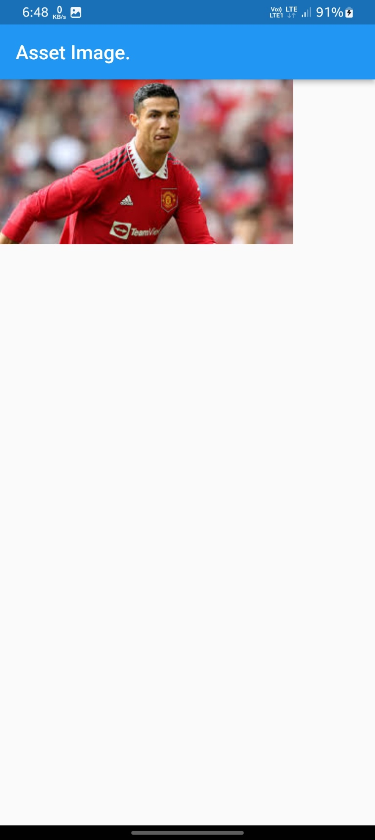

**2. WAP to display an Image from a WEB URL using a cached network Image.**

import 'package:flutter/material.dart';  
  
class NetWorkImage extends StatelessWidget {  
 @override  
 Widget build(BuildContext context) {  
 return Scaffold(  
 appBar: AppBar(  
 title: const Text("NetWork Image"),  
 ),  
 body: const Image(  
 image: NetworkImage(  
 'https://h5p.org/sites/default/files/h5p/content/1209180/images/file-6113d5f8845dc.jpeg'),  
 ),  
 );  
 }  
}

**OutPut :**

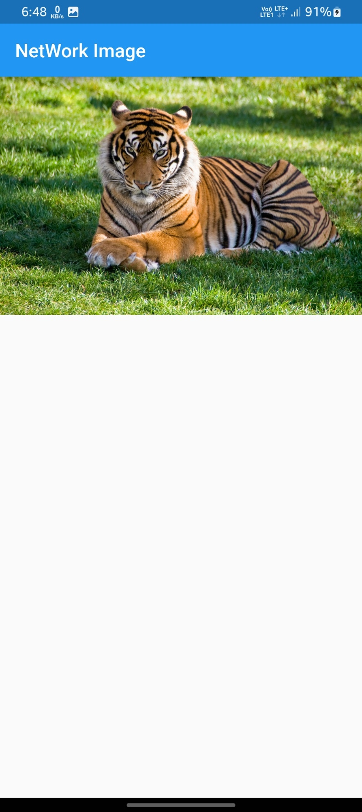

**3. WAP to use Stack widget and show text upon an Image.**

import 'package:flutter/material.dart';  
  
class StackWidget extends StatelessWidget {  
 @override  
 Widget build(BuildContext context) {  
 return Scaffold(  
 appBar: AppBar(  
 title: const Text("App Bar."),  
 ),  
 body: Stack(  
 children: const [  
 Image(  
 image: AssetImage('assets/images/person.jfif'),  
 ),  
 Text("It's Possible Using Stack Widget !",style: TextStyle(fontWeight: FontWeight.*bold*),),  
 ],  
 ),  
 );  
 }  
}

**OutPut :**

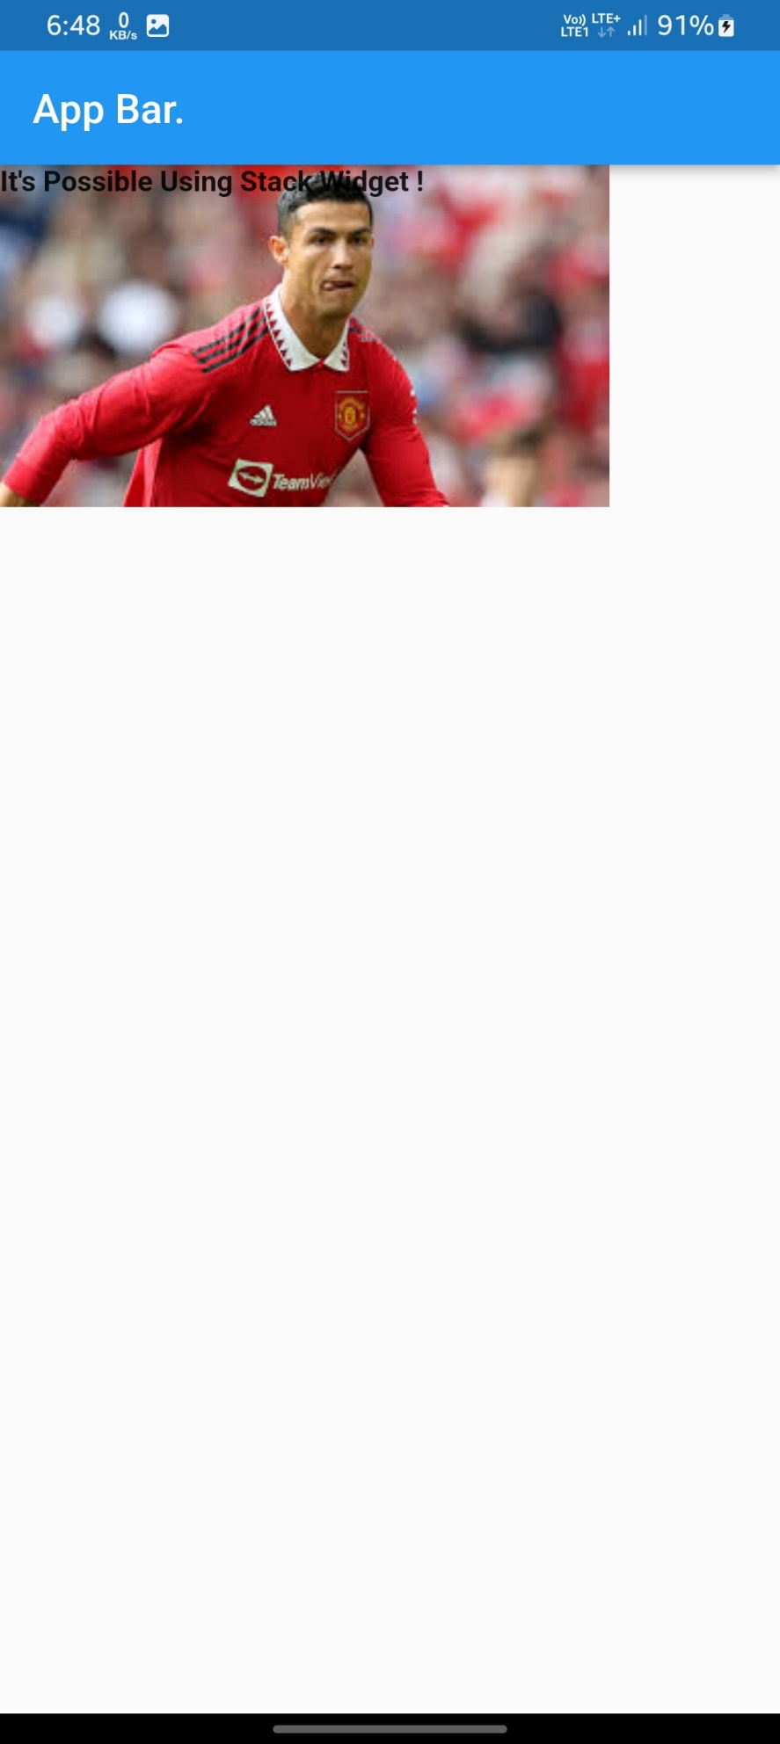

**4. WAP to create a birthday card using different widgets.**

import 'package:flutter/material.dart';  
  
class BirthDayCard extends StatelessWidget {  
 const BirthDayCard({Key? key}) : super(key: key);  
  
 @override  
 Widget build(BuildContext context) {  
 return Scaffold(  
 appBar: AppBar(  
 title: const Text('BirthDay Card'),  
 ),  
 body: Stack(  
 fit: StackFit.expand,  
 children: [  
 Image.asset(  
 'assets/images/birthday.png',  
 fit: BoxFit.fill,  
 ),  
 const Center(  
 child: Text(  
 "Happy birthday!\nEnjoy your day! It's\n only one in every 365 days",  
 textAlign: TextAlign.center,  
 style: TextStyle(fontSize: 24,fontFamily: 'Dancing Script',fontWeight: FontWeight.*w600*),  
 ),  
 ),  
 ],  
 ),  
 );  
 }  
}

**OutPut :**

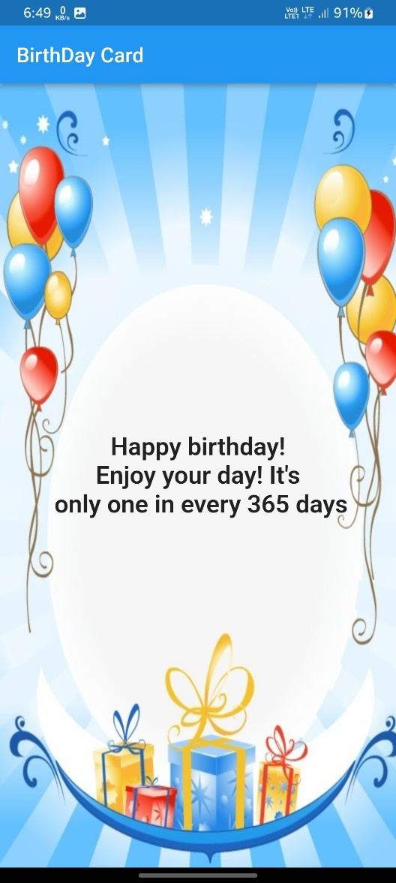

**5. WAP to roll a dice on the Button click event.**

import 'dart:math';  
import 'package:flutter/material.dart';  
  
int i = Random().nextInt(5)+1;  
class LudoDice extends StatefulWidget {  
 const LudoDice({Key? key}) : super(key: key);  
  
 @override  
 State<LudoDice> createState() => _LudoDiceState();  
}  
  
class _LudoDiceState extends State<LudoDice> {  
 @override  
 Widget build(BuildContext context) {  
 return Scaffold(  
 backgroundColor: Colors.*purple*,  
 appBar: AppBar(  
 title: const Text("Ludo Dice"),  
 ),  
 body: InkWell(  
 onTap: () {  
 setState((){  
 i = Random().nextInt(6)+1;  
 });  
 },  
 child: Container(  
 margin: const EdgeInsets.fromLTRB(20, 0, 20, 0),  
 child: Center(  
 child: Image.asset('assets/images/dice$i.png'),  
 ),  
 ),  
 ),  
 );  
 }  
}

**OutPut :**

