Package.json
It is automatically created when we initialize our project using “npm init” . It is like a manifest file for the project. The name and versions of the installed packages are stored in this file.

1. Project details
It contains basic details like name and version of the project, description and main script to run when package is executed. These details become important when the package is deployed on npm or Git.
2. Scripts
Using scripts, we can run complex command just by running the script. We can run script in CLI by calling
“npm run <script_name>” (e.g.: npm run dev).
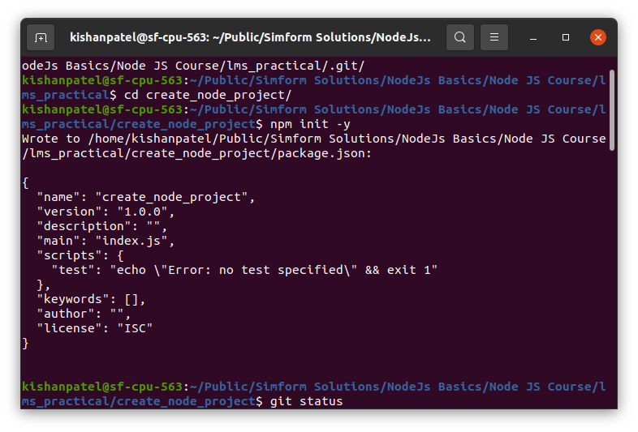

3. Dependencies
It is a list of npm packages required by the project. When we install package using npm. It is automatically inserted into this list.

4. DevDependencies
It is a list of npm packages required for development purposes. These dependencies are not
required to run projects on production.

