Steps to create a node project
1. Create a folder with the name of your project
2. Open terminal and navigate to the folder of your NodeJs Project.
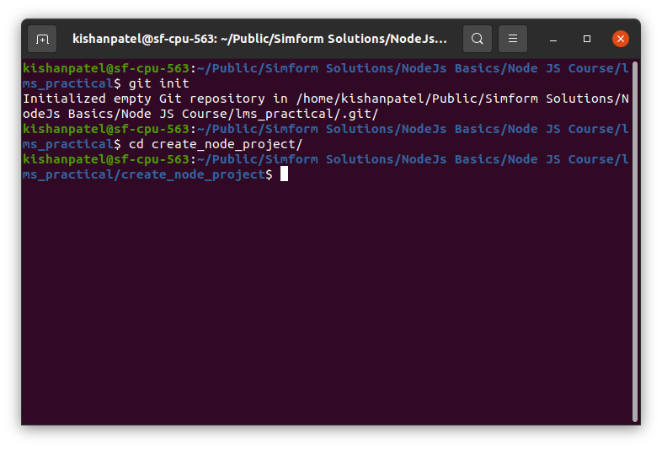

3. Now use ‘npm init ‘ command to initialize npm in your project
a. “npm init –y “ will set npm with default options. It will create package.json file
into the root of your project folder.

