Module (JAVASCRIPT BASIC & DOM) – 4

1)What is JavaScript?

JavaScript is a versatile, high-level programming language that is widely used for web development. It enables interactive web pages by allowing developers to implement dynamic content, control multimedia, animate images, and manage data.

2) What is the use of isNaN function?

The isNaN function checks whether a value is ‘NaN’ (Not-a-Number). It returns ‘true’ if the value is ‘NaN’, and ‘false’ otherwise. Example: ‘isNaN('hello')’ returns ‘true’, while ‘isNaN(123)’ returns ‘false’.

3) What is negative Infinity?

Negative Infinity is a special value in JavaScript that represents a value less than any other number. It is the result of dividing a negative number by zero or subtracting Infinity from any number. Example: ‘-Infinity’ is returned by ‘-1 / 0’.

4) Which company developed JavaScript?

JavaScript was developed by Netscape Communications Corporation, specifically by Brendan Eich.

5) What are undeclared and undefined variables?

* **Undeclared Variables:** Variables that are used without first being declared with ‘var’, ‘let’, or ‘const’.
* **Undefined Variables:** Variables that have been declared but have not been assigned a value.

6) Write the code for adding new elements dynamically?

Code:

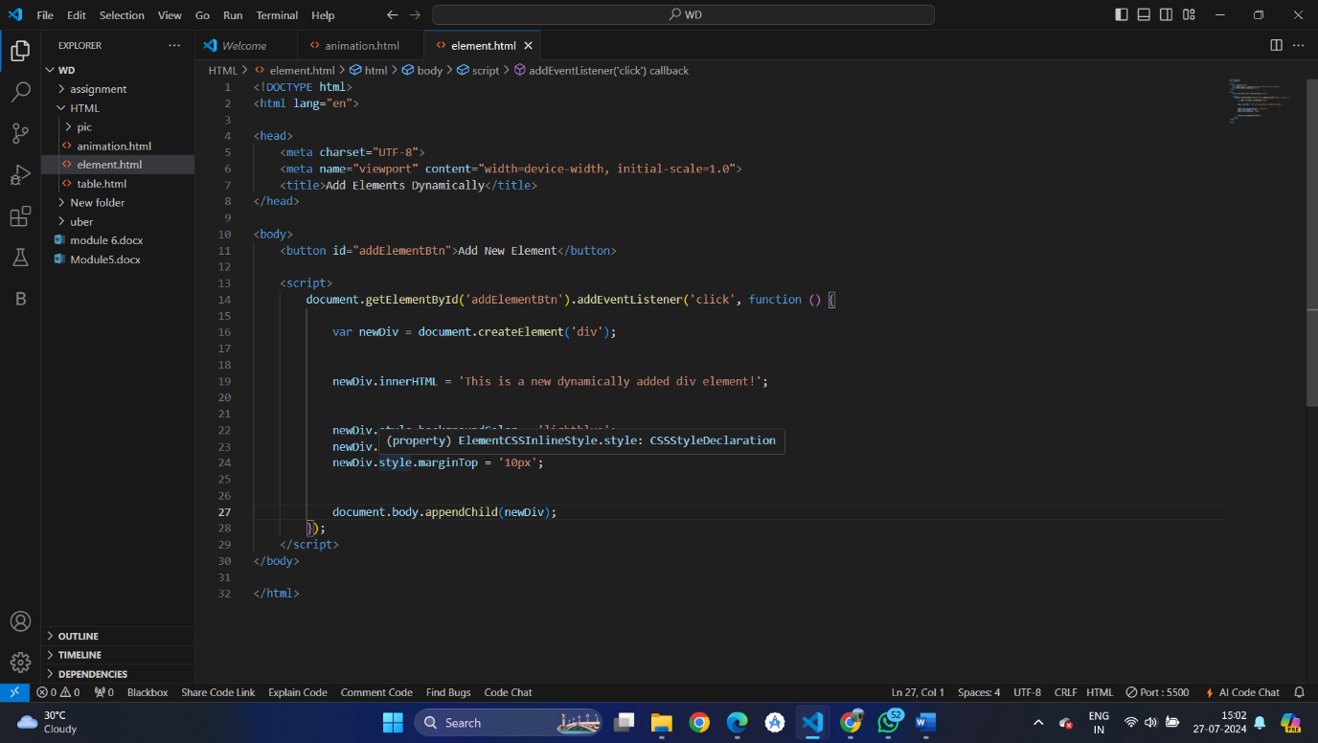

Output:

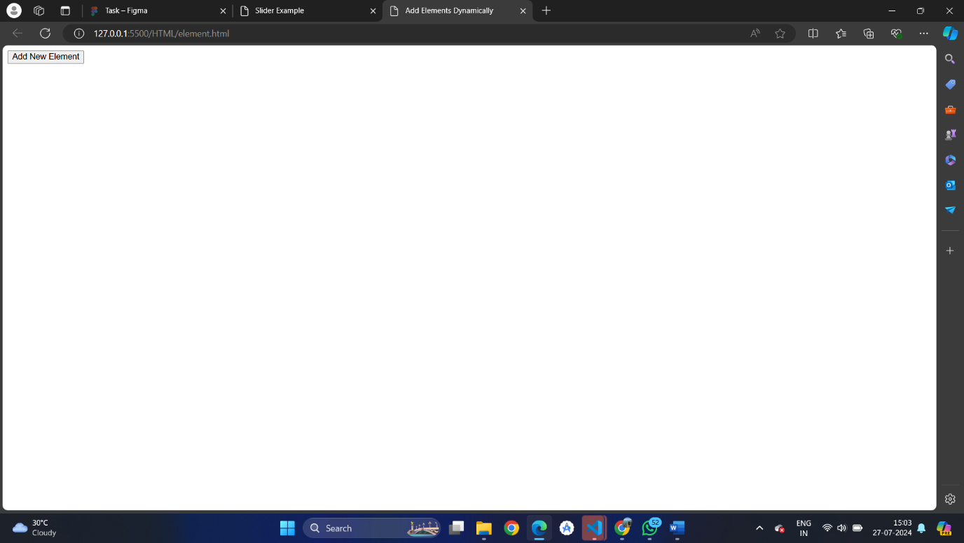

* Click on new element button:

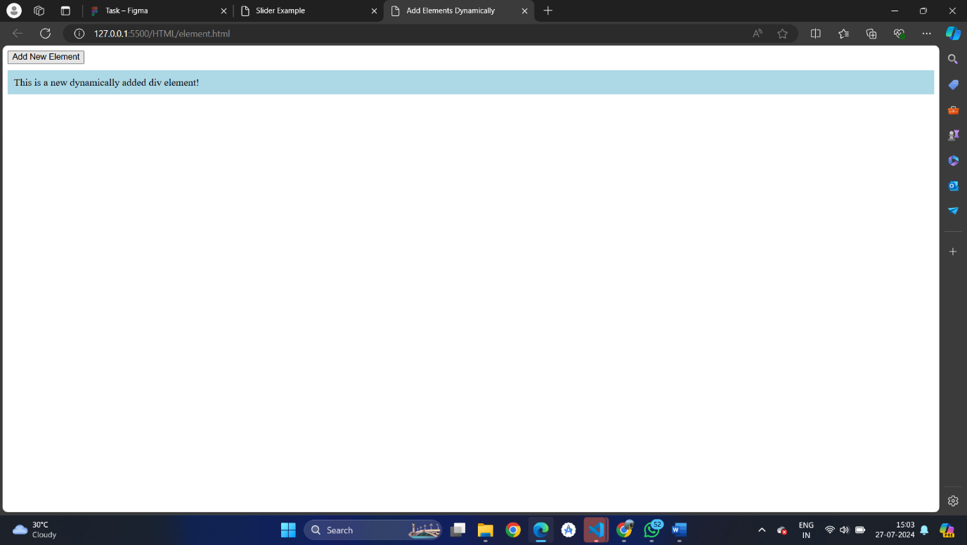

* One more time click on new element button:

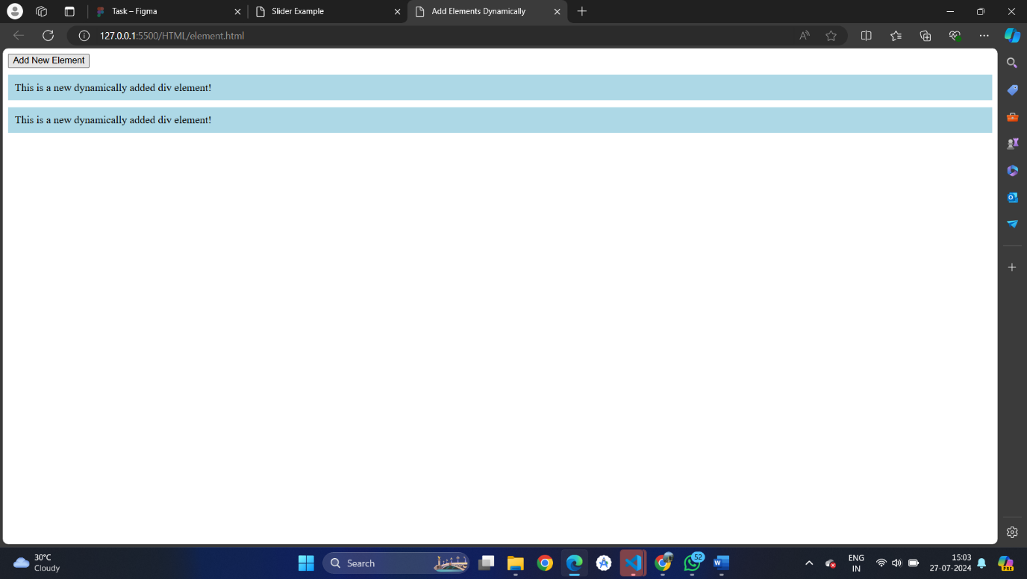

7) What is the difference between ViewState and SessionState?

* **ViewState:** Used to preserve page and control values between postbacks within a single page.
* **SessionState:** Used to store user data across different pages in a web application during a user's session.

8) What is === operator?

The ‘===’ operator checks for both value and type equality. Example: ‘5 === '5' ‘returns ‘false’, while ‘5 === 5’ returns ‘true’.

9) How can the style/class of an element be changed?

* **Style:** element. style. color = 'blue';
* **Class:** element. class Name = 'newClass'; or element.classList.add('newClass');

10) What are all the looping structures in JavaScript?

* for loop
* while loop
* do...while loop
* for...in loop
* for...of loop

11) How can you convert the string of any base to an integer in JavaScript?

var num = parseInt('1010', 2);

12) What is the function of the delete operator?

The ‘delete’ operator removes a property from an object. Example: ‘delete object. property;’

13) What are all the types of Pop-up boxes available in JavaScript?

**Types of pop-up boxes in JavaScript:**

* ‘alert ()’
* ‘confirm ()’
* ‘prompt ()’

14) What is the use of Void (0)?

The void(0) operator evaluates the expression and returns undefined, commonly used to prevent the default action of a link.

Example: ‘<a href="JavaScript: void(0);">Click me</a>’

15) How can a page be forced to load another page in JavaScript?

window.location.href = 'https://www.example.com';

16) What are the disadvantages of using inner HTML in JavaScript?

* Can lead to cross-site scripting (XSS) attacks if not properly sanitized.
* Overwrites existing content and event listeners.
* Less efficient for frequent DOM updates compared to other methods like ‘document.createElement’.