**Database Management System Project**

**Group members**

Name - Kishan Patel MIS - 111803172

Name - Swebert Correa MIS - 111807076

Branch - Computer Engineering

Div - 2

Batch - T4

1. **Problem Statement**

We are designing a social media platform.

1. **Introduction**

Our main objective is to create an online social community for sharing photos. Here people can interact by posting photos and captions, while others can comment, like and share those posts.

1. **Functional Requirements**

**Tectstack** -

* Frontend - HTML, CSS and JavaScript.
* Backend - Flask python framework
* Relational Database – Python MySQL Connector.

**Use cases** -

* Users can create accounts.
* Users can follow other users.
* Users post images and add captions.
* Users can see the news feeds of people whom they follow.
* Users can comment and like the posts on their news feed.
* Users can also share those posts on their own page.

1. **ER Diagram**

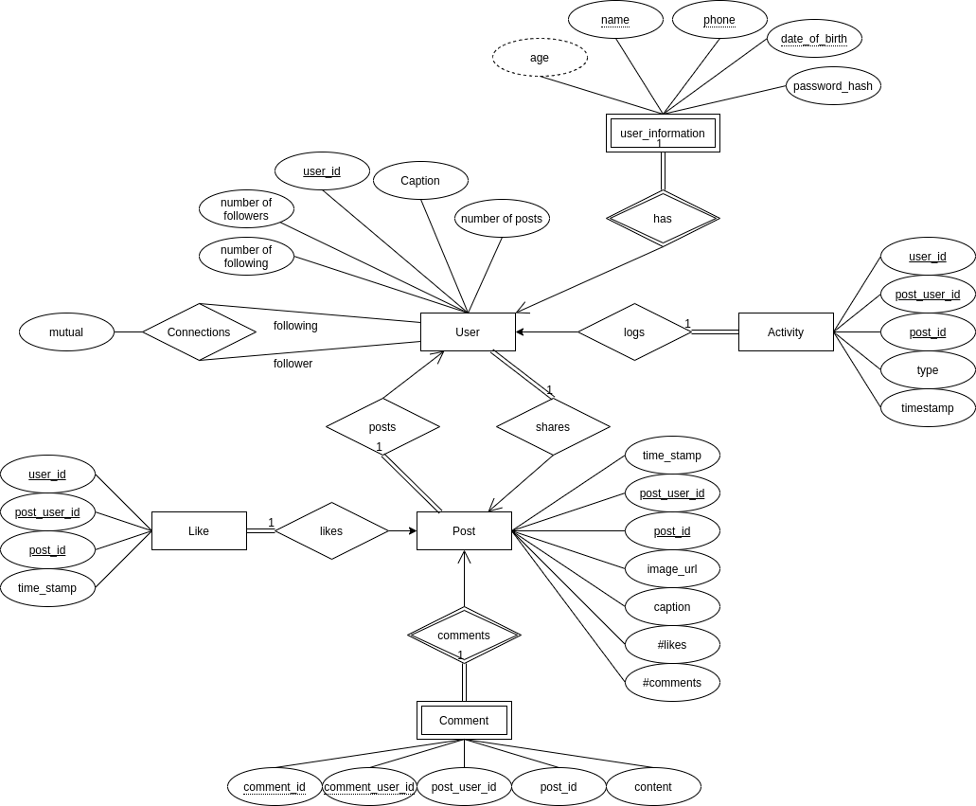

1. **Relational Schema**

