**Database Management System Project**

**Group members**

Name - Kishan Patel MIS - 111803172

Name - Swebert Correa MIS - 111807076

Branch - Computer Engineering

Div - 2

Batch - T4

1. **Problem Statement**

We are designing a social media platform.

1. **Introduction**

Our main objective is to create an online social community for sharing photos. Here people can interact by posting photos and captions, while others can comment, like and share those posts.

1. **Functional Requirements**

**Tectstack** -

* Frontend - HTML, CSS and JavaScript.
* Backend - PHP
* Relational Database - SQL.

**Use cases** -

* Users can create accounts.
* Users can follow other users.
* Users post images and add captions.
* Users can see the news feeds of people whom they follow.
* Users can comment and like the posts on their news feed.
* Users can also share those posts on their own page.

1. **ER Diagram**

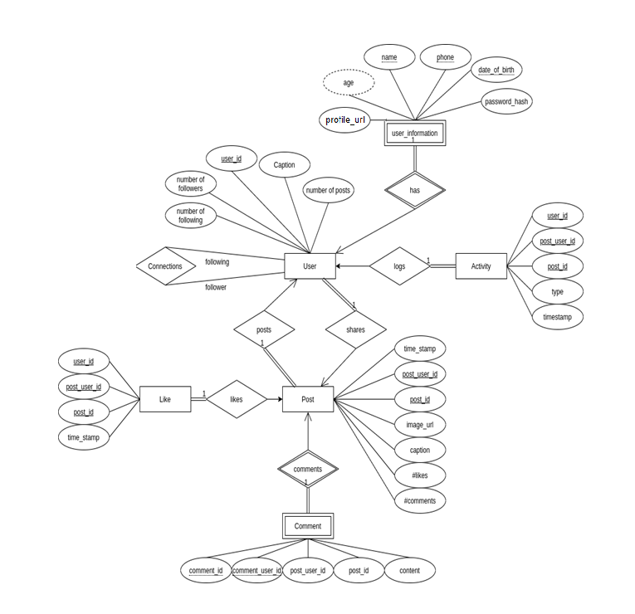

1. **Relational Schema**

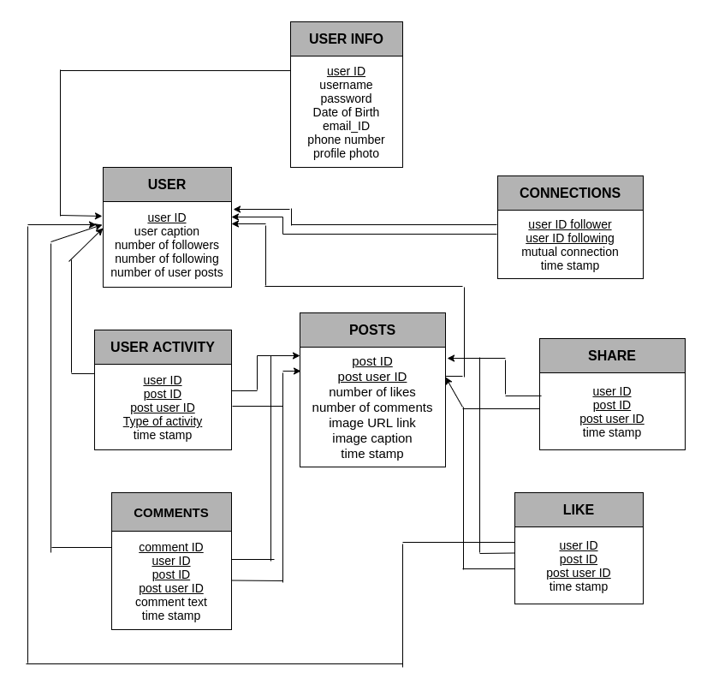

1. **Functional Dependencies**

**User Information Table**

**FD : {user ID} --->** {username, password, data of birth, email ID,

phone number, profile photo URL}

All attributes in relation are not composite or multi-valued attributes.

Relation does not have any partial dependencies.

Relation does not have any transitive dependencies.

**User Table**

**FD : {user ID} --->** {user caption, no. of followers,

no. of following, no. of user posts}

All attributes in relation are not composite or multi-valued attributes.

Relation does not have any partial dependencies.

Relation does not have any transitive dependencies.

**Connections**

**FD : {user ID follower, user ID following} --->** {mutual connections,

time stamp}

All attributes in relation are not composite or multi-valued attributes.

Relation does not have any partial dependencies.

Relation does not have any transitive dependencies.

**Posts**

**FD : {post ID, post user ID} --->** {no. of likes, no. of comments, image

URL, image captions,timestamp }

All attributes in relation are not composite or multi-valued attributes.

Relation does not have any partial dependencies.

Relation does not have any transitive dependencies.

**Likes**

**FD : {post ID, post user ID, user ID} --->** {timestamp}

All attributes in relation are not composite or multi-valued attributes.

Relation does not have any partial dependencies.

Relation does not have any transitive dependencies.

**Comments**

**FD : {comment ID, user ID, post ID, post user ID} --->** {comment,

timestamp}

All attributes in relation are not composite or multi-valued attributes.

Relation does not have any partial dependencies.

Relation does not have any transitive dependencies.

**Share**

**FD : {user ID, post ID, post user ID} --->** {timestamp}

All attributes in relation are not composite or multi-valued attributes.

Relation does not have any partial dependencies.

Relation does not have any transitive dependencies.

**User Activity**

**FD :**

**{user ID, post ID, post user ID, Type of Activity} --->** { timestamp }

All attributes in relation are not composite or multi-valued attributes.

Relation does not have any partial dependencies.

Relation does not have any transitive dependencies.