**Exercise 21**

My Image: “Mona Lisa Photoshop”-Google Images search, result: “hqdefault.jpg”

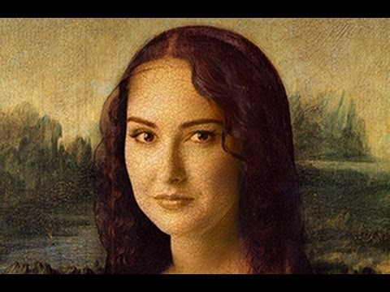  
Source Citation:

*Mona Lisa Photoshop*. Digital image. *YouTube*. Blue Lightning TV Photoshop, 31 Jan. 2012. Web. 12 June 2017. <https://www.youtube.com/watch?v=V-7qn807E1E>.

I think it is pretty clear that the vintage image of Mona Lisa was modified to display a different face (of another person) instead of the original one.

Finding a tutorial was not hard. Search terms could be: “Mona Lisa photoshop tutorial”

I found three sources for this. They are:

<https://www.youtube.com/watch?v=V-7qn807E1E>

<https://www.youtube.com/watch?v=jcuanyDgJxc>

<https://www.youtube.com/watch?v=Vx_9pfhQGa0>

The questions and answers are as follows:

**Source 1:**

Q: How close is the tutorial to what you want to do?

A: It is the exact match. I found the image within the tutorial so it will be the perfect video.

Q: Is the tutorial up-to-date and does it work with your version of Photoshop?

A: The tutorial is not as new, but will work with my version of Photohop CC 2017.

Q: Is the creator of the tutorial trustworthy or competent? How do you know?

A: Yes. The channel is quite good and they explain very well. They are dedicated just to photoshop tutorials, hence they have many related videos.

Q: Is the tutorial appropriate for your skill level?

A: Yes, the tutorial is perfect because it does not use any skill that I have not learnt in this class.

**Source 2:**

Q: How close is the tutorial to what you want to do?

A: It is pretty close, but it just replaces the entire head with a new one instead of replacing just the face.

Q: Is the tutorial up-to-date and does it work with your version of Photoshop?

A: The tutorial is not as new, but will work with my version of Photohop CC 2017.

Q: Is the creator of the tutorial trustworthy or competent? How do you know?

A: Not quite. It just has one photoshop tutorial, and is more dedicated to other general stuff like travel or building things.

Q: Is the tutorial appropriate for your skill level?

A: Yes, the tutorial is appropriate because it does not use any skill that I have not learnt in this class.

**Source 3:**

Q: How close is the tutorial to what you want to do?

A: It is fairly good and does a face swap, so it would be a good source to look into. There is no voice and just text on the screen, which makes it kind of boring. Also, they basically just use the layer mask with adjustments in brightness/contrast/etc. It might not be a good source to learn new things.

Q: Is the tutorial up-to-date and does it work with your version of Photoshop?

A: The tutorial is not as new, but will work with my version of Photohop CC 2017.

Q: Is the creator of the tutorial trustworthy or competent? How do you know?

A: Yes. The channel is dedicated just to photoshop tutorials, hence they have many related videos. There is no direct copying from other sources and the creators themselves do the edits.

Q: Is the tutorial appropriate for your skill level?

A: Yes, the tutorial is good because it does not use any skill that I have not learnt in this class.

Based on my answers and the tutorials, I would obviously go for the first one as it will guide me step by step on how exactly to get a different face on the Mona Lisa painting.