INTERMEET 2026
Three days of leadership, laughter and learning in Kadiri
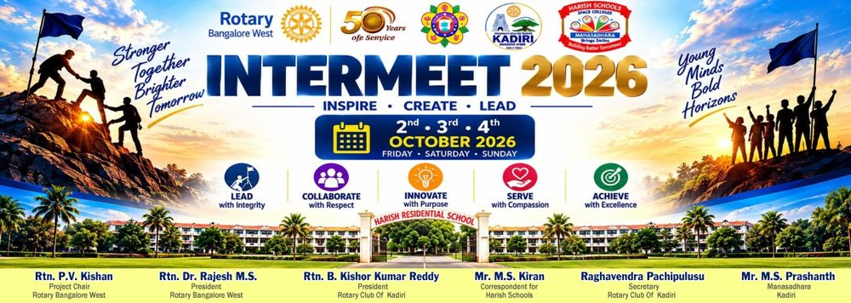
For three days in early October, the green campus of Harish Residential School in Kadiri turned into a playground of ideas. Under the theme Inspire · Create · Lead, children came together to discover the leader within them and, as the photos in this report show, to have a great deal of fun doing it. Intermeet 2026 was a joint project led by Rotary Bangalore West (District 3192) with Rotary Club of Kadiri (District 3160), hosted at Harish Residential School.
Lead club | Rotary Bangalore West (District 3192)
Dates | 2, 3 and 4 October 2026 (Friday to Sunday)
Venue | Harish Residential School, Kadiri, Andhra Pradesh
Co-hosted by | Rotary Bangalore West, Rotary Club of Kadiri (District 3160), Harish Schools and Manasa Dhara Charitable Trust
For | Boys and girls aged 14–16 (classes 8, 9 and 10): 96 registered; 100+ children benefited as the residential campus welcomed more
Overall budget | Approximately INR 4 lakhs

Meet the trainers
The heart of Intermeet was a team of trainers from Buoyancee Training Academy, who made leadership feel like play.
Ms. Sunitha Kolar · Trainer · Clarity Mentor · Accountability Partner
Helps people gain clarity, build discipline and strengthen self-belief through a calm, grounded and judgement-free style, which made her sessions a safe space for the children to open up.
Ms. Sindhu Sajeev · Human Potential and Transformation Coach · Facilitator
ICF-certified coach with 27+ years of experience across corporate leadership, coaching and learning facilitation. She also brings yoga and mindfulness practice, and has run RYLA student sessions in government residential schools.

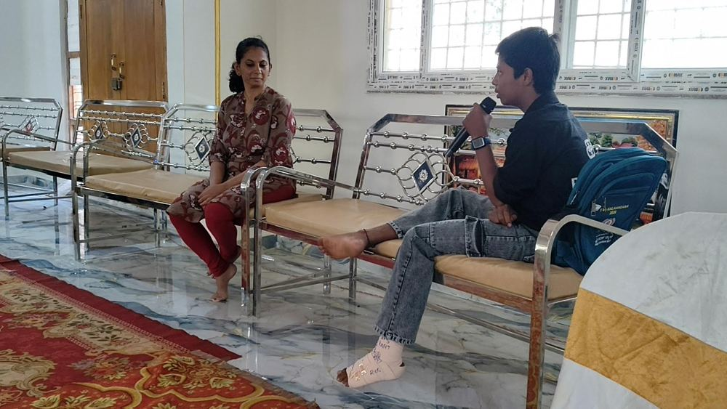  Ms. Sunitha Kolar listens as a child shares his thoughts | 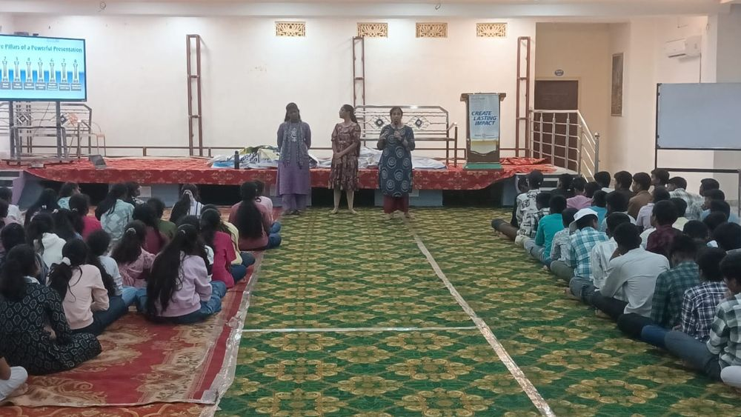  Ms. Sindhu Sajeev (right) with fellow trainers
Kids' facilitators: Ms. Usha G and Ms. Kavya N, who led the children's activities.

Before the children arrived
Good camps are won before they begin. A few of our Rotarians travelled to Kadiri well ahead of the dates for a recce of the campus, the dining hall, the session rooms and the open ground. By the night of 1 October the setup team had landed to help with arrangements: banners went up, kits were counted and the registration desk took shape.
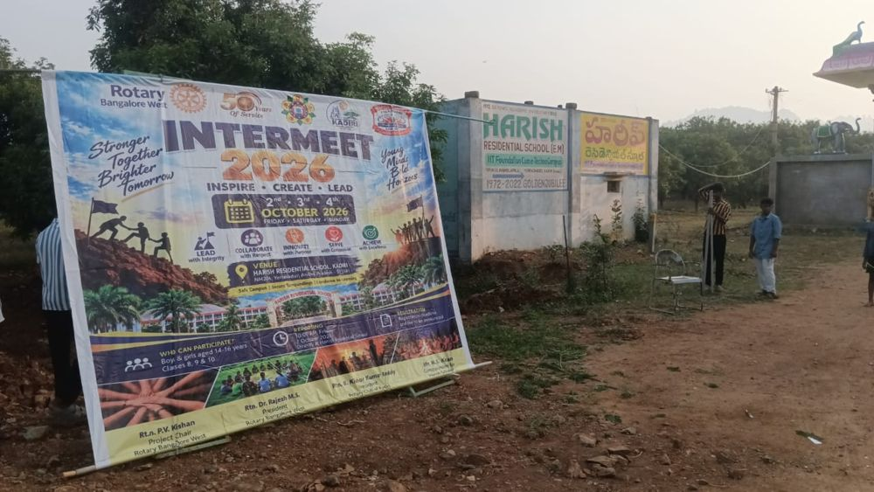  Welcome banner goes up, early on 2 October | 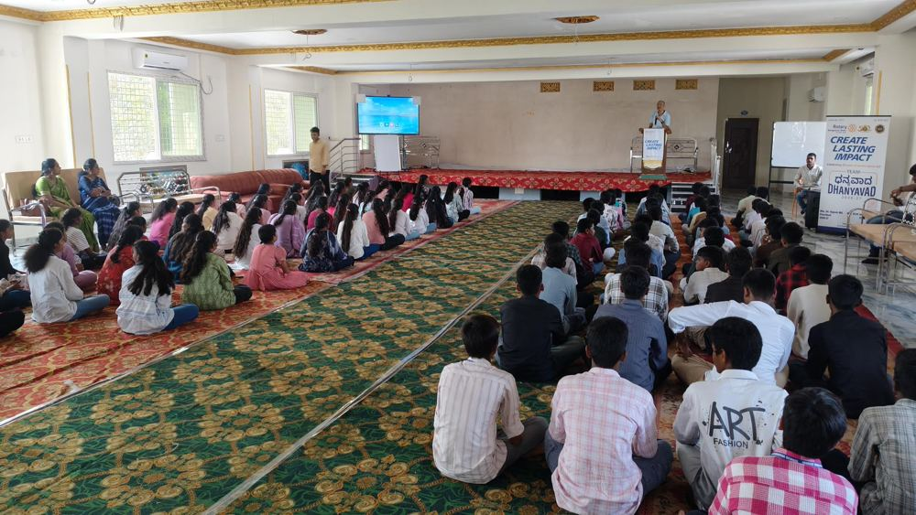  Rotarians brief the children on the first morning

Day 1 · Friday 2 October: Discover & Inspire
Registration opened at 8:30 AM. The children arrived with bags, curiosity and a fair bit of nervous energy, and the Rotarians themselves served the first breakfast. Every participant was welcomed under the Rotary banner and handed a camp kit; within minutes the nervousness gave way to name-tags, introductions and new friends.
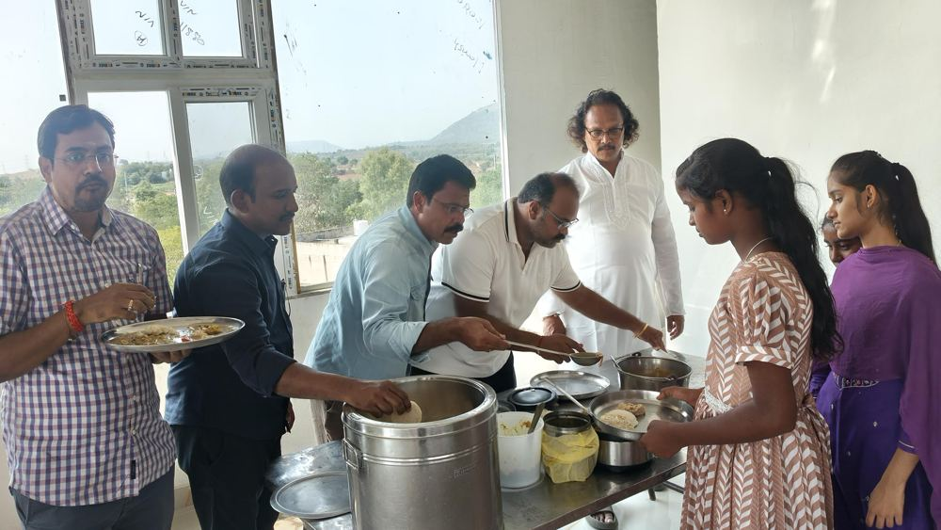  Rotarians serve breakfast to the children | 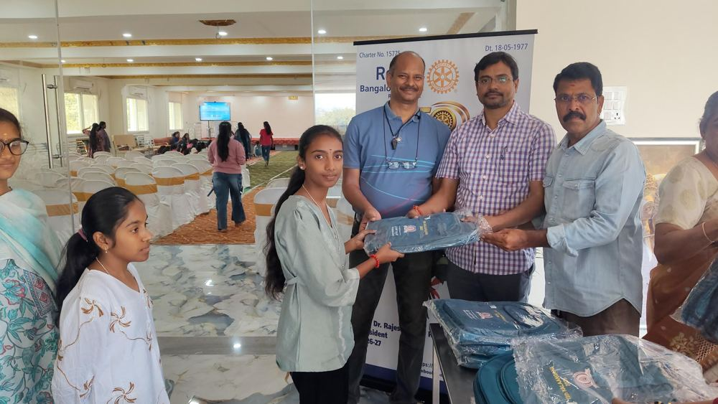  Camp kits handed out with a smile | 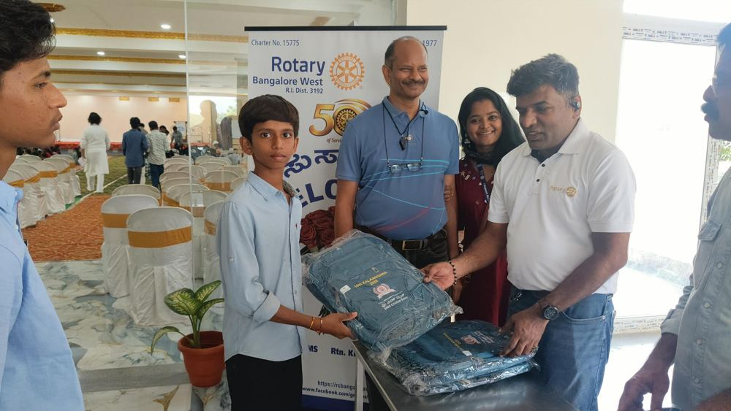  Every child gets a kit and a welcome
Then came the sessions: the icebreaker Meet, Move and Connect, self-awareness and confidence, and team challenges called Together We Rise, all led by our trainers with Ms. Usha G and Ms. Kavya N of Buoyancee keeping the children moving. In the evening session on speaking, listening and influencing, the children learned the 8 Core Pillars of a Powerful Presentation, from voice and body language to eye contact and handling the unexpected.
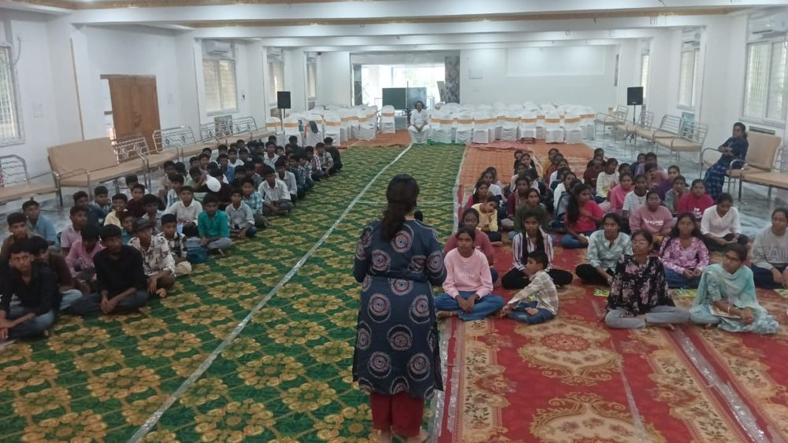  Trainer working with the children | 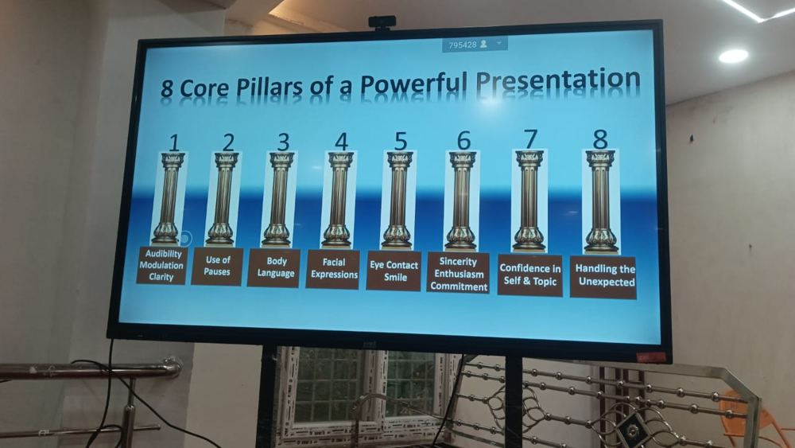  8 Core Pillars of a Powerful Presentation | 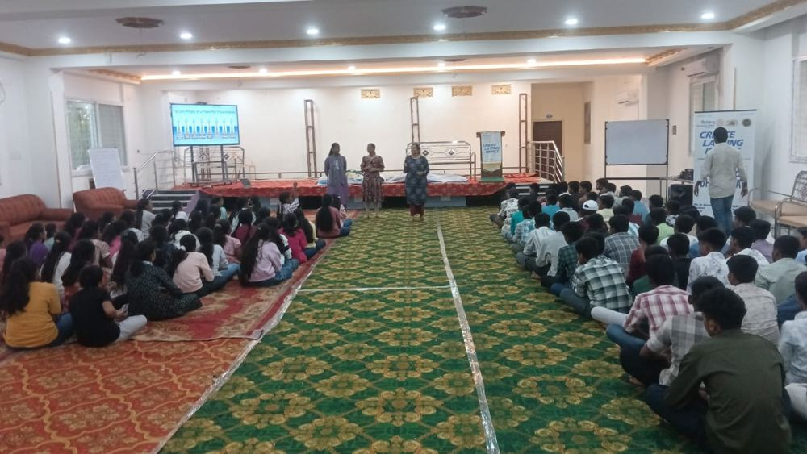  The communication session in the hall

Stars on stage
The part the children will remember longest is the evening. On Friday night, after dinner, the stage belonged to them. My Moment to Shine, the individual talent show, saw children dance, sing, act and tell stories in front of 100+ friends, many for the very first time. Volunteers from Rotaract Bangalore West hosted the show and kept the energy high, and the Rotarians clapped louder than anyone.
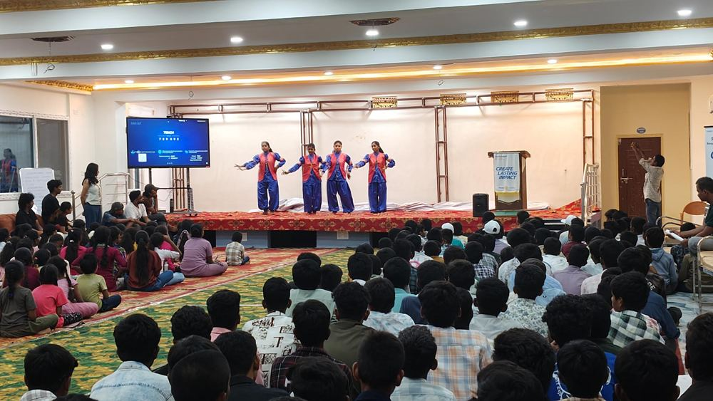  Group dance: four girls in blue and red | 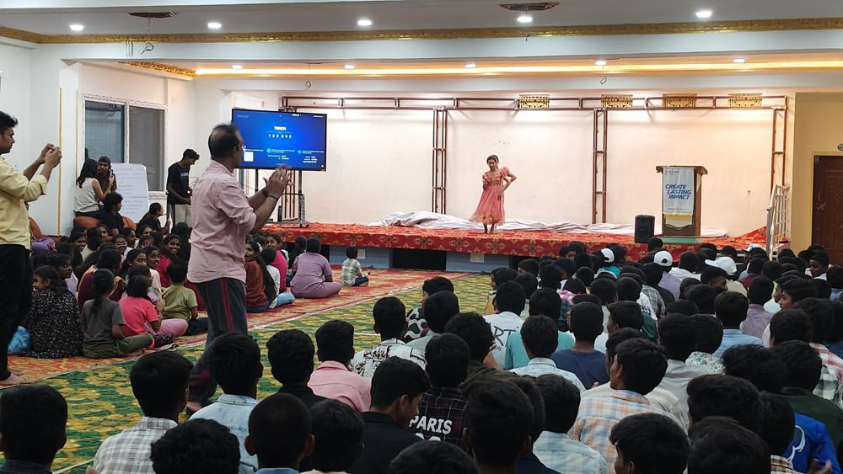  A solo classical performance | 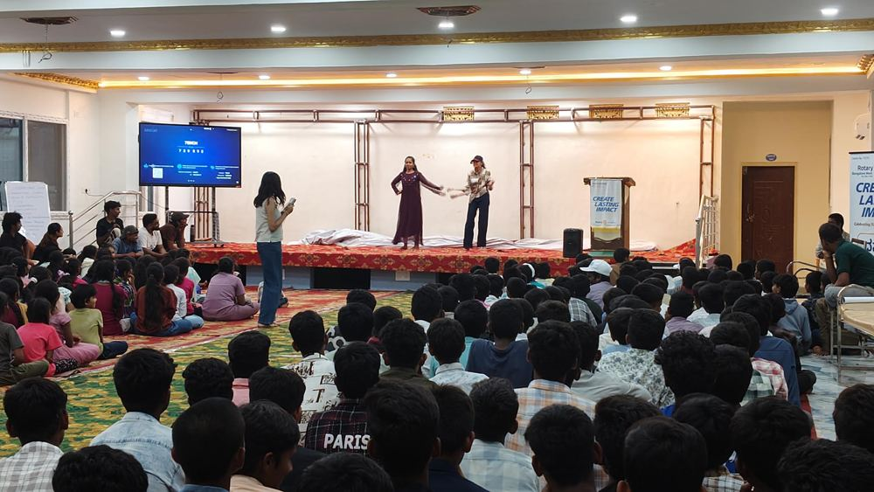  A duet performance, to the cheers of the hall
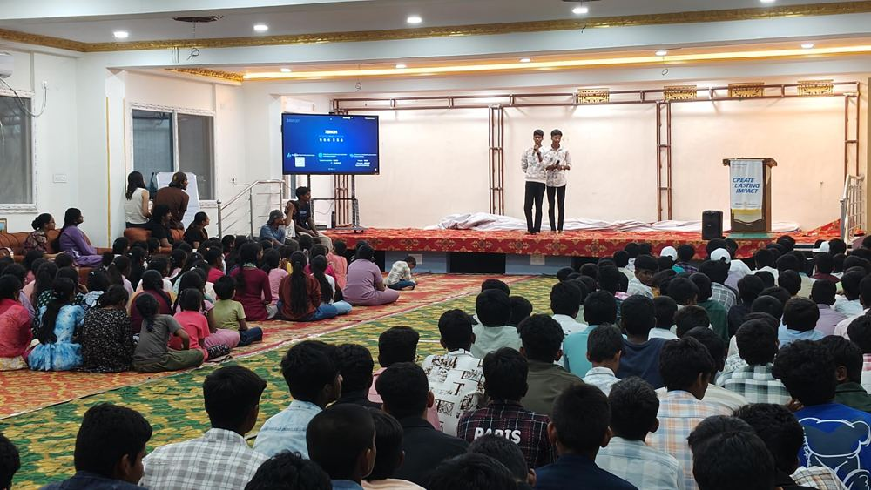  Two boys sing together on stage | 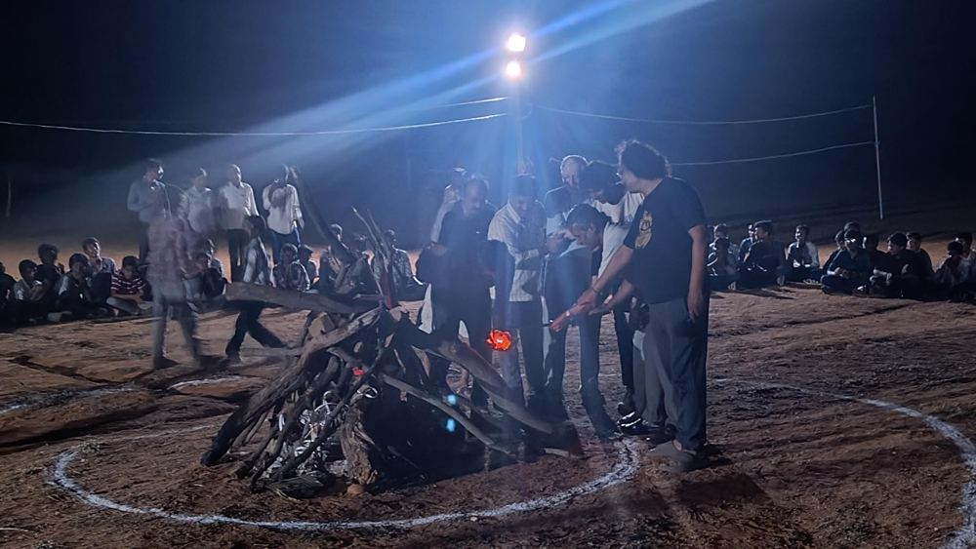  Saturday night: Rotarians and children light the campfire | 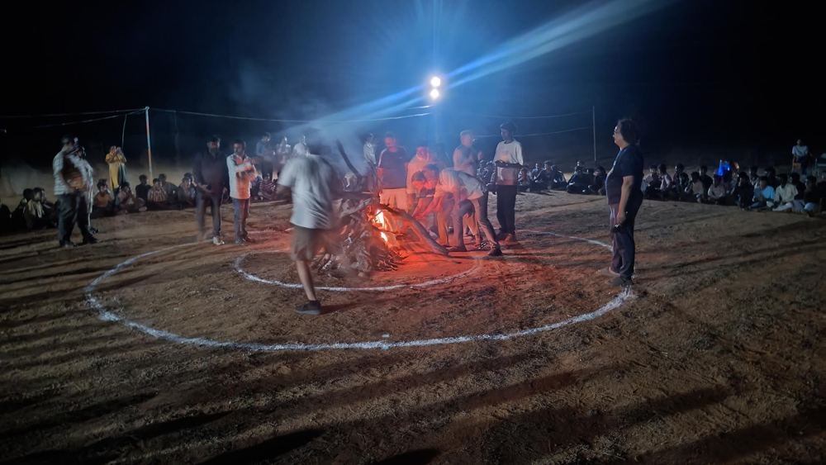  Campfire games
On Saturday night the stage moved outdoors. Fun Around the Fire, campfire games and the group talent show Stronger Together brought the whole camp, children and Rotarians, together around the flames.

Day 2 · Saturday 3 October: Create, Serve & Collaborate
The day began at 6 AM with yoga and stretching on the open ground. Morning sessions on leadership and ethical choices had children opening up, with children sharing their thoughts on the mic to a patient, encouraging audience. Then came the session we had planned most carefully: Stay Strong, Stay Safe.
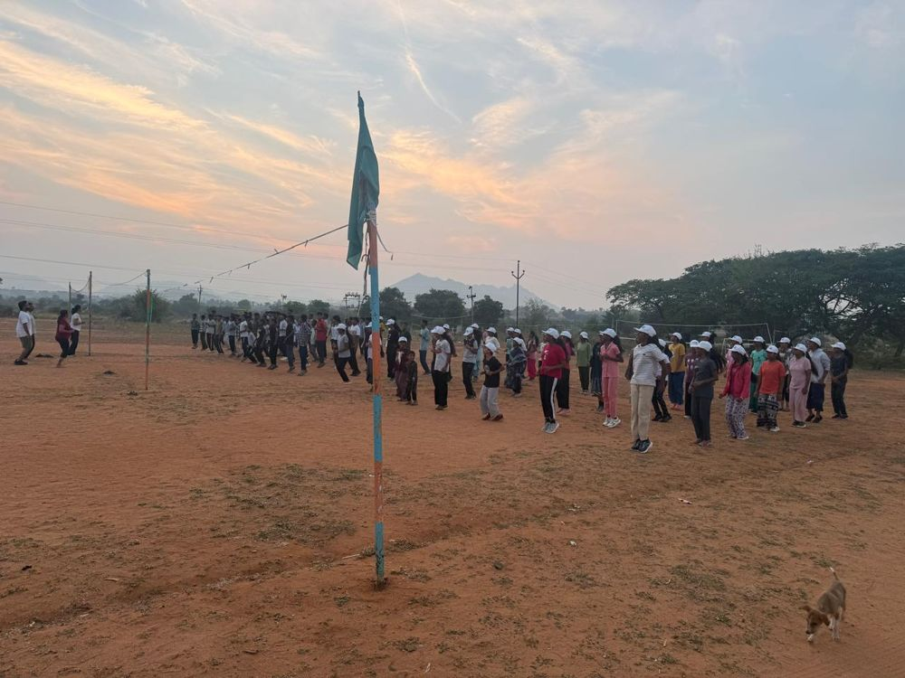  Sunrise assembly and yoga | 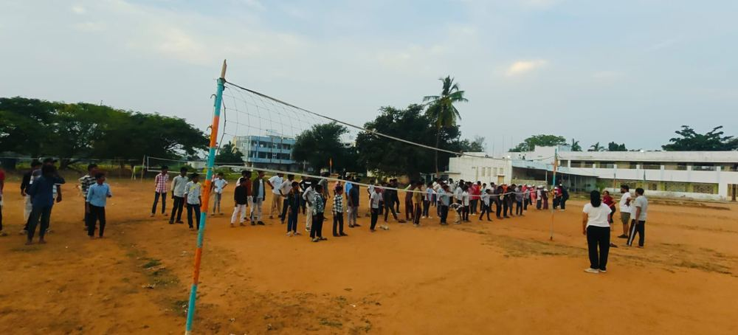  Morning activities on the ground

Substance abuse and human trafficking awareness
These are real concerns in and around Kadiri, so we brought in special facilitators, volunteers Mr. Munichowdappa and Ms. Padmini of Prakruthi NGO, for an age-appropriate session on substance abuse, trafficking, personal safety and, importantly, how and where to seek help. The children sat in circles, asked questions and listened. The session worked because the facilitators spoke with them, not at them.
Awareness session: volunteers Mr. Munichowdappa and Ms. Padmini of Prakruthi NGO.
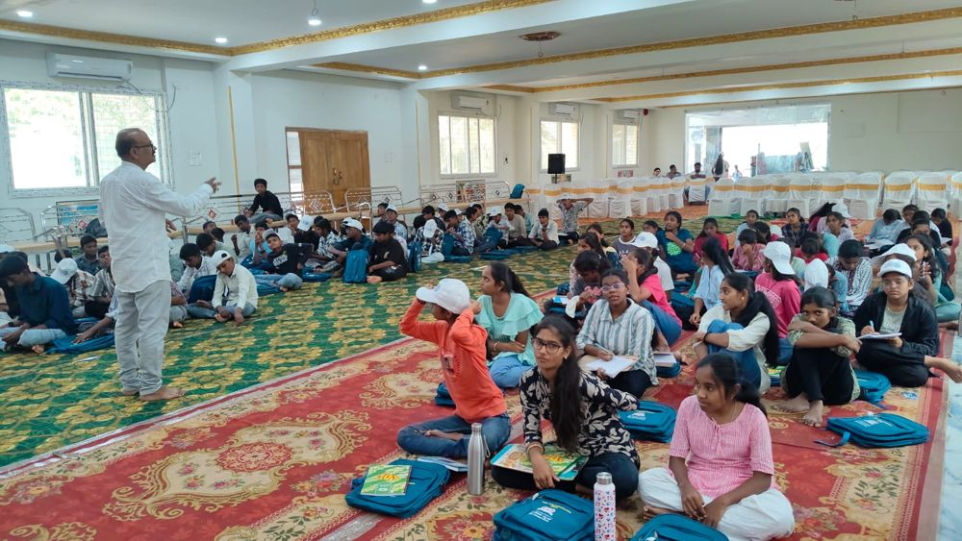  Prakruthi NGO volunteers with the children | 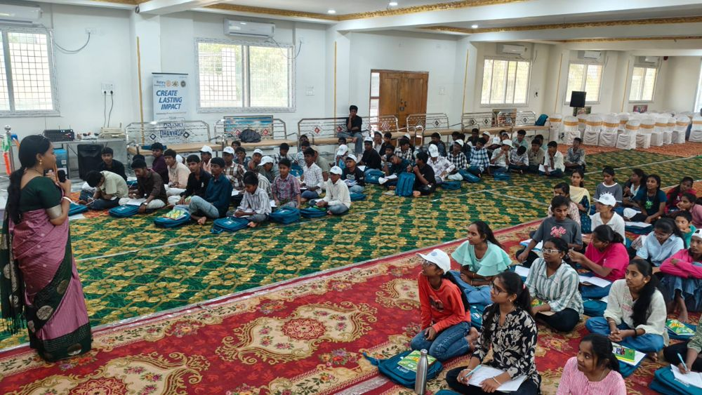  The hall during the awareness session | 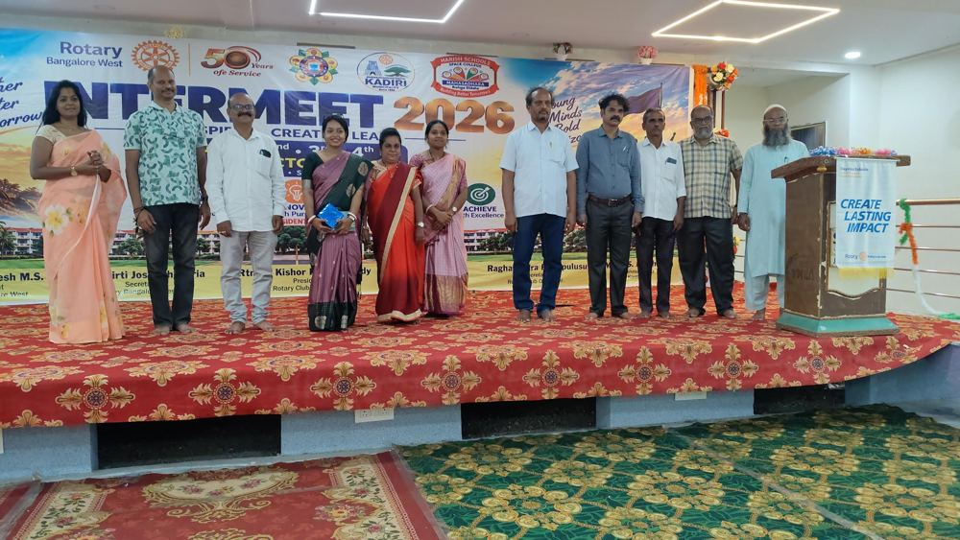  Facilitators and guests on stage

Cervical cancer awareness, running in parallel
While the camp carried on, senior girl students at the Government Junior College for Girls, Kadiri, joined a Cervical Cancer Awareness & HPV Vaccination programme organised by Rotary Bangalore West, Rotary Club of Kadiri and Manasa Dhara Charitable Trust. Expert medical practitioners explained prevention, early detection and the facts and myths around HPV vaccination, and the students were encouraged to ask anything.
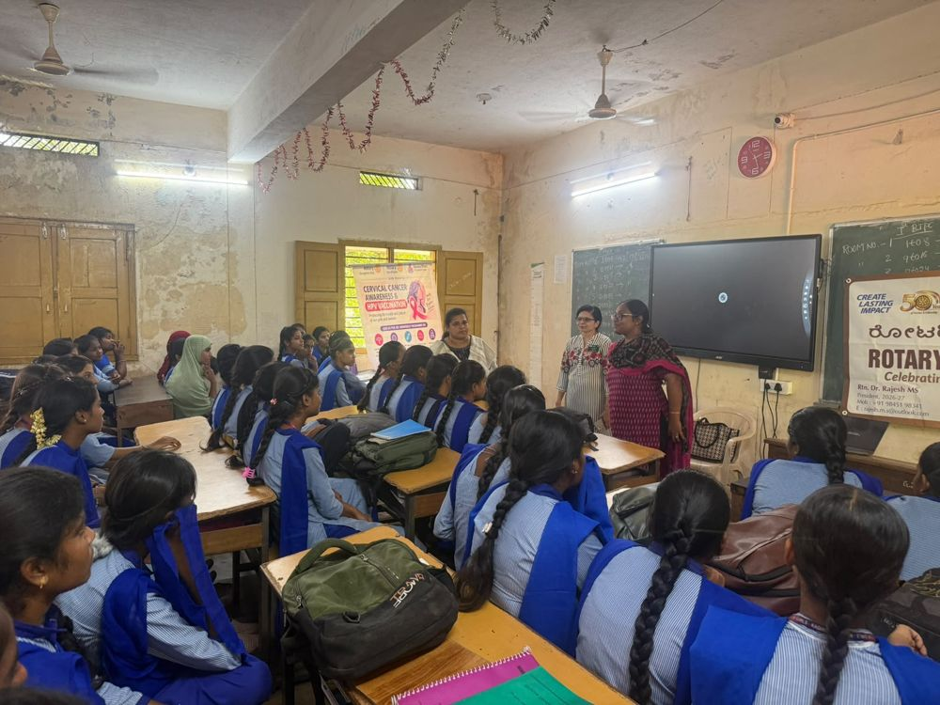  Students at the college session | 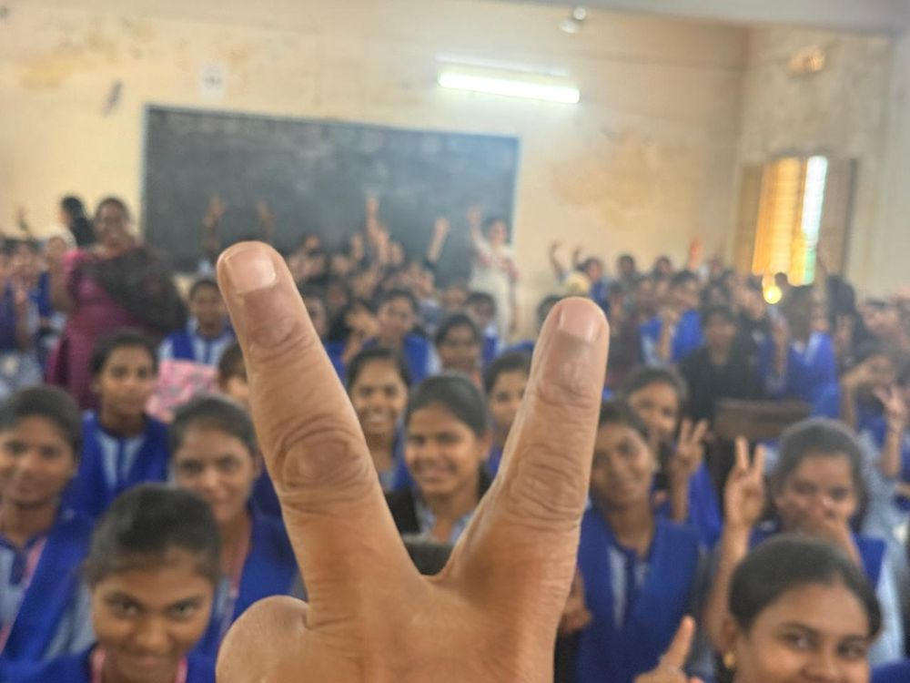  Smiles and V-signs after the session | 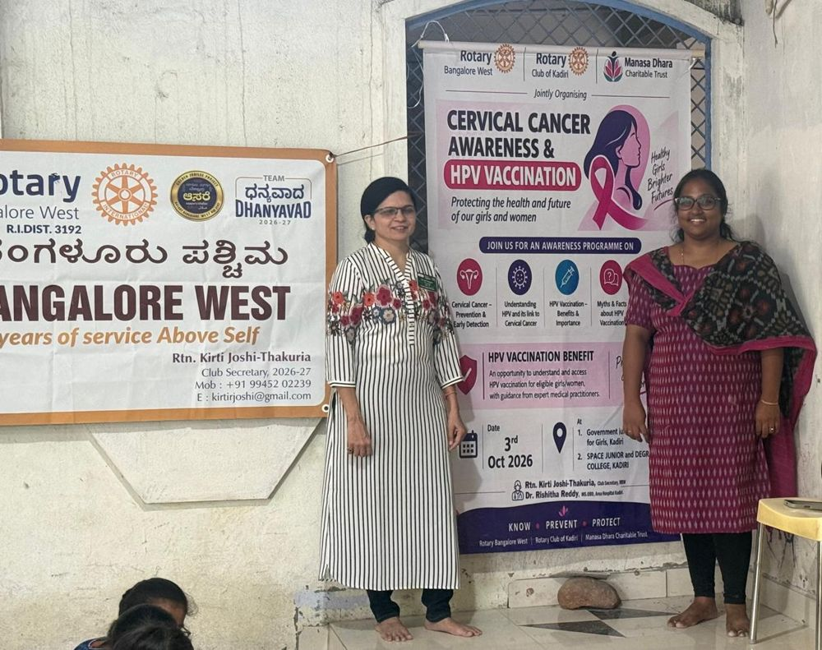  Programme poster with the doctors
The afternoon moved to Design Your Future (career discovery) and Service Begins with Me (Rotary values and service ideas), followed by sports and a spread of local millet dishes at dinner that children and Rotarians happily tucked into.
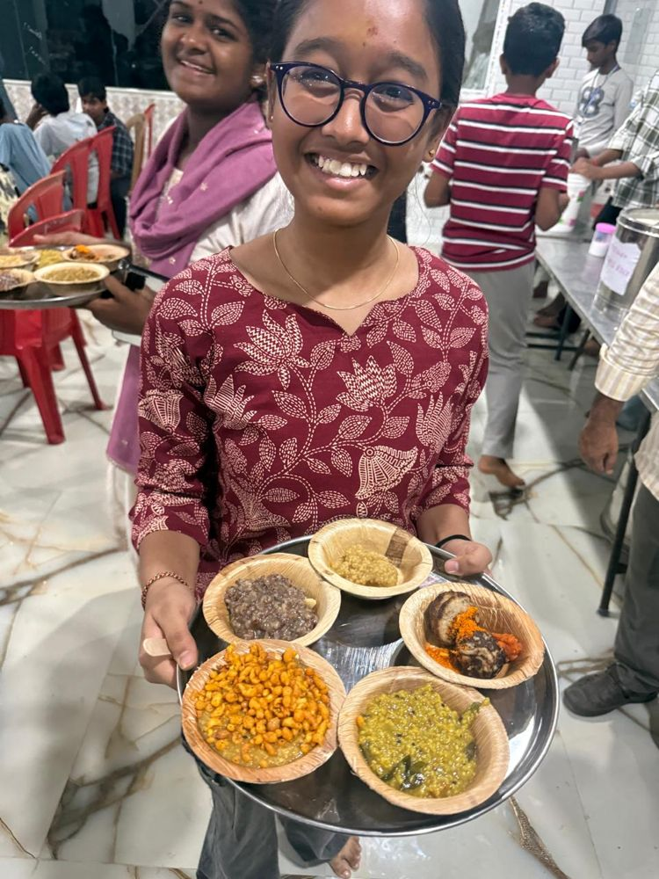  Dinner time, big smile | 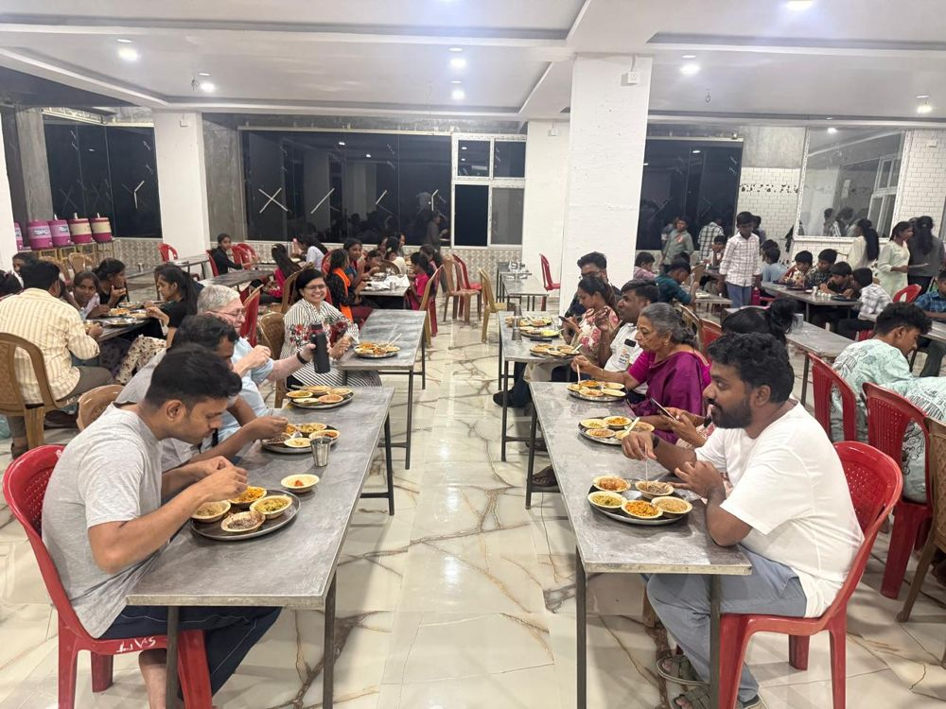  Rotarians and the team at dinner

Day 3 · Sunday 4 October: Lead Forward and the Valedictory
Sunday started with a mindful morning of yoga, followed by From Ideas to Action and My Leadership Promise, where each child wrote down a personal commitment. An RTO Inspector shared practical road safety tips, and then the children planned their own closing ceremony.
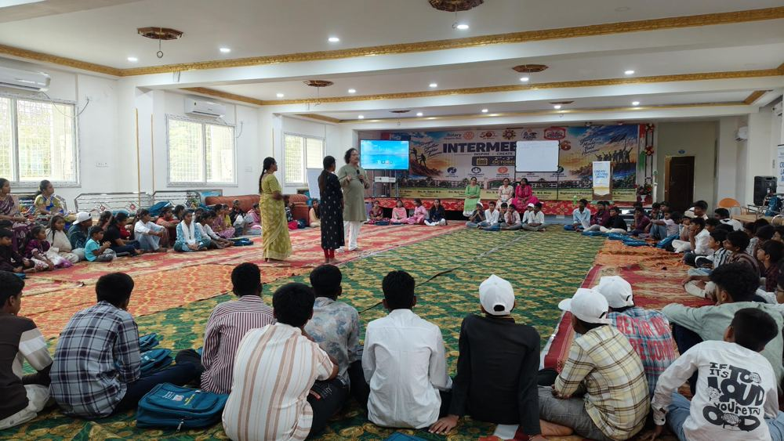  Reflection circle with the facilitator | 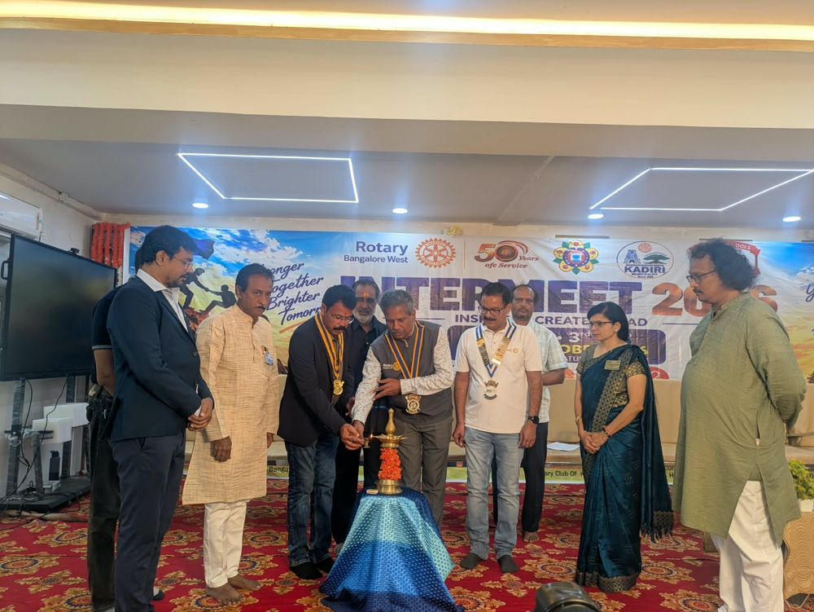  Lighting the lamp at the Valedictory
The camp closed on 4 October with the Valedictory, a joint Rotary club meeting of Rotary Bangalore West (District 3192) and Rotary Club of Kadiri (District 3160), whose agenda was the closure of Intermeet. On the dais were District Governor of District 3160 Rtn. Keshav Reddy, Past District Governor Rtn. Chinappa Reddy and Assistant Governor Rtn. Narendra Reddy, along with Rtn. Kishore, President, and Rtn. Raghavendra, Secretary, of Rotary Club of Kadiri. The lamp was lit, and the programme moved through participant presentations, performances, certificates of participation and a vote of thanks. Several children said it was the first time they had spoken on stage. Every one of them held their certificate with pride.
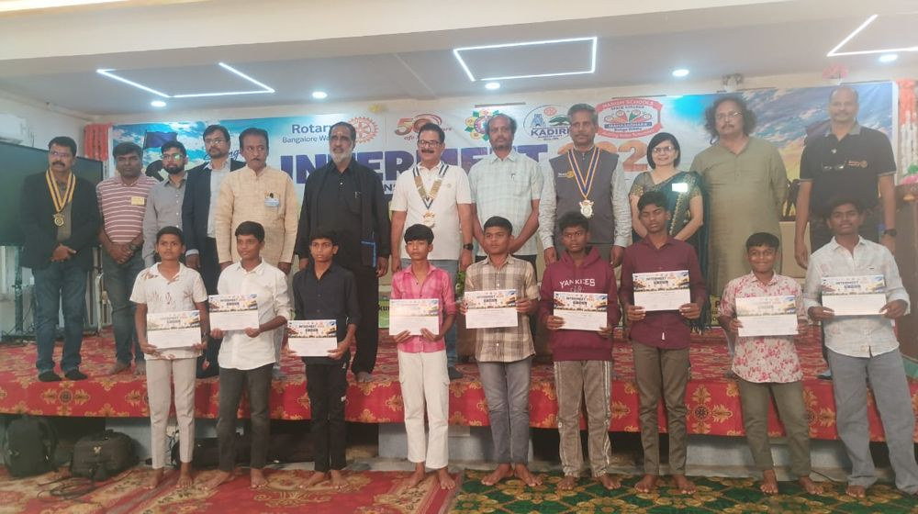  Participants with their certificates, along with the DG, PDG and AG of Districts 3192 and 3160 | 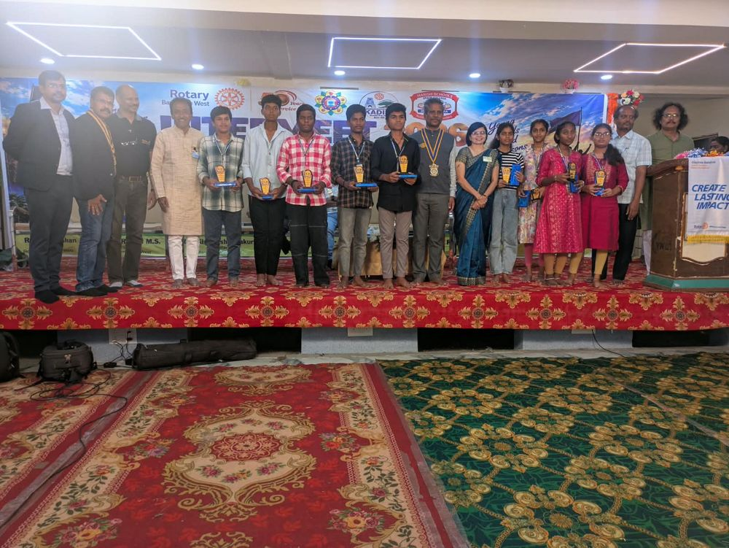  Rotarians, school children and volunteers at the Valedictory
The certificates of participation were handed over at the Valedictory itself, the last event of the camp on 4 October.
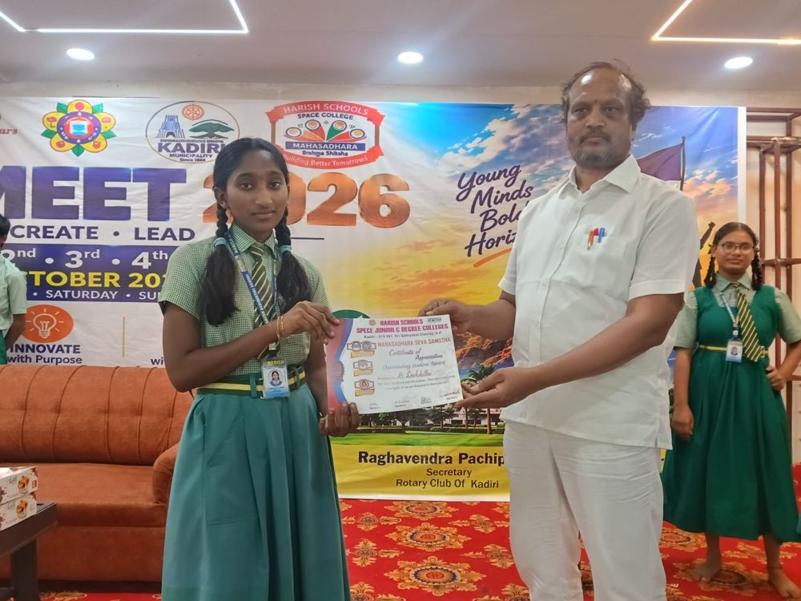  Rtn. Prashanth handing over participation certificates at the Valedictory | 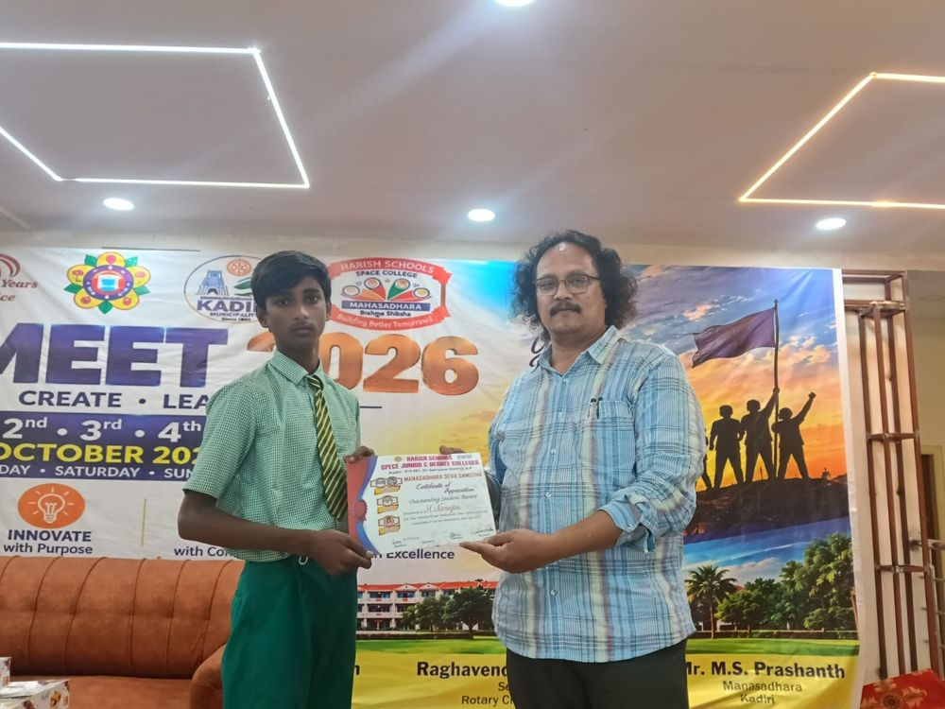  Another participant receiving a participation certificate at the Valedictory

In the news
Kadiri's Telugu dailies, including Andhra Jyothy and Surya, carried the story across several days, with headlines such as "Confidence can help you achieve anything" and "Rotary Intermeet to develop leadership in students". The reports highlight the leadership, communication and safety sessions and the Valedictory.
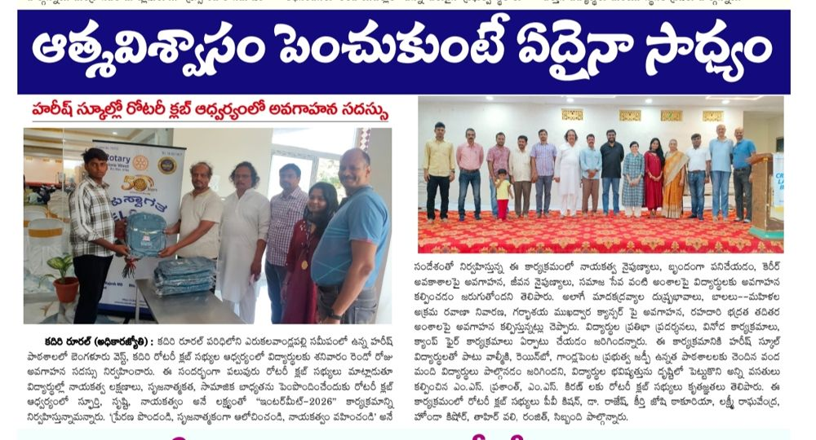  Press coverage | 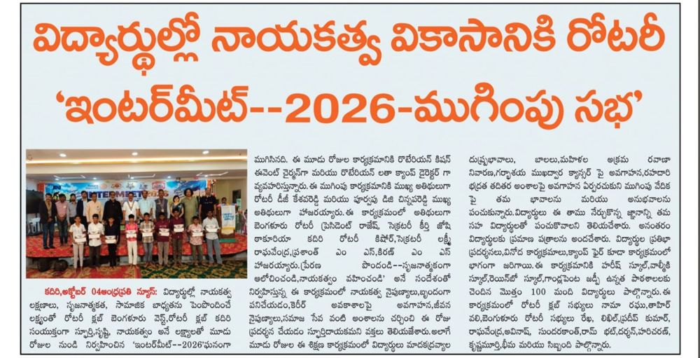  Coverage of the Valedictory

Rotarians, cake and tea
The Rotarians had their own fun too. Rtn Krishnamurthy, who had come to the venue with his wife Ann Beena, was surprised with a birthday cake, shared with the Rotarians and the children. And before the camp had even begun, on the night of 1 October, a group of us made a late-night trip out for tea, a small tradition of every good Rotary camp.
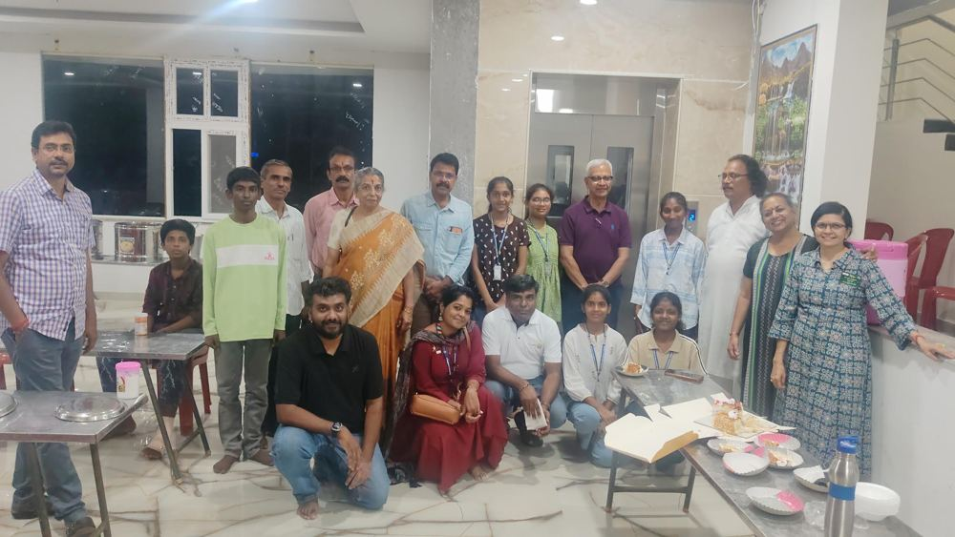
Birthday celebration with Rotarians and children
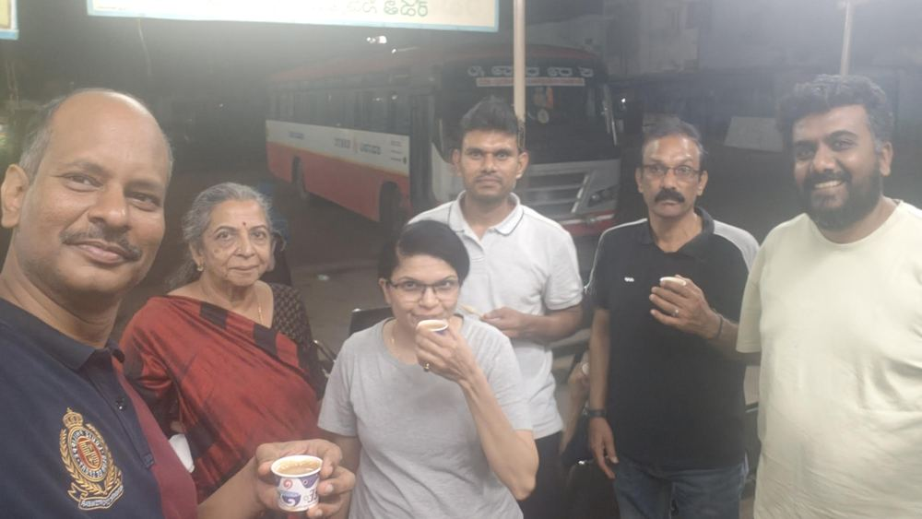  1 October night: tea at the bus stand | 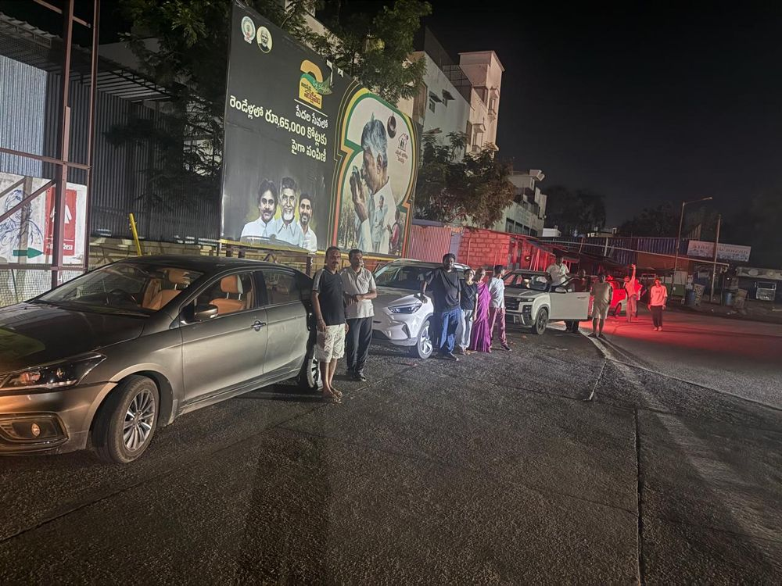  Night drive in Kadiri

Rotary impact
Children reached: 96 registered; 100+ benefited as the residential campus welcomed more. Areas of Focus: basic education and youth leadership, and disease prevention (cervical cancer and HPV awareness). Rotarian involvement: recce and setup, serving meals, handing out kits, hosting sessions and lighting the campfire. Long-term: children went home with a personal leadership promise, safety awareness and ideas for service projects in their own communities.

Thank you
Our heartfelt thanks to everyone who made Intermeet possible, and above all to the children, whose energy made it what it was.
Special thanks
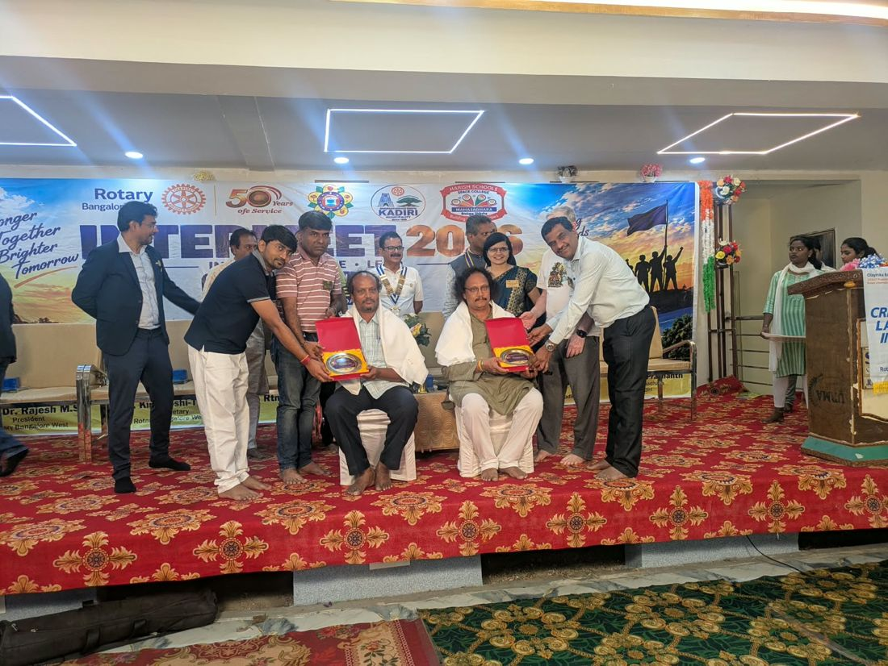
Rtn. M.S. Prashanth and Rtn. M.S. Kiran, Correspondents of Harish Residential School and key members of Manasa Dhara Charitable Trust, felicitated at the Valedictory
Rtn. Nagesh Babu for initiating the whole discussion with Harish School.
Rtn. M.S. Prashanth and Rtn. M.S. Kiran, Correspondents of Harish Schools and key members of Manasa Dhara Charitable Trust, our main pillars of help, for opening the campus and their hearts.
Rtn. Vinaykumar, for spearheading the volunteers from Prakruthi NGO.
Rtn. Hariharan of Rotary Bangalore West, for his immense help.
Rotary Bangalore West (District 3192): Rtn. Dr. M.S. Rajesh, President, and Rtn. Kriti T, Secretary.
Rotary Club of Kadiri (District 3160): Rtn. Kishore, President, and Rtn. Raghavendra, Secretary, and the Kadiri team.
Rotaract Bangalore West: Rtr. Niraj, President, and Rtr. Dhriti, Secretary, and their volunteers.
Our trainers and volunteers: Ms. Sunitha Kolar, Ms. Sindhu Sajeev, Ms. Usha G and Ms. Kavya N of Buoyancee, and Mr. Munichowdappa and Ms. Padmini of Prakruthi NGO.
Partners: Manasa Dhara Charitable Trust and our doctors for the cervical cancer awareness programme.
Rotary Bangalore West volunteers who travelled all the way to Kadiri and helped make this journey a fantastic memory.

Camp Chairman: Kishan Pallapothu · Camp Director: Latha S · Youth Service Director: Pradeepkumar K N

