DDL Observation
Tables used: STUDENT, FACULTY, DEPARTMENT/DEPT, COURSE.

-- 1. CREATE: Create database and table
CREATE DATABASE company;
USE company;

CREATE TABLE employees (
emp_id INT PRIMARY KEY AUTO_INCREMENT,
emp_name VARCHAR(50) NOT NULL,
department VARCHAR(30),
salary DECIMAL(10,2),
hire_date DATE
);
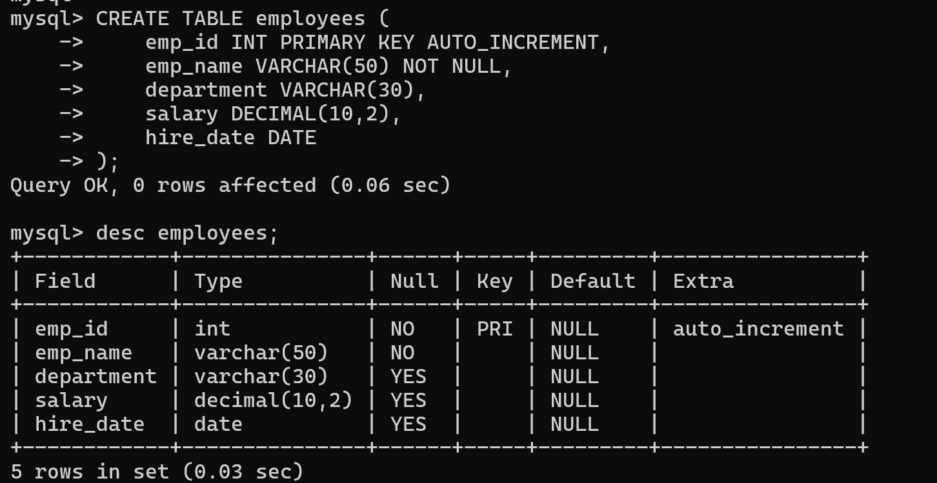

-- 2. ALTER TABLE: Add columns
-- Modify FACULTY by adding column Dept VARCHAR(10)
ALTER TABLE FACULTY ADD Dept VARCHAR(10);
ALTER TABLE FACULTY ADD Age NUMBER(3); -- fails: NUMBER is not a valid MySQL type

-- ALTER TABLE - DROP COLUMN (demonstration)
ALTER TABLE STUDENT ADD TempCol VARCHAR(5); -- add a throwaway column
ALTER TABLE STUDENT DROP COLUMN TempCol; -- then drop it
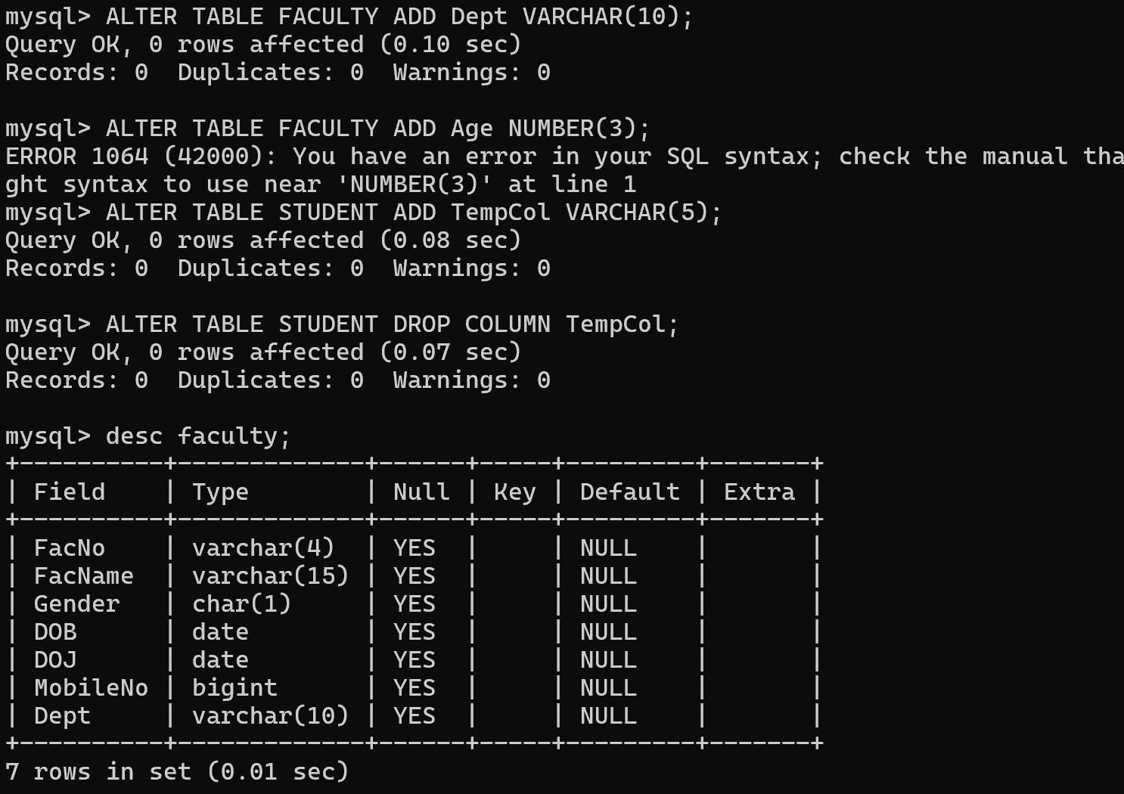

-- 3. Adding Constraint: PRIMARY KEY
ALTER TABLE STUDENT ADD PRIMARY KEY (RegNo);
ALTER TABLE FACULTY ADD PRIMARY KEY (FacNo);
ALTER TABLE DEPARTMENT ADD PRIMARY KEY (DeptNo);
ALTER TABLE COURSE ADD PRIMARY KEY (CourseNo);
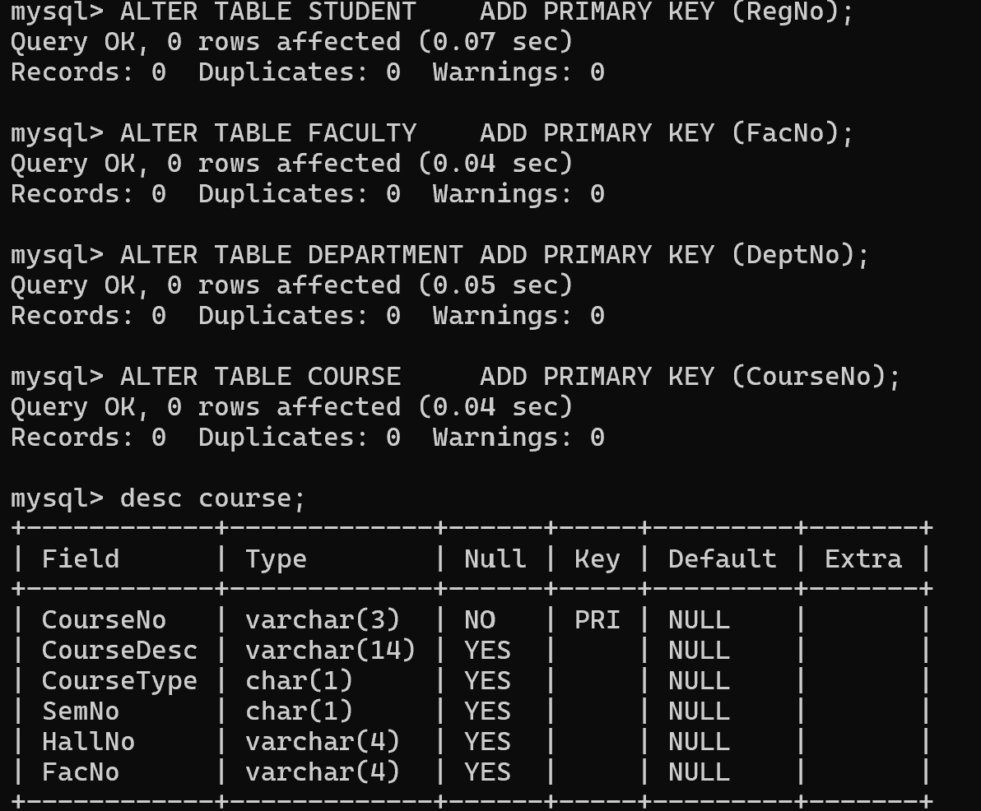

-- 4. ALTER TABLE - ADD FOREIGN KEY constraint
ALTER TABLE COURSE ADD CONSTRAINT fk_course_faculty
FOREIGN KEY (FacNo) REFERENCES FACULTY(FacNo);

ALTER TABLE DEPARTMENT ADD CONSTRAINT fk_dept_head
FOREIGN KEY (DeptHead) REFERENCES FACULTY(FacNo);
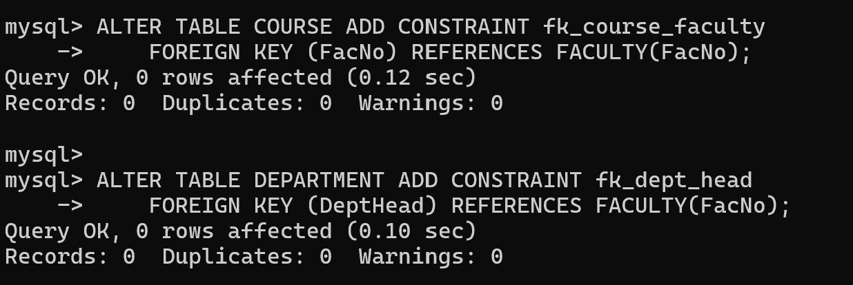

-- 5. RENAME TABLE
RENAME TABLE DEPARTMENT TO DEPT;
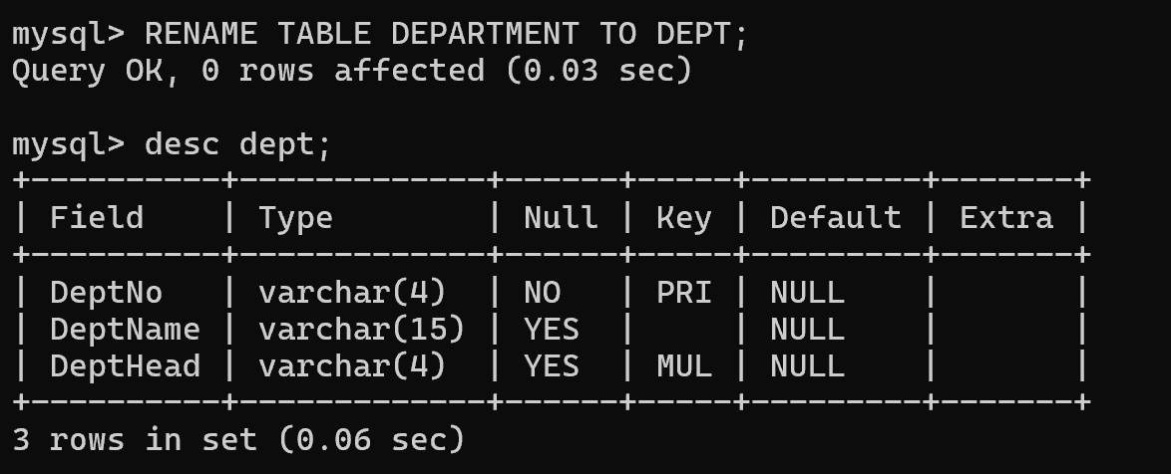

-- 6. TRUNCATE TABLE and DROP TABLE
CREATE TABLE SCRATCH (id INT);
INSERT INTO SCRATCH VALUES (1), (2), (3);
TRUNCATE TABLE SCRATCH;
DROP TABLE SCRATCH;
