DML Observation
Tables used: STUDENT, FACULTY, DEPT (renamed from DEPARTMENT), COURSE.
ALTER TABLE FACULTY ADD Age INT;

-- 1. INSERT: Populate all tables with data
INSERT INTO FACULTY (FacNo, FacName, Gender, DOB, DOJ, MobileNo, Dept, Age) VALUES
('F001', 'Ramesh', 'M', '1978-05-14', '2005-06-01', 9840012345, 'CSE', 48),
('F002', 'Mohan', 'M', '1965-11-02', '1998-07-15', 9840012346, 'CSE', 60),
('F003', 'Sunitha','F', '1980-03-22', '2008-08-20', 9840012347, 'ECE', 46),
('F004', 'Kavya', 'F', '1958-01-10', '1990-06-10', 9840012348, 'IT', 68),
('F005', 'Arjun', 'M', '1975-09-30', '2003-09-01', 9840012349, 'CSE', 51);
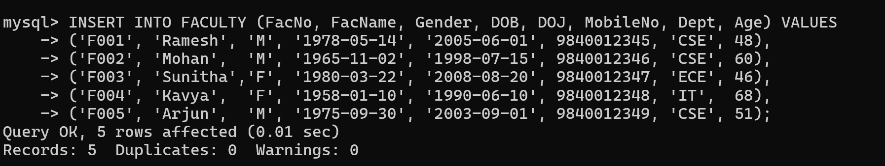

INSERT INTO STUDENT VALUES
(191, 'Aravind', 'M', '2001-04-12', 9884012345, 'Chennai'),
(192, 'Divya', 'F', '2001-07-19', 9884012346, 'Madurai'),
(193, 'Karthik', 'M', '2000-12-05', 9884012347, 'Coimbatore'),
(194, 'Meena', 'F', '2001-02-27', 9884012348, 'Salem'),
(195, 'Suresh', 'M', '2000-08-16', 9884012349, 'Trichy');
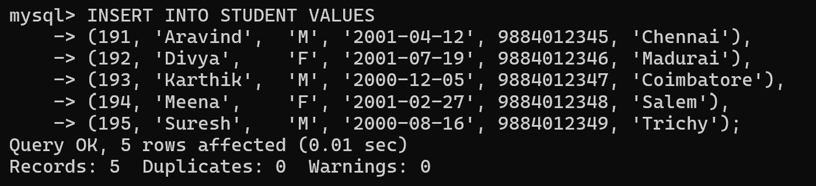

-- 2. SELECT: View all records from every table
SELECT * FROM STUDENT;
SELECT * FROM FACULTY;
SELECT * FROM DEPT;
SELECT * FROM COURSE;
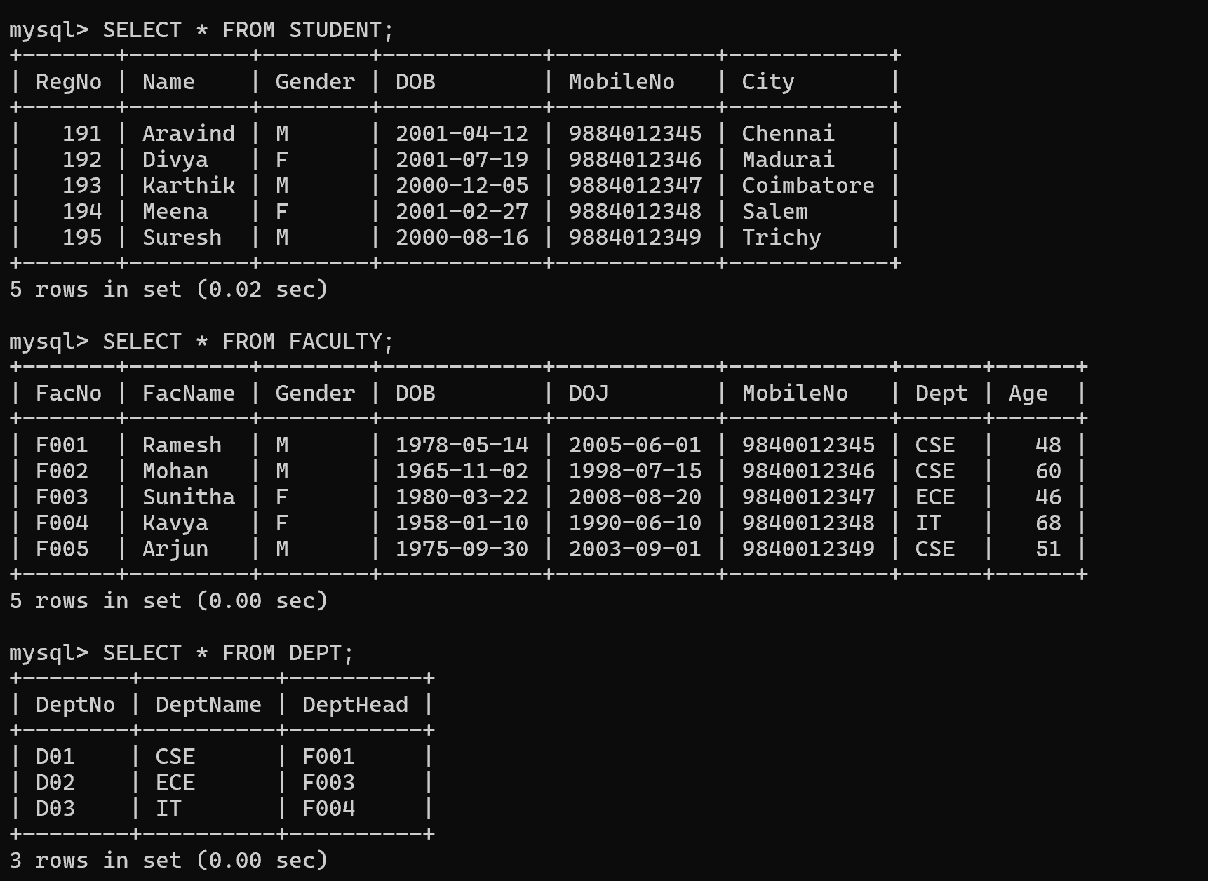

-- 2.1. Select Specific columns
SELECT Name, City FROM STUDENT;
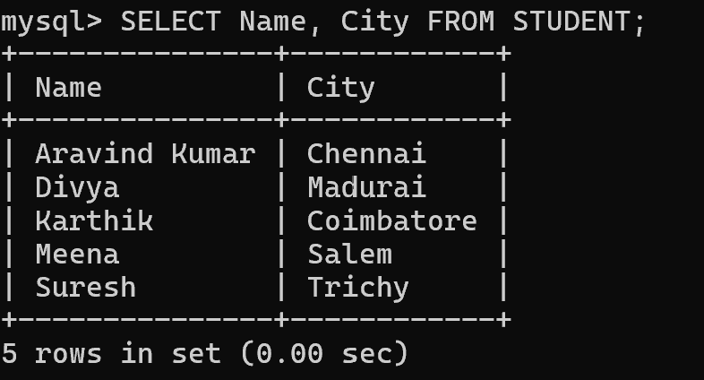

-- 2.2. Select Using Where
SELECT * FROM FACULTY WHERE Dept = 'CSE';
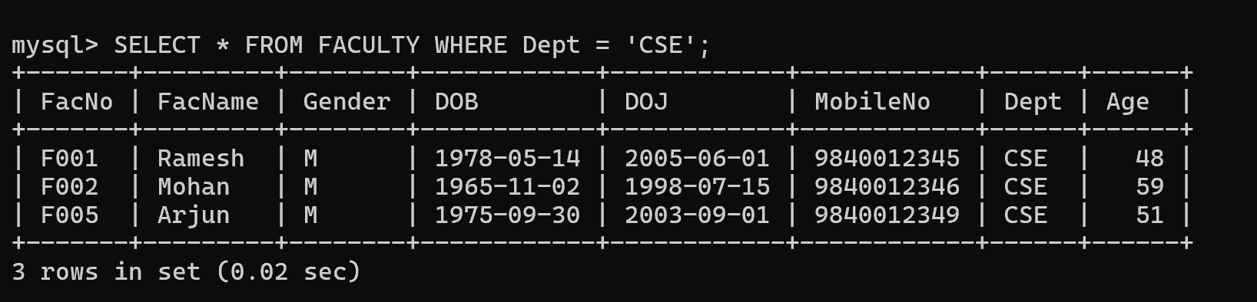

-- 3. UPDATE: Modify existing records
-- Update the student name for a given register number
UPDATE STUDENT SET Name = 'Aravind Kumar' WHERE RegNo = 191;
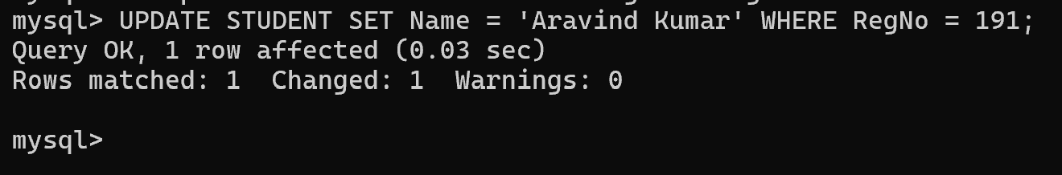

-- Set age = 59 for faculty named 'Mohan'
UPDATE FACULTY SET Age = 59 WHERE FacName = 'Mohan';
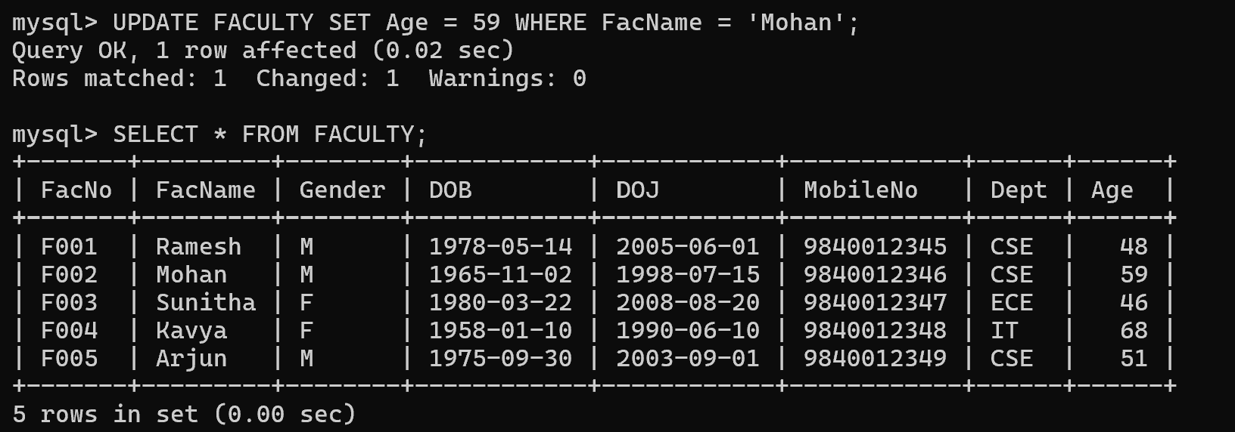

-- 4. DELETE: Remove records
-- Delete the faculty record who resigned (FacNo 'F004')
DELETE FROM FACULTY WHERE FacNo = 'F004';

-- Remove all faculty over 65 years of age
DELETE FROM FACULTY WHERE Age > 65;
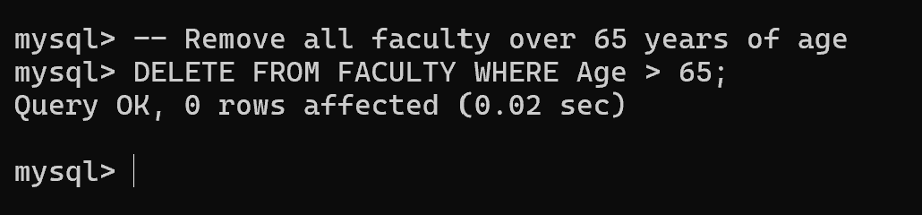

SELECT * FROM STUDENT;
SELECT * FROM FACULTY;
