AI IN ACTION – Project Documentation
Job Recommendation System using Machine Learning

1. Abstract
This project presents an AI-based Job Recommendation System that analyzes user resumes and recommends suitable job roles using Machine Learning techniques. It extracts skills, matches them with job datasets, predicts roles, and identifies missing skills.

2. Problem Statement
Job seekers face difficulty choosing roles and identifying missing skills. This system automates resume analysis and provides job recommendations with skill gap insights.

3. Technologies Used
Python, Pandas, NumPy, Matplotlib, Seaborn, Scikit-learn, NetworkX, PyPDF2

4. Methodology
Data Collection → Preprocessing → TF-IDF → Model Training → Resume Processing → Job Matching → Skill Gap Analysis

5. Machine Learning Models
Logistic Regression, Random Forest, KNN, Naive Bayes

6. Visualizations (From Notebook)

Figure 1
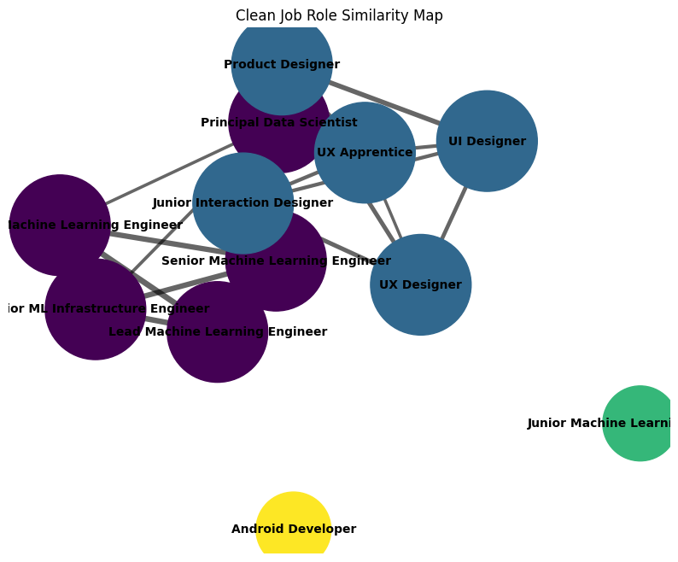
Confusion matrix showing prediction performance.

Figure 2
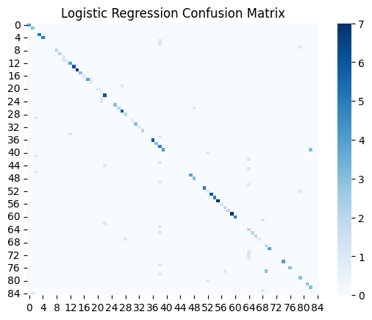
Comparison of ML model accuracy.

Figure 3
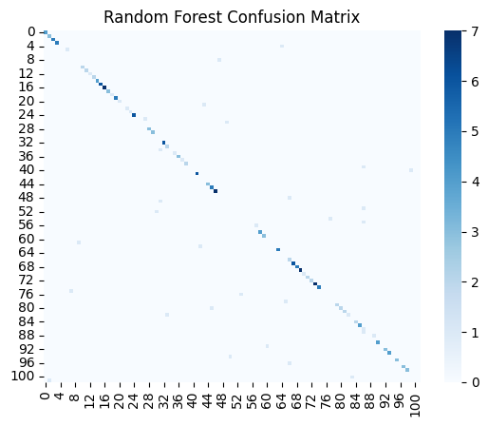
Network graph of job role similarity.

Figure 4
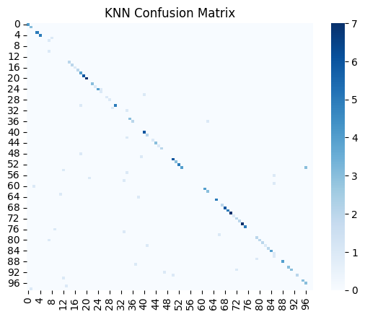
Skill gap between user and job.

Figure 5
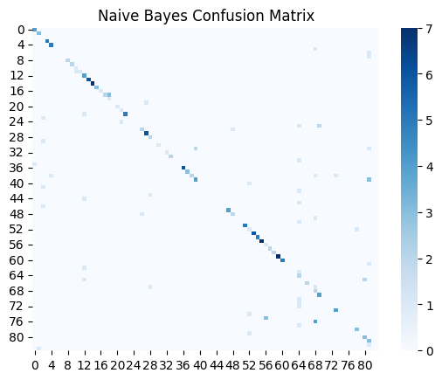
Feature distribution in dataset.

Figure 6
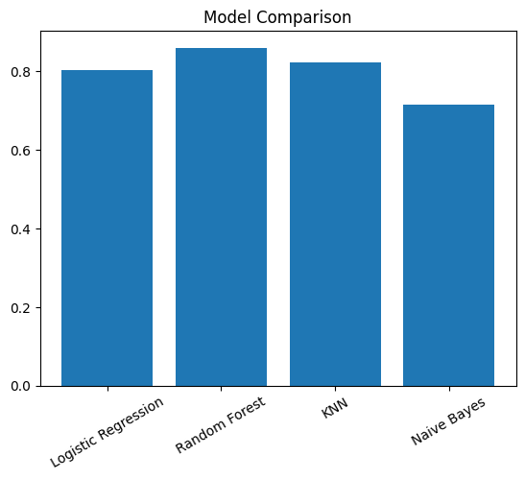
Model prediction visualization.

Figure 7
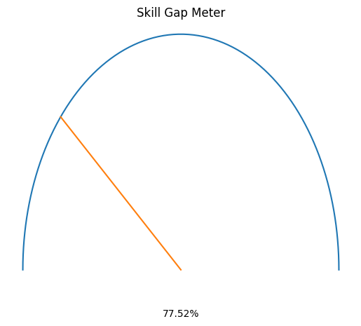
Similarity score comparison.

Figure 8
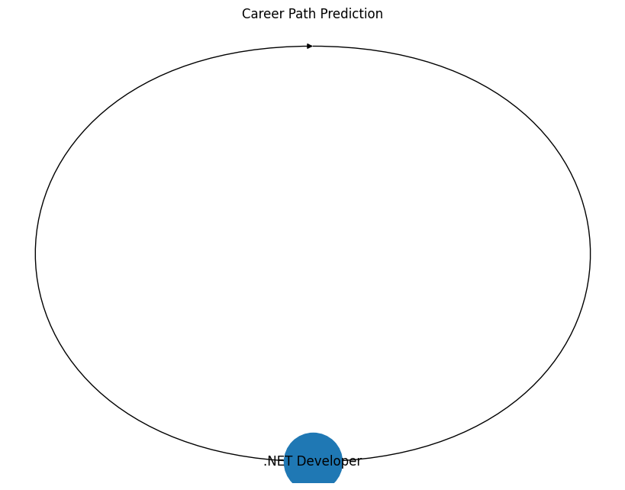
Training vs Testing accuracy.

Figure 9
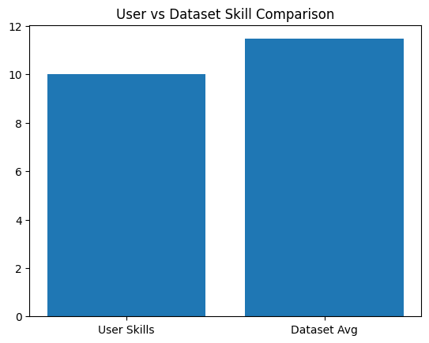
Additional analysis insights.

7. Conclusion
The system effectively recommends jobs and identifies skill gaps using machine learning, helping users make informed career decisions.

