

**CARMEL VIDYA BHAVAN TRUST’S**

**CHRIST COLLEGE, PUNE14**

**A**

**PROJECT REPORT ON**

**“**Playing Game Using Gesture Control**”**

**SUBMITTED BY**

Mr. Kishan Sharma (64)

**SUBMITTED TO**

**SAVITRIBAI PHULE PUNE UNIVERSITY**

**IN THE FULFILLMENT OF**

**THIRD YEAR BACHELOR OF**

**BUSINESS ADMINISTRATION (CA)**

**(Semester V)**

**SAVITRIBAI PHULE PUNE UNIVERSITY**

(2023 - 2024)

**CARMEL VIDYA BHAVAN TRUST’S**

**CHRIST COLLEGE, ARTS, COMMERCE & SCIENCE**

**PUNE** - **411014**

**DEPARTMENT OF MANAGEMENT**

**CERTIFICATE**

Date: __/ __ /____

*This is to certify that Mr.Kishan Sharma**of TYBBA(CA) has satisfactorily completed the Project report on “* **Playing Game Using Gesture Control”** *in partial fulfillment of the BBA(CA) Semester V course of Savitribai Phule Pune University for the Academic year 2023-2024.*

|  |  |  |
| --- | --- | --- |
| Mrs. Petricia Roseline  (Project Guide) | Internal Examiner | External Examiner |
| Mrs Leena Sanu  (BBA-CA Coordinator) | Mrs. Deepa Sujith  (Head of Department) | Dr. (Fr) Arun Antony Chully CMI  (Principal) |

**ACKNOWLEDGEMENT**

First and foremost, we thank the Almighty for granting us the grace and ability to see this project to fruition.

We extend our gratitude to the Department of Management, Christ College, Pune for providing us with the necessary support required to complete our project.

We are deeply indebted to Dr. Fr Arun Antony Chully, CMI, Director Christ College Pune , Mrs. Deepa Sujith, Head of the Department of Management, Christ College Pune Mrs. Leena Sanu Coordinator of BBA CA for rendering their immeasurable support during the course of the project work and we express our thanks for giving us the opportunity to carry out the same. We extend our special thanks to our coordinator, Mrs Leena Sanu, for her continuous support.

We would also like to thank our project guide Mrs.Petricia Leema for her support in the initial stages of the project and supported us with his knowledge and feedback on the project enabling us in making our problem statement and formulating the approach towards the project.

We also extend our thanks to our classmates and colleagues for their advice and support. The relief we felt at having peers to go forward in this project with is unfathomable. Our solidarity played a key role in the completion of this project.

Date: ____ / _____/ _______

Place: Pune

**INDEX**

|  |  |  |
| --- | --- | --- |
| Serial no. | Content | Page no. |
| 1 | **Abstract** | 1 |
| 2 | **Introduction**  • Motivation  • Problem Statement  • Purpose/objective and goals  • Project Scope and Limitations | 2-3 |
| 3 | **Technology Stack**  • Overview of this technology.  • Libraries & Framework Used.  • Roles of each technology.  • Requirement Analysis  o Functional  o Performance  o Security | 4-7 |
| 4 | **Implementation Details**  • Software / Hardware Specifications | 8-10 |
| 5 | **System Architecture**  **•** Work Flow of Files  • Component Diagram  • Decision Tree Diagram | 11-14 |
| 6 | **Outputs and Reports Testing** | 15-16 |
| 7 | **Conclusion** | 17 |
| 8 | **Future Scope** | 18 |
| 9 | **Bibliography and References** | 19 |

**ABSTRACT**

This project introduces an innovative gesture control application specifically designed for the Beach Buggy game, offering a novel and immersive gaming experience. The application empowers users to interact with the game using hand gestures, obviating the need for conventional input devices. Leveraging advanced computer vision and machine learning techniques, the system accurately interprets and responds to a diverse range of gestures.

Significantly, the application has been developed to be compatible with both mobile and desktop platforms, ensuring accessibility to a wide and diverse user base. Rigorous user testing and feedback sessions were conducted to meticulously assess the system's accuracy and responsiveness. These evaluations have yielded positive reviews and affirm its potential to revolutionize the gaming interface as we know it.

Beyond its immediate application in gaming, the incorporation of gesture-based controls carries promising implications across various interactive domains. These domains span from the immersive realms of virtual reality to the ever-evolving landscape of accessibility technology. In essence, this project represents a significant stride in the ongoing evolution of user interfaces, delivering a new echelon of immersion and interaction not only within the gaming world but also across a broad spectrum of interactive experiences.

**INTRODUCTION**

**2.1 Motivation**

The motivation for creating a gaming project using gesture control in Python stems from the desire to enhance user interaction and immersion in virtual environments. By harnessing the power of gestures, players can engage with games intuitively, breaking barriers of traditional input methods.

This technology not only offers a unique and entertaining gaming experience but also promotes physical activity and social interaction. Additionally, it fosters innovation by combining cutting-edge computer vision techniques with programming skills, encouraging enthusiasts to explore the realms of artificial intelligence and human-computer interaction.

Ultimately, this project aims to revolutionize gaming, making it more accessible, enjoyable, and inclusive for players of all ages and abilities.

**2.2 Problem Statement**

In the realm of modern gaming, there is a burgeoning demand for innovative interfaces that transcend traditional controls. The challenge lies in developing a sophisticated and responsive gesture control system using Python, enabling gamers to manipulate in game actions seamlessly.

The complexity arises from the need for precise gesture recognition in various environmental conditions, ensuring realtime responsiveness without compromising accuracy. Moreover, the system must be adaptable to diverse gaming genres and accessible to users with different physical abilities.

Addressing these challenges necessitates the creation of robust algorithms and interfaces that guarantee an immersive, intuitive, and inclusive gaming experience, ultimately revolutionizing the way gamers interact with virtual worlds.

**2.3 Purpose / Objective and Goals**

The purpose of our gaming project using gesture control in Python is to redefine the gaming experience by integrating cutting edge technology with immersive gameplay. Our objective is to develop a responsive and intuitive gesture control system that allows players to interact with virtual environments using natural hand movements.

We aim to create a diverse library of gestures mapped to in game actions, ensuring seamless control across various gaming genres. Additionally, our goal is to prioritize inclusivity by designing adaptive interfaces, enabling gamers of all abilities to participate effortlessly. Through this project, we aspire to show case Python's potential in enhancing user engagement, fostering innovation, and shaping the future of interactive gaming interfaces.

**2.4 Project Scope and Limitation**

The gaming project utilizing gesture control in Python aims to create an immersive gaming experience by developing a responsive and versatile gesture recognition system.

The scope includes designing a comprehensive library of gestures for actions like movement, combat, and interaction, applicable across a wide range of gaming genres. The project encompasses the integration of gesture controls into existing games and the development of new games specifically tailored for this interface. It also involves user interface design, realtime gesture processing, and compatibility testing across platforms.

The project faces limitations in achieving absolute accuracy, especially in challenging lighting conditions and complex hand gestures. It might require specific hardware for optimal performance, limiting accessibility. Additionally, the system's adaptability to fastpaced games and the learning curve for users transitioning from traditional controls present challenges.

**TECHNOLOGY STACK**

**3.1 Libraries & Frameworks Used:**

**1. Python:** Python is a versatile, high-level programming language known for its simplicity and readability. It supports multiple paradigms, making it popular for web development, data analysis, artificial intelligence, and automation.

**2. OpenCV:** OpenCV, or Open Source Computer Vision Library, is an open-source computer vision and machine learning software library. It provides tools and algorithms for image and video analysis, enabling tasks like object detection, facial recognition, and image processing through programming languages like Python and C++.

**3. Mediapipe:** MediaPipe is an open-source framework by Google that simplifies the development of machine learning applications for audio and visual data. It provides pre-built models and a comprehensive set of tools for tasks like hand tracking, pose estimation, and facial recognition, enhancing real-time multimedia experiences.

**4. PyAutoGUI:** PyAutoGUI is a Python library that provides functions to automate mouse and keyboard interactions.

It allows developers to programmatically control the mouse and keyboard, enabling tasks like GUI automation, game testing, and repetitive operations. PyAutoGUI is platform-independent and supports various operating systems, making it a valuable tool for automation tasks.

**5. Threading:** Threading in computer programming refers to the ability of a process to execute multiple threads (smaller units of a program) concurrently.

Threads share the same memory space, allowing for efficient multitasking, improved performance, and responsiveness in applications. Threading is essential for handling tasks simultaneously, enhancing the overall efficiency of software programs.

**6. Pygame :** Pygame is a popular Python library designed for game development.

It provides tools and modules to create interactive games and multimedia applications. Pygame simplifies tasks like drawing graphics, handling user input, and managing game states. It is widely used for both educational purposes and professional game development due to its ease of use and flexibility.

**3.2 Roles of Each Technology:**

**1.Python:** Serving as the core development language, Python orchestrates the entire project. Its versatility and extensive libraries make it ideal for integrating various components and managing the overall application flow.

**2.OpenCV:** This computer vision library is instrumental in capturing video frames from the camera feed. It processes these frames, enabling the system to identify hand movements accurately. OpenCV's robust features empower real-time image processing, a crucial aspect of gesture recognition.

**3.Mediapipe:** Working in conjunction with OpenCV, Mediapipe specializes in estimating hand poses. By enhancing the accuracy of gesture recognition, it ensures that the system interprets user gestures correctly, providing a more immersive gaming experience.

**4. PyAutoGUI:** This library enables the simulation of keyboard inputs. It translates the recognized gestures into in-game actions, allowing users to control the game through their hand movements seamlessly.

**5. Threading:** Threading technology plays a pivotal role in improving system responsiveness. By enabling parallel processing of gesture recognition tasks, it ensures that the application can handle multiple inputs simultaneously, enhancing overall performance and user satisfaction.

Together, these technologies form a cohesive framework, where Python acts as the backbone, OpenCV captures and processes video frames, Mediapipe refines gesture recognition accuracy, PyAutoGUI translates gestures into actions, and Threading enhances system responsiveness.

This collaborative synergy ensures the effective implementation of gesture-controlled gaming, providing users with an immersive and enjoyable gameplay experience.

**3.3 Requirement Analysis:**

**Functional Requirements:**

**Accurate Hand Tracking**: The system must precisely track hand movements in real-time, ensuring seamless and responsive interaction between the user's gestures and the game environment.

**Gesture Recognition:** The system should recognize predefined gestures that correspond to specific in-game actions. This feature allows users to control the game intuitively, enhancing their gaming experience.

**Realtime Interaction:** Recognized gestures must be translated into immediate in-game responses. Real-time interaction ensures that users' actions are mirrored instantly within the game, maintaining an immersive and dynamic gameplay environment.

**3.4 Performance Requirements:**

**Low Latency:** The system demands minimal latency between gesture recognition and in-game action execution. Reduced delay ensures that users experience immediate responses to their gestures, enhancing the overall gaming responsiveness and user satisfaction.

**High Accuracy:** Accurate gesture recognition is paramount to prevent false positives and negatives. High precision in recognizing gestures ensures that the intended actions are correctly interpreted, avoiding unintended or incorrect in-game responses.

This accuracy contributes significantly to the user's sense of control and gameplay immersion.

**Smooth Interaction:** The system must facilitate smooth and natural mapping of gestures to in-game movements. Fluid interaction enhances the gaming experience, making it intuitive and enjoyable for users.

Natural gestures should seamlessly translate into corresponding in-game actions, providing players with a responsive and immersive gameplay environment. Achieving these performance benchmarks ensures a seamless, accurate, and engaging user experience.

**3.5 Security Requirements:**

**Data Privacy:** The system must uphold user privacy by refraining from storing or transmitting sensitive user data. Ensuring that personal information remains within the gaming environment enhances user trust and confidentiality.

**Authentication (Optional):** Implementing robust authentication methods for user profiles adds an extra layer of security. Secure logins safeguard user accounts, preventing unauthorized access and ensuring that only authenticated users can interact with the system.

**Secure Communication (Optional):** If networking functionalities are integrated, employing encrypted channels for data transmission is imperative. Secure communication protocols protect data from potential eavesdropping or tampering, guaranteeing the integrity and confidentiality of information exchanged between the system and external sources. These security measures collectively safeguard user data and system integrity, fostering a secure gaming environment.

**3.6 Stakeholders:**

• Project Owner and Development Team

o Kishan sharma

o Gaurav Nayak

• End Users (External Stakeholders)

o Customers

**IMPLEMENTATION DETAILS**

**1. Hand Tracking and Pose Estimation:**

The system employs OpenCV and Mediapipe to capture webcam frames, implementing real-time algorithms for hand movement tracking and pose estimation. This technology enables precise detection of hand gestures and positions, forming the foundation for interactive gameplay.

**2. Gesture Recognition:**

Utilizing landmarks provided by Mediapipe, the system interprets specific hand gestures as in-game commands. For instance, an open hand might signify "jump," while a closed fist indicates "attack." Gesture recognition logic translates these gestures into actionable game inputs, enhancing user engagement and immersion.

**3. Gesture Translation:**

PyAutoGUI is utilized to simulate keyboard inputs corresponding to recognized gestures. Each gesture is mapped to specific keyboard keys or game controller inputs, facilitating seamless integration with various gaming platforms. This translation process ensures that player gestures directly influence in-game actions, providing an intuitive and interactive gaming experience.

**Game Integration (Optional):**

Seamlessly integrate gesture controls into the game mechanics, enhancing user immersion. Define gestures for character movement, actions, or power-ups, aligning them with the game's logic. This optional feature allows developers to adapt existing games, transforming them into interactive, gesture-controlled experiences, expanding gameplay possibilities.

**User Feedback:**

Implement visual and auditory cues to provide real-time feedback on gesture recognition. Display on-screen prompts or animations corresponding to recognized gestures, ensuring players understand their actions' impact. Audio signals, such as sounds or voice prompts, enhance feedback, enhancing user engagement. Clear and intuitive feedback enhances user experience, making the gameplay responsive and enjoyable.

**Software:**

**Python:** The system is developed using Python, leveraging its versatile capabilities for efficient coding and integration.

**OpenCV:** The project requires a compatible version of OpenCV tailored to the chosen Python version. OpenCV is vital for capturing and processing video frames, enabling advanced computer vision functionalities.

**Mediapipe:** Utilizing the latest version of Mediapipe, the software achieves accurate hand pose estimation and gesture recognition. This library enhances the system's ability to interpret intricate hand movements, ensuring precise user interaction.

**PyAutoGUI:** The latest PyAutoGUI version is employed to simulate keyboard inputs based on recognized gestures. This feature enables seamless translation of gestures into in-game actions.

**Game Engine:** If integrating with Unity, the chosen Python scripting must align with Unity's requirements. For Pygame, the software utilizes the latest Pygame version compatible with the selected Python version, ensuring smooth gameplay integration and performance.

**Hardware:**

**Webcam:** A high-resolution webcam with a good frame rate is essential for accurate hand tracking. It ensures clear and precise capture of hand movements, enhancing gesture recognition.

**Processor:** The system demands a multicore processor with high processing speed to enable real-time gesture recognition. A powerful processor is crucial for swift and efficient image processing tasks.

**Memory:** Sufficient RAM is necessary to handle real-time image processing tasks seamlessly. Adequate memory ensures smooth execution of algorithms and reduces latency in gesture recognition.

**Storage:** The hardware should provide ample storage space to accommodate the game, image processing libraries, and related files. Sufficient storage ensures the system operates efficiently without storage-related bottlenecks.

**Input Devices:** Additional input devices like a keyboard or game controller can be integrated for enhanced controls within the game. These devices offer players diverse ways to interact with the gaming environment.

**Operating System:** The hardware setup must be compatible with the chosen Python version and the required libraries. Ensuring compatibility guarantees the seamless functioning of the gaming application and its associated components.

**Graphics Card (for 3D games, if applicable):** In the case of 3D games, a dedicated graphics card is required for smooth rendering and immersive visual experiences. It enhances the overall gaming graphics quality.

**SYSTEM ARCHITECTURE**

**Design Constraints:**

1. **Hardware Limitations:** The system's accuracy and responsiveness depend on the user's webcam quality and capabilities, potentially affecting gesture recognition precision.

2. **Lighting Conditions:** Adequate lighting is crucial for reliable hand tracking. Low-light environments might hinder accurate recognition, impacting the system's performance and user experience.

3. **Gesture Complexity:** Complex or rapid gestures pose challenges in accurate recognition, potentially leading to misinterpretation and affecting gameplay fluidity.

4. **Processing Power:** The system's efficiency relies on the computer's processing capabilities. Resource-intensive tasks, especially during gesture recognition, can lead to delays and reduced responsiveness.

5. **Learning Curve:** Users may require time to adapt to gesture controls, especially for intricate gestures, impacting initial user experience. Familiarity and ease of use are vital for user acceptance.

6. **Game Compatibility:** Integrating gesture controls into existing games necessitates substantial modifications, limiting the number of compatible games. Development efforts increase when adapting games not originally designed for gesture interaction.

7. **Data Privacy:** If personal data, such as user profiles, is processed, adherence to privacy regulations and obtaining user consent are paramount. Ensuring data security is essential to maintain user trust and comply with legal standards.

**Work Flow**

The workflow of my gaming project utilizing gesture control in Python follows a systematic process. Initially, the project captures webcam frames using OpenCV and Mediapipe, allowing real-time hand tracking and pose estimation.

Landmarks extracted from hand gestures are interpreted, translating them into in-game commands. PyAutoGUI is then employed to simulate corresponding keyboard inputs. The system integrates game logic, mapping gestures to specific actions like movement or attacks.

Visual and auditory feedback mechanisms provide real-time responses to the user's gestures, enhancing the gaming experience. Continuous testing and optimization refine gesture recognition algorithms, ensuring accuracy and responsiveness. The project also includes user guides for gesture calibration and troubleshooting. This streamlined workflow ensures seamless integration of gesture controls, resulting in an immersive and intuitive gaming environment.

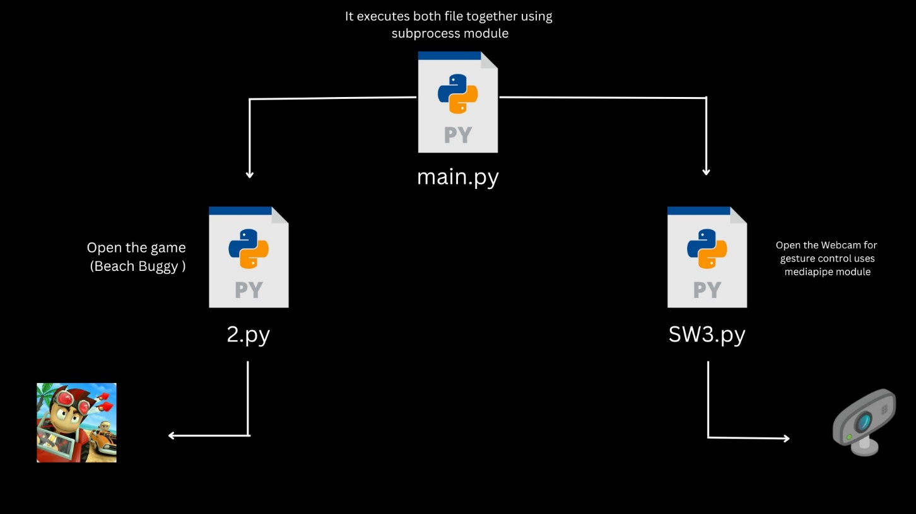

**Component Diagram**

In the component diagram of my gaming project employing gesture control in Python, key components are visually represented. The diagram illustrates the system's modular structure, depicting elements like the webcam interface, OpenCV, and Mediapipe for capturing and processing video frames.

It includes modules for gesture recognition and translation using PyAutoGUI, indicating the flow of data and control between these components. Additionally, game logic integration and feedback mechanisms are shown, highlighting their interactions with gesture recognition modules.

The diagram showcases the seamless integration of these components, emphasizing their collaboration to enable intuitive user gestures, translating them into meaningful in-game actions. This visual representation aids developers in understanding the project's architecture, fostering efficient communication and collaboration among team members during the implementation process.

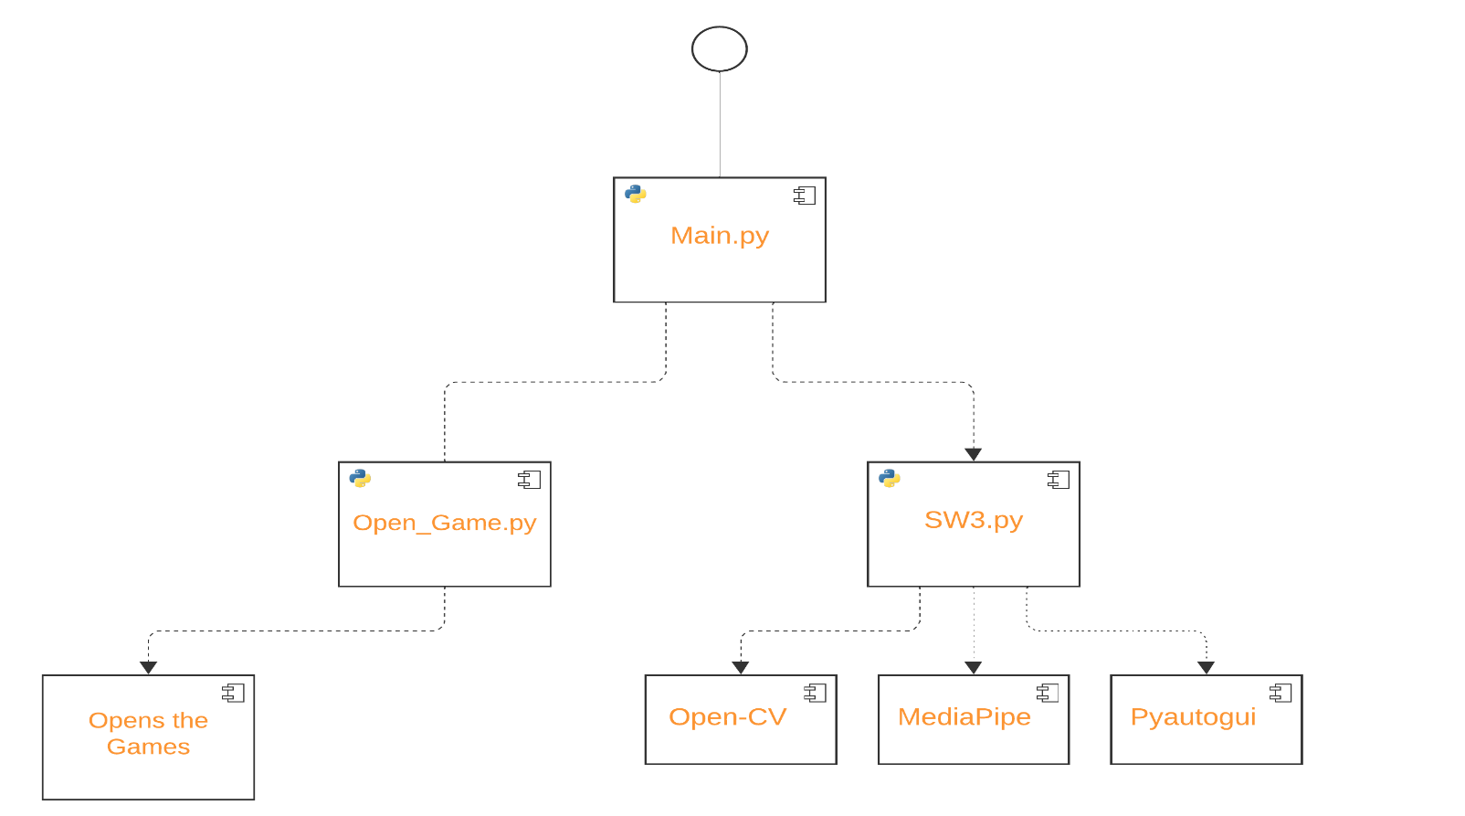

**Decision Tree**

In my gaming project, a decision tree algorithm is employed to interpret hand gestures accurately. It processes landmarks from OpenCV and Mediapipe, making decisions based on the positions of detected points. This algorithm aids in mapping specific gestures to corresponding in-game commands, enhancing user interaction and gameplay experience.

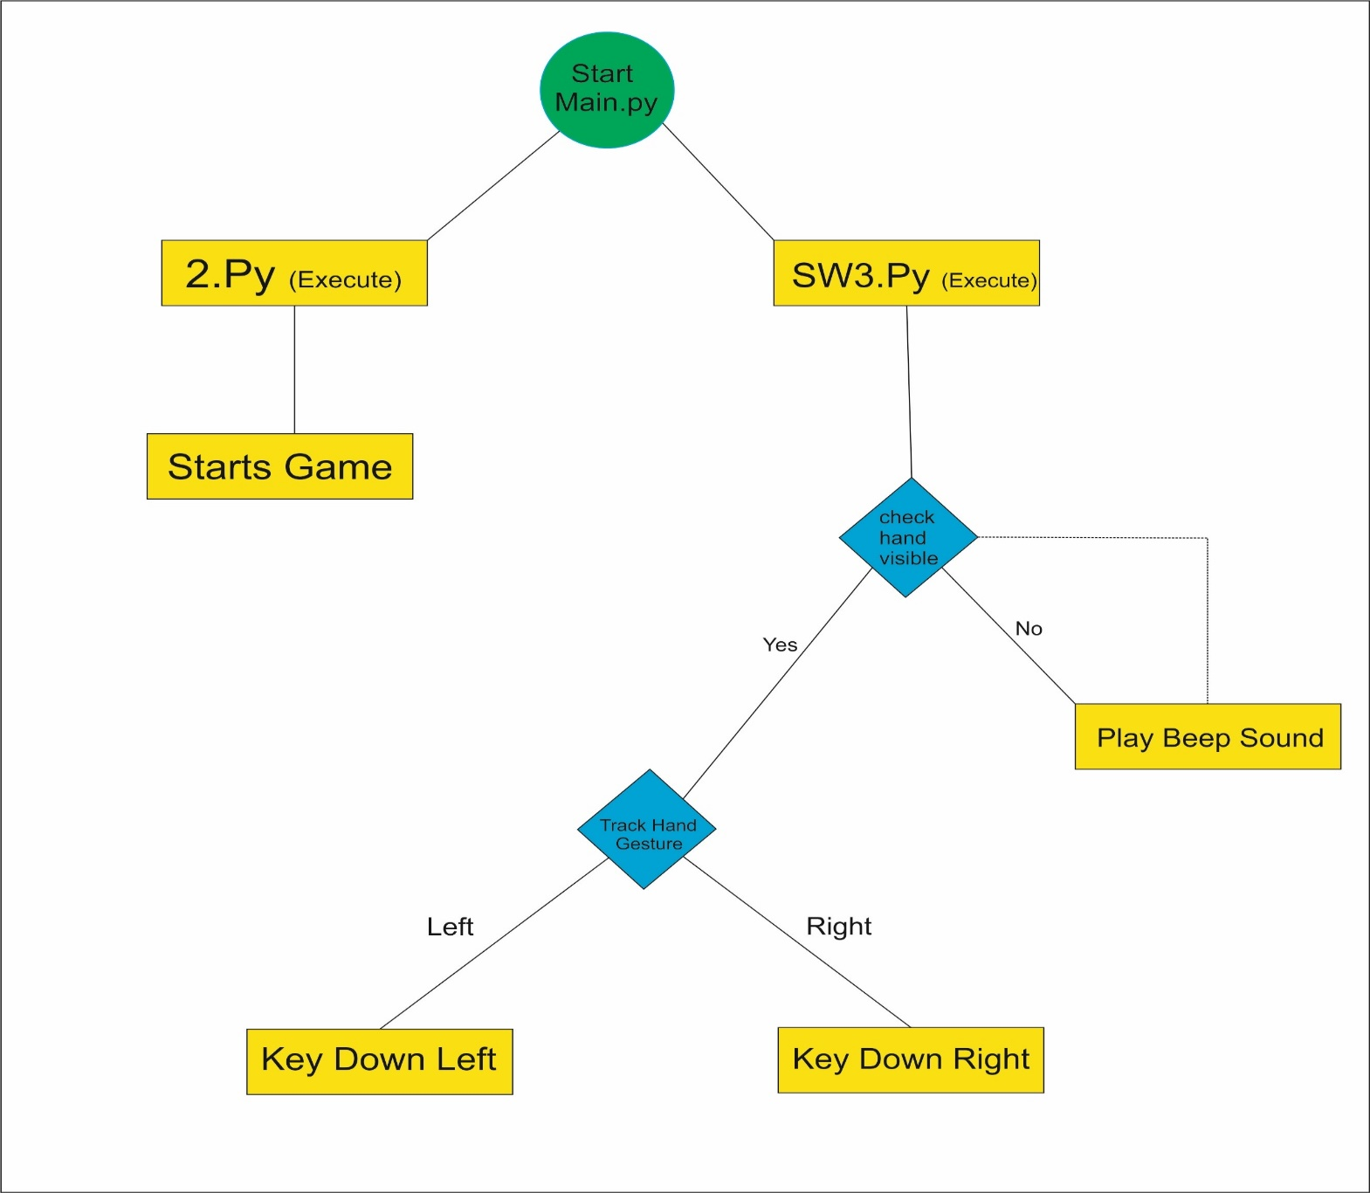

**Output Screens**

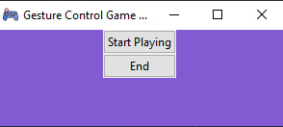

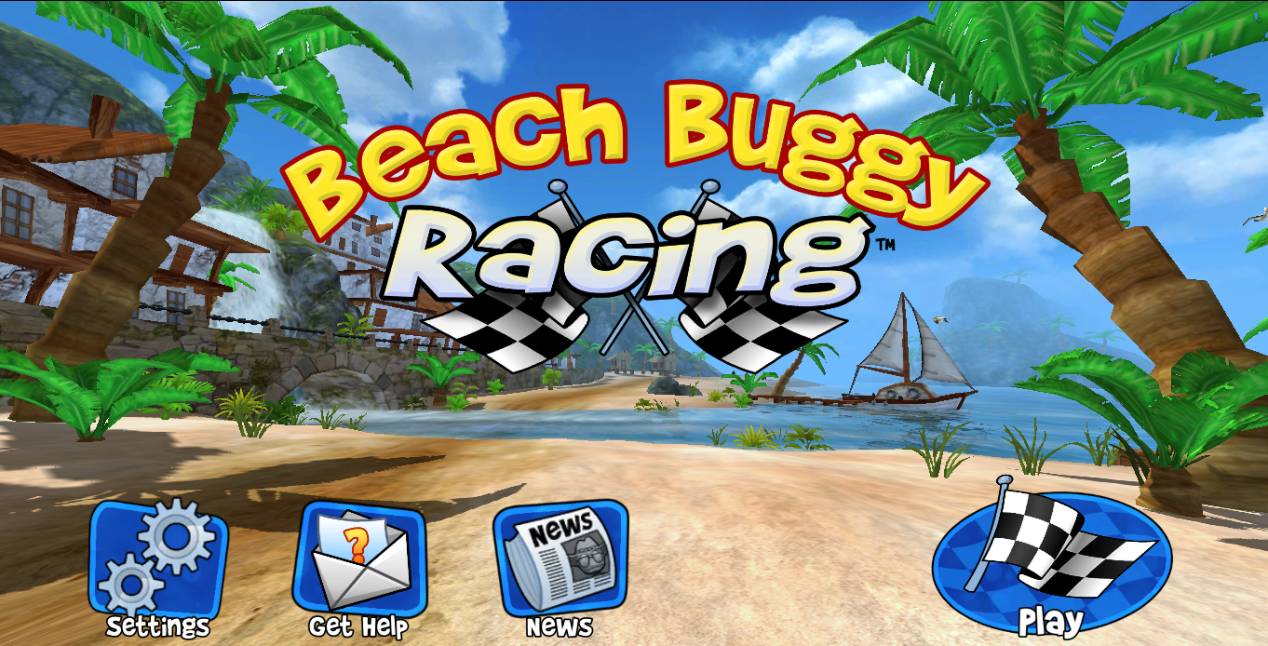

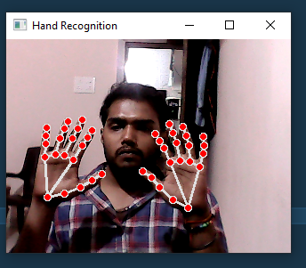

**CONCLUSION**

In the realm of interactive gaming, this groundbreaking project represents a significant leap forward, seamlessly blending the virtual world with real-life actions through the innovative use of gesture control within the Python programming environment. This transformative milestone redefines the way players engage with games, acting as a bridge that connects the digital gaming landscape with the physical realm.

At its core, the project harnesses the formidable capabilities of cutting-edge computer vision libraries, specifically OpenCV and Mediapipe, to capture and interpret intricate hand gestures in real time. These libraries provide the foundation for precise gesture recognition, enabling users to control in-game actions intuitively and effortlessly. Additionally, the integration of PyAutoGUI facilitates the translation of recognized gestures into tangible game inputs, ensuring a seamless connection between the user's movements and the on-screen gameplay.

Despite the challenges encountered, such as varying hardware limitations and the complexity of interpreting gestures accurately, the project has emerged triumphant. Its success underscores the vast potential of gesture-based interfaces within the gaming industry. By overcoming these hurdles, the project has not only enhanced user engagement but also laid the groundwork for future gaming innovations.

This achievement heralds a new era of gaming, where players are no longer bound by traditional input devices. Instead, they can interact with virtual worlds using natural hand movements, elevating immersion levels to unprecedented heights. The project serves as an inspiration for developers and gamers alike, encouraging the exploration of novel gameplay mechanics and interactive experiences.

In essence, this project epitomizes a monumental stride towards the future of gaming. It signifies more than just technological advancement; it represents a paradigm shift in how players perceive and interact with games. Through intuitive gesture control, this endeavor has redefined the very essence of player engagement, paving the way for a richer, more intuitive, and ultimately, more enjoyable gaming experience.

**FUTURE SCOPE**

**1. Enhanced Gesture Recognition Algorithms:**

Research and implement advanced gesture recognition algorithms using machine learning and deep learning techniques. These innovations can significantly enhance the system's accuracy and broaden the spectrum of recognizable gestures, ensuring a more intuitive and precise user experience.

**2. Integration with Virtual Reality (VR) and Augmented Reality (AR):**

Seamlessly integrate gesture control with VR and AR technologies, creating immersive digital experiences. Gesture-based interactions within virtual and augmented environments can redefine user engagement, allowing users to interact naturally with digital content and environments, enhancing immersion and interaction.

**3. Multiplayer and Online Gaming:**

Implement gesture control in multiplayer and online gaming contexts, enabling players to communicate and strategize using gestures. This integration opens avenues for team-based games and collaborative gameplay experiences, fostering a new level of social interaction and teamwork.

**4. Health and Fitness Applications:**

ExtExtend the gesture control concept to health and fitness applications, creating interactive fitness games. Users can control exercise routines and receive real-time feedback based on their gestures, promoting physical activity and a healthier lifestyle.

**5. Accessibility and Assistive Technologies:**

Explore applications in accessibility and assistive technologies, empowering people with disabilities to interact with computers and games using gestures. Customizable gestures tailored to individual needs can enhance accessibility, promoting inclusivity and independence.

**6. Gesture Based Storytelling and Educational Games:**

Develop interactive storytelling experiences and educational games where gestures drive the narrative or solve challenges. This immersive approach enhances learning and engagement for users of all ages, making education and storytelling more interactive and enjoyable.

7. Gesture-Controlled Smart Home Integration:

Extend gesture control to smart home devices, enabling users to control lights, thermostats, and other appliances through intuitive hand movements. This integration enhances user convenience and promotes the adoption of gesture-based interfaces in everyday life.

8. Gesture-Driven Art and Creative Applications:

Implement gesture control in creative software applications, allowing artists and designers to use natural hand gestures for drawing, sculpting, and manipulating digital art elements. This intuitive approach enhances the creative process and opens new avenues for artistic expression.

9. Gesture-Based Virtual Conferencing:

Integrate gesture control into virtual conferencing platforms, enabling participants to express themselves through gestures in virtual meetings. This innovation enhances non-verbal communication, making virtual interactions more engaging and expressive, especially in remote work scenarios.

10. Gesture-Controlled Music and Performance:

Develop applications where gestures control musical instruments or affect live performances. Musicians and performers can create unique sounds and visual effects through hand gestures, adding a new layer of creativity and interactivity to live music and entertainment experiences.

**BIBLIOGRAPHY AND REFERENCES**

* **Online Articles:**
  + Brown, Michael. "The Future of Gesture Control in Gaming." GamingTech Insights, URL, Accessed Date.
* **OpenCV Documentation:**
  + OpenCV. "OpenCV Documentation." OpenCV Official Website, URL, Accessed Date.
* **Mediapipe Documentation:**
  + Google. "Mediapipe Documentation." Google Mediapipe Official Website, URL, Accessed Date.
* **PyAutoGUI Documentation:**
  + PyAutoGUI. "PyAutoGUI Documentation." PyAutoGUI Official Documentation, URL, Accessed Date.
* **Geeks For Geeks**

https://www.geeksforgeeks.org/