

**CARMEL VIDYA BHAVAN TRUST’S**

**CHRIST COLLEGE, PUNE14**

**A**

**PROJECT REPORT ON**

**“**Playing Game Using Gesture Control**”**

**SUBMITTED BY**

Mr. Gaurav Nayak (22)

Mr. Kishan Sharma (64)

**SUBMITTED TO**

**SAVITRIBAI PHULE PUNE UNIVERSITY**

**IN THE FULFILLMENT OF**

**THIRD YEAR BACHELOR OF**

**BUSINESS ADMINISTRATION (CA)**

**(Semester V)**

**SAVITRIBAI PHULE PUNE UNIVERSITY**

(2023 - 2024)

**CARMEL VIDYA BHAVAN TRUST’S**

**CHRIST COLLEGE,**

**ARTS, COMMERCE & SCIENCE**

**PUNE -** 411014



**DEPARTMENT OF MANAGEMENT**

**CERTIFICATE**

Date: __/ __ /____

*This is to certify that* ***Mr. Kishan Sharma (64)*** *and* ***Mr.Gaurav Nayak (22)*** *of TYBBA(CA) has satisfactorily completed the Project report on* **Playing Game Using Gesture Control***in partial fulfilment of the BBA(CA) Semester V course of Savitribai Phule University Pune for the Academic year 2023- 2024.*

|  |  |  |  |
| --- | --- | --- | --- |
| **Mrs.Petricia Leema** | **Mrs. Deepa Sujith** | **Dr. (Fr) Arun Antony Chully CMI** | |
| (Project Guide) | (Head of Department) | | (Principal) |

|  |  |
| --- | --- |
| ________________________ | _________________________ |
| **INTERNAL EXAMINER** | **EXTERNAL EXAMINER** |

**ACKNOWLEDGEMENT**

First and foremost, we thank the Almighty for granting us the grace and ability to see this project to fruition.

We extend our gratitude to the Department of Management, Christ College, Pune for providing us with the necessary support required to complete our project.

We are deeply indebted to Dr. Fr Arun Antony Chully, CMI, Director Christ College Pune , Mrs. Deepa Sujith, Head of the Department of Management, Christ College Pune and Mrs. Leena Sanu Head of the Department of BBA CA for rendering their immeasurable support during the course of the project work and we express our thanks for giving us the opportunity to carry out the same. We extend our special thanks to our coordinator, Mrs Leena Sanu, for her continuous support.

We would also like to thank our project guide Mrs.Petricia Leema for her support in the initial stages of the project and supported us with his knowledge and feedback on the project enabling us in making our problem statement and formulating the approach towards the project.

We also extend our thanks to our classmates and colleagues for their advice and support. The relief we felt at having peers to go forward in this project with is unfathomable. Our solidarity played a key role in the completion of this project.

Date: ____ / _____/ _______

Place: Pune

**INDEX**

|  |  |  |
| --- | --- | --- |
| Serial no. | Content | Page no. |
| 1 | **Abstract** | 1 |
| 2 | **Introduction**  • Motivation  • Problem Statement  • Purpose/objective and goals  • Project Scope and Limitations |  |
| 3 | **Technology Stack**  • Overview of this technology.  • Libraries & Framework Used.  • Roles of each technology.  • Requirement Analysis  o Functional  o Performance  o Security |  |
| 4 | **System Architecture**   * Work Flow of Files * Component Diagram * Decision Tree Diagram |  |
| 5 | **Implementation Details**  • Software / Hardware Specifications |  |
| 6 | **Outputs and Reports Testing** |  |
| 7 | **Conclusion** |  |
| 8 | **Future Scope** |  |
| 9 | **Bibliography and References** |  |

**ABSTRACT**

This project introduces an innovative gesture control application specifically designed for the Beach Buggy game, offering a novel and immersive gaming experience. The application empowers users to interact with the game using hand gestures, obviating the need for conventional input devices. Leveraging advanced computer vision and machine learning techniques, the system accurately interprets and responds to a diverse range of gestures.

Significantly, the application has been developed to be compatible with both mobile and desktop platforms, ensuring accessibility to a wide and diverse user base. Rigorous user testing and feedback sessions were conducted to meticulously assess the system's accuracy and responsiveness. These evaluations have yielded positive reviews and affirm its potential to revolutionize the gaming interface as we know it.

Beyond its immediate application in gaming, the incorporation of gesture-based controls carries promising implications across various interactive domains. These domains span from the immersive realms of virtual reality to the ever-evolving landscape of accessibility technology. In essence, this project represents a significant stride in the ongoing evolution of user interfaces, delivering a new echelon of immersion and interaction not only within the gaming world but also across a broad spectrum of interactive experiences.

**INTRODUCTION**

**2.1 Motivation**

The motivation behind developing a gaming project using gesture control in Python stems from the desire to revolutionize the gaming experience. By harnessing natural hand movements, this technology brings players closer to their virtual worlds, fostering immersive gameplay.

Additionally, it promotes inclusivity, allowing individuals of diverse abilities to engage with games effortlessly. Through this project, we aim to show case the innovative potential of Python in creating interactive, responsive, and accessible gaming interfaces, enhancing user enjoyment and paving the way for future advancements in the gaming industry.

**2.2 Problem Statement**

In the realm of modern gaming, there is a burgeoning demand for innovative interfaces that transcend traditional controls. The challenge lies in developing a sophisticated and responsive gesture control system using Python, enabling gamers to manipulate in game actions seamlessly. The complexity arises from the need for precise gesture recognition in various environmental conditions, ensuring realtime responsiveness without compromising accuracy. Moreover, the system must be adaptable to diverse gaming genres and accessible to users with different physical abilities. Addressing these challenges necessitates the creation of robust algorithms and interfaces that guarantee an immersive, intuitive, and inclusive gaming experience, ultimately revolutionizing the way gamers interact with virtual worlds.

**2.3 Purpose / Objective and Goals**

The purpose of our gaming project using gesture control in Python is to redefine the gaming experience by integrating cutting edge technology with immersive gameplay. Our objective is to develop a responsive and intuitive gesture control system that allows players to interact with virtual environments using natural hand movements.

We aim to create a diverse library of gestures mapped to in game actions, ensuring seamless control across various gaming genres. Additionally, our goal is to prioritize inclusivity by designing adaptive interfaces, enabling gamers of all abilities to participate effortlessly. Through this project, we aspire to show case Python's potential in enhancing user engagement, fostering innovation, and shaping the future of interactive gaming interfaces.

**2.4 Project Scope and Limitation**

The gaming project utilizing gesture control in Python aims to create an immersive gaming experience by developing a responsive and versatile gesture recognition system. The scope includes designing a comprehensive library of gestures for actions like movement, combat, and interaction, applicable across a wide range of gaming genres. The project encompasses the integration of gesture controls into existing games and the development of new games specifically tailored for this interface. It also involves user interface design, realtime gesture processing, and compatibility testing across platforms.

The project faces limitations in achieving absolute accuracy, especially in challenging lighting conditions and complex hand gestures. It might require specific hardware for optimal performance, limiting accessibility. Additionally, the system's adaptability to fastpaced games and the learning curve for users transitioning from traditional controls present challenges.

**Technology Stack**

**3.1 Libraries & Frameworks Used:**

**1. Python:** Core programming language for project development.

**2. OpenCV:** Computer vision library for real time hand tracking and gesture recognition.

**3. Mediapipe:** Provides hand pose estimation solutions, enhancing gesture recognition accuracy.

**4. PyAutoGUI:** Simulates keyboard inputs based on recognized gestures.

**5. Threading:** Used for parallel processing, ensuring responsiveness of gesture recognition algorithms.

**6. Pygame (Optional):** Game engines for developing interactive games compatible with gesture controls.

**3.2 Roles of Each Technology:**

**1.Python:** Core development language, orchestrating the entire project.

**2.OpenCV:** Captures video frames, processes images, and tracks hand movements.

**3.Mediapipe:** Enhances gesture recognition accuracy by estimating hand poses.

**4. PyAutoGUI:** Simulates keyboard inputs, translating recognized gestures into ingame actions.

**5. Threading:** Improves system responsiveness by enabling parallel processing of gesture recognition tasks.

**3.3 Requirement Analysis:**

**Functional Requirements:**

**Accurate Hand Tracking**: System must accurately track hand movements in real time.

**Gesture Recognition:** Recognize predefined gestures representing various in game actions.

**Realtime Interaction:** Translate recognized gestures into immediate in game responses.

**3.4 Performance Requirements:**

**Low Latency:** Minimal delay between gesture recognition and in game action.

**High Accuracy:** Accurate recognition of gestures to avoid false positives/negatives.

**Smooth Interaction:** Smooth and natural mapping of gestures to in game movements.

**3.5 Security Requirements:**

**Data Privacy:** Ensure that the system does not store or transmit sensitive user data.

**Authentication (Optional):** Implement secure authentication mechanisms for user profiles.

**Secure Communication (Optional):** If networking is involved, use encrypted channels to transmit data securely.

**Implementation Details**

**1. Hand Tracking and Pose Estimation:**

Utilize OpenCV and Mediapipe to capture video frames from the webcam.

Implement algorithms to track hand movements and estimate hand poses in

realtime.

**2. Gesture Recognition:**

Develop gesture recognition logic using landmarks provided by Mediapipe.

Define specific gestures for in game actions (e.g., open hand for "jump," closed fist for "attack").

**3. Gesture Translation:**

Use PyAutoGUI to simulate keyboard inputs based on recognized gestures.

Map each gesture to corresponding keyboard keys or game controller inputs.

**Software:**

**Python:** Developed using Python programming language.

**OpenCV:** Version compatible with the chosen Python version.

**Mediapipe:** Latest version for hand pose estimation and gesture recognition.

**PyAutoGUI:** Latest version for simulating keyboard inputs.

**Game Engine:** If using Unity, ensure compatibility with Python scripting.

For Pygame, use the latest Pygame version compatible with Python.

**Hardware:**

**Webcam:** High resolution webcam with good frame rate for accurate hand tracking.

**Processor:** Multicore processor with high processing speed for realtime gesture recognition.

**Memory:** Adequate RAM to handle realtime image processing tasks.

Graphics Card (for 3D games): Dedicated graphics card for smooth rendering (if applicable).

**Storage:** Sufficient storage space for the game, image processing libraries, and related files.

**Input Devices:** Keyboard or game controller for additional controls within the game (optional).

**Operating System:** Compatible with the chosen Python version and required libraries.

**System Architecture**

**Work Flow**

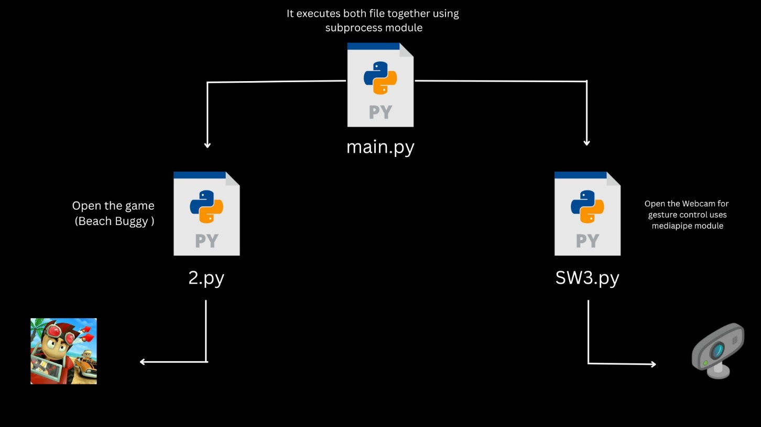

**Component Diagram**

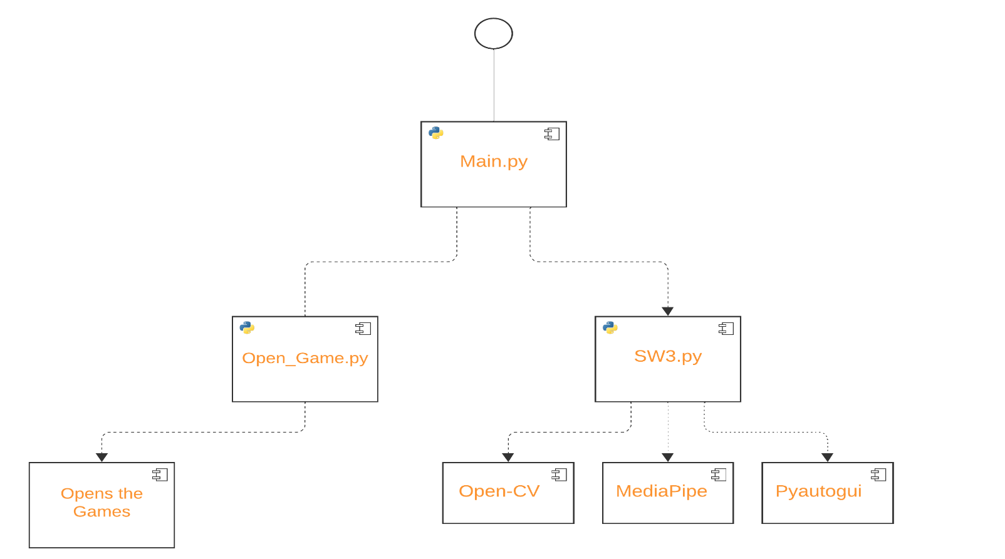

**Decision Tree**

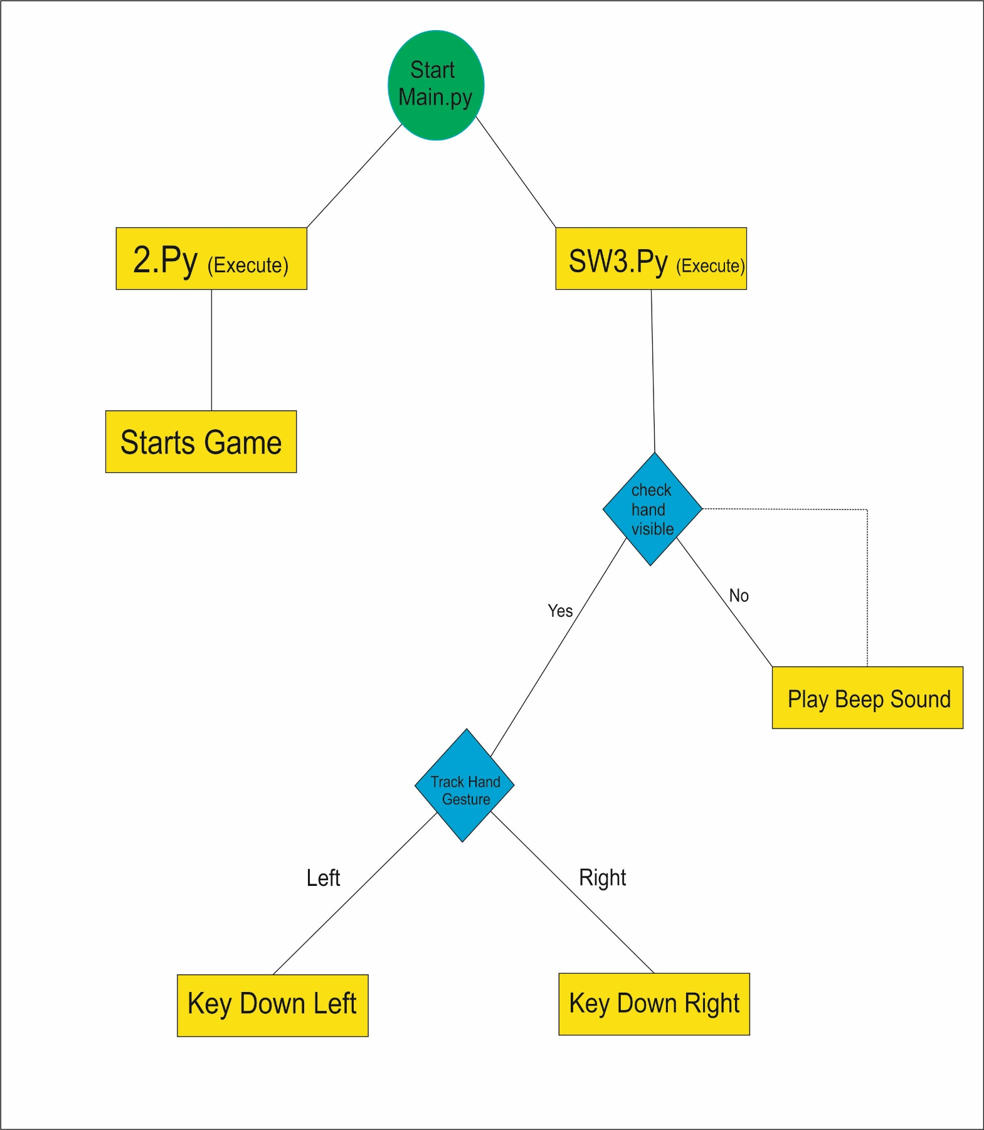

**Output Screens**

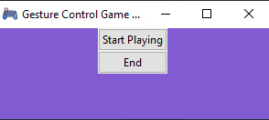

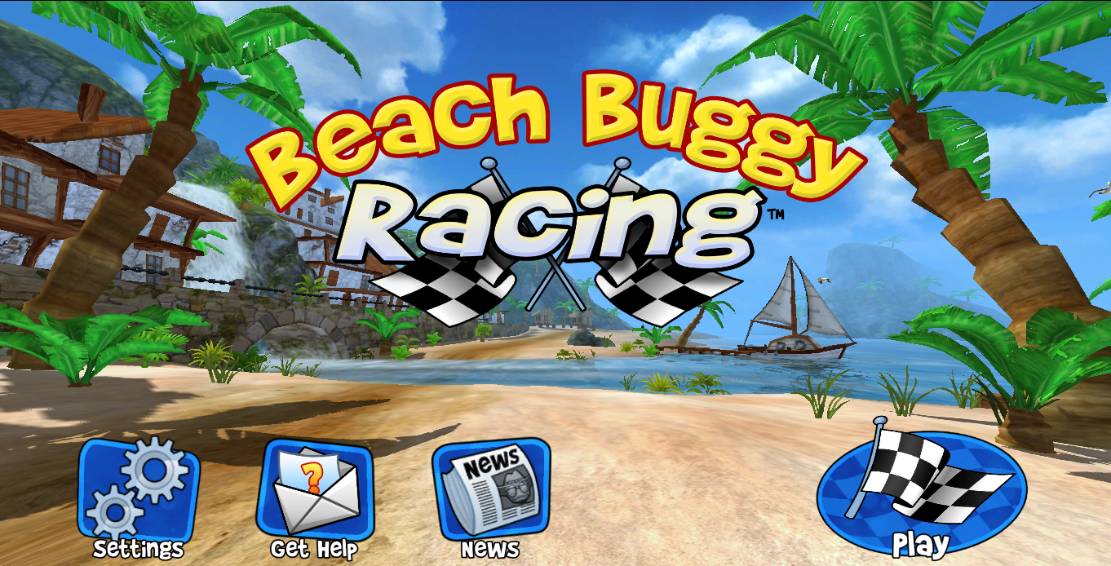

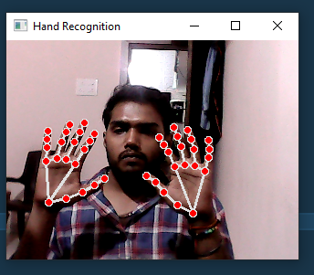

**Conclusion**

In summary, this ground breaking gaming project, which leverages gesture control within the Python programming environment, marks a transformative milestone in interactive gaming experiences. It serves as a bridge connecting the realms of virtual gaming with real-life actions. The project harnesses the formidable capabilities of computer vision libraries such as OpenCV and Mediapipe, in tandem with PyAutoGUI for gesture translation, to craft an all-encompassing and immersive gameplay environment.

Users now possess the ability to seamlessly control in-game actions through intuitive hand gestures, thereby elevating the levels of engagement and immersion in their gaming experiences. Despite encountering challenges, such as hardware limitations and the intricacies of interpreting gestures, the project's resounding success underscores the immense potential of gesture-based interfaces within the gaming industry.

This achievement ushers in a new era of gaming innovation, presenting a fertile ground for the development of novel gameplay mechanics. It paves the way for an enriched and intuitive gaming experience, thereby redefining the very essence of player engagement and interaction. In essence, this project epitomizes a monumental stride towards the future of gaming..

**FUTURE SCOPE**

**1. Enhanced Gesture Recognition Algorithms:**

Research and implement more sophisticated gesture recognition algorithms using machine learning and deep learning techniques. This can improve the system's accuracy and expand the range of recognizable gestures.

**2. Integration with Virtual Reality (VR) and Augmented Reality (AR):**

Integrate gesture control with VR and AR technologies to create truly immersive experiences. Gesture based interactions in virtual and augmented **environments can redefine how users engage with digital content.**

**3. Multiplayer and Online Gaming:**

Implement gesture control in multiplayer and online gaming scenarios, allowing players to communicate and strategize using gestures. This opens up avenues for team based games and collaborative gameplay experiences.

**4. Health and Fitness Applications:**

Extend the concept to health and fitness applications. Develop interactive fitness games where users can control exercise routines and receive realtime feedback based on their gestures, promoting physical activity.

**5. Accessibility and Assistive Technologies:**

Explore applications in accessibility and assistive technologies, enabling people with disabilities to interact with computers and games through gestures. Customizable gestures can cater to various user needs.

**6. Gesture Based Storytelling and Educational Games:**

Develop interactive storytelling experiences and educational games where gestures are used to advance the plot or solve challenges. This immersive approach can enhance learning and engagement for users of all ages.

**BIBLIOGRAPHY AND REFERENCES**