JAYPEE INSTITUTE OF INFORMATION TECHNOLOGY
Sector-128, Noida

DEPARTMENT OF COMPUTER SCIENCE & ENGINEERING
AND INFORMATION TECHNOLOGY


Placement Cell Automation System

Submitted To:
Mr. Janardhan Kumar Verma
Department of Computer Science & Engineering and Information Technology

Submitted By:
Enrolment Number | Name of Student
992401040077 | Kishan Soni
992401040073 | Krishna Chawla
992401040079 | Satyam Pundhir
992401040110 | Siddhartha Tyagi

Course: Web Technologies & Applications(24B11CS225) | B.Tech IT | 2025–2026
Acknowledgement
We sincerely thank Mr. Janardhan Kumar Verma guidance and motivation throughout the project. We are grateful to the open-source community for the tools and frameworks that made this project feasible. Software Engineering concepts studied during the course played a significant role in system design. We also thank our classmates, the Institute, and all those who supported the completion of this project.

Table of Contents

1. Customer Problem Statement

1.1 Problem Statement

1.2 Decomposition into Sub-problems

2. Goals, Requirements, and Analysis

2.1 Business Goals

2.2 Enumerated Functional Requirements

2.3 Enumerated Non-Functional Requirements

3. Use Cases

3.1 Stakeholders

3.2 Actors and Goals

3.3 Use Case Diagram

4. Software Engineering Principles & Process Models

4.1 Software Engineering Principles

4.2 Agile Model & Sprint Planning

4.3 Project Planning – CPM, PERT & Gantt

5. Requirement Engineering

5.1 Functional Requirements

5.2 Non-Functional Requirements

5.3 Software Requirement Specification (IEEE SRS)

6. Software Design

6.1 UML Diagrams

6.1.1 Activity Diagram

6.1.2 Class Diagram

6.1.3 Sequence Diagram

6.2 Cohesion and Coupling

6.3 System Architecture & MVC

7. Software Construction

7.1 Coding Standards, Refactoring & Optimization

7.2 Reusable Components

7.3 Defensive Programming

8. Software Metrics

8.1 Size-Oriented & Function Point Metrics

8.2 COCOMO Model

9. Implementation

10. Test Case Report

10.1 Testing Strategies

10.2 Test Cases and Results

11. Contribution of Each Team Member

12. Conclusion

13. References

1. Customer Problem Statement

1.1 Problem Statement
Every year, hundreds of final-year students at JIIT Noida approach the Placement Cell hoping to secure their first job. But the placement office runs almost entirely on manual effort — Excel sheets for student records, WhatsApp groups for notifications, printed lists for eligibility checks, and phone calls to coordinate with company recruiters. Students routinely miss drives because notifications arrive late or not at all. Eligible students are skipped due to human error during manual filtering. Recruiters waste time sifting through hundreds of profiles when they only need candidates from specific branches with a minimum CGPA.
The Placement Cell needs a centralized, digital platform that automates the entire placement lifecycle — from student registration and profile management, to company onboarding, eligibility-based filtering, drive scheduling, and real-time status tracking. The solution must be accessible to three types of users: students who apply for drives, placement administrators who manage the process, and company recruiters who review and select candidates. It should eliminate manual work, reduce errors, and ensure every eligible student gets a fair and equal opportunity.

1.2 Decomposition into Sub-problems
Based on the problem statement, the overall problem is decomposed into the following sub-problems:
- Student Profile Management: No standardized digital way for students to maintain academic records, upload resumes, and track their own placement status.
- Automated Eligibility Filtering: Manual CGPA and branch-based shortlisting is slow and error-prone when done for each drive across hundreds of students.
- Company & Drive Management: Placement coordinators lack a unified tool to onboard companies, post job roles with criteria, and schedule drives.
- Real-Time Status Tracking: Neither students nor admins have live visibility into application status, shortlisting outcomes, or placement results.
- Secure Role-Based Access: Different user types (students, admins, recruiters) need differentiated access with proper authentication and authorization.
- Placement Reporting & Analytics: Generating branch-wise and year-wise placement statistics currently requires manually consolidating data from multiple spreadsheets.

2. Goals, Requirements, and Analysis

2.1 Business Goals
The following hierarchical goals guide the development of PCAS:
- G1: Digitize and automate the end-to-end campus placement process
  - G1.1: Eliminate paper-based and manual record-keeping
  - G1.2: Enable instant digital communication between all stakeholders
- G2: Ensure fair and accurate eligibility-based student participation
  - G2.1: Automate CGPA and branch-based eligibility filtering per drive
  - G2.2: Prevent ineligible students from submitting applications
- G3: Provide secure, role-based access for all stakeholders
  - G3.1: Students access only their own profiles and applicable drives
  - G3.2: Admins have full control over drives, companies, and reports
  - G3.3: Recruiters can view and act on only shortlisted candidates
- G4: Enable real-time visibility and analytics for placement management
  - G4.1: Live application status visible to students and recruiters
  - G4.2: Automated generation of branch-wise and year-wise placement reports

2.2 Enumerated Functional Requirements
REQ-ID | Priority Weight | Description
FR-01 | High (9/10) | System shall allow students to register with valid institutional email and CGPA
FR-02 | High (9/10) | System shall authenticate users with role-based access (Student, Admin, Recruiter)
FR-03 | Critical (10/10) | Eligibility engine shall filter students based on CGPA threshold and eligible branches per drive
FR-04 | High (8/10) | Admins shall create and manage placement drives with date, company, role, and criteria
FR-05 | High (8/10) | Recruiters shall view shortlisted applicants and update placement status
FR-06 | Medium (7/10) | System shall generate branch-wise and year-wise placement reports
FR-07 | Medium (7/10) | Students shall be notified upon application submission and status changes

2.3 Enumerated Non-Functional Requirements
REQ-ID | Priority Weight | Description
NFR-08 | Critical (10/10) | Security: Passwords stored as bcrypt hashes; all routes protected with JWT middleware
NFR-09 | High (9/10) | Performance: System shall respond to API requests within 500ms under normal load
NFR-10 | High (8/10) | Scalability: Three-tier architecture supports horizontal scaling of API and DB layers
NFR-11 | Medium (7/10) | Usability: Responsive UI operable on desktop and mobile browsers
NFR-12 | Medium (7/10) | Reliability: MySQL with connection pooling ensures 99.5% uptime under normal usage

3. Use Cases

3.1 Stakeholders
The following stakeholders have an interest in the PCAS system:
- Students (B.Tech IT/CSE/ECE) – Primary users who register, maintain profiles, and apply for placement drives.
- Placement Administrators (Placement Cell Staff) – Manage the entire placement process, onboard companies, schedule drives, and generate reports.
- Recruiters (Company HR Representatives) – Post job roles, review shortlisted applicants, and update recruitment outcomes.
- JIIT Management / Faculty – Consume placement analytics and reports for institutional decision-making.

3.2 Actors and Goals
Actor | Type | Goals
Student | Initiating | Register profile, upload resume, browse available drives, apply to eligible drives, track application status
Placement Admin | Initiating | Onboard companies, schedule drives, manage student data, generate placement reports, manage users
Recruiter | Initiating | Post job roles with eligibility criteria, view shortlisted candidates, update placement status
JIIT Management | Participating | View placement analytics and branch-wise/year-wise placement statistics

3.3 Use Case Diagram
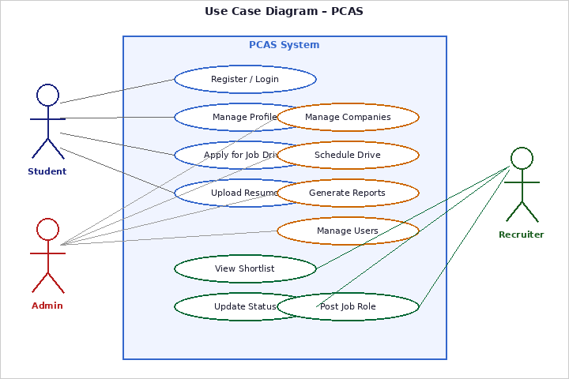
Figure 1: Use Case Diagram – PCAS

4. Software Engineering Principles & Process Models

4.1 Software Engineering Principles
PCAS development was guided by the following core Software Engineering principles:
- Modularity: Six independent modules — Auth, Student, Job, Eligibility, Report, Notification — each independently testable and deployable.
- Reusability: Shared UI components (DataTable, StatusBadge, ModalDialog) and backend services (AuthService, EligibilityEngine) reused across modules.
- Abstraction: Clean RESTful APIs hide implementation details from the frontend consumers.
- Maintainability: Separated frontend/backend with JSDoc documentation on all API handlers.
- Separation of Concerns: Authentication, business logic, data access, and presentation maintained in dedicated layers.

4.2 Agile Model & Sprint Planning
After evaluating Waterfall, Incremental, and Spiral models, Agile/Scrum was selected for PCAS due to requirement volatility, incremental delivery needs, and a small collaborative team. Nine sprints were completed covering requirements, design, authentication, profile management, job posting, eligibility filtering, drive scheduling, reporting, and final testing.

4.3 Project Planning – CPM, PERT & Gantt
Critical path activities included database schema design, user authentication, eligibility filtering engine, API integration, and integration testing. PERT three-point estimation was applied for uncertain activities:
Activity | O (days) | M (days) | P (days) | Te (days) | Owner
Database Schema Design | 2 | 3 | 5 | 3.2 | Krishna
Authentication Implementation | 3 | 5 | 8 | 5.2 | Kishan
Eligibility Filtering Engine | 4 | 6 | 10 | 6.3 | Satyam
API Integration | 2 | 4 | 7 | 4.2 | All
Integration Testing | 3 | 5 | 9 | 5.3 | All

5. Requirement Engineering

5.1 Functional Requirements
- FR-01: System shall allow students to register with valid institutional email and CGPA
- FR-02: System shall authenticate users with role-based access (Student, Admin, Recruiter)
- FR-03: Eligibility engine shall filter students based on CGPA threshold and eligible branches
- FR-04: Admins shall create and manage placement drives with date, company, and criteria
- FR-05: Recruiters shall view shortlisted applicants and update placement status
- FR-06: System shall generate branch-wise and year-wise placement reports
- FR-07: Students shall be notified upon application submission and status changes

5.2 Non-Functional Requirements
- Performance: System shall respond to API requests within 500ms under normal load
- Security: Passwords stored as bcrypt hashes; all routes protected with JWT middleware
- Scalability: Three-tier architecture supports horizontal scaling of API and DB layers
- Usability: Responsive UI operable on desktop and mobile browsers
- Reliability: MySQL with connection pooling ensures 99.5% uptime under normal usage

5.3 Software Requirement Specification (IEEE SRS)
The SRS document follows IEEE Std 830-1998 structure. Requirement validation was performed through stakeholder review, prototype walkthroughs, and cross-checking against functional scenarios. All requirements were traced to corresponding test cases to ensure completeness.

6. Software Design

6.1 UML Diagrams

6.1.1 Activity Diagram
The Activity Diagram illustrates the control flow of the job application process including eligibility checking, application submission, and notifications.
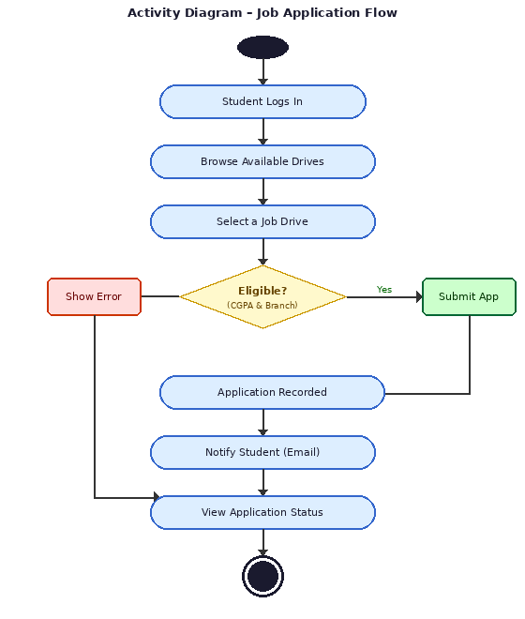
Figure 2: Activity Diagram – Job Application Flow

6.1.2 Class Diagram
The Class Diagram shows the six core entity classes – User, Student, Company, JobDrive, Application, and EligibilityEngine – along with their attributes, methods, and relationships.
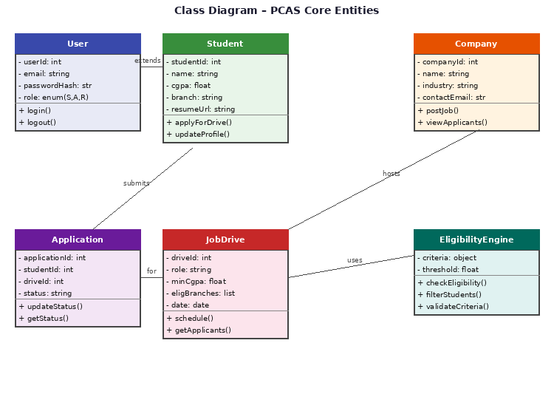
Figure 3: Class Diagram – PCAS Core Entities

6.1.3 Sequence Diagram
The Sequence Diagram captures the message flow between the Student, Frontend Browser, Express API Server, and AuthService/DB for login and job application operations.
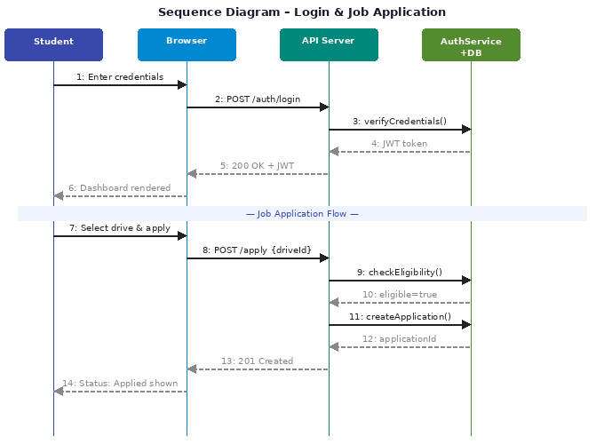
Figure 4: Sequence Diagram – Login & Job Application

6.2 Cohesion and Coupling

Cohesion (Functional Cohesion)
PCAS achieves functional cohesion — each module performs a single, well-defined responsibility:
- AuthService: Handles only authentication, password hashing, and JWT generation/validation
- StudentService: Handles only student profile creation, updates, and retrieval
- JobService: Handles only job posting creation, retrieval, and closure
- EligibilityEngine: Handles only CGPA and eligibility criteria computation (LCOM ≈ 0)
- ReportService: Handles only placement data aggregation and report generation
- NotificationService: Handles only sending alerts and messages to users
Object-Oriented Metrics: The EligibilityEngine class achieves LCOM close to 0, indicating high cohesion. Maximum Depth of Inheritance (DIT) = 1, keeping class structures simple and maintainable.

Coupling (Loose Coupling)
- Data Coupling: Modules share only minimal data via typed function parameters and JSON API responses — no shared global state
- REST API Boundaries: Frontend and backend are completely decoupled, communicating only through well-defined HTTP endpoints
- Dependency Injection: Services injected as dependencies rather than instantiated inside controllers, enabling easy unit testing
- CBO Metric: ApplicationController coupled only to StudentService and JobService, maintaining low CBO values

6.3 System Architecture & MVC
PCAS follows MVC architecture: Model (MySQL + Sequelize — Student, Company, Job, Application entities), View (HTML/CSS/JS — Dashboard, Profile, Jobs UI), Controller (Express.js route handlers — routes requests, invokes services, returns JSON). Communication uses HTTPS between client and server, and TCP/IP between server and database.

7. Software Construction

7.1 Coding Standards, Refactoring & Optimization
Standards adopted: camelCase for JS variables, PascalCase for classes, snake_case for DB columns, JSDoc comments on all API handlers, 2-space indentation, constants in environment variables.
Key refactoring: Eligibility logic extracted into EligibilityEngine service; repeated DB setup consolidated into db.js; multiple fetch queries unified into getStudentsByFilter(); report queries optimized with JOIN-based SQL replacing sequential queries.
Optimizations: DB indexing on student_id, cgpa, branch; connection pooling (pool size=10); server-side pagination on all list endpoints; placement report caching for 10 minutes; frontend asset minification.

7.2 Reusable Components
Frontend: DataTable (sortable, paginated), StatusBadge (Applied/Shortlisted/Placed/Rejected), ModalDialog (confirmations and alerts), FormValidator (centralized input validation).
Backend: AuthService (JWT), EligibilityEngine (criteria checking), ReportGenerator (aggregation query builder), EmailNotifier (notification stub).

7.3 Defensive Programming
- Input Validation middleware validates all API request parameters before processing
- CGPA Boundary Check: values validated within [0.0, 10.0]
- SQL Injection Prevention: parameterized prepared statements throughout
- XSS Prevention: user fields sanitized using validator.js
- Resume Upload: PDF-only, max 2 MB enforced at middleware level

8. Software Metrics

8.1 Size-Oriented & Function Point Metrics
Metric | Value
Lines of Code (LOC) | ~3,000 – 4,000
Frontend Pages | 8 pages
Backend API Endpoints | 18 endpoints across 6 route files
Database Tables | 7 tables
Language Composition | JS: 72%, HTML: 15%, CSS: 10%, SQL: 3%
Reusable Components | 8 (frontend: 4, backend: 4)
Total Function Points (UFP) | 171 FPs

8.2 COCOMO Model
PCAS is categorized as Organic (small experienced team, well-understood domain, ~3,500 LOC). Basic COCOMO: Effort = 2.4 × (3.5)^1.05 ≈ 9.0 Person-Months; Development Time = 2.5 × (9.0)^0.38 ≈ 6.5 Months; Avg Team Size ≈ 2–3 Developers. These estimates align with the actual 10-week, 3-member project.

9. Implementation
The PCAS system was implemented as a three-tier web application using Node.js (Express.js) on the backend, a plain HTML/CSS/JavaScript frontend, and MySQL as the relational database. The following key modules were implemented and tested:
- Student Registration & Login – JWT-based authentication with bcrypt password hashing
- Student Profile Dashboard – View and update academic details, upload PDF resume
- Job Drive Listing – Eligibility-filtered list of open placement drives
- Application Submission – One-click apply with real-time eligibility check
- Admin Drive Management – Create, edit, and close placement drives
- Recruiter Shortlist View – Filtered applicant list with status update capability
- Placement Reports – Branch-wise and year-wise statistics dashboard
Screenshots of the working application are attached in Appendix A (to be inserted at the time of viva submission as per submission guidelines).

10. Test Case Report

10.1 Testing Strategies
White Box Testing (basis path, condition, loop testing) was applied to EligibilityEngine and AuthService. All 6 execution paths through login and eligibility were verified. Black Box Testing covered registration, login, job application, drive creation, report generation, and status updates.
Boundary Value Analysis covered CGPA [0.0–10.0], password length [8–64 chars], resume size [1KB–2MB], CTC [1–100 LPA]. Equivalence Class Partitioning identified valid and invalid classes for all major inputs. Regression Testing was performed after each major feature addition.

10.2 Test Cases and Results
The following test cases cover all functional requirements and include both Pass and Fail scenarios:
TC# | Test Case | Input | Expected Result | Status
TC-01 | Valid Student Login | Registered email + correct password | Dashboard displayed, JWT issued | ✓ Pass
TC-02 | Invalid Password | Registered email + wrong password | 401 Unauthorized error | ✓ Pass
TC-03 | Unregistered Email | Non-existent email | 404 User not found | ✓ Pass
TC-04 | Student Registration | Valid name, email, CGPA, branch | Account created successfully | ✓ Pass
TC-05 | Duplicate Email Registration | Already registered email | 409 Conflict error returned | ✓ Pass
TC-06 | Eligible Student Applies | CGPA 8.5, drive threshold 7.5 | Application accepted | ✓ Pass
TC-07 | Ineligible CGPA | CGPA 6.8, drive threshold 7.5 | Rejected – CGPA below requirement | ✓ Pass
TC-08 | Ineligible Branch | Branch ECE; eligible: CSE, IT only | Rejected – Branch not eligible | ✓ Pass
TC-09 | Admin Creates Drive | Valid company, role, date, CGPA threshold | Drive created, students notified | ✓ Pass
TC-10 | Drive with Past Date | Drive date set to yesterday | Validation error: invalid date | ✓ Pass
TC-11 | Recruiter Views Shortlist | Recruiter login + view applicants | Only eligible applicants listed | ✓ Pass
TC-12 | Status Update to Placed | Recruiter marks student as Placed | Status updated, report reflects change | ✓ Pass
TC-13 | Branch-wise Report Generation | Admin generates CSE branch report | Correct placement count displayed | ✓ Pass
TC-14 | Valid PDF Resume Upload | Valid PDF file < 2 MB | Resume uploaded and linked to profile | ✓ Pass
TC-15 | Non-PDF File Rejected | .docx file uploaded as resume | Error: only PDF files allowed | ✓ Pass
TC-16 | Oversized Resume Rejected | PDF file > 2 MB | Error: file exceeds 2 MB limit | ✓ Pass
TC-17 | CGPA Boundary – Max Valid | Student CGPA = 10.0 | Accepted as valid CGPA value | ✓ Pass
TC-18 | CGPA Boundary – Above Max | Student CGPA = 10.1 | Validation error returned | ✓ Pass
TC-19 | Empty Required Fields | Submit form with blank required fields | Validation errors displayed | ✓ Pass
TC-20 | Unauthorized Route Access | Student accesses /admin/reports | 403 Forbidden response returned | ✓ Pass

11. Contribution of Each Team Member
Team Member | Enrolment No. | Contributions
Kishan Soni | 992401040077 | Project lead; front-end development (dashboard, profile, jobs UI pages); system integration; final documentation and report compilation
Krishna Chawla | 992401040073 | Database schema design; user authentication module (JWT, bcrypt); backend REST API development for auth and student routes
Satyam Pundhir | 992401040079 | Eligibility filtering engine; drive scheduling module; testing strategy (white-box, BVA, regression); PERT and CPM analysis

12. Conclusion
The Placement Cell Automation System (PCAS) successfully demonstrates how a well-engineered, modular web application can digitize and streamline institutional placement management. The system achieved all primary objectives: secure three-tier architecture with RBAC, automated CGPA-based eligibility filtering, real-time placement tracking, comprehensive analytics reporting, and robust security (bcrypt, JWT, input sanitization).
All key Software Engineering principles — modularity, separation of concerns, reusability, defensive programming, Agile development, MVC architecture, and comprehensive testing (white box, black box, BVA, ECP, regression) — were rigorously applied throughout the development lifecycle. The project provided hands-on experience in the complete SDLC, reinforcing theoretical Software Engineering concepts in a real-world applied context.

13. References
- IEEE Std 830-1998. Recommended Practice for Software Requirements Specifications. IEEE Computer Society.
- Pressman, R. S., & Maxim, B. R. (2019). Software Engineering: A Practitioner’s Approach (9th ed.). McGraw-Hill Education.
- Sommerville, I. (2016). Software Engineering (10th ed.). Pearson Education.
- Booch, G., Rumbaugh, J., & Jacobson, I. (2005). The Unified Modeling Language User Guide (2nd ed.). Addison-Wesley.
- Myers, G. J., Sandler, C., & Badgett, T. (2011). The Art of Software Testing (3rd ed.). John Wiley & Sons.
- Node.js Official Documentation. (2024). https://nodejs.org/en/docs
- Express.js Documentation. (2024). https://expressjs.com
- MySQL Documentation. (2024). https://dev.mysql.com/doc
- Agile Alliance. (2024). Agile Manifesto and Principles. https://agilemanifesto.org
- OWASP Foundation. (2024). OWASP Top Ten. https://owasp.org/www-project-top-ten

