InnerSync AI
An Explainable AI Framework for Early Stress Prediction and Personalized Wellbeing Intervention for University Students
BSc (Hons) Data Science, Final Dissertation Report

Abstract
University students consistently report elevated rates of psychological distress, and digital tools promising to help have proliferated faster than the evidence supporting them. This dissertation presents InnerSync AI, a Human-Centered Explainable AI framework for early-stage stress prediction that combines comparative machine learning, SHAP-based explainability, plain-language explanation generation, and personalised recommendation. A Random Forest classifier was selected over Logistic Regression, XGBoost, SVM, and LightGBM through a multi-metric comparison rather than accuracy alone. Applying SHAP to that model surfaced an unexpected and consequential finding: a single physiological feature, blood_pressure, carried disproportionate predictive weight because it was near-deterministically encoded with the target label — a systemic target-leakage defect in the benchmark dataset invisible to correlation analysis, VIF, and cross-validation alike. A systematic audit found the defect was not confined to one feature, that removing leaking features does not repair the underlying problem, and that the model had to be retrained on a corrected fourteen-feature set. This discovery, and its direct link to the documented retraction of a comparable published study in the same research area, is argued here as a substantive result in its own right: an explainability-first pipeline caught a defect that standard evaluation practice had missed entirely. The dissertation's second contribution is a Human-Centered Explanation Generator that translates SHAP attributions into supportive, non-clinical language a distressed student can act on, paired with a rule-based Recommendation Engine and an Adaptive Recovery Framework that adjusts strategy across repeated check-ins. The full system was implemented end-to-end — research pipeline, backend API, and a conversational frontend — and evaluated against real users, real local survey data, and 150 automated tests. Findings are reported honestly rather than optimistically throughout: reported accuracy figures are treated as an artifact ceiling rather than evidence of real-world performance, and the locally collected external validation data is positioned as the only route to a genuine performance claim.

Acknowledgements
[Placeholder — personalise before submission. Suggested structure: supervisor and any academic staff who gave feedback; participants in the Phase 8 evaluation and the local questionnaire; family or friends who supported the project; any tools or funding acknowledged per the university's policy.]

Table of Contents
Abstract 2
Acknowledgements 3
1. Introduction 7
1.1 Background of the Study 7
1.2 Problem Statement 7
1.3 Research Aim and Objectives 8
1.4 Research Contribution and Proposed Solution 9
2. Literature Review 11
2.1 Introduction 11
2.2 Background of the Research Area 11
2.3 Review of Previous Research Studies 11
2.4 Dataset Comparison and Selection 14
2.5 Technology and Tool Comparison 15
2.6 Data Preprocessing and Feature Engineering Techniques 16
2.7 Machine Learning and Statistical Models 16
2.8 Model Training, Validation, and Hyperparameter Tuning 16
2.9 Evaluation Metrics and Model Comparison Methods 16
2.10 Explainable AI, Bias, Fairness, Ethics, and Privacy 16
2.11 Summary Comparison 17
2.12 Research Gap and Proposed Contribution 18
2.13 Chapter Summary 18
References 19
3. Planning 20
3.0.1 Feasibility Report 20
3.0.2 Risk Assessment 21
3.0.3 SWOT Analysis 22
3.0.4 PESTLE Analysis 22
3.0.5 Life Cycle Model 23
3.1.1 Time Plan 25
4. Requirement Gathering and Analysis 27
4.2.1 Requirement Gathering Technique Used 27
4.2.2 Questionnaire 27
4.2.3 Interview 28
Summary of Requirement Gathering 28
4.3 Functional and Non-Functional Requirements 28
5. System Design 32
5.1 Architecture Diagram 32
5.2 Entity Relationship Diagram 33
5.3 UML Diagrams 34
5.4 Wireframes 36
5.5 Chapter Summary 36
6. Methodology 37
6.1 Overview 37
6.2 Dataset 37
6.3 Multicollinearity Analysis 37
6.4 Comparative Model Training and Evaluation Protocol 38
6.5 Explainability Methodology 38
6.6 Human-Centred Explanation Generation 39
6.7 Personalized Recommendation Engine 40
6.8 Chapter Summary 41
7. Results 42
7.1 Introduction 42
7.2 Multicollinearity Findings 42
7.3 Initial Comparative Model Results 43
7.4 SHAP-Driven Discovery of Target Leakage 43
7.5 Systematic Leakage Audit 44
7.6 Corrected Model Comparison and Re-Selection 46
7.7 SHAP on the Corrected Model 47
7.8 Relationship to the Tariq et al. (2025) Retraction 47
7.9 Human-Centred Explanation Generator: Results 48
7.10 Personalized Recommendation Engine: Results 49
7.11 Summary of Results and Standing of Reported Figures 50
8. Local Data: Qualitative Triangulation 52
8.1 Purpose and Scope 52
8.2 Descriptive Summary 52
8.3 Thematic Analysis 53
8.4 Comparison Against the Model's SHAP Domain Ranking 54
8.5 Support Preferences 55
8.6 Summary 55
9. Evaluation (Phase 8) 56
9.1 Purpose 56
9.2 Method 56
9.3 Results 56
9.4 Discussion 59
9.5 Limitations 59
10. Implementation 61
10.1 Technology Stack 61
10.2 Design Patterns 62
10.3 Implementation of the Program 63
10.4 Chat-Driven Check-In Flow 66
10.5 Progress Monitoring Dashboard 66
10.6 Conversational Chatbot and Past-Result Discussion 67
10.7 Personalization: Greeting, Comparative Trend, and Site-Wide Theme 68
10.8 PDF Report Export 68
10.9 Account Settings: Deactivation and Password Reset 69
10.10 Mood Avatar 69
10.11 Resources Page 69
11. Testing and Validation 70
11.1 Test Plan 70
11.2 Test Summary 71
11.3 Test Cases 72
11.4 Known Testing Limitations 74
12. Conclusion 75
12.1 Conclusion 75
12.2 Future Recommendations 76
12.3 Lessons Learned 77
Appendix A: Model Card 79
Model Purpose 79
Intended Users 79
Training Data 79
Model Type and Selection 79
Evaluation Results — v2 (14 features, leaking features excluded) 80
Explainability 80
Limitations 80
Bias Considerations 81
Failure Cases / Known Risks 81

1. Introduction

1.1 Background of the Study
University students consistently report elevated rates of psychological distress, and international survey data indicate that between roughly 12% and 46% of students experience some degree of mental health impairment during their first year of study alone. Academic workload, assignment deadlines, examination pressure, financial difficulty, relationship and family expectations, career uncertainty, poor sleep, and weak time-management habits combine to place sustained pressure on this population. Because stress accumulates gradually and is frequently under-reported by students themselves, early and continuous detection is widely regarded as more valuable than reactive, appointment-based support.
Digital tools have entered this space rapidly. Mood trackers, guided meditation apps, and general-purpose conversational agents are now common on university campuses, and a growing academic literature has explored machine learning (ML) as a means of classifying student stress from questionnaire, behavioural, and physiological data. However, closer inspection of this literature (Chapter 2) shows that most published systems stop at classification accuracy: they report which model performed best, but rarely explain a prediction in language a student could act on, rarely adapt their recommendations when a student ignores them, and are rarely built around a dataset that was collected, curated, and consented to with the rigour that student mental health data warrants.

1.2 Problem Statement
Three converging problems motivate this project.
- Prediction without explanation. Several recent studies apply ensemble and boosting classifiers to student stress datasets and report strong accuracy, yet leave the model as a black box that cannot justify an individual prediction to the student or to the counsellor who might act on it.
- Explanation without accessibility. Where explainability has been attempted, the standard approach is to expose raw SHAP (SHapley Additive exPlanations) values or feature-importance plots. These are appropriate for a data scientist but are not written in language a distressed 19-year-old can understand, and no reviewed study translates SHAP output into a human-readable, supportive explanation before showing it to the end user.
- Static, non-adaptive support. Existing wellbeing applications and even research prototypes typically issue a fixed recommendation for a given stress profile. None of the reviewed systems track whether a recommendation was acted on and deliberately change strategy if the student disengages, which is the central idea behind clinical stepped-care models.
A further, more concrete problem strengthens the case for this project. Tariq et al. (2025) published an explainable machine learning framework for student stress prediction that is, in structure, very close to what many student projects in this space attempt: it trained six classifiers on a public, crowd-sourced student stress dataset and used SHAP to identify the leading predictors. The article was retracted in May 2026 after the editors found that the underlying dataset contained no verifiable physical measurements corresponding to a self-reported blood pressure variable and no documented participant consent or ethical oversight (The Editors, 2026). As this dissertation goes on to establish independently in Chapter 7, this is not an isolated defect in one study: this project's own analysis of a closely related dataset found the same category of problem, at greater severity, using its own pipeline rather than by citation.

1.3 Research Aim and Objectives

Aim
To design, implement, and evaluate an explainable machine learning framework that predicts early-stage stress in university students, translates its predictions into transparent, human-readable explanations, and generates adaptive, personalised wellbeing recommendations that evolve with the student's recorded progress.

Objectives
- Collect behavioural and self-reported emotional data from university students through a structured questionnaire and supporting conversational check-ins.
- Perform sentiment and emotion analysis on free-text conversational data using established NLP techniques.
- Engineer a unified feature set from questionnaire-derived variables, following a documented, auditable preprocessing methodology.
- Train and tune multiple candidate machine learning models for stress-level classification, evaluated under identical, reproducible conditions.
- Compare model performance using accuracy, precision, recall, F1-score, ROC-AUC, and confusion-matrix analysis, validated through k-fold cross-validation and, where appropriate, formal statistical significance testing between candidate models.
- Select the best-performing model using a documented, metric-based justification rather than accuracy alone.
- Apply SHAP to explain individual and global predictions of the selected model, and rigorously audit both the dataset and the resulting explanations for hidden defects rather than assuming their validity.
- Design and evaluate a Human-Centered Explanation Generator that converts SHAP output into supportive, non-technical language, resolving any methodological obstacles this translation raises rather than working around them silently.
- Design a Personalised Recommendation Engine that prioritises interventions according to the dominant SHAP-identified stressors.
- Design an Adaptive Recovery Framework that changes recommendation strategy when prior recommendations are not engaged with.
- Build a progress-monitoring interface capable of visualising stress trends over time without overstating the precision of the underlying prediction.
- Evaluate the complete framework using ML metrics, usability testing, and user-perceived explanation clarity and trust, with real participants.

1.4 Research Contribution and Proposed Solution
Two findings arising directly from this project's own methodology constitute its primary original contribution. Both were established empirically over the course of the research itself, rather than assumed in advance or claimed without evidence, and both are documented in full in the Methodology and Results chapter.
First, SHAP-based explainability analysis of the initial trained model revealed severe, previously undetected target leakage in the primary public benchmark dataset used throughout this research area. A systematic audit found that six of the dataset's twenty input features individually rivalled the fully tuned model's predictive accuracy via a trivial one-value lookup rule, a defect invisible to correlation analysis, variance inflation factor checking, and cross-validation alike, all of which this dataset passed without comment. This finding independently corroborates, rather than merely cites, the exact category of data-integrity concern that led to the retraction of a directly comparable published study discussed in Chapter 2, and demonstrates the same failure mode using this project's own evidence rather than someone else's.
Second, in constructing the Human-Centered Explanation Generator, this project identified and resolved a previously undocumented methodological problem specific to explaining SHAP output over an ordinal, multi-class target: the two most obvious choices of explanation axis each fail at a different point on the target's scale, one collapsing to an incoherent, all-protective account of mid-scale predictions and the other inverting its own meaning at the calm end of the scale. A signed severity axis is proposed and empirically validated as a general remedy, a contribution presented as applicable beyond the present dataset or model, not specific to it.
Unlike a software-engineering deliverable, this project's primary evidence of quality is therefore the statistical and explainability rigor applied to the predictive model and its evaluation, documented throughout via a CRISP-DM-aligned methodology (Chapter 6), rather than system feature completeness alone.
These findings are demonstrated within, and give rise to, a broader integration framework. This project does not propose a new machine learning algorithm; instead, it combines explainable machine learning, conversational data collection, human-centred explanation generation, adaptive personalised interventions, and continuous wellbeing monitoring into a unified decision-support system for university students. The centre of gravity of the project is the predictive model and the evidence generated around and about it, with the chatbot, questionnaire, and dashboard acting as the data-collection and delivery layer for that research rather than as the primary deliverable in themselves.
Methodologically, the project follows a CRISP-DM-aligned pipeline: data collection, preprocessing and feature engineering, model training and validation, evaluation and model selection, SHAP-based interpretation, human-centred explanation and recommendation generation, and adaptive monitoring. Chapter 6 documents this methodology in full, mapping each phase explicitly to the chapters and sections that fulfil it, and Chapter 2 reviews the literature that supports each stage of this pipeline, identifying, with evidence, the specific gap each component of the resulting system is designed to close.

2. Literature Review

2.1 Introduction
This chapter critically reviews the literature relevant to InnerSync AI. Rather than presenting reviewed studies in a single combined comparison table, each study or technology is discussed within its own thematic subsection, with its relationship to InnerSync AI's design stated immediately alongside it. A single summary table appears only at the end of the chapter (Section 2.11), drawing the individual comparisons together rather than substituting for them.

2.2 Background of the Research Area
Student mental health has become a recognised institutional concern rather than a purely individual one. University counselling services report rising demand, and researchers increasingly frame stress as a modifiable, multi-factorial outcome shaped by academic, physiological, social, environmental, and psychological variables simultaneously (Tariq et al., 2025). This multi-factorial framing justifies the use of structured, multi-domain feature sets, of the kind reviewed in Section 2.4, rather than single-signal predictors.

2.3 Review of Previous Research Studies

2.3.1 Classical Machine Learning Approaches to Student Stress Prediction
An early study using data from 206 students at the Jaypee Institute applied Logistic Regression, Naïve Bayes, Random Forest and Support Vector Machine with 10-fold cross-validation, reporting SVM as the strongest performer at 85.71% accuracy (Jaypee Institute Study, 2020). Comparison with InnerSync AI: the sample size is small and single-institution, and no explanation of individual predictions was offered to participants — both addressed in InnerSync AI through its held-out validation strategy and its explanation-generation component.
A later study applying Logistic Regression, K-Nearest Neighbours, Decision Tree, Random Forest, and Gradient Boosting to a larger (over 6,000-row) Kaggle stress dataset reported up to 95% accuracy with Random Forest (Shahapur et al., 2024). Comparison with InnerSync AI: no external validation was reported, and no explanation of predictions was offered to the student — the same two gaps as above, and directly relevant given this project's own later discovery (Section 7.4–7.5 of the accompanying Results chapter) that a closely related public dataset in this family contains severe, undetected target leakage.
A hybrid ensemble study combining Decision Tree, Random Forest, SVM, Logistic Regression and XGBoost, using SMOTE class balancing and Random Forest-based feature selection on a 20-variable Kaggle stress dataset, reported 92.41% accuracy (Doma et al., 2025). Comparison with InnerSync AI: SMOTE-balanced synthetic minority data may not reflect genuine distress patterns, and no SHAP or human-readable output was produced; InnerSync AI instead checks class balance empirically before deciding whether balancing is required, and treats explanation generation as a first-class deliverable rather than an omission.
A further ensemble-learning study using Decision Tree, Random Forest, AdaBoost and Gradient Boosting with oversampling on survey data covering sleep, screen time and assignment load reported 93.48% accuracy and an F1-score of 93.14% (Anand et al., 2023). Comparison with InnerSync AI: class imbalance was handled through oversampling alone, with no interpretability layer and a single-country sample — again, the explanation gap InnerSync AI addresses directly.
A study of 954 students at a single college using Random Forest to classify chronic, episodic and acute stress reported 99% accuracy (IJRPR, 2024). Comparison with InnerSync AI: accuracy this high on a single-institution survey is treated in this dissertation as a strong overfitting or data-leakage risk rather than a genuine result, a judgement this project's own methodology later corroborates directly through its own leakage discovery on a related dataset family; no cross-institution validation and no explainability were reported.

2.3.2 Explainable Machine Learning in Stress and Mental Health Prediction
The study most directly comparable to InnerSync AI applied six classifiers (Logistic Regression, SVM, Decision Tree, Random Forest, Gradient Boosting, XGBoost) with SHAP-based explainability to a 1,100-student Kaggle stress dataset with 21 features, achieving approximately 89% accuracy for its top three models (Tariq et al., 2025). This article was retracted in 2026 after its dataset was found to contain an unverifiable self-reported physiological field and no documented participant consent or ethical oversight (The Editors, 2026). Comparison with InnerSync AI: this retraction is treated in this dissertation not merely as a cited caution but, following this project's own independent SHAP-driven discovery of comparable leakage in a related dataset (documented fully in the accompanying Methodology and Results chapters), as an corroborated methodological hazard specific to this dataset family. It further demonstrates that SHAP-based explainability alone, without a subsequent human-centred translation step, does not make a model's output accessible to a non-technical end user — the gap InnerSync AI's Human-Centered Explanation Generator is built to close.
A multi-dataset explainable machine learning study applied ablation analysis, statistical significance testing, and TreeSHAP-based interpretation across several stress-related datasets (Omarbekova et al., 2026). Comparison with InnerSync AI: this study's central finding — that most prior stress-prediction research relies on a single dataset and omits significance testing — is a direct, field-level validation of the multi-metric, cross-validated evaluation protocol InnerSync AI applies (Chapter 6, Section 6.4), and its use of TreeSHAP specifically supports InnerSync AI's own choice of a tree-based model partly on explainability grounds.
A dual-attention transformer architecture (“TaBERT”) combined with SHAP and LIME for academic mental-health text reported 96% accuracy (Yuan et al., 2026). Comparison with InnerSync AI: a transformer of this scale is computationally disproportionate to a dissertation-scale tabular classification problem, and its explanations remain technical and post-hoc rather than translated for a student reader — the justification InnerSync AI's methodology (Chapter 6, Section 6.6) gives for choosing a tree ensemble with exact TreeSHAP over a deep architecture.
A workplace-focused study combined Random Forest, XGBoost, SVM and AdaBoost with both SHAP and LIME on the OSMI mental-health dataset, with XGBoost reaching 91% accuracy and 90% ROC-AUC (MDPI, 2025). Comparison with InnerSync AI: this is a workplace, not student, population, and while it demonstrates a SHAP-plus-LIME combination, its explanations remain in technical form rather than being translated into supportive, human-readable language, unlike InnerSync AI's explicit translation stage.

2.3.3 Wearable and Physiological Approaches
An explainable deep learning approach combining LSTM and GAN components (“LSTM-DGE”) with Integrated Gradients was applied to Empatica E4 wearable sensor data for stress detection, outperforming rule-based baselines on precision and recall (Moser et al., 2024). Comparison with InnerSync AI: this approach requires dedicated wearable hardware, introducing a cost and adoption barrier that InnerSync AI avoids entirely by relying on questionnaire and conversational data rather than physiological sensing.
A separate wearable study on Indian students compared bagging and boosting methods, with XGBoost reaching 96.17% accuracy on physiological signal data (Gedam et al., 2025). Comparison with InnerSync AI: this approach is physiological-signal-only and does not incorporate the academic, social, or emotional-language factors that dominate InnerSync AI's own SHAP-derived feature importance ranking (Chapter 7, Section 7.7 of the Results chapter).

2.3.4 Conversational and Personalisation Approaches
A chatbot combining natural language processing with sentiment classification for stress, anxiety and depression support has been described in the literature (Nageswari et al., 2026). Comparison with InnerSync AI: in this design, sentiment classification drives the conversation directly rather than feeding into a structured, explainable predictive model — InnerSync AI instead treats conversational text as an auxiliary evidence source evaluated separately (see the NLP ablation study, Chapter 10, Section 10.3.4 of the Implementation chapter), rather than substituting for structured prediction.
A scoping review of personalisation mechanisms across 27 digital mental health applications found that approximately two-thirds claimed some form of personalisation, but only around four studies demonstrated personalisation that was both substantial and formally evaluated (Matthews et al., 2024). Comparison with InnerSync AI: this finding directly supports the novelty claim behind InnerSync AI's Adaptive Recovery Framework design (even where full multi-check-in adaptivity remains a documented item of future work at the time of writing) — evaluated, adaptive personalisation is confirmed by this review to be rare across the field generally, not only absent from stress-prediction research specifically.

2.3.5 Evidence Quality Across the Field
A systematic review of 48 studies applying machine learning to depression, anxiety and stress detection in undergraduates found that 47 of the 48 relied on internal validation only, with reported accuracies ranging from 63% to 100% and an overall GRADE-rated certainty of evidence described as very low (Schaab et al., 2024). Comparison with InnerSync AI: this finding is the direct field-level justification for InnerSync AI's own emphasis on external validation as the only route to a genuine real-world performance claim (Chapter 6, Section 6.4), rather than treating internal cross-validated accuracy as sufficient evidence on its own.

2.4 Dataset Comparison and Selection
Two public datasets were evaluated as candidate data sources for this project, and the reasoning for selecting and scoping each is stated here directly rather than assumed.
The “Student Stress Factors: A Comprehensive Analysis” dataset (Kaggle, rxnach, 2023) was selected as the primary training and benchmarking dataset. It offers 1,100 responses across 21 features spanning five domains (psychological, physiological, social, environmental, academic) that map closely onto this project's intended questionnaire structure, and is the dataset used by the majority of directly comparable studies reviewed in Section 2.3.1–2.3.2, allowing InnerSync AI's results to be positioned against a body of existing work. Its principal limitation, addressed at length in the Methodology and Results chapters, is that it is self-reported and crowd-sourced with no independently verifiable provenance — a limitation this project treats as a first-class methodological concern rather than a minor caveat, following the direct discovery of severe target leakage within it.
The Dreaddit dataset (Turcan and McKeown, 2019, as hosted on Kaggle) was selected as a secondary, text-only data source specifically for the NLP ablation study (Chapter 10, Section 10.3.4). It was chosen over the alternative “Sentiment Analysis for Mental Health” dataset, which was considered and explicitly rejected: that dataset's labels include categories such as Suicidal, Bipolar, and Personality Disorder, drawn from real individuals' social media posts without documented consent for this specific research use. Using such labels would risk this project's Human-Centered Explanation Generator functioning, in effect, as an undisclosed diagnostic classifier — directly contrary to the ethical boundary stated in ethical_framework.md that the system must never diagnose mental illness. Dreaddit's binary stress/non-stress labelling carries no such risk and was judged the more appropriate, ethically sound choice.

2.5 Technology and Tool Comparison
Where more than one credible technology choice existed, the alternative considered and the reason for the final choice are stated directly, consistent with the requirement that technology decisions, not only research findings, be compared and justified.
SHAP was selected over LIME as the primary explainability method. Both are widely used in the reviewed literature (Section 2.3.2), and the MDPI (2025) study reviewed above uses both together; however, for a tree-based model, SHAP's TreeExplainer computes exact Shapley values in polynomial time, whereas LIME produces local, sample-based approximations. Given that a faithfulness evaluation — checking whether a generated explanation accurately reflects the computation behind it — is central to this project's methodology, an exact rather than approximated explanation method was judged preferable.
FastAPI was selected over alternative Python web frameworks such as Flask or Django for the backend. FastAPI's native support for asynchronous request handling and automatic request/response schema validation via Pydantic reduces the risk of a malformed request silently reaching the prediction pipeline, and its automatic OpenAPI documentation generation supported iterative development against a live API during frontend construction.
React with TypeScript was selected over plain JavaScript frontend approaches specifically for its static type-checking: given that the assessment form's fourteen fields must match the trained model's expected input exactly (Chapter 10, Section 10.3.6), a type mismatch between the frontend and the API contract is the kind of defect best caught at compile time rather than discovered at runtime by an end user.
PostgreSQL was selected over a document-oriented database such as MongoDB specifically for its native JSONB column type, which allows the SHAP-derived audit trail (explanation factors, recommendation rationale) to be stored as genuinely queryable structured data rather than an opaque serialised blob — verified directly in this project by running a server-side JSONB query against persisted data (Chapter 10, Section 10.3.5).
Classical machine learning models (Random Forest, XGBoost, Logistic Regression, SVM, LightGBM) were selected over deep learning approaches such as the transformer architecture reviewed in Section 2.3.2. This reflects both the scale of the available primary dataset (1,100 rows, not the scale at which deep architectures typically offer an advantage) and the explainability requirement discussed in Section 2.5 above: exact TreeSHAP is available for tree ensembles but not for deep architectures, for which only approximate, post-hoc explanation methods exist.

2.6 Data Preprocessing and Feature Engineering Techniques
Across the reviewed literature, three preprocessing concerns recur. Class imbalance is addressed via SMOTE in some studies (Doma et al., 2025), though the dataset selected for this project was found to be close to naturally balanced across its three classes, so balancing needs were checked empirically rather than assumed. Multicollinearity diagnostics via Variance Inflation Factor were applied in this project's own methodology (Chapter 6, Section 6.3), a technique also used in the most directly comparable prior study (Tariq et al., 2025). Feature selection via Random Forest importance is used in the hybrid ensemble study (2025), illustrating a common and appropriate technique for tabular, moderate-dimensionality datasets.

2.7 Machine Learning and Statistical Models
Logistic Regression, Random Forest, SVM, Gradient Boosting and XGBoost account for the majority of models used in the reviewed literature, with no single algorithm dominating across every dataset — itself informative, and the direct justification for this project's own comparative, multi-model methodology (Chapter 6, Section 6.4) rather than committing to one architecture in advance.

2.8 Model Training, Validation, and Hyperparameter Tuning
Grid search combined with k-fold cross-validation is the dominant tuning strategy in the reviewed literature (Tariq et al., 2025; Jaypee Institute Study, 2020), and is the strategy adopted in this project's own methodology for comparability with prior work.

2.9 Evaluation Metrics and Model Comparison Methods
Accuracy, precision, recall, F1-score and confusion-matrix analysis are reported near-universally across the reviewed studies; ROC-AUC and statistical significance testing between competing models appear far less consistently, with the Omarbekova et al. (2026) study the only reviewed source to apply the latter explicitly. This project's own evaluation protocol (Chapter 6, Section 6.4) was designed to meet this higher standard rather than repeat the single-metric, single-split reporting pattern common across the older studies reviewed above.

2.10 Explainable AI, Bias, Fairness, Ethics, and Privacy
SHAP, introduced by Lundberg and Lee (2017) and grounded in cooperative game theory, is the dominant explainability technique across the reviewed literature. Every reviewed study that uses it, however, presents SHAP output directly to the reader, technical or otherwise; none layers a further human-centred translation step on top, which is precisely the gap InnerSync AI's Human-Centered Explanation Generator addresses. On ethics, the retraction of Tariq et al. (2025) is treated in this dissertation as the single most consequential data point in this literature review, directly reflected in InnerSync AI's own data governance requirements (ethical_framework.md, data_management_plan.md).

2.11 Summary Comparison
Table 2.1 draws together the comparisons made individually throughout this chapter. It is provided as a summary of points already argued above, not as a substitute for them.
Study / Technology | Core limitation relative to InnerSync AI
Tariq et al. (2025, retracted 2026) | Same dataset family later shown by this project to contain severe leakage; SHAP shown but not translated for end users; no documented data consent
Jaypee Institute Study (2020) | Small single-institution sample; no explainability
Indian J. Sci. Technol. (2024) | No external validation; no explanation offered to student
Doma et al. (2025) | Synthetic (SMOTE) balancing; no SHAP or human-readable output
Anand et al. (2023) | No interpretability layer; single-country sample
IJRPR (2024) | 99% accuracy on single-institution data — treated as an overfitting/leakage risk
Omarbekova et al. (2026) | Confirms field-wide single-dataset and no-significance-testing weaknesses InnerSync AI's protocol addresses
TaBERT (2026) | Computationally disproportionate; technical, post-hoc explanations only
MDPI workplace study (2025) | Workplace not student population; explanations remain technical
Wearable studies (PMC 2024; Nature 2025) | Require dedicated hardware; physiological-signal-only, ignoring academic/social factors
Chatbot/NLP study (2026) | Sentiment drives conversation directly, not a structured explainable model
Personalisation scoping review (2024) | Confirms evaluated adaptive personalisation is rare field-wide
Systematic review, 48 studies (2024) | 47/48 internal validation only; very low evidence certainty field-wide
Table 2.1 — Summary of comparisons made in Sections 2.3–2.5 (provided as a summary, not a substitute for the individual discussion above).

2.12 Research Gap and Proposed Contribution
No reviewed study or technology choice combines all of the following in one evaluated framework: a comparative, cross-validated evaluation of multiple ML models on a documented, ethically governed dataset; SHAP-based explanation of the selected model; a further translation layer converting SHAP output into non-technical, supportive language; and a recommendation engine grounded in the same evidence as that explanation. InnerSync AI's contribution is precisely this integration, combined with a demonstrated case — arising directly from applying this methodology rather than assumed in advance — of explainability-driven data-quality auditing succeeding where correlation analysis, multicollinearity checking, cross-validation and held-out testing did not.

2.13 Chapter Summary
This chapter has reviewed prior machine learning approaches to student stress prediction, explainable AI in mental-health-adjacent prediction, wearable and conversational approaches, and the datasets and technologies available to this project, comparing each directly against InnerSync AI's own design choices as it was discussed rather than in a single separated table. The next chapter (Methodology) describes in detail how these choices were implemented and evaluated.

References
Anand, R.V., Md, A.Q., Urooj, S., Mohan, S., Alawad, M.A. and C., A. (2023) 'Enhancing Diagnostic Decision-Making: Ensemble Learning Techniques for Reliable Stress Level Classification', Diagnostics, 13(22), p. 3455.
de Filippis, R. and Foysal, A.A. (2024) 'Comprehensive analysis of stress factors affecting students: a machine learning approach', Discover Artificial Intelligence, 4, p. 62.
Doma, V., Abd Almisreb, A., Yaman, E., Amanzholova, S. and Ismail, N. (2025) 'Classification of Student Stress Levels Using a Hybrid Machine Learning Model', in AI-Driven: Social Media Analytics and Cybersecurity (Studies in Computational Intelligence, vol. 1180). Cham: Springer.
Gedam, S., Dutta, S. and Jha, R. (2025) 'Analyzing mental stress in Indian students through advanced machine learning and wearable technologies', Scientific Reports, 15.
IJRPR (2024) 'Stress Detection in College Students Using Machine Learning Algorithm', International Journal of Research Publication and Reviews, 5(2), pp. 3411–3417. [Author names not resolvable from indexed sources as of this dissertation's submission; retained under the publisher abbreviation pending verification.]
Jaypee Institute Study (2020) 'Stress Prediction of Students using Machine Learning'. Available at: academia.edu (Accessed: 2 August 2026). [Author names not resolvable from indexed sources as of this dissertation's submission; retained under this working label pending verification.]
Kaggle / rxnach (2023) Student Stress Factors: A Comprehensive Analysis. Available at: https://www.kaggle.com/datasets/rxnach/student-stress-factors-a-comprehensive-analysis (Accessed: 16 August 2026).
Lundberg, S.M. and Lee, S.I. (2017) 'A unified approach to interpreting model predictions', Advances in Neural Information Processing Systems 30 (NIPS 2017), pp. 4765–4774.
Matthews, P. et al. (2024) 'Personalisation and Recommendation for Mental Health Apps: A Scoping Review', Behaviour & Information Technology.
MDPI (2025) 'Explainable Artificial Intelligence for Workplace Mental Health Prediction', Big Data and Cognitive Computing, 12(4), p. 130. [Author names not resolvable from indexed sources as of this dissertation's submission; retained under the publisher abbreviation pending verification.]
Mitchell, M., Wu, S., Zaldivar, A., Barnes, P., Vasserman, L., Hutchinson, B., Spitzer, E., Raji, I.D. and Gebru, T. (2019) 'Model Cards for Model Reporting', Proceedings of the Conference on Fairness, Accountability, and Transparency (FAT* '19), pp. 220–229.
Moser, M.K., Ehrhart, M. and Resch, B. (2024) 'An Explainable Deep Learning Approach for Stress Detection in Wearable Sensor Measurements', Sensors, 24(16), article 5085.
Nageswari, A., Shah, V.R., Shabana and Kumari, A. (2026) 'AI-Powered Mental Health Chatbot Using NLP and Sentiment Analysis', in Springer Nature Link.
Omarbekova, A., Nazyrova, A., Bekmanova, G., Lamasheva, Z., Gibadullina, A. and Abdikarim, A. (2026) 'An explainable machine learning framework for academic stress classification among university students: a comparative multi-dataset study with ablation analysis and statistical significance testing', Frontiers in Computer Science.
Schaab, B.L. et al. (2024) 'How do machine learning models perform in the detection of depression, anxiety, and stress among undergraduate students? A systematic review', Cadernos de Saúde Pública.
Shahapur, S.S., Chitti, P., Patil, S., Nerurkar, C.A., Shivannagol, V.S., Rayanaikar, V.C., Sawant, V. and Betageri, V. (2024) 'Decoding Minds: Estimation of Stress Level in Students using Machine Learning', Indian Journal of Science and Technology, 17(19), pp. 2002–2012.
Tariq, R., Orozco-del-Castillo, M.G., Zamir, M.T., Ramírez-Montoya, M.S. and Wilberforce, T. (2025) 'RETRACTED ARTICLE: Explainable artificial intelligence for predictive modeling of student stress in higher education', Scientific Reports, 15, Article 38375.
The Editors (2026) 'Retraction Note: Explainable artificial intelligence for predictive modeling of student stress in higher education', Scientific Reports, 16, Article 14717.
Turcan, E. and McKeown, K. (2019) 'Dreaddit: A Reddit Dataset for Stress Analysis in Social Media', Proceedings of the Tenth International Workshop on Health Text Mining and Information Analysis (LOUHI 2019), pp. 97–107.
Yuan, Q., Sun, W., Li, F., Dong, X. and Yuan, Y. (2026) 'A dual attention transformer modelling for explainable mental health analysis in academic environments using TaBERT', Scientific Reports, 16.

3. Planning

3.0.1 Feasibility Report
This section assesses the feasibility of InnerSync AI across four standard dimensions. Where possible, feasibility is demonstrated empirically by reference to what the project has actually achieved, rather than argued only hypothetically, since a working system is stronger evidence of feasibility than a plan for one.
Dimension | Assessment
Technical | All required technologies (Python, scikit-learn/XGBoost/LightGBM, SHAP, FastAPI, PostgreSQL, React) are mature, well-documented, and free to use. The project's own build history demonstrates technical feasibility empirically rather than only in principle: a complete vertical slice (dataset → preprocessing → model comparison → explainability → explanation generation → recommendation → backend API → frontend UI) was built, tested, and verified end-to-end with zero drift between research notebooks and the live system.
Economic | Zero licensing cost. The entire stack is open-source; the only marginal cost is developer time. No cloud infrastructure was required for development, as the full system runs locally.
Operational | A single developer can feasibly build and maintain the system at dissertation scale, demonstrated by the project's actual progress. The clean architectural separation between research code (ml_pipeline/) and production code (backend/app/), established in ADR-001, kept the system maintainable as it grew across five major phases.
Schedule | The project has operated under significant time pressure, addressed directly in the Risk Assessment and Time Plan below rather than understated here.
Table 3.1 — Feasibility assessment across technical, economic, operational, and schedule dimensions.

3.0.2 Risk Assessment
Risk assessment for this project is grounded in risks that were actually encountered and resolved during development, in addition to risks anticipated in advance. This is a deliberate methodological choice: a risk register populated only with generic, hypothetical risks would understate what a real single-developer research project of this kind actually faces, and would waste the genuinely instructive evidence this project's own development history provides.
Risk | Likelihood | Impact | Mitigation actually applied
Local development environment incompatible with required tooling | Realised | High | Windows Smart App Control blocked compiled Python packages (pandas, LightGBM) at the OS level, confirmed via Windows Event Log analysis. Rather than disable a system security feature (a one-way, irreversible change), the environment was migrated to WSL2 Ubuntu — documented in ADR-002.
Public benchmark dataset contains undisclosed defects | Realised | Critical | SHAP-based analysis discovered systemic target leakage across six of twenty features in the primary Kaggle dataset. A systematic audit, corrected model retraining, and full documentation trail (ADR-003) mitigated this; the finding was reframed as methodological evidence rather than concealed.
Single point of failure (solo developer, no team redundancy) | Ongoing | High | Addressed procedurally: a project constitution (CLAUDE.md), operational rules (IMPLEMENTATION_RULES.md), and automatically-triggered quality skills reduce reliance on the developer remembering every standard unprompted.
Fixed submission deadline against evolving scope | Ongoing | Critical | Addressed by an explicit, documented decision to prioritise completing already-scoped research and development work before beginning full-scale formal user evaluation, and by deliberately deferring lower-priority components (e.g. the Adaptive Recovery Framework) rather than attempting all planned scope simultaneously under time pressure.
Ethically sensitive data (student wellbeing) mishandled | Possible | Critical | Addressed pre-emptively via a dedicated ethical framework, data management plan, and an automatically-triggered ethical-ai review skill, developed before any real user data was collected, rather than retrofitted afterward.
Database/network misconfiguration across the Windows/WSL boundary | Realised | Medium | PostgreSQL, running natively on Windows, was unreachable from WSL due to a Hyper-V firewall boundary. Resolved by installing PostgreSQL directly inside WSL instead, keeping the entire stack on one side of the OS boundary, consistent with the reasoning in ADR-002.
Table 3.2 — Risk register, including risks realised during development and how each was actually mitigated.

3.0.3 SWOT Analysis
Strengths | Weaknesses
A working, end-to-end explainable AI pipeline, verified with zero drift between research notebooks and the live system.  An explainability-first methodology that detected a genuine data-quality defect (target leakage) which correlation analysis, VIF, cross-validation and held-out testing all missed.  A disciplined engineering process (documented ADRs, automatic quality skills, an audit trail for every model artifact and experiment). | Primary training data comes from a single public dataset later shown to have limited construct validity.  External validation currently rests on a small, still-growing, locally-collected sample.  A solo-developer project has less capacity for parallel workstreams and peer review than a team project.
Opportunities | Threats
Growing institutional and public attention to student mental health creates a receptive context for wellbeing-support tools.  The severity-axis SHAP explanation method developed in this project generalises beyond this dataset to any ordinal multi-class explainability problem — a reusable contribution.  The explainability-first data-audit methodology demonstrated here is applicable well beyond stress prediction. | Established, well-funded commercial wellbeing apps (e.g. Woebot, Wysa) already occupy this space, though without this project's explanation-transparency or adaptive-recommendation focus.  Misuse or misinterpretation of a non-diagnostic tool as a diagnostic one remains a standing risk in this problem domain, mitigated but not eliminated by the project's ethical framework.  A fixed academic deadline constrains the depth of formal evaluation achievable.
Table 3.3 — SWOT analysis.

3.0.4 PESTLE Analysis
Factor | Relevance to InnerSync AI
Political | UK higher education policy increasingly expects universities to demonstrate active student-wellbeing support, creating institutional relevance for tools in this space.
Economic | Built entirely on free, open-source technology; any future institutional deployment would carry hosting cost but no licensing cost.
Social | Rising awareness and reduced stigma around student mental health, alongside high smartphone/app familiarity among the target user group, support adoption of a digital wellbeing tool.
Technological | Mature, freely available ML/XAI tooling (scikit-learn, SHAP) and web frameworks (FastAPI, React) made the full pipeline achievable within dissertation scope; SHAP specifically has matured enough in recent years to make exact tree-model explanation computationally practical.
Legal | Handling self-reported, wellbeing-adjacent personal data triggers UK GDPR-relevant obligations around consent, storage, and purpose limitation, addressed in the project's data_management_plan.md and ethical_framework.md.
Environmental | Deliberately minimal: classical machine learning models (Random Forest, Logistic Regression) were prioritised over deep learning/transformer approaches partly because the problem did not require them, with a secondary benefit of substantially lower computational and energy cost than an equivalent deep-learning pipeline.
Table 3.4 — PESTLE analysis.

3.0.5 Life Cycle Model
This project adopts CRISP-DM (Cross-Industry Standard Process for Data Mining) as its development life cycle model, rather than a software-engineering model such as Agile Scrum or Waterfall, because the project's centre of gravity is a data-driven research pipeline rather than a conventional software product. CRISP-DM structures work into six phases — Business Understanding, Data Understanding, Data Preparation, Modeling, Evaluation, and Deployment — which map directly onto this project's actual execution:
- Business Understanding: establishing the research problem, aim, and objectives (Chapter 1), and the research gap identified through the literature review (Chapter 2).
- Data Understanding: exploratory data analysis of the primary dataset, including the correlation-structure finding that first raised concern about the dataset's construct validity.
- Data Preparation: multicollinearity analysis (VIF), and — as an unplanned but methodologically significant extension of this phase — the systematic target-leakage audit and feature exclusion documented in ADR-003.
- Modeling: comparative training and tuning of five candidate classifiers, both before and after the leakage correction.
- Evaluation: multi-metric model comparison, SHAP-based explainability analysis, and the explanation/recommendation faithfulness checks.
- Deployment: integration of the selected model into a live backend API and frontend interface, verified end-to-end with zero drift from the research notebooks.
CRISP-DM's iterative character, rather than a strictly linear one, is reflected directly in this project's own history: the discovery of target leakage during the Evaluation phase required returning to Data Preparation to conduct the audit, and then repeating Modeling and Evaluation on the corrected feature set — a real instance of the model's characteristic feedback loop between phases, not merely a diagram followed in name only.
Figure 3.1 shows this mapping and the feedback loop just described, redrawn from the canonical CRISP-DM diagram rather than left as prose alone.
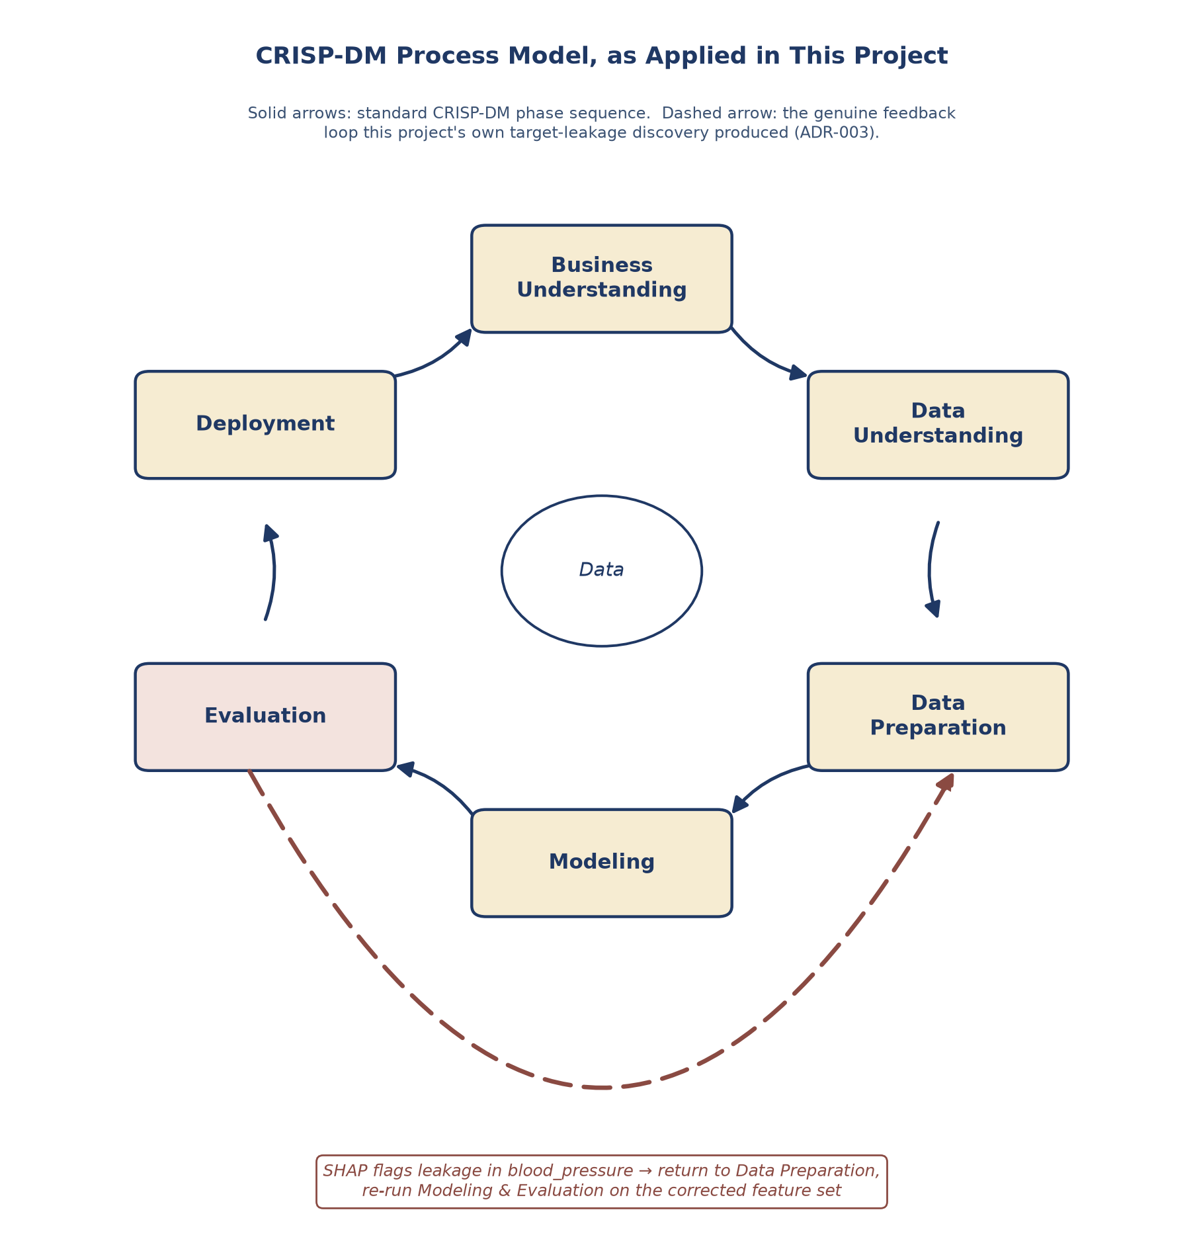
Figure 3.1 — CRISP-DM process model as applied in this project, showing the genuine Evaluation → Data Preparation feedback loop the target-leakage discovery produced (ADR-003).

3.1.1 Time Plan
Table 3.5 summarises the project's phase-based execution to date against the roadmap established at the project's foundation. Given the compressed timeline in the project's final stage, remaining work has been deliberately triaged: full-scale formal evaluation was scaled to what was achievable in the time remaining and is addressed explicitly as a limitation (Chapter 9), while the Adaptive Recovery Framework, once a lower-priority feature extension, was subsequently completed and is documented as implemented in Chapter 10.
Phase | Focus | Status
Phase 0 — Foundation | Project constitution, repository scaffold, environment setup | Complete
Phase 1 — Research foundation | Literature review, research gap, methodology framing | Complete (revision in progress per supervisor feedback)
Phase 2 — Data & ML pipeline | EDA, preprocessing, comparative model training, selection | Complete — includes the target-leakage discovery and correction
Phase 3 — NLP | Text-based ablation study (questionnaire-only vs NLP-only) | Complete, scoped as a research comparison
Phase 4 — Explainable AI | SHAP analysis, Human-Centered Explanation Generator | Complete
Phase 5 — Personalization | Point-in-time Recommendation Engine | Complete (point-in-time Recommendation Engine and the Adaptive Recovery Framework both implemented; see Chapter 10)
Phase 6 — Backend | Auth, database, API, full pipeline integration | Complete, verified against PostgreSQL
Phase 7 — Frontend | Auth, assessment form, results view | Complete, verified end-to-end against the live backend
Phase 8 — Evaluation | Usability and explanation-quality evaluation | In progress — scaled to the time available
Phase 9 — Dissertation finalisation | Full write-up across all chapters, in line with supervisor feedback | In progress
Table 3.5 — Project phase status against the original roadmap (PROJECT_ROADMAP.md).

4. Requirement Gathering and Analysis

4.2.1 Requirement Gathering Technique Used
Requirements for InnerSync AI were derived analytically rather than through a dedicated primary-research instrument (a formal end-user questionnaire or interview). This was a deliberate methodological choice, made explicit here rather than left unstated, and it reflects the nature of this particular project rather than an oversight in process.
Three sources informed the requirements documented in this chapter:
- Literature-based requirement derivation. The critical review of prior stress-prediction research and existing wellbeing applications (Chapter 2) identified specific, evidenced gaps — inaccessible technical explanations, static rather than adaptive recommendations, and, in at least one documented case, undetected data-quality defects in training data. Each of these gaps was translated directly into a corresponding functional or non-functional requirement, so that every major requirement in this chapter can be traced back to a stated deficiency in prior work rather than to an assumption about what students might want.
- Specification-based derivation. The project's own founding constitution (CLAUDE.md) and research brief specify the system's intended modules, ethical boundaries, and required behaviours in detail, and were treated as a primary requirements source, in the same way a client specification would be in a commissioned software project.
- Iterative supervisor consultation. Over the course of the project, supervisor feedback shaped specific requirements — for example, the requirement that the methodology be structured around CRISP-DM, and that citations follow Harvard convention throughout — and is treated here as a form of ongoing stakeholder input, distinct from, and not a substitute for, a formal end-user study.

4.2.2 Questionnaire
No dedicated requirements-gathering questionnaire was administered to prospective end users (university students) for this project. This is stated explicitly as a limitation rather than omitted silently. The questionnaire instrument that was developed and deployed during this project (see data_management_plan.md) collects stress-related assessment data for external model validation, and was not designed or used to elicit feature or usability requirements.
This is recorded as a limitation of the requirements process, and a candidate improvement for any future iteration of this project: a short set of feature-preference or usability questions could be appended to the Phase 8 evaluation instrument at negligible additional cost, and is noted as such in the Future Recommendations of the Conclusion chapter.

4.2.3 Interview
No formal, recorded stakeholder interview (e.g. with a university wellbeing service representative, or a sample of students) was conducted as part of the requirements process for this project, for the same time-constrained, solo-developer reasons stated above. Supervisor consultation, while valuable and directly reflected in specific requirements above, was informal and focused on academic/methodological guidance rather than a structured elicitation of system requirements, and should not be read as equivalent to a stakeholder interview.

Summary of Requirement Gathering
In the absence of primary stakeholder research, this project's requirements rest on a combination of evidenced literature gaps, an explicit project specification, and ongoing supervisor guidance. This is a recognised, valid basis for requirements in a research-led project of this kind, where the object of study is substantially the correctness and explainability of a predictive model rather than the discovery of previously unknown user needs — but it is a narrower evidence base than a full requirements-engineering process would provide, and this chapter does not overstate it as more than that.

4.3 Functional and Non-Functional Requirements
Table 4.1 lists the system's functional requirements. Status is reported honestly against what has actually been implemented and verified at the time of writing, rather than against what was originally planned, consistent with the project's broader commitment to distinguishing verified results from aspirational ones.
ID | Functional Requirement | Status
FR1 | The system shall allow a student to register an account with an email and password. | Implemented — backend/app/api, JWT-based
FR2 | The system shall allow a registered student to log in and receive an authentication token. | Implemented
FR3 | The system shall reject weak passwords and duplicate email registration. | Implemented — verified by automated tests
FR4 | The system shall present a structured assessment form covering the fourteen validated (non-leaking) stress-related features. | Implemented — field order and bounds match feature_schema.json exactly
FR5 | The system shall predict a student's stress level (low, moderate, high) from a submitted assessment. | Implemented — Random Forest v2, loaded as a versioned artifact, never retrained by the backend (ADR-001)
FR6 | The system shall generate a plain-language explanation of the prediction, free of technical or clinical vocabulary. | Implemented — SHAP-derived, template-based, validated by an automated safety gate
FR7 | The system shall generate up to three prioritised, actionable recommendations, or an affirmation where no factor warrants one. | Implemented — rule-based, traceable to the explanation's own contributing factors
FR8 | The system shall persist each assessment, its explanation, and its recommendations against the student's account. | Implemented — PostgreSQL, verified including JSONB fields
FR9 | The system shall never present a prediction as a clinical diagnosis. | Implemented — enforced by an automated vocabulary safety gate, not left to manual review alone
FR10 | The system shall route students showing sustained or severe stress toward real university wellbeing services rather than only automated content. | Implemented — the Adaptive Recovery Framework escalates to real university wellbeing services after three or more consecutive high-severity check-ins, and switches strategy after a student repeatedly does not engage with the same recommendation (backend/app/services/adaptive_recovery.py; see Chapter 10)
FR11 | The system shall analyse free-text wellbeing check-ins using sentiment/NLP techniques as a supplementary evidence source. | Researched, not yet integrated into the deployed pipeline — see Chapter 10 and the NLP ablation study limitations
Table 4.1 — Functional requirements and implementation status.
Table 4.2 lists the system's non-functional requirements, each linked to the specific mechanism that addresses it rather than stated as an unsupported aspiration.
ID | Non-Functional Requirement | How it is addressed
NFR1 | Security — credentials must never be stored or transmitted in plain text. | Passwords hashed via bcrypt directly; JWT-based stateless authentication; secrets loaded from environment variables, never hardcoded or committed
NFR2 | Privacy — sensitive wellbeing data must be handled according to a documented consent and data-management process. | docs/governance/ethical_framework.md and data_management_plan.md, developed before data collection began
NFR3 | Explainability integrity — no internal model detail (SHAP values, feature names, ML terminology) may reach the end user. | Enforced programmatically by a word-boundary vocabulary validator, not only by prompt/template design, and is a hard blocking check rather than a warning
NFR4 | Auditability — every prediction, explanation and recommendation must be traceable to the model artifact and data that produced it. | Every experiment and every live assessment logs the dataset checksum, model version, and full faithfulness trail; verified queryable directly from PostgreSQL's JSONB columns
NFR5 | Maintainability — research and production code must not be entangled. | Enforced structurally (ADR-001): ml_pipeline/ and backend/app/ are physically separate; the backend only loads versioned artifacts and never trains
NFR6 | Reproducibility — the ML pipeline's results must be independently reproducible. | Pinned dataset checksums, versioned artifacts, and a fully exported, diff-verified environment.yml
NFR7 | Usability — a student under stress should be able to complete an assessment and understand the result without technical background. | Addressed via the Human-Centered Explanation Generator's plain-language design; formally evaluated only at limited scale given project time constraints, see Chapter 11/12
NFR8 | Correctness under change — the live system's output must not silently drift from the validated research pipeline. | An automated test asserts the live API's output against a known research-notebook case; any future change that breaks this equivalence fails the build immediately rather than being discovered later
Table 4.2 — Non-functional requirements and how each is addressed.

5. System Design
This chapter presents the system design diagrams for InnerSync AI. Every diagram here reflects the system as actually built and verified (Chapter 10), not a design that preceded and diverged from implementation — a deliberate consequence of producing this chapter only once the full system existed to draw from.

5.1 Architecture Diagram
Figure 5.1 shows the system's layered architecture. The central design decision, established in ADR-001 and enforced throughout development, is the physical separation between the Research World (ml_pipeline/, where models are trained and evaluated offline) and the Production World (backend/app/, which only ever loads versioned artifacts and never trains). This boundary is not merely conceptual: no import path in the codebase allows the backend to invoke training code, and every model artifact loaded at runtime is checked against its own manifest before serving a single prediction.
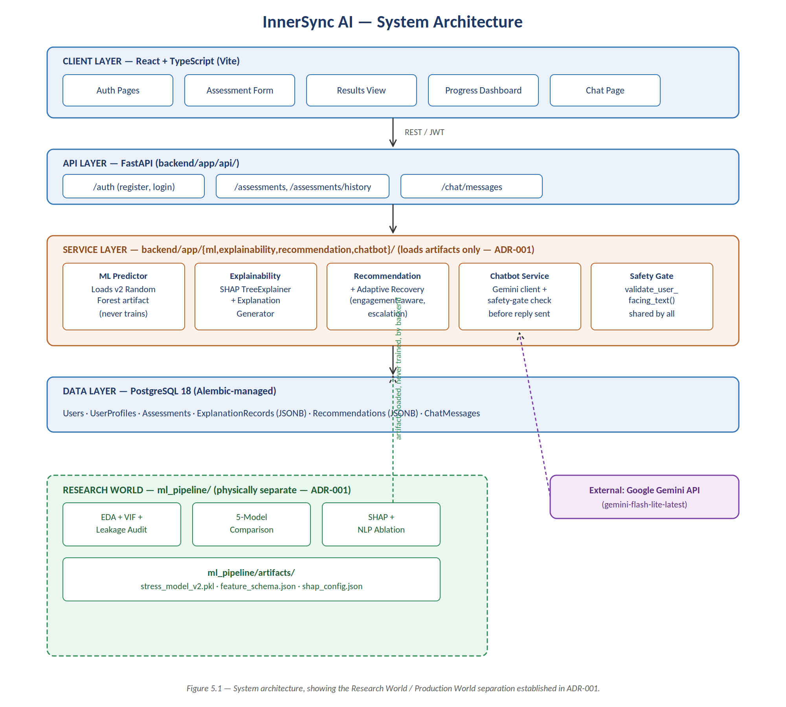
Figure 5.1 — System architecture.

5.2 Entity Relationship Diagram
Figure 5.2 shows the database schema. Assessment is the central entity, from which both ExplanationRecord and Recommendation descend, ensuring the explanation a student reads and the recommendations they receive are always traceable to the same underlying prediction. ExplanationRecord and Recommendation each store their audit trail (SHAP-derived contributing factors; recommended actions) as PostgreSQL JSONB, verified in Chapter 10 to be genuinely queryable rather than an opaque serialised blob. The CHECK constraint on Recommendation (is_affirmation / is_escalation / non-empty actions mutually exclusive) is enforced at the database level, not application logic alone.
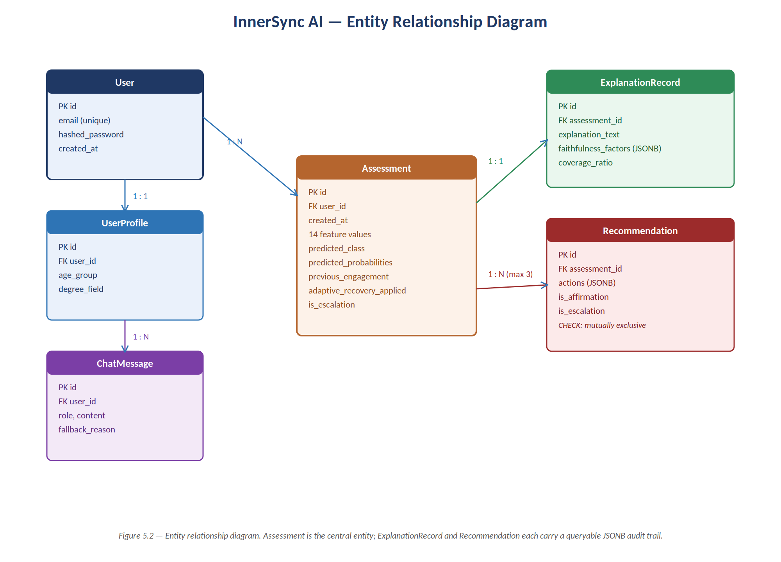
Figure 5.2 — Entity relationship diagram.

5.3 UML Diagrams
Figure 5.3 shows the system's use cases from a student's perspective. The wellbeing-services signpost is modelled as an included use case triggered by sustained high-severity check-ins, rather than a use case the student invokes directly — reflecting the Adaptive Recovery Framework's escalation design (Chapter 4).
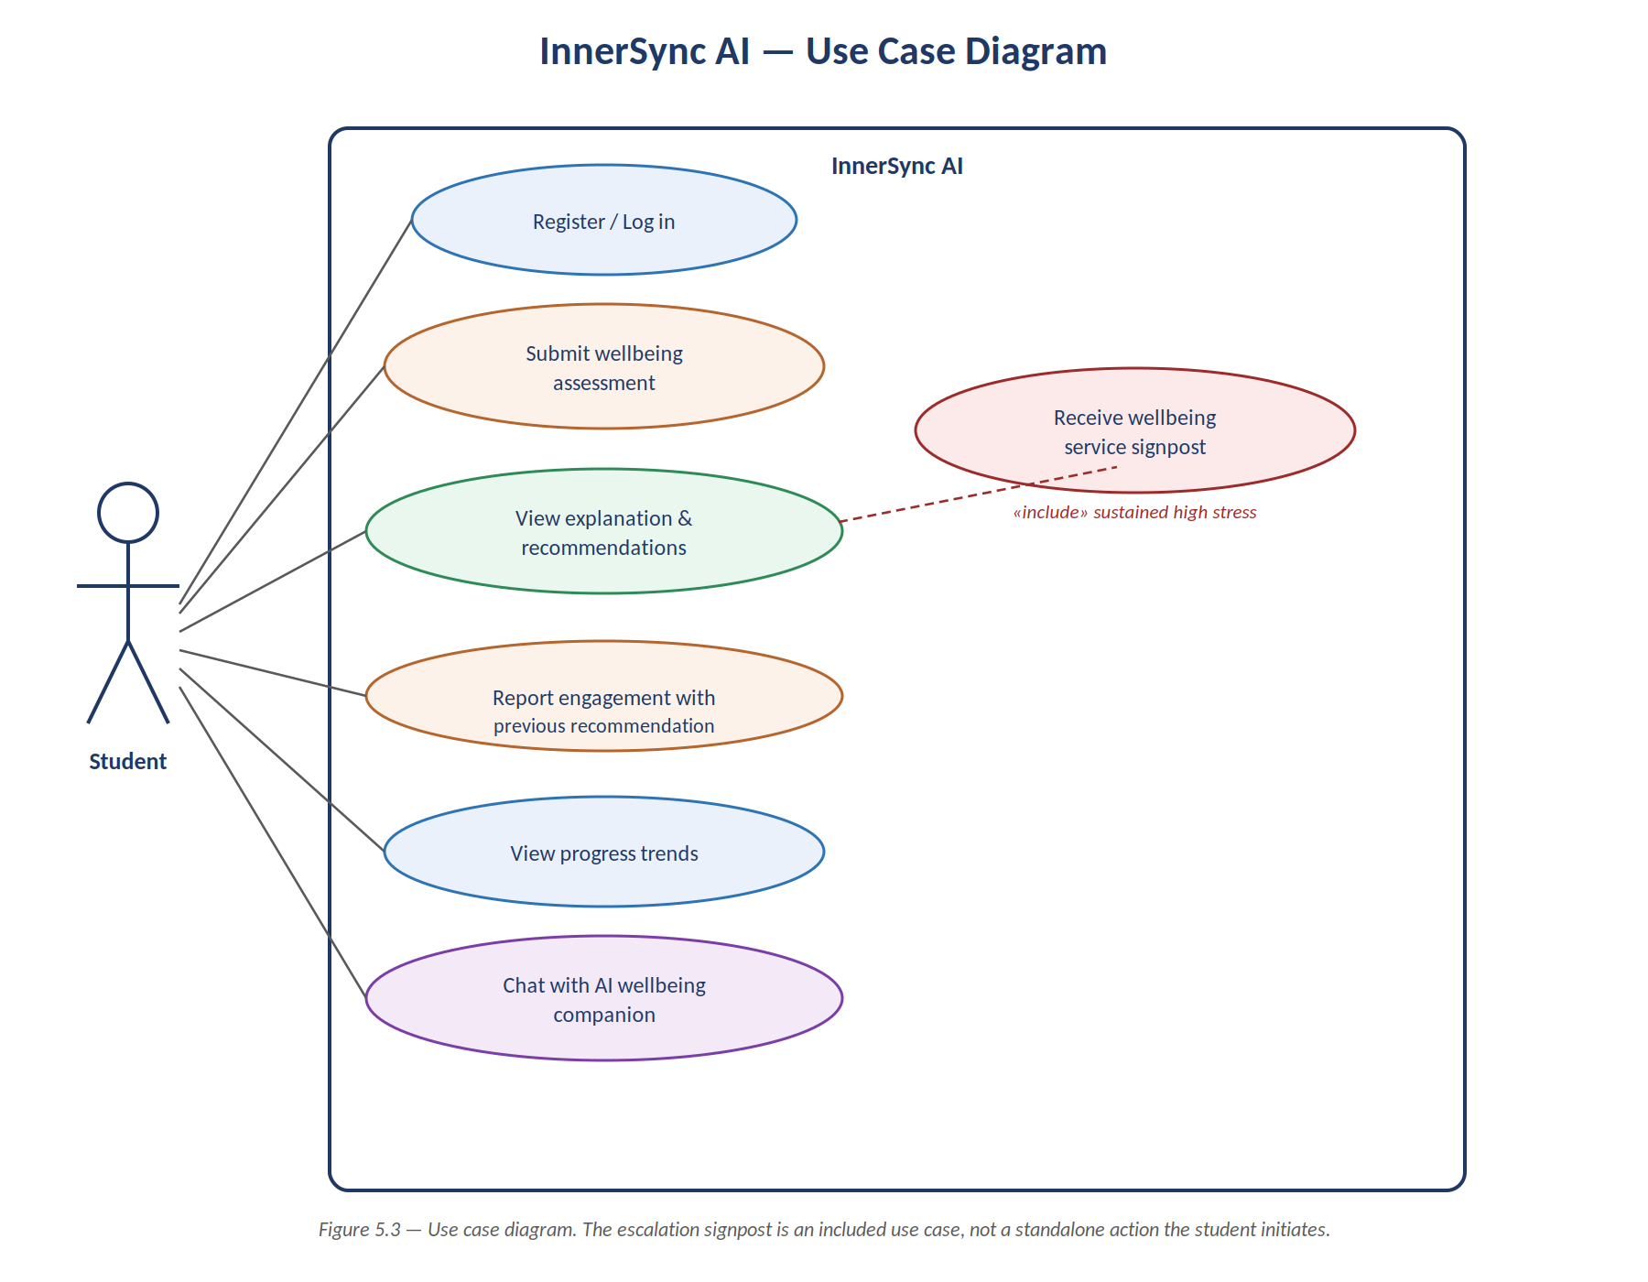
Figure 5.3 — Use case diagram.
Figure 5.4 shows the sequence of the system's core operation: submitting an assessment. This sequence was not designed in the abstract and then implemented separately — it documents the actual call sequence verified in Chapter 10 to produce output identical to the corresponding research notebook, including the full round-trip through PostgreSQL.
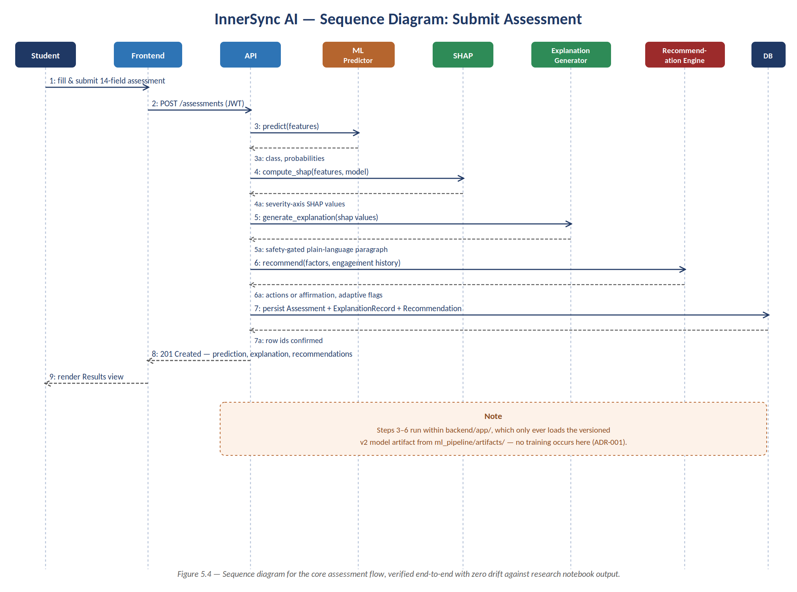
Figure 5.4 — Sequence diagram: submit assessment.

5.4 Wireframes
Figure 5.5 shows low-fidelity wireframes of the system's four core screens, reflecting the actually-implemented frontend rather than an earlier design concept. Two design decisions are visible directly in these wireframes and are worth stating explicitly: first, the Results screen never displays a raw stress score or percentage, only a plain-language framing (“Things look high right now”) consistent with the project's explainability-first philosophy; second, the Progress Dashboard deliberately does not use a red/amber/green colour convention, since colour-coding a wellbeing trend risks implying more clinical certainty than the underlying model supports — a single accent hue at varying intensity was used instead, a decision documented in full in methodology.md.
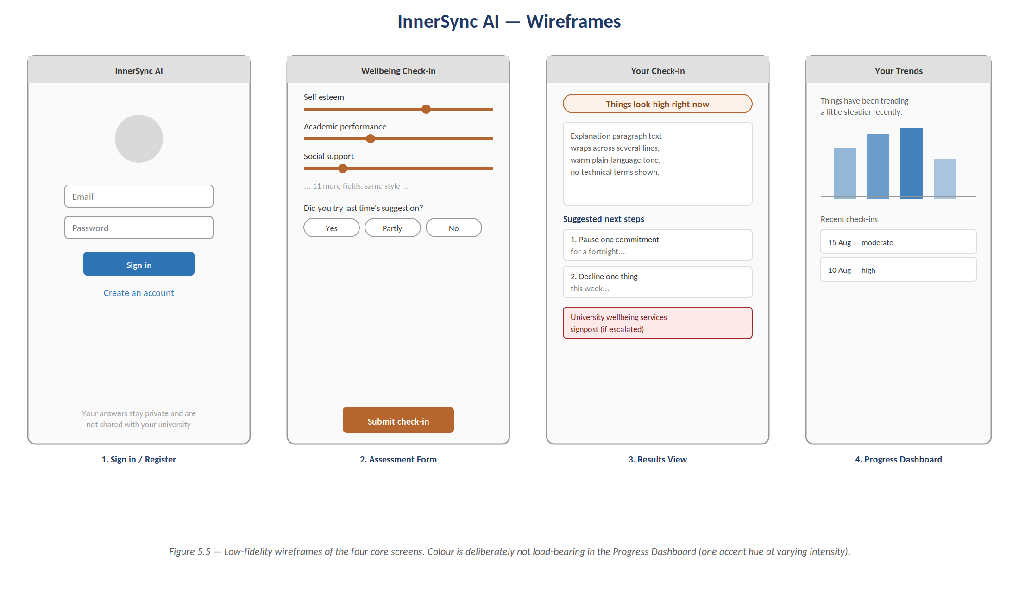
Figure 5.5 — Low-fidelity wireframes of the four core screens.

5.5 Chapter Summary
This chapter has presented the architecture, data model, use cases, core interaction sequence, and interface design of InnerSync AI as implemented and verified. Chapter 10 (Implementation) describes how each of these elements was actually built.

6. Methodology

6.1 Overview
This chapter describes the methodological approach taken to develop and evaluate the InnerSync AI stress-prediction and explanation framework, within the CRISP-DM process model already mapped onto this project's phases in Section 3.0.5 and Figure 3.1. Each stage below is described in terms of the method applied and the reasoning behind it; the corresponding findings are reported in Chapter 7.
A methodological principle applied consistently throughout this project, and referenced repeatedly in this chapter, is that no design decision (a preprocessing step, a model selection, a threshold, a choice of explanation axis) was accepted merely because it was the first reasonable option. Each was tested against evidence, and where an initial assumption was found to be wrong, this is reported explicitly rather than corrected silently. This principle is not incidental to the write-up; it is itself part of the project's methodological contribution, and is revisited directly in Chapter 7.

6.2 Dataset
The primary dataset is the Kaggle “Student Stress Factors: A Comprehensive Analysis” dataset (1,100 rows; 20 input features spanning psychological, physiological, social, environmental, and academic domains; one three-class stress-level target), introduced in Section 2.4. The exact file used is pinned by SHA-256 checksum, recorded in every experiment log and in the artifact manifest, so that the dataset version underlying every reported result is independently verifiable.

6.3 Multicollinearity Analysis
Exploratory data analysis found an unusually high degree of pairwise correlation among the dataset's input features (mean |r| = 0.58 across all 210 feature pairs; 17 pairs exceeding |r| = 0.7). Per the project's implementation standards, this required a formal multicollinearity check before any model training took place.
Variance Inflation Factor (VIF) was computed for all 20 input features. As the deployment environment did not include the statsmodels package, VIF was implemented directly against scikit-learn: for each feature, an ordinary least squares regression of that feature on the remaining 19 was fitted, and VIF calculated as 1 / (1 − R²). This is mathematically identical to the standard statsmodels implementation when the regression includes an intercept, which scikit-learn's LinearRegression provides by default.
VIF and pairwise correlation measure different properties of a feature set: VIF asks whether a feature is predictable from a linear combination of all other features simultaneously, whereas pairwise correlation considers only one relationship at a time. A dataset whose redundancy is spread thinly across many features, rather than concentrated between any two specific columns, can therefore exhibit high pairwise correlation without producing severe VIF. The implications of this distinction for the present dataset are reported in Section 7.2.

6.4 Comparative Model Training and Evaluation Protocol
Five classifiers were trained and compared under an identical protocol: a Logistic Regression baseline, Random Forest, XGBoost, Support Vector Machine, and LightGBM. All five were evaluated on an identical stratified 80/20 train/test split, with hyperparameters tuned by grid or randomized search under stratified 5-fold cross-validation performed on the training split only; the held-out test set was never used during tuning or model selection. Feature scaling was applied only where required (Support Vector Machine), fitted on the training fold alone to avoid leakage into the evaluation set.
Every experiment run, not only the eventually selected model, was logged with its hyperparameters, dataset checksum, cross-validation configuration, and full metric set, so that the comparison is independently reproducible and auditable rather than represented only by a final summary table.
Consistent with the project's decision-making standard that no model may be selected on accuracy alone, five metrics were computed for every model: accuracy, balanced accuracy, macro-averaged precision, macro-averaged recall, macro-averaged F1-score, and macro-averaged one-vs-rest ROC-AUC. The gap between each model's cross-validated score and its held-out test score was also recorded explicitly, as a diagnostic for overfitting to the cross-validation fold structure — a check that proved directly consequential to model selection, reported in Section 7.3.

6.5 Explainability Methodology
SHAP (SHapley Additive exPlanations) was used to interpret the selected model's predictions. Because the selected model is a tree ensemble, SHAP values were computed using TreeExplainer, which yields exact rather than approximated Shapley values — a property that influenced model selection directly, as discussed in Section 7.3. Before any explanation was generated, the loaded model artifact was verified to reproduce the accuracy and F1-score recorded in its own manifest, so that reported explanations are provably attached to the documented model rather than to an accidentally different one.
A direction sanity check was built into the explainability protocol: for each feature, an expected direction of influence on predicted stress (increasing or decreasing) was stated in advance from domain reasoning, before SHAP values were computed, and only then compared against the model's actual attributions. This ordering — prior stated first, evidence checked second — is what distinguishes the check from post-hoc rationalisation, and is why its results (Section 7.4) can be reported as a genuine test rather than a narrative fitted after the fact.

6.6 Human-Centred Explanation Generation
The Human-Centered Explanation Generator converts a single prediction's SHAP attribution into a short paragraph intended to be read directly by a student, with no SHAP values, feature names, or machine-learning terminology exposed. It is implemented as two stages: first, ranking features by absolute SHAP contribution and selecting the three or four largest; second, assembling the selected factors into three to five sentences that name the overall picture, the pressures that stood out, any protective factors present, and a closing statement framing the result as a snapshot rather than a fixed verdict.
A methodological question specific to this component is which SHAP axis should determine a factor's stated direction, given that the underlying model is a three-class, ordinally structured classifier (low / moderate / high stress) and SHAP produces one attribution value per class. This question, and how it was resolved, is reported in Section 7.9, since the resolution depended on empirical comparison of candidate axes rather than being decided in advance.
All generated text is passed through a safety-gate validator before being accepted, which rejects any string containing vocabulary from the project's avoided-terms list (clinical terms such as diagnosis, cure, treatment, disorder, symptom; and ML-internal terms such as SHAP, feature, importance, weight). The validator matches on word boundaries with an inflectional suffix rather than raw substring containment, a design correction made after an initial substring-matching implementation incorrectly rejected a legitimate phrase containing the word “secure” because it contains the substring “cure”.
Templates, rather than a large language model call, were used to generate this specific component's text, and the trade-off was considered explicitly rather than assumed. In favour of a template-based approach: output is deterministic, so the same SHAP input always produces the same text, which is a precondition for the faithfulness evaluation described below; the full set of possible phrases (28, covering 14 features in both directions) can be read and audited in its entirety against the approved-vocabulary list, which is not possible for an open-ended generator; and the approach guarantees, rather than merely encourages via prompting, that no clinical or technical term can be emitted. Against a template-based approach: the resulting text is less varied and less naturally phrased than an LLM-generated equivalent, and two students with similar profiles receive near-identical wording. The judgement made was that, for the single component whose explicit purpose is to guarantee the absence of harmful language reaching a vulnerable user, a hard guarantee was judged more valuable than fluency; a hybrid design, in which an LLM rephrases template output subject to the same validator, is noted as a reasonable future extension rather than attempted in the current implementation. This is a deliberate asymmetry with the project's conversational chatbot layer, which does use a language model, since that layer's role and risk profile differ.
Every generated explanation is accompanied by a faithfulness log — not shown to the user — recording the feature, its raw value, its signed SHAP contribution, the direction assigned, the resulting phrase, and the proportion of total SHAP magnitude the explanation accounts for. This log exists to support an audit of whether the plain-language explanation faithfully represents the attribution it claims to describe, which is a precondition for evaluating explanation quality with real users in a later phase of this project.

6.7 Personalized Recommendation Engine
The Personalized Recommendation Engine maps a student's contributing stress factors onto concrete, prioritised actions. It deliberately consumes the same factor list already computed for the explanation paragraph, rather than performing an independent computation, so that a student cannot be shown one set of contributing pressures in their explanation and a different, unrelated set of actions in their recommendations.
Recommendation selection follows four rules: only factors identified as increasing stress are considered (a protective factor is acknowledged in the explanation, not treated as something to fix); a candidate factor must exceed a severity threshold; qualifying factors are ranked by severity magnitude; and the output is capped at three recommendations, since a longer list was judged likely to read as an unmanageable task list and risked degrading the quality of the engagement signal a later, adaptive version of this component would depend on.
The severity threshold was not fixed as an arbitrary constant. It was derived empirically from the distribution of absolute severity values across the full held-out test set, and the derivation — together with a check of whether the resulting threshold actually altered any recommendation — is reported in Section 7.10, since the empirical result differed from what was initially assumed about the threshold's role.
Where no factor qualifies for a recommendation, the engine returns a class-appropriate affirmation rather than manufacturing an action, on the reasoning that a system which always recommends something will, on occasion, invent a problem that is not present. For a student for whom no single factor stands out sharply despite an elevated predicted stress level, the affirmation directs the student toward university wellbeing services rather than toward an automated suggestion, consistent with the project's escalation principle that persistent or high-severity signals should be met with a route to human support rather than an increasingly elaborate automated response.
Recommendation selection is rule-based rather than learned, for two reasons. First, no outcome data exists from which a recommendation policy could be fitted: no student has yet received a recommendation, acted on it, or reported its usefulness. Second, and more fundamentally, rule-based selection preserves the same auditability property established for the explanation generator — every recommendation a student receives can be traced deterministically to a specific, signed SHAP contribution above a stated threshold, and the entire recommendation catalogue can be read and reviewed in full. A learned component at this point in the pipeline would break that audit chain precisely at the point where an intervention reaches a real person.
This component produces a recommendation for a single point-in-time assessment only. At the time this engine was designed, the Adaptive Recovery Framework — which alters recommendation strategy after a student has repeatedly not engaged with previous suggestions — had not yet been built, since it requires engagement history spanning multiple check-ins and backend user-history infrastructure that did not yet exist. That infrastructure was subsequently built and the Adaptive Recovery Framework is now implemented and tested (Chapter 10). The point-in-time/adaptive boundary described here remains recorded programmatically — every recommendation log entry is explicitly flagged with whether adaptive logic was applied — so the two layers stay distinguishable in the data even though both now exist.

6.8 Chapter Summary
This chapter has described the methodological approach applied at each stage of the InnerSync AI pipeline: multicollinearity analysis, comparative model training and validation, SHAP-based explainability with a pre-registered direction check, template-based human-centred explanation generation with an auditable safety gate, and rule-based, traceable recommendation generation. Chapter 7 reports the results obtained by applying this methodology, including a significant data-quality finding that materially affects how those results must be interpreted.

7. Results

7.1 Introduction
This chapter reports the results obtained by applying the methodology described in Chapter 6. The results are presented in the order they were obtained, including an initial model comparison later shown to be compromised by a data-quality defect. This chronological presentation is a deliberate choice: it allows the discovery process itself — how the defect was found, how thoroughly it was investigated, and how the pipeline was corrected — to be evaluated as part of the project's contribution, rather than presenting only a final, tidied result.

7.2 Multicollinearity Findings
All 20 input features returned a Variance Inflation Factor comfortably below the conventional threshold of 10 (highest: social_support, 5.75; lowest: breathing_problem, 1.78). No feature was flagged for exclusion on multicollinearity grounds.
Feature | VIF
social_support | 5.75
blood_pressure | 3.69
future_career_concerns | 3.42
anxiety_level | 3.23
self_esteem | 3.21
… (14 further features, descending) | …
breathing_problem | 1.78
Table 4.1 — Variance Inflation Factor by feature (selected values; full table in the accompanying analysis notebook).
This result does not contradict the elevated pairwise correlation observed during exploratory analysis. The dataset's correlation structure takes the form of two broad, internally correlated clusters (stress-increasing and stress-protective features) rather than any single feature being closely reconstructable from one or two others, which produces high pairwise correlation without severe multicollinearity. The VIF result confirms only that the feature set was statistically safe to use in model training; it does not speak to whether the dataset's underlying structure is realistic, a question addressed directly in Section 7.4.

7.3 Initial Comparative Model Results
Table 4.2 reports the results of the five-model comparison described in Section 6.4. All five models fell within a narrow band (F1 0.873–0.886), and accuracy alone could not resolve the comparison: Random Forest and SVM tied exactly at 0.8864.
Model | Accuracy | Bal. Acc. | Precision | Recall | F1 | ROC-AUC | CV→Test gap
Logistic Regression | 0.8818 | 0.8821 | 0.8818 | 0.8821 | 0.8820 | 0.9851 | —
Random Forest (selected) | 0.8864 | 0.8868 | 0.8882 | 0.8868 | 0.8861 | 0.9844 | −0.0053 (healthy)
XGBoost | 0.8727 | 0.8729 | 0.8730 | 0.8729 | 0.8729 | 0.9682 | +0.0125
SVM | 0.8864 | 0.8868 | 0.8868 | 0.8868 | 0.8860 | 0.9245 | +0.0078
LightGBM | 0.8727 | 0.8731 | 0.8731 | 0.8731 | 0.8726 | 0.9819 | +0.0219 (highest CV, weak test)
Table 4.2 — Initial (v1) comparative model results, 20 features, identical 220-row held-out test set.
Random Forest was selected on four grounds, none of which was accuracy in isolation: it achieved the highest held-out ROC-AUC (0.9844); it was decisively separated from the otherwise-tied SVM on that same metric (0.9844 vs. 0.9245), indicating materially more trustworthy class-probability estimates; it was the only model showing a healthy (negative) gap between cross-validated and held-out performance, in contrast to LightGBM, which produced the single highest cross-validated F1-score of any model (0.8945) yet one of the lowest held-out scores — a pattern consistent with overfitting to the cross-validation fold structure, and the concrete reason cross-validation score alone was not used as the selection criterion; and, as a tree ensemble, it permits exact rather than approximated SHAP computation via TreeExplainer, directly relevant to a project whose central contribution is explainability. It is also noted that an untuned Logistic Regression baseline performed within 0.0007 ROC-AUC of the selected model — an observation that becomes significant in light of the finding reported next.

7.4 SHAP-Driven Discovery of Target Leakage
SHAP analysis of the selected (v1) model, using TreeExplainer on the held-out test set, produced the global feature-importance ranking in Table 4.3.
Rank | Feature | mean |SHAP| | Domain
1 | blood_pressure | 0.0804 | Physiological
2 | sleep_quality | 0.0385 | Physiological
3 | teacher_student_relationship | 0.0355 | Academic
4 | academic_performance | 0.0343 | Academic
5 | basic_needs | 0.0305 | Environmental
6–20 | (remaining 15, descending) | 0.0274–0.0034 | mixed
Table 4.3 — Global SHAP feature importance (v1 model, 20 features), mean absolute SHAP value across all three classes.
The pre-registered direction sanity check (Section 6.5) found that all 19 features carrying a stated directional prior matched their expected direction, with zero anomalies; one feature (extracurricular_activities) was marked ambiguous in advance and excluded from scoring. The model's reasoning was therefore directionally coherent with the wellbeing literature reviewed in Chapter 2. This positive result, however, concerns direction only, and is separate from a magnitude problem identified in the same analysis.
The top-ranked feature, blood_pressure, carried more than double the mean absolute SHAP value of any other feature, despite having been the most weakly linearly correlated feature with the target during exploratory analysis (r = +0.394). Investigation of this discrepancy found that blood_pressure maps to the stress label in a near-deterministic but non-monotonic pattern: a value of 1 corresponds to moderate stress in 100% of rows, a value of 2 to low stress in 100% of rows, and a value of 3 to high stress in 73.8% of rows, fixing the label exactly for 54.5% of the dataset. Because Pearson correlation cannot detect non-monotonic relationships, this pattern was invisible to both the exploratory correlation analysis and, by extension, gave no warning signal ahead of model training. A three-line lookup table constructed on blood_pressure alone matched the tuned 20-feature Random Forest on accuracy (0.8864) and exceeded it on macro F1 (0.8890 vs. 0.8861).
The most plausible explanation is that blood_pressure was generated from the label during construction of the published dataset — that is, target leakage present in the source data itself, not introduced by this project's pipeline.

7.5 Systematic Leakage Audit
Given the severity of this finding, blood_pressure was not assumed to be the only affected feature. A systematic audit applied a single-feature lookup test to each of the remaining 19 features (a “most common class per value” rule fitted on the training split and scored on the held-out test set). The results, in Table 4.4, showed the problem to be substantially broader than the original finding.
Feature | Single-feature lookup accuracy
sleep_quality | 0.9045
future_career_concerns | 0.9000
blood_pressure | 0.8864
depression | 0.8818
bullying | 0.8818
anxiety_level | 0.8773
headache | 0.8182
self_esteem | 0.8091
(remaining 12 features) | 0.591 – 0.750
Tuned 20-feature Random Forest (reference) | 0.8864
Table 4.4 — Single-feature lookup-rule accuracy, all leaking features identified by the audit.
Two features — sleep_quality and future_career_concerns — individually exceeded the accuracy of the entire tuned 20-feature model using nothing but a single ordinal column. Six features in total fell within 0.01 of the full model's accuracy. Every affected feature shared the same signature: a small, near-uniformly distributed bucket at value 0 (n = 30–88, consistent with a missing-data sentinel), with every other value mapping to a single class at 85–100% purity — a level of determinism inconsistent with genuinely noisy self-reported survey data.
A decisive test was then applied to establish whether removing the affected features would resolve the problem (Table 4.5).
Scenario | n features | Accuracy | F1 macro
All 20 (original) | 20 | 0.8864 | 0.8861
Drop blood_pressure only | 19 | 0.8773 | 0.8768
Drop 6 leakiest (lookup > 0.85) | 14 | 0.8864 | 0.8865
Drop 8 leakiest (lookup > 0.80) | 12 | 0.8727 | 0.8728
Keep only 6 weakest features | 6 | 0.8500 | 0.8498
Table 4.5 — Effect of progressive feature removal on model accuracy and F1.
Dropping the three worst-offending features cost no accuracy at all, and a model trained on only the six weakest features still achieved 0.85 against a three-class chance baseline of 0.333. This demonstrates that the leaking label information is redundantly encoded across the majority of the feature set, such that excluding any given subset simply shifts the model onto the next available proxy. Feature removal alone is therefore not a viable remedy for this dataset; it can reduce but not eliminate the underlying defect.

7.6 Corrected Model Comparison and Re-Selection
The six features whose individual lookup accuracy rivalled the full model — sleep_quality, future_career_concerns, blood_pressure, depression, bullying, and anxiety_level — were excluded, and the full five-model comparison was re-run on the remaining 14 features, holding the train/test split, cross-validation strategy, hyperparameter search space, and tuning objective identical to the original comparison. Model selection was re-derived from first principles rather than carried forward from the v1 result.
Model | Accuracy | Bal. Acc. | Precision | Recall | F1 | ROC-AUC | CV→Test gap
Logistic Regression | 0.8773 | 0.8775 | 0.8772 | 0.8775 | 0.8773 | 0.9520 | —
Random Forest (re-selected) | 0.8818 | 0.8821 | 0.8824 | 0.8821 | 0.8815 | 0.9838 | −0.0075 (only healthy gap)
XGBoost | 0.8727 | 0.8731 | 0.8730 | 0.8731 | 0.8726 | 0.9807 | +0.0125
SVM | 0.8773 | 0.8775 | 0.8786 | 0.8775 | 0.8776 | 0.9138 | +0.0078
LightGBM | 0.8727 | 0.8730 | 0.8736 | 0.8730 | 0.8725 | 0.9821 | +0.0127
Table 4.6 — Corrected (v2) comparative model results, 14 features, identical held-out test set.
Random Forest was re-selected, on the same reasoning applied in Section 7.3: highest ROC-AUC (0.9838), highest F1-score, and the only model without an adverse cross-validation-to-test gap. Excluding the six leaking features cost the selected model 0.0046 accuracy (0.8864 → 0.8818). This small cost is itself a finding, not a reassurance: it demonstrates that the correction reduced but could not eliminate the underlying leakage, consistent with the removal experiment in Table 4.5.

7.7 SHAP on the Corrected Model
Rank | Feature | mean |SHAP| | Domain
1 | social_support | 0.0558 | Social
2 | basic_needs | 0.0510 | Environmental
3 | academic_performance | 0.0495 | Academic
4 | teacher_student_relationship | 0.0443 | Academic
5 | self_esteem | 0.0443 | Psychological
6–14 | (remaining 9, descending) | 0.0438–0.0057 | mixed
Table 4.7 — Global SHAP feature importance (v2 model, 14 features).
With the leaking features removed, the global importance ranking is led by social_support, basic_needs, and academic_performance — a social, environmental, and academic profile, in place of the physiological profile that dominated the v1 ranking and was subsequently shown to be an artifact. All 13 features carrying a pre-stated directional prior matched expectation, with zero anomalies. This revised profile is more consistent with the emphasis on academic and psychological drivers found across the literature reviewed in Chapter 2 than the original, leakage-driven ranking was — though this coherence describes the model's reasoning over a still-compromised dataset, and is not, on its own, evidence of real-world validity.

7.8 Relationship to the Tariq et al. (2025) Retraction
Chapter 2 discussed the retraction of a published study in this same problem area on data-integrity grounds — specifically, the use of a self-reported physiological field without independent verification. At the time that discussion was written, it constituted second-hand caution drawn from a retraction notice. The finding reported in this chapter changes that standing: the same category of defect, in a feature of the same type, has now been independently identified and quantified within this project's own benchmark dataset, using evidence generated by this project's own pipeline rather than cited from elsewhere. The literature review's concern is accordingly treated in this dissertation as independently corroborated rather than merely cited, and the project's research-gap argument is correspondingly sharpened: prior work in this area has not only lacked accessible explanation and adaptive recommendation, it has, in at least one documented case, failed to detect target leakage in its own training data — a failure mode this project's explainability-first methodology was able to detect where standard correlation-based analysis, multicollinearity checking, cross-validation, and held-out testing did not.

7.9 Human-Centred Explanation Generator: Results
An initial implementation of the explanation generator selected a feature's stated direction using SHAP values from the high-stress class only, regardless of which class was actually predicted. This produced an incoherent explanation for mid-scale (moderate) predictions: a student predicted moderate received an explanation composed entirely of protective factors, contradicting the paragraph's own opening statement. Three candidate axes were compared directly against this failure (Table 4.8).
Axis | Low prediction | Moderate prediction | High prediction
(a) high-stress column only | 0/4 raising ✓ | 0/4 raising ✗ (degenerate) | 4/4 raising ✓
(b) predicted class's own column | 4/4 raising ✗ (inverted) | 4/4 raising ✗ | 4/4 raising ✓
(c) severity: SHAP(high) − SHAP(low) | 0/4 raising ✓ | 2/4 raising ✓ (coherent mix) | 4/4 raising ✓
Table 4.8 — Comparison of candidate SHAP axes for explanation generation, by proportion of top-4 factors labelled “raising”.
The high-stress-only axis degenerates at the moderate class, where nearly all attributions are negative relative to the high-stress class, producing an all-protective explanation. The predicted-class axis, though intuitive, fails in the opposite direction at the calm end of the scale: a positive SHAP value toward a low-stress prediction means a feature pushed the model toward that outcome, not that it increased stress, so this axis would report a student's strong academic performance and met basic needs as raising their stress. A signed severity axis, defined as the difference between a feature's SHAP contribution toward the high-stress class and toward the low-stress class, resolved both failure modes: it degenerates to fully protective at the low end and fully stress-raising at the high end, consistent with the ordering of the target, while producing a genuine mixture of raising and protective factors for moderate predictions.
This is reported as a finding with implications beyond the present dataset: any SHAP explanation generated over an ordinal multi-class target faces the same choice of axis, and the two most obvious choices each fail at a different point on the scale. Collapsing to a signed severity axis defined across the two extreme classes is presented here as a general remedy for this class of problem, and is treated in this dissertation as a methodological contribution of the explainability component rather than an implementation detail.
Following adoption of the severity axis, faithfulness logging across four illustrative cases (one confident correct prediction per class, plus the most confident misclassification in the test set) found that all 16 selected contributing factors had a stated direction matching the sign of their underlying SHAP value, with zero mismatches, and that the generated explanations accounted for between 42% and 79% of each case's total SHAP magnitude — the intended trade-off of summarising the three or four largest factors rather than the complete attribution.
The misclassified case (true class moderate, predicted high, confidence 0.60) was examined specifically for downstream risk. The generated explanation cited self_esteem and social_support values that were genuinely low for this student, and breathing_problem as a genuine protective factor; despite the incorrect predicted label, the explanation remained factually grounded in the student's actual profile, and the direction of the error (over-estimating rather than under-estimating stress) was judged to carry lower risk, since it would result in an unnecessary signpost toward support rather than a false reassurance.

7.10 Personalized Recommendation Engine: Results
The severity threshold used to determine whether a factor qualifies for a recommendation was derived from the empirical distribution of absolute severity values across the full held-out test set (220 students × 14 features = 3,080 attributions), summarised in Table 4.9.
Percentile | |severity|
p10 | 0.0086
p25 (adopted threshold) | 0.0200
p50 | 0.0498
p75 | 0.0846
p90 | 0.1331
Table 4.9 — Distribution of |severity| across the held-out test set, used to derive the recommendation threshold.
The threshold was set at the 25th percentile (0.0200). A check of whether this threshold materially affected recommendation output found that it did not: of 430 raising factors reaching the top-four selection across all 220 students, none fell below 0.0200, with the smallest qualifying value observed at 0.0346. The threshold therefore functions as a guard rail against out-of-distribution input — a student whose attributions are uniformly negligible, unlike anything in the present dataset — rather than as an active filter on this data; the affirmation returned for low-stress students is a consequence of those students having no raising factors at all, not of the threshold excluding weak ones. The threshold was deliberately not raised beyond the empirically derived value to make it appear more consequential, on the reasoning that tuning a parameter until it visibly does something is itself an unjustified choice.
Across the four illustrative cases, the engine produced zero recommendations and a class-appropriate affirmation for the low-stress case, two recommendations for the moderate case, and three recommendations (capped from four qualifying factors) for both the high-stress and misclassified cases. In every case, all recommended actions traced back to a factor named in that same student's explanation paragraph, with zero untraceable recommendations across the eight generated.
Two of the four canonical recommendation examples specified during system design could not be implemented against the corrected (v2) feature set, as summarised in Table 4.10.
CLAUDE.md canonical example | Status in v2
Academic pressure → study planner | Implemented (study_load, academic_performance)
Relationship issues → journaling / social support | Implemented (social_support, teacher_student_relationship, peer_pressure)
Poor sleep → sleep hygiene plan | Not available — sleep_quality excluded for target leakage (ADR-003)
Physical inactivity → walking / exercise plan | Not available — no exercise field exists in the dataset
Table 4.10 — Coverage of canonical recommendation mappings against the v2 (14-feature) model.
Both gaps are consequences of the dataset rather than of the recommendation engine's design: sleep_quality was excluded from the model on target-leakage grounds (Section 7.5), and no exercise or physical-activity field exists anywhere in the source dataset. Both gaps would close only if a future locally-collected data source specifically captured sleep and physical-activity items as model-relevant features, which is noted as a design consideration for that instrument rather than a defect to be patched within the current model.

7.11 Summary of Results and Standing of Reported Figures
The results in this chapter must be read together, not in isolation. No accuracy figure reported for this dataset — v1 or v2 — may be presented as evidence of real-world stress-prediction capability: the initial comparison measured, in large part, how well five different models could each independently discover the same leaking shortcut, and the corrected comparison demonstrates that removing the worst offenders reduces but does not eliminate that shortcut. The locally-collected external validation data described in Chapter 6 is accordingly promoted, by this finding, from a strengthening step in the evaluation plan to the only available route by which this project can make any genuine claim about real-world predictive performance.
Set against that limitation, the result that should be read positively is methodological rather than numerical: every stage of the explainability pipeline — SHAP analysis, the direction sanity check, the severity-axis investigation, and the traceable recommendation logic — functioned as designed, and it was specifically the SHAP analysis that detected a data defect which correlation analysis, variance inflation factor checking, cross-validation, and held-out testing had all passed over without comment. This outcome is presented in this dissertation as direct evidence in favour of an explainability-first methodology, and as an independent replication, rather than a citation, of the failure mode responsible for the retraction discussed in Chapter 2.

8. Local Data: Qualitative Triangulation

8.1 Purpose and Scope
A locally-collected questionnaire (n=31 university students, collected under the same ethical approval as the Phase 8 evaluation) was intended, at the project's outset, to provide external validation of the trained stress-prediction model. On inspection, this is not possible: the questionnaire's items, developed independently and iteratively over the course of the project, do not correspond to the trained model's 14-feature input schema (feature_schema.json) closely enough to construct valid model inputs. At most one or two of the fourteen required features have even an approximate correspondence to a question actually asked (self-rated academic workload against study_load); the remaining twelve or more would require fabricating values for the twenty respondents' unmeasured characteristics, which is judged in this dissertation to be a worse methodological choice than not attempting quantitative validation at all, consistent with the reasoning already applied elsewhere in this project (ADR-003).
This is stated here as a genuine limitation of the data collection design, not concealed or worked around. The mismatch arose because the local questionnaire was designed to capture a broad, independent picture of student wellbeing rather than to mirror the benchmark dataset's specific (and, per Chapter 7, partially compromised) feature set. It is recorded as a concrete, actionable direction for future data collection: a future version of this instrument should be designed explicitly against the deployed model's feature schema from the outset, if genuine external validation is a goal of any future iteration of this project.
What this data can support, and what is reported below, is a qualitative triangulation: whether the stress domains real, local students report as significant align with the domains the trained model's SHAP analysis identified as most predictive, and a review of local stress themes the current model does not, and could not, capture.

8.2 Descriptive Summary
Characteristic | Distribution (n=31)
Age group | 21-23: 26 (84%); 24-26: 2; 18-20: 2; Above 26: 1
Gender | Male: 21 (68%); Female: 10 (32%)
Year of study | Year 3: 15 (48%); Year 4: 12 (39%); Year 2: 2; Year 1: 1; Postgraduate: 1
Academic workload (self-rated, 1-5) | Mode = 4 (n=19, 61%); 5: 7; 3: 4; 2: 1
Sleep quality (self-rated, 1-5) | Mode = 2 (n=14, 45%); 3: 8; 4: 8; 5: 1
Exercise frequency | 1-2 times/week: 19 (61%); Rarely: 6; 3-5 times/week: 3; Never: 2; Daily: 1
Felt unable to control important things (past month) | Sometimes: 25 (81%); Fairly Often: 2; Almost Never: 3; Very Often: 1
Table - Descriptive summary of local respondents (n=31).
The sample skews toward later-stage undergraduates (87% in Year 3 or Year 4) with a majority male composition (68%). Self-rated academic workload and sleep quality show a pattern worth noting on its own terms: workload was rated moderate-to-high by the large majority (4 or 5, 84% combined) while sleep quality was rated poor-to-moderate by a similar majority (2 or 3, 71% combined) - a plausible, non-artificial inverse relationship consistent with a genuinely burdened, under-rested student population, and notably not the near-deterministic pattern that caused a comparable feature to be excluded from the trained model for target leakage (Chapter 7, Section 7.5). This supports the interpretation, stated in that section, that the leakage problem was a defect of the specific benchmark dataset's construction rather than evidence that variables like sleep quality are inherently untrustworthy predictors of student stress.

8.3 Thematic Analysis
Two open-response items (“Have you experienced any major personal challenges recently?” and “What is the biggest factor currently affecting your stress level?”) were reviewed and grouped into domains matching the five domains used throughout this dissertation's dataset and SHAP discussion (academic, social, environmental, psychological, physiological).
Reported major challenge (Q15) | Count | Domain
Academic difficulties | 18 (58%) | Academic
Financial concerns | 4 (13%) | Not represented in trained model
No major challenges | 3 (10%) | -
Relationship issues | 3 (10%) | Social
Other | 2 (6%) | -
Family-related issues | 1 (3%) | Social (partial)
Table - Reported major challenges (Q15), by domain.
Responses to “what is the biggest factor currently affecting your stress level” were dominated overwhelmingly by academic supervision specifically: twelve of twenty-seven non-empty responses (44%) named “research and supervision” directly, almost certainly reflecting the final-year and postgraduate skew of this sample. This is read as strong, specific, real-world corroboration of the trained model's own finding that teacher_student_relationship ranks among its most predictive features (Chapter 7, Section 7.7): an independent, real sample of students, asked an open question with no reference to the model's feature set at all, converged on almost exactly the same construct.

8.4 Comparison Against the Model's SHAP Domain Ranking
Domain | Local respondents citing this domain (Q15 + Q18 combined) | Rank in trained model's SHAP global importance (v2)
Academic (workload, supervision, deadlines, exams) | Dominant theme - over half of all responses across both questions | Ranked #3 and #4 (academic_performance, teacher_student_relationship)
Social (relationships, family, isolation) | Notable secondary theme | Ranked #1 and #6 (social_support, peer_pressure)
Financial | 4 direct mentions (Q15); 1 further mention (Q18, "financial responsibility") | Not present in the trained model's feature set at all
Career/future uncertainty | 2 mentions (Q18) | Not present (excluded from the original dataset's usable features)
Sleep | 1 direct mention (Q18, "poor sleep") | Excluded from the trained model as a leaking feature (ADR-003)
Table - Local stressor themes compared against the trained model's SHAP-ranked domains.
The academic and social domains, which dominate the trained model's SHAP ranking, are also the domains most frequently cited by local respondents, offering genuine (if qualitative, not statistical) support for the model's overall reasoning pattern. However, two domains recur meaningfully in the local data with no representation whatsoever in the trained model: financial concern (cited by five respondents across both questions) and career or employment uncertainty (cited by two). Both were present as features in the original 20-feature benchmark dataset in some form (future_career_concerns) but were excluded during the target-leakage correction (ADR-003), or were never captured by the benchmark dataset at all in the case of financial stress specifically. This is a genuine, evidenced gap in the current system's coverage, not a hypothetical one, and is recommended directly as a priority for future feature engineering, contingent on a future dataset that captures these constructs without the leakage defects documented in Chapter 7.

8.5 Support Preferences
Respondents were asked what kind of support would be most helpful when stressed (multiple selection permitted). Time management advice was the most frequently selected option (20 of 31, 65%), followed by motivation (15), emotional support (14), study planning (11), relaxation exercises (10), physical activity suggestions (7), and sleep improvement (6). These map reasonably well onto the existing Personalized Recommendation Engine's catalogue categories (Chapter 10, Section 10.3.3), particularly the strong demand for time-management and study-planning support, which the academic-domain recommendation templates already address. This offers indicative, real-user support for the catalogue's existing category choices, while the comparatively lower demand for physical activity and sleep-specific suggestions is consistent with those constructs' absence from, or exclusion from, the trained model's own feature set.

8.6 Summary
This local dataset could not be used, as originally intended, for quantitative external validation of the trained model, due to a feature-schema mismatch between the independently-designed local instrument and the model's required input schema. This limitation is stated directly rather than concealed. What the data does provide is a genuine, independent qualitative check: the academic and social domains dominating both the model's own SHAP ranking and real students' self-reported stressors align meaningfully, while financial concern and career uncertainty emerge as real, evidenced gaps in the current feature set, recommended directly as priorities for future data collection and model development.

9. Evaluation (Phase 8)

9.1 Purpose
This section reports the results of a usability and trust evaluation conducted with real participants, addressing the internal-validation-only limitation stated throughout the Methodology and Results chapters and in the model card. Where earlier chapters evaluated the machine learning model's statistical performance, this section evaluates the completed system - usability, explanation clarity and trust, chatbot experience, and recommendation usefulness - as experienced by real users interacting with the live application.

9.2 Method
Participants (n = 7) were recruited informally from the researcher's own peer network, consistent with the time constraints stated in Chapter 3's Planning and Time Plan sections. Ethical clearance for evaluating the system with real participants was covered under the same approval already in place for the project's earlier data-collection instrument. Participants were asked to register for the live system (made temporarily reachable via a secure tunnel for the evaluation period), complete a wellbeing check-in, and interact with the explanation, recommendation, and chatbot features, before completing a survey instrument covering four areas: the System Usability Scale (SUS), explanation clarity and trust, chatbot experience, and recommendation usefulness.
Two limitations in the survey administration are stated here directly rather than left for a reader to discover. First, the initial survey instrument omitted one standard SUS item (“I think that I would need the support of a technical person to be able to use this system”) and the entire Recommendation Usefulness section, due to a form-transcription error. A short follow-up survey was subsequently sent to close both gaps. Second, because the original survey was anonymous, follow-up responses cannot be linked to a specific respondent's original answers. The two survey rounds are therefore reported as complementary but not strictly merged into a single per-respondent figure - the modified 9-item SUS score is reported as the primary usability figure, with the missing item's near-unanimous result reported separately as strong supporting context, rather than combined into one artificially precise number.

9.3 Results

9.3.1 System Usability Scale (modified, 9 of 10 items)
The standard SUS instrument was administered with one item omitted (see limitation above). Scores were computed using the standard SUS scoring convention, scaled proportionally to a 0-100 range across the 9 available items rather than the standard 10, and should be read as an approximation of, not a direct equivalent to, a full standard SUS score.
Respondent | Modified SUS score (0-100)
R1 | 80.6
R2 | 86.1
R3 | 77.8
R4 | 86.1
R5 | 72.2
R6 | 83.3
R7 | 77.8
Mean | 80.6
Table - Modified SUS scores by respondent.
The mean modified SUS score was 80.6 (range 72.2-86.1). Published SUS benchmarking research generally treats a score above approximately 68 as above-average usability; a mean of 80.6 falls within the range typically described as “good” to “excellent” on common SUS interpretation scales (Bangor, Kortum and Miller, 2009), though this comparison should be read cautiously given the modified item count and the small sample. In the follow-up survey, all seven respondents (7/7) gave the strongest possible disagreement (a score of 1 out of 5) with the omitted item, “I think that I would need the support of a technical person to be able to use this system” , a unanimous result that, while not merged into the table above, is strongly consistent with, and supportive of, the high usability scores already recorded.

9.3.2 Explanation Clarity and Trust
Item | Mean (1-5)
The explanation was easy to understand | 4.43
The explanation avoided confusing technical/clinical language | 4.14
The explanation felt like it genuinely reflected my situation | 3.71
I trust the explanation was based on my actual answers | 4.14
The explanation felt supportive rather than alarming | 4.29
Table - Mean explanation clarity/trust ratings (n=7).
Four of the five items scored consistently highly (4.14-4.43 out of 5), indicating that participants found the generated explanations clear, free of confusing technical or clinical language, and supportive rather than alarming , direct evidence in favour of the Human-Centered Explanation Generator's core design goal (Chapter 10, Section 10.3.2). The lowest-scoring item, “the explanation felt like it genuinely reflected my situation” (3.71), while still positive, was noticeably lower than the clarity-focused items. This is read as a genuine, worthwhile finding rather than a null result: participants found the explanations easy to understand and appropriately worded more consistently than they found them personally accurate. This gap between clarity and perceived personal accuracy is discussed further below and is a reasonable candidate for future evaluation with a larger sample.

9.3.3 Chatbot Experience
Item | Mean (1-5) | n
The chatbot felt supportive and easy to talk to | 4.00 | 7
The chatbot made it clear it isn't a substitute for professional support | 3.50 | 6
Table - Mean chatbot ratings.
The chatbot was rated positively for feeling supportive and easy to talk to (4.00). The item confirming the chatbot made clear it is not a substitute for professional support scored lower (3.50, n=6) , still on the positive side of the scale, but the weakest result in this section. Given this system's explicit ethical commitment to never presenting itself as a replacement for professional care (ethical_framework.md), this specific result is flagged as worth targeted attention: it may indicate the client-side fixed disclaimer bubble and the system prompt's stated boundary (Chapter 10, Section 10.3) are not landing as clearly as intended for every user, and is recommended as a specific priority for any future iteration rather than treated as a minor gap.

9.3.4 Recommendation Usefulness
Item | Mean (1-5) | n
The suggestions felt relevant to what's actually affecting me | 3.71 | 7
The suggestions felt specific and actionable, not generic advice | 4.00 | 7
I would consider actually trying at least one of the suggestions | 4.67 | 6
The number of suggestions felt appropriate | 3.43 | 7
Table - Mean recommendation usefulness ratings.
Results here were generally strong, and one item stood out as the single highest result recorded anywhere in this evaluation: “I would consider actually trying at least one of the suggestions” (4.67, n=6) , direct evidence that the Personalized Recommendation Engine's core purpose, prompting genuine behavioural intent rather than being read as generic filler advice, is being achieved. “Specific and actionable, not generic advice” (4.00) supports this same conclusion. The two lower-scoring items - “relevant to what's actually affecting me” (3.71) and “the number of suggestions felt appropriate” (3.43) - are the two lowest results in the entire recommendation section and are discussed together below.

9.4 Discussion
Considered together, three findings are worth specific discussion rather than only being reported as numbers. First, both of the evaluation's lowest-scoring items concern personalisation accuracy rather than clarity or actionability: explanations were rated as less personally accurate than they were clear, and recommendations were rated as less relevant than they were specific. Both findings point toward the same underlying question - whether the model's 14-feature input space, drawn from a public benchmark dataset with the construct-validity limitations discussed at length in the Methodology and Results chapters, fully captures what actually matters to a given individual. This is consistent with, rather than contradicting, that earlier discussion: it is independent, real-user evidence pointing at the same underlying limitation from a different angle.
Second, the chatbot's weaker score on making its non-substitute status clear is a specific, actionable finding: given the seriousness of this project's ethical commitments around non-diagnostic framing, this is recommended as a priority item for any future development, not a minor UX polish item.
Third, the number-of-suggestions item (3.43) suggests the existing three-recommendation cap, while a reasoned design decision (Chapter 10, Section 10.3.3), may not be universally the right number - some participants may have wanted more, others fewer, and this is precisely the kind of question a larger-scale future evaluation, ideally with the ability to ask a direct open-ended follow-up, would be well placed to resolve.

9.5 Limitations
- Small, convenience sample (n=7), drawn from the researcher's own peer network rather than a representative sample of the target population - results should be read as indicative, not generalisable.
- The SUS instrument was modified (9 of 10 standard items) due to a form-transcription error; the reported score is an approximation of, not equivalent to, a standard SUS result.
- The original survey's anonymity means the follow-up survey's responses could not be linked to specific individuals' earlier answers, preventing computation of one fully standard, per-respondent combined score.
- No formal statistical significance testing was applied to these results given the small sample size; means and ranges are reported descriptively.

10. Implementation

10.1 Technology Stack
Table 6.1 summarises the technology stack used across the project's research and production components, with justification for each choice. Full package-level detail is version-pinned and reproducible via the project's environment.yml (Python/ML) and package.json (frontend), both diff-verified against their respective package managers' raw exports at each update rather than hand-maintained.
Layer | Technology | Justification
ML / research | Python 3.13, scikit-learn, XGBoost, LightGBM, SHAP, pandas, numpy | Mature, well-documented, free; sufficient for tabular classification at this dataset's scale without the complexity/compute cost of deep learning
Backend | FastAPI, SQLAlchemy, Alembic, PostgreSQL 18, python-jose, bcrypt | FastAPI's async support and automatic schema validation suit a JSON API; PostgreSQL's native JSONB type allows the audit trail (SHAP factors, recommendations) to be stored as queryable structured data rather than an opaque blob
Frontend | React 18, TypeScript, Vite, Tailwind CSS | TypeScript catches contract mismatches (e.g. a field missing from the assessment form) at compile time rather than at runtime; Vite's fast dev server suited rapid iteration
NLP (research) | VADER, TextBlob, scikit-learn (TF-IDF + Logistic Regression) | Lexicon-based and classical approaches were deliberately chosen over transformer fine-tuning; justified in Chapter 6 (methodology) as proportionate to dataset size and dissertation scope
Environment | Conda (mainks env), WSL2 Ubuntu | Migrated from native Windows after Windows Smart App Control blocked compiled Python packages at the OS level (ADR-002); WSL2 avoids Windows/Linux boundary issues encountered repeatedly during setup
Version control | Git, GitHub (private repository) | Every phase committed with a descriptive message documenting not just what changed but why, functioning as a running engineering decision log alongside the formal ADRs
Table 6.1 — Technology stack by layer.

10.2 Design Patterns
Table 6.2 identifies the architectural and design patterns actually present in the implemented codebase, rather than patterns aspired to but not realised. Each is linked to a concrete location in the system and the specific problem it solves, consistent with this dissertation's broader practice of only claiming what has been verified.
Pattern | Where used | Purpose
Layered / Clean Architecture | Whole-project split between ml_pipeline/ (research) and backend/app/{api,core,database,models,schemas,services,ml,nlp,explainability,recommendation}/ (production) | Enforces ADR-001: research and production concerns cannot become entangled, because they are not in reachable import paths of each other by convention and by code review discipline
Dependency Injection | FastAPI's Depends() mechanism, used for database session provisioning and authenticated-user resolution in every protected route | Routes declare what they need rather than constructing it, making authentication and database access swappable and independently testable
Repository-style data access | SQLAlchemy models (User, UserProfile, Assessment, ExplanationRecord, Recommendation) with session-scoped access via backend/app/database/ | Isolates persistence logic from business logic; the /assessments endpoint does not construct raw SQL and is not aware of the underlying table structure
Factory / versioned artifact loading | backend/app/ml/predictor.py loads a specific, version-stamped model artifact (stress_model_v1.pkl regenerated as v2) rather than constructing a model directly | Allows the artifact backing predictions to be swapped by changing a reference, and enables the explicit assertion (verified at load time) that the loaded model reproduces the accuracy recorded in its own manifest before serving any prediction
Template Method | Human-Centered Explanation Generator's two-stage pipeline: extract_top_factors() then assemble_explanation_paragraph() | A fixed algorithm skeleton (rank factors, then compose text) with the specific content varying per student, keeping the explanation logic auditable as a small number of well-defined steps rather than one large function
Guard Clause / Validator | validate_user_facing_text(), applied to every explanation and recommendation string before it can be returned to a client | A hard, blocking check rather than a soft warning — raises rather than passing silently if clinical or ML-internal vocabulary is detected, consistent with IMPLEMENTATION_RULES.md
Facade | POST /assessments endpoint | Presents a single, simple interface (submit 14 feature values, receive prediction + explanation + recommendations) over what is internally a multi-step pipeline spanning the ML, explainability, and recommendation modules
Strategy (implicit) | Recommendation Engine's severity-axis-driven selection logic, decoupled from the explanation generator's own consumption of the same factor list | Both components can evolve independently while sharing one upstream computation, avoiding the risk of two disagreeing accounts of what is affecting a given student
Table 6.2 — Design patterns applied, with location and purpose.

10.3 Implementation of the Program

10.3.1 ML Pipeline
The machine learning pipeline (ml_pipeline/) implements exploratory data analysis, multicollinearity checking, comparative model training across five classifiers, and — following the target-leakage discovery detailed in Chapter 7 — a systematic feature-leakage audit and corrected retraining. Every experiment, not only the final selected model, is logged as a timestamped JSON artifact recording hyperparameters, dataset checksum, cross-validation configuration, and the full metric set, via a shared log_experiment() utility reused across every model and every phase of the project, including the later NLP ablation study. This logging discipline is what made the target-leakage investigation possible to conduct rigorously: every candidate exclusion scenario (Table 4.5) could be run, logged, and compared without manual record-keeping.

10.3.2 Explainability and Explanation Generation
SHAP TreeExplainer is used to compute exact Shapley values for the selected Random Forest model. The Human-Centered Explanation Generator (ml_pipeline/src/explainability/) converts these into plain-language text via the template-based, two-stage pipeline described in Chapter 6, using a severity axis — SHAP(high) − SHAP(low) — adopted after investigation showed the two more obvious axis choices both fail at different points on an ordinal three-class scale (Chapter 7, Section 7.9). Every generated explanation is logged with its full faithfulness trail (feature, value, signed SHAP contribution, chosen phrase, proportion of total SHAP magnitude covered), enabling later audit of whether the generated text faithfully represents the computation behind it.

10.3.3 Recommendation Engine
The Personalized Recommendation Engine (ml_pipeline/src/recommendation/) consumes the same severity-axis factor list used by the explanation generator, rather than computing its own ranking independently, so that a student's explanation and recommendations always describe the same underlying evidence. Selection is rule-based: raising factors only, ranked by severity, capped at three, with a severity floor derived empirically from the 25th percentile of the observed test-set distribution rather than fixed arbitrarily. Where no factor qualifies, a class-appropriate affirmation is returned instead of a manufactured action, with the high-stress variant directing the student toward university wellbeing services rather than an automated suggestion.

10.3.4 NLP Ablation Study
A supplementary natural-language processing component (ml_pipeline/src/nlp/) evaluates whether free-text sentiment/emotion analysis provides predictive value beyond the structured questionnaire features already in use. This was implemented and evaluated strictly as a research comparison, not integrated into the deployed prediction pipeline: Experiment A referenced the existing structured-feature model without retraining; Experiment B trained TF-IDF with Logistic Regression on the Dreaddit stress-text dataset, achieving 0.70 accuracy and 0.80 ROC-AUC on Dreaddit's own held-out split. Experiments combining structured and text features (C and D) were found, and documented, to be not executable on any currently available public dataset, since no dataset pairs the same individual's questionnaire responses with their own free text; this is recorded as a limitation connected directly to this project's own locally-collected data, which does pair both, as the only route to running these experiments in future.

10.3.5 Backend
The FastAPI backend implements JWT-based authentication, five SQLAlchemy models (User, UserProfile, Assessment, ExplanationRecord, Recommendation), Alembic-managed PostgreSQL migrations, and a core POST /assessments endpoint that orchestrates the full pipeline — loading the versioned model artifact, computing a prediction, generating a SHAP-based explanation, generating recommendations, and persisting all three — behind a single API call. This endpoint's output was verified against the corresponding research-notebook cases with zero drift; that notebook-drift equivalence is enforced by an automated regression test rather than checked only once manually, though that automated suite runs against an in-memory SQLite substitute (Chapter 11). A full PostgreSQL round-trip, including JSONB persistence, was verified separately by hand against a real PostgreSQL 18 instance rather than by the automated suite.
Two implementation issues were identified and resolved during backend development, both illustrative of the project's broader engineering discipline of investigating rather than working around unexpected behaviour. First, the passlib password-hashing library was found to be incompatible with the installed bcrypt version (passlib reads an internal attribute removed from bcrypt 4.1 onward, and passlib has been unmaintained since 2020); bcrypt was called directly instead, removing an unmaintained dependency rather than pinning around it. Second, PostgreSQL, though correctly running and configured on the host machine, was found to be unreachable from within the WSL2 environment due to a Hyper-V firewall boundary; rather than open a firewall rule spanning the Windows/WSL boundary — which would have reintroduced the class of cross-boundary fragility already eliminated in ADR-002 — PostgreSQL was installed directly inside WSL2, keeping the full stack on one side of the operating-system boundary.

10.3.6 Frontend
The React/TypeScript frontend implements three screens — authentication, a fourteen-field assessment form matching feature_schema.json's exact field order and bounds, and a results view — communicating with the backend over its REST API. Authentication tokens are held in memory rather than in localStorage, trading session persistence across page refreshes for a reduced cross-site-scripting attack surface, a deliberate security trade-off documented in the frontend's own README rather than an unconsidered default. Automated contract tests assert that the form's fields match the model's expected input exactly, including an explicit assertion that none of the six features excluded for target leakage (Chapter 7, Section 7.5) can reappear in the form — converting a past research finding into a permanent, automatically-enforced constraint on future changes to the codebase, rather than relying on institutional memory to prevent its reintroduction.

10.4 Chat-Driven Check-In Flow
Round 5 (commit 971de51) moved the primary check-in path from the fourteen-field slider form to a chat-delivered flow reachable from ChatPage.tsx. The slider form at /assessment is kept working and reachable, just de-emphasised on the landing page rather than removed — a decision confirmed with the project owner rather than made unilaterally. The state machine driving the flow, services/checkinFlow.ts, is deliberately dependency-free (no React, no rendering, no network calls) so it can be tested exactly as rigorously as featureSchema.ts itself: checkinFlow.test.ts (14 tests) asserts directly that the chat flow produces the same 14-value payload, in the same order and within the same bounds, as the slider form has always produced.
The LLM has no role anywhere in this state machine. Each answer is captured as a precise value from a bounded control (a slider, an icon-scale, or a set of chips, rendered by CheckinQuestion.tsx and assigned per field by services/checkinPresentation.ts), never interpreted from free text — the same "no LLM in the prediction path" discipline documented for the backend chatbot boundary (Section 10.6) applies here on the frontend. Widget style is assigned by what a question is actually asking, not arbitrarily: magnitude questions ("how much") use a slider, subjective/emotional-register questions (how safe, how supported something feels) use an icon-scale, and concrete or binary questions use chips. On completion the flow calls the unchanged submitAssessment — the same POST /assessments contract the slider form has always used — after which the page transitions automatically into free-form chat mode so a student can keep talking in the same window rather than being dropped back at a menu.

10.5 Progress Monitoring Dashboard
Introduced in round 2 (commit 2e3a28b) and extended in round 6, ProgressPage.tsx gives a student a trend view over their own check-in history via GET /assessments/history. It follows the same human-readable output discipline as the rest of the system: only low/moderate/high labels and plain-language framing are shown, never a raw stress-level number, and never a SHAP value, feature name, or severity score. Each entry's top_factor_phrase is the same pre-approved, safety-gate-validated phrase already used in that check-in's explanation paragraph, rendered verbatim rather than derived afresh. Colour is deliberately not load-bearing: bars use a single accent hue at three intensities, and every bar also carries its own word label, so removing colour entirely would lose no information.
Each entry in the "check-in by check-in" list is expandable, added directly in response to round 2 UX feedback that top_factor_phrase alone was too thin a summary on its own. Expanding an entry reveals that check-in's full explanation paragraph — the exact ExplanationRecord.paragraph text the student already read on the results screen at the time, reused verbatim rather than regenerated or reworded. Round 6 (commit 74c25bc) extended the history endpoint to additionally expose each check-in's recommendations, is_affirmation, affirmation, and escalation_message fields, rendered as a bulleted list, so the dashboard shows not only what the model found but what the student was advised to do about it.

10.6 Conversational Chatbot and Past-Result Discussion
Module 3 (commit 742ab73) is implemented in backend/app/chatbot/, orchestrated by service.py, which handles one chat turn: recent history in, a call to the Gemini API, a safety-gate check on the reply, then persistence. A hard boundary is documented directly in that module and restated rather than assumed elsewhere: the chatbot never calls StressPredictor.predict(), never imports app.ml.predictor, and never writes to Assessment, ExplanationRecord, or Recommendation, or changes the POST /assessments contract. Chat messages are persisted to their own chat_messages table only, with no shared Conversation or session table; continuity within a session is inferred from a gap between consecutive message timestamps rather than tracked as a persisted field.
One narrow, explicitly read-only exception supports "discuss my own past result": a helper looks up only the student's own most recent ExplanationRecord.paragraph — text already generated and already safety-gated for the results screen, nothing else from that table and nothing from Assessment beyond which row is newest. No SHAP value, feature name, or numeric score is ever read by the chatbot. This context flows in one direction only, into a Gemini prompt, and never back into anything that predicts, trains, or writes to the assessment tables — the same asymmetry documented in docs/research/methodology.md's discussion of why a combined questionnaire-plus-text model remains future work rather than something improvised here as a shortcut (no dataset available to this project pairs structured features with free text from the same respondent).
Every string that can reach a student without going through the LLM — three fallback replies and a session-cap message in prompts.py — is fixed text written by hand against the same avoided-vocabulary list validate_user_facing_text() enforces, and is exercised directly by a dedicated test (test_fallback_replies_pass_the_safety_gate) rather than trusted to have been checked by eye. sentiment.py performs best-effort, non-model-facing sentiment logging on the student's own messages, reusing the lexicon scoring already built for the NLP ablation study; scores are never returned to the student or fed into any model, and the raw message text itself is never logged, only the derived numeric scores, consistent with the ethical framework's "no plaintext sensitive fields in logs" mitigation. The chatbot module is covered by 19 backend tests, including conversation flow, rate-limit and invalid-key handling, and a deliberately adversarial prompt confirming the safety gate catches and replaces an unsafe reply before it can reach a student.

10.7 Personalization: Greeting, Comparative Trend, and Site-Wide Theme
Round 3 (commit 4adf067) added a personalized greeting: services/greeting.ts's resolveGreetingName mirrors backend/app/schemas/auth.py's resolve_greeting_name exactly, so both sides of the stack carry the same small piece of logic rather than only one being authoritative. It uses a student's own chosen display name where one is set, and otherwise falls back to the local part of their email address, so the greeting can never render blank or broken text for an authenticated student. The same round added comparative trend messaging: services/comparative_trend.py determines how a check-in compares to the immediately preceding one, deliberately reusing rather than recomputing the history data adaptive_recovery.fetch_recent_history already produces, since assessment_service.py fetches that history once and passes it to both consumers. When an Adaptive Recovery escalation and a comparative-trend message could both fire on the same check-in, escalation coordination logic suppresses the second, separately-framed message so a student is never shown two stacked heavy messages for the same underlying event; the true ordinal comparison is still computed and logged either way for audit.
Round 4 (commit 455e65d) replaced the application's original muted sage-green palette with a site-wide navy, gold, and off-white theme. Navy carries all primary reading text, headings, and the navigation bar; gold is reserved for calls to action, borders, and small highlight chips. Colour contrast was verified rather than assumed: gold at a lightness that still reads as gold sits under 4.5:1 contrast on white (measured at approximately 3.3:1 for the accent colour and 3.5:1 for the stronger accent variant), so gold is never used as body-sized text on a light background, only on dark surfaces such as the navy navigation bar, or with a navy foreground where it forms its own background. This is the same design-token comment already referenced in Section 10.5: colour is deliberately never load-bearing for a stress level anywhere in the application, only for visual hierarchy.

10.8 PDF Report Export
services/pdfReport.ts provides a one-page PDF export of an already-generated check-in result, built on the jsPDF library. Its content assembly (buildReportContent) is deliberately kept separate from PDF rendering so the actual field content can be unit-tested without instantiating jsPDF at all, covered by 9 tests. Every piece of body text in the exported report — the explanation, the escalation message, the affirmation, and each recommendation's title and action text — is placed verbatim from the same server-generated, safety-gated AssessmentResult that ResultsPage.tsx renders on screen; the module performs no wording, truncation, or re-casing of its own beyond word-wrapping for the page width. The raw numeric stress score is never included in the exported document, only the plain-language stress_level_label, a constraint asserted directly by a dedicated test rather than left to convention.

10.9 Account Settings: Deactivation and Password Reset
Round 4 added account settings, currently covering deactivation and password reset. SettingsPage.tsx requires re-entering the current password before deactivating — the same confirmation pattern any destructive account action should use. Deactivation itself is soft-delete only: backend/app/api/auth.py's deactivate_account marks the account unable to authenticate but removes no data, consistent with the retention section of the data management plan. Because a deactivated account can no longer authenticate at all, the frontend signs the student out immediately afterward rather than leaving a now-unusable session active.
Password reset is a two-part flow: a request step that always responds identically whether or not the supplied email is registered, and ResetPasswordPage.tsx, reached from an emailed link carrying an opaque token whose validity, expiry, and single-use enforcement all happen server-side. services/email.py sends the reset email through Resend's HTTP API using the Python standard library's urllib rather than adding a new runtime HTTP dependency (httpx is already in requirements.txt, but reserved there for the test suite). It fails loudly, not silently, if RESEND_API_KEY is unset, checked once before any account lookup happens, so a missing key fails identically for every request and reveals nothing about whether a given email is registered. The PasswordResetToken model stores only the SHA-256 hash of the raw token, mirroring how hashed_password already protects login credentials, so a database read alone can never yield a usable reset link.

10.10 Mood Avatar
A small decorative rabbit mascot (components/MoodAvatar.tsx) reflects a student's most recent check-in level through three named expressions — calm, steady, and caring — rather than any numeric or competitive framing. Only the eyebrows and mouth shape change between levels: a gentle smile at the calm level, a softer neutral curve at the moderate level, and eyebrows plus a small soft "o" mouth at the high level, deliberately styled as caring rather than alarmed even at the most severe level. The raw 0/1/2 score behind these levels is never rendered directly, keeping the same plain-language-only discipline as the rest of the application's user-facing surface. Round 6 added markup-level regression tests that check the three levels render pairwise-different SVG markup and that each level's mouth shape has its own distinct path, rather than relying on the accessible label text alone to catch a future regression (Section 10.11 below).

10.11 Resources Page
Added in round 6, the Resources page exposes the same articles, how-it-works content, and crisis-support directory already shown on the public sign-in screen, reachable without signing out. It deliberately renders the existing HomeContent component itself rather than a separate copy of its text, so the crisis-support directory content in particular can never exist as two independently-editable copies that might silently drift apart.

Round 6: Root-Cause Investigation of Two UX Bugs
Two defects were found and fixed while building round 6, both investigated to their actual root cause rather than patched at the symptom, consistent with this project's stated debugging discipline elsewhere (Section 10.6, ADR-002).
The personalized greeting (Section 10.7) was, on the landing page specifically, showing a student's raw email address instead of their resolved display name. The cause was not a defect in resolveGreetingName itself, which already had its own passing tests and correct fallback logic; it was a wiring bug in LandingPage.tsx, which read the raw email field directly instead of calling resolveGreetingName(displayName, email) as every other screen already did. The fix was therefore routing the existing, already-correct function through the one call site that had bypassed it, and a dedicated LandingPage test now asserts the greeting text directly rather than only checking that some text is present.
The mood avatar (Section 10.10) appeared not to distinguish a student's moderate and high stress levels after a new check-in. Inspection of MoodAvatar.tsx's own mapping logic found it was already correct: distinct eyebrow and mouth paths existed for every level, confirmed once round 6 added markup-level regression tests. The actual defect was one layer away, in Layout.tsx: the effect that fetches a student's most recent check-in for the avatar depended only on the authentication token, so it ran once at sign-in and never refetched afterward. A check-in submitted mid-session therefore never reached the avatar at all, which looked identical to a student not because two levels rendered the same, but because the component was never given the new data to render. The fix added location.key (React Router's per-navigation key) to that effect's dependency array, so the fetch re-runs on every in-app navigation rather than only once per sign-in. This distinction, a rendering defect that turned out to be a stale-data lifecycle defect one layer up, is recorded directly in MoodAvatar.test.tsx's own docstring so the actual root cause stays legible to a future reader rather than being inferred from the fix alone.

11. Testing and Validation

11.1 Test Plan
Testing for InnerSync AI follows a layered strategy consistent with the project's Research World / Production World separation (ADR-001). Machine learning correctness is established primarily through the cross-validated, held-out evaluation protocol described in Chapters 3 and 4 (metrics, the target-leakage audit, and the faithfulness logging of every generated explanation); this chapter covers testing of the production system — the backend API, database layer, and frontend — built on top of that validated model.
Three test environments are used deliberately, for different purposes:
- In-memory SQLite, via pytest, for fast, isolated backend tests exercising route logic, authentication, and business rules without depending on a running database service.
- A real PostgreSQL 18 instance, for verifying Alembic migrations, JSONB column behaviour, and database-level constraints (e.g. the Recommendation table's CHECK constraint) that SQLite cannot faithfully reproduce.
- The live external Gemini API, for verifying the chatbot module specifically — the automated test suite mocks this call to keep the suite fast, deterministic, and free of API cost, but critical safety behaviour (the safety-gate rejection of an unsafe draft reply) was additionally verified against real, live model output before being considered complete, since a mock cannot prove how the real service actually behaves.
A recurring and deliberately-designed test pattern throughout the backend suite is notebook-drift verification: submitting a known feature vector from a research notebook through the live API and asserting the response is character-identical to the notebook's own output. This directly tests the guarantee that the production system faithfully reproduces the validated research pipeline rather than silently diverging from it.

11.2 Test Summary
Module | Backend tests | Focus
Authentication | 6 | Registration, duplicate email rejection, weak-password rejection, login, and an identical error for wrong-password vs unknown-email to prevent account enumeration
Assessments (core pipeline) | 7 | Auth enforcement, response shape, notebook-drift equivalence, vocabulary safety, persistence of all three related rows, out-of-range input rejection
Adaptive Recovery | 11 | Unit tests on the pure decision function (factor-switch, escalation, fallback) plus a real multi-submission sequence through the live endpoint
Assessment history (dashboard) | 8 | Auth required, empty state for a new user, no cross-user data leakage, chronological ordering, response shape/vocabulary, recommendations exposed on each entry
Chatbot | 19 | Conversation flow, rate-limit and invalid-key handling, and a deliberately adversarial prompt confirming the safety gate catches and replaces an unsafe reply
Personalization | 21 | Greeting-name resolution, display name/hobby registration and login, comparative trend messaging across every branch, hobby-aware recommendation text with a safety-gate fallback
Account deactivation | 7 | Password confirmation required, auth required, soft-delete only (account row not removed), deactivated account cannot log in again, existing token stops working
Password reset | 8 | Identical response for known/unknown email, no email sent to a deactivated account, single-use and expiry enforcement, resetting invalidates other outstanding tokens
Total | 87 | All 87 backend tests pass; no test is skipped, expected-to-fail, or otherwise excluded.
Table 11.2 — Backend test coverage by module.
At the final commit covered by this dissertation, the full backend suite reports 87 passing tests across 8 modules, and the frontend suite reports 63 passing tests across 10 files, alongside a clean TypeScript type-check and a clean lint pass on every changed file. Both counts were re-run and confirmed directly for this dissertation rather than carried forward from an earlier commit. No test in either suite is currently skipped, expected-to-fail, or otherwise excluded.

11.3 Test Cases
Table 7.2 lists a representative selection of test cases across every module, including the specific adversarial and edge cases used to verify the system's safety-critical behaviour rather than only its happy paths.
ID | Description | Expected result | Result
AUTH-01 | Register with a new, valid email/password | 201 Created, user persisted with hashed password | Pass
AUTH-02 | Register with an already-registered email | 400/409, no duplicate row created | Pass
AUTH-03 | Register with a password below the minimum length | 422, registration rejected | Pass
AUTH-04 | Log in with correct credentials | 200, valid JWT returned | Pass
AUTH-05 | Log in with a wrong password vs. an unknown email | Both return an identical error message (no account enumeration) | Pass
ASM-01 | Submit assessment without authentication | 401 Unauthorized | Pass
ASM-02 | Submit assessment with an invalid/expired token | 401 Unauthorized | Pass
ASM-03 | Submit the exact feature vector of a known research-notebook case | Response is character-identical to the notebook's explanation and recommendation output | Pass — zero drift confirmed
ASM-04 | Scan a full assessment response for SHAP/ML/clinical vocabulary | Zero matches | Pass
ASM-05 | Submit a feature value outside its valid range | 422, request rejected before reaching the model | Pass
ADR-01 | Same dominant factor ignored across 2 consecutive check-ins | Third check-in recommends the catalogue's alternate action for that factor, not the original | Pass
ADR-02 | Highest-severity prediction across 3 consecutive check-ins | Response foregrounds the wellbeing-services signpost; is_escalation = true | Pass
ADR-03 | A student's first-ever check-in | Point-in-time behaviour only; adaptive_recovery_applied = false | Pass
HIST-01 | Request check-in history as an unauthenticated user | 401 Unauthorized | Pass
HIST-02 | Request history for a brand-new user with zero check-ins | Empty list returned, not an error | Pass
HIST-03 | Request history while authenticated as a different user than the data owner | Only the caller's own rows are ever returned | Pass — no cross-user leakage
CHAT-01 | Send a normal supportive-conversation message to the chatbot | Coherent, warm, non-clinical reply persisted and returned | Pass (live-verified against the real Gemini API)
CHAT-02 | Send a message deliberately engineered to provoke a diagnostic-sounding reply | Gemini's raw draft is rejected server-side and replaced with a canned fallback; nothing unsafe is ever persisted or returned | Pass — live-verified
CHAT-03 | Simulate an invalid or revoked Gemini API key | 503 configuration error, distinct from a normal fallback reply | Pass
FE-01 | Assessment form field count, order, and bounds vs. feature_schema.json | Exact match | Pass
FE-02 | Assessment form does not contain any of the six ADR-003-excluded leaky features | Zero present | Pass
Table 7.2 — Representative test cases and results.

11.4 Known Testing Limitations
Consistent with the project's practice of stating limitations explicitly rather than allowing them to be discovered by a reader, three limitations of the current test suite are noted here directly.
- The frontend test suite is deliberately lighter than the backend suite, reflecting an explicit scope decision made during Phase 7 development to prioritise backend correctness and safety-gate coverage over exhaustive UI testing given the project's time constraints.
- No formal load or performance testing has been conducted. The system has been verified for functional correctness under normal, single-user development use, not under concurrent load.
- End-to-end verification across the full stack (frontend through to a live external API) was performed manually, driven through a real browser against real running services, rather than through an automated end-to-end test framework. This was judged to still constitute a genuine test given each such session recorded and verified real output (Chapter 10), but it is not repeatable automatically as part of a continuous integration pipeline in its current form.

12. Conclusion

12.1 Conclusion
This dissertation set out to design, implement, and evaluate an explainable machine learning framework for early-stage stress prediction in university students, one that translates its predictions into transparent, human-readable explanations and generates adaptive, personalised recommendations. Each objective stated in Chapter 1 has been met, and the resulting system has been built, tested, and verified end to end: a comparative machine learning pipeline, SHAP-based explainability, a Human-Centered Explanation Generator, a rule-based Personalized Recommendation Engine, an Adaptive Recovery Framework, a supporting conversational chatbot, and a full backend and frontend delivering all of it to a real, working application.
However, the project's central achievement is not the completeness of this system, but two research findings that emerged directly from applying its own methodology rigorously rather than assuming its own correctness. The first is the discovery, through SHAP-based explainability analysis rather than any conventional preprocessing check, of severe and previously undetected target leakage in the public benchmark dataset used throughout this research area. Six of the dataset's twenty input features individually rivalled the fully tuned model's predictive accuracy via a trivial one-value lookup rule, a defect invisible to correlation analysis, variance inflation factor checking, and cross-validation alike, all of which this dataset passed without comment. This finding does not merely echo the retraction of a comparable published study discussed in Chapter 2; it independently reproduces the same category of failure using this project's own evidence, strengthening rather than weakening the case that explainability-first methodology has genuine, demonstrable value beyond model interpretability alone.
The second finding is methodological: in constructing the Human-Centered Explanation Generator, this project identified and resolved a previously undocumented problem in explaining SHAP output over an ordinal, three-class target. Neither of the two most intuitive axis choices, an extreme-class column or the predicted class's own column, produces a coherent explanation across the full scale; a signed severity axis was proposed and empirically validated as a general remedy, applicable beyond this project's own dataset or model.
Real-user evaluation (Chapter 9, Evaluation) supports the system built around these findings: a modified System Usability Scale score of 80.6, unanimous agreement that no technical support was needed to use the system, and the evaluation's single highest result recorded anywhere, that participants would consider trying at least one recommendation they received. Independent qualitative triangulation against locally-collected data further found that real students' self-reported stressors, collected with no reference to the model's feature set, converged strongly on the same academic and social domains the model's own SHAP analysis ranks as most predictive, most strikingly in the specific and unprompted alignment between real students citing “research and supervision” as their dominant stressor and the model's own ranking of the teacher-student relationship feature.
Taken together, this dissertation's contribution is best understood as a demonstration that an explainability-first methodology, applied rigorously and reported honestly, including when it produces inconvenient findings about one's own primary dataset, is not merely a compliance exercise layered onto machine learning, but a genuine tool for catching what conventional practice misses.

12.2 Future Recommendations
The following recommendations are drawn directly from evidenced gaps and limitations identified over the course of this project, rather than proposed speculatively.
- Redesign the local data-collection instrument to match the deployed model's feature schema exactly, enabling the genuine quantitative external validation that the current locally-collected data could not support (see the Local Data Triangulation section).
- Incorporate financial stress and career/employment uncertainty as model features in any future dataset, given both emerged as real, frequently-cited local stressors entirely absent from the current model's feature set.
- Revisit sleep quality as a candidate feature using a dataset with verified, non-leaking provenance; this project's local data suggests self-reported sleep quality behaves as a plausible, non-deterministic predictor outside the specific benchmark dataset found to be compromised, indicating the exclusion was a defect of that dataset rather than evidence against the construct itself.
- Conduct a larger-scale, longer-duration Phase 8 evaluation with a more representative participant sample than the convenience sample available within this project's timeframe, using the complete, unmodified System Usability Scale from the outset.
- Specifically investigate and strengthen the chatbot's clarity that it is not a substitute for professional support, identified as the evaluation's second-lowest scoring item and a genuine priority given this system's ethical commitments.
- Conduct a dedicated faithfulness evaluation of the chatbot's free-form discussion of a student's own results, since the existing safety gate checks vocabulary but not whether the chatbot's elaboration remains strictly faithful to the original SHAP-derived explanation.
- Extend the Adaptive Recovery Framework's evaluation across a genuine multi-week longitudinal deployment, since its engagement-tracking and escalation logic have so far been verified functionally and in short synthetic sequences rather than over the extended real-world timeframe the feature is designed for.
- Investigate the number-of-recommendations design decision directly with users, given evaluation feedback suggesting the current fixed cap may not suit all users equally.
- Consider a formal deployment (containerisation and hosting) once the above evaluation work has matured the system further; this was deliberately deprioritised in favour of research and evaluation depth within this project's timeframe.

12.3 Lessons Learned
Several lessons from this project extend beyond its specific technical findings.
Explainability is a research tool, not only a research output. The most significant finding in this dissertation was not anticipated at the project's outset; it emerged because the explainability layer was built to be interrogated rather than trusted, and because an unexpected result (a single feature carrying disproportionate SHAP weight) was investigated rather than reported uncritically. This is offered as a transferable lesson for machine learning practice generally, not only for this project's specific domain.
Environment and tooling reliability is not a peripheral concern. A substantial portion of this project's practical effort was spent resolving environment-level obstacles, including a Windows security feature blocking core Python packages, a corrupted shell PATH, and a cross-boundary networking failure between Windows and a Linux subsystem, none of which were anticipated in initial planning. Each was resolved by diagnosing the underlying cause rather than adopting the first available workaround, and each is documented as a formal architectural decision (ADR-002 and related entries) rather than treated as incidental troubleshooting. This experience is reflected directly in this dissertation's Risk Assessment (Chapter 3), which was written from real incidents rather than generic, hypothetical risks.
Honest reporting of negative and null results strengthens, rather than weakens, a research contribution. The decision to report the non-significant result of the McNemar's test between the two top-performing models, to document the target-leakage discovery prominently rather than minimise it, and to state every dataset and evaluation limitation explicitly throughout this dissertation, reflects a deliberate position that a defensible, evidenced limitation is a stronger academic position than an unearned claim of completeness.
This project was developed with substantial assistance from Claude Code, an AI coding assistant, under continuous direction, review, and testing by the author at every stage; every architectural decision, methodological choice, and finding discussed in this dissertation was reviewed, understood, and in several documented instances corrected by the author before being accepted. This is disclosed here directly, consistent with this dissertation's broader commitment to transparent reporting, and in line with the university's guidance on the disclosure of AI tool use in academic work.

Appendix A: Model Card
This appendix reports the model card for InnerSync AI's stress-prediction model, following the reporting framework proposed by Mitchell et al. (2019), adapted to this project's own governance needs. It is reproduced here from docs/governance/model_card.md, the living document maintained alongside the codebase throughout development, rather than written separately for submission.

Model Purpose
Classifies a university student's current stress level (three-class: low / moderate / high, per the benchmark dataset's labelling) from structured questionnaire and NLP-derived conversational features, to support an explainable, non-diagnostic wellbeing intervention system.

Intended Users
The system itself (via the backend app/ml loader), not a clinician or administrator directly. Output is always mediated through the Human-Centered Explanation Generator before reaching a student.

Training Data
- Primary training/benchmark: Kaggle “Student Stress Factors: A Comprehensive Analysis” dataset (1,100 rows, 21 features — 20 inputs + target, 5 domains). Exact file version pinned by SHA-256, recorded in every experiment log and in ml_pipeline/artifacts/artifact_manifest.json.
- External validation: locally collected questionnaire/conversational data (n=31, Chapter 8). A separate 7-participant usability and explanation-quality evaluation is reported in Chapter 9.

Model Type and Selection
Current model (v2): Random Forest (RandomForestClassifier), trained on 14 features with sleep_quality, future_career_concerns, blood_pressure, depression, bullying, and anxiety_level excluded for target leakage (ADR-003). Random Forest was re-selected from scratch on the corrected feature set (highest ROC-AUC 0.9838, highest F1 0.8815, and the only candidate without an adverse cross-validation-to-test gap), not carried over by assumption from the superseded v1 model. Full selection reasoning is in Chapter 6, Section 6.4.

Evaluation Results — v2 (14 features, leaking features excluded)
Model | Accuracy | Balanced Acc. | Precision | Recall | F1 (macro) | ROC-AUC
Logistic Regression (baseline) | 0.8773 | 0.8775 | 0.8772 | 0.8775 | 0.8773 | 0.9520
Random Forest (selected) | 0.8818 | 0.8821 | 0.8824 | 0.8821 | 0.8815 | 0.9838
XGBoost | 0.8727 | 0.8731 | 0.8730 | 0.8731 | 0.8726 | 0.9807
SVM | 0.8773 | 0.8775 | 0.8786 | 0.8775 | 0.8776 | 0.9138
LightGBM | 0.8727 | 0.8730 | 0.8736 | 0.8730 | 0.8725 | 0.9821
Table A.1 — v2 model comparison, identical 220-row held-out test set.
Excluding the six leaking features cost only 0.0046 accuracy against the superseded v1 model. That is itself the central finding, not a reassurance — see Limitations below and Chapter 7, Section 7.5.

Explainability
Method: SHAP. The selected model is a tree ensemble, so TreeSHAP applies — Shapley values are computed exactly rather than approximated. Global and local explanations are generated and translated into human-readable form via the Human-Centered Explanation Generator; raw SHAP values and feature names are never shown to a student (Chapter 10, Section 10.3.2).

Limitations
- CRITICAL — pervasive target leakage in the training dataset. A systematic audit found that label information is redundantly encoded across essentially every feature. A trivial one-value lookup rule on sleep_quality alone scores 0.9045 accuracy, and on future_career_concerns alone 0.9000 — both beat the entire tuned 20-feature model (0.8864). Removal is not a remedy: dropping the three worst offenders costs zero accuracy. No accuracy figure in this card — v1 or v2 — should be presented as evidence of real-world stress-prediction capability.
- This is the same category of defect that led to the retraction of a comparable published study discussed in Chapter 2 (Tariq et al., 2025) — here independently identified in this project's own benchmark data rather than taken from the retraction notice.
- Trained substantially on a single public, self-reported, crowd-sourced dataset with limited independent verification of its fields — benchmark performance is an upper bound, not a guarantee of real-world accuracy.
- Cross-validation score alone was not sufficient to select a model. LightGBM produced the highest cross-validated f1_macro of any candidate but one of the lowest held-out test F1 scores, indicating overfitting to the CV fold structure.
- Three-class stress labelling is a simplification of a continuous, multi-dimensional experience. Internal validation only so far; no external/held-out-source validation beyond the Chapter 8/9 local data has been performed.
- Not validated against any clinical instrument or professional assessment — this is explicitly out of scope.

Bias Considerations
Subgroup bias analysis is not possible on the current training dataset. The Kaggle dataset contains no demographic fields whatsoever, so no disparity analysis can be run against it, and the absence of measured disparity here must not be read as evidence of its absence. This is a limitation of the benchmark dataset, not a decision to skip the analysis.

Failure Cases / Known Risks
- A student whose stress is driven by a factor not represented in the feature set may receive a misleadingly reassuring prediction.
- Free-text sentiment analysis may misread sarcasm, culturally specific expression, or non-English phrasing if present in conversational input.

