Assignment 1: SDLC Overview - Create a one-page infographic that outlines the SDLC phases (Requirements, Design, Implementation, Testing, Deployment), highlighting the importance of each phase and how they interconnect.
Defining SDLC:-A systematic approach that generates a structure for the developer to design, create and deliver high-quality software based on customer requirements and needs. The primary goal of the SDLC process is to produce cost-efficient and high-quality products.
The process comprises a detailed plan that describes how to develop, maintain, and replace the software.
SDLC can be a great tool that can help us with the highest level of documentation and management control. But failure to consider customer’s requirements, users or stakeholders can lead to project failure.
The process is about creating a detailed plan to guide the development of the product and then breaking down the development process into smaller modules that can be assigned, completed, and measured to make the whole thing more manageable.

The 7 Phases of SDLC (Software Development Life Cycle):-
Stage 1: Project Planning
Stage 2: Gathering Requirements & Analysis
Stage 3: Design
Stage 4: Coding or Implementation
Stage 5: Testing
Stage 6: Deployment
Stage 7: Maintenance

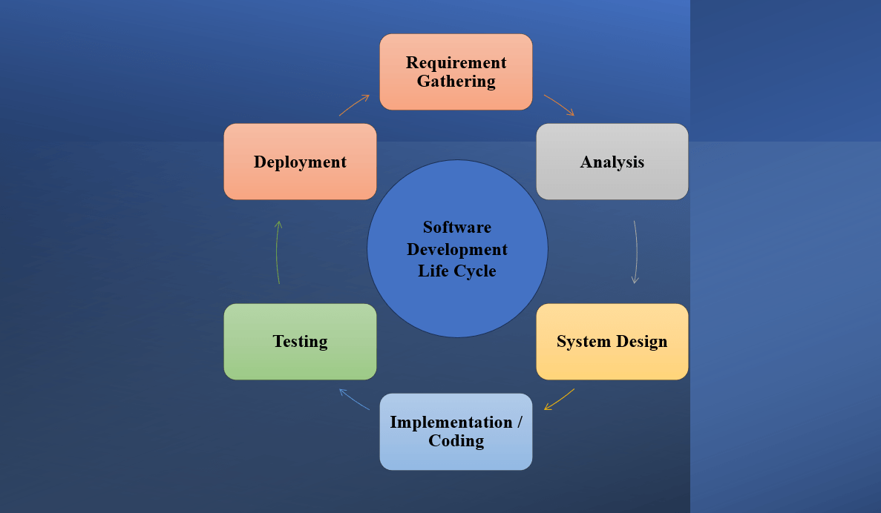

All the stages are explained in below as brief:
Stage 1: Project Planning:-
Project planning is a vital role in the software delivery lifecycle.
The team estimates the cost and defines the requirements of the new software.
In project planning stage the team focus the project out line.
Defining and Breakdown of tasks and their dependencies.
The Planning phase fosters effective communication and collaboration within the team. By defining clear roles, responsibilities, and expectations, it lays a solid foundation for an efficient software development process.
Stage 2: Gathering Requirements & Analysis:-
The second step of SDLC is gathering maximum information from the client requirements for the product.
They discuss each detail and specification of the product with the customer.
The development team will then analyse the requirements keeping the design and code of the software in mind.
Further, investigating the validity and possibility of incorporating these requirements into the software system.
After collecting the data, the team analyses it, distinguishing the essential features from the desirable ones. This analysis helps the team understand the software’s functionality, performance, security, and interface needs.
The main goal of this stage is that everyone understands even the minute detail of the requirement.
Stage 3: Design:-
The design phase (3rd step of SDLC), the program developer scrutinizes whether the prepared software suffices all the requirements of the end-user.
Additionally, if the project is feasible for the customer technologically, practically, and financially.
The culmination of these tasks is an exhaustive Software Design Document (SDD). This document serves as the roadmap for the team during the coding phase. It meticulously details the software’s design, from system architecture to data design, and even user interface specifics.
Once the developer decides on the best design approach, he then selects the program languages like Oracle, Java, etc., that will suit the software.
Stage 4: Coding or Implementation:-
Translating the design to a computer-legible language.
In this fourth stage of SDLC, the tasks are divided into modules or units and assigned to various developers.
The developers will then start building the entire system by writing code using the programming languages they chose.
This stage is considered to be one of the longest in SDLC. The developers need certain predefined coding guidelines, and programming tools like interpreters, compilers, debugger to implement the code.
Another key aspect of this phase is regular code reviews. Team members carefully examine each other’s work to identify any bugs or inconsistencies.
These meticulous assessments uphold high code standards, ensuring the software’s reliability and robustness. This phase also includes preliminary internal testing to confirm the software’s basic functionality.
The developers can show the work done to the business analysts in case if any modifications or enhancements required.
Stage 5: Testing:-
Once the developers build the software, then it is deployed in the testing environment.
Then the testing team tests the functionality of the entire system. In this fifth phase of SDLC, the testing is done to ensure that the entire application works according to the customer requirements.
The development team then fixes the bugs and send it to QA for a re-test. This process goes on until the software is stable, bug-free and working according to the business.
Testing process begins by setting clear parameters in line with the software’s requirements. This includes identifying the necessary software conditions, and outlining diverse scenarios to examine these conditions. This step aids in creating an efficient testing strategy.
Stage 6: Deployment:-
Once the testing is done, and the product is ready for deployment, it is released for customers to use.
The size of the project determines the complexity of the deployment. The users are then provided with the training or documentation that will help them to operate the software.
Stage 7: Maintenance:-
The actual problem starts when the customer actually starts using the developed system and those needs to be solved from time to time. Maintenance is the seventh phase of SDLC where the developed product is taken care of.
According to the changing user end environment or technology, the software is updated timely.
The primary focus is to adapt to the software’s changing needs. This adaptation involves responding to user feedback, resolving unexpected issues, and upgrading the software based on users’ evolving requirements.

Assignment 2: Requirements Gathering - Conduct a 30-minute mock interview to gather requirements for a fictional app that helps organize community events. Summarize the requirements and how you would document and trace them in a one-page brief.

Requirements for a fictional app:-
7 Key Tips for Gathering Good App Requirements
Identify the key stakeholders.
Understand the business needs.
Identify the user requirements.
Define the functional requirements.
Define the technical requirements.
Prioritize the requirements.
Document the requirements.
Identify the key stakeholders:-
Start by identifying the key stakeholders who will be impacted by the app, including business owners, users, and other decision-makers. Make sure to involve all relevant stakeholders in the requirements gathering process. Giving people a voice in the earliest stages of the project will also help with app adoption at the end of the project.
Understand the business needs:-
Understand the business needs that the app is intended to address. This can include understanding the goals and objectives of the business, as well as any challenges or soar points that the app should address. This will provide understanding of why the app and its features are important, not just what the app needs to do.
Identify the user requirements:-
Identify the requirements of the end-users who will be using the app. This can include understanding their needs, goals, and sore points, as well as any usability or accessibility requirements. Despite all other planning efforts, there’s no substitute for speaking with actual end-users.

Define the functional requirements:-
Define the functional requirements of the app, including the features and capabilities that are required. This can include requirements for data input and output, integration with other systems, and reporting and analytics.

Define the technical requirements:-
Define the technical requirements of the app, including the platforms, technologies, and infrastructure that will be used. This can include requirements for scalability, performance, and security. While gathering these requirements shouldn’t be skipped, using a low-code cloud platform for development can greatly simplify the implementation, as the right platform will check all the boxes.
Prioritize the requirements:-
Prioritize the app requirements based on their importance and impact on the success of the project. This can help ensure that the most critical requirements are addressed first and that the project stays on track. This is especially important when the scope may potentially exceed the timeline. In that case, a prioritized backlog of requirements can facilitate a conversation about taking a phased approach.
Document the requirements:-
Document the app requirements in a clear and concise manner, using a format that is easily accessible to all stakeholders. This can include use cases, user stories, functional specifications, and technical specifications. While there are specialized tools available for managing requirements backlogs and task management, spreadsheets can also work depending on what’s available

Throughout the requirements gathering and design process, it’s important to remember one thing: Design like you know everything, but listen like you know nothing. It is only natural to feel protective of your app and to become defensive if someone offers some criticism or a differing opinion. However it’s far easier to evaluate and implement feedback before an app ships, and can only lead to a better first experience for users.
By following these 7 key steps for gathering good app requirements, you can gather requirements for your web or mobile app project in a structured and effective manner. This will help ensure that the app meets the needs of the business and end-users and delivers value to your organization.
So for every application the above are the same requirement analysis is done to gather all the useful and important requirements so that the interface or the application looks similar or familiar to the end user or the costumer.

Assignment 3: Agile Principles Application - Write a two-paragraph reflection on how the Agile values of individuals and interactions, working solutions, and customer collaboration apply to the development of the community event app.
Agile values emphasize four key priorities that shape the foundations of agile methodologies: valuing individuals and interactions over processes and tools to complete work; valuing working software over comprehensive documentation; valuing customer collaboration over contract negotiation; and valuing responding to change over following a pre-defined plan.
These values encourage teams to take an adaptive, flexible approach focused on delivering customer value through continuous collaboration and improvement.
1) Individuals and interactions over processes and tools,
2) Working software over comprehensive documentation,
3) Customer collaboration over contract negotiation,
4) Responding to change over following a plan.

Individuals and Interactions Over Processes and Tools:-
any processes or tools to manage the pr No matter how well-researched your process and high-tech your tools are, it’s the team you work with and the way you work together that determines success. Your team and their ability to communicate effectively and efficiently is more valuable than the processes they follow or the tools you use.
This isn’t to say that agile philosophies discourage formalized processes or tools. Both can be helpful in providing structure for your team and facilitating interactions. But at the end of the day, they come second.
After all, processes and tools are worthless if your team can’t communicate. But put a smart, motivated team up to a task without object and chances are they’ll find some way to get it done.
Working Software Over Comprehensive Documentation:-
Traditional product development processes often required extensive documentation before a single line of code was written. Under the agile philosophy, getting software in the hands of customers is the highest priority. After all, how are you going to improve your product if you don’t get it out in the wild and collect feedback from real users?
While this value highlights the importance of shipping software over letting documentation be a bottleneck, it’s important to note that documentation in itself is not a bad thing…as long as you don’t overdo it.
Customer Collaboration Over Contract Negotiation:-
The agile philosophy highlights the importance of customer-centric product development practices over product-centric approaches. While contracts will always have their place in business, a list of the things you’re offering your customer is no replacement for actually communicating with them about what their needs are and where their challenges are.
Traditional product-centric processes allowed contracts to dictate what was delivered in the end, which left a lot of room for mismatched expectations. The agile philosophy (and many of the formalized processes that have come out of it) encourage building a continuous customer feedback loop into development cycles.
Under the agile philosophy, customer collaboration begins early in the development process and happens frequently throughout. This culture of close collaboration with real customers helps product people ensure they’re delivering effective, useful solutions to customers. When you talk to customers often and build feedback into your development process, you reduce risk and eliminate guesswork.

Responding to Change Over Following a Plan Graphic Showing The Cycle of Build, Measure, Learn, and Adjust as a Continuum:-
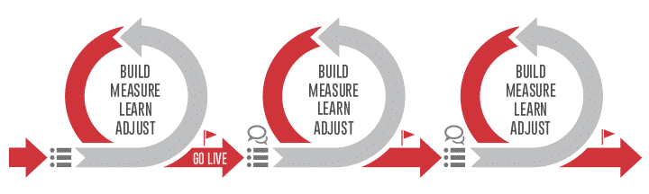

An important benefit of the agile methodology is that it encourages frequent reviewing and retooling of current plans based on new information that the team is continually gathering and analyzing.
The product roadmap, then, is no longer a static document, but a dynamic strategy. Product managers in agile environments will need to learn to present their dynamic roadmaps to stakeholders in a transparent manner that reflects the likelihood of change based on new learnings.
In other words, the agile methodology lets a product team adjust its priorities and plans whenever doing so makes strategic sense. These teams do not get stuck in an outdated plan simply because they have committed to seeing it through.

Assignment 4: Scrum Framework Overview - Prepare a one-page cheat sheet on the Scrum framework that includes roles, responsibilities, artifacts, and ceremonies. Provide a brief example of a Sprint task list for the earlier mentioned app project.
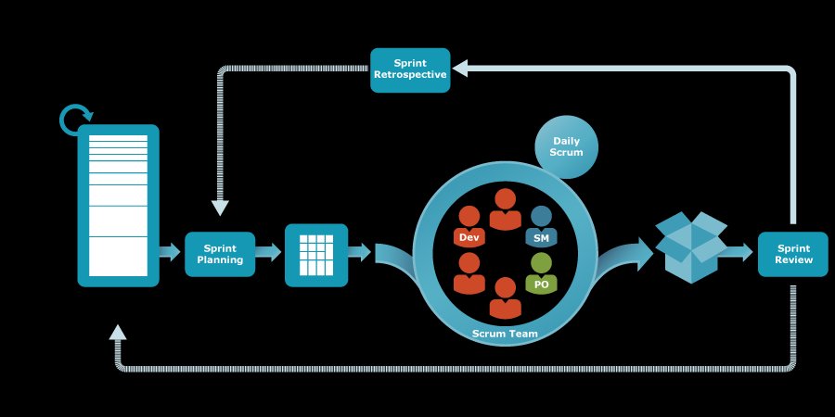

Scrum Framework:-
Scrum is a simple empirical process that enables teams to build products incrementally in iterations, to keep abreast of the changing market needs and align themselves to the organization's business goals.
Scrum advocates self-organizing teams working towards a common goal through continuous inspection and adaptation. A minimum viable product at the end of each iteration provides an option for the teams to quickly get feedback from end users and respond much faster.
By the principles of Transparency, Inspection, and Adaptation, Scrum framework carved a new path for teams thirsty for efficiency and adaptability. The Scrum Framework empowers teams to optimize processes and deliver value through its well-architected roles, events, and artifacts.
Methods in scrum:-
The Scrum Methodologies includes the following things.
1) Scrum Roles,
2) Scrum Events,
3) Scrum Artifacts,
4) Scrum Values.
The above methods are explained briefly as following:-
Roles of Scrum:-
The scrum team is mainly divided into three roles which are Product Owner, a Scrum Master and the Development Team. Each role has their seperate work assigned to them.
A Product Owner in a scrum team decides what needs to be built. This person has complete knowledge about the market and business needs, has a vision, and owns the return on investment (ROI) or the value delivered by the product.
The key responsibilities of the Product Owner are Prioritizes features by market value, Represents business, and is responsible for the ROI, Negotiates with the team and business to deliver the right product at the right time.
The Scrum Master's major responsibility is to ensure that scrum is understood and practiced by every team member in the true spirit.
Scrum Master must draw out quiet people during stand-up meetings or when planning poker sessions, should create an environment of safety for the team, and guide and facilitate team collaboration.
The Development team in scrum is the team that has all the skills necessary to execute the backlog items, It is a self-organizing team that collaborates, shares their special skills and knowledge and are committed completely to fulfil the objectiv, The Development team decides how much work is to be done in a sprint, and commits to delivering a 'potentially shippable product increment (PSPI)', without sacrificing quality and speed. The team also makes continuous self-improvements.
Artifacts of Scrum:-.
Scrum focuses more on a working software at the end of every sprint rather than comprehensive documentation. This does not imply that there is no documentation at all. The documentation is to facilitate collaboration and interactions, rather than tracking.
The progress is always measured through a working software. Scrum Documentation has three main artifacts namely: Product backlog, Sprint backlog, Increment.
A product backlog is a dynamic list of functionalities the product might include, such that it provides value to users.
The Product Owner maintains this list and is responsible for creating, managing, and prioritizing the backlog by focusing on 'WHAT' brings the highest value to the users. These are a few unique characteristics of a product backlog.
Sprint backlog is a subset of the entire product backlog that the scrum team plans to implement in one iteration or sprint.
During the sprint planning, the team selects items from the product backlog that they commit to complete in one sprint and thereby, create the sprint backlog. The Product Owner and Scrum Master should not provide inputs that may impact the team's decision. Sprint backlog has.
An increment is the work delivered at the end of every sprint. Typically, after every iteration there will be a Product Increment (PI) that delivers value and the final product will be a working software.
This increment is a sum of all the capabilities that were delivered in the previous sprints as a part of the PI. At the end of every sprint, the Product Owner decides whether to release the working product increment or wait until the next release.

Events/ ceremonies of scrum:-
All scrum activities are time-boxed and allow teams to inspect their current work and implement those learnings in future time-boxes.
The sprint is a time-boxed iteration, typically ranging from 1 to 4 weeks, at the end of which, a potentially shippable product increment is delivered by the Development team.
Scrum Events are: Sprint planning, Daily scrum, Sprint review, Sprint retrospective.
Sprint planning meeting happens at the start of every sprint. This helps the Product Owner and Development teams to plan the product backlog items that will be taken up for implementation during the sprint.
Considers and discusses product backlog items with the Product Owner, Ensures a shared understanding about those items.
There are two activities to be done to ensure that the above are achieved:
Part I: Define 'WHAT' work will be done, Part II: Explain 'HOW' the work will get done.
Daily scrum is a 15-minute time-boxed event in which the team manages its daily activities. Daily Scrum is also called the daily stand-up meeting.
The scrum team meets every day, preferably at the same time and same place, so that it becomes a habit. During the meeting, each member answers three critical questions.
The daily scrum also ensures that the impediments blocking the progress of the sprint are identified and resolved without further delay. Detailed problem solving does not happen during this meeting. Broadcasting individual updates to everyone in the team avoids unnecessary meetings.
A sprint review is an event that happens at the end of every sprint, where the scrum team demonstrates the work that is done in the sprint to the stakeholders. The following happens during this meeting.
A demo of the product increment showcasing the new features and underlying technology,
Feedback from the review provides input to the team to further discuss on refining the existing backlogs and plan for future sprints.
During a sprint retrospective meeting, the scrum team inspects the previously completed sprint and identifies areas of improvement to be enacted for the upcoming sprints.
This happens after every sprint and right after sprint review in which the whole scrum team participates.
During this meeting: The team introspects on what went well in terms of collaboration, planning, process, and tools.
They try to identify potential improvements that can be taken up in the next sprint to make the scrum processes more efficient by learning from previous shortfalls.
Scrum also states five core values to which teams have to adhere. The core values are: Commitment, Courage, Focus, Openness, and Respect. These values should be imbibed and lived by the scrum team to ensure the fulfilment of scrum pillars of transparency, inspection, and adaptation. It builds trust among everyone.
Successful use of scrum depends on people becoming more proficient in these 5 values:-
People personally commit to achieving the goals of the scrum team.
The scrum team members have the courage to do the right thing and work on tough problems.
Everyone focuses on the work of the sprint and the goals of the scrum team.
The scrum team and its stakeholders agree to be open to all the work and the challenges that they encounter while performing the work.
Scrum team members respect each other and consider everyone to be capable and independent.

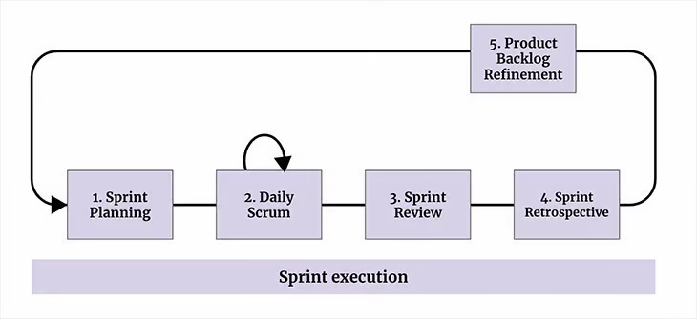

Q) Agile Project Planning - Create a one-page project plan for a new software feature using agile planning techniques. Include backlog items with estimated story points and a prioritized list of user stories:-
Agile project management refers to an iterative approach to planning and guiding project processes. Just as in Agile software development, an Agile project is completed in small sections.
These sections are called iterations. In Agile software development, for instance, an iteration refers to a single development cycle.
Agile project management is designed to be flexible enough to handle projects with potentially moving, changing and evolving requirements and agile enough to be able to provide the end customer with functional portions of the overall final solutions promptly and as needed.
It transcends the rigidity of the Waterfall process by embracing the change in scope that can so often accompany a project of even the most dedicated requirements.
In Agile project management, the product itself is developed in sprints.
Before each sprint begins, a sprint planning meeting takes place between the product owner and development team members.
The user stories and backlog are reviewed to determine the tasks that can be completed during the sprint.
These plans deliver a finer level of detail (compared to the high-level release plan), including which tasks are to be performed by which team members and how long each task will take.
Activities that occur during the project planning process in the Agile method include the following.

Task planning:-
Agile team members break the features down into tasks and then team members take those tasks on. As a matter of best practice, look at the time estimates and try to break any task that may take longer than a day down into smaller tasks.
This helps to reduce uncertainty and foster successful task completion. It also feeds into the job of estimating, as it is much easier to estimate the time required to complete a smaller task.

Agile estimating:-
Estimating the time to completion can seem like a matter of luck and guesswork more than science, but some principles can help to make it seem less like guesswork. As a best practice, rely on past success to estimate a particular effort.
For example, rely on past feature delivery time actuals to plan future estimates.
If the team was able to deliver X number of features in the previous iteration, then plan to deliver X number of features in the current cycle. Best practices in Agile method estimating would logically suggest these useful practices for estimating time to completion:

Reference historical data – team specific
Be realistic, not optimistic
Estimate based on smaller units of work rather than larger ones. Estimates based on tasks rather than features, therefore, are going to be more accurate
User stories development
By communicating with the customer, you can determine the overall goal for the project and, in turn, an overall goal for the sprint/iteration.
Rely on that goal to develop your feature/user story priorities and then allow your priorities to guide the selection of which features/user stories to develop during the iteration.

Backlog management:-
There are two types of backlogs to consider:

The Product Backlog is the master list of things to be built into the product.
The Iteration Backlog is the list of priority items to be built during the current iteration.
The key to managing backlogs is managing priorities. Work with your customers to ensure that the most important features are delivered. The key is to deliver reliable results by engaging customers in frequent interactions and shared ownership.
The customer can tell you which backlog items have the highest priority, and which backlog items have the highest priority at that time. Priorities can shift, so be sure to check with customers periodically to make certain that the next iteration is still being planned appropriately.

Agile scheduling:-
Agile scheduling is perhaps the most “project managerial” of project management activities. The following are some useful guidelines for managing scheduling:

Schedule in detail only for the immediate iteration: Sprints/iterations are useful for managing uncertainty, but it is adaptability that drives sprints/iterations.
Scheduling too far in advance prevents you from being nimble and responding to changing priorities.
Involve the entire team: Scheduling is a team activity that is driven by estimates, so the team should be involved in the entire process, not merely for accurate scheduling, but also to promote buy-in.
Design and testing are also part of development: Keep the time for these required activities during sprints/iterations in mind as you build estimates and schedules.
Include time for the demo meeting: The demo is an important part of the release and should be part of the schedule.
The Agile method attempts to limit project uncertainties by attempting to limit dependencies through sprint/iteration planning because tasks are not developed with an overarching project in mind,
but in a more granular form in which a set of features can be developed in parallel and delivered in working order during the one to four-week period that typically defines a sprint/iteration.
As a matter of best practice, plan your sprints/iterations to avoid dependencies.

Teamwork and Collaboration:-
Agile projects are managed by the entire team, primarily at the iteration level. The team must work together to select features from the backlog that will be built into the current iteration, estimate time, schedule work, and drive the project towards the product vision.
The project manager maintains the plan, but it is really the team that owns the plan and is responsible for meeting plan requirements and deadlines.

Agile is about individuals and interactions, but it is also about teamwork and team ownership. In traditional project management, it can feel as though the project manager is in a lonely position, gathering data to put together a plan that is then handed down to task owners.
In Agile the project manager is a task owner among task owners and everyone contributes.

Q) Daily Standup Simulation - Write a script for a Daily Standup meeting for a development team working on the software feature from Assignment 1. Address a common challenge and incorporate a solution into the communication flow.

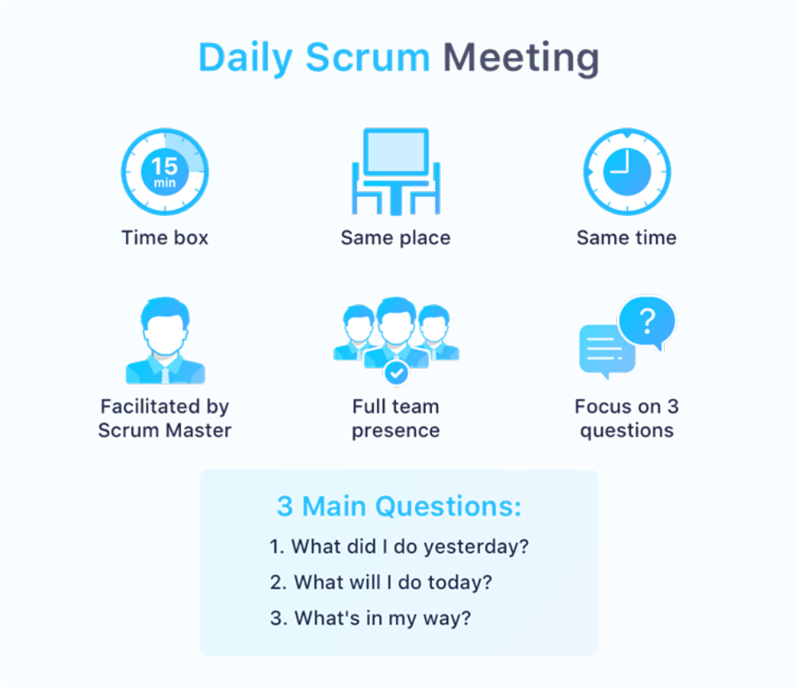

A daily stand-up meeting is a short organizational meeting that is held each day. The meeting, generally limited to between five and 15 minutes long, is sometimes referred to as a stand-up, a morning roll-call or a daily Scrum.
The daily stand-up meeting is a technique popularized by Agile methodologies, with the aim to streamline team communication and quickly address immediate concerns
The purpose of a stand-up meeting is to create transparency regarding what everyone is working on, identify potential roadblocks, and facilitate necessary collaboration.
It also enforces accountability, as team members regularly report their progress and plans.
In a stand-up meeting, each team member answers three key questions:

What did you do yesterday?
What will you do today?
Are there any impediments in your way?
By answering these questions, each team member provides an overview of their tasks, facilitating better visibility into the project's status and potential challenges.
It gives everyone a quick snapshot of what tasks need to be done and any issues someone might be facing.
In essence, the daily Scrum standup meeting is all about keeping teams in sync, fostering collaboration, and ensuring everyone is moving forward in unison. It serves as a critical pulse-check to prevent any inefficiencies and align efforts towards reaching project goals.

