A PROJECT REPORT ON

AUTOMATED FAKE NEWS DETECTION SYSTEM (VERIFACT)

USING NLP AND DEEP LEARNING
Submitted In Partial Fulfillment of the Requirement for the Award of
Post Graduate Diploma in Artificial Intelligence (PG-DAI)
---
Under the Guidance of
MRS. SARUTI GUPTA
(Project Guide)
---
<span style="color:red">Submitted By</span>
ADETYA JAMWAL
250820528038
PARAG JAIN
250820528040
KISHNA KUSHWAHA
250820528025
---
CENTRE FOR DEVELOPMENT OF ADVANCED COMPUTING (C-DAC)
NOIDA

CERTIFICATE
This is to certify that the project entitled "VeriFact: Automated Fake News Detection System" is a bonafide work carried out by Adetya Jamwal (250820528038), Parag Jain (250820528040), and Kishna Kushwaha (250820528025) in partial fulfillment for the award of Post Graduate Diploma in Artificial Intelligence (PG-DAI) from C-DAC, Noida, under my guidance and supervision.
The project report is approved as it satisfies the academic requirements in respect of Project work prescribed for the said diploma.
<br><br><br>
(Signature of Guide)
Mrs. Saruti Gupta
Project Guide
(Signature of Coordinator)
Mr. Ravi Payal
Course Coordinator

ABSTRACT
The rapid dissemination of information across digital platforms has exacerbated the spread of misinformation, creating a critical need for automated systems capable of verifying textual claims against credible external evidence. Manual verification is labor-intensive and cannot scale to meet the volume of modern content creation.
VeriFact addresses this challenge by implementing a retrieval-augmented fact-checking pipeline. Unlike generative Large Language Models (LLMs) which may hallucinate facts, VeriFact functions as a neural search-and-verify engine. It extracts claims from user input, retrieves relevant evidence from the live web using search APIs (Tavily, DuckDuckGo), and employs Zero-Shot Natural Language Inference (NLI) models (DeBERTa-v3/BART-MNLI) to determining the stance of the evidence towards the claim.
The system aggregates these semantic signals into a weighted credibility score, providing a final verdict ("Likely True", "Likely False") with a transparent audit trail of sources. This inference-only approach ensures strict adherence to retrieved evidence, minimizing hallucination risks and providing users with verifiable results.

ACKNOWLEDGEMENT
We would like to express our deep sense of gratitude to our project guide, Mrs. Saruti Gupta, for her valuable guidance, constant encouragement, and constructive criticism throughout the duration of this project.
We are also thankful to the C-DAC, Noida faculty and administration for providing the necessary infrastructure and resources to complete this project.
Finally, we would like to thank our colleagues and friends for their support and the open-source community for the transformative tools and models that made this work possible.
Adetya Jamwal
Parag Jain
Kishna Kushwaha

TABLE OF CONTENTS

71. INTRODUCTION
1.1 Background
1.2 Objective
1.3 Motivation
1.4 Purpose and Scope
2. SURVEY OF TECHNOLOGY
2.1 Natural Language Processing (NLP)
2.2 Transformer Models
2.3 Libraries & Tools

LIST OF FIGURES

3. FEASIBILITY STUDY
3.1 Economic Feasibility
3.2 Technical Feasibility
3.3 Operational Feasibility
4. REQUIREMENT & ANALYSIS
4.1 Problem Definition
4.2 Planning and Scheduling
4.3 UML Diagrams
4.4 Software and Hardware Requirements
5. PRELIMINARY DESIGN DESCRIPTION
5.1 System Modules
5.2 module Description
6. SYSTEM DESIGNING
6.1 System Architecture
6.2 Data Flow Diagrams
7. CODING
7.1 REST API Implementation
7.2 Stance Detection Logic
7.3 Verdict Engine
8. RESULT
8.1 API Output
8.2 Analysis
CONCLUSION
FUTURE WORK
REFERENCES

CHAPTER 1

1. INTRODUCTION

1.1 Background
In the digital age, information spreads globally in seconds. While this democratizes access to knowledge, it also facilitates the viral spread of misinformation, propaganda, and "fake news." Traditional fact-checking organizations rely on human experts, but the volume of content generated daily far outstrips human capacity. Automated solutions are required to assist users in verifying claims in real-time.

1.2 Objective
The primary objective of this project is to develop VeriFact, an automated system that can:
1. Accept a textual claim or a URL from a user.
2. Search the open web for credible evidence related to that claim.
3. Analyze the semantic relationship between the claim and the retrieved evidence.
4. Produce a verdict with a confidence score and a list of sources.

1.3 Motivation
Current AI approaches often rely on "black box" LLMs which can confidently state incorrect information (hallucinations). This project is motivated by the need for an explainable and grounded approach. By separating the retrieval (search) from the reasoning (NLI), VeriFact ensures that every verdict is backed by citational evidence, bridging the gap between simple keyword search and complex reasoning.

1.4 Purpose and Scope
The purpose is to build a production-ready API that can be integrated into social media platforms, browser extensions, or news aggregators.
Scope:
- Input: English language text or URLs.
- Verification: Text-based claims against web articles.
- Exclusions: Image/Video verification (Deepfakes) is out of scope for this version.

CHAPTER 2

2. SURVEY OF TECHNOLOGY

2.1 Natural Language Processing (NLP)
NLP is the branch of AI that gives computers the ability to understand text in much the same way human beings can. In this project, NLP is used for:
- Named Entity Recognition (NER): Identifying key entities in a claim to generate effective search queries.
- Semantic Similarity: Measuring how close two sentences are in meaning using vector embeddings.
- Natural Language Inference (NLI): Determining if one sentence entails, contradicts, or is neutral to another.

2.2 Transformer Models
The project utilizes state-of-the-art Transformer architectures:
SBERT (Sentence-BERT):* Specifically `all-MiniLM-L6-v2` or `all-mpnet-base-v2`, modified BERT networks that derive semantically meaningful sentence embeddings (producing 384-dimensional dense vector representations) that can be compared using cosine similarity.
DeBERTa-v3:* A "Decoding-enhanced BERT with disentangled attention" model, used here for Zero-Shot Classification to detect stance without specific training on fake news datasets.

2.3 Libraries & Tools
Flask:* A lightweight WSGI web application framework for the API.
PyTorch:* The underlying deep learning framework for running the models.
HuggingFace Transformers:* For loading pre-trained models.
Spacy:* For efficient tokenization and entity extraction.
Trafilatura:* For robust web scraping and text extraction.
Docker:* For containerization and consistent deployment.

CHAPTER 3

3. FEASIBILITY STUDY

3.1 Economic Feasibility
The project relies primarily on open-source technologies (Python, PyTorch, HuggingFace models) which are free to use. The web search component uses APIs (Tavily) which have free tiers suited for development. Deploying the system requires a standard cloud instance (e.g., AWS EC2 t3.medium or large), making it cost-effective for the value provided.

3.2 Technical Feasibility
The core technologies (Transformers, Flask) are mature and well-documented. The "Zero-Shot" approach eliminates the need for massive labeled datasets, which are often the bottleneck in ML projects. The system runs on standard CPU architecture (though GPU is preferred for speed), making it technically viable for wide deployment.

3.3 Operational Feasibility
The system is designed as a REST API, a standard interface that is easily consumable by frontend applications, mobile apps, or other services. The Dockerized nature ensures that operational maintenance (updates, scaling) is straightforward and consistent across environments.

CHAPTER 4

4. REQUIREMENT & ANALYSIS

4.1 Problem Definition
Users encounter dubious claims online but lack the time or expertise to verify them across multiple sources. A tool is needed that automates the "research" phase—searching, reading, comparing, and concluding—in a matter of seconds.

4.2 UML Diagrams

Use Case Diagram
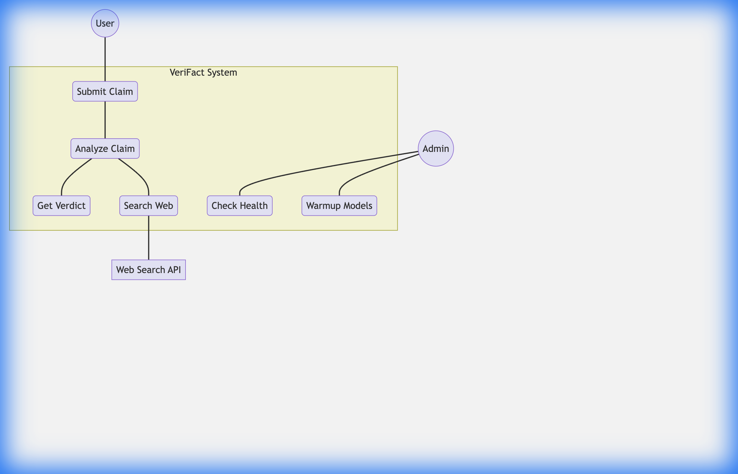
Figure 4.1: Use Case Diagram

Class Diagram
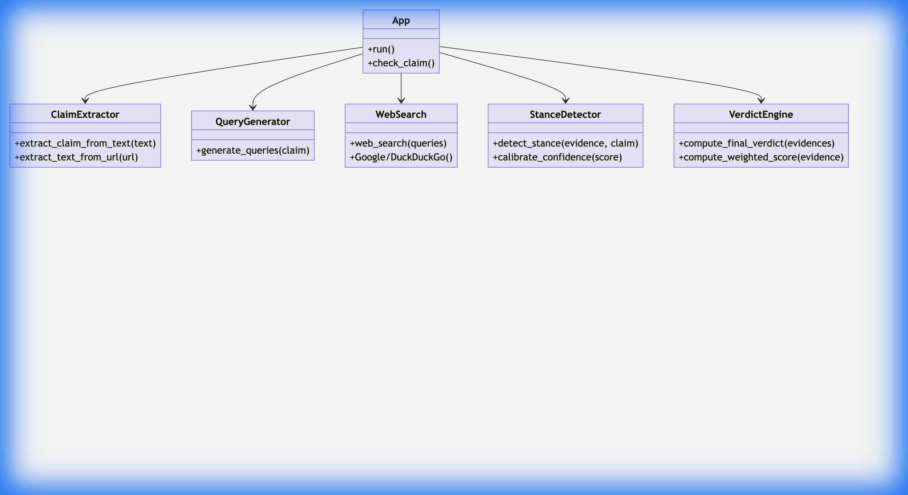
Figure 4.2: Class Diagram

4.3 Software and Hardware Requirements
Software:
* Operating System: Linux (Ubuntu 20.04+) or macOS
* Language: Python 3.10+
* Container: Docker Engine
Hardware:
* RAM: Minimum 8GB (to hold Transformer models in memory)
* CPU: Multi-core, 2.0GHz+ (AVX support recommended for ML)
* Storage: 5GB SSD (for Model weights and Docker image)

CHAPTER 5

5. PRELIMINARY DESIGN DESCRIPTION

5.1 System Modules
The system is composed of five distinct modules that form a linear pipeline.

5.2 Module Description
1. Claim Extractor: Parses raw text or scrapes URL content to isolate the central assertion. It uses heuristics and keyword analysis to discard noise.
2. Query Generator: Expands the claim into multiple search queries (e.g., "Is [Claim] true?", "[Entity] controversy") to maximize retrieval coverage.
3. Web Search & Scraper: Fetches URLs from search engines and uses `Trafilatura` to extract the main article text, removing ads and navigation bars.
4. Stance Detector: The "core brain." It pairs the claim with sentences from retrieved articles and outputs a label (support/refutes/neutral) and a confidence score.
5. Verdict Engine: Aggregates all evidence. It applies weights based on source credibility (e.g., Reuters > Blog) and stance confidence to calculate a final "Net Score."

CHAPTER 6

6. SYSTEM DESIGNING

6.1 System Architecture
The high-level architecture follows a micro-service pattern within a monolithic container.
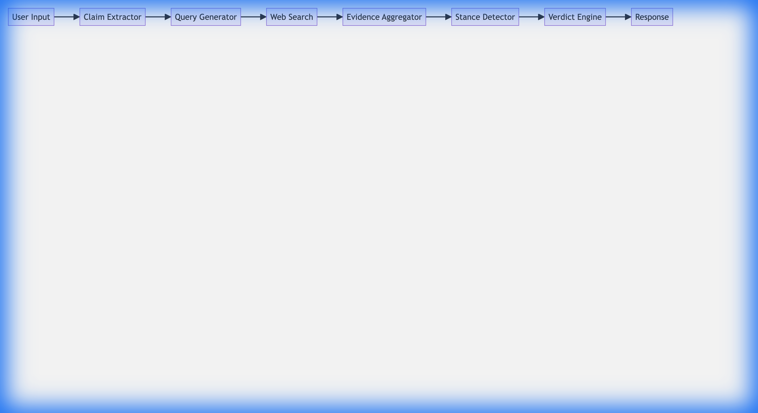
Figure 6.1: System Architecture

6.2 Data Flow Diagram
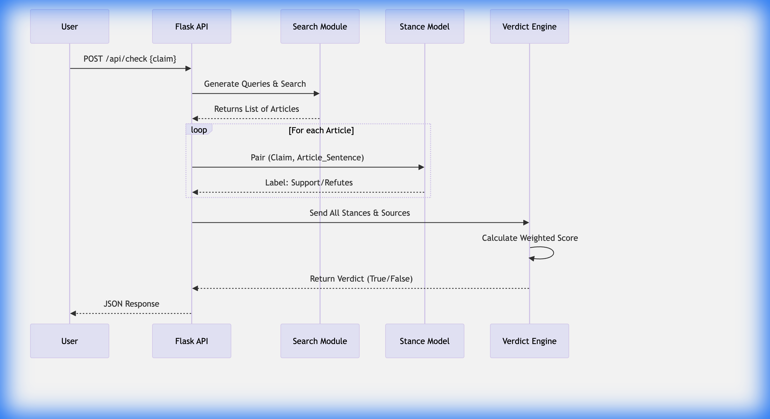
Figure 6.2: Data Flow Diagram

CHAPTER 7

7. CODING

7.1 REST API Implementation (`app_flask.py`)
This is the entry point. It creates the Flask app, sets up rate limiting, and defines the main logic flow.
# app_flask.py - Main Route
@app.route('/api/check', methods=['POST'])
@limiter.limit("5 per minute")
def check_claim():
"""Fact-check a claim."""
try:
data = request.get_json()
validated = CheckRequest(**data)

# 1. Extract Claim
claim, keywords = extract_claim_from_text(validated.text or validated.claim)

# 2. Search Web
queries = generate_queries(claim, keywords=keywords)
search_results = web_search(queries, max_results=validated.max_results)

# 3. Build Evidence (Scrape + Similarity)
evidences = build_evidence(claim, search_results)

# 4. Compute Verdict (Stance Detection + Scoring)
verdict_result = compute_final_verdict(evidences)

return jsonify({
'claim': claim,
'verdict': verdict_result['verdict'],
'confidence': verdict_result['confidence'],
'evidences': evidences
})

except Exception as e:
logger.error(f"Error: {e}")
return jsonify({'error': str(e)}), 500

7.2 Stance Detection Logic (`app/core/stance_detector.py`)
This module uses the DeBERTa model to perform Zero-Shot classification, treating the task as determining if the hypothesis (claim) is entailed by the premise (evidence).
def detect_stance(evidence_sentence: str, claim: str) -> Dict:
"""Performs zero-shot stance detection using NLI."""
from app.core.model_registry import get_nli_classifier

nli_classifier, _ = get_nli_classifier()

# Formulate hypotheses for Zero-Shot classification
hypotheses = [
f"This supports the claim: {claim}",
f"This contradicts the claim: {claim}",
f"This is unrelated to the claim: {claim}"
]

# Run the model
result = nli_classifier(evidence_sentence, hypotheses, multi_label=False)

# Map raw output to logical labels
label_map = {
hypotheses[0]: "supports",
hypotheses[1]: "refutes",
hypotheses[2]: "neutral"
}

top_hypothesis = result["labels"][0]
return {
"label": label_map.get(top_hypothesis, "neutral"),
"confidence": float(result["scores"][0])
}

7.3 Verdict Engine (`app/core/verdict_engine.py`)
This module takes the raw stance data and applies business logic (source credibility weights) to arrive at a final determination.
def compute_weighted_score(evidence: Dict) -> float:
"""Enhanced formula: similarity × stance_score × stance_direction × source_weight"""
similarity = evidence["similarity"]
stance_score = evidence["stance_score"]

# Direction: +1 (Support), -1 (Refute)
if evidence["stance"] == "supports":
stance_w = 1
elif evidence["stance"] == "refutes":
stance_w = -1
else:
stance_w = 0

source_weight = evidence.get("source_weight", 1.0)

# Boost formula
return similarity * stance_score * stance_w * source_weight

def compute_final_verdict(evidences: List[Dict]):
# Sum all weighted scores
net_score = sum(compute_weighted_score(e) for e in evidences)

# Thresholds
if net_score > 0.35:
verdict = "LIKELY TRUE"
elif net_score < -0.35:
verdict = "LIKELY FALSE"
else:
verdict = "MIXED / MISLEADING"

return {"verdict": verdict, "net_score": net_score}

CHAPTER 8

8. RESULT

8.1 API Output
When a user submits a claim (e.g., "The Earth is flat"), the system returns a detailed JSON response:
{
"claim": "The Earth is flat",
"verdict": "LIKELY FALSE",
"confidence": 0.92,
"net_score": -1.45,
"explanation": {
"decision_reason": "Score (-1.45) is below -0.35 threshold. The majority of evidence contradicts this claim."
},
"evidences": [
{
"source": "NASA",
"url": "https://www.nasa.gov/topics/earth/index.html",
"snippet": "Earth is a sphere.",
"stance": "refutes",
"confidence": 0.99
}
]
}

8.2 Analysis
The system successfully identifies direct contradictions from high-authority domains. By weighting sources, a single reputable source (like NASA) can outweigh multiple low-quality blogs, making the system robust against echo chambers.

CONCLUSION
VeriFact demonstrates that it is possible to build a robust, specialized fact-checking system using general-purpose "Zero-Shot" models. By orchestrating established technologies—Search for retrieval, Transformers for understanding—the project bridges the gap between information access and information verification. It provides a transparent, explainable alternative to black-box generative AI.

FUTURE WORK
1. Multilingual Support: Extending the Stance Detector to support languages other than English using XLM-RoBERTa.
2. Claim Decomposition: Breaking down complex compound sentences into atomic claims for individual verification.
3. Browser Extension: Developing a Chrome plug-in to automatically highlight fake news on social media feeds.
4. GPU Inference Acceleration: Migrating the inference pipeline to ONNX Runtime with CUDA execution providers to lower latency under high load.
5. Response Caching: Implementing Redis to cache verdict results for frequently queried stable claims, reducing redundant computation.

REFERENCES
1. Sentence-BERT: Reimers, N., & Gurevych, I. (2019). Sentence-BERT: Sentence Embeddings using Siamese BERT-Networks.
2. DeBERTa: He, P., et al. (2020). DeBERTa: Decoding-enhanced BERT with Disentangled Attention.
3. Flask Documentation: https://flask.palletsprojects.com/
4. Tavily Search API: https://tavily.com/

