OpenShift Cluster Installation:
• Bootstrap
• Master (Control Plane)
• Worker
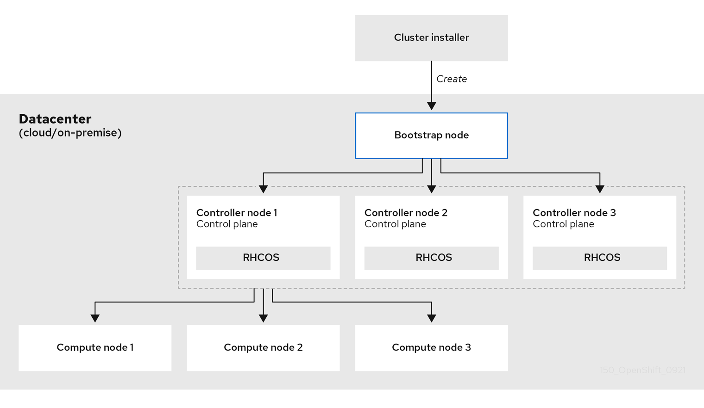
Node Type | vCPU | RAM | Storage | Notes
Admin | 2 | 4GB | 50GB | Instruction node
Bootstrap | 4 | 16 GB | 100 GB | Deleted after install
Master | 4–8 | 16 GB | 100 GB | Runs etcd, API
Worker | 4 | 16 GB | 100 GB | Runs application pods

Note: OpenShift Cluster comes with HA cluster we:
Node Type | No Of Nodes | vCPU | RAM | Storage | Notes
Admin |  | 1 | 2GB | 50GB | Instruction node
Bootstrap | 1 | 4 | 8 GB | 100 GB | Deleted after install
Master | 3 | 4–8 | 16 GB | 100 GB | Runs etcd, API
Worker | 2 | 4 | 16 GB | 100 GB | Runs application pods

# IP Address Inventory

# Servers
Hostname | IP Address | Purpose
Bootstrap | 192.168.65.9 | Bootstrap
master1 | 192.168.65.10 | OpenShift Master
master2 | 192.168.65.11 | OpenShift Master
master2 | 192.168.65.11 | OpenShift Master
worker1 | 192.168.65.20 | Worker Node
gateway | 192.168.65.2 | Network Gateway
Jump-host | 192.168.65.128 | Jump-host

DNS
DHCP
Stable Internet Connection:
- Access OpenShift Cluster Manager to download the installation program and perform subscription management.
- Access Quay.io to obtain the packages that are required to install your cluster.
- Obtain the packages that are required to perform cluster updates.

Loadblancer (HAProxy)
Port / Range | Protocol | Direction or Notes | Purpose / Service
6443 | TCP | Inbound / from clients / control plane | Kubernetes / OpenShift API server (primary API endpoint)
22623 | TCP | Inbound / control plane / machine config daemon | Used during install / for machine-config server
80 | TCP | Inbound / from users / external loads | HTTP ingress for applications / HTTP routes
443 | TCP | Inbound / from users / external loads | HTTPS ingress for applications / TLS routes
1936 | TCP | Inbound | For ingress health / metrics etc.
2379 | TCP | Inbound (control plane) | etcd client traffic
2380 | TCP | Inbound (control plane) | etcd peer / internal replication
53 | TCP/UDP | Inbound | DNS service for cluster internal resolution
30000–32767 | TCP | Inbound / NodePort services | For exposing services via NodePort
9000–9999 | TCP | Inbound / host-level services | Some host services use this range
49152–65535 | TCP | Inbound / dynamic / private ports | Dynamically assigned / ephemeral ports
4789 | UDP | Node-to-node | For SDN (VXLAN, etc) between pods on different nodes
Firewall following ports need to add

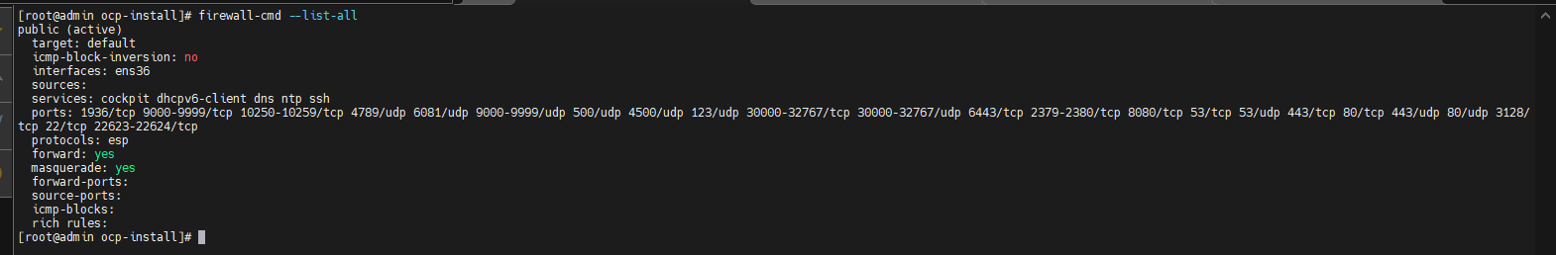
Preparing Infra Node or Admin Node

- Download the necessary tools utilities like OpenShift command-line interface (oc), OpenShift Installer and pull secrets from https://console.redhat.com/openshift/download section.
- Extracts the file and move to user local bin directory
- tar –xzvf openshift-client-linux-4.14.57.tar.gz openshift-install-linux.tar.gz
- after extraction we get oc, openshift-install, kubectl command line utilities
- move to user local bin directory
mv oc openshift-install /user/local/bin
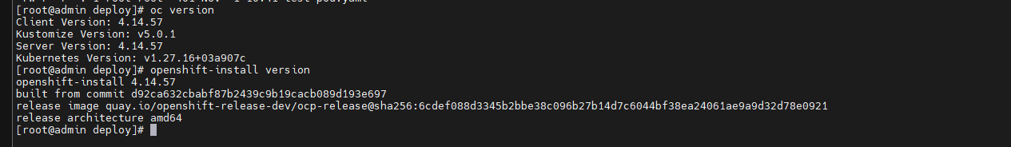
DNS Configuration
- The following DNS records are required for a user-provisioned OpenShift Container Platform cluster and they must be in place before installation. In each record, <cluster_name> is the cluster name and <base_domain> is the base domain that you specify in the install-config.yaml file. A complete DNS record takes the form: <component>.<cluster_name>.<base_domain>.
Component | Record | Description
Kubernetes API | api.<cluster_name>.<base_domain>. | A DNS A/AAAA or CNAME record, and a DNS PTR record, to identify the API load balancer. These records must be resolvable by both clients external to the cluster and from all the nodes within the cluster.
 | api-int.<cluster_name>.<base_domain>. | A DNS A/AAAA or CNAME record, and a DNS PTR record, to internally identify the API load balancer. These records must be resolvable from all the nodes within the cluster.
Routes | *.apps.<cluster_name>.<base_domain>. | A wildcard DNS A/AAAA or CNAME record that refers to the application ingress load balancer. The application ingress load balancer targets the machines that run the Ingress Controller pods. The Ingress Controller pods run on the compute machines by default. These records must be resolvable by both clients external to the cluster and from all the nodes within the cluster.  For example, console-openshift-console.apps.<cluster_name>.<base_domain> is used as a wildcard route to the OpenShift Container Platform console.
Bootstrap machine | bootstrap.<cluster_name>.<base_domain>. | A DNS A/AAAA or CNAME record, and a DNS PTR record, to identify the bootstrap machine. These records must be resolvable by the nodes within the cluster.
Control plane machines | <master><n>.<cluster_name>.<base_domain>. | DNS A/AAAA or CNAME records and DNS PTR records to identify each machine for the control plane nodes. These records must be resolvable by the nodes within the cluster.
Compute machines | <worker><n>.<cluster_name>.<base_domain>. | DNS A/AAAA or CNAME records and DNS PTR records to identify each machine for the worker nodes. These records must be resolvable by the nodes within the cluster.

- Install Bind and bind utilis
- Sudo dnf install bind bind-utils –y
Configure the named.conf but before that we need fqdn and cluster name here I am using cluster Name test and Domain Name ocp.com
Vim /etc/named.conf
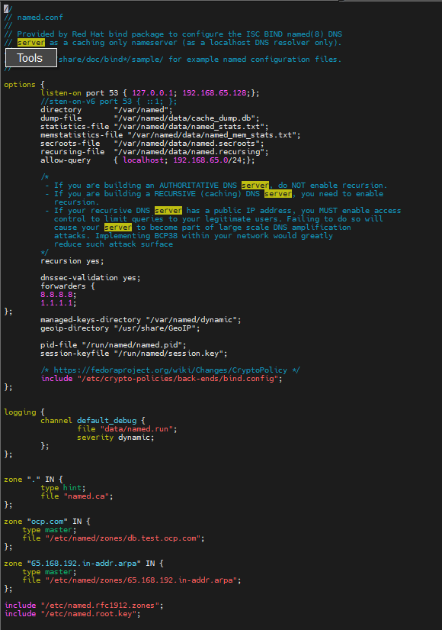

- Now Create Zones for forward and reverse that translate IPs into Name
I have created to zones here and gave reference in named.conf
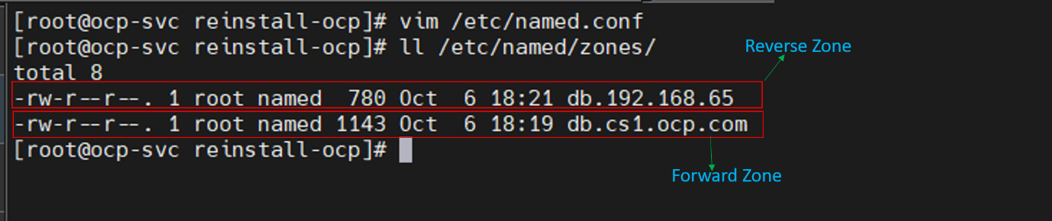

Forward Zone
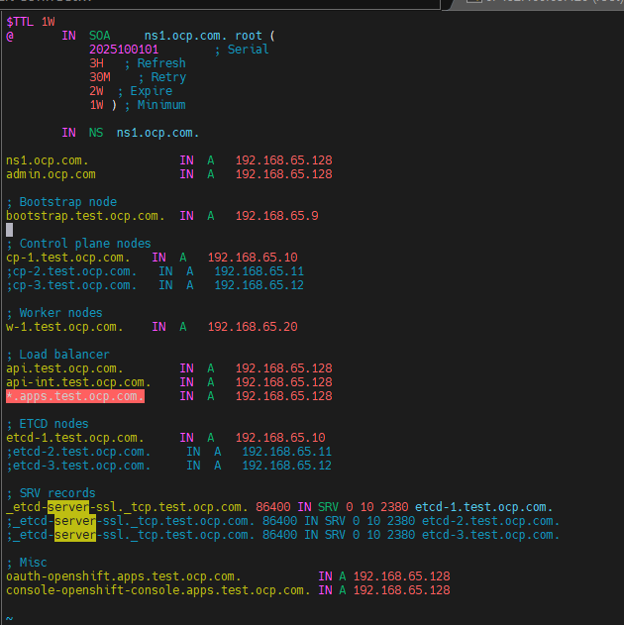
Reverse Zone
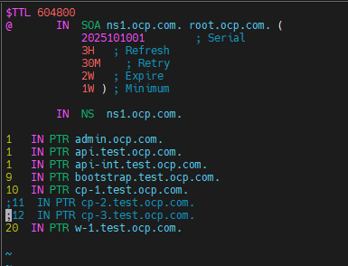
Validating the dns entries
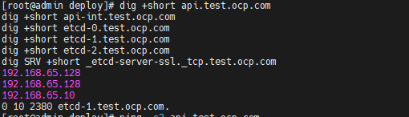
LoadBalancer
Install HAproxy on Admin node or give spate node for load balancer
Sudo dnf install –y haproxy
Vim /etc/haproxy add following content
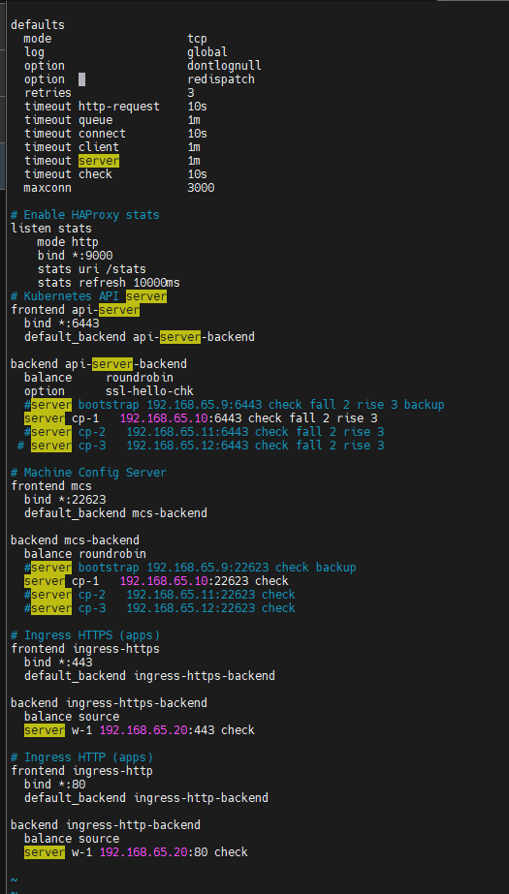
Start and enable the haproxy service
Sudo systemctl enable –now haproxy
Now validate the haproxy configuration
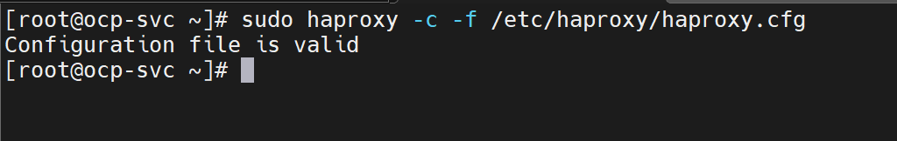
Here I am using local DHCP for persistent IP for nodes
Role | Count | Example Hostname | Example IP
Bootstrap | 1 | bootstrap.ocp.com | 192.168.65.9
Worker | 1 | worker1.ocp.com | 192.168.65.20
Control Plane | 1 | master1.ocp.com | 192.168.65.10
Load Balancer | 1 | lb.ocp.com | 192.168.65.128
DNS Server | 1 | dns.ocp.com | 192.168.65.128
admin node | 1 | admin.ocp.com | 192.168.65.128

# Installing Require packages
Sudo dnf install dhcp-server -y
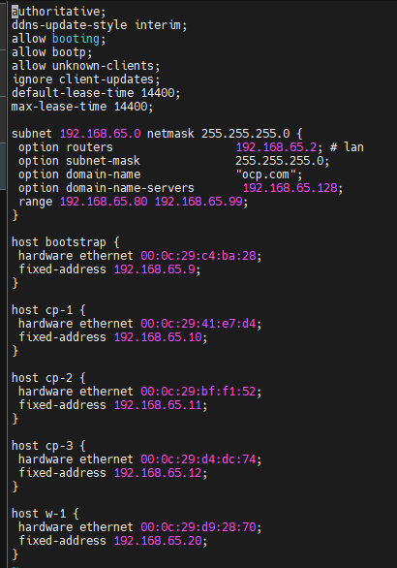
Default Gatway
DNS Server IP
MAC Address
Persistent IP
Start and enable the service for dhcp
Sudo systemctl enable –now dhcpd
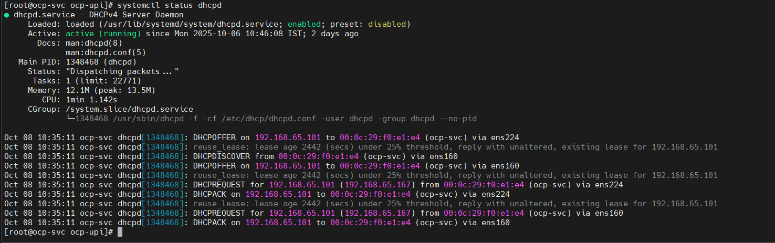
Generating a key pair for cluster node SSH access
During an OpenShift Container Platform installation, you can provide an SSH public key to the installation program. The key is passed to the Red Hat Enterprise Linux CoreOS (RHCOS) nodes through their Ignition config files and is used to authenticate SSH access to the nodes. The key is added to the ~/.ssh/authorized_keys list for the core user on each node, which enables password-less authentication.
- Generate the ssh key
ssh-keygen
- View the public key
cat ~/.ssh/id_rsa.pub
- Add the SSH private key identity to the SSH agent for your local user, if it has not already been added. SSH agent management of the key is required for password-less SSH authentication onto your cluster nodes, or if you want to use the ./openshift-install gather command.
- Start ssh-agent in background
- $ eval "$(ssh-agent -s)"
- Add your private key into
- ssh-add ~/.ssh/id_rsa

Download the Installation Program Utilities :-
- Access the Infrastructure Provider page on the OpenShift Cluster Manager site. If you have a Red Hat account, log in with your credentials. If you do not, create an account.
- Select your infrastructure provider.
- Navigate to the page for your installation type, download the installation program for your operating system, and place the file in the directory where you will store the installation configuration files.
- Extract the installation program. For example, on a computer that uses a Linux operating system, run the following command:
$ tar -xvf openshift-install-linux.tar.gz

- Download your installation pull secret from the Red Hat OpenShift Cluster Manager. This pull secret allows you to authenticate with the services that are provided by the included authorities, including Quay.io, which serves the container images for OpenShift Container Platform components.
Download the Openshift CLI Utilities :-
- Navigate to the OpenShift Container Platform downloads page on the Red Hat Customer Portal.
- Select the appropriate version in the Version drop-down menu.
- Click Download Now next to the OpenShift v4.14 Linux Client entry and save the file.
- Extract the tar:
- $ tar -xvf openshift-client-linux.tar.gz
- Put the oc utility on user local bin
$ mv oc /usr/local/bin/
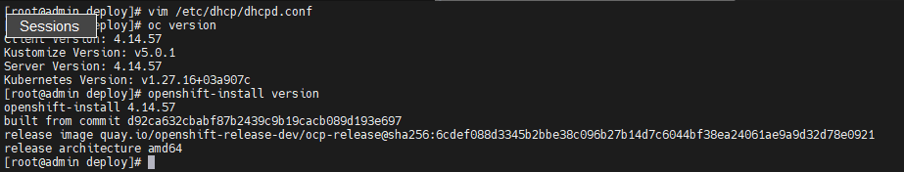
Next step generate the install-config.yaml ( I copied form official document and did some changes according my env )
apiVersion: v1 -- apiVersion: The schema version of the config file.
baseDomain: example.com --## baseDomain: The DNS domain under which all cluster components will be created.
compute:
- hyperthreading: Enabled
name: worker
replicas: 0
controlPlane:
hyperthreading: Enabled
name: master
replicas: 3
metadata:
name: test #--The name of the OpenShift cluster. This will prefix cluster subdomains:test.example.com, api.test.example.com, apps.test.example.com,
networking:
clusterNetwork:
- cidr: 10.128.0.0/14
hostPrefix: 23
networkType: OpenShiftSDN
serviceNetwork:
- 172.30.0.0/16
platform:
none: {}
fips: false
pullSecret: '{"auths": ...}'
sshKey: 'ssh-ed25519 AAAA...'

Step: 2
Creating the manifests file run following command
Openshift-install create manifests –dir=<installation_dir>
Step:3
Create the Ignition configuration files, run the following command from the directory that contains the installation program:
# openshift-install create ignition-configs --dir <installation_directory>
Ignition config files are created for the bootstrap, control plane, and compute nodes in the installation directory. The kubeadmin-password and kubeconfig files are created in the ./<installation_directory>/auth directory:
.
├── auth
│ ├── kubeadmin-password
│ └── kubeconfig
├── bootstrap.ign
├── master.ign
├── metadata.json
└── worker.ign

Step 4: Hosting the ignition files on webserver that can installation access them
## install the apache webserver
$ sudo dnf install –y httpd
## Change the default port of httpd
Vim /etc/http/httpd.conf
## Edit the listenport
80 8080
## add http or port on firewall
$ sudo firewall-cmd –add-port=8080/tcp –perment
$ sudo firewall-cmd –reload

## Upload the bootstrap, control plane, and compute node Ignition config files that the installation program created to your HTTP server. Note the URLs of these files.
$ cp *.ign /var/www/html/
## start and enable the service
$ sudo systemctl enable –now httpd
And test connectivity
$ curl –k localhost:8080/bootstrap.ign
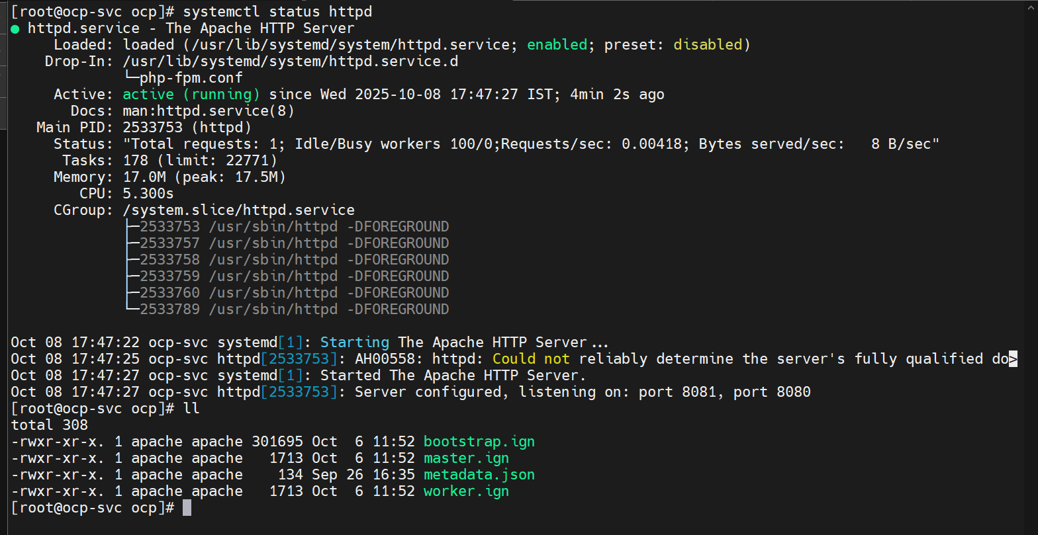
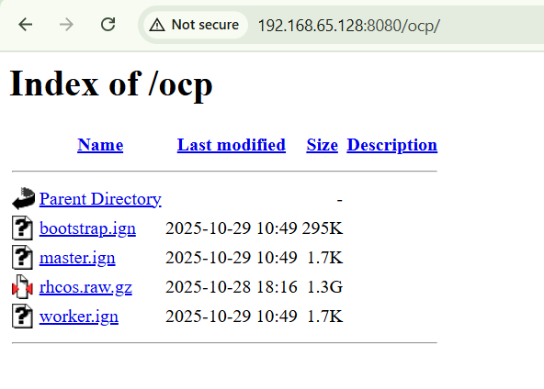
## Preparing Bootstrap Node
To install OpenShift Container Platform on bare metal infrastructure that you provision, you must install Red Hat Enterprise Linux CoreOS (RHCOS) on the machines

Installing RHCOS by using an ISO image
You can use an ISO image to install RHCOS on the machines.
Prerequisites
- You have created the Ignition config files for your cluster.
- You have configured a suitable network, DNS and load balancing infrastructure.
- You have an HTTP server that can be accessed from your computer, and from the machines that you create.
- You have reviewed the Advanced RHCOS installation configuration section for different ways to configure features, such as networking and disk partitioning.
Step2: From the installation host, validate that the Ignition config files are available on the URLs. The following example gets the Ignition config file for the bootstrap node:
curl -k http://<HTTP_server>/bootstrap.ign
step3: Run the coreos-installer command and specify the options that meet your installation requirements. At a minimum, you must specify the URL that points to the Ignition config file for the node type, and the device that you are installing to:
sudo coreos-installer install --ignition-url=http://<HTTP_server>/bootstrap.ign <device> --insecure –insecure-ignition
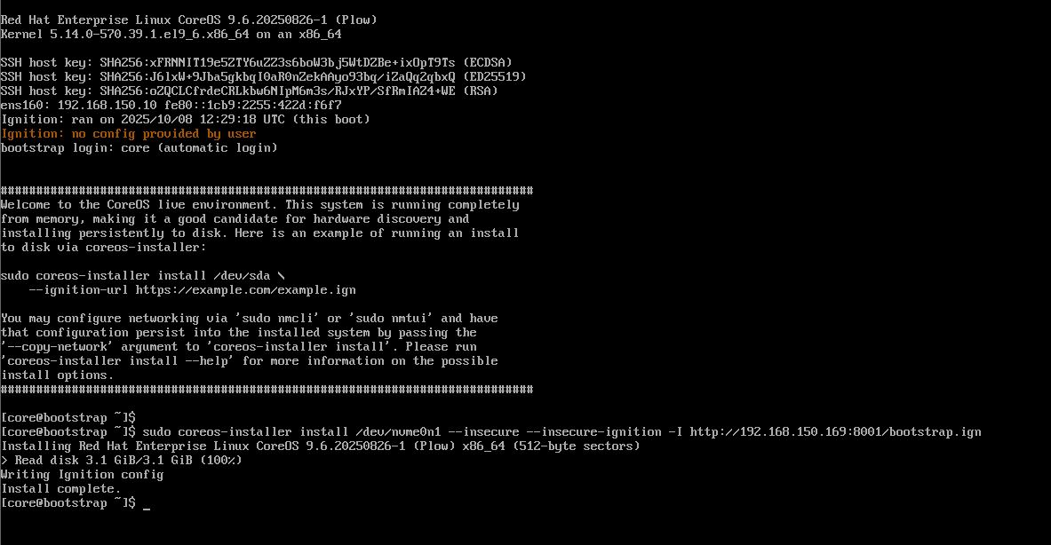
Step4:- Do same steps for master
sudo coreos-installer install --ignition-url=http://<HTTP_server>/master.ign <device> --insecure –insecure-ignition
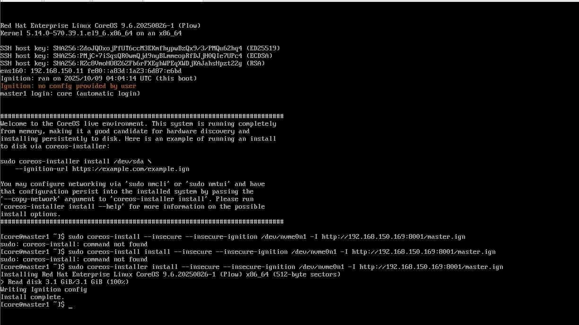

Reboot the both systems

## Waiting for the bootstrap process to complete
The OpenShift Container Platform bootstrap process begins after the cluster nodes first boot into the persistent RHCOS environment that has been installed to disk. The configuration information provided through the Ignition config files is used to initialize the bootstrap process and install OpenShift Container Platform on the machines. You must wait for the bootstrap process to complete.
Step-1 Monitor the bootstrap process:
# openshift-install --dir=<installation_dir> wait-for bootstrap-complete --log-level=debug

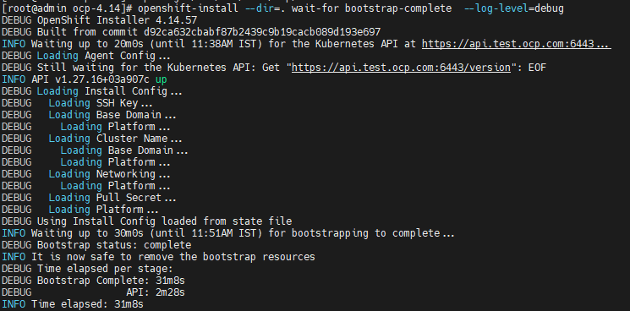

After the bootstrap process is complete, remove the bootstrap machine from the load balancer. 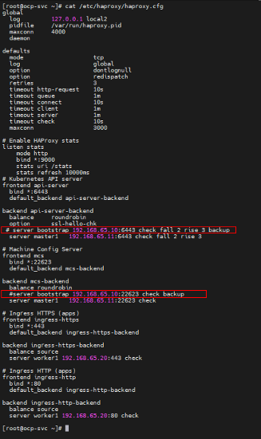

Logging in to the cluster by using the CLI

export KUBECONFIG=<installation_directory>/auth/kubeconfig
Verify you can run oc commands successfully using the exported configuration by running the following command:
$ oc whoami
Output
system:admin
Approving the certificate signing requests for your machines:
When you add machines to a cluster, two pending certificate signing requests (CSRs) are generated for each machine that you added. That we need to approve them manually
# oc get csr
If their any pending request then we approve using following command
oc adm certificate approve <csr_id>

Initial Operator configuration
After the control plane initializes, you must immediately configure some Operators so that they all become available.
oc get clusteroperators

wait until all operators become true

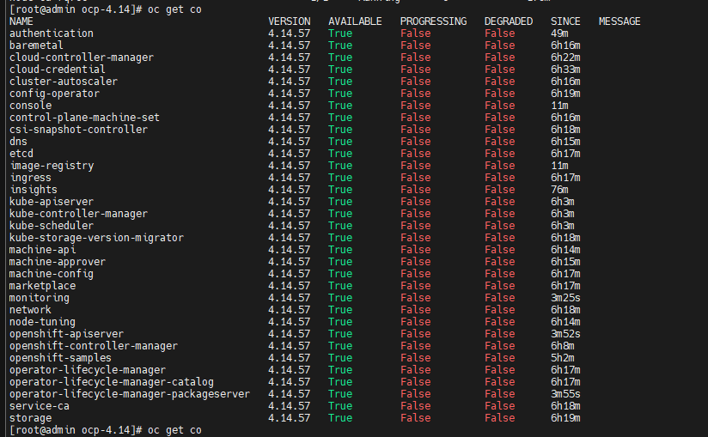

Once all cluster operators get true run final command to complete installation of cluster
openshift-install –dir=<installation_dir> wait-for install-complete –log-level=debug
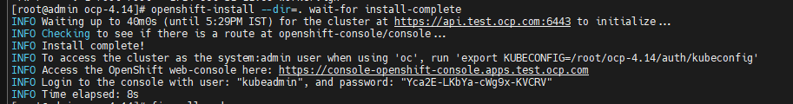
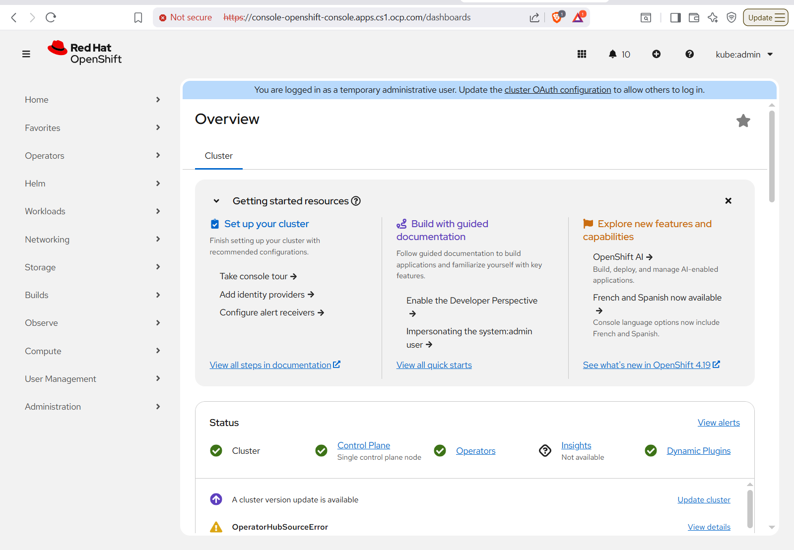

Apply self-signed wildcard TLS certificate for OpenShift
1) Generate key and self-signed cert
mkdir -p /tmp/ocp-cert && cd /tmp/ocp-cert
# Generate a 4096-bit private key openssl genrsa -out wildcard.key 4096
# Generate a self-signed cert valid for 2 years; put your name in O= field.
# Replace "Your Name" with your actual name (no slashes). Keep CN and SAN for the domain.
openssl req -x509 -new -nodes -key wildcard.key -sha256 -days 730
-out wildcard.crt
-subj "/CN=*.apps.test.ocp.com/O=Kishor/OU=IT"
-addext "subjectAltName=DNS:*.apps.test.ocp.com,DNS:apps.test.ocp.com"

Notes: - CN=*.apps.test.ocp.com ensures the router will serve the cert for oauth-openshift.apps.test.ocp.com and other app routes. - Put your name in O= (Organization) or OU= if you want your personal name recorded.
2) Create the TLS secret in openshift-ingress
oc create secret tls custom-router-certs \
-n openshift-ingress \
--cert=wildcard.crt \
--key=wildcard.key
# Verify the secret
oc get secret custom-router-certs -n openshift-ingress -o yaml
3) Patch the default IngressController to use the secret
oc patch ingresscontroller default \
-n openshift-ingress-operator \
--type=merge \
-p '{"spec":{"defaultCertificate":{"name":"custom-router-certs"}}}'
4) Wait for router pods to roll and verify
# Watch router pods restart
oc get pods -n openshift-ingress -w
# When pods are Running, verify certificate from a host
openssl s_client -connect oauth-openshift.apps.test.ocp.com:443 -showcerts \
| openssl x509 -noout -subject -issuer -dates -text
# Quick TLS subject check
openssl s_client -connect oauth-openshift.apps.test.ocp.com:443 -servername oauth-openshift.apps.test.ocp.com \
2>/dev/null | openssl x509 -noout -subject -issuer -dates

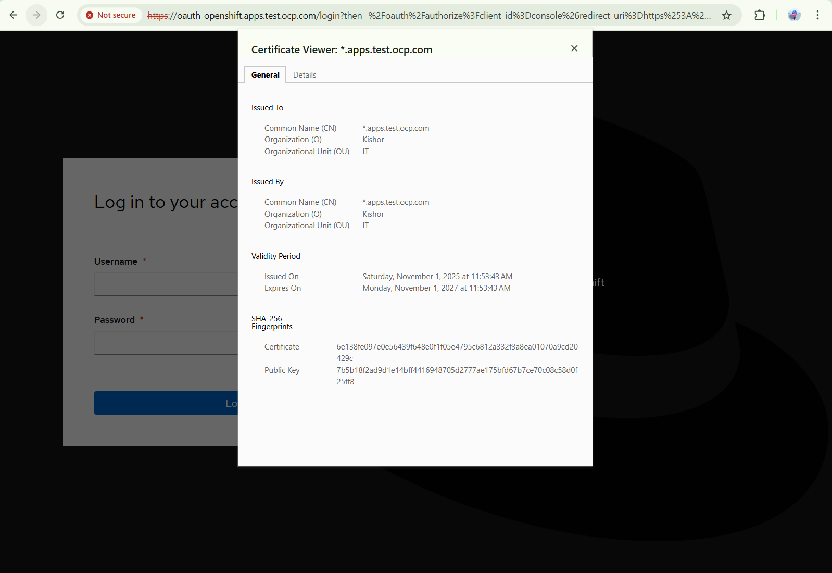

Create OpenShift users: kishor & prajwal
Purpose: Create two local users in OpenShift using the HTPasswd identity provider: - kishor — cluster-admin privileges - prajwal — limited/developer privileges (project test)

1. Install htpasswd utility
sudo dnf install httpd-tools -y

2. Create the htpasswd file and users
Create the file and add kishor (run once with -c to create the file):
# create file and add kishor (bcrypt hashed)
htpasswd -c -B -b users.htpasswd kishor <user_login_password>
Add prajwal (do NOT use -c again):
htpasswd -B -b users.htpasswd prajwal <user_login_password>
Verify:
cat users.htpasswd
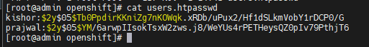

3. Create a Kubernetes secret to store the htpasswd data
oc create secret generic htpass-secret \
--from-file=htpasswd=users.htpasswd \
-n openshift-config
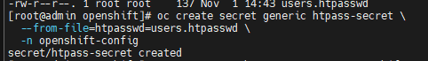
oc get secret htpass-secret -n openshift-config -o yaml
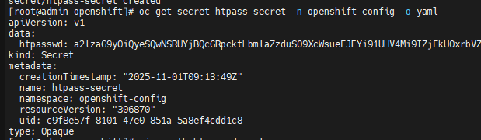

4. Configure OAuth in OpenShift to use the HTPasswd provider
Create a file oauth-htpasswd.yaml with the following content:
apiVersion: config.openshift.io/v1
kind: OAuth
metadata:
name: cluster
spec:
identityProviders:
- name: localusers
mappingMethod: claim
type: HTPasswd
htpasswd:
fileData:
name: htpass-secret
Apply it:
oc apply -f oauth-htpasswd.yaml
Wait for the authentication components to reconcile (1–2 minutes). To check:
oc get pods -n openshift-authentication
oc get oauth cluster -o yaml

5. Grant roles to users
Grant cluster-admin to admin:
oc adm policy add-cluster-role-to-user cluster-admin kishor
Login with CLI
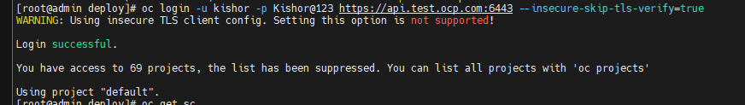
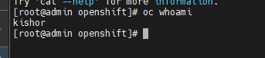
Login with GUI mode
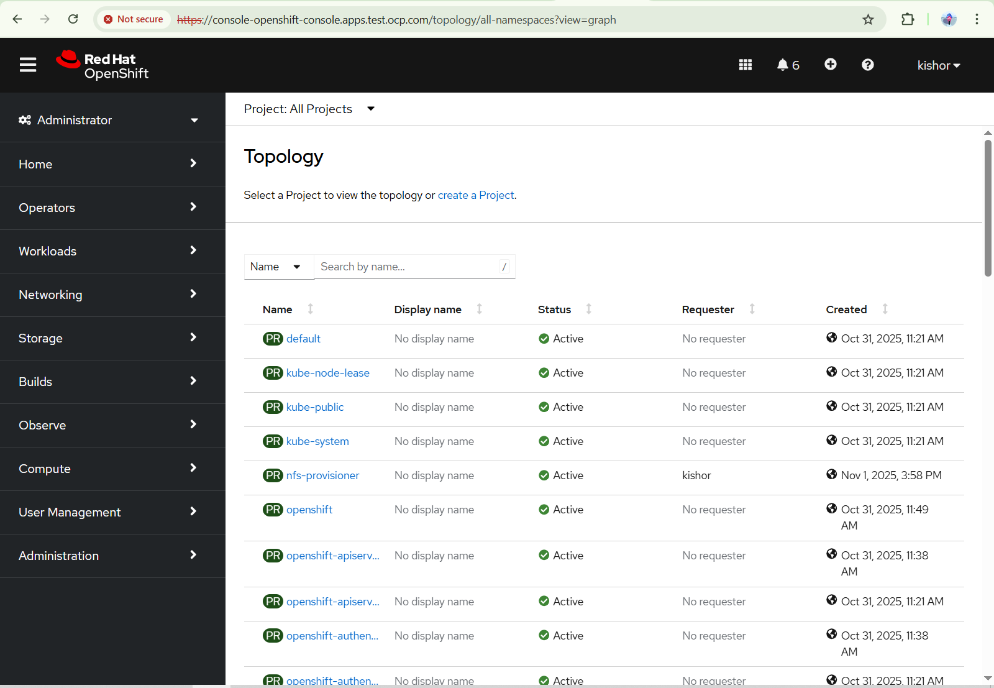
Create a test project and grant prajwal the edit role on it:
oc new-project test
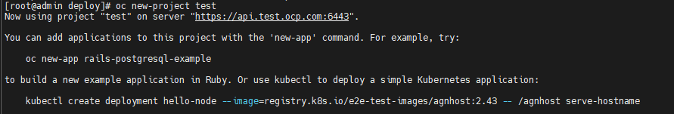
oc adm policy add-role-to-user edit test -n test
Login with CLI
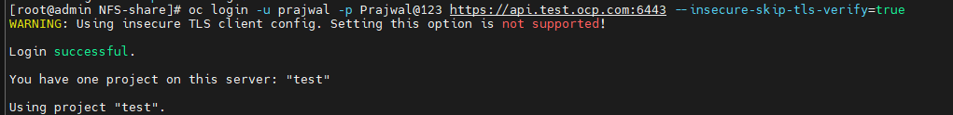

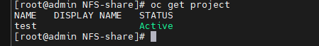
Login with GUI mode
