1. Write a PERL script to find the factorial of a number.

print "Enter the number: ";

$number = <>;

$fact = 1;

for( $i = 1; $i <= $number ; $i=$i+1 ){

$fact = $fact*$i;

}

print "Factorial of $number is: $fact";

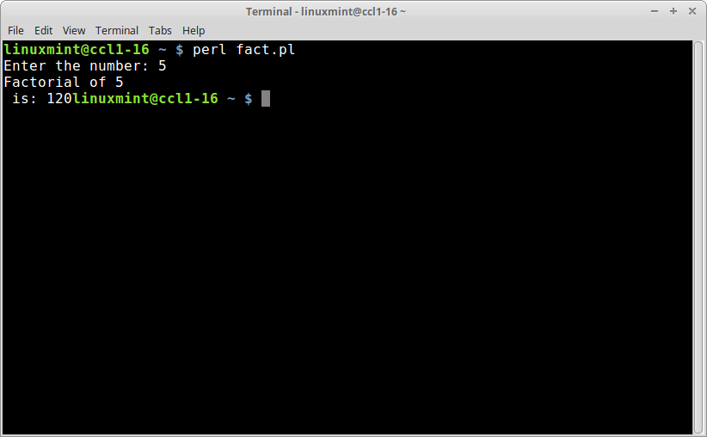

1. Start your web page with an <html> tag

i) Add a heading.

ii) Add a title.

iii) Start the <body> section.

iv) Start a new paragraph with multiple lines.

Create Hyperlinks:

1. Within the HTML document.
2. To another URL.
3. To a file that can be rendered in the browser.

<!DOCTYPE html>

<html>

<h1>Heading</h1>

<title> Title </title>

<body>

<p>

Paragraph with multiple lines

<br>line 1

<br>line 2

<br>line 3

</p>

<a name="Internet_technology"></a>

Click<a href="#Internet_Technology"> here </a>for hyperlink within same document

<br>Click<a href="http://www.yahoo.com#YahoosAnchor"> here </a>for hyperlink to another URL

<br>Click<a href="/home/linuxmint/Desktop/abcd.png"> here </a>for hyperlink to a local png image file

</body>

