1. Create a webpage that accepts essay title and content of the essay. Provide hint to the user regarding how many characters remain at the time of typing title as well as content.

<!DOCTYPE html>

<html>

<head>

    <title>Essay Input</title>

    <script>

        function updateCount(id, max) {

            let remaining = max - document.getElementById(id).value.length;

            document.getElementById(id + "Count").innerText = remaining + " characters remaining";

        }

    </script>

</head>

<body>

    <h2>Essay Input</h2>

    <input type="text" id="title" maxlength="100" oninput="updateCount('title', 100)">

    <p id="titleCount">100 characters remaining</p>

    <textarea id="content" maxlength="1000" oninput="updateCount('content', 1000)"></textarea>

    <p id="contentCount">1000 characters remaining</p>

</body>

</html>

Output:

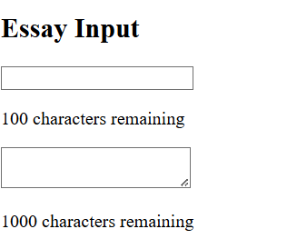

2) Create a webpage that accepts personal information of the user as shown below.

User can also add a new language if it is not available in the list by clicking on Add

Language link

<!DOCTYPE html>

<html>

<head>

    <title>Personal Info</title>

    <script>

        function addLanguage() {

            let newLang = prompt("Enter new language:");

            if (newLang) {

                let option = new Option(newLang, newLang);

                document.getElementById("language").add(option);

            }

        }

    </script>

</head>

<body>

    <h2>Personal Information</h2>

    <input type="text" id="name" placeholder="Name">

    <input type="email" id="email" placeholder="Email">

    <input type="tel" id="phone" placeholder="Phone">

    <select id="language">

        <option>English</option>

        <option>Spanish</option>

    </select>

    <button onclick="addLanguage()">Add Language</button>

</body>

</html>

Output:

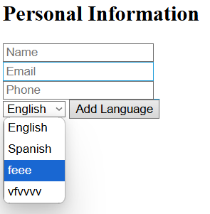

3) Suppose we want to read some text file (introduction of Ajax) of Ajax and call it in our

web-page on the click of some button using AJAX.

<!DOCTYPE html>

<html>

<body>

  <div id="demo">

    <h1>The XMLHttpRequest Object</h1>

    <button type="button" onclick="loadDoc()">Change Content</button>

  </div>

  <script>

    function loadDoc() {

      var xhttp = new XMLHttpRequest();

      xhttp.onreadystatechange = function () {

        if (this.readyState == 4 && this.status == 200) {

          document.getElementById("demo").innerHTML =

            this.responseText;

        }

      };

      xhttp.open("GET", "ajax_intro .txt", true);

      xhttp.send();

    }

  </script>

</body>

</html>

ajax_intro.txt

AJAX

AJAX is not a programming language.

AJAX is a technique for accessing web servers from a web page.

AJAX stands for Asynchronous JavaScript And XML.

Output:

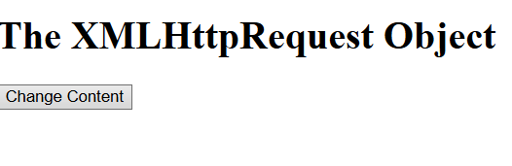



4) Create a web-page to read Catlog.xml file and read it using ajax

<!DOCTYPE html>

<html lang="en">

  <head>

    <meta charset="UTF-8" />

    <meta name="viewport" content="width=device-width, initial-scale=1.0" />

    <title>Read XML using AJAX</title>

    <style>

      body {

        font-family: Arial, sans-serif;

        margin: 20px;

      }

      table {

        width: 100%;

        border-collapse: collapse;

        margin-top: 20px;

      }

      th,

      td {

        border: 1px solid black;

        padding: 10px;

        text-align: left;

      }

      th {

        background-color: #f2f2f2;

      }

    </style>

  </head>

  <body>

    <h2>CD Catalog</h2>

    <button onclick="loadXML()">Load Catalog</button>

    <table id="cdTable">

      <tr>

        <th>Title</th>

        <th>Artist</th>

        <th>Country</th>

        <th>Company</th>

        <th>Price</th>

        <th>Year</th>

      </tr>

    </table>

    <script>

      function loadXML() {

        let xhttp = new XMLHttpRequest();

        xhttp.onreadystatechange = function () {

          if (this.readyState == 4 && this.status == 200) {

            displayXML(this);

          }

        };

        xhttp.open("GET", "catlog.xml", true);

        xhttp.send();

      }

      function displayXML(xml) {

        let xmlDoc = xml.responseXML;

        let table = document.getElementById("cdTable");

        let cds = xmlDoc.getElementsByTagName("CD");

        for (let i = 0; i < cds.length; i++) {

          let row = table.insertRow(-1);

          row.insertCell(0).innerText =

            cds[i].getElementsByTagName("TITLE")[0].textContent;

          row.insertCell(1).innerText =

            cds[i].getElementsByTagName("ARTIST")[0].textContent;

          row.insertCell(2).innerText =

            cds[i].getElementsByTagName("COUNTRY")[0].textContent;

          row.insertCell(3).innerText =

            cds[i].getElementsByTagName("COMPANY")[0].textContent;

          row.insertCell(4).innerText =

            cds[i].getElementsByTagName("PRICE")[0].textContent;

          row.insertCell(5).innerText =

            cds[i].getElementsByTagName("YEAR")[0].textContent;

        }

      }

    </script>

  </body>

</html>

catlog.xml

<CATALOG>

    <CD>

        <TITLE>Empire Burlesque</TITLE>

        <ARTIST>Bob Dylan</ARTIST>

        <COUNTRY>USA</COUNTRY>

        <COMPANY>Columbia</COMPANY>

        <PRICE>10.90</PRICE>

        <YEAR>1985</YEAR>

    </CD>

    <CD>

        <TITLE>Hide Your Heart</TITLE>

        <ARTIST>Bonnie Tyler</ARTIST>

        <COUNTRY>UK</COUNTRY>

        <COMPANY>CBS Records</COMPANY>

        <PRICE>9.90</PRICE>

        <YEAR>1988</YEAR>

    </CD>

</CATALOG>

Output:

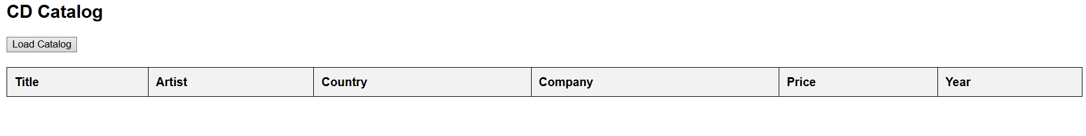

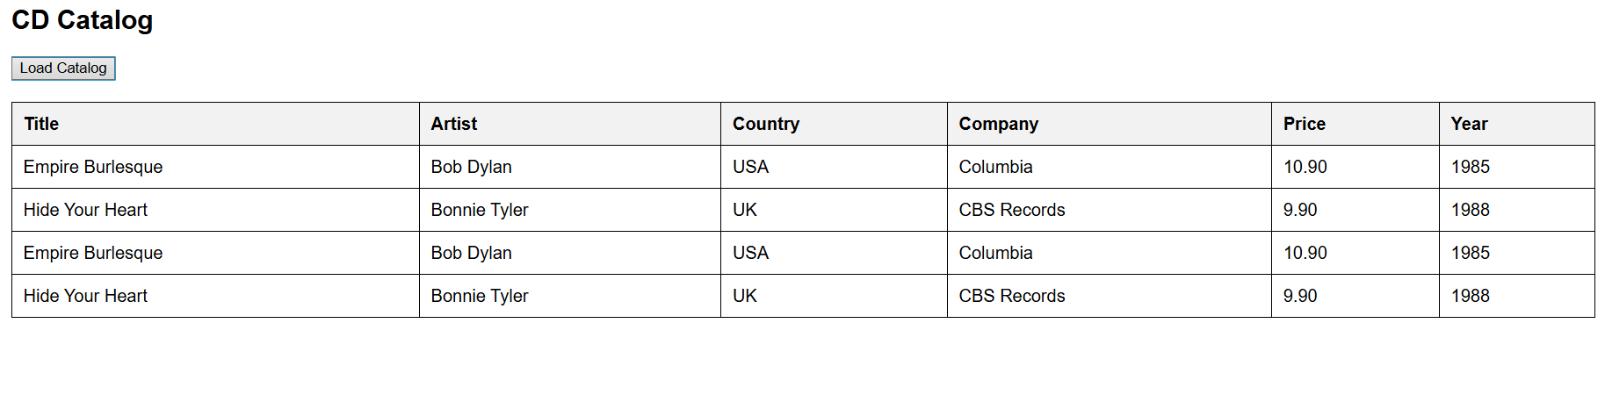

5) Create a web-page to read stud.json file and call it using

AJAX technology.

<!DOCTYPE html>

<html>

<head>

    <title>Load Student JSON</title>

    <script>

        function loadJSON() {

            fetch("stud.json").then(response => response.json())

                .then(data => {

                    document.getElementById("content").innerHTML = `

                    <p>Name: ${data.name}</p>

                    <p>Class: ${data.class}</p>

                    <p>Email: ${data.email}</p>`;

                });

        }

    </script>

</head>

<body>

    <button onclick="loadJSON()">Load Student Info</button>

    <div id="content"></div>

</body>

</html>

stud.json

{

    "name":"Zeel Contractor",

    "class": 10,

    "email":"zeel4u@gmail.com"

}

Output:



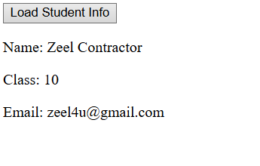

6) Create a web-page to read Employee JSON object(Emp.json) using AJAX.

(Combined AJAX, JSON and jQuery)

<!DOCTYPE html>

<html>

<head>

    <title>Load Employee JSON</title>

    <script>

        function loadEmployee() {

            fetch("emp.json").then(response => response.json())

                .then(data => {

                    document.getElementById("content").innerHTML = `

                    <p>ID: ${data.Empid}</p>

                    <p>Name: ${data.Name}</p>

                    <p>Salary: ${data.Salary}</p>`;

                });

        }

    </script>

</head>

<body>

    <button onclick="loadEmployee()">Load Employee Info</button>

    <div id="content"></div>

</body>

</html>

emp.json

{

    "Empid":"E10001",

    "Name":"Jaymin A. Swami",

    "DOJ":"1/Jan/2006",

    "Salary":50000,

    "Email":"jayminswami@gmail.com"

}

Output:

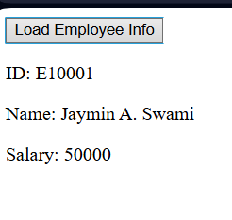

7) Create a JSON file representing some students(stud_list.json). Read that file using

AJAX and displays its content in HTML table on the ready event of the document

using jQuery.

<!DOCTYPE html>

<html lang="en">

<head>

    <meta charset="UTF-8">

    <meta name="viewport" content="width=device-width, initial-scale=1.0">

    <title>Student List</title>

    <script src="https://code.jquery.com/jquery-3.6.0.min.js"></script>

    <style>

        table {

            width: 100%;

            border-collapse: collapse;

            margin-top: 20px;

        }

        th,

        td {

            border: 1px solid black;

            padding: 10px;

            text-align: left;

        }

        th {

            background-color: #f2f2f2;

        }

    </style>

</head>

<body>

    <h2>Student List</h2>

    <table id="studentTable">

        <tr>

            <th>Name</th>

            <th>City</th>

            <th>Contact</th>

            <th>Email</th>

        </tr>

    </table>

    <script>

        $(document).ready(function () {

            $.getJSON("stud_list.json", function (data) {

                let table = $("#studentTable");

                $.each(data, function (key, student) {

                    table.append(`<tr><td>${student.name}</td><td>${student.city}</td><td>${student.contact}</td><td>${student.email}</td></tr>`);

                });

            });

        });

    </script>

</body>

</html>

stud_list.json

{

    "1": {

        "name": "Rahil",

        "city": "Surat",

        "contact": 8942382352,

        "email": "rahil@yahoo.co.in"

    },

    "2": {

        "name": "Dhaval",

        "city": "Baroda",

        "contact": 6587451234,

        "email": "dhval412@hotmail.com"

    },

    "3": {

        "name": "Aaman",

        "city": "Mumbai",

        "contact": 7854121245,

        "email": "aman123@gmail.com"

    }

}

Output:

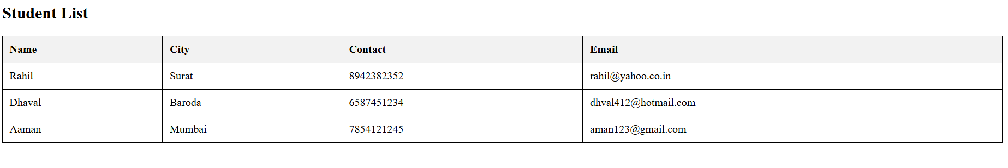

8) Create a “E-Commerce website for Electronics” using the following technologies:

1. HTML and CSS

2. Bootstrap

3. JQuery and JavaScript

4. JSON and AJAX Use these technologies wherever required.

a. Create a Registration page (Perform all validation using jQuery)

b. Create a JSON file for all product Catalogue (includes ProdName, Price, Image)

c. Display the Product Catalogue in HTML using jQuery by fetching data from JSON.

Index.html

<html lang="en">

<head>

    <meta charset="UTF-8">

    <meta name="viewport" content="width=device-width, initial-scale=1.0">

    <title>Electronics Store</title>

    <link rel="stylesheet" href="https://cdn.jsdelivr.net/npm/bootstrap@5.3.0/dist/css/bootstrap.min.css">

    <script src="https://code.jquery.com/jquery-3.6.0.min.js"></script>

    <script src="https://cdn.jsdelivr.net/npm/bootstrap@5.3.0/dist/js/bootstrap.bundle.min.js"></script>

    <script src="script.js" defer></script>

    <script src="https://kit.fontawesome.com/a076d05399.js" crossorigin="anonymous"></script>

    <script src="https://cdnjs.cloudflare.com/ajax/libs/font-awesome/6.4.2/js/all.min.js"

        crossorigin="anonymous"></script>

    <style>

        .product-image {

            height: 200px;

            object-fit: cover;

        }

    </style>

</head>

<body>

    <nav class="navbar navbar-expand-lg navbar-dark bg-dark">

        <div class="container">

            <a class="navbar-brand" href="index.html">Electronics Store</a>

            <button class="navbar-toggler" type="button" data-bs-toggle="collapse" data-bs-target="#navbarNav">

                <span class="navbar-toggler-icon"></span>

            </button>

            <div class="collapse navbar-collapse" id="navbarNav">

                <ul class="navbar-nav ms-auto">

                    <li class="nav-item"><a class="nav-link text-white" href="index.html">Home</a></li>

                    <li class="nav-item"><a class="nav-link text-white" href="about.html">About</a></li>

                    <li class="nav-item"><a class="nav-link text-white" href="contact.html">Contact</a></li>

                    <li class="nav-item"><a class="nav-link text-white" href="register.html">Register</a></li>

                    <li class="nav-item"><a class="nav-link text-white" href="#" id="view-cart"><i

                                class="fa-solid fa-cart-plus"></i> Cart (<span id="cart-count">0</span>)</a></li>

                </ul>

            </div>

        </div>

    </nav>

    <header class="bg-primary text-white text-center py-5 bg-dark">

        <h1>Welcome to Electronics Store</h1>

        <p>Your one-stop shop for the latest electronics</p>

    </header>

    <div class="container mt-4 text-center">

        <div class="row">

            <main class="col-md-12">

                <h2 class="text-center">Product Catalogue</h2>

                <div id="product-list" class="row mt-3"></div>

            </main>

        </div>

    </div>

    <script>

    </script>

</body>

</html>

register.html

<!DOCTYPE html>

<html lang="en">

<head>

    <meta charset="UTF-8" />

    <meta name="viewport" content="width=device-width, initial-scale=1.0" />

    <title>Registration Form</title>

    <style>

        body {

            font-family: "Segoe UI", Tahoma, Geneva, Verdana, sans-serif;

            /* Modern font */

            background: linear-gradient(135deg,

                    #e0f2fe,

                    #d1c4e9);

            /* Gradient background */

            display: flex;

            justify-content: center;

            align-items: center;

            height: 100vh;

            margin: 0;

        }

        .registration-form {

            background-color: #ffffff;

            padding: 30px;

            border-radius: 12px;

            box-shadow: 0 8px 16px rgba(0, 0, 0, 0.1);

            width: 400px;

            /* Increased width */

        }

        .registration-form h2 {

            text-align: center;

            margin-bottom: 30px;

            color: #374151;

            /* Darker text */

        }

        .form-group {

            margin-bottom: 20px;

        }

        .form-group label {

            display: block;

            margin-bottom: 8px;

            color: #4b5563;

            font-weight: 600;

        }

        .form-group input,

        .form-group select {

            width: calc(100% - 20px);

            padding: 12px;

            border: 1px solid #e5e7eb;

            border-radius: 8px;

            box-sizing: border-box;

            transition: border-color 0.3s ease;

        }

        .form-group input:focus,

        .form-group select:focus {

            outline: none;

            border-color: #6366f1;

            /* Focus color */

            box-shadow: 0 0 8px rgba(99, 102, 241, 0.3);

        }

        .form-group button {

            background: linear-gradient(135deg,

                    #6366f1,

                    #818cf8);

            /* Gradient button */

            color: white;

            padding: 14px 20px;

            border: none;

            border-radius: 8px;

            cursor: pointer;

            width: 100%;

            font-weight: 600;

            transition: background 0.3s ease;

        }

        .form-group button:hover {

            background: linear-gradient(135deg, #4f46e5, #6b7280);

        }

        .error-message {

            color: #ef4444;

            font-size: 0.9em;

            margin-top: 5px;

        }

        @media (max-width: 480px) {

            .registration-form {

                width: 90%;

                /* Responsive width */

                padding: 20px;

            }

        }

    </style>

</head>

<body>

    <div class="registration-form">

        <h2>Registration</h2>

        <form id="registrationForm">

            <div class="form-group">

                <label for="firstName">First Name:</label>

                <input type="text" id="firstName" name="firstName" required />

                <span id="firstNameError" class="error-message"></span>

            </div>

            <div class="form-group">

                <label for="lastName">Last Name:</label>

                <input type="text" id="lastName" name="lastName" required />

                <span id="lastNameError" class="error-message"></span>

            </div>

            <div class="form-group">

                <label for="email">Email:</label>

                <input type="email" id="email" name="email" required />

                <span id="emailError" class="error-message"></span>

            </div>

            <div class="form-group">

                <label for="password">Password:</label>

                <input type="password" id="password" name="password" required />

                <span id="passwordError" class="error-message"></span>

            </div>

            <div class="form-group">

                <label for="confirmPassword">Confirm Password:</label>

                <input type="password" id="confirmPassword" name="confirmPassword" required />

                <span id="confirmPasswordError" class="error-message"></span>

            </div>

            <div class="form-group">

                <label for="gender">Gender:</label>

                <select id="gender" name="gender">

                    <option value="male">Male</option>

                    <option value="female">Female</option>

                    <option value="other">Other</option>

                </select>

            </div>

            <div class="form-group">

                <button type="submit">Register</button>

            </div>

        </form>

    </div>

    <script>

        // JavaScript validation remains the same

    </script>

</body>

</html>

products.json

[

    { "ProdName": "Smartphone", "Price": "$699", "Image": "i.jpg" },

    { "ProdName": "Laptop", "Price": "$1299", "Image": "https://avatars.mds.yandex.net/i?id=04447c133f6039902db57a562813764b-5420434-images-thumbs&n=13" },

    { "ProdName": "Smartwatch", "Price": "$199", "Image": "https://www.gsconto.com/files/post/190/iWatch2-17.jpeg" },

    { "ProdName": "Smartphone", "Price": "$699", "Image": "https://frankfurt.apollo.olxcdn.com/v1/files/bo3a22cmr4701-KZ/image" },

    { "ProdName": "Laptop", "Price": "$1299", "Image": "https://avatars.mds.yandex.net/i?id=04447c133f6039902db57a562813764b-5420434-images-thumbs&n=13" },

    { "ProdName": "Smartwatch", "Price": "$199", "Image": "https://www.gsconto.com/files/post/190/iWatch2-17.jpeg" }

]

script.js

$(document).ready(function() {

    // Registration Form Validation

    $('#register-form').submit(function(event) {

        event.preventDefault();

        let isValid = true;

        if ($('#fullname').val().trim() === '') {

            $('#name-error').text('Full Name is required');

            isValid = false;

        } else {

            $('#name-error').text('');

        }

        if ($('#email').val().trim() === '') {

            $('#email-error').text('Email is required');

            isValid = false;

        } else {

            $('#email-error').text('');

        }

        if ($('#password').val().trim().length < 6) {

            $('#password-error').text('Password must be at least 6 characters');

            isValid = false;

        } else {

            $('#password-error').text('');

        }

    });

    // Fetch and Display Products

    $.getJSON("products.json", function(data) {

        let productHTML = "";

        $.each(data, function(key, product) {

            productHTML += `

                <div class="col-md-4">

                    <div class="card mb-3">

                        <img src="${product.Image}" class="card-img-top" alt="${product.ProdName}">

                        <div class="card-body">

                            <h5 class="card-title">${product.ProdName}</h5>

                            <p class="card-text">Price: ${product.Price}</p>

                        </div>

                    </div>

                </div>`;

        });

        $('#product-list').html(productHTML);

    });

});

$(document).ready(function() {

    let cart = [];

    function updateCart() {

        $('#cart').empty();

        cart.forEach((item, index) => {

            $('#cart').append(`<li class="list-group-item">${item.name} - ${item.price} <button class="btn btn-danger btn-sm float-end remove-item" data-index="${index}">Remove</button></li>`);

        });

        $('#cart-count').text(cart.length);

    }

    $.getJSON("products.json", function(data) {

        let productHTML = "";

        $.each(data, function(key, product) {

            productHTML += `

                <div class="col-md-4">

                    <div class="card mb-3">

                        <img src="${product.Image}" class="card-img-top product-image" alt="${product.ProdName}">

                        <div class="card-body">

                            <h5 class="card-title">${product.ProdName}</h5>

                            <p class="card-text">Price: ${product.Price}</p>

                            <button class="btn border-black buy-btn" data-name="${product.ProdName}" data-price="${product.Price}">Add to Cart</button>

                            <button class="btn border-black sell-btn" data-name="${product.ProdName}" data-price="${product.Price}">Buy Now</button>

                        </div>

                    </div>

                </div>`;

        });

        $('#product-list').html(productHTML);

        $(document).on("click", ".buy-btn", function() {

            let productName = $(this).data("name");

            let productPrice = $(this).data("price");

            cart.push({ name: productName, price: productPrice });

            updateCart();

        });

        $(document).on("click", ".remove-item", function() {

            let index = $(this).data("index");

            cart.splice(index, 1);

            updateCart();

        });

    });

});

Output:

