Day 14

DIY

1.How to create Amazon EBS Lifecycle policy

Output Screenshot

Snopshot lifecyle policy

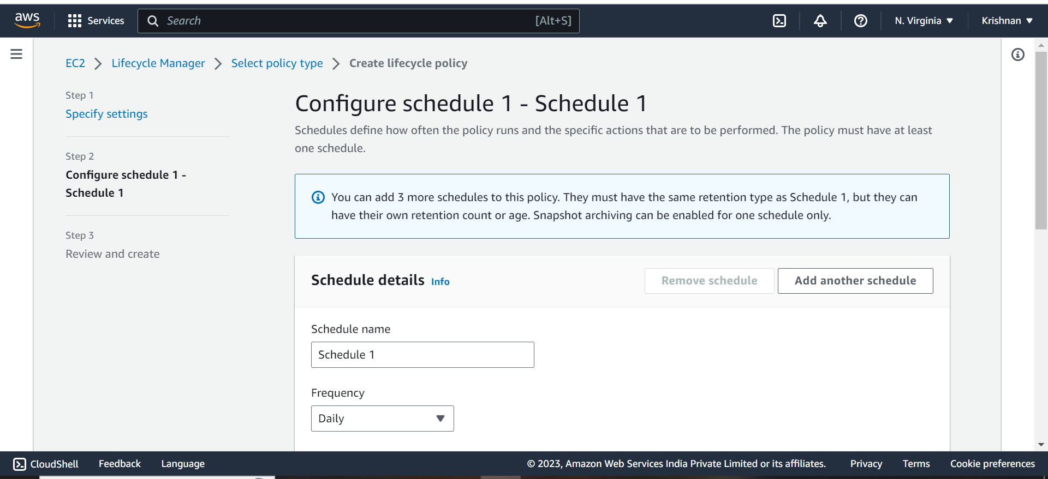

Review policy

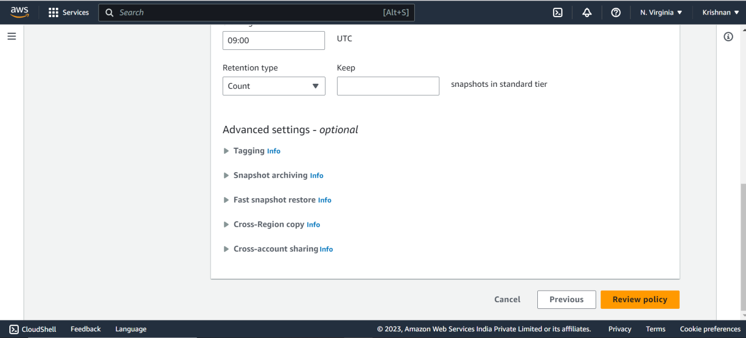

Created lifecyle policy

