Day 18-DIY

1. Enable the access log for your classic Load Balancer

Step 1: Go to the EC2 Console and Create a classic Load balancer

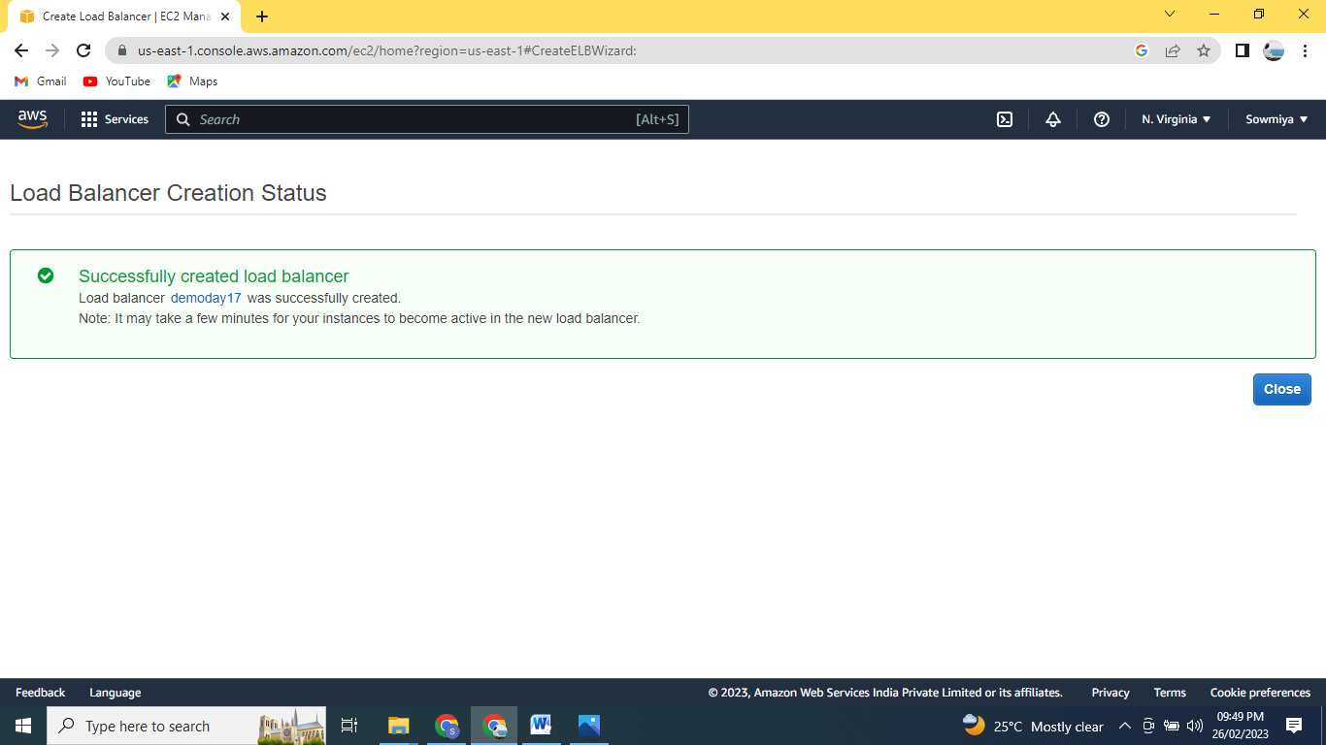

Step 2: Select the Load Balancer and got to the Attributes

Enable the log

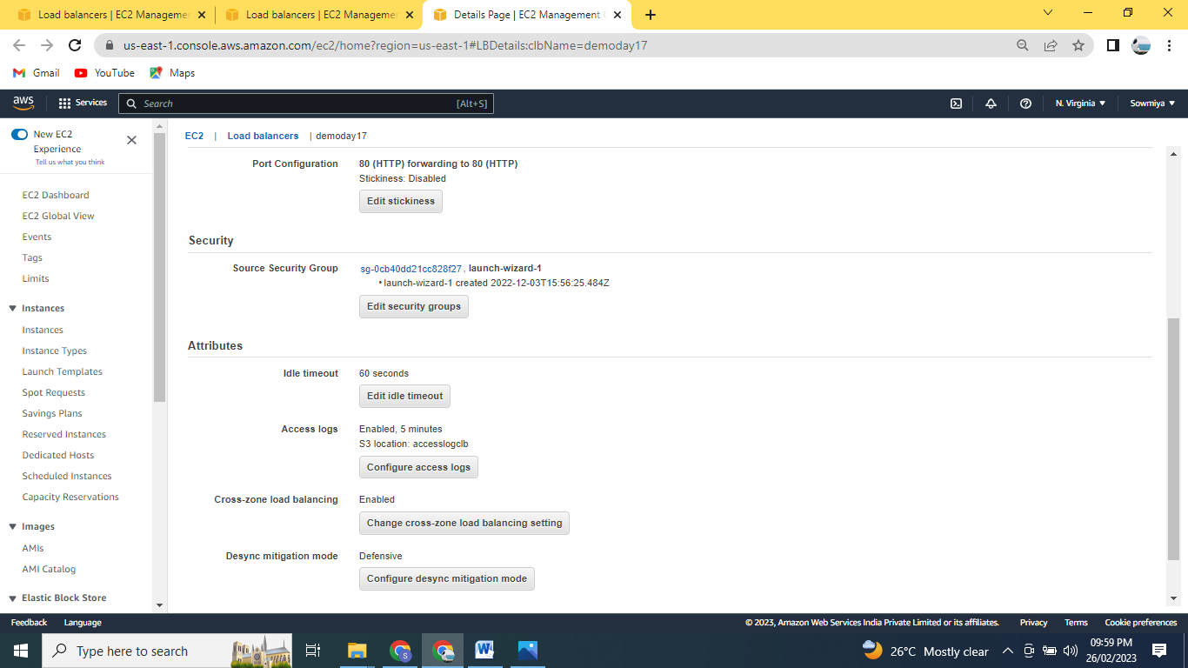

Step 3: go to the S3 and check the object and ,thepermission for the classic Load Balancer

