Day 19 DIY

1. Sticky sessions for your Application Load Balancer

Screen Shot;

EC2 Instance Dashboard

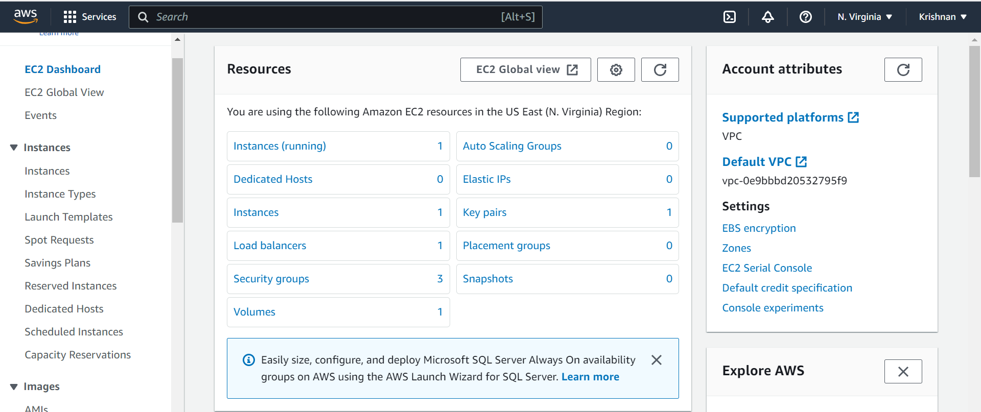

Create Application Load Balancer

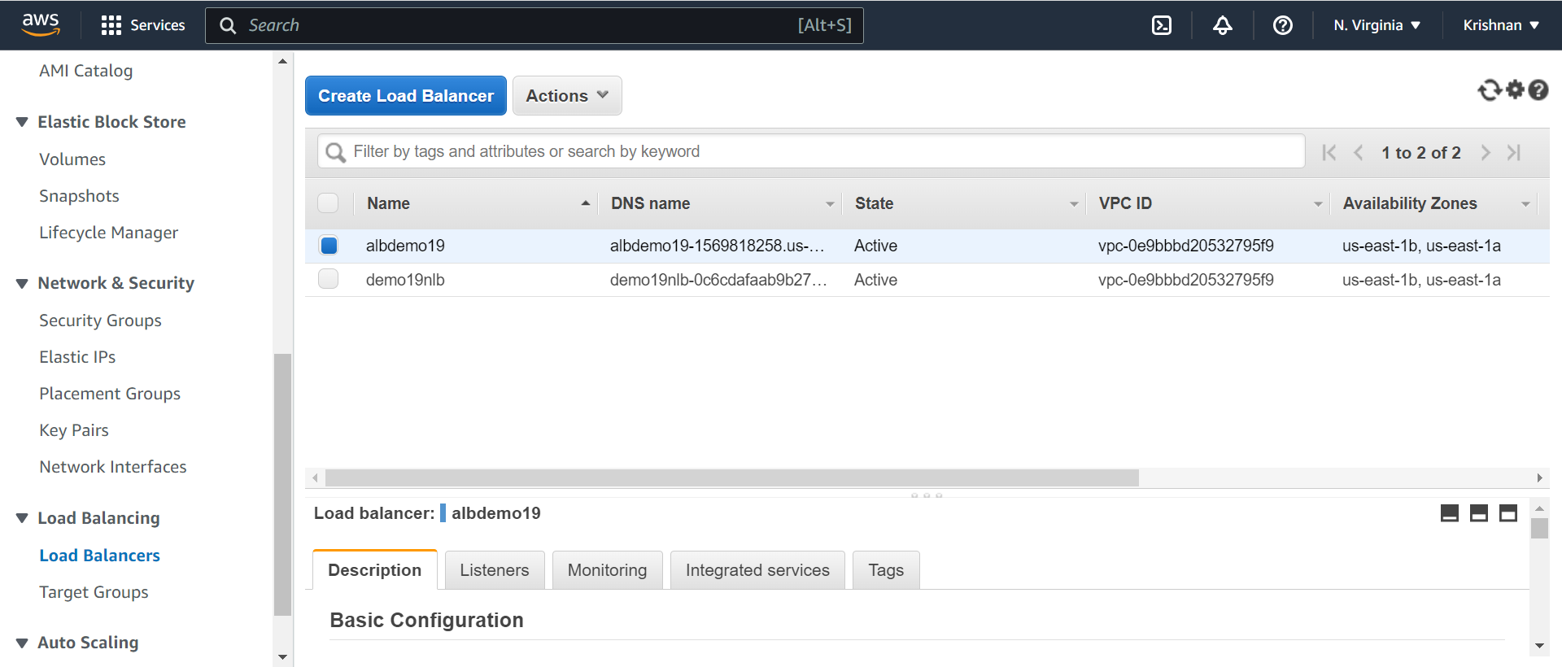

Create ALB target group

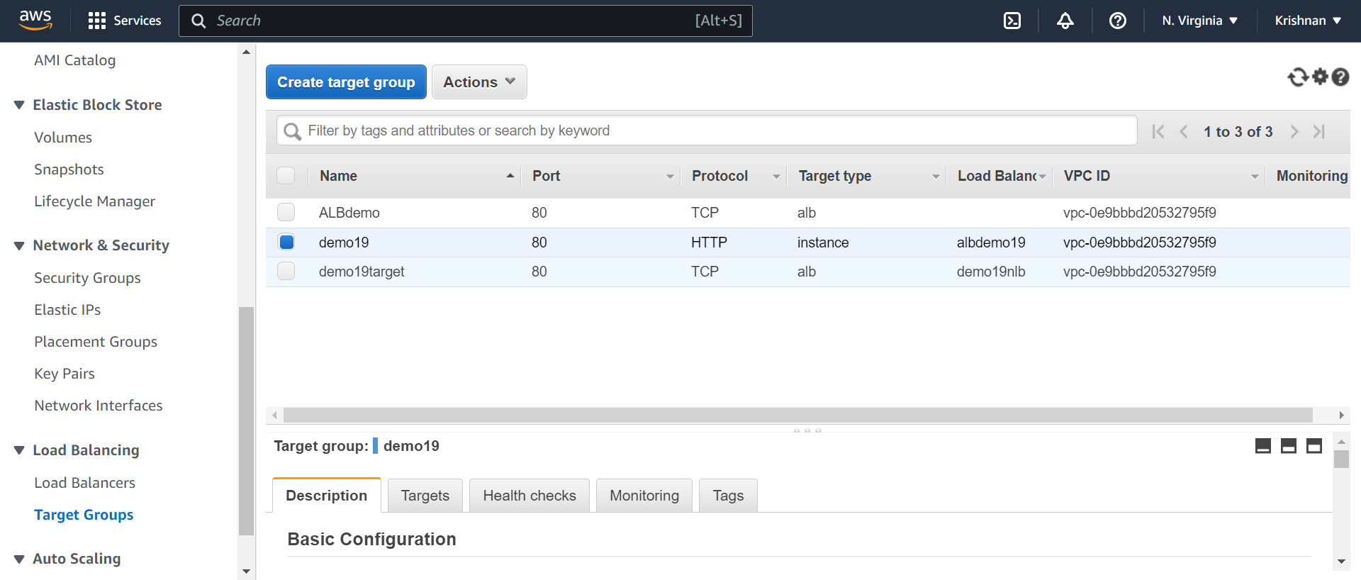

Create a Attributes stickiness size enabled

