Day 21 DIY

1. How to Transitioning to latency-based routing in Amazon Route 53

Create Hosted Zone

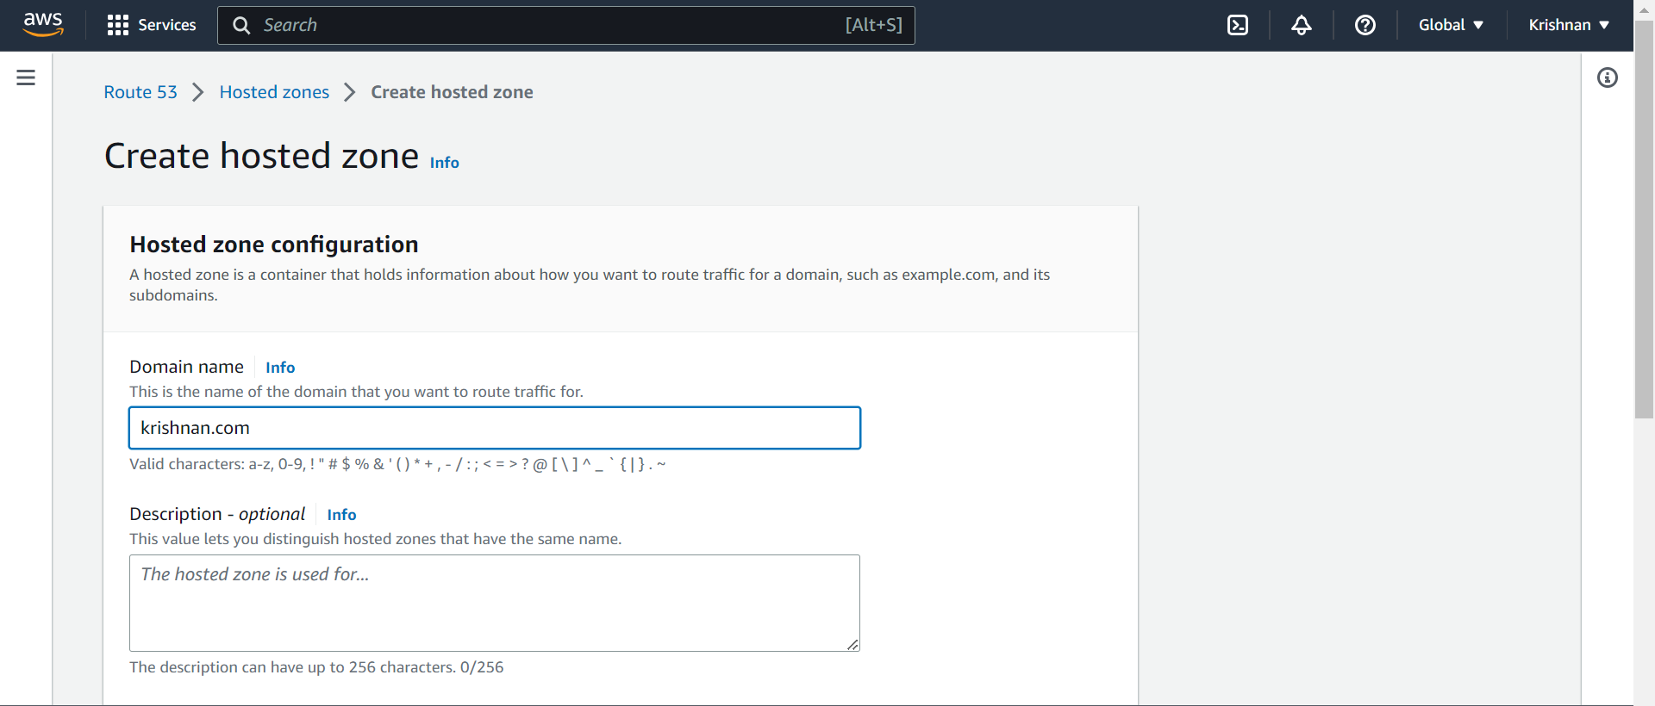

Create record Krishnan.com

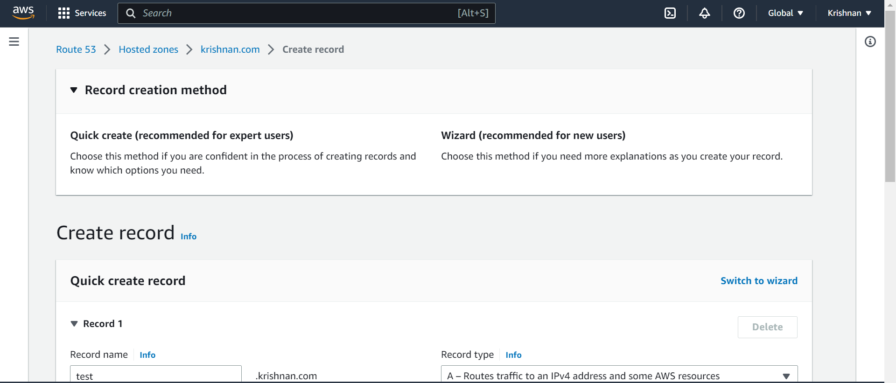

Created by route 53 krishnan.com

