Day 25 DIY

1. How to create VPC and subnets using the AWS CLI?

Output;

VPC CREATE

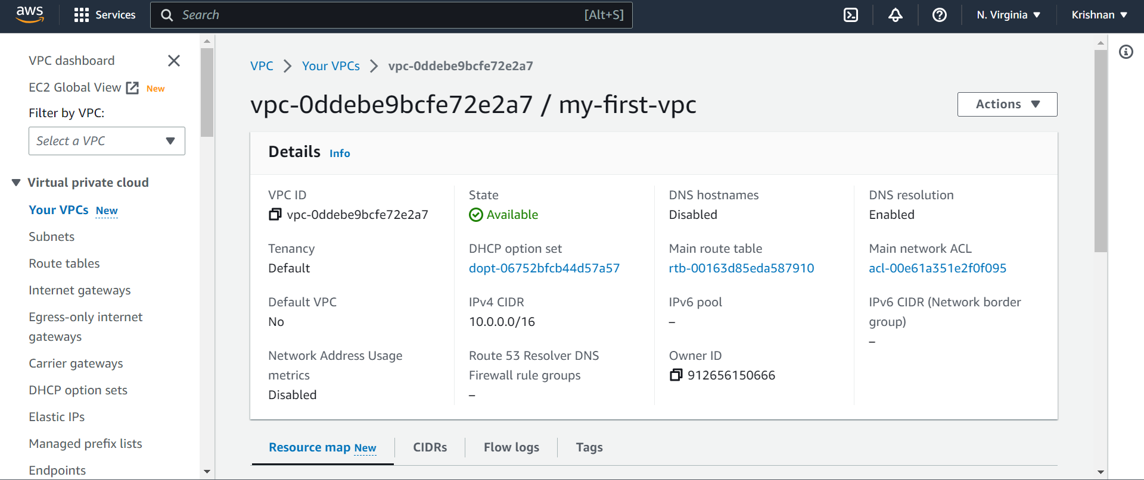

SUBNETRS CREATED

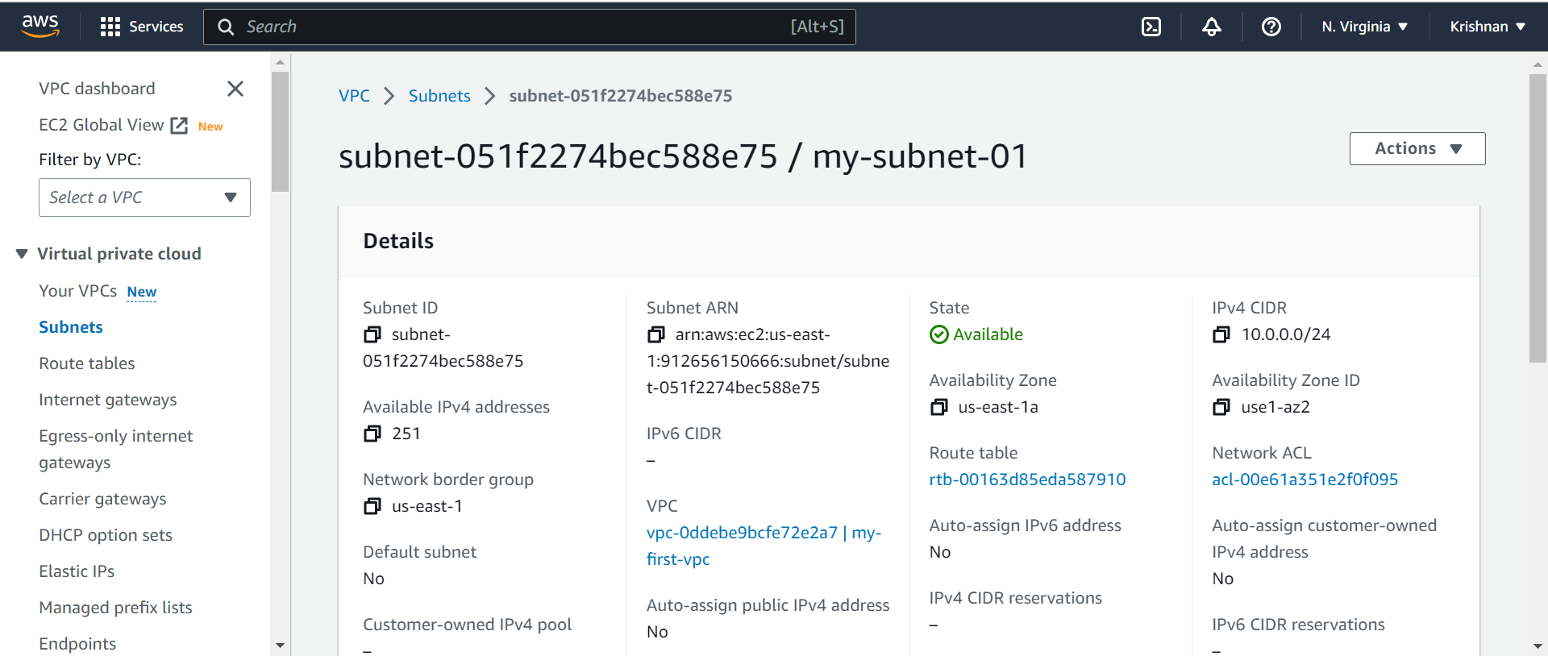

INTERNET GATEWAYS CREATE

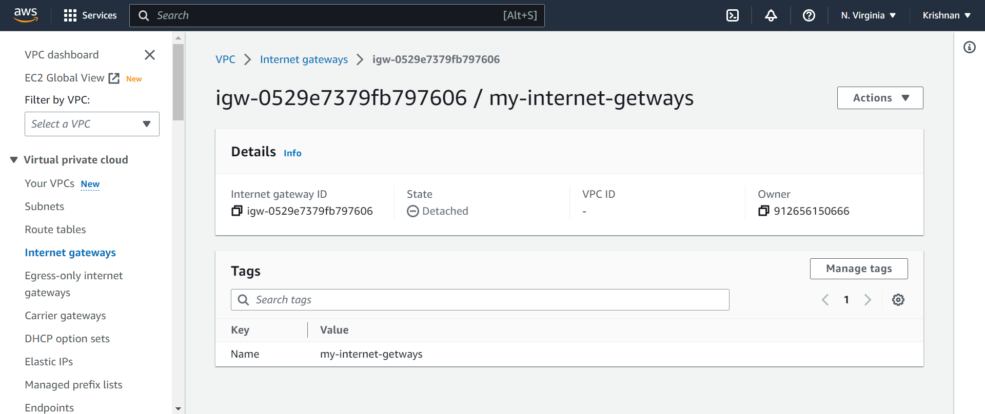

ROUTE TABLES

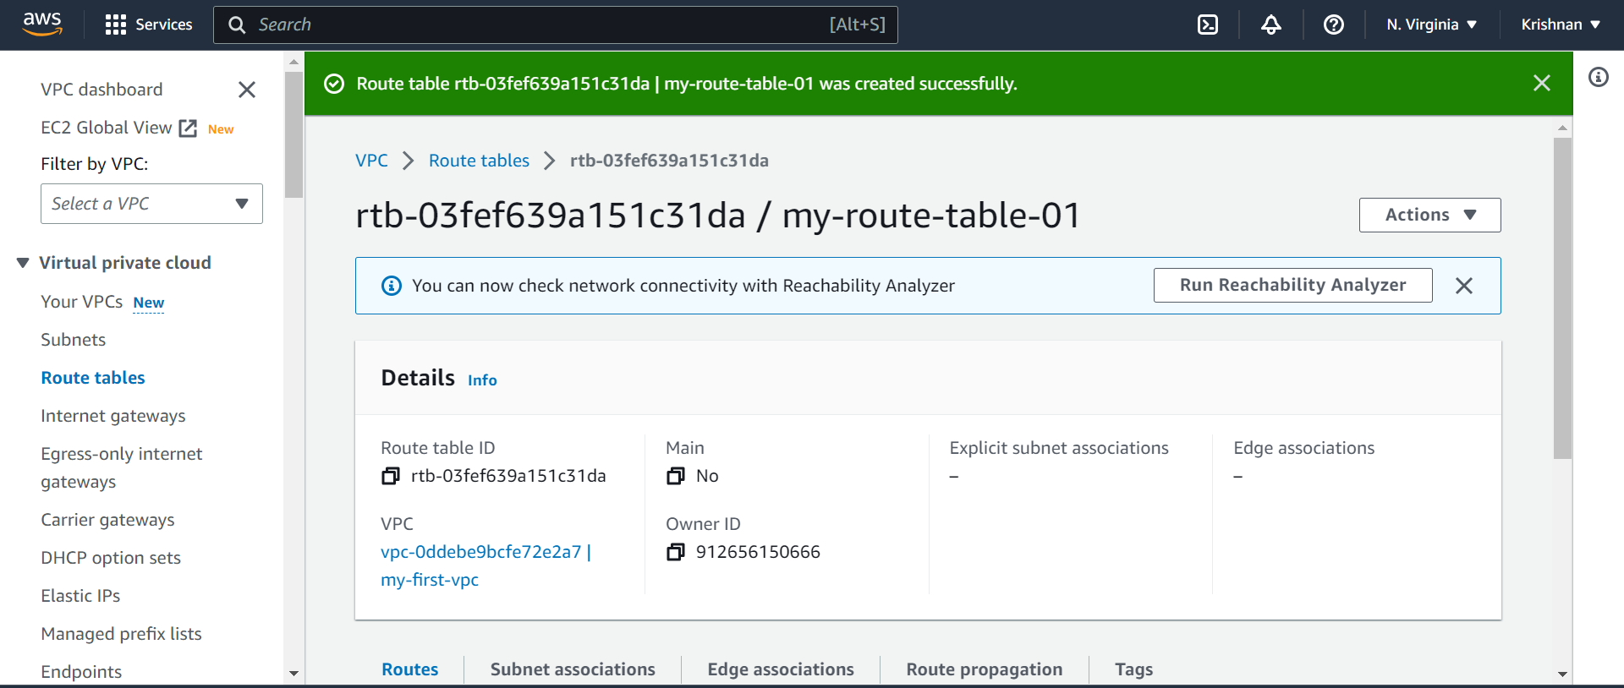

COMMAND LINE INTERFACE

