Day 34 DIY

1. How to Set up a scaled and load-balanced application to ensure fault tolerance

And high availability?

Lanch templates in Instances

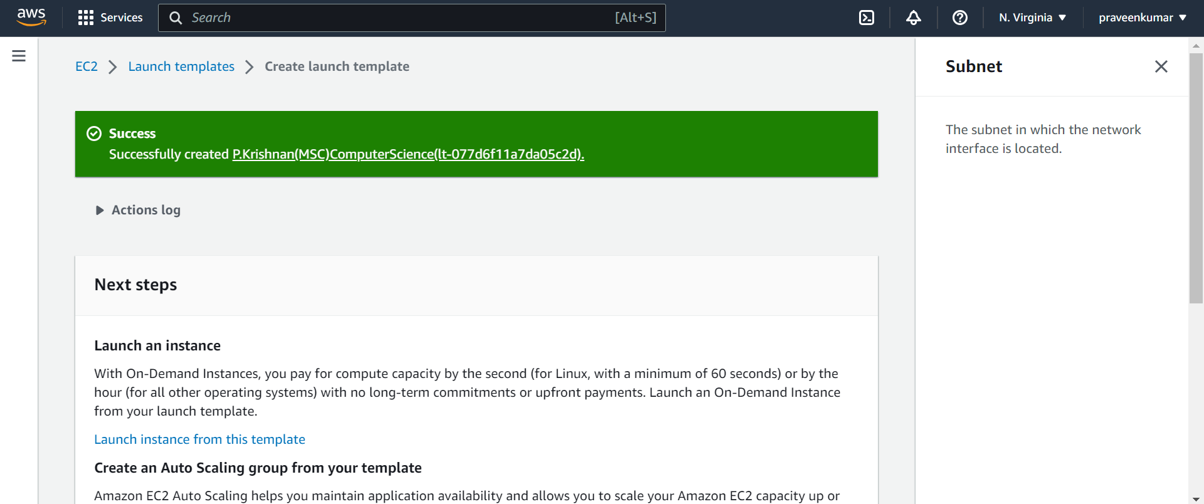

Create a Auto Scaling Group

