Day 38 DIY

1.How to Set Alerts and Create a Budget for Your AWS Account?

Billing preferences

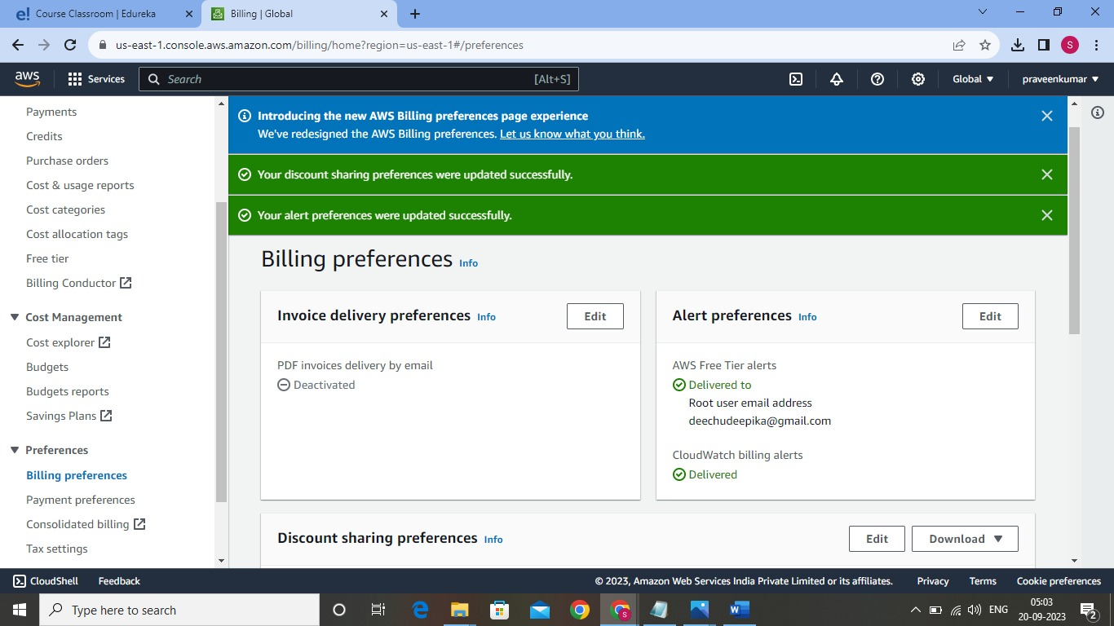

Budgets

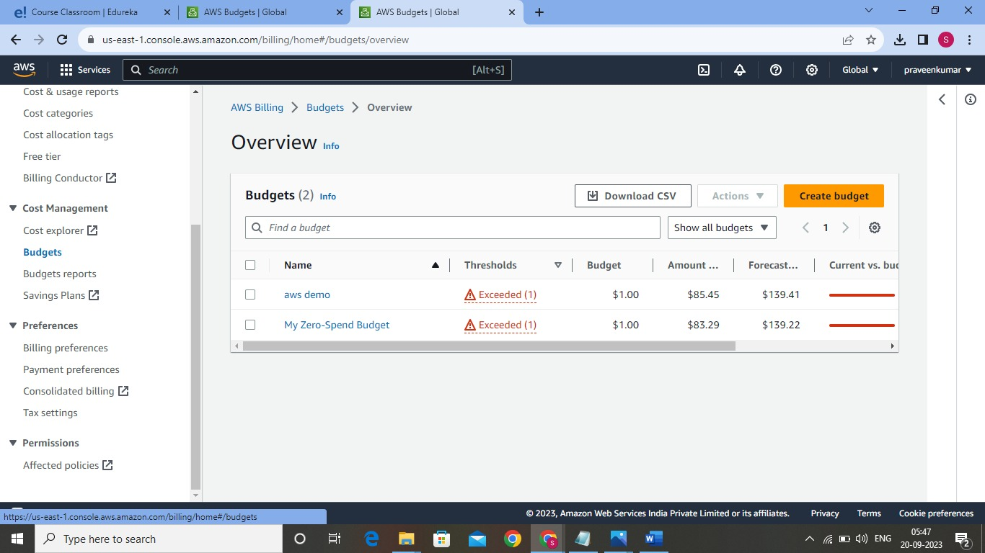

Create group in IAM

