Day 17 **DIY**

**1.How to Enable S3 Intelligent-Tiering Archive Access and Deep Archive Access tiers**

**Output Screenshot;**

Create bucket

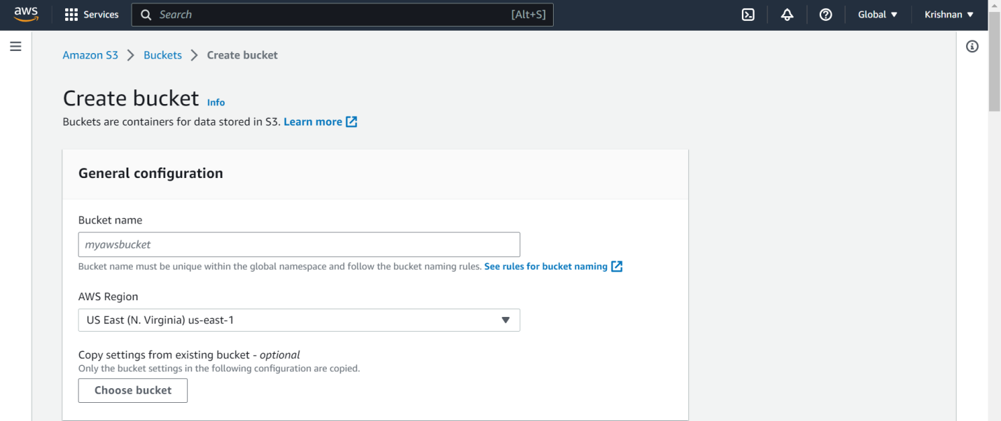

Test-console-int-objects

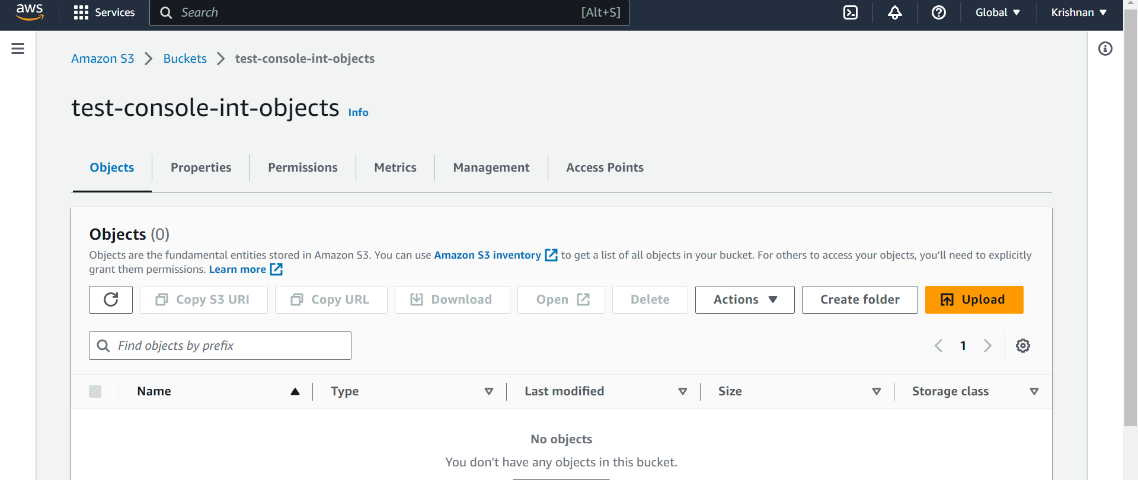

Upload succeeded

