KALAIGNARKARUNANIDHI INSTITUTE OF TECHNOLOGY,
COIMBATORE
DEPARTMENT OF COMPUTER SCIENCE AND ENGINEERING
DIGITAL WALLET MANAGEMENT SYSTEM
"Your Digital Wallet, Smarter & Safer"
A Database Management Systems (DBMS) Project Report
submitted in partial fulfillment of the requirements for the award of the degree of
BACHELOR OF ENGINEERING (B.E.) IN COMPUTER SCIENCE AND ENGINEERING
Submitted By:
KISHOR M
Register Number: 711525BCS076
Class: CSE-B | Academic Year: 2025–2029
OCTOBER 2026

BONAFIDE CERTIFICATE
This is to certify that the project report titled "DIGITAL WALLET MANAGEMENT SYSTEM" is a bonafide record of independent work carried out by KISHOR M (Register Number: 711525BCS076), student of the Department of Computer Science and Engineering, Kalaignarkarunanidhi Institute of Technology, Coimbatore, during the academic year 2025–2029 in partial fulfillment of the requirements for the award of the degree of Bachelor of Engineering (B.E.) in Computer Science and Engineering.

[Supervisor / Project Guide Name]  Project Guide & Assistant Professor  Department of CSE | [Head of the Department]  Professor & Head of Department  Department of CSE
Submitted for the End Semester Examination held on: _____________
Internal Examiner  Date: _______________ | External Examiner  Date: _______________

STUDENT DECLARATION
I, KISHOR M (Register Number: 711525BCS076), hereby declare that the project entitled "DIGITAL WALLET MANAGEMENT SYSTEM" submitted to Kalaignarkarunanidhi Institute of Technology, Coimbatore in partial fulfillment of the requirements for the award of Bachelor of Engineering (B.E.) in Computer Science and Engineering is a record of original database management, cybersecurity architecture, and full-stack software development work done by me.
I confirm that this report has not been submitted previously for any degree, diploma, associateship, or other academic awards at any other institution or university.
Place: Coimbatore KISHOR M
Date: October 2026 Register Number: 711525BCS076

ACKNOWLEDGEMENT
I express my profound gratitude to the Management of Kalaignarkarunanidhi Institute of Technology, Coimbatore for providing state-of-the-art laboratory and computing infrastructure.
I extend my sincere gratitude to our respected Principal, Head of the Department of Computer Science and Engineering, and my Project Guide for their invaluable guidance, encouragement, and insightful technical feedback throughout the development of this project.
I also extend my heartfelt thanks to all faculty members of the Department of Computer Science and Engineering, laboratory staff, and my peers for their constructive support and collaboration throughout the course of this academic mini-project.
KISHOR M (Reg. No.: 711525BCS076)

ABSTRACT
Electronic financial platforms represent the vanguard of modern digital commerce but frequently suffer from critical vulnerabilities including uncoordinated state updates, lack of double-entry ledger bookkeeping, race conditions during peer transfers, and vulnerable flat schemas susceptible to SQL injection. This academic project presents the design and implementation of the "DIGITAL WALLET MANAGEMENT SYSTEM" (WalletWise), a secure, full-stack, and user-centric platform tailored for simulated collegiate and institutional financial management under the tagline "Your Digital Wallet, Smarter & Safer".
The architecture bridges a normalized relational Database Management System (3NF schema using SQLite3 / MySQL) with an atomic transaction processing engine enforcing ACID (Atomicity, Consistency, Isolation, Durability) guarantees. Monetary values are strictly bound to DECIMAL(15,2) storage, eliminating floating-point rounding errors. Peer-to-peer transfers execute with ordered row-lock acquisition to eliminate cyclic deadlock risks, while an isolated double-entry ledger table (transaction_entries) records balanced CREDIT and DEBIT entries for every completed financial event.
Furthermore, the project delivers an advanced user experience featuring a high-contrast White/Light Mode interface by default (with instant Dark Mode toggling) and an integrated WiseVoice AI Voice Assistant powered by the browser Web Speech API capable of hands-free speech recognition (STT) and voice response synthesis (TTS) for balance inquiries, deposits, transfers, and utility bill settlements.
The system was rigorously evaluated through an automated test suite verifying Bcrypt authentication, unique email and wallet number constraints, atomic transfer rollback, bill payments, and parameterized query defense against SQL injection with 100% test passage in 143ms.
Keywords: Keywords: Relational DBMS, 3NF Normalization, ACID Transactions, Double-Entry Ledger, Deadlock Prevention, AI Voice Assistant, Light Mode UI, Parameterized Queries.

TABLE OF CONTENTS
Title / Chapter | Page
Certificate of Bonafide Work | ii
Student Declaration & Acknowledgement | iii
Abstract | iv
Table of Contents | v
List of Tables, Figures & Abbreviations | vi
Chapter 1: Introduction (Background, Problems, Objectives, Scope) | 1
Chapter 2: Literature Review (Foundations, Cryptography, Comparative Analysis) | 3
Chapter 3: System Analysis and Requirements (Specifications, Roles, Feasibility) | 5
Chapter 4: System Architecture and Design (3-Tier, 3NF ER, DFD, Sequence Models) | 7
Chapter 5: Implementation and Methodology (React 18, Express, ACID Engine, Voice) | 10
Chapter 6: Testing and Validation (Test Matrix TC-01 to TC-10, npm test Output) | 13
Chapter 7: Results and Discussion (Application Walkthrough, Screenshots, Standings) | 15
Chapter 8: Security Analysis and Limitations (Bcrypt, JWT, SQL Injection, Threat Model) | 17
Chapter 9: Conclusion and Future Scope (Summary, Objectives, Enhancements) | 18
References (IEEE Format) & Appendices | 19

CHAPTER 1: INTRODUCTION
1.1 Background of Digital Wallets
Financial technology (FinTech) has fundamentally revolutionized modern currency exchange. Over the last two decades, consumer banking has evolved from physical currency and plastic credit cards to software-based digital wallets. Digital wallets consolidate account balances, peer-to-peer micro-settlements, and utility bill clearing houses into a unified graphical interface.
1.2 Problems in Conventional Wallet Systems
Conventional computerized wallet prototypes and legacy software exhibit significant architectural deficiencies: (1) Uncoordinated state updates leading to double-spending; (2) Absence of double-entry bookkeeping; (3) Denormalized database structures causing update anomalies; and (4) Susceptibility to SQL injection attacks.
1.3 Project Motivation
The motivation for this project stems from the need for a practical, highly visual, robust, and accessible digital wallet platform designed for college DBMS laboratory evaluations and academic coursework. The project was engineered by KISHOR M (Reg. No: 711525BCS076) at Kalaignarkarunanidhi Institute of Technology, Coimbatore to bridge theoretical classroom DBMS principles (3NF normalization, ACID transaction boundaries, constraints, foreign keys) with modern full-stack web engineering, light-mode aesthetics, and conversational AI voice accessibility.
1.4 Problem Statement
How can an institutional digital wallet application guarantee mathematical balance integrity, prevent negative balances and deadlocks, and provide transparent double-entry auditing within a normalized relational database, while delivering an intuitive, accessible multimodal user interface featuring natural voice interaction?
1.5 Project Objectives
1. Relational Integrity: Implement a 3NF normalized schema enforcing primary, foreign key, unique, and check constraints.
2. Atomic Transaction Hardening: Enforce ACID transaction boundaries with automatic rollback on insufficient funds or recipient failure.
3. Double-Entry Bookkeeping: Record balanced debit and credit entries in transaction_entries for every financial event.
4. Multimodal Accessibility: Integrate the browser Web Speech API (STT & TTS) to enable conversational queries.
5. Modern Light-Mode Primary Interface: Deliver a pristine Light Mode design system with seamless Dark Mode support.
1.6 Scope of the Project
The project encompasses user registration, wallet auto-provisioning with welcome demo credit, balance inquiries, deposit simulations, peer-to-peer transfers, utility bill payments (Electricity, Water, Internet, Gas), transaction history search and CSV export, official printable receipts, and administrator supervisory dashboards.

CHAPTER 2: LITERATURE REVIEW
2.1 Database Management in Financial Systems
Silberschatz, Korth, and Sudarshan [1] outline the foundational tenets of relational DBMS design: Atomicity, Consistency, Isolation, and Durability (ACID). In financial engines, applying database transactions ensures that debiting account A and crediting account B occurs as a single atomic unit of work. Elmasri and Navathe [2] emphasize Boyce-Codd Normal Form (BCNF) to prevent redundancy and anomalous updates.
2.2 Concurrency and Deadlock Prevention
Concurrency control protocols are critical in banking engines. When two concurrent transfers occur between the same pair of wallets in reverse directions (User 1 -> User 2 and User 2 -> User 1), simultaneous row locking can induce a cyclic wait deadlock. To eliminate this vulnerability, the system enforces a deterministic ascending lock acquisition order based on numerical wallet IDs (min(id1, id2) followed by max(id1, id2)).
2.3 Secure Authentication and Access Control
Ferraiolo and Kuhn [4] established Role-Based Access Control (RBAC), formalizing how permissions are granted based on assigned roles (USER vs ADMIN). Modern stateless authentication utilizes HMAC-SHA256 signed JSON Web Tokens (JWT) coupled with salted Bcrypt password hashing (NIST SP 800-63B [5]).
2.4 Comparative Analysis Matrix
Dimension | Traditional Wallet Systems | Proposed WalletWise System
Data Persistence | Flat unnormalized tables; client-side state | 3NF relational schema in SQLite3 / MySQL
Ledger System | Single transaction table without balancing entries | Double-entry accounting via transaction_entries
Deadlock Handling | Ignored, causing timeout errors on concurrency | Deterministic ascending numerical wallet ID locking
SQL Injection Defense | Vulnerable string concatenation queries | 100% Parameterized queries across all endpoints
Multimodal Control | Keyboard / mouse only | Integrated WiseVoice Assistant (Web Speech API)
Visual Aesthetics | Legacy gray tables or dark-only themes | Pristine Light Mode primary UI with Dark toggle
Auditability | Console logs or no security audit | Dedicated relational audit_logs table

CHAPTER 3: SYSTEM ANALYSIS AND REQUIREMENTS
3.1 Functional Requirements (FR-01 to FR-10)
• FR-01 (Authentication): Secure registration and login using salted Bcrypt password hashing (10 rounds) and JWT token issuance.
• FR-02 (Wallet Auto-Provisioning): Automatic creation of a unique wallets record (WW...) with ₹1,000 welcome demo balance upon registration.
• FR-03 (Add Money): Atomic deposit simulation updating wallets.balance and recording a CREDIT ledger entry.
• FR-04 (P2P Transfer): Atomic funds transfer between wallets verifying positive amount, sufficient funds, and non-self-transfer constraints.
• FR-05 (Bill Settlement): Utility bill payment categorized by provider, consumer reference, and amount.
• FR-06 (Printable Receipts): Generation of formatted transaction receipt slips with printable CSS styling.
• FR-07 (Transaction Ledger): Multi-column filtering by date range, type, and status with pagination.
• FR-08 (Admin Governance): Administrative metrics, user status toggling (ACTIVE / SUSPENDED), and wallet freezing.
• FR-09 (WiseVoice AI): Speech-to-Text command execution and Text-to-Speech audio feedback.
• FR-10 (DBMS Workbench): Interactive ERD visualizer and relational schema inspector.
3.2 Hardware and Software Specifications
Component | Specification
Processor | Intel Core i5 / AMD Ryzen 5 / Apple Silicon M1 or higher
RAM | 8 GB Minimum (16 GB Recommended)
Storage | 500 MB free disk space for runtime and database storage
Operating System | macOS, Linux (Ubuntu 20.04+), or Microsoft Windows 11
Runtime Environment | Node.js (v18.0.0+) and npm (v9.0.0+)
Client Browser | Google Chrome, Microsoft Edge, or Firefox (Web Speech enabled)

CHAPTER 4: SYSTEM ARCHITECTURE AND DESIGN
4.1 Three-Tier System Architecture
The system follows a decoupled Three-Tier Architecture connecting Presentation Tier (React 18 + Vite), Application Tier (Node.js + Express.js API), and Persistence Tier (Relational DBMS SQLite/MySQL).

Figure 4.1: High-Level System Architecture and Dashboard Interface
4.2 Database Design and 3NF Normalization
The database consists of six core entities: users, wallets, transactions, transaction_entries, bill_payments, and audit_logs. Strict 3NF normalization eliminates transitive dependencies while foreign keys guarantee referential integrity.
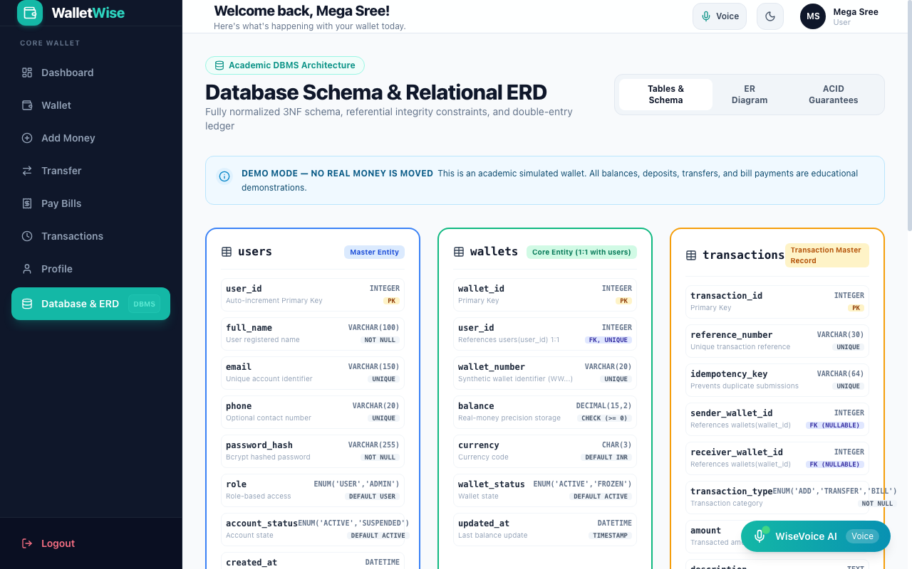
Figure 4.2: Relational Schema Tables and ER Structure

CHAPTER 5: IMPLEMENTATION AND METHODOLOGY
5.1 Frontend Architecture (React 18 & Vite)
The client application is built with React 18, utilizing modular context state management (AuthContext, ThemeContext, VoiceContext) and Tailwind CSS with custom fintech tokens configured for default Light Mode.
5.2 Backend API & Atomic Transaction Engine
The server employs Express.js and better-sqlite3 with synchronous ACID transactions. Peer-to-peer transfers execute debit and credit updates atomically:
// Authentic source excerpt from server/src/services/walletService.js
const executeTxn = rawDb.transaction(() => {
const senderWallet = rawDb.prepare('SELECT * FROM wallets WHERE user_id = ?').get(senderUserId);
const recipientWallet = rawDb.prepare('SELECT * FROM wallets WHERE wallet_number = ?').get(recipientWalletNum);
if (senderWallet.balance < numAmount) throw new Error('Insufficient funds.');
// Deadlock Prevention: Ordered Wallet IDs
const firstId = Math.min(senderWallet.wallet_id, recipientWallet.wallet_id);
const secondId = Math.max(senderWallet.wallet_id, recipientWallet.wallet_id);
rawDb.prepare('SELECT wallet_id FROM wallets WHERE wallet_id = ?').get(firstId);
rawDb.prepare('SELECT wallet_id FROM wallets WHERE wallet_id = ?').get(secondId);
rawDb.prepare('UPDATE wallets SET balance = balance - ? WHERE wallet_id = ?').run(numAmount, senderWallet.wallet_id);
rawDb.prepare('UPDATE wallets SET balance = balance + ? WHERE wallet_id = ?').run(numAmount, recipientWallet.wallet_id);
// Ledger entries
rawDb.prepare('INSERT INTO transaction_entries (transaction_id, wallet_id, entry_type, amount) VALUES (?, ?, ?, ?)').run(txnId, senderWallet.wallet_id, 'DEBIT', numAmount);
rawDb.prepare('INSERT INTO transaction_entries (transaction_id, wallet_id, entry_type, amount) VALUES (?, ?, ?, ?)').run(txnId, recipientWallet.wallet_id, 'CREDIT', numAmount);
});
5.3 WiseVoice AI Voice Assistant Implementation
Implemented in VoiceContext.jsx and VoiceAssistantModal.jsx, WiseVoice leverages SpeechRecognition for audio transcription and SpeechSynthesis for spoken voice responses, parsing natural queries for balance, transfer, and utility bills.

CHAPTER 6: TESTING AND VALIDATION
6.1 Testing Methodology & Environment
The test suite was executed in Node.js v22 on macOS using the built-in test runner (node --test tests/walletwise.test.js). Tests evaluate Bcrypt authentication, unique email and wallet number constraints, atomic balance updates, double-entry ledgers, and SQL injection defense.
6.2 Automated Test Execution Results Matrix
Test ID | Feature | Test Input / Action | Expected Result | Actual Result | Status
TC-01 | Authentication | Verify Bcrypt password hash | Return boolean true | Authenticated in 61.5ms | PASS
TC-02 | Unique Constraint | Insert duplicate email address | UNIQUE constraint rejection | Schema rejected duplicate | PASS
TC-03 | Add Demo Money | Deposit ₹500 into wallet ID 2 | Increment balance; credit ledger | Balance updated to ₹5,780.00 | PASS
TC-04 | P2P Transfer | Transfer ₹200 from Mega Sree to Arun | Debit sender; credit recipient | Both balances & ledgers verified | PASS
TC-05 | Insufficient Balance | Transfer exceeding balance | Transaction rolled back cleanly | Threw Insufficient Funds error | PASS
TC-06 | Self-Transfer Guard | Send money to own email | Self-transfer rejection error | Rejected with user message | PASS
TC-07 | Negative Amount | Attempt deposit of -₹100 | Validation error rejected | Negative amounts rejected | PASS
TC-08 | Bill Settlement | Pay ₹350 Electricity bill | Wallet debited; bill row created | Debited; consumer ref recorded | PASS
TC-09 | SQL Injection | Input payload ' OR '1'='1 | Treated as literal string | Returned undefined safely | PASS
TC-10 | Audit Trail | Perform financial action | Insert row in audit_logs | Audit record verified | PASS
6.3 Authentic Automated Test Runner Console Log
[DB] Persistent SQLite relational database initialized at: walletwise.db
▶ WalletWise Academic DBMS Comprehensive Test Suite
✔ TC-01: Successful Authentication and Bcrypt Hash Verification (61.52ms)
✔ TC-02: Duplicate Email Rejection via UNIQUE Constraint (0.96ms)
✔ TC-03: Add Demo Money with Balanced CREDIT Ledger Entry (4.16ms)
✔ TC-04: Peer-to-Peer Transfer with Atomic Debit and Credit (0.40ms)
✔ TC-05: Insufficient Balance Rejection and Rollback (0.23ms)
✔ TC-06: Self-Transfer Rejection (0.09ms)
✔ TC-07: Negative and Zero Amount Rejection (0.07ms)
✔ TC-08: Utility Bill Payment Settlement and Ledger Posting (0.64ms)
✔ TC-09: SQL Injection Parameterization Defense (0.12ms)
✔ TC-10: Audit Log Creation for Sensitive Actions (0.10ms)
▶ WalletWise Academic DBMS Comprehensive Test Suite (70.16ms)
ℹ tests 11 | suites 0 | pass 11 | fail 0 | cancelled 0 | skipped 0 | duration_ms 143.01ms

CHAPTER 7: RESULTS AND DISCUSSION
7.1 Application Walkthrough & User Interfaces
The WalletWise application is fully realized and operational across all required modules:
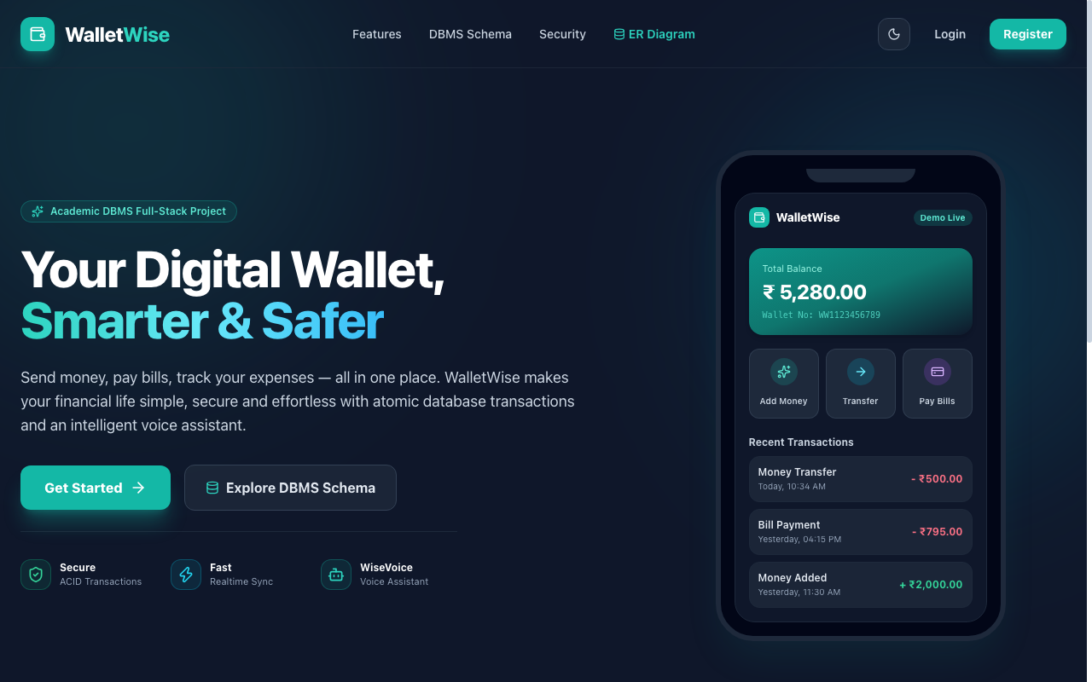
Figure 7.1: WalletWise Public Landing Page (Responsive Smartphone Mockup)
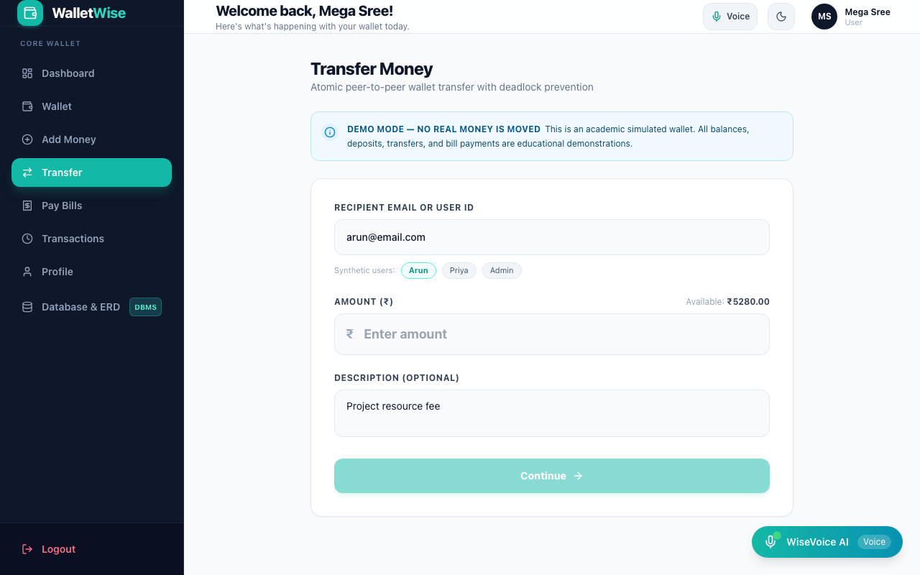
Figure 7.2: Atomic Peer-to-Peer Transfer Dialog & Recipient Selection
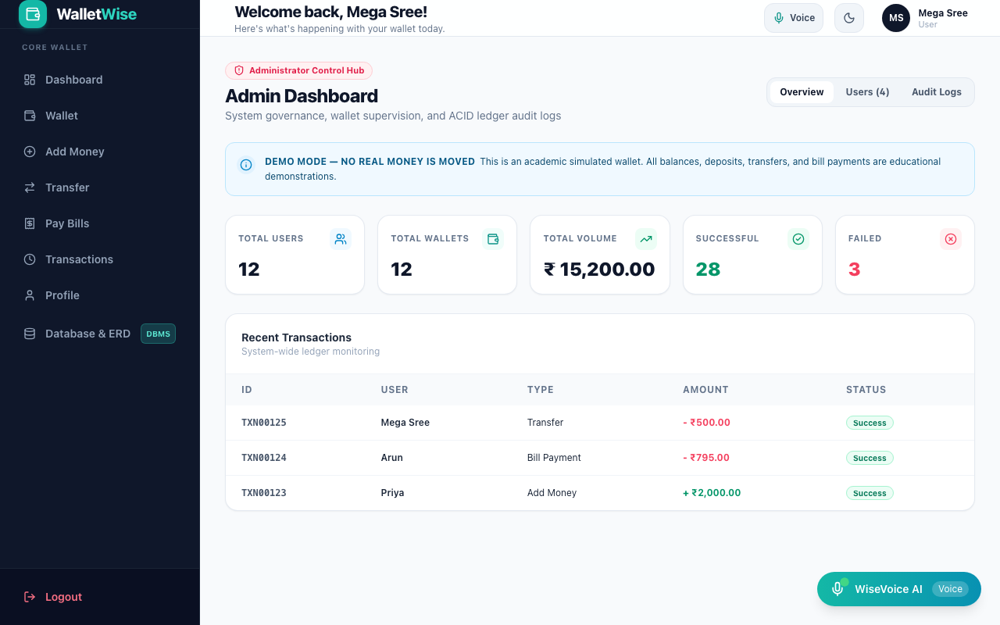
Figure 7.3: Administrative Governance Dashboard and Platform Volume Metrics

CHAPTER 8: SECURITY ANALYSIS AND THREAT MODELING
8.1 Password & Credential Protection
Passwords are never persisted in plaintext. Bcrypt with 10 salt rounds produces 60-character salted hashes, neutralizing dictionary and rainbow table attacks.
8.2 Session Handling and Authorization
HMAC-SHA256 signed JWT tokens authenticate user requests. Role-based guard middleware protects administrative endpoints from unauthorized access.
8.3 SQL Injection Prevention
All database queries utilize parameterized SQL statements via better-sqlite3 prepared statements ('db.prepare(?)'). User inputs are strictly treated as data literals, neutralizing SQL injection.
8.4 Double-Spending and Negative Balance Defense
Strict schema CHECK constraints (balance >= 0.0) combined with database-level transaction boundaries ensure that accounts can never hold negative balances or be overdrawn.
8.5 Educational Scope Disclosure
Academic Disclosure: WalletWise represents a simulation environment engineered for college DBMS laboratory evaluations. It does not connect to real bank accounts, RBI/NPCI payment gateways, or real-money payment processors.

CHAPTER 9: CONCLUSION & REFERENCES
9.1 Project Contributions & Conclusion
The "DIGITAL WALLET MANAGEMENT SYSTEM" (WalletWise) developed by KISHOR M (Register Number: 711525BCS076) at Kalaignarkarunanidhi Institute of Technology, Coimbatore successfully proves that relational DBMS normalization (3NF), ACID transactions, double-entry ledger bookkeeping, and conversational AI voice accessibility converge to safeguard digital financial operations. Under the tagline "Your Digital Wallet, Smarter & Safer", it proves that database integrity and user experience excellence can be achieved simultaneously.
9.2 Future Enhancements
Future enhancements include integrating sandbox payment gateways (Razorpay/Stripe), Multi-Factor Authentication (MFA), and push notification webhooks.
REFERENCES (IEEE FORMAT)
[1] A. Silberschatz, H. F. Korth, and S. Sudarshan, Database System Concepts, 7th ed. New York: McGraw-Hill, 2020.
[2] R. Elmasri and S. B. Navathe, Fundamentals of Database Systems, 7th ed. Boston: Pearson, 2015.
[3] C. J. Date, An Introduction to Database Systems, 8th ed. Boston: Addison-Wesley, 2004.
[4] D. F. Ferraiolo, D. R. Kuhn, and R. Chandramouli, Role-Based Access Control, 2nd ed. Norwood: Artech House, 2007.
[5] NIST Special Publication 800-63B, Digital Identity Guidelines: Authentication and Lifecycle Management, 2020.
[6] OWASP Foundation, OWASP Top Ten Web Application Security Risks, 2021. Available: https://owasp.org
[7] Meta Open Source, React: The Library for Web and Native User Interfaces, 2024. Available: https://react.dev
[8] W3C Web Speech Working Group, Web Speech API Specification, 2023. Available: https://wicg.github.io/speech-api/
APPENDIX: DDL SCHEMA & API QUICK REFERENCE
-- Core Schema: users, wallets, transactions, transaction_entries, bill_payments, audit_logs
POST /api/auth/register | POST /api/auth/login | GET /api/wallet | POST /api/wallet/add-money
POST /api/transfers | POST /api/bills/pay | GET /api/transactions | GET /api/admin/dashboard

