**DAY 1**

1) create table depart(DEPART_ID number(4) PRIMARY KEY,DEPART_NAME varchar2(30) NOT NULL,MANAGER_ID number(6) UNIQUE);

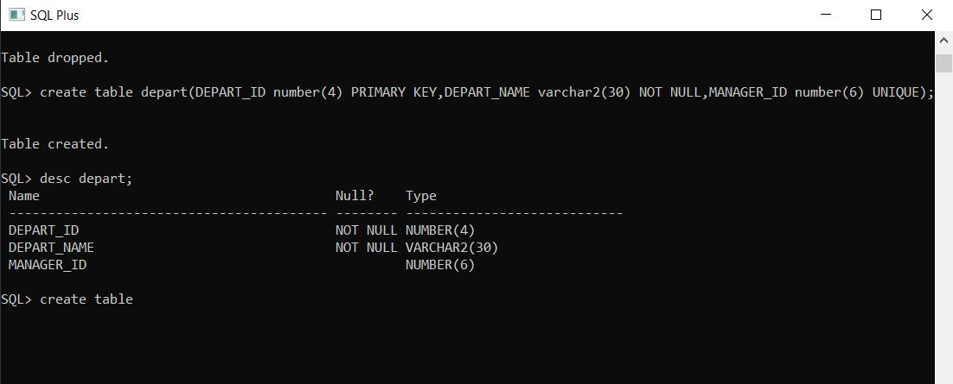

2) create table employees(EMP_ID number(6) PRIMARY KEY,EMP_NAME varchar2(20),EMAIL character(25),PHONE_NUMBER varchar(10),DEPT_ID number(4));

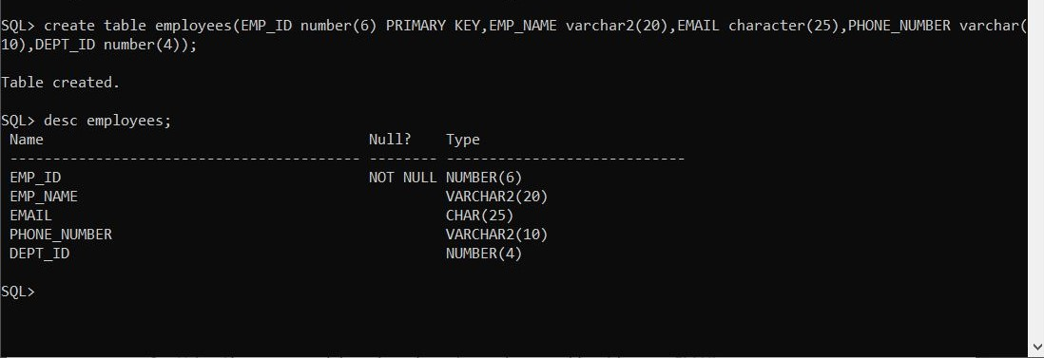

3) alter table employees add salary number(8,2);

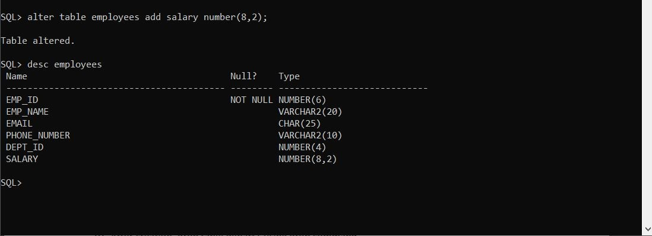

4) alter table employees add constraint for_key foreign key(DEPT_ID) references depart(DEPART_ID);

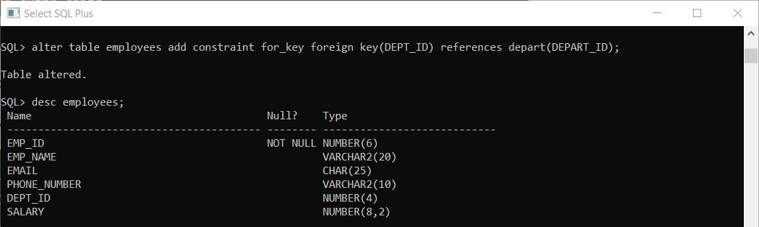

5) alter table empl drop constraint for_key;

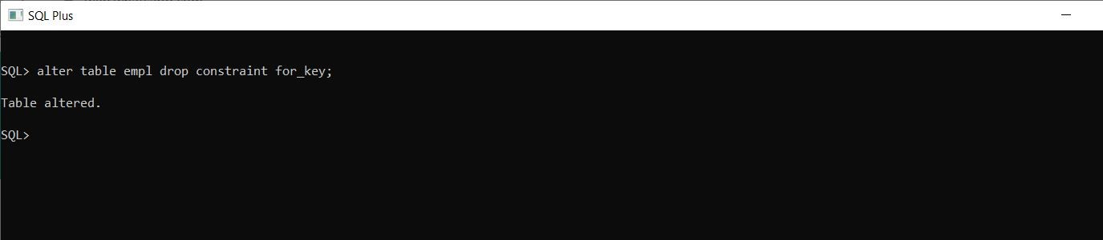

6) alter table employees drop column EMAIL;

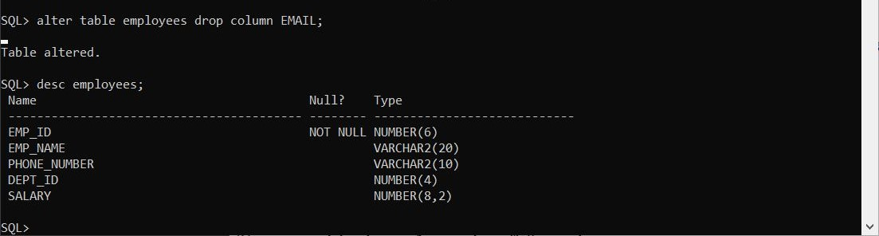

7) alter table employees add constraint check_salary check(SALARY >10000);

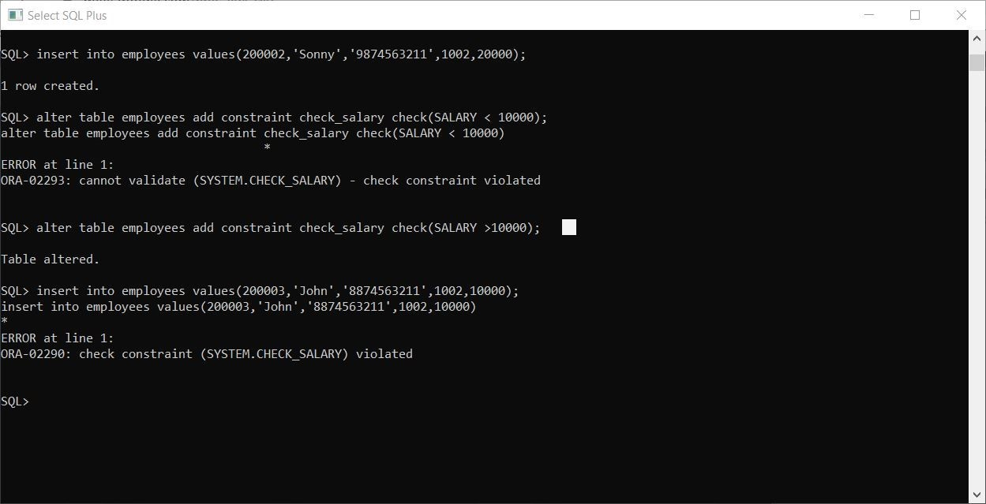

8) alter table employees rename to empl;

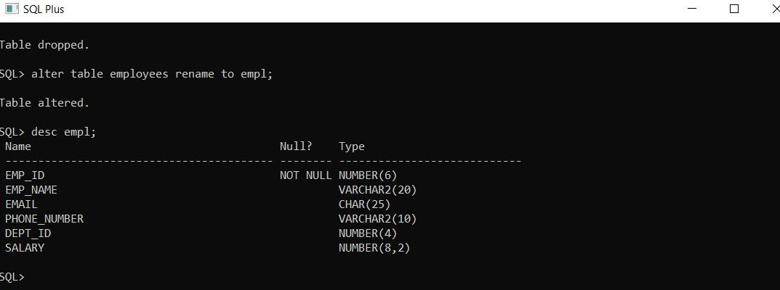

9) create table depart1 as select * from depart;

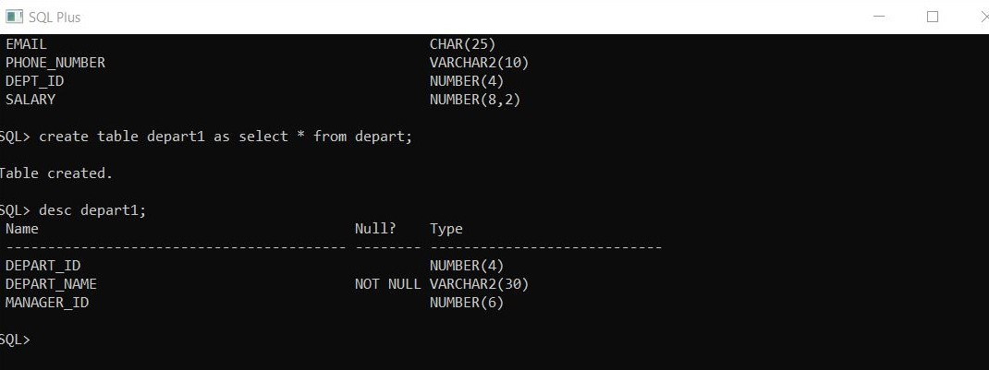

10) drop table depart1;

