DAY 2

1) insert all

into depart(DEPART_ID,DEPART_NAME,MANAGER_ID) values(10,'purchase',123)

into depart(DEPART_ID,DEPART_NAME,MANAGER_ID) values(20,'inventory',345)

into depart(DEPART_ID,DEPART_NAME,MANAGER_ID) values(30,'sales',567)

into depart(DEPART_ID,DEPART_NAME,MANAGER_ID) values(40,'materials',789)

into depart(DEPART_ID,DEPART_NAME,MANAGER_ID) values(50,'production',911)

select * from dual;

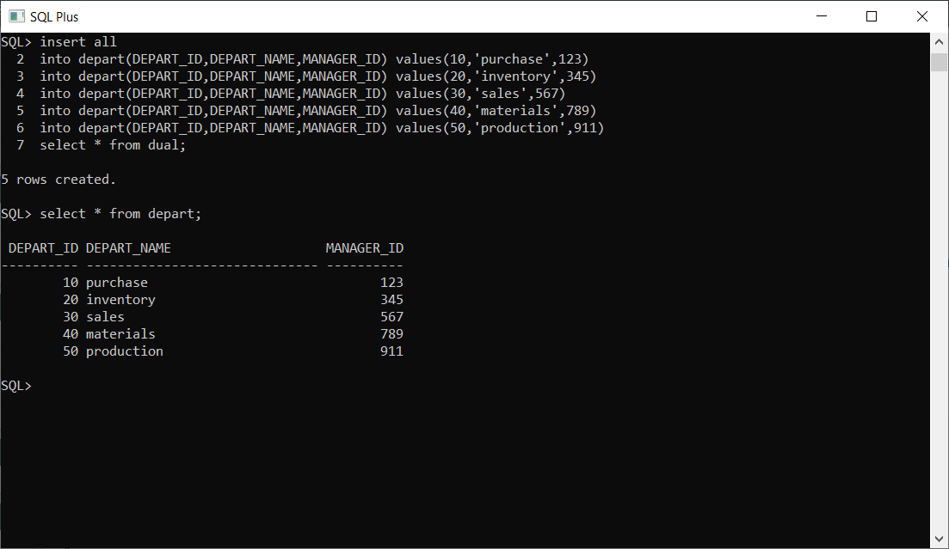

2) insert all

into employees(EMP_ID,EMP_NAME,EMAIL,PHONE_NUMBER,DEPT_ID,SALARY) values(101,'Babu','babu101@gmail.com','9448341201',10,12000)

into employees(EMP_ID,EMP_NAME,EMAIL,PHONE_NUMBER,DEPT_ID,SALARY) values(102,'Somu','somu102@gmail.com','9448534120',20,10000)

into employees(EMP_ID,EMP_NAME,EMAIL,PHONE_NUMBER,DEPT_ID,SALARY) values(103,'Ramu','ramu103@gmail.com','9448886634',40,15000)

into employees(EMP_ID,EMP_NAME,EMAIL,PHONE_NUMBER,DEPT_ID,SALARY) values(104,'Gobu','gobu104@gmail.com','9447783412',50,11500)

into employees(EMP_ID,EMP_NAME,EMAIL,PHONE_NUMBER,DEPT_ID,SALARY) values(105,'Anbu','anbu105@gmail.com','9848341200',40,22000)

select * from dual;

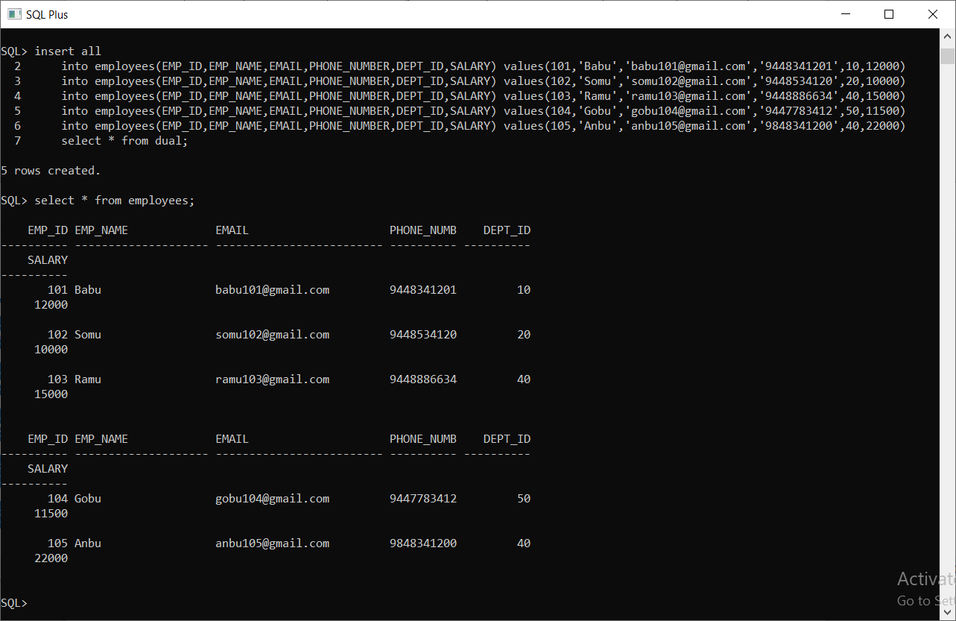

3.a) select * from employees where DEPT_ID=40;

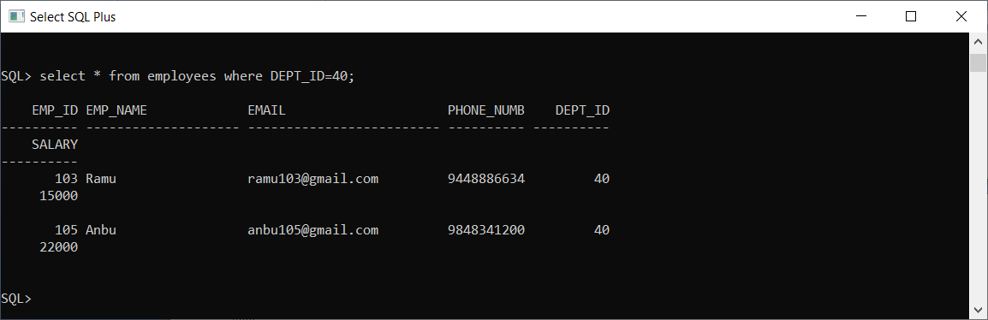

b) select DEPT_ID,EMP_NAME from employees where DEPT_ID=30;

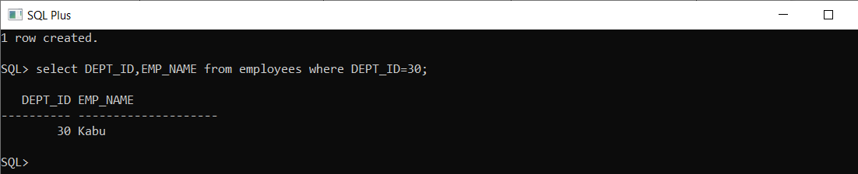

c) select EMP_NAME from employees where DEPT_ID=40 and SALARY>15000;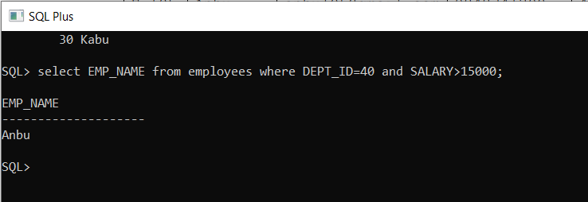

d) SELECT EMP_NAME,SALARY,salary + (salary * 5/100) as BONUS from employees;

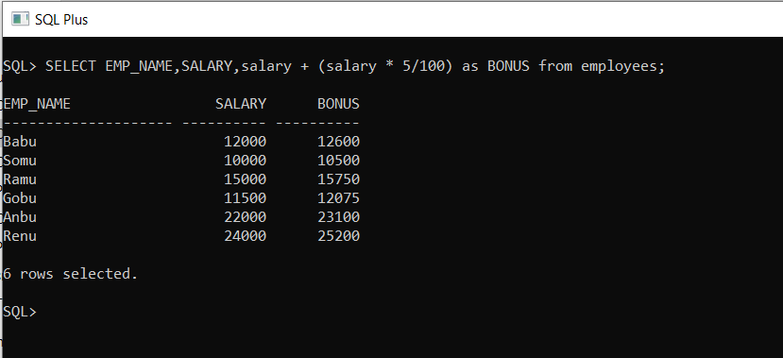

e) select * from employees where EMP_NAME like 'R_%';

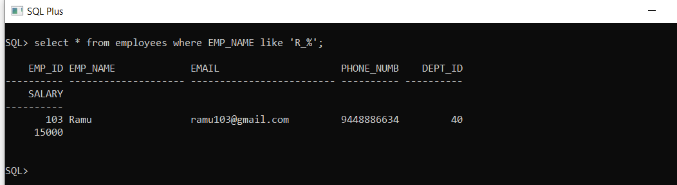

4.a) update employees set SALARY=SALARY+SALARy*0.10 where DEPT_ID=30;

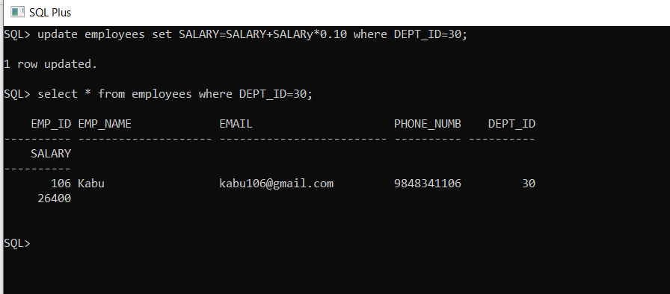

b) update employees set SALARY=SALARY-SALARY*0.03 where DEPT_ID=20;

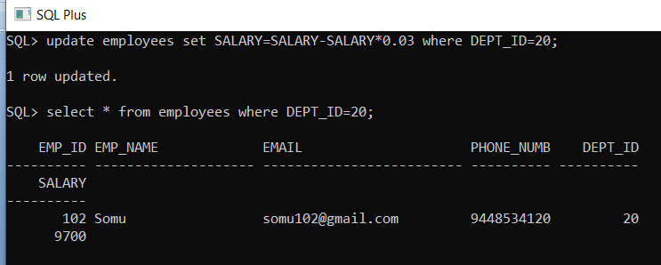

5) create table updatedemp as select EMP_ID,EMP_NAME,EMAIL,DEPT_ID from employees where DEPT_ID>20;

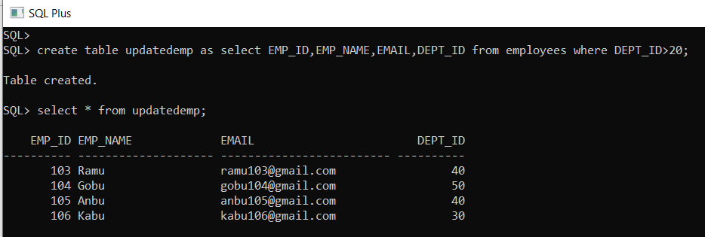

6) delete from employees where salary<12000;

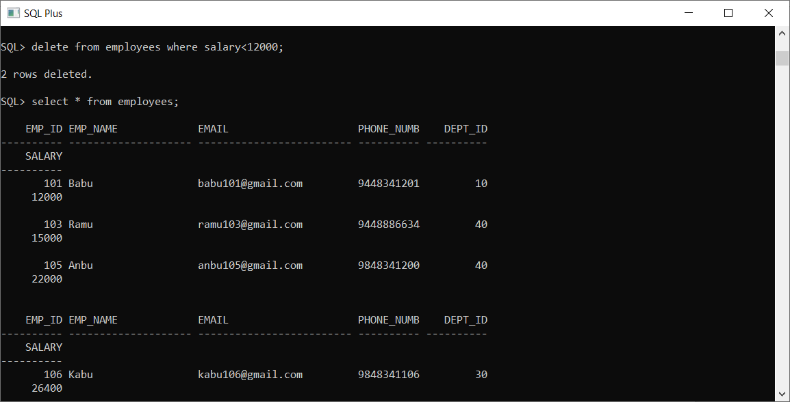

7) create table viewtab as select * from updatedemp;

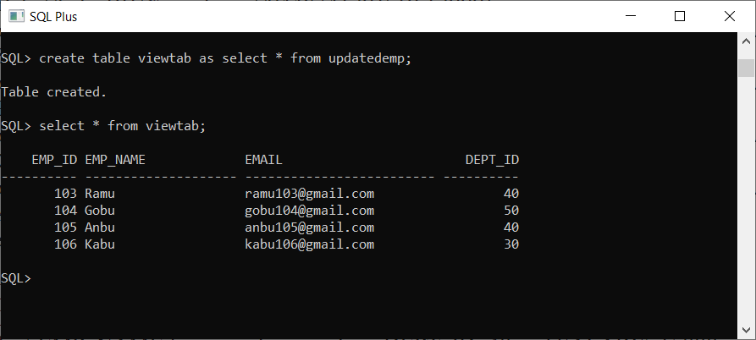

8) create view mytab as select EMP_ID,EMP_NAME,DEPT_ID,SALARY from employees where SALARY>=10000;

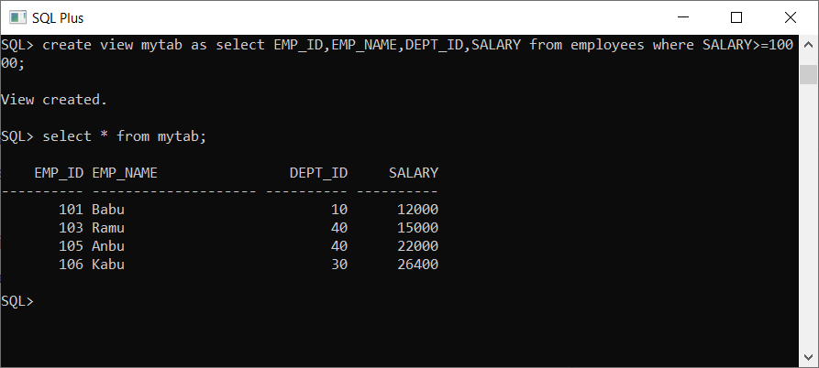

9) select * from employees order by SALARY asc;

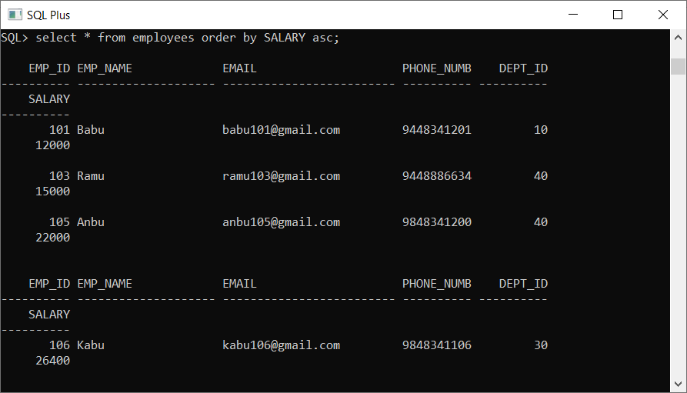

10) select * from employees order by EMP_NAME desc;

