**Phase-3 Submission Template**

**Student Name:** Kishore.R

**Register Number:** 421823104026

**Institution:** Saraswathy College Of Engineering and Technology

**Department:** Computer Science and Engineering

**Date of Submission:** 15.05.2025

**Github Repository Link:** [Update the project source code to your Github Repository]

# Problem Statement

The problem statement for accurately forecasting house prices using smart regression techniques in data science is: develop a robust predictive model that can accurately estimate the selling price of a house based on various factors, leveraging sophisticated regression algorithms to achieve high precision and minimize prediction errors.

# Abstract

An abstract discussing house price forecasting using data science would typically outline the research goals, methodology, and expected outcomes related to predicting house prices with accuracy. The key aspects would include using regression techniques, exploring various machine learning algorithms, and assessing the performance of different models.

Here's a more detailed breakdown of what you'd typically find in such an abstract:

**1. Problem Statement & Research Goal:**

The abstract would introduce the problem of accurately predicting house prices, highlighting its importance for real estate professionals, investors, and consumers.

It would state the specific goal of the research, which is to develop a robust and accurate model for house price forecasting.

**2. Methodology:**

The abstract would describe the data science techniques used, including data preprocessing, feature engineering, and the selection of appropriate regression models.

It would mention the types of regression models used, such as linear regression, decision trees, random forests, or other advanced algorithms like XGBoost or support vector regression.

The abstract would also mention the evaluation metrics used to assess model performance, such as Mean Squared Error (MSE) or R-squared.

**3. Expected Outcomes & Contributions:**

The abstract would highlight the expected outcomes, which would likely include improved accuracy in house price prediction, a better understanding of the factors influencing house prices, and potentially new insights into the real estate market.

It would mention the contributions of the research, which might involve developing a new model, improving existing models, or providing a comprehensive analysis of different approaches to house price forecasting.

**4. Key Aspects & Techniques:**

Data Preprocessing:

Mentioning steps like cleaning the data, handling missing values, and transforming data to make it suitable for machine learning models.

Feature Engineering:

Describing how new features are created from existing data to improve model accuracy.

Regression Models:

Briefly describing the different regression techniques used, such as linear regression, polynomial regression, and tree-based models.

Model Evaluation:

Mentioning the metrics used to assess the performance of the models, such as Mean Absolute Error (MAE), Mean Squared Error (MSE), and R-squared.

Ensemble Methods:

Discussing the use of ensemble methods, where multiple regression models are combined to improve accuracy and robustness.

Performance Comparison:

Mentioning the comparison of different regression models to identify the most accurate one for house price prediction.

# System Requirements

***Hardware:***

*Processor: A powerful CPU (e.g., Intel Core i7, AMD Ryzen) for model training and prediction.*

*Memory (RAM): Sufficient RAM (e.g., 16GB or more) to handle large datasets and model complexity.*

*Storage: SSD or NVMe storage for fast data access and model loading.*

*GPU (Optional): A GPU (e.g., NVIDIA GeForce RTX series, AMD Radeon Pro series) can accelerate neural network training significantly.*

***Software:***

*Programming Languages: Python (with libraries like Pandas, NumPy, Scikit-learn, TensorFlow, PyTorch) is widely used in data science.*

*Data Analysis and Visualization Tools: Tools like Matplotlib, Seaborn, and Tableau for exploring data and visualizing results.*

*Machine Learning Frameworks: Scikit-learn, TensorFlow, PyTorch, and XGBoost for model building and training.*

# Objectives

The problem statement for accurately forecasting house prices using smart regression techniques in data science is: develop a robust predictive model that can accurately estimate the selling price of a house based on various factors, leveraging sophisticated regression algorithms to achieve high precision and minimize prediction errors.

# Flowchart of Project Workflow

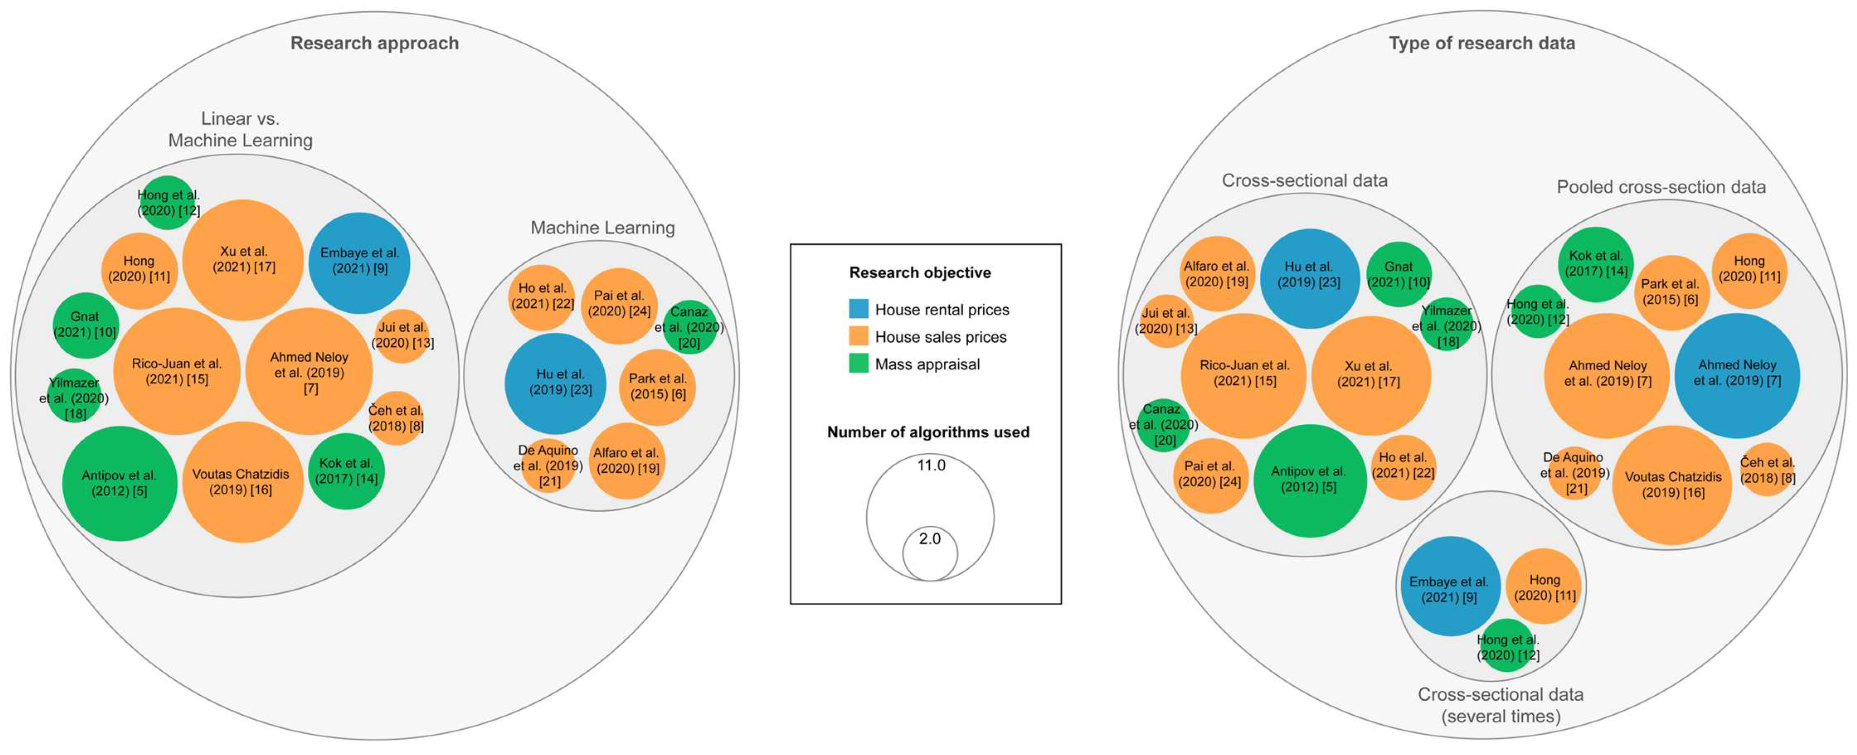Classification of articles according to the research approach (**left**), and according to the type of research data (**right**). The legend (**center**) shows in color the research objective and the size of the circle shows the number of algorithms used by the authors. Source: own elaboration. Note: Studies used to create the figure:

[5,6,7,8,9,10,11,12,13,14,15,16,17,18,19,20,21,22,23,24].

# Dataset Description

## *File descriptions*

* train.csv - the training set
* test.csv - the test set
* data_description.txt - full description of each column, originally prepared by Dean De Cock but lightly edited to match the column names used here
* sample_submission.csv - a benchmark submission from a linear regression on year and month of sale, lot square footage, and number of bedrooms

## Data fields

Here's a brief version of what you'll find in the data description file.

* SalePrice - the property's sale price in dollars. This is the target variable that you're trying to predict.
* MSSubClass: The building class
* MSZoning: The general zoning classification
* LotFrontage: Linear feet of street connected to property
* LotArea: Lot size in square feet
* Street: Type of road access
* Alley: Type of alley access
* LotShape: General shape of property
* LandContour: Flatness of the property
* Utilities: Type of utilities available
* LotConfig: Lot configuration
* LandSlope: Slope of property
* Neighborhood: Physical locations within Ames city limits
* Condition1: Proximity to main road or railroad
* Condition2: Proximity to main road or railroad (if a second is present)
* BldgType: Type of dwelling
* HouseStyle: Style of dwelling
* OverallQual: Overall material and finish quality
* OverallCond: Overall condition rating
* YearBuilt: Original construction date
* YearRemodAdd: Remodel date
* RoofStyle: Type of roof
* RoofMatl: Roof material
* Exterior1st: Exterior covering on house
* Exterior2nd: Exterior covering on house (if more than one material)
* MasVnrType: Masonry veneer type
* MasVnrArea: Masonry veneer area in square feet
* ExterQual: Exterior material quality
* ExterCond: Present condition of the material on the exterior
* Foundation: Type of foundation
* BsmtQual: Height of the basement
* BsmtCond: General condition of the basement
* BsmtExposure: Walkout or garden level basement walls
* BsmtFinType1: Quality of basement finished area
* BsmtFinSF1: Type 1 finished square feet
* BsmtFinType2: Quality of second finished area (if present)
* BsmtFinSF2: Type 2 finished square feet
* BsmtUnfSF: Unfinished square feet of basement area
* TotalBsmtSF: Total square feet of basement area
* Heating: Type of heating
* HeatingQC: Heating quality and condition
* CentralAir: Central air conditioning
* Electrical: Electrical system
* 1stFlrSF: First Floor square feet
* 2ndFlrSF: Second floor square feet
* LowQualFinSF: Low quality finished square feet (all floors)
* GrLivArea: Above grade (ground) living area square feet
* BsmtFullBath: Basement full bathrooms
* BsmtHalfBath: Basement half bathrooms
* FullBath: Full bathrooms above grade
* HalfBath: Half baths above grade
* Bedroom: Number of bedrooms above basement level
* Kitchen: Number of kitchens
* KitchenQual: Kitchen quality
* TotRmsAbvGrd: Total rooms above grade (does not include bathrooms)
* Functional: Home functionality rating
* Fireplaces: Number of fireplaces
* FireplaceQu: Fireplace quality
* GarageType: Garage location
* GarageYrBlt: Year garage was built
* GarageFinish: Interior finish of the garage
* GarageCars: Size of garage in car capacity
* GarageArea: Size of garage in square feet
* GarageQual: Garage quality
* GarageCond: Garage condition
* PavedDrive: Paved driveway
* WoodDeckSF: Wood deck area in square feet
* OpenPorchSF: Open porch area in square feet
* EnclosedPorch: Enclosed porch area in square feet
* 3SsnPorch: Three season porch area in square feet
* ScreenPorch: Screen porch area in square feet
* PoolArea: Pool area in square feet
* PoolQC: Pool quality
* Fence: Fence quality
* MiscFeature: Miscellaneous feature not covered in other categories
* MiscVal: $Value of miscellaneous feature
* MoSold: Month Sold
* YrSold: Year Sold
* SaleType: Type of sale
* SaleCondition: Condition of sale

# Data Preprocessing

* *Handle missing values, outliers, and inconsistencies in the data to ensure model accuracy.*
* *Handle missing values (here, simply dropping them).*
* Select relevant features (sqft, num_bedrooms, etc.) and the target variable (price)

# Exploratory Data Analysis (EDA)

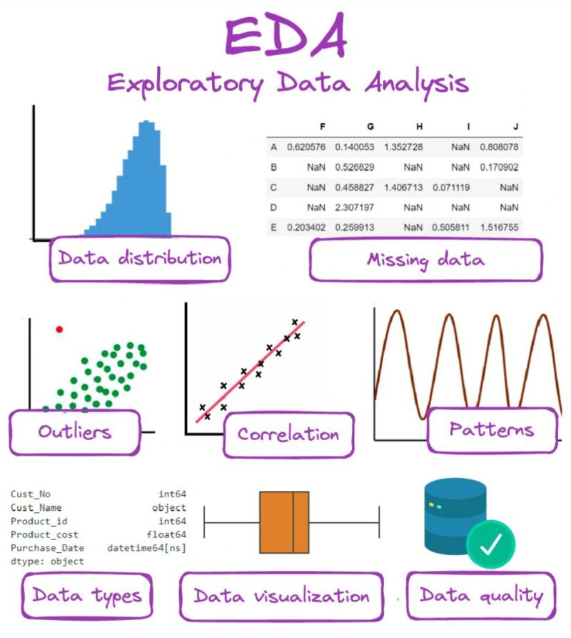

* *Exploratory Data Analysis (EDA) is an important step in any data analysis or machine learning project. EDA is the process of investigating the dataset to discover patterns, relationships, and outliers. EDA gives us a chance to look into the data on what really influences the value of a house.*

# Feature Engineering

#### 1. **Handling Categorical Variables**

Categorical features like location, property_type, neighborhood, and garage_type often need encoding for machine learning algorithms to interpret them correctly.

* One-Hot Encoding: Converts categorical variables into a series of binary columns (0 or 1) to represent categories.

df = pd.get_dummies(df, columns=['location', 'property_type'], drop_first=True)

* Label Encoding: If your categorical variables have an inherent order (like garage_type with levels such as "small", "medium", "large"), you can use label encoding.

from sklearn.preprocessing import LabelEncoder

le = LabelEncoder()

df['garage_type'] = le.fit_transform(df['garage_type'])

Frequency Encoding: Replace categorical values with the frequency of their occurrence in the dataset.

location_freq = df['location'].value_counts()

df['location_freq'] = df['location'].map(location_freq)

#### 2. **Creating Interaction Features**

Interaction features capture the relationship between two or more features, which might have a synergistic effect on the target variable.

* Interaction between sqft and num_bedrooms:

df['sqft_bedroom_interaction'] = df['sqft'] * df['num_bedrooms']

Interaction between lot_size and location:

df['lot_size_location_interaction'] = df['lot_size'] * df['location_freq']

#### 3. **Date/Time Features**

If your dataset includes date information like the year built, sale date, or renovation date, you can extract useful time-related features.

* Age of the Property: The age of the house can significantly influence its price. You can create a new feature by calculating the age of the house based on the year it was built.

current_year = 2023

df['house_age'] = current_year – df['year_built']

Time Since Renovation: If there’s a column like last_renovated, you can calculate how long it has been since the last renovation df['years_since_renovation'] = current_year – df['last_renovated']

# Model Building

***Univariate linear regression***

* First, we used a single independent variable to construct a linear regression model. We assume the area of the house as the only independent variable, and the model is shown as the following:

󰇜 y=ß₀+ß₁*house area+ϵ

*  This study uses the least squares (OLS) to estimate the parameters and in the model. With the training data, we can obtain estimates of the intercept and regression coefficients.

**Multivariable linear regression**

* Univariate models use a limited number of variables to predict a single characteristic. In order to improve the prediction accuracy of the model, the program introduces several features and constructs a multivariate linear regression model. Multiple characteristics are accounted in this model (e.g. area, number of bedrooms, number of bathrooms, etc.), and the model is shown as the following:

  󰇛󰇜 y=ß₀+ß₁x₁+…...+ßₓxₓ+ϵ

* Similarly, this research use the least squares method to estimate the various regression coefficients and fit the model with the training data.

# Model Evaluation

* *Evaluate the model's accuracy using metrics like mean squared error (MSE) or R-squared.*
* *Tune model parameters and iterate on the process to optimize performance and achieve the desired accuracy.*

# Deployment

* *Deploy the trained model for real-time house price predictions.*
* *Continuously monitor the model's performance and retrain it with new data to maintain accuracy and adapt to market changes.*
* *Specific techniques used:*
* *Linear Regression:*
* *A simple yet effective method for identifying linear relationships between features and house prices.*
* *Support Vector Regression (SVR):*
* *A powerful technique that can handle complex, non-linear relationships in the data.*
* *Random Forest:*
* *An ensemble method that combines multiple decision trees to improve accuracy and robustness.*
* *Gradient Boosting:*
* *Another ensemble method that builds models sequentially, with each model correcting the errors of the previous one.*
* *Neural Networks:*
* *Complex models that can learn intricate patterns in the data, suitable for capturing non-linear relationship*

# Source code

# Import libraries

import pandas as pd

import numpy as np

from sklearn.model_selection import train_test_split, GridSearchCV

from sklearn.preprocessing import StandardScaler

from sklearn.metrics import mean_squared_error, r2_score

from xgboost import XGBRegressor

import matplotlib.pyplot as plt

import seaborn as sns

# Load dataset (e.g., from Kaggle's House Prices dataset)

data = pd.read_csv('house_prices.csv')

# Preprocess data

# Handle missing values

data.fillna(data.mean(), inplace=True)

# Encode categorical variables

data = pd.get_dummies(data, drop_first=True)

# Feature and target selection

X = data.drop(['SalePrice'], axis=1)

y = data['SalePrice']

# Feature scaling

scaler = StandardScaler()

X_scaled = scaler.fit_transform(X)

# Train-test split

X_train, X_test, y_train, y_test = train_test_split(X_scaled, y, test_size=0.2, random_state=42)

# Smart regression model: XGBoost

model = XGBRegressor(n_estimators=100, learning_rate=0.1, max_depth=5, random_state=42)

model.fit(X_train, y_train)

# Predict and evaluate

y_pred = model.predict(X_test)

mse = mean_squared_error(y_test, y_pred)

r2 = r2_score(y_test, y_pred)

print("Mean Squared Error:", mse)

print("R^2 Score:", r2)

# Plot predictions

plt.figure(figsize=(10, 6))

sns.scatterplot(x=y_test, y=y_pred)

plt.xlabel("Actual Price")

plt.ylabel("Predicted Price")

plt.title("Actual vs Predicted House Prices")

plt.show()

# Future scope

#### a. **Geospatial Data (Geolocation and Satellite Imagery)**

* Geospatial Analysis: Real estate prices are strongly influenced by location factors like proximity to public transport, schools, parks, business districts, etc. By integrating latitude and longitude data, you can model price variations based on distance from key locations.
* Satellite Imagery: Using satellite images, you can extract features like land use, surrounding infrastructure, and even predict the level of urbanization. Deep learning models like Convolutional Neural Networks (CNNs) can be employed to analyze images and improve predictions.

Example Application:

* + Distance to city center: Calculate the distance of a property from the nearest city center or business hub and integrate it into the model.
  + Urbanization Trends: Predict how rapidly developing areas will increase in price based on urban expansion patterns visible in satellite images.

#### b. **Social Media Data**

* Real estate prices can be influenced by public sentiment or trends. Analyzing social media platforms like Twitter, Instagram, or Reddit for mentions of particular locations or neighborhoods can provide valuable information about the desirability of certain areas.

Example Application:

* + Collecting geo-tagged data to see how often a neighborhood is mentioned in a positive context.
  + Analyzing online reviews of neighborhoods or communities to correlate with price growth.

# 13. Team Members and Roles

|  |  |  |
| --- | --- | --- |
| **NAME** | **ROLE** | **RESPONSIBILITIES** |
| KEERTHNA.J | DATA SCIENTIST | DATA CLEANING, MODEL BUILDING |
| KISHORE.R | ML ENGINEER | MODEL EVALUATION, FEATURE ENGINEERING |
| LAKSHMI.P | DATA ANALYST | EDA VISUALIZATION |
| MARI.M | DEVELOPER | DEVELOPMENT SETUP/ APP DASHBOARD DEVELPER |