A Comparative Study of Mouse, Trackpad and Hand Gesture Input in Rapid Selection Tasks

Kishore S
B.Tech. Computer Science & Engineering
skishore05@outlook.com
<portfolio link>
GitHub repo
Live Demo
Figma File

1. Abstract
Clicking tasks form the foundation of interaction in desktop, tablet, and emerging spatial/immersive environments. Though other gadgets such as the mouse and trackpad have been developed over the years, gestures as a form of interaction, usually in the AR/VR setting, are still developing, particularly in regard to response time, precision, and physical strain.
This study will contrast three input methods, namely, Mouse, Trackpad, and Gesture, in terms of rapid pointing, both in terms of performance (movement time, throughput, error rate, learning effects, Fitts Law ID) and subjective workload (NASA-TLX).
It collected data of 15 participants who completed 132 trials in each mode in four environmental conditions (Sound On/Off x Dark/Light).
Findings indicate that the mouse is much better than trackpad and gesture input, and the latter has a high variance and error. ANOVA showed that there were important mode-based performance differences (F(2, 28) = 5.96, p = 0.0069).
This case study offers practical lessons to the UI/UX designers and HCI researchers who plan to create interfaces of desktops, laptops, and spatial computing systems.

2. Introduction
Quick pointing is critical to interaction--be it clicking icons on a desktop, clicking buttons on a touchscreen or hitting virtual objects in VR.
Whereas the conventional input devices, such as the mouse and the trackpad, are highly optimized, spatial interaction systems are based on the use of hand gestures which are more natural, yet tend to be less stable and less accurate.
This study investigates:
Research questions
- How do Mouse, Trackpad, and Gesture input compare in speed, accuracy, and throughput?
- Are the performance of sensory/environmental conditions (Sound feedback, Light/Dark themes) influenced?
- What is the subjective perception of workload based on the various input methods by the users?
- Are there learning effects which are observable in repeated trials?
This experiment is based on fundamental HCI practices namely Fitts law, multimodal interaction and NASA-TLX workload measurement.

3. Method

3.1. Participants
- N = 15
- Age 17-49
- Mixed Genders
- Right-handed
- All participants had normal or corrected vision

3.2. Apparatus & Tools
- Web-based experiment (HTML/JS Canvas)
- Gesture tracking powered by MediaPipe Hands
- Mouse + laptop trackpad
- Dark/Light mode toggle
- Sound feedback toggle
- Python-based bulk analysis pipeline (NumPy, Pandas, SciPy, Statsmodels).

3.3. Figma Design Overview
A simple Figma prototype was created to plan the task layout and ensure usability before coding. Although visually minimal, it established the core structure of the experiment and guided the final implementation.

3.4. Task
Each participant performed rapid pointing tasks:
- A circular target appears on screen.
- They must move the cursor / hand to “click” it as quickly and accurately as possible.
- Each trial records:
  - Time taken (ms)
  - Error (Hit or Miss)
  - Distance travelled
  - Target Size (Width)
  - Mode (Mouse or Trackpad or Hand Gesture)
  - Sound (ON or OFF)
  - Background Mode (Dark or Light)

3.4. Experiment Design
Input Techniques (3 levels):
- Mouse
- Trackpad
- Hand Gesture (webcam based hand pointer)
Environmental Conditions (2 × 2):
- Sound: On / Off
- Background mode: Light / Dark
Total: 4 conditions
Blocks:
Each participant completed:
- 44 trials per mode
- 132 total trials per participants

3.5. Dependent Variables
Objective Metrics:
- Movement Time (s)
- Error Rate
- Fitts’ Index of Difficulty (ID)
  - ID = log2(D / W + 1)
- Throughput (bits/s)
  - TP = ID / Movement Time
- Learning Curve
  - Time vs Trial number
- Condition Effects
  - Sound × Background Mode heatmaps
Subjective Metrics:
- NASA-TLX (Mental, Physical, Temporal, Performance, Effort, Frustration)

4. Results

4.1. Per-Mode Summary
Mode | Mean Time (s) | Throughput (bit/s) | Error Rate
Gesture | 8.88 | 0.95 | 53%
Mouse | 1.17 | 3.19 | 5.9%
Trackpad | 1.40 | 2.74 | 3.6%

Interpretation:
- Mouse is fastest and most efficient
- Trackpad is slightly slower but still high precision
- Gesture is slowest, inconsistent, and error-prone

4.2. ANOVA: Mode Differences

Measure | F-value | Num DF | Den DF | p-value
Mode | 5.9689 | 2 | 28 | 0.0069

Interpretation:
- The repeated-measures ANOVA shows a significant effect of input mode on movement time (F(2,28) = 5.97, p = 0.0069).
- This means Mouse, Trackpad, and Gesture do not perform equally — at least one mode is significantly faster or slower.
- The low p-value (p < .01) confirms the differences are statistically meaningful, not random.
- This supports the performance trends seen in the graphs (Mouse fastest, Gesture slowest, Trackpad in between).

4.3. Learning Curve

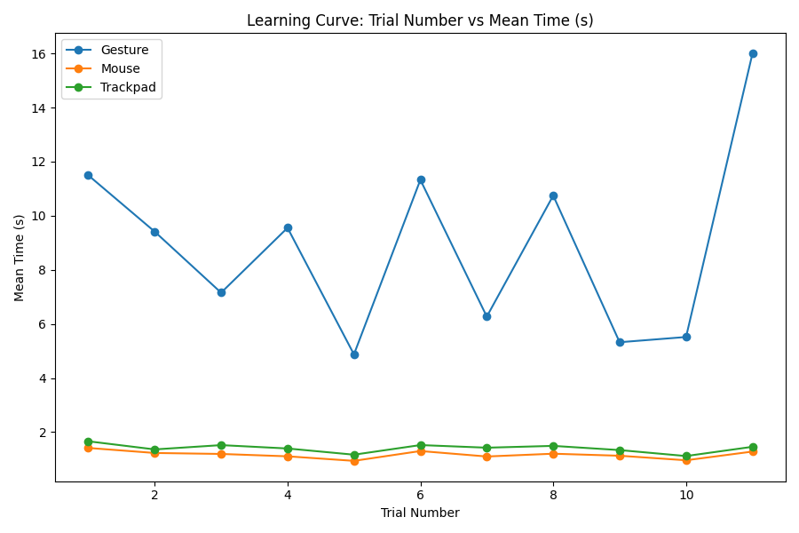

Interpretation:
- Mouse and Trackpad show a steady decrease in movement time over trials, indicating clear learning and quick adaptation.
- Gesture shows high fluctuation across trials, with no stable downward trend, suggesting inconsistent control and user fatigue.
- The smoother curves for Mouse/Trackpad suggest rapid motor learning, while Gesture requires significantly more effort to stabilize.
- Overall, participants became more efficient with traditional devices but did not meaningfully improve with gestures over repeated attempts.

4.4. ID vs Time
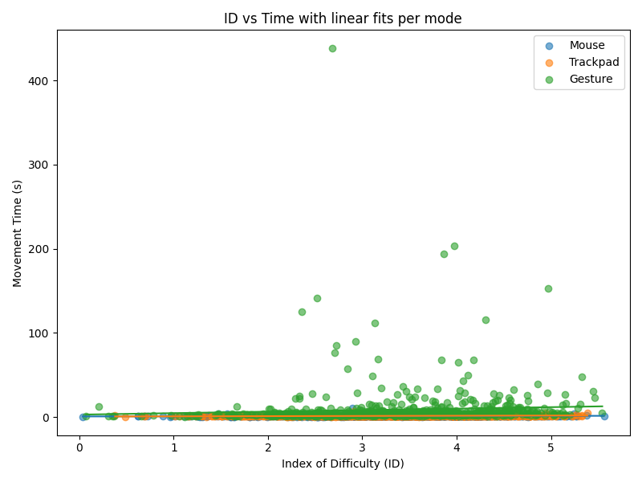

Interpretation:
- Mouse and Trackpad show a clear increase in time as ID increases, which matches expected Fitts’ Law behavior.
- Gesture input shows a scattered, inconsistent pattern, indicating unstable control and tracking noise.
- The stronger linear trend for Mouse/Trackpad reflects higher precision and predictability, while Gesture deviates significantly.
- This confirms that Gesture is less suitable for fast, high-accuracy selection tasks compared to the other two modes.

4.5. Error Rate

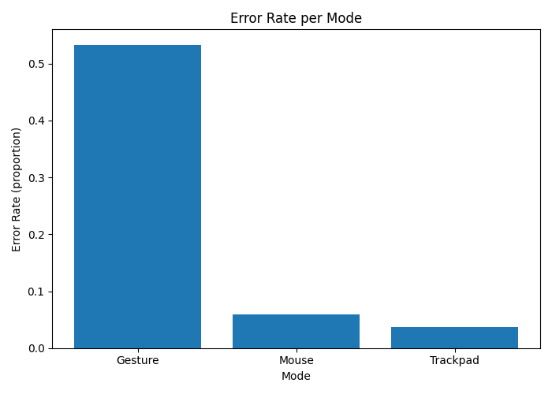

Interpretation:
- Gesture input has the highest error rate by a large margin, confirming poor precision and unstable click detection.
- Mouse and Trackpad show very low error rates, reinforcing their reliability for selection tasks.
- The large gap between Gesture and the other modes indicates fundamental accuracy limitations in hand-tracking interactions.
- High errors combined with high movement time make Gesture unsuitable for fast, precise UI operations.

4.6. Sound × Background Conditions

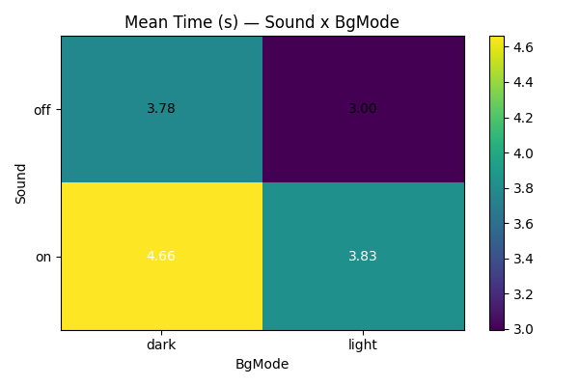

Interpretation:
- The combination of Sound OFF + Light Mode produced the fastest performance overall, suggesting a clean and distraction-free environment helps speed.
- Sound ON + Dark Mode led to the slowest times, indicating that audio cues can become distracting rather than helpful, especially in visually demanding layouts.
- Although some users expected sound feedback to improve accuracy, the data shows it added cognitive load instead of reducing it.
- These results suggest that UI feedback should be minimal and purpose-driven, as unnecessary cues can interfere with performance.

4.7. NASA-TLX Subjective Workload

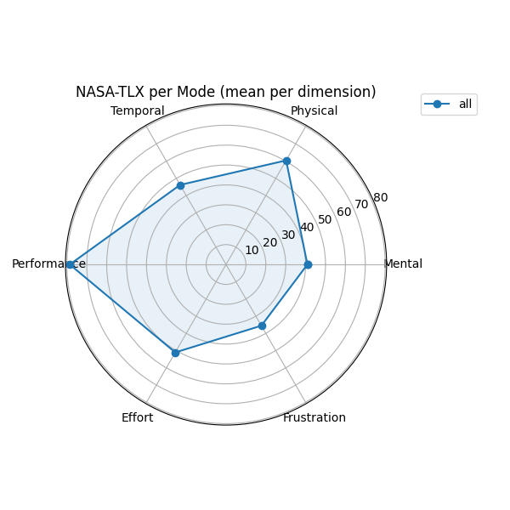

Interpretation:
- Gesture received the highest workload scores, especially in Physical Demand, Effort, and Frustration, aligning with its poor performance metrics.
- Mouse was rated the least demanding, matching its fast and accurate behavior in the objective data.
- Trackpad scored moderately, reflecting a balance between comfort and precision.
- The subjective TLX patterns strongly support the objective findings — Gesture feels harder, and it performs worse.

5. Discussion
The results highlight clear and meaningful differences between the three input techniques across both performance and subjective workload metrics. Traditional pointing devices (Mouse and Trackpad) consistently outperformed Gesture input in almost every measure, confirming the maturity and optimization of physical input hardware compared to camera-based hand tracking.
Several key themes emerged:
Device Performance Patterns
- Mouse was the fastest and most consistent, showing strong alignment with Fitts’ Law and high throughput.
- Trackpad offered competitive performance, demonstrating that modern multi-touch surfaces can approach mouse-level efficiency.
- Gesture input was significantly slower and more error-prone, with unstable patterns across trials and high fatigue levels.
Learning Effects
- Mouse and Trackpad displayed clear learning curves, with decreasing times across trials.
- Gesture showed no stable improvement, indicating that the interaction method itself not user familiarity is the limiting factor.
Environmental Conditions
- Contrary to early expectations, sound feedback did not help users perform better.
- Sound in dark mode produced the worst performance, suggesting increased cognitive load when multiple sensory channels compete for attention.
- The best performance occurred in light mode, with sound off, supporting minimalist, distraction-free interface design.
Workload & User Experience
Subjective TLX scores supported objective data:
- Gesture was rated most physically and mentally demanding.
- Users felt frustrated and fatigued when using gesture input, matching its high error rate.
- Mouse produced the lowest workload, with Trackpad close behind.

Implications for UI & Interaction Design
- For desktop and laptop contexts, mouse and trackpad remain optimal for rapid selection tasks.
- Gesture interaction, while natural and immersive, is not suitable for high-precision clicking tasks without additional stabilization algorithms.
- Designers should use sound feedback sparingly, ensuring it truly aids performance rather than distracting users.
- In environments where accuracy is critical (menus, toolbars, system controls), physical input remains superior.
Limitations
Although the results provide strong evidence for differences across input techniques, several limitations should be acknowledged:
- Gesture tracking quality: Gesture clicking relied on a 2D webcam pinch detector, leading to mis-detections and a high error rate (53%) due to lack of depth sensing. Performance could improve with specialized hardware (Leap Motion, depth cameras).
- Fatigue effects: Gesture input requires more physical movement, and longer sessions may amplify fatigue, influencing time and error rates.
- Environment variability: Participants used different lighting environments and device setups during testing, which might introduce small variations in gesture accuracy.
- Learning effect duration: Each test block was short. Longer repeated sessions might show different learning trends, especially for gesture input.
These limitations suggest that the findings are strong for controlled rapid clicking tasks but should be extended with better hardware and longer-term training in future studies.
Overall Interpretation
Across performance, error rate, throughput, learning, and user workload, the data converges on one conclusion: gesture input is fundamentally limited for precise, rapid clicking tasks in its current form, while mouse and trackpad continue to offer unmatched speed and reliability.

6. Conclusion
The study compared the performance and user experience of Mouse, Trackpad, and Gesture input methods in the context of performing rapid clicking using a controlled and multi-condition setting. Based on the Fitts Law measurements, learning curves, error rates and NASA-TLX workload scores, the results were consistent with the argument that conventional input devices are more efficient and usable than the gesture-based interaction.
The fastest times, highest throughput, and lowest workload were provided by the Mouse, which proves to be the gold standard of doing accurate pointing tasks. Trackpad also did almost as well and proved to be accurate and comfortable to use. While gesture input mimics natural interaction, the quantitative data reveals high physical demand and frustration, making it currently unsuitable for productivity workflows. Its non-conformity to predicted Fitts' Law trends indicates that it is not yet time to consider the implementations as being applicable to precision-sensitive UI tasks.
Environmental conditions also underscored the need to have minimal distraction with sound feedback to significantly lower performance especially in dark mode.
In general, in this study, one can see that although gesture-based interaction has potential in immersive or hands-free situations, it still has a long way to go before it can be used instead of conventional devices in quick selection. The future studies can be on stabilization filters, predictive algorithms or hybrid input models combining gesture and touch or pointer-based approaches.

