

DATABASE MANAGEMENT SYSTEM LABORATORY
MINI PROJECT REPORT

A REPORT

Submitted by

DHANIS AHMED K (9517202206014)

HARI HARA SUDAN M (9517202206021)

KISHORE N A (9517202206024)

MEPCO SCHLENK ENGINEERING COLLEGE, SIVAKASI (AUTONOMOUS)

DECEMBER 2023

BONAFIDE CERTIFICATE

Certified that this project report is the bonafide work of DHANIS AHMED K (22BIT037), HARI HARA SUDAN M(22BIT043) , KISHORE N A (22BIT045) who carried out the project work under my supervision.

SIGNATURE SIGNATURE
Dr.R.Venitta Raj,BTech., M.E .,Ph.D., Dr. T. Revathi, M.E., Ph.D.,
STAFF IN-CHARGE HEAD OF THE DEPARTMENT
Assistant Professor (Sl. G) Senior Professor
Information Technology Information Technology
Mepco Schlenk Engineering College Mepco Schlenk Engineering College
Virudhunagar Dt. – 626 005 Virudhunagar Dt. – 626 005

ACKNOWLEDGEMENT

We have taken efforts in this project. However, it would not have been possible without the kind support and help of many individuals and our reputed institution Mepco Schlenk Engineering College, Sivakasi. We would like to extend our sincere thanks to our Principal Dr. S. Arivazhagan ME., PhD.

We would like to express my special gratitude and thanks to Dr.T.Revathi ME., PhD. Senior Professor & Head of the Department for giving us such a wonderful experience.

We are highly indebted to Dr. T. Revathi Sr. Prof. & HOD, Dr. R. Venitta Raj AP(SL. Grade)/IT and Mrs. M. Prasha Meena Assistant Professor for their guidance and constant supervision as well as for providing necessary information regarding the project & also for their support in completing the project.

We would like to express our gratitude towards other teaching and non teaching staff members of IT Department for their kind co-operation and encouragement which help us in all means to complete this project successful.

Abstract:

Our project is to develop the Inventory Database Management System. The Siva Stores Database Management System (SS-DBMS) is a sophisticated and integrated solution designed to enhance the operational efficiency and management capabilities of Siva Stores ltd. This comprehensive system encompasses various facets of the inventory shop business, including dealer information, product details , category management and billing, offering a centralized platform for streamlined operations.
The system provides a user-friendly interface for efficiently adding and retrieving product details. This functionality includes maintaining a comprehensive database of customer preferences, purchase histories, and contact information. By having instant access to this information, Siva Stores can personalize customer interactions and tailor their offerings to individual preferences. In the realm of product management, SS-DBMS tracks product details such as quantity, category, and cost.
This real-time monitoring ensures that the inventory is accurately reflected, allowing for informed decision-making regarding restocking and product offerings. The system's dynamic features enable a seamless update of product information as the business evolves .SS-DBMS extends its capabilities to dealer management, recording vital information about personnel within the organization. This includes details about dealer’s, their city, and salary information. The system accommodates changes in staffing by allowing for updates when dealer join or leave the company. Moreover, the system able to preview ,save bill as PDF and to print bill according to predefined company policies.

TABLE OF CONTENTS

1. Introduction | 6
1.1Purpose | 8
1.2 Scope | 11
1.3 Definitions, Acronyms and Abbreviations | 14
1.4 References | 17
2.ER-Diagram | 18
3. Normalization | 19
4. Implementation | 20
5. PL/SQL | 62
5.1 Triggers | 62
5.2 Procedures | 63
5.3 Functions | 64
6. Screenshots | 65
7. Conclusion | 70

1.INTRODUCTION:

In the dynamic landscape of automotive and industrial finishing, effective management of inventory shops plays a pivotal role in ensuring quality outcomes, operational efficiency, and customer satisfaction. The increasing demand for diverse inventory applications and the complexity of managing various processes within a inventory shop necessitate the implementation of robust technological solutions. This mini-project endeavors to address these challenges by proposing a comprehensive Inventory Shop Management System.

Objective:

The primary objective of this project is to design and implement a database management system tailored for inventory shops, streamlining their operations and enhancing overall efficiency. This system aims to automate and optimize key aspects of inventory shop management, including inventory tracking, order processing, dealer management, and quality control.

Scope:

The scope of the Inventory Shop Management System encompasses the entire inventory shop workflow, starting from order placement to the final quality check. The system will facilitate seamless communication and coordination between different units within the inventory shop, providing real-time insights into inventory levels, production schedules, and resource utilization.

Significance:

In the contemporary manufacturing environment, achieving precision in inventory application is crucial not only for meeting industry standards but also for maintaining a competitive edge. The proposed system recognizes the significance of integrating technology into inventory shop management, offering a centralized platform to monitor and control various aspects of the inventory bussiness process.

Key Features:

The Inventory Shop Management System will incorporate key features such as inventory management, order processing, dealer scheduling, billing and quality assurance. Additionally, it will provide reporting tools to analyze performance metrics, identify bottlenecks, and support informed decision-making.

As we delve into the subsequent sections of this report, we will detail the design and implementation of the database schema, discuss the functionalities of the system, and present the results of testing and validation. Through this mini-project, we aim to contribute to the advancement of inventory shop management practices, fostering efficiency, reliability, and adaptability in the ever-evolving domain of surface finishing.

1.1 PURPOSE:

In the intricate realm of inventory shop operations, the implementation of a Database Management System (DBMS) is motivated by a multitude of compelling reasons. The purpose of creating a DBMS tailored for a inventory shop environment is rooted in addressing key challenges and enhancing overall efficiency. Below are the primary objectives and purposes behind the development of such a system:

1. Streamlining Operations:
- Objective: The core purpose is to streamline and automate various processes within the inventory shop, from order processing to the final quality check.
- Purpose: By centralizing data and automating routine tasks, the DBMS aims to reduce manual errors, minimize delays, and optimize the entire workflow.

2. Inventory Management:
- Objective: Efficient tracking and management of inventory/ materials, ensuring optimal stock levels and preventing shortages or excesses.
- Purpose: To eliminate instances of material shortages or wastage, thereby improving cost-effectiveness and ensuring timely completion of orders.

3. Order Processing and Tracking:
- Objective: Seamless processing of customer orders and real-time tracking of order status throughout the production cycle.
- Purpose: Enhance customer satisfaction by providing accurate and timely information on order progress, delivery schedules, and potential delays.

4. Resource Utilization:
- Objective: Optimal utilization of resources, including human resources and machinery, to maximize production efficiency.
- Purpose: Improve resource allocation and scheduling to meet production demands without overburdening the workforce or equipment.

5. Quality Assurance:
- Objective: Implementation of quality control measures at every stage of the inventory process to ensure consistent and high-quality outcomes.
- Purpose: Minimize defects, rework, and customer complaints by integrating quality checks and reporting mechanisms into the system.

6. Data Analysis and Reporting:
- Objective: Provide tools for analyzing performance metrics, identifying trends, and generating insightful reports.
- Purpose: Enable informed decision-making by offering a comprehensive view of key performance indicators, production trends, and areas for improvement.

7. Compliance and Documentation:
- Objective: Ensure compliance with industry standards, regulations, and customer specifications.
- Purpose: Maintain accurate and accessible documentation for auditing purposes, certifications, and traceability.

8. Adaptability to Industry Changes:

- Objective: Create a flexible system capable of adapting to changes in inventory formulations, production processes, and industry standards.
- Purpose: Future-proof the inventory shop operations by providing a scalable and adaptable platform.

In essence, the creation of a dedicated DBMS for a inventory shop serves to modernize and optimize operations, fostering efficiency, accuracy, and adaptability in the face of the evolving demands of the surface finishing industry. Through this initiative, the aim is not only to meet current industry challenges but also to position the inventory shop for sustained growth and success in the future.

1.2 SCOPE:
The scope of a Inventory Shop Management System is broad and covers various aspects of managing operations within a inventory shop environment. Here's an outline of the potential scope for such a system:

1. Order Management:
- Objective: Efficiently process and manage customer orders for inventory services.
- Scope: Order creation, order status tracking, order modification, and order history.

2. Inventory Management:

- Objective: Track and manage inventory materials, ensuring optimal stock levels.
- Scope: Inventory tracking, material consumption analysis, reorder alerts, and supplier management.

3. Dealer Management:
- Objective: Efficiently schedule and manage the workforce involved in the inventory shop operations.
- Scope: Dealer scheduling, performance tracking, training records, and role-based access control.

4. Workflow Automation:
- Objective: Automate routine tasks and processes to streamline the overall workflow.
- Scope: Automation of order processing, task assignments, and notification systems.

5. Quality Control:
- Objective: Implement quality checks at every stage of the inventory process to ensure consistent and high-quality outcomes.
- Scope: Quality control checkpoints, defect tracking, and compliance with industry standards.

6. Resource Utilization:

- Objective: Optimize the use of resources, including human resources and machinery.
- Scope: Equipment scheduling, resource allocation, and performance monitoring.

7. Reporting and Analytics:
- Objective: Provide tools for analyzing performance metrics and generating insightful reports.
- Scope: Customizable reports, performance dashboards, and trend analysis.

8. Customer Relationship Management (CRM):
- Objective: Enhance customer satisfaction by providing transparent and timely information.
- Scope: Customer communication logs, order history, and feedback management.

9. Compliance and Documentation:
- Objective: Ensure compliance with industry standards, regulations, and customer specifications.
- Scope: Document management, compliance tracking, and audit trails.

10. Adaptability and Scalability:
- Objective: Create a system that can adapt to changes in inventory formulations, production processes, and industry standards.

- Scope: Modular architecture, easy system updates, and scalability for future growth.

11. Security:
- Objective: Ensure the security and integrity of sensitive data within the system.
- Scope: Role-based access control, data encryption, and regular security audits.

12. Mobile Accessibility:
- Objective: Allow access to critical information and functionalities through mobile devices.
- Scope: Mobile-friendly interfaces, notifications, and remote monitoring.

13. Integration with External Systems:
- Objective: Integrate with other enterprise systems for seamless data flow.
- Scope: Integration with ERP systems, supply chain management, and financial systems.

1.3 DEFINITION, ACRONYMNS AND ABBREVIATIONS:

DDL (Data Definition Language):
Definition: A subset of SQL that includes commands for defining and managing the structure of a database, such as creating tables and altering their structure.

DML (Data Manipulation Language):
Definition: A subset of SQL used for manipulating data stored in the database, including operations like inserting, updating, and deleting records.

Normalization:
Definition: The process of organizing data in a database to reduce redundancy and improve data integrity. It involves breaking down large tables into smaller, related tables.

ACID (Atomicity, Consistency, Isolation, Durability):
Definition: A set of properties that guarantee that database transactions are processed reliably. Transactions should be atomic (indivisible), consistent, isolated, and durable.

Primary Key:
Definition: A unique identifier for a record in a table. It ensures that each record can be uniquely identified and is often used as a reference in other tables.

Foreign Key:
Definition: A field in a database table that is a primary key in another table. It establishes a link between the two tables, representing a relationship.

Index:
Definition: A data structure that improves the speed of data retrieval operations on a database table. Indexing involves creating an organized structure to quickly locate and access the requested data.

JOIN:
Definition: A SQL operation used to combine rows from two or more tables based on a related column between them. Common types include INNER JOIN, LEFT JOIN, and RIGHT JOIN.

VIEW:
Definition: A virtual table generated from the result of a SELECT query. Views allow users to present a subset of data or combine data from multiple tables without altering the underlying database structure.

TRIGGER:
Definition: A set of instructions that are automatically executed or fired in response to certain events on a particular table or view in a database. Triggers can perform actions such as validation, data modification, or auditing.

PROCEDURE:
Definition: A set of SQL statements stored in the database and executed as a single unit. Procedures are often used to encapsulate a series of tasks, providing modularity and reusability.

FUNCTION:
Definition: A database object that encapsulates a set of SQL statements and returns a single value. Functions can be used in SQL queries, providing a way to perform calculations or operations on data.

INDEX:
Definition: A database object that improves the speed of data retrieval operations on a database table. Indexing involves creating an organized structure to quickly locate and access the requested data.

TRANSACTION:
Definition: A sequence of one or more SQL statements that are executed as a single unit of work. Transactions ensure the consistency and integrity of the database by either committing all changes or rolling back to the state before the transaction.

CONSTRAINT:
Definition: A rule or restriction applied to a column or set of columns in a database table. Constraints ensure the accuracy and reliability of data by defining limits or relationships between columns.

ACRONYMS:

DBMS : Database Management System
JDBC : Java Database Connectivity
GUI : Graphical User Interface
SQL : Structured Query Language
API : Application Programming Interface
OCI : Oracle Call Interface
ODB : Oracle Database
IDE : Integrated Development Environment
UI : User Interface
CRUD : Create, Read, Update, Delete (Database Operations)
MVC : Model-View-Controller (Design Pattern)
DAO : Data Access Object
DTO : Data Transfer Object
ORM : Object-Relational Mapping
JPA : Java Persistence API
ACID : Atomicity, Consistency, Isolation, Durability (Database Transaction Properties)

1.4 REFERENCES:
- Schildt, Herbert. "Java: The Complete Reference." McGraw-Hill Education.

- Loy, Marc; Eckstein, Robert; Wood, Dave; Elliott, James. "Java Swing." O'Reilly Media.

- Bryla, Bob; Loney, Kevin. "Oracle Database 12c: The Complete Reference." McGraw-Hill Education.

- Reese, George. "Java Database Best Practices." O'Reilly Media.

- Hernandez, Michael J. "Database Design for Mere Mortals." Addison-Wesley.

- Sierra, Kathy; Bates, Bert. "Head First Java." O'Reilly Media,.

2. ER DIAGRAM:

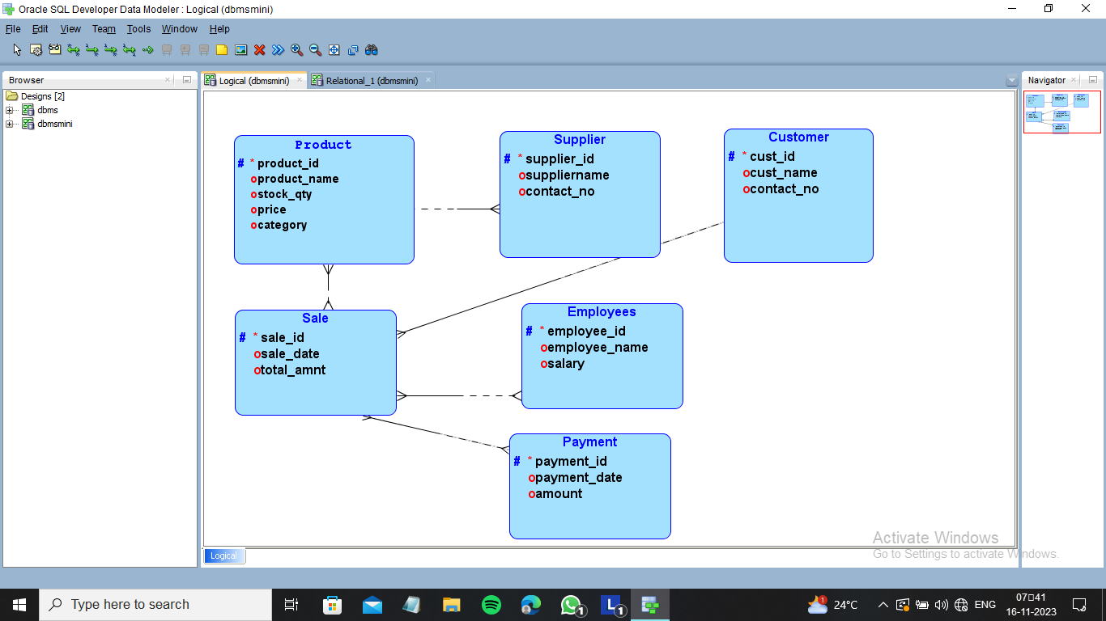

RELATIONAL DIAGRAM
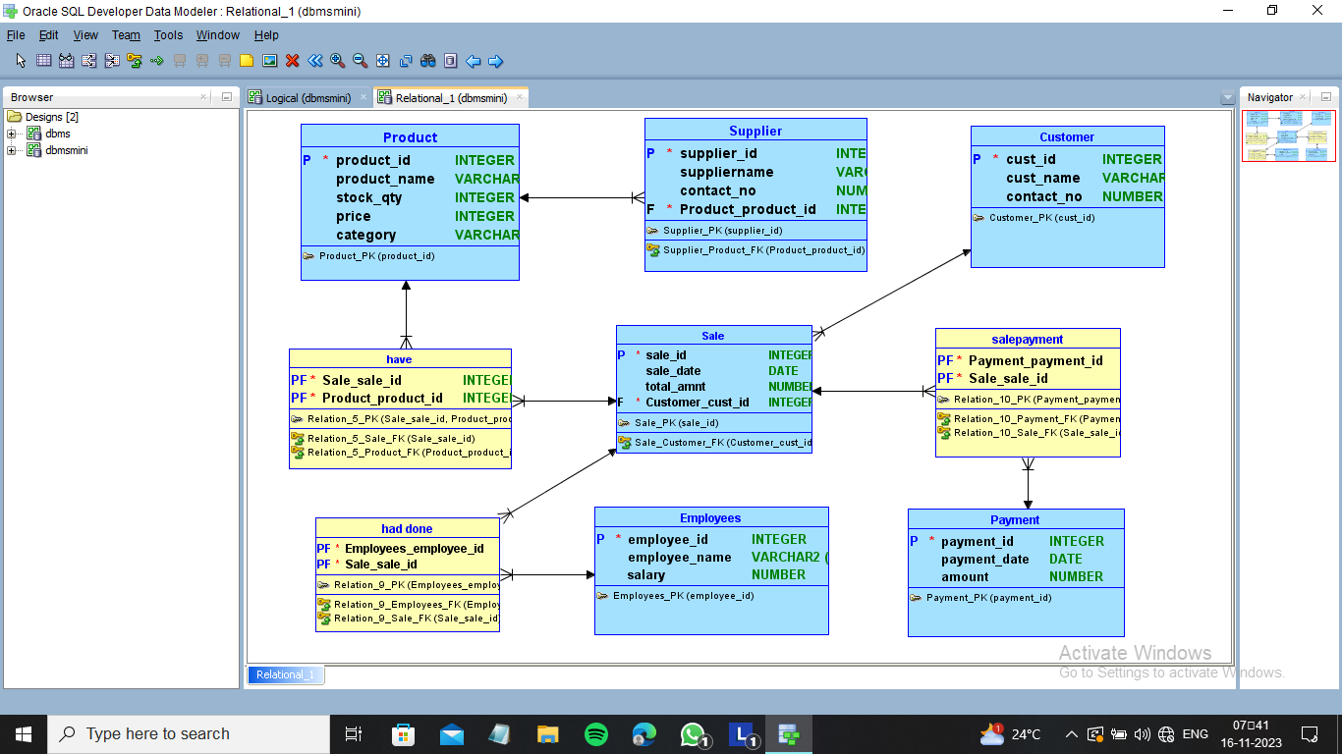
3. Normalization:
Original Tables:
- product( pid, pname, pquantity, pprice, pcatgory);
- selltable( sellid. sellname, sellpass, sellgen, age );
- category(id, name, pass);
- admin(id, name, pass);
- customer(id,name,address,ph_no);

Normalized Tables:
1 NF :
- product(pid (PK), pname, pquantity, pprice, pcategory);
- selltable(sellid (PK), sellname, sellpass, sellgen, age);
- category(id (PK), name);
- admin(id (PK), name);
- customer(id (PK), name, address, ph_no);
2 NF:
1) SELLERTABLE (SID, SNAME, SADD, GSTIN, CONTACTNO)
2) Products (PID, PNAME, QUANTITY, PRICE, SNAME)
3) Product_Details (PID, CANSIZE, PURDATE)
4) Employees (EID, ENAME, SALARY, ADDR, CONTACTNO, EXP, JOIN_DETAIL)
5) Customer (CID, CNAME, ADDR, CONTACTNO, GSTIN, CUSTTYPE)
6) Bill (BILLDATE, BILLNO, CODE, NAME, RATE, QUANTITY, AMOUNT, BILL_DATE)
7) Bill_Customer (BILLDATE, CID)

3 NF:
1) SELLERTABLE (SID, SNAME, SADD, GSTIN, CONTACTNO)
2) Products (PID, PNAME, QUANTITY, PRICE, SNAME)
3) Product_Details (PID, CANSIZE, PURDATE)
4) Employees (EID, ENAME, SALARY, ADDR, CONTACTNO, EXP, JOIN_DETAIL)
5) Customer (CID, CNAME, ADDR, CONTACTNO, GSTIN, CUSTTYPE)
6) Bill (BILLDATE, BILLNO, CODE, NAME, RATE, QUANTITY, AMOUNT, BILL_DATE)
7) Bill_Customer (BILLDATE, CID)

4. IMPLEMENTATION:

LOGIN PAGE:

package supermarket;
import javax.swing.table.DefaultTableModel;
import javax.swing.JOptionPane;
import java.sql.Connection;
import java.sql.DriverManager;
import java.sql.PreparedStatement;
import java.sql.ResultSet;
import java.sql.SQLException;
import java.awt.HeadlessException;
import java.sql.*;
public class login extends javax.swing.JFrame {
public login() {
initComponents();
}
Connection con=null;
PreparedStatement st=null;
ResultSet rs=null;
private void jButton1MouseClicked(java.awt.event.MouseEvent evt) {
if(role.getSelectedItem().toString().equals("Employee")){
String query = "SELECT * FROM selltable WHERE sellname=? AND sellpassword=?";
try {
con = DriverManager.getConnection("jdbc:oracle:thin:@localhost:1521:xe", "system", "15-06-2005");
try (PreparedStatement pstmt = con.prepareStatement(query)) {
pstmt.setString(1, uid.getText());
pstmt.setString(2, pass1.getText());

try (ResultSet resultSet = pstmt.executeQuery()) {
if (resultSet.next()) {
new selling().setVisible(true);
this.dispose();
} else {
JOptionPane.showMessageDialog(this, "Invalid Sellername or Password");
}
}
}
} catch (SQLException e) {
e.printStackTrace();
JOptionPane.showMessageDialog(this, "Error in authentication: " + e.getMessage());
} finally {
try {
if (con != null) {
con.close();
}
} catch (SQLException ex) {
ex.printStackTrace();
}
}}
else{
String query = "SELECT * FROM admin WHERE name=? AND pass=?";
try {
con = DriverManager.getConnection("jdbc:oracle:thin:@localhost:1521:xe", "system", "15-06-2005");
try (PreparedStatement pstmt = con.prepareStatement(query)) {
// Assuming uid and pass are JTextField objects
pstmt.setString(1, uid.getText().trim());
pstmt.setString(2, pass1.getText().trim());
System.out.println("Username: " + uid.getText().trim());
System.out.println("Password: " + pass1.getText().trim());
try (ResultSet resultSet = pstmt.executeQuery()) {
if (resultSet.next()) {
// Successfully logged in
new Product().setVisible(true);
this.dispose();
} else {
// Login failed
JOptionPane.showMessageDialog(this, "Invalid Admin or Password");
}
}
}
} catch (SQLException e) {
e.printStackTrace(); // Handle the exception appropriately (e.g., log or display an error message)
} finally {
// Close the connection in a finally block
try {
if (con != null) {
con.close();
}
} catch (SQLException e) {
e.printStackTrace(); // Handle the exception appropriately
}
}
}
}

private void jButton2MouseClicked(java.awt.event.MouseEvent evt) {
uid.setText("");
pass1.setText("");
}
public static void main(String args[]) {
java.awt.EventQueue.invokeLater(new Runnable() {
public void run() {
new login().setVisible(true);
}
});
}
// Variables declaration - do not modify
private javax.swing.JButton jButton1;
private javax.swing.JButton jButton2;
private javax.swing.JLabel jLabel1;
private javax.swing.JLabel jLabel2;
private javax.swing.JLabel jLabel3;
private javax.swing.JLabel jLabel4;
private javax.swing.JLabel jLabel5;
private javax.swing.JLabel jLabel6;
private javax.swing.JLabel jLabel7;
private javax.swing.JLabel jLabel8;
private javax.swing.JPanel jPanel1;
private javax.swing.JPasswordField pass1;
private javax.swing.JComboBox<String> role;
private javax.swing.JTextField uid;
// End of variables declaration
}

PRODUCT PAGE:

package supermarket;
import javax.swing.table.DefaultTableModel;
import javax.swing.JOptionPane;
import java.sql.Connection;
import java.sql.DriverManager;
import java.sql.PreparedStatement;
import java.sql.ResultSet;
import java.sql.SQLException;
import java.awt.HeadlessException;
import java.sql.*;

public class Product extends javax.swing.JFrame {
Connection con=null;
PreparedStatement st=null;
ResultSet rs=null;

public Product() {
initComponents();
SelectProduct();
getcat();
}
public void SelectProduct() {
try {
Class.forName("oracle.jdbc.driver.OracleDriver");
con = DriverManager.getConnection("jdbc:oracle:thin:@localhost:1521:xe", "system", "15-06-2005");
st = con.prepareStatement("SELECT * FROM product order by pid");
rs = st.executeQuery();
ResultSetMetaData rsmd = rs.getMetaData();
DefaultTableModel tbl = new DefaultTableModel();

int col = rsmd.getColumnCount();
String[] colname = new String[col];
for (int i = 0; i < col; i++) {
colname[i] = rsmd.getColumnName(i + 1);
}

tbl.setColumnIdentifiers(colname);
while (rs.next()) {
String pid = String.valueOf(rs.getInt(1));
String pname = rs.getString(2);
String pqunatity = String.valueOf(rs.getInt(3));
String pprice = String.valueOf(rs.getInt(4));
String pcate = rs.getString(5); // Corrected variable name
String[] tdata = {pid, pname, pqunatity, pprice, pcate};
tbl.addRow(tdata);
}
producttable.setModel(tbl);
con.close();
} catch (Exception e) {
System.out.println(e.getMessage());
}
}
private void getcat(){
try {
Class.forName("oracle.jdbc.driver.OracleDriver");
con = DriverManager.getConnection("jdbc:oracle:thin:@localhost:1521:xe", "system", "15-06-2005");
st = con.prepareStatement("SELECT * FROM category");
rs = st.executeQuery();
while(rs.next()){
String mycat = rs.getString("name");
pcate.addItem(mycat);
}
} catch (Exception e) {
System.out.println(e.getMessage());
}
}
private void jButton1MouseClicked(java.awt.event.MouseEvent evt) {
if (pid.getText().isEmpty() || pname.getText().isEmpty() || pquantity.getText().isEmpty() || pprice.getText().isEmpty()) {
JOptionPane.showMessageDialog(this, "Missing information");
} else {
try {
con = DriverManager.getConnection("jdbc:oracle:thin:@localhost:1521:xe", "system", "15-06-2005");
String sql = "INSERT INTO product VALUES(?, ?, ?, ?, ?)";
st = con.prepareStatement(sql);
st.setInt(1, Integer.valueOf(pid.getText()));
st.setString(2, pname.getText());
st.setInt(3, Integer.valueOf(pquantity.getText()));
st.setInt(4, Integer.valueOf(pprice.getText()));
st.setString(5, pcate.getSelectedItem().toString());

// Execute the query without using executeQuery() as it is an INSERT statement
int rowsAffected = st.executeUpdate();

if (rowsAffected > 0) {
JOptionPane.showMessageDialog(null, "Added to database");
SelectProduct();
} else {
JOptionPane.showMessageDialog(null, "Invalid");
}
} catch (SQLException ex) {
if (ex.getErrorCode() == -20001) {
JOptionPane.showMessageDialog(null, "Error: Quantity must be at least 5.");
} else {
ex.printStackTrace();
JOptionPane.showMessageDialog(null, "Error: " + ex.getMessage());
}
} finally {
// Close resources
try {
if (st != null) {
st.close();
}
if (con != null) {
con.close();
}
} catch (SQLException ex) {
ex.printStackTrace();
}
}
}
}

private void producttableMouseClicked(java.awt.event.MouseEvent evt) {
DefaultTableModel model = (DefaultTableModel) producttable.getModel();
int myindex = producttable.getSelectedRow();
pid.setText(model.getValueAt(myindex, 0).toString());
pname.setText(model.getValueAt(myindex, 1).toString());
pquantity.setText(model.getValueAt(myindex, 2).toString());
pprice.setText(model.getValueAt(myindex, 3).toString());
}

private void jButton2MouseClicked(java.awt.event.MouseEvent evt) {

if (pid.getText().isEmpty() || pname.getText().isEmpty() || pquantity.getText().isEmpty() || pprice.getText().isEmpty()) {
JOptionPane.showMessageDialog(null, "Missing information");
} else {
try {
con = DriverManager.getConnection("jdbc:oracle:thin:@localhost:1521:xe", "system", "15-06-2005");
String query = "UPDATE product SET pname=?, pquantity=?, pprice=?, PCATEGORY=? WHERE pid=?";
try (PreparedStatement pstmt = con.prepareStatement(query)) {
pstmt.setString(1, pname.getText());
pstmt.setString(2, pquantity.getText());
pstmt.setString(3, pprice.getText());
pstmt.setString(4, pcate.getSelectedItem().toString());
pstmt.setInt(5, Integer.parseInt(pid.getText()));

int rowsAffected = pstmt.executeUpdate();

if (rowsAffected > 0) {
JOptionPane.showMessageDialog(null, "Updated successfully");
SelectProduct();
} else {
JOptionPane.showMessageDialog(null, "No record found with the given pid");
}
}
} catch (SQLException e) {
e.printStackTrace();
JOptionPane.showMessageDialog(null, "Error updating record: " + e.getMessage());
} finally {
try {
if (con != null) {
con.close();
}
} catch (SQLException ex) {
ex.printStackTrace();
}
}
}
}
private void jButton4MouseClicked(java.awt.event.MouseEvent evt) {

if (pid.getText().isEmpty()) {
JOptionPane.showMessageDialog(null, "Enter the pid:");
} else {
try {
con = DriverManager.getConnection("jdbc:oracle:thin:@localhost:1521:xe", "system", "15-06-2005");
String id = pid.getText();
String query = "DELETE FROM product WHERE pid=?";
try (PreparedStatement pstmt = con.prepareStatement(query)) {
pstmt.setInt(1, Integer.parseInt(pid.getText()));
pstmt.executeUpdate();
}
SelectProduct();
JOptionPane.showMessageDialog(null, "Product Deleted successfully");
} catch (Exception e) {
e.printStackTrace();
JOptionPane.showMessageDialog(null, "Error deleting product: " + e.getMessage());
} finally {
try {
if (con != null) {
con.close();
}
} catch (SQLException ex) {
ex.printStackTrace();
}
}
}
}

private void jButton3MouseClicked(java.awt.event.MouseEvent evt) {
pid.setText("");
pname.setText("");
pquantity.setText("");
pprice.setText("");
}

private void jLabel8MouseClicked(java.awt.event.MouseEvent evt) {
System.exit(0);
}

private void jLabel10MouseClicked(java.awt.event.MouseEvent evt) {
new seller().setVisible(true);
this.dispose();
}

private void jLabel12MouseClicked(java.awt.event.MouseEvent evt) {
new category().setVisible(true);
this.dispose();
}

private void jLabel13MouseClicked(java.awt.event.MouseEvent evt) {
new login().setVisible(true);
this.dispose();
}

private void jButton5MouseClicked(java.awt.event.MouseEvent evt) {
new selling().setVisible(true);
this.dispose();
}

public static void main(String args[]) {
java.awt.EventQueue.invokeLater(new Runnable() {
public void run() {
new Product().setVisible(true);
}
});
}
private javax.swing.JButton jButton1;
private javax.swing.JButton jButton2;
private javax.swing.JButton jButton3;
private javax.swing.JButton jButton4;
private javax.swing.JButton jButton5;
private javax.swing.JLabel jLabel10;
private javax.swing.JLabel jLabel12;
private javax.swing.JLabel jLabel13;
private javax.swing.JLabel jLabel2;
private javax.swing.JLabel jLabel3;
private javax.swing.JLabel jLabel4;
private javax.swing.JLabel jLabel5;
private javax.swing.JLabel jLabel6;
private javax.swing.JLabel jLabel7;
private javax.swing.JLabel jLabel8;
private javax.swing.JLabel jLabel9;
private javax.swing.JPanel jPanel1;
private javax.swing.JPanel jPanel2;
private javax.swing.JPanel jPanel3;
private javax.swing.JScrollPane jScrollPane1;
private javax.swing.JComboBox<String> pcate;
private javax.swing.JTextField pid;
private javax.swing.JTextField pname;
private javax.swing.JTextField pprice;
private javax.swing.JTextField pquantity;
private javax.swing.JTable producttable;
// End of variables declaration
}

SELLER DETAILS:

package supermarket;
import javax.swing.table.DefaultTableModel;
import javax.swing.JOptionPane;
import java.sql.Connection;
import java.sql.DriverManager;
import java.sql.PreparedStatement;
import java.sql.ResultSet;
import java.sql.SQLException;
import java.awt.HeadlessException;
import java.sql.*;
;

/**
*
* @author HP
*/
public class seller extends javax.swing.JFrame {
Connection con=null;
PreparedStatement st=null;
ResultSet rs=null;

public seller() {
initComponents();
Selectseller();
}
public void Selectseller(){

try {
Class.forName("oracle.jdbc.driver.OracleDriver");
con = DriverManager.getConnection("jdbc:oracle:thin:@localhost:1521:xe", "system", "15-06-2005");
st = con.prepareStatement("SELECT * FROM selltable order by sellid");
rs = st.executeQuery();
ResultSetMetaData rsmd = rs.getMetaData();

DefaultTableModel tbl = new DefaultTableModel();

int col = rsmd.getColumnCount();
String[] colname = new String[col];
for (int i = 0; i < col; i++) {
colname[i] = rsmd.getColumnName(i + 1);
}

tbl.setColumnIdentifiers(colname);

while (rs.next()) {
String id = String.valueOf(rs.getInt(1));
String name = rs.getString(2);
String password = rs.getString(3);
String gender = rs.getString(4);
String age = String.valueOf(rs.getString(5));
String[] tdata = {id, name, password, gender, age};
tbl.addRow(tdata);
}

// Set the new model to the JTable
tablesell.setModel(tbl);

con.close();
} catch (Exception e) {
System.out.println(e.getMessage());
}
}
private void addbtnMouseClicked(java.awt.event.MouseEvent evt) {
if (sellid.getText().isEmpty() || sellname.getText().isEmpty() || sellpassword.getText().isEmpty() || age.getText().isEmpty()) {
JOptionPane.showMessageDialog(this, "Missing information");
} else {
try {
con = DriverManager.getConnection("jdbc:oracle:thin:@localhost:1521:xe", "system", "15-06-2005");
String sql = "INSERT INTO selltable VALUES(?, ?, ?, ?, ?)";
st = con.prepareStatement(sql);
st.setInt(1, Integer.valueOf(sellid.getText()));
st.setString(2, sellname.getText());
st.setString(3, sellpassword.getText());
st.setString(4, sellgen.getSelectedItem().toString());
st.setInt(5, Integer.valueOf(age.getText()));

int rowsAffected = st.executeUpdate();

if (rowsAffected > 0) {
JOptionPane.showMessageDialog(null, "Success");
Selectseller();
} else {
JOptionPane.showMessageDialog(null, "Failed to insert data");
}

con.close();
} catch (SQLException ex) {
// Check if the SQLException is due to the custom error raised by the trigger
if (ex.getErrorCode() == -20001) {
JOptionPane.showMessageDialog(null, "Error: Seller must be at least 18 years old.");
} else {
ex.printStackTrace();
JOptionPane.showMessageDialog(null, "Error: " + ex.getMessage());
}
}
}
}

private void tablesellMouseClicked(java.awt.event.MouseEvent evt) {
DefaultTableModel model = (DefaultTableModel) tablesell.getModel();
int myindex = tablesell.getSelectedRow();
sellid.setText(model.getValueAt(myindex, 0).toString());
sellname.setText(model.getValueAt(myindex, 1).toString());
sellpassword.setText(model.getValueAt(myindex, 2).toString());
}

private void clrbtnMouseClicked(java.awt.event.MouseEvent evt) {
sellid.setText("");
sellname.setText("");
sellpassword.setText("");
}

private void delbtnMouseClicked(java.awt.event.MouseEvent evt) {
if (sellid.getText().isEmpty()) {
JOptionPane.showMessageDialog(null, "Enter the Sellid:");
} else {
try {
con = DriverManager.getConnection("jdbc:oracle:thin:@localhost:1521:xe", "system", "15-06-2005");
String sid = sellid.getText();
String query = "DELETE FROM selltable WHERE sellid=?";
try (PreparedStatement pstmt = con.prepareStatement(query)) {
pstmt.setInt(1, Integer.parseInt(sid));
pstmt.executeUpdate();
}
Selectseller();
JOptionPane.showMessageDialog(null, "Seller Deleted successfully");
} catch (Exception e) {
e.printStackTrace();
JOptionPane.showMessageDialog(null, "Error deleting seller: " + e.getMessage());
} finally {
try {
if (con != null) {
con.close();
}
} catch (SQLException ex) {
ex.printStackTrace();
}
}
}
}

private void editbtnMouseClicked(java.awt.event.MouseEvent evt) {
if (sellid.getText().isEmpty() || sellname.getText().isEmpty() || sellpassword.getText().isEmpty() || age.getText().isEmpty()) {
JOptionPane.showMessageDialog(null, "missing information");
} else {
try {
con = DriverManager.getConnection("jdbc:oracle:thin:@localhost:1521:xe", "system", "15-06-2005");
String query = "update selltable set sellname='" +sellname.getText()+ "',SELLPASSWORD='" +sellpassword.getText()+ "',SELLGEN='" +sellgen.getSelectedItem().toString()+ "',age = "+age.getText()+" where sellid="+sellid.getText();
Statement add=con.createStatement();
add.executeUpdate(query);
JOptionPane.showMessageDialog(null, "updated sucessfully");
Selectseller();
}
catch(SQLException e){
e.printStackTrace();
} }
}

private void jLabel8MouseClicked(java.awt.event.MouseEvent evt) {
System.exit(0);
}
private void jLabel11MouseClicked(java.awt.event.MouseEvent evt) {
new Product().setVisible(true);
this.dispose();
}

private void jLabel12MouseClicked(java.awt.event.MouseEvent evt) {
new category().setVisible(true);
this.dispose();
}

private void jLabel13MouseClicked(java.awt.event.MouseEvent evt) {
new login().setVisible(true);
this.dispose();
}
private void jLabel1MouseClicked(java.awt.event.MouseEvent evt) {
new Updateadmin().setVisible(true);
this.dispose();
}
public static void main(String args[]) {
try {
System.setProperty("java.util.logging.ConsoleHandler.level", "FINEST");
for (javax.swing.UIManager.LookAndFeelInfo info : javax.swing.UIManager.getInstalledLookAndFeels()) {
if ("Nimbus".equals(info.getName())) {
javax.swing.UIManager.setLookAndFeel(info.getClassName());
break;
}
}
} catch (ClassNotFoundException | InstantiationException | IllegalAccessException | javax.swing.UnsupportedLookAndFeelException ex) {
java.util.logging.Logger.getLogger(seller.class.getName()).log(java.util.logging.Level.SEVERE, null, ex);
}

java.awt.EventQueue.invokeLater(() -> {
new seller().setVisible(true);
});
}
private javax.swing.JButton addbtn;
private javax.swing.JTextField age;
private javax.swing.JButton clrbtn;
private javax.swing.JButton delbtn;
private javax.swing.JButton editbtn;
private javax.swing.JLabel jLabel1;
private javax.swing.JLabel jLabel11;
private javax.swing.JLabel jLabel12;
private javax.swing.JLabel jLabel13;
private javax.swing.JLabel jLabel2;
private javax.swing.JLabel jLabel3;
private javax.swing.JLabel jLabel4;
private javax.swing.JLabel jLabel5;
private javax.swing.JLabel jLabel6;
private javax.swing.JLabel jLabel7;
private javax.swing.JLabel jLabel8;
private javax.swing.JLabel jLabel9;
private javax.swing.JPanel jPanel1;
private javax.swing.JPanel jPanel2;
private javax.swing.JPanel jPanel3;
private javax.swing.JScrollPane jScrollPane1;
private javax.swing.JComboBox<String> sellgen;
private javax.swing.JTextField sellid;
private javax.swing.JTextField sellname;
private javax.swing.JTextField sellpassword;
private javax.swing.JTable tablesell;
// End of variables declaration
}

CATEGORY DETAILS:

package supermarket;
import javax.swing.table.DefaultTableModel;
import javax.swing.JOptionPane;
import java.sql.Connection;
import java.sql.DriverManager;
import java.sql.PreparedStatement;
import java.sql.ResultSet;
import java.sql.SQLException;
import java.awt.HeadlessException;
import java.sql.*;
public class category extends javax.swing.JFrame {
Connection con=null;
PreparedStatement st=null;
ResultSet rs=null;
public category() {
initComponents();
Selectcate();
}
public void Selectcate(){

try {
Class.forName("oracle.jdbc.driver.OracleDriver");
con = DriverManager.getConnection("jdbc:oracle:thin:@localhost:1521:xe", "system", "15-06-2005");
st = con.prepareStatement("SELECT * FROM category order by id");
rs = st.executeQuery();
ResultSetMetaData rsmd = rs.getMetaData();

DefaultTableModel tbl = new DefaultTableModel();

int col = rsmd.getColumnCount();
String[] colname = new String[col];
for (int i = 0; i < col; i++) {
colname[i] = rsmd.getColumnName(i + 1);
}

tbl.setColumnIdentifiers(colname);

while (rs.next()) {
String id = String.valueOf(rs.getInt(1));
String name = rs.getString(2);
String des = rs.getString(3);
String[] tdata = {id, name, des};
tbl.addRow(tdata);
}

// Set the new model to the JTable
catetable.setModel(tbl);

con.close();
} catch (Exception e) {
System.out.println(e.getMessage());
}

}
package supermarket;
import javax.swing.table.DefaultTableModel;
import javax.swing.JOptionPane;
import java.sql.Connection;
import java.sql.DriverManager;
import java.sql.PreparedStatement;
import java.sql.ResultSet;
import java.sql.SQLException;
import java.awt.HeadlessException;
import java.sql.*;

public class category extends javax.swing.JFrame {
Connection con=null;
PreparedStatement st=null;
ResultSet rs=null;
public category() {
initComponents();
Selectcate();
}
public void Selectcate(){

try {
Class.forName("oracle.jdbc.driver.OracleDriver");
con = DriverManager.getConnection("jdbc:oracle:thin:@localhost:1521:xe", "system", "15-06-2005");
st = con.prepareStatement("SELECT * FROM category order by id");
rs = st.executeQuery();
ResultSetMetaData rsmd = rs.getMetaData();

DefaultTableModel tbl = new DefaultTableModel();

int col = rsmd.getColumnCount();
String[] colname = new String[col];
for (int i = 0; i < col; i++) {
colname[i] = rsmd.getColumnName(i + 1);
}

tbl.setColumnIdentifiers(colname);

while (rs.next()) {
String id = String.valueOf(rs.getInt(1));
String name = rs.getString(2);
String des = rs.getString(3);
String[] tdata = {id, name, des};
tbl.addRow(tdata);
}

// Set the new model to the JTable
catetable.setModel(tbl);

con.close();
} catch (Exception e) {
System.out.println(e.getMessage());
}
java.awt.EventQueue.invokeLater(new Runnable() {
public void run() {
category frame = new category();
frame.setLocationRelativeTo(null);
frame.setVisible(true);
}
});
}

// Variables declaration - do not modify
private javax.swing.JButton addbtn;
private javax.swing.JTextField catedes;
private javax.swing.JTextField cateid;
private javax.swing.JTextField catename;
private javax.swing.JTable catetable;
private javax.swing.JButton jButton2;
private javax.swing.JButton jButton3;
private javax.swing.JButton jButton4;
private javax.swing.JLabel jLabel1;
private javax.swing.JLabel jLabel10;
private javax.swing.JLabel jLabel11;
private javax.swing.JLabel jLabel12;
private javax.swing.JLabel jLabel2;
private javax.swing.JLabel jLabel3;
private javax.swing.JLabel jLabel4;
private javax.swing.JLabel jLabel5;
private javax.swing.JLabel jLabel6;
private javax.swing.JLabel jLabel8;
private javax.swing.JPanel jPanel1;
private javax.swing.JPanel jPanel2;
private javax.swing.JPanel jPanel3;
private javax.swing.JScrollPane jScrollPane1;
// End of variables declaration
}

BILLING PAGE :

package supermarket;
import javax.swing.table.DefaultTableModel;
import javax.swing.JOptionPane;
import java.sql.Connection;
import java.sql.DriverManager;
import java.sql.PreparedStatement;
import java.sql.ResultSet;
import java.sql.SQLException;
import java.awt.HeadlessException;
import java.sql.*;

public class selling extends javax.swing.JFrame {

Connection con=null;
PreparedStatement st=null;
ResultSet rs=null;
public selling() {
initComponents();
SelectProduct();
getcat();
}
public void SelectProduct() {
try {
Class.forName("oracle.jdbc.driver.OracleDriver");
con = DriverManager.getConnection("jdbc:oracle:thin:@localhost:1521:xe", "system", "15-06-2005");
st = con.prepareStatement("SELECT * FROM product order by pid");
rs = st.executeQuery();
ResultSetMetaData rsmd = rs.getMetaData();
DefaultTableModel tbl = new DefaultTableModel();

int col = rsmd.getColumnCount();
String[] colname = new String[col];
for (int i = 0; i < col; i++) {
colname[i] = rsmd.getColumnName(i + 1);
}

tbl.setColumnIdentifiers(colname);

while (rs.next()) {
String pid = String.valueOf(rs.getInt(1));
String pname = rs.getString(2);
String pqunatity = String.valueOf(rs.getInt(3));
String pprice = String.valueOf(rs.getInt(4));
String pcate = rs.getString(5); // Corrected variable name
String[] tdata = {pid, pname, pqunatity, pprice, pcate};
tbl.addRow(tdata);
}
producttable.setModel(tbl);
con.close();
} catch (Exception e) {
System.out.println(e.getMessage());
}
}
int prid,newq;
public void update(){
try (Connection con = DriverManager.getConnection("jdbc:oracle:thin:@localhost:1521:xe", "system", "15-06-2005");
CallableStatement callableStatement = con.prepareCall("{ call update_product_quantity(?, ?) }")) {
callableStatement.setInt(1, prid);
callableStatement.setInt(2, newq);
callableStatement.execute();
SelectProduct();
} catch (SQLException e) {
e.printStackTrace();
JOptionPane.showMessageDialog(null, "Error updating record: " + e.getMessage());
}
}
private void getcat(){
try {
Class.forName("oracle.jdbc.driver.OracleDriver");
con = DriverManager.getConnection("jdbc:oracle:thin:@localhost:1521:xe", "system", "15-06-2005");
st = con.prepareStatement("SELECT * FROM category");
rs = st.executeQuery();
while(rs.next()){
String mycat = rs.getString("name");
pcate.addItem(mycat);
}
} catch (Exception e) {
System.out.println(e.getMessage());
}
}
private boolean isQuantityValid(int productId, int enteredQuantity) {
try (Connection con = DriverManager.getConnection("jdbc:oracle:thin:@localhost:1521:xe", "system", "15-06-2005");
CallableStatement callableStatement = con.prepareCall("{ ? = call IS_QUANTITY_VALID(?, ?) }")) {

// Register the OUT parameter
callableStatement.registerOutParameter(1, Types.INTEGER);

// Set the function parameters
callableStatement.setInt(2, productId);
callableStatement.setInt(3, enteredQuantity);

// Execute the function
callableStatement.execute();

// Retrieve the result
int result = callableStatement.getInt(1);
return result == 1;
} catch (SQLException e) {
e.printStackTrace();
// Handle the exception appropriately (e.g., log or display an error message)
return false; // Return false if an error occurs
}
}
private void clrbtnMouseClicked(java.awt.event.MouseEvent evt) {

name.setText("");
quantity.setText("");
}
private void jLabel8MouseClicked(java.awt.event.MouseEvent evt) {
System.exit(0);
}
Double uprice,prodtot=0.0,gtot=0.0;int aquan;
private void producttableMouseClicked(java.awt.event.MouseEvent evt) {
DefaultTableModel model = (DefaultTableModel) producttable.getModel();
int myindex = producttable.getSelectedRow();
prid = Integer.valueOf(model.getValueAt(myindex, 0).toString());
aquan = Integer.valueOf(model.getValueAt(myindex, 2).toString());

uprice = Double.valueOf(model.getValueAt(myindex, 3).toString());
name.setText(model.getValueAt(myindex, 1).toString());
}
int i=0;boolean isQuantityValid;
private void billbtnMouseClicked(java.awt.event.MouseEvent evt) {
String quantityText = quantity.getText().trim();
if (!quantityText.isEmpty() && quantityText.matches("\\d+")) {
int quantityValue = Integer.parseInt(quantityText);
prodtot = uprice * quantityValue;
isQuantityValid = isQuantityValid(prid, quantityValue);
} else {

JOptionPane.showMessageDialog(this, "Invalid quantity input");

}

if(quantity.getText().isEmpty()||name.getText().isEmpty())
{
JOptionPane.showMessageDialog(this, "Missing information");
}else if(!isQuantityValid){
JOptionPane.showMessageDialog(this, "not enough stockt");
}
else{
newq = aquan - Integer.valueOf(quantity.getText());
i++;
gtot = gtot + prodtot;
if(i==1){
biltxt.setText(biltxt.getText()+" =========PRAVEEN SHOP========== \nBILL ID:"+billid.getText()+"\n"+" NUM PRODUCT PRICE QUANTITY TOTAL\n"+i+" "+name.getText()+" "+uprice+" "+quantity.getText()+" "+prodtot+"\n");

}else{
biltxt.setText(biltxt.getText()+i+" "+name.getText()+" "+uprice+" "+quantity.getText()+" "+prodtot+"\n");

}
gtotb.setText("RS "+gtot);
update();
}
}
private void printMouseClicked(java.awt.event.MouseEvent evt) {
try (Connection con = DriverManager.getConnection("jdbc:oracle:thin:@localhost:1521:xe", "system", "15-06-2005");
Statement stmt = con.createStatement()) {

// Fetch the next value from the sequence
ResultSet rs = stmt.executeQuery("SELECT bill_id_seq.NEXTVAL FROM DUAL");

if (rs.next()) {
// Set the generated value in the billid textbox
int newBillId = rs.getInt(1);
billid.setText(String.valueOf(newBillId));
biltxt.setText(" ");
}

} catch (SQLException e) {
e.printStackTrace();
JOptionPane.showMessageDialog(null, "Error generating bill ID: " + e.getMessage());
}}
private void ftrMouseClicked(java.awt.event.MouseEvent evt) {

try {
Class.forName("oracle.jdbc.driver.OracleDriver");
con = DriverManager.getConnection("jdbc:oracle:thin:@localhost:1521:xe", "system", "15-06-2005");

// Assuming pcate is a JComboBox
String selectedCategory = pcate.getSelectedItem().toString();

// Use a parameterized query to avoid SQL injection
st = con.prepareStatement("SELECT * FROM product WHERE pcategory = ?");
st.setString(1, selectedCategory);

rs = st.executeQuery();
ResultSetMetaData rsmd = rs.getMetaData();
DefaultTableModel tbl = new DefaultTableModel();

int col = rsmd.getColumnCount();
String[] colname = new String[col];
for (int i = 0; i < col; i++) {
colname[i] = rsmd.getColumnName(i + 1);
}

tbl.setColumnIdentifiers(colname);

while (rs.next()) {
String pid = String.valueOf(rs.getInt(1));
String pname = rs.getString(2);
String pqunatity = String.valueOf(rs.getInt(3));
String pprice = String.valueOf(rs.getInt(4));
String pcate = rs.getString(5); // Corrected variable name
String[] tdata = {pid, pname, pqunatity, pprice, pcate};
tbl.addRow(tdata);
}
producttable.setModel(tbl);
con.close();
} catch (Exception e) {
System.out.println(e.getMessage());
}

}
public static void main(String args[]) {
java.awt.EventQueue.invokeLater(new Runnable() {
public void run() {
new selling().setVisible(true);
}
});
}
private javax.swing.JButton billbtn;
private javax.swing.JTextField billid;
private javax.swing.JTextArea biltxt;
private javax.swing.JButton clrbtn;
private javax.swing.JButton ftr;
private javax.swing.JLabel gtotb;
private javax.swing.JLabel jLabel12;
private javax.swing.JLabel jLabel2;
private javax.swing.JLabel jLabel4;
private javax.swing.JLabel jLabel5;
private javax.swing.JLabel jLabel6;
private javax.swing.JLabel jLabel8;
private javax.swing.JLabel jLabel9;
private javax.swing.JPanel jPanel1;
private javax.swing.JPanel jPanel2;
private javax.swing.JScrollPane jScrollPane1;
private javax.swing.JScrollPane jScrollPane2;
private javax.swing.JTextField name;
private javax.swing.JComboBox<String> pcate;
private javax.swing.JButton print;
private javax.swing.JTable producttable;
private javax.swing.JTextField quantity;
private javax.swing.JButton ref;
}

PL/SQL

PL/SQL is a block structured language that enables developers to combine the power of SQL with procedural statements.All the statements of a block are passed to oracle engine all at once which increases processing speed and decreases the traffic.

TRIGGERS
1.
CREATE OR REPLACE TRIGGER check_seller_age
BEFORE INSERT ON selltable
FOR EACH ROW
DECLARE
v_min_age CONSTANT NUMBER := 18;
BEGIN
IF :NEW.age < v_min_age THEN
RAISE_APPLICATION_ERROR(-20001, 'Seller must be at least 18 years old.');
END IF;
END;
/
This trigger is used whenever we insert new seller if the Age is less than 18,it gives an application error message to the user.

2.
CREATE OR REPLACE TRIGGER check_product_quantity
BEFORE INSERT ON product
FOR EACH ROW
DECLARE
v_min_quantity CONSTANT NUMBER := 5;
BEGIN
IF :NEW.pquantity < v_min_quantity THEN
RAISE_APPLICATION_ERROR(-20001, 'Quantity must be at least 5.');
END IF;
END;
/

Trigger created.
This trigger is used whenever we insert a product in product table, if the product is less than 5 then it show an application error message to the user.

FUNCTIONS

CREATE OR REPLACE FUNCTION is_quantity_valid(
p_product_id IN NUMBER,
p_entered_quantity IN NUMBER
) RETURN NUMBER
IS
v_available_quantity NUMBER;
BEGIN

SELECT pquantity INTO v_available_quantity
FROM product
WHERE pid = p_product_id;
IF p_entered_quantity <= v_available_quantity THEN
RETURN 1;
ELSE
RETURN 0;
END IF;
END is_quantity_valid;
/
This function used to check the quantity of the product when bill the products .

PROCEDURES

CREATE OR REPLACE PROCEDURE update_product_quantity(
p_product_id IN NUMBER,
p_new_quantity IN NUMBER
)
IS
BEGIN
UPDATE product
SET pquantity = p_new_quantity
WHERE pid = p_product_id;

COMMIT;
END update_product_quantity;
/
This procedure is used to update the quantity when the bill the product.
SCREENSHOTS:
LOGIN PAGE:
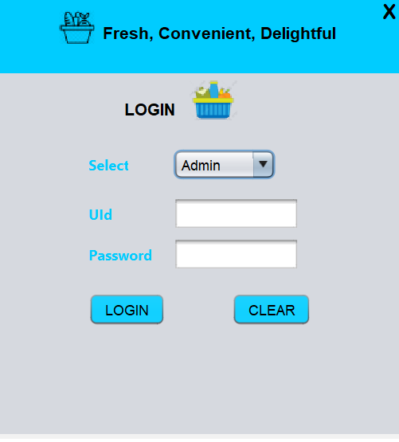
PRODUCT PAGE:
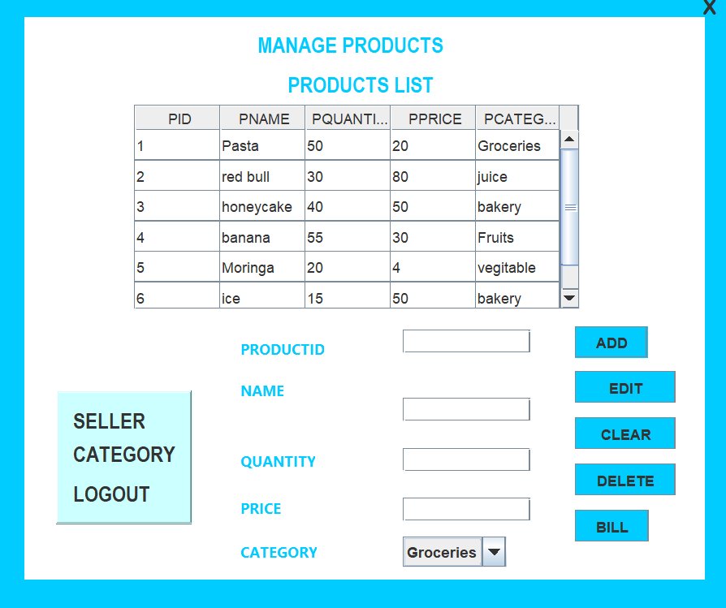
SELLER PAGE:
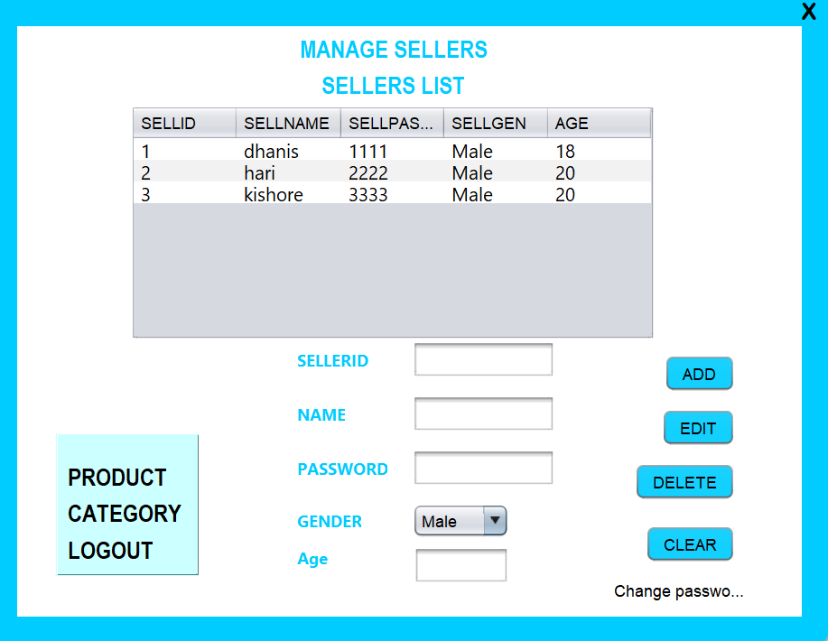
CATEGORY PAGE:
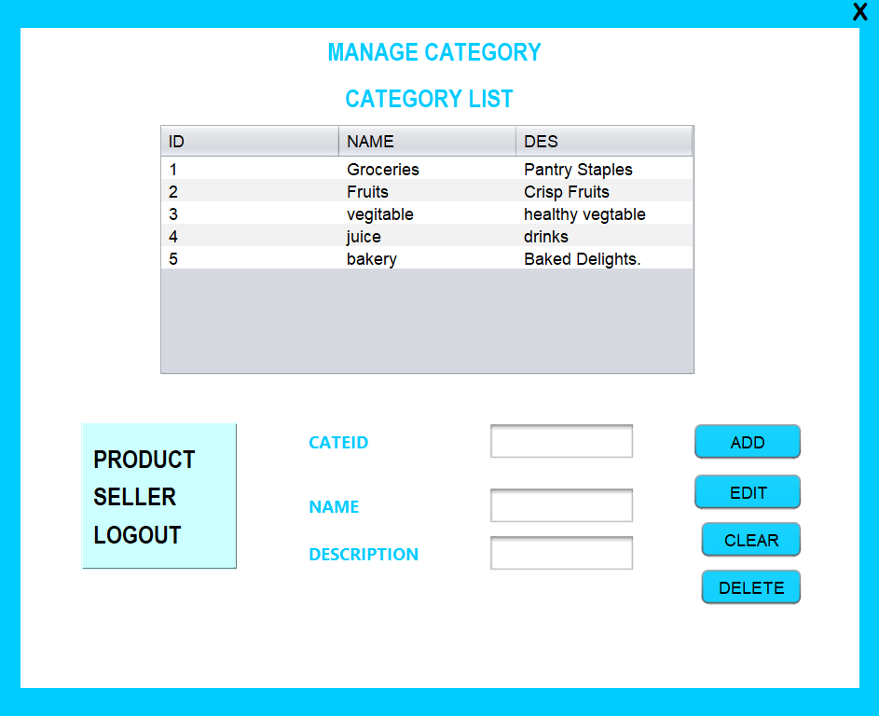
BILLING PAGE:
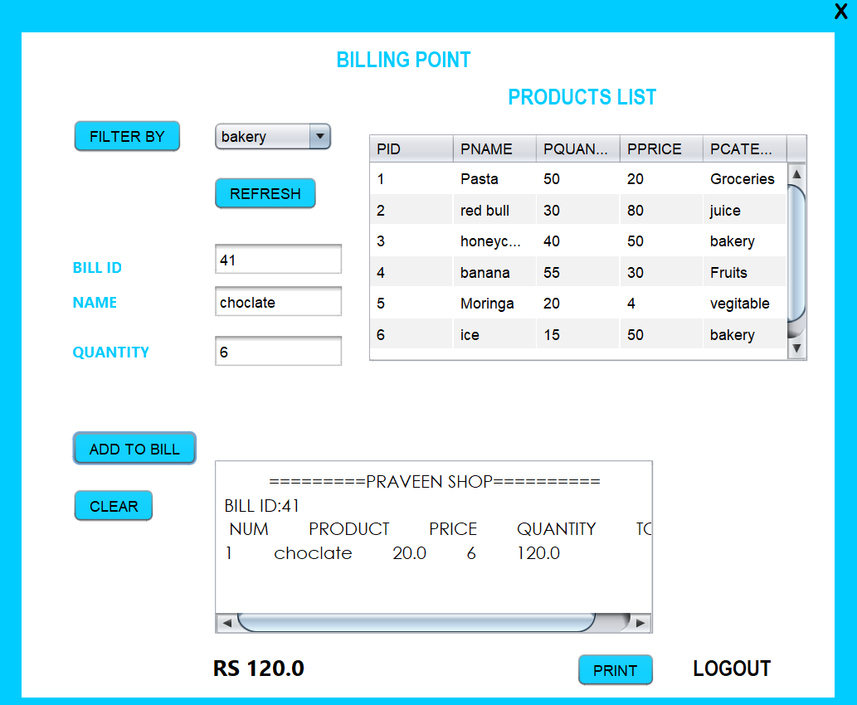

TRIGGER 1:

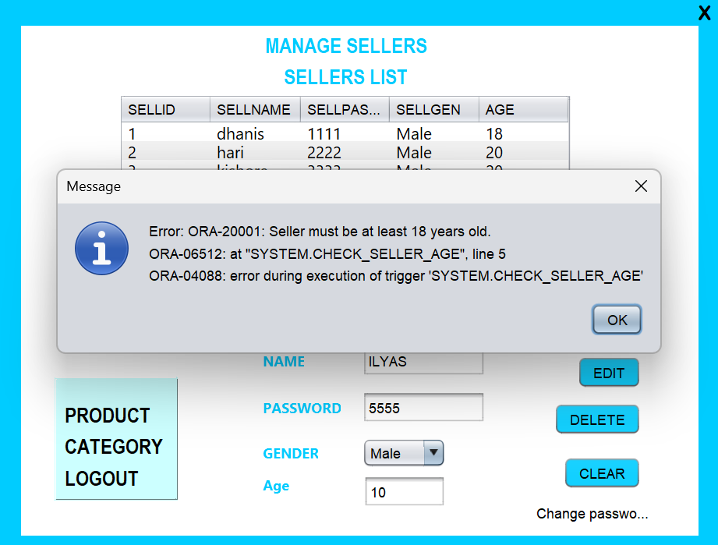
TRIGGER 2:

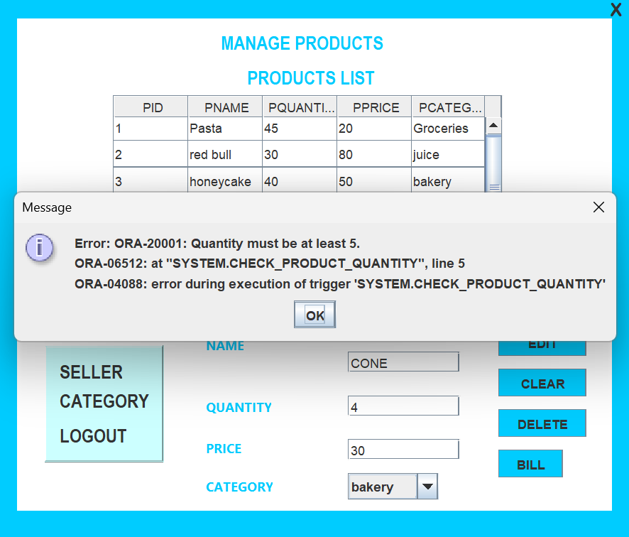

FUNCTION :

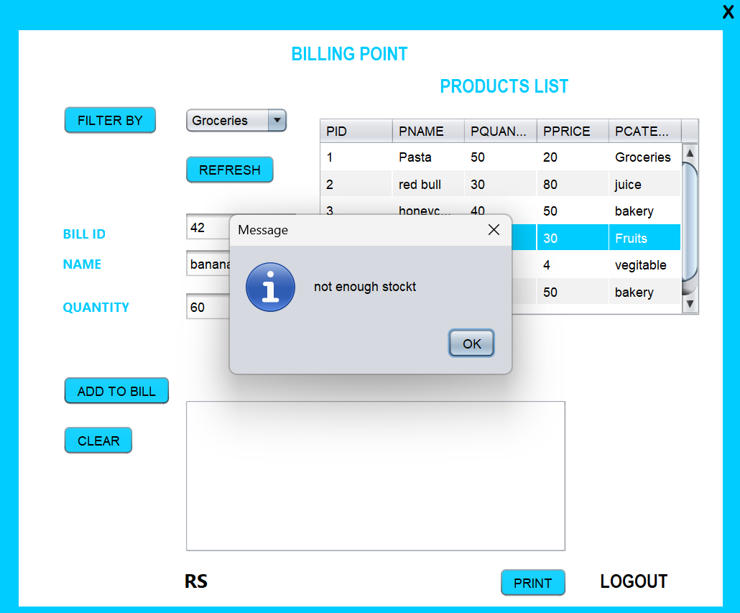

PROCEDURE :
BEFORE:
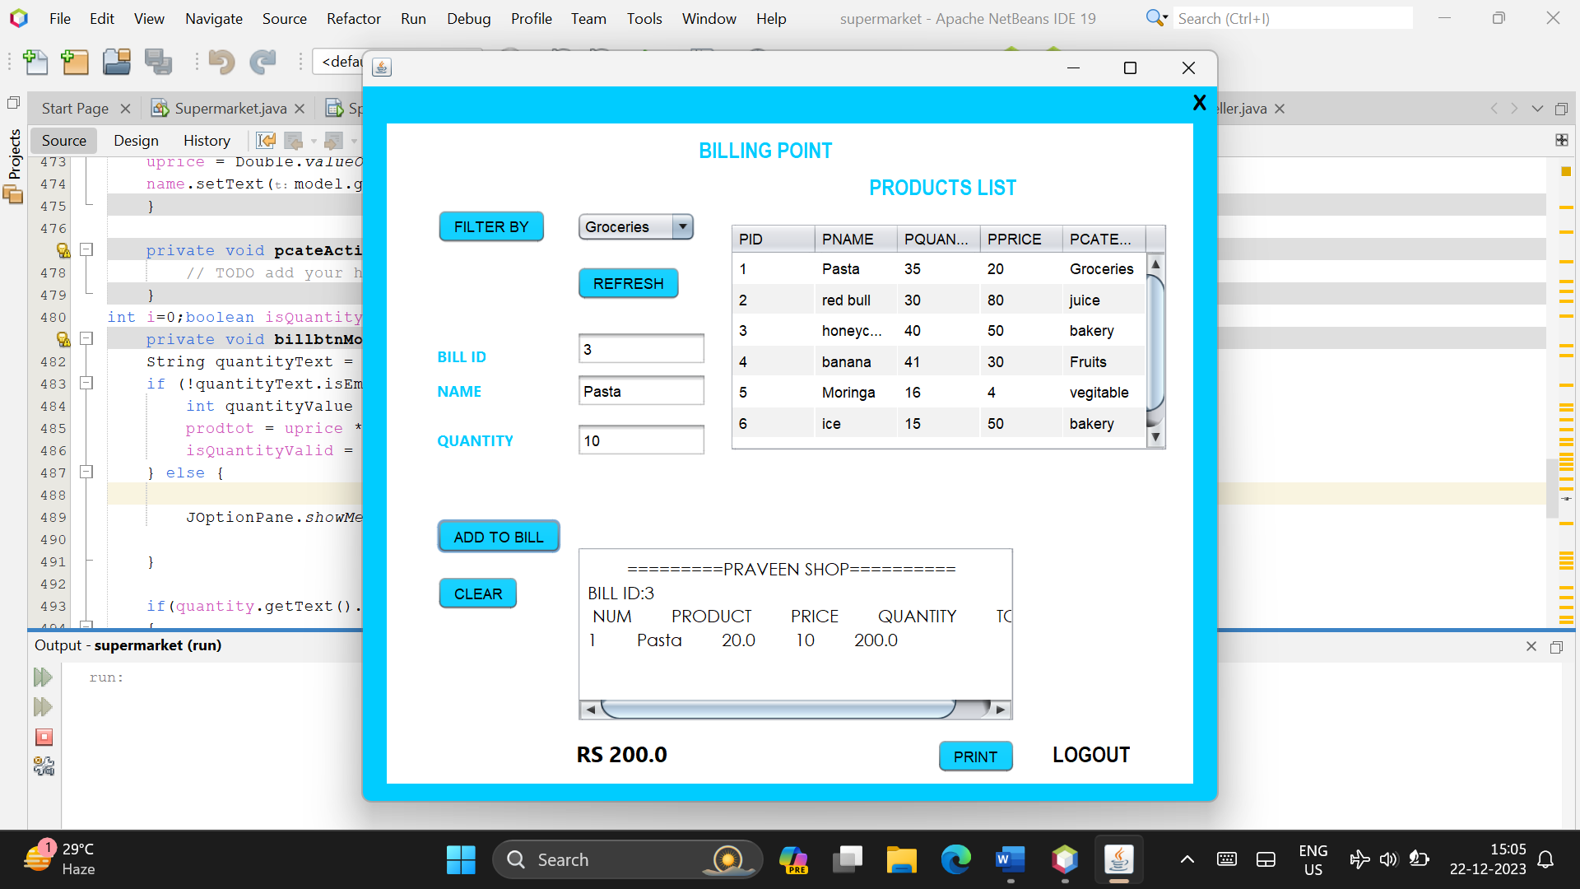

AFTER:
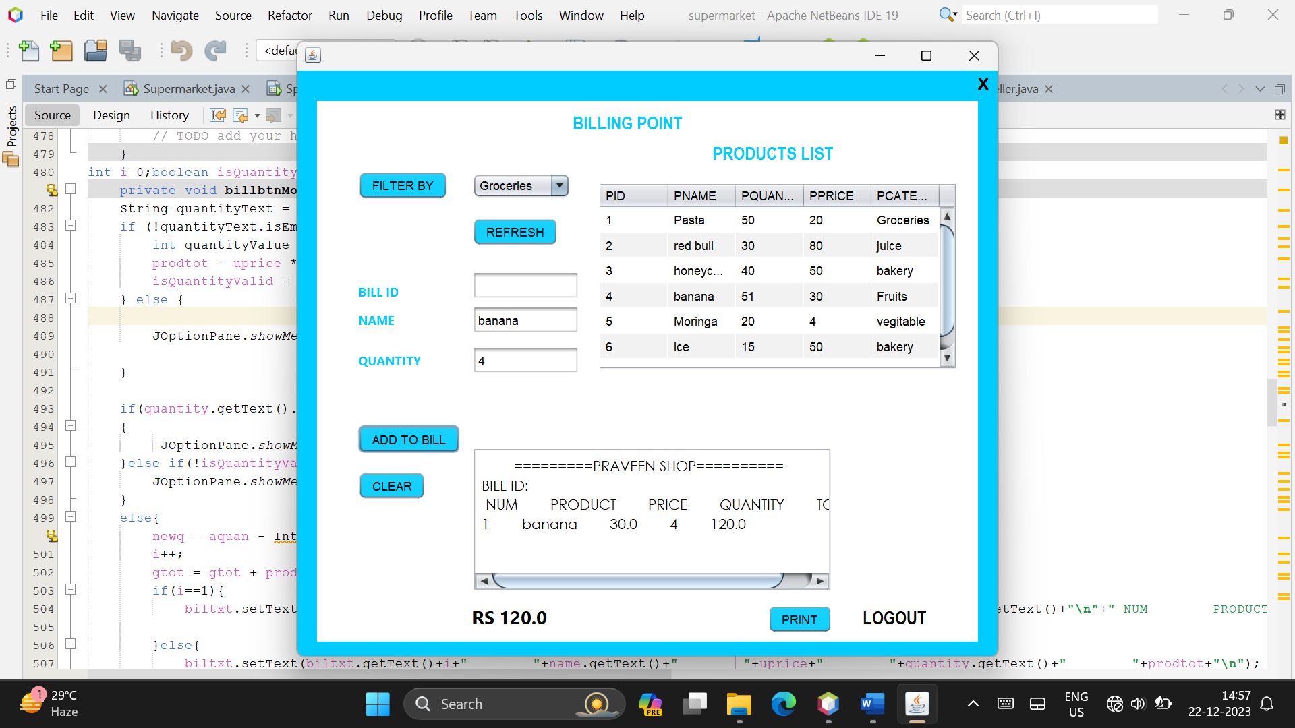

Conclusion:
The development and implementation of a Inventory/ Shop Management System represent a significant leap forward in the quest for operational excellence, efficiency, and quality within the surface finishing industry. This mini-project has sought to address the intricate challenges faced by cloth shops by proposing a comprehensive system that encapsulates the entire inventory shop workflow.

Through the process of designing and implementing this Database Management System (DBMS), several key findings and achievements have emerged. The successful creation of an integrated platform for order management, inventory control, dealer scheduling, quality assurance, and reporting signifies a substantial step towards modernizing and optimizing inventory shop operations.

Key Achievements:

1. Workflow Optimization:
The implemented system facilitates the seamless flow of tasks, automating routine processes and reducing manual errors. This optimization has led to improved efficiency and a reduction in turnaround times for order fulfillment.

2. Resource Utilization:
By providing tools for resource allocation and scheduling, the system has contributed to the optimal use of both human and machinery resources, resulting in increased productivity.

3. Quality Assurance:
The incorporation of quality control measures at every stage of the process has significantly enhanced the consistency and precision of inventory application, reducing defects and rework.

4. Inventory Management:
The system's inventory tracking and management features have resulted in better control over inventory and coating materials, preventing shortages, minimizing waste, and ensuring timely replenishment.

5. Data Analysis and Reporting:
The reporting and analytics capabilities of the system have empowered decision-makers with valuable insights into performance metrics, production trends, and areas for improvement.

Future Directions:
While the current implementation marks a substantial achievement, there are avenues for future enhancements and refinements. The system can be extended to include predictive analytics for inventory management, machine learning algorithms for quality prediction, and further integrations with external systems for a more holistic approach to enterprise resource planning.

Closing Thoughts:
In conclusion, the Inventory/ Shop Management System developed in this mini-project represents a vital tool for navigating the complexities of modern dress shop operations. By addressing key main points and introducing automation and optimization, this system not only contributes to the immediate efficiency of the cloth shop but also positions it for sustained growth, adaptability to industry changes, and a competitive edge in the ever-evolving landscape of surface finishing. This mini-project stands as a testament to the potential of technology in revolutionizing traditional industries, ensuring their relevance and success in the face of contemporary challenges.

