Lab Report Interpretation System
AI-Powered Clinical Insight & Safety Validation Platform

Employee Name: Kishore Gopi
Employee Id:11442

1. Project Overview
- Healthcare laboratories generate large volumes of raw numerical test results that are difficult for non-clinical users to interpret and time-consuming for clinicians to review. Misinterpretation or delayed review of abnormal lab values can lead to serious clinical risks.
- The Lab Report Interpretation System is a local AI-powered chatbot and workflow automation system designed to convert raw laboratory reports into clinically interpretable insights, while ensuring safety validations, rule-based checks, and risk explanations (not diagnoses).
- This system combines traditional data processing, rule-based medical thresholds, and Retrieval-Augmented Generation (RAG) using a local LLM to provide safe, explainable, and auditable responses.

2. Business Requirements
2.1 Problem Statement
- Lab reports are numeric and difficult to understand for patients and junior staff
- Manual review of abnormal and critical values is time-consuming
- Risk explanation must be safe, non-diagnostic, and auditable
- Data privacy requires local processing

2.2 Business Objectives
- Interpret lab reports in human-readable language
- Detect abnormal and critical lab values
- Provide risk explanations, not medical diagnoses
- Support chat-based interaction
- Notify reviewers when critical values are detected
- Run entirely on local infrastructure

3. Scope of the System
In Scope
- CSV-based lab report upload
- Parsing and normalization of lab values
- Rule-based abnormal and critical checks
- AI-assisted interpretation using RAG
- Risk scoring and explanation
- Reviewer alerts (email / console)
- Chat-based querying
Out of Scope
- Medical diagnosis
- Treatment recommendations
- Real-time hospital device integration
- Cloud deployment (current version)

4. High-Level Workflow

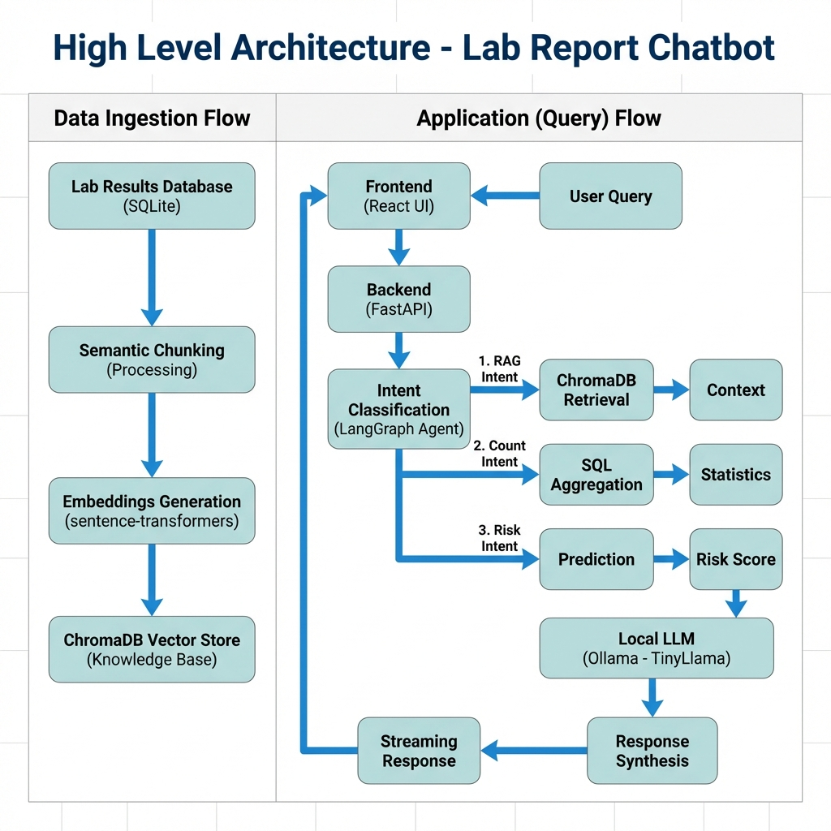

5. System Architecture Overview
The system is divided into two major flows:
5.1 Data Ingestion Flow
Responsible for building the knowledge base used during AI interpretation.
5.2 Application (Query) Flow
Handles user queries, intent detection, retrieval, analysis, and response generation.

6. Architecture Components
6.1 Frontend (React UI)
- Upload CSV lab reports
- Chat interface for querying results
- Displays streaming AI responses
- Shows abnormal and critical flags

6.2 Backend API (FastAPI)
- Acts as the central orchestration layer
- Handles file uploads, queries, and streaming responses
- Routes queries to appropriate intent handlers

6.3 Lab Results Database (SQLite)
- Stores:
  - Patient lab values
  - Test metadata
  - Reference ranges
- Enables fast aggregation and statistics

6.4 Semantic Chunking Module
- Converts structured lab data into:
  - Patient-centric summaries
  - Test-wise textual chunks
- Ensures chunks preserve medical meaning

6.5 Embeddings Generation
- Uses sentence-transformers
- Converts chunks into vector embeddings
- Enables semantic retrieval

6.6 ChromaDB Vector Store
- Acts as the knowledge base
- Stores embeddings of lab history and rules
- Supports similarity-based retrieval for RAG

6.7 Intent Classification (LangGraph Agent)
User queries are classified into one of three intents:
Intent Type | Description
RAG Intent | Explanation / interpretation queries
Count Intent | Statistical or aggregation queries
Risk Intent | Risk assessment and severity explanation

6.8 Intent-Specific Processing
a) RAG Intent
- Retrieves relevant lab context from ChromaDB
- Supplies context to LLM for grounded responses
b) Count Intent
- Executes SQL aggregation queries
- Computes statistics such as:
  - Number of abnormal values
  - Critical occurrences
  - Trends over time
c) Risk Intent
- Applies medical risk rules
- Generates a risk score
- Explains severity in non-diagnostic language

6.9 Local LLM (Ollama – LLaMA 3.1 / TinyLlama)
- Runs fully offline
- Generates:
  - Interpretations
  - Risk explanations
- Strict prompt rules to avoid diagnosis

6.10 Response Synthesis & Streaming
- Combines:
  - Retrieved context
  - Rule outputs
  - LLM reasoning
- Streams responses token-by-token to UI

6.11 Alerting & Notifications
- Triggers when:
  - Critical thresholds are crossed
- Sends:
  - Email alerts
  - Console warnings for reviewers

7. AI Safety & Guardrails
- No diagnosis allowed
- No treatment advice
- All responses framed as:
  - “Possible risk”
  - “Requires clinical review”
- Rule-based validation runs before AI response
- AI outputs constrained via system prompts

8. Dataset Description
Source
MIMIC-IV Clinical Database
https://physionet.org/content/mimiciv/
Usage
- Lab event tables used for:
  - Reference ranges
  - Historical patterns
- Data processed locally
- No PHI exposed in outputs

9. Technology Stack
Layer | Technology
Backend | FastAPI
Frontend | React
Database | SQLite
Vector DB | ChromaDB
Embeddings | Sentence Transformers
LLM | Ollama (LLaMA 3.1)
Data Processing | Pandas
Alerts | Email / Console

10. Deployment Model
- Fully local deployment
- No external API dependency
- Suitable for:
  - Hospitals
  - Research labs
  - Offline clinical environments

11. Future Enhancements
- Role-based access control
- Doctor review dashboard
- PDF report generation
- Multi-language support
- HL7 / FHIR integration
- Model fine-tuning with clinical prompts

13. API Documentation
This section describes all REST APIs exposed by the Lab Report Interpretation System.
The APIs are designed using FastAPI, follow REST principles, and are optimized for analytics, AI inference, and real-time streaming.

13.1 Base Configuration
- Base URL: http://localhost:8000
- Protocol: HTTP
- Authentication: Not implemented (local deployment)
- Response Format: JSON / Server-Sent Events (SSE)
- LLM Mode: Local inference via Ollama

13.2 Dashboard APIs
GET /dashboard
Description:
Renders the main lab statistics dashboard.
- Response Type: text/html
- Purpose: Visual overview of lab result distributions
- Used By: Admin / Reviewer

GET /ml-dashboard
Description:
Displays ML-based patient risk analytics.
- Response Type: text/html
- Purpose: Visualizes patient risk predictions
- Used By: Clinical reviewers

13.3 AI Summary API
GET /chat/patient/{subject_id}/ai-summary
Description:
Returns an AI-generated clinical summary for a patient.
- Path Parameter:
  - subject_id (integer)
Behavior:
- Returns cached summary if available
- Otherwise triggers background generation
Use Case:
Quick high-level patient understanding without manual review

13.4 Reporting APIs (Count & Aggregation Intent)
GET /reports/summary
Returns overall lab result distribution.
Output:
- NORMAL
- ABNORMAL
- CRITICAL
- UNKNOWN

GET /reports/patient-risk
Returns patient-level risk distribution.
Logic:
- CRITICAL → at least one critical lab
- ABNORMAL → abnormal but no critical
- NORMAL → all normal

GET /reports/high-risk-patients
Returns count of patients with at least one CRITICAL lab.

GET /reports/by-lab
Returns most impacted lab tests.
Grouping:
- Test Name
- Status (ABNORMAL / CRITICAL)

GET /reports/by-gender
Returns abnormal and critical labs grouped by gender.

GET /reports/unreviewed-critical
Returns list of CRITICAL labs not yet reviewed.
Purpose:
Drives alerting and reviewer workflow.

GET /reports/unreviewed-critical-summary
Returns count of pending critical alerts.

GET /reports/recent-critical
Returns CRITICAL lab activity within a time window.
- Query Parameter:
  - hours (default: 24)

13.5 Risk Prediction APIs (Risk Intent)
GET /predict/patient/{subject_id}/risk
Predicts patient risk using ML model.
Output Includes:
- Risk level
- Confidence score
- Probability distribution
- Feature importance

GET /predict/risk-distribution
Returns risk distribution across all patients.
⚠️ Note:
Computationally expensive (runs ML for all patients)

GET /predict/high-risk
Returns high-risk patients.
Query Parameters:
- risk_level (default: CRITICAL)
- limit (default: 50)

13.6 Agentic Chatbot API
POST /chat/stream
Description:
Main conversational API using LangGraph Agent with streaming responses.
- Request Body:
{
"question": "What are the abnormal results for patient 10001725?"
}
- Response Type:
text/event-stream
Supported Query Types:
- Lab explanations (RAG)
- Count-based questions
- Risk assessment queries

13.7 Chat Processing Paths
Fast Path 0 – Greetings
- No LLM calls
- Instant response
Fast Path 1 – Count Intent
- SQL aggregation
- 1 LLM call (verbalization only)
Fast Path 2 – Risk Intent
- ML prediction
- 1 LLM call
Fast Path 3 – Patient RAG
- ChromaDB retrieval
- Context-limited generation
Normal Path
- Full LangGraph workflow
- Intent classification → routing → execution → synthesis

13.8 Error Handling
Standard Error Format:
{
"error": "Description of the issue"
}
Common Status Codes:
- 200 – Success
- 400 – Bad request
- 404 – Not found
- 500 – Server error

13.9 Summary of APIs
Category | Count
Dashboards | 2
AI Summary | 1
Reporting | 8
Risk Prediction | 3
Chatbot | 1
Total | 15 APIs

14. Conclusion
The Lab Report Interpretation System successfully demonstrates how traditional clinical data processing can be combined with modern AI techniques to create a safe, explainable, and efficient healthcare support platform.

