Q1. Why are you looking for new job opportunity?

I am looking for new opportunity because, I have realized that there is less opportunity to grow carrier wise in my present company , also I feel to settle down somewhere ( I feel china has a very complicated law system which is not easy for foreigners )

Q2. Why are you interested in Uzabase?

1. I have always been interested in financial and business related company.
2. It is a Japanese Company , Great admiration and respect for Japan and its culture ( all the good examples been given to me from school to college is from Japan and Japanese people )

Above two is what made me to consider Uzabase , and the company got interesting products and I think it will have more and wanted to be a part of it !

Q3.What do you want to do in Uzabase concretely?

Since worked on some latest web technologies, I can improve or be part of next level products of Uzabase , wanted to support engineers who working along and enjoy the technical and cultural stuff from them.

Q4. Please tell us the most challenging task, or most difficult task you have worked on in software system development. Your experience to solve technical problems is preferable.

Problem:

Most challenging task for me was calculating and creating **Driver Working hours** **Dashboard** for my present company’s GPS tracking system. The European Driving Rules were really complicated and understating and taking that logic to a GPS real time tracking system was rally challenging. The rules were given on following links

<https://www.gov.uk/guidance/drivers-hours-goods-vehicles/1-eu-and-aetr-rules-on-drivers-hours>

<https://en.wikipedia.org/wiki/Drivers%27_working_hours>

From the tucks the GPS info is send at frequent intervals (mostly every minute), my task was to separate the data and calculate the different times intervals as specified in the guideline above , the interesting part of it was modeling a system to find Truck engine behavior to its movement and calculate the traffic and subtract /add those value to each calculated items of ( eg, driver total time worked (driver time - driver rest time + traffic time ) , in which calculating each part was complicated and in reality the drivers takes more breaks for a day than the guidelines ( guideline to human behavior changes makes it hard to calculate) .

I designed following section and solved all the server side and client side problems except the tablet section,

* Dequeuer is a message queue if customer chooses to go with socket he can listen to a queue for latest data or system will poll on frequent intervals.

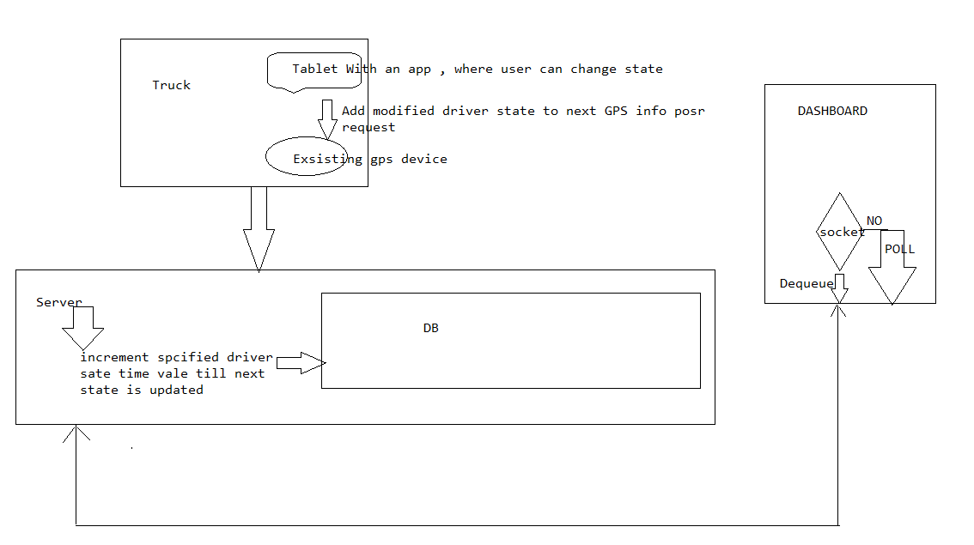

Q5.Please tell us the most interesting or favorite programming language, application design technique, or OSS right now. You do not need to explain about overall in full detail, explanation in depth with small scope would be good.

My Favorite **Open-source software** is The **Spring Framework**:

Reason for Spring is my favorite is it provides a easy mechanism or environment to develop project in a short span and it’s easy to maintain,

1. It eliminates use of application servers ( we can run our projects with servlet containers like Tomcat )
2. Eliminating application servers elements the complexity
3. Spring is based on POJO (plain Java objects) , with most of the EJB functionality available under its frame work is an added advantage.

The concepts of AOP ( Aspect oriented programing ) , and DI ( dependency injection ) is enabling possibility to Java projects to add new functionality on runtime without any source code modifications or depend on what a class needs rather than a class depends on others ( program to interface is utilized to maximum in DI).

* It is well structured with plug in type of integration allows us to use what we need and discard others.
* For an example we started with Spring JDBC ( spring provided JDBC support ) and later changed to MyBatis ( this conversion in most other technology may require lot of changes and may get complicated , but with spring with some basic configuration changes make it possible without wasting time , it enables us to use different ORM in a matter of configuration )
* In my previous company we used mostly Spring MVC framework and in my present company most of the server side is based on spring rest.
* It's a configuration framework maintainable and extendable made a special interest in me.

Q6. Please see the Chart1, a map. You are going to find a direction to move from Crossing A to Crossing B by car. Please explain an algorithm where it could find efficiently a direction from A to B with less frequency passing the crossing. All points where the roads are meeting up with other roads are defined to be the crossing. You may answer this by itemizing, or pseudo-code.

Since the solution should contain less number of traffic signals and applying following map to graph (taken as un weighted directed graph ) , I have used **Breadth-First-Search**  shortest path algoritham to find a shortest path from Source A to B

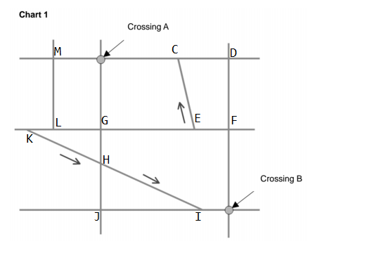

**Adjacency list:**

A: [(A,C), (A,M), (A,G)];

B: [(B,I), (B,F];

C: [(C,E), (C,A), (C,D)];

D: [(D,C), (D,F)];

E: [(E,F), (E,G)];

F: [(F,B), (F,E)];

G: [(G,B), (G,H), (G,J)];

H: [(H,I), (H,J), (H,G)];

I: [(I,H), (I,J), (I,B)]];

J: [(J,H), (J,I)];

K: [(K,L), (K,H)];

L: [(L,M), (L,G), (L,K)]];

M: [(M,A), (M,L)];

N: [(N,A), (N,E), (N,H), (N, L)]];

[shortest path to each vertex from {A}]:

Path to node B: { A -> G -> H ->I -> B }

* Travel from source node and push its adjacent to queue and de-queue each and continue same till the end of queue and use flags to set visited state and array to note each vertex its parent where we came from.

**pseudo-code : BFS**

Algorithm BFS(s)

**Input:** s is the source vertex

**Output :** Mark all vertices that can be visited from s

**For** each vertex *v*

**do** flag(v) := false;

prev[v] :=1; // initialize all pred to -1

Q = empty queue;

flag[s] := true;

enqueue(Q,s);

**while** Q is not empty

**do** v := dequeue(Q);

**for** each w adjacent to v

**do** **if** flag[w]= false;

**then** flag[w]= true;

prev[w]:=v;

enqueue(Q, w);

7. You are going to make an application where it imports a RSS feed, make a conversion process and read out. Please implement an application where it meets the specifications and requirements mentioned below. Please also submit class diagram. The assignment is scored whether it is designed object-oriented.

A working version can be found at,

<https://github.com/kishore-r/rss-feed>

Class diagram can be found at

<https://github.com/kishore-r/rss-feed/blob/master/SpeedaRssFeed.png>