FINAL PROJECT REPORT
GROUP 7

Short-Term Load Forecasting using Smart Meter Data and Neural Networks: A Comparative Approach

Submitted by: Steve Burgos, Jason Kluge, Ivan Macsemchuck, Kishore Prakasan

ABSTRACT

Energy load forecasting stands as a critical component in the management and optimization of power systems, crucial for ensuring efficiency, sustainability, and economic viability in energy distribution. Accurate predictions of energy demand facilitate better planning and resource allocation, enabling a more resilient and responsive energy grid. In our research, we focus on the application of advanced neural network models – specifically, Mogrifier LSTM, LSTM, RNN, and Momentum RNN – to predict energy loads with heightened accuracy and reliability. We delve into the latest developments in these models, with a particular emphasis on the innovative Mogrifier LSTM and Momentum RNN, applying and adapting these cutting-edge techniques to refine our forecasting methods. Alongside, we utilize established RNN and LSTM libraries as benchmarks, allowing for a comprehensive comparison. Our work not only demonstrates the enhanced predictive capabilities of these advanced models but also paves the way for their practical implementation in real-world energy forecasting scenarios. By harnessing the power of these sophisticated neural networks, our study contributes significantly to the field of energy load forecasting, offering novel insights and robust solutions to meet the challenges of modern energy demands.

BACKGROUND

In 2022 the US used 4.05 trillion kWh (kilowatts-hour) of electricity [1]. A kilowatt-hour is equal to outputting 1 thousand watts of energy for one hour. For reference a 60 watt lightbulb uses 60 watts-hour, so if you left it on for an entire day it would use 1,440 watts-hours. And this is just the amount of energy used. The amount of electricity produced in the US during that year was 4.23 trillion kWh, that’s an overproduction of around 181 billion kWh [2]. Because a lot of this energy is generated through the use of fossil fuels you can see how being able to make accurate energy usage predictions is important. If electrical companies are able to calculate expected energy needs with little error they won’t overproduce, leading to the burning of more fossil fuels and just overall waste.
This leads us to the subject we are looking at in this paper, short-term load forecasting. Short-term load forecasting (STLF) is the method of predicting energy usage an hour to a week in advance [3]. Other types of forecasting include medium-term load forecasting, which is a month to a year in advance, and long-term, 1 to 10 years in advance.
STLF is used to help with generation scheduling and optimizing the operation of power plants. Generation scheduling seeks to minimize cost while working around operation limitations and constraints. If you can have more accurate predictions of next week’s energy demand you can create better, more effective schedules and this will help optimize power plants operations. The other important use of STLF is increasing the reliability of power systems. If the energy load required is underestimated this leads to power shortages. If the energy load is overestimated you’ve wasted resources, operational resources, fossil fuels, and the money it takes to generate that power.

PROBLEM

The problem we are looking at in this paper is the short-term load forecasting for residential energy usage on a city scale, specifically London, focusing on neural networks within the recurrent neural network family. The reason we decided to focus solely on neural networks is because they are currently the most popular and modern tool for predicting energy usage.

OUR SOLUTION

Dataset(s) Used
The dataset used was one found on Kaggle [4]. This dataset is actually a collection of three different datasets, London Weather Data, ACORN classifications, and London Household Electrical Consumption.

London Weather Data
London weather data was collected using DarkSkyAPI. DarkSkyAPI provides several different weather features including things like dew points, temperature max, temperature min, and wind speed.
Weather data is very commonly used in load forecasting and is of increasing importance in energy systems. It’s especially important when looking at renewable energy systems but it also has been considered during electrical power generation because of things that have become electrically powered like heating [5]. So outside temperature would affect electrical usage and demand.
Acorn Classifications
Acorn classifications are collections of UK demographic information sectioned by postal codes [6]. The goal of Acorns is to be able to tell the user about the make-up of people that live in that region/postal code. This data is used to get more information on the individual households whose consumption levels are recorded in the dataset below.
London Household Electrical Consumption
This data was collected from smart meters installed in 5,517 different London households from November 2011 to February 2014. The meters collected energy usage at every half hour intervals. This data comes from the Low Carbon London Project which was the result of a push from the government to have smart meters installed in every home.

Overall once all of these dataset were combined the resulting data was 7.14 GB. For each household we used all of the half-hourly data provided. There were 828 days contained in this data which means there were around 39,744 half hourly readings of energy consumption from all 5,517 households. The dataset was then split in half with the first half being used for training and the second half being used for testing the models.

Other Solutions

Traditional predictive models for energy demand are time series. Time series use historical electrical load data and statistics and mathematics to predict future load [7]. However these statistical models have a major limitation. They are limited in terms of the amount of data they can utilize. In order to utilize a large dataset with several features a lot of computational power is required [8].
Knowledge-based expert models have also been considered in regards to load forecasting [9]. These use knowledge from experts to create facts and rules about a subject or system to produce outputs. Sometimes, in load forecasting, they are combined with neural nets that will help with initial predictions. While expert based models are very useful they do require someone that is very educated on the subject at hand. Therefore neural nets tend to be more approachable to most researchers and companies.
Trends on other methods seem to be leaning towards neural networks for load forecasting or hybrid methods that combine two or three different load forecasting methods.

Neural Nets Used

Recurrent Neural Networks were initially introduced by Rumelhart et al., revealing that practical learning through perceptrons could be achieved in most cases via their innovative error propagation scheme [12]. In the seminal work by Hochreiter et al, Long Short-Term Memory (LSTM) networks were introduced as a type of RNN architecture, designed to lower the vanishing gradient problem and capture long term dependencies in sequential data [13]. MomentumRNN was introduced as a framework for integrating momentum into RNN cells, leading to accelerated training and improved performance in sequential data prediction tasks compared to traditional RNN’s [14]. Mogrifier LSTM was introduced as an LSTM model, conditioning input embeddings on the hidden state [15]. Hippert et al. demonstrated the versatility of Neural Networks in the domain of STLF, showcasing their applicability across a broad range of forecasting tasks [16]. Kong et al. expanded research on STLF by forecasting the individual household and showed that aggregating individual forecasted electricity usage opposed to forecasting aggregated electricity usage yields better results [17].

Methodology
In this study, our methodology involves a comparative analysis of various neural network models, namely Mogrifier LSTM, Simple RNN, Momentum RNN, and LSTM, to evaluate their efficacy in predicting energy consumption. We utilized temperature data from London as a key variable in our models. To ensure our analysis reflected a city-scale perspective, we aggregated the predicted energy consumption from each household. This approach allowed us to assess the performance of each neural network model in predicting energy consumption patterns at a granular level while also providing insights into broader, city-wide energy usage trends. Our methodology is structured to offer a comprehensive understanding of how different neural network architectures handle time-series data in the context of energy consumption forecasting.

RESULTS

Hardware and Software Specs
For training and testing we used an Apple M2 chip, featuring an 8-core CPU and a 16-core Neural Engine. The Neural Engine is specifically designed for machine learning tasks and can process up to 15.8 trillion operations per second. The tasks were performed with 16GB of unified memory under the macOS Ventura 13.6 operating system.

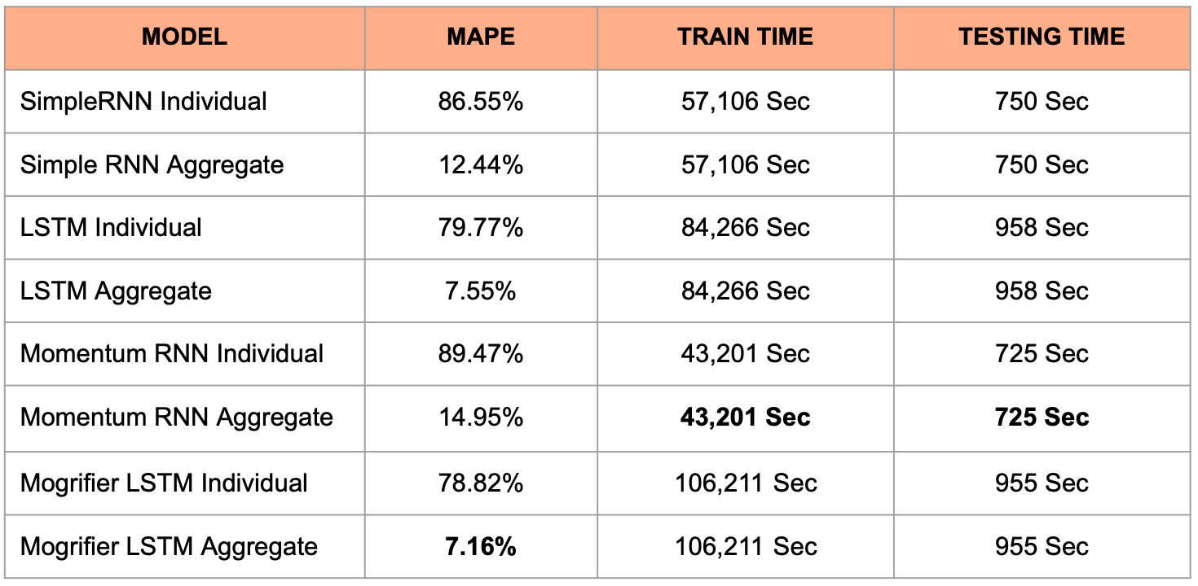
Training and Test Results
Figure 1: MAPE results of individual and aggregate model outputs
In the analysis of neural network models using aggregate data, the Mogrifier LSTM model exhibited a notable performance with a MAPE of 7.16%, indicating a relatively lower error rate and thus higher accuracy among the aggregate models. This suggests that the Mogrifier LSTM was particularly effective in handling aggregated data compared to the other models.
Additionally, the Momentum RNN model demonstrated the best efficiency in terms of computational resources. It had the lowest training time of 43,201 seconds and the shortest testing time of 725 seconds among all models. This efficiency is crucial in practical applications where time and computational resources are limiting factors.
The contrast in performance between individual and aggregate data processing across the models underscores the complexity and varied capabilities of different neural network architectures. While individual data processing generally yielded lower accuracy, the results with aggregate data, especially the lower MAPE for the Mogrifier LSTM, suggest that certain models may still perform effectively with less granular data. The findings from the Momentum RNN model further highlight that efficiency in processing does not necessarily correlate with a compromise in predictive accuracy.

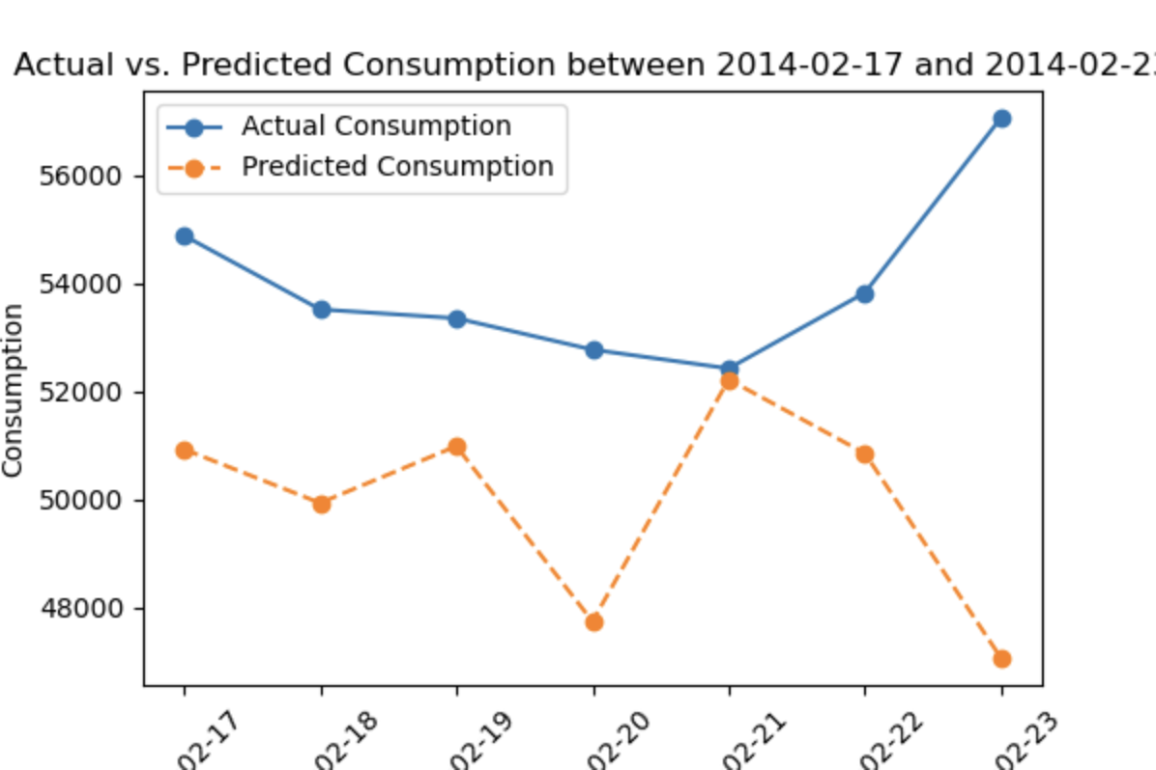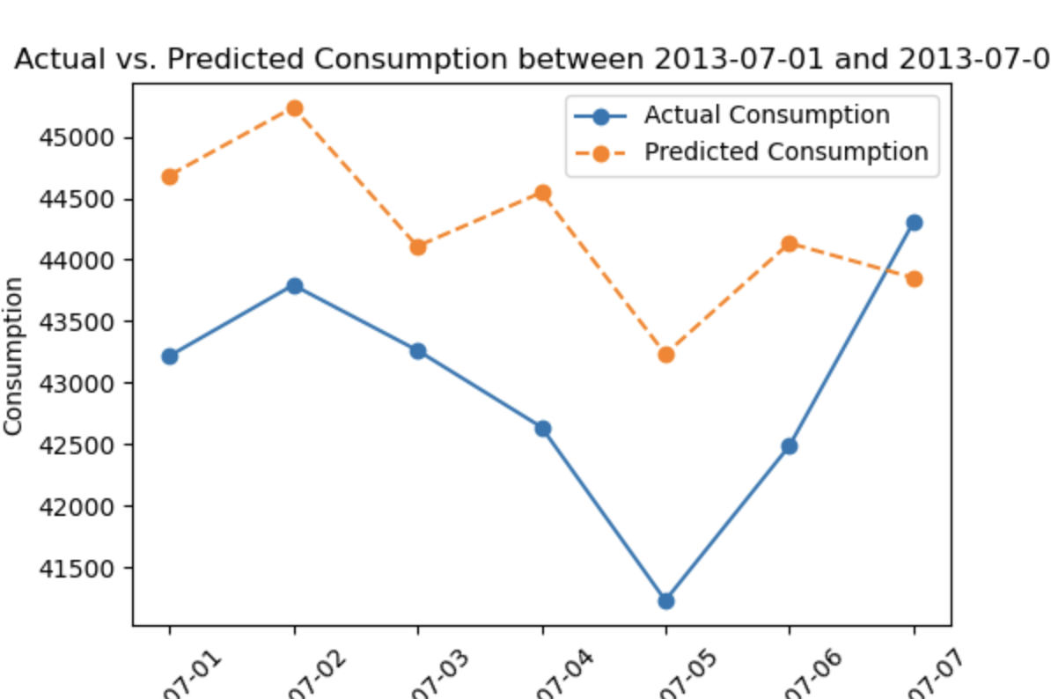
Figure 2: Comparison between Actual and Predicted results on the aggregate level

Referring to Figure 2 in our analysis, it becomes evident that the predictions from the Mogrifier LSTM model did not converge in the expected manner. Specifically, after the 16th week, the model's predicted values consistently fell below the actual ground truth values, indicating a tendency towards underestimation. This pattern suggests a bias in the model's predictive behavior, where it is more inclined to underestimate rather than overestimate energy consumption.

DISCUSSION
In our study, we addressed STLF by applying various neural network models to forecast energy loads, focusing on London's residential energy usage. The importance of STLF lies in its ability to inform better planning and resource allocation, enabling a more efficient and responsive energy grid. Accurate STLF helps minimize overproduction, reduce fossil fuel consumption, and optimize power plant operations, thereby contributing to environmental sustainability and economic efficiency.
Our comparative analysis of neural networks, including Mogrifier LSTM, LSTM, RNN, and Momentum RNN, provided valuable insights into the capabilities and limitations of these models in the realm of STLF. The results indicated that while some models like the Mogrifier LSTM performed well with aggregated data, there remains a significant challenge in achieving high accuracy with individual household data.
The Mogrifier LSTM's lower MAPE in aggregate forecasting suggests its potential in broader-scale energy predictions, but the need for more precise individual household forecasting is evident. The Momentum RNN model's efficiency in training and testing times was a noteworthy outcome, highlighting the potential for rapid and resource-efficient forecasting in real-time scenarios. This efficiency is particularly relevant in STLF, where timely predictions are crucial for operational decision-making. However, our research also underscores the need for further exploration in enhancing the accuracy of individual load forecasting.
The current models, while effective to a certain extent, still leave room for improvement in handling the complexity and variability of individual household energy consumption patterns. One potential avenue for future research could be the development of tailored models for each household. Such individualized models could potentially address the unique energy usage patterns and characteristics of each household, leading to more accurate and personalized predictions. l
The LSTM models performing better over the RNN models might have something to do with length of memory. Especially in data over several years it is helpful to be able to account for special days or holidays in which household electrical use might spike due to people being off from work. The RNN models could be failing to capture or remember these days as well as the LSTMs.

CONTRIBUTIONS

Steve Burgos: Building MogrifierLSTM, training and testing models

Jason Kluge: Data preprocessing, building MomentumRNN model

Ivan Macsemchuck: Training and testing of models, capturing results

Kishore Prakasan: Data preprocessing, capturing results

REFERENCES

[1] “U.S. electricity consumption 2022 | Statista.” Statista. Accessed: Dec. 14, 2023. [Online]. Available: https://www.statista.com/statistics/201794/us-electricity-consumption-since-1975/#:~:text=Electricity%20consumption%20in%20the%20United,in%20the%20period%20under%20consideration.
[2] “Frequently Asked Questions (FAQs) - U.S. Energy Information Administration (EIA).” Homepage - U.S. Energy Information Administration (EIA). Accessed: Dec. 14, 2023. [Online]. Available: https://www.eia.gov/tools/faqs/faq.php?id=427&amp;t=3#:~:text=In%202022,%20about%204,231%20billion,facilities%20in%20the%20United%20States.&amp;text=About%2060%%20of%20this%20electricity,,%20petroleum,%20and%20other%20gases.
[3] M. Q. Raza and A. Khosravi, “A review on artificial intelligence based load demand forecasting techniques for smart grid and buildings”, Renewable Sustain. Energy Rev., vol. 50, pp. 1352–1372, Oct. 2015. Accessed: Dec. 14, 2023. [Online]. Available: https://doi.org/10.1016/j.rser.2015.04.065
[4] Jean-Michel D. (2022). Smart meters in London. Kaggle. https://www.kaggle.com/datasets/jeanmidev/smart-meters-in-london?select=acorn_details.csv
[5] B. H.C et al., “The importance of weather and climate to energy systems: A workshop on Next Generation Challenges in Energy-Climate Modelling”, Bull. Amer. Meteorolog. Soc., pp. 1–23, Jan. 2021. Accessed: Dec. 14, 2023. [Online]. Available: https://doi.org/10.1175/bams-d-20-0256.1
[6] HM Land Registry. “Acorn consumer classification (CACI).” GOV.UK. Accessed: Dec. 14, 2023. [Online]. Available: https://www.gov.uk/government/statistics/quality-assurance-of-administrative-data-in-the-uk-house-price-index/acorn-consumer-classification-caci
[7] S. Akhtar et al., “Short-Term Load Forecasting Models: A Review of Challenges, Progress, and the Road Ahead”, Energies, vol. 16, no. 10, p. 4060, May 2023. Accessed: Dec. 14, 2023. [Online]. Available: https://doi.org/10.3390/en16104060
[8] M. K. M. Shapi, N. A. Ramli, and L. J. Awalin, “Energy consumption prediction by using machine learning for smart building: Case study in Malaysia”, Develop. in the Built Environ., vol. 5, p. 100037, Mar. 2021. Accessed: Dec. 14, 2023. [Online]. Available: https://doi.org/10.1016/j.dibe.2020.100037
[9] H. K. Alfares and M. Nazeeruddin, “Electric load forecasting: Literature survey and classification of methods”, Int. J. Syst. Sci., vol. 33, no. 1, pp. 23–34, Jan. 2002. Accessed: Dec. 14, 2023. [Online]. Available: https://doi.org/10.1080/00207720110067421
[10] G. R. Halegoua, “Ch 1 Introduction to Smart Cities,” in Smart cities, Cambridge, MA: The MIT Press, 2020, pp. 5
[11] M. Q. Raza, “A review on artificial intelligence based load demand forecasting techniques for smart grid and buildings,” Science Direct, https://www.sciencedirect.com/science/article/abs/pii/S1364032115003354 (accessed Sep. 18, 2023).
[12] Rumelhart, D. E., Hinton, G. E., & Williams, R. J. (1985). Learning Internal Representations by Error Propagation. https://doi.org/10.21236/ada164453
[13] Hochreiter, S., & Schmidhuber, J. (1997). Long short-term memory. Neural Computation, 9(8), 1735–1780. https://doi.org/10.1162/neco.1997.9.8.1735
[14] Tan M. Nguyen, Richard G. Baraniuk, Andrea L. Bertozzi, Stanley J. Osher, & Bao Wang. (2020). MomentumRNN: Integrating Momentum into Recurrent Neural Networks.
[15] Gábor Melis, Tomáš Kočiský, & Phil Blunsom. (2020). Mogrifier LSTM.
[16] H. S. Hippert, C. E. Pedreira and R. C. Souza, "Neural networks for short-term load forecasting: a review and evaluation," in IEEE Transactions on Power Systems, vol. 16, no. 1, pp. 44-55, Feb 2001, doi: 10.1109/59.910780.
[17] W. Kong, Z. Y. Dong, Y. Jia, D. J. Hill, Y. Xu and Y. Zhang, "Short-Term Residential Load Forecasting Based on LSTM Recurrent Neural Network," in IEEE Transactions on Smart Grid, vol. 10, no. 1, pp. 841-851, Jan. 2019, doi: 10.1109/TSG.2017.2753802.

