**Speech Controlled Robotic Arm**

ME735-Computer Graphics & Product Modelling

*Guide: Prof. S.S.Pande*

**Akash Kishore 130010010**

**Vivek Pandit 130010009**

**Prajval Somani 130040003**

**Jivraj Karwa 13D100017**



**Department of Mechanical Engineering**

**INDIAN INSTITUTE OF TECHNOLOGY, BOMBAY**

**November, 2016**

# 

# Table of contents

**Objective****3**

**Algorithm****3**

**Results****4**

**Future Work****5**

**References****6**

# Introduction

Speech recognition (SR) is the inter-disciplinary sub-field of computational linguistics which incorporates knowledge and research in the linguistics, computer science, and electrical engineering fields to develop methodologies and technologies that enables the recognition and translation of spoken language into text by computers and computerized devices such as those categorized as smart technologies and robotics. It is also known as "automatic speech recognition" (ASR), "computer speech recognition", or just "speech to text" (STT).

Some SR systems use "training" (also called "enrollment") where an individual speaker reads text or isolated vocabulary into the system. The system analyzes the person's specific voice and uses it to fine-tune the recognition of that person's speech, resulting in increased accuracy. Systems that do not use training are called "speaker independent" systems. Systems that use training are called "speaker dependent".

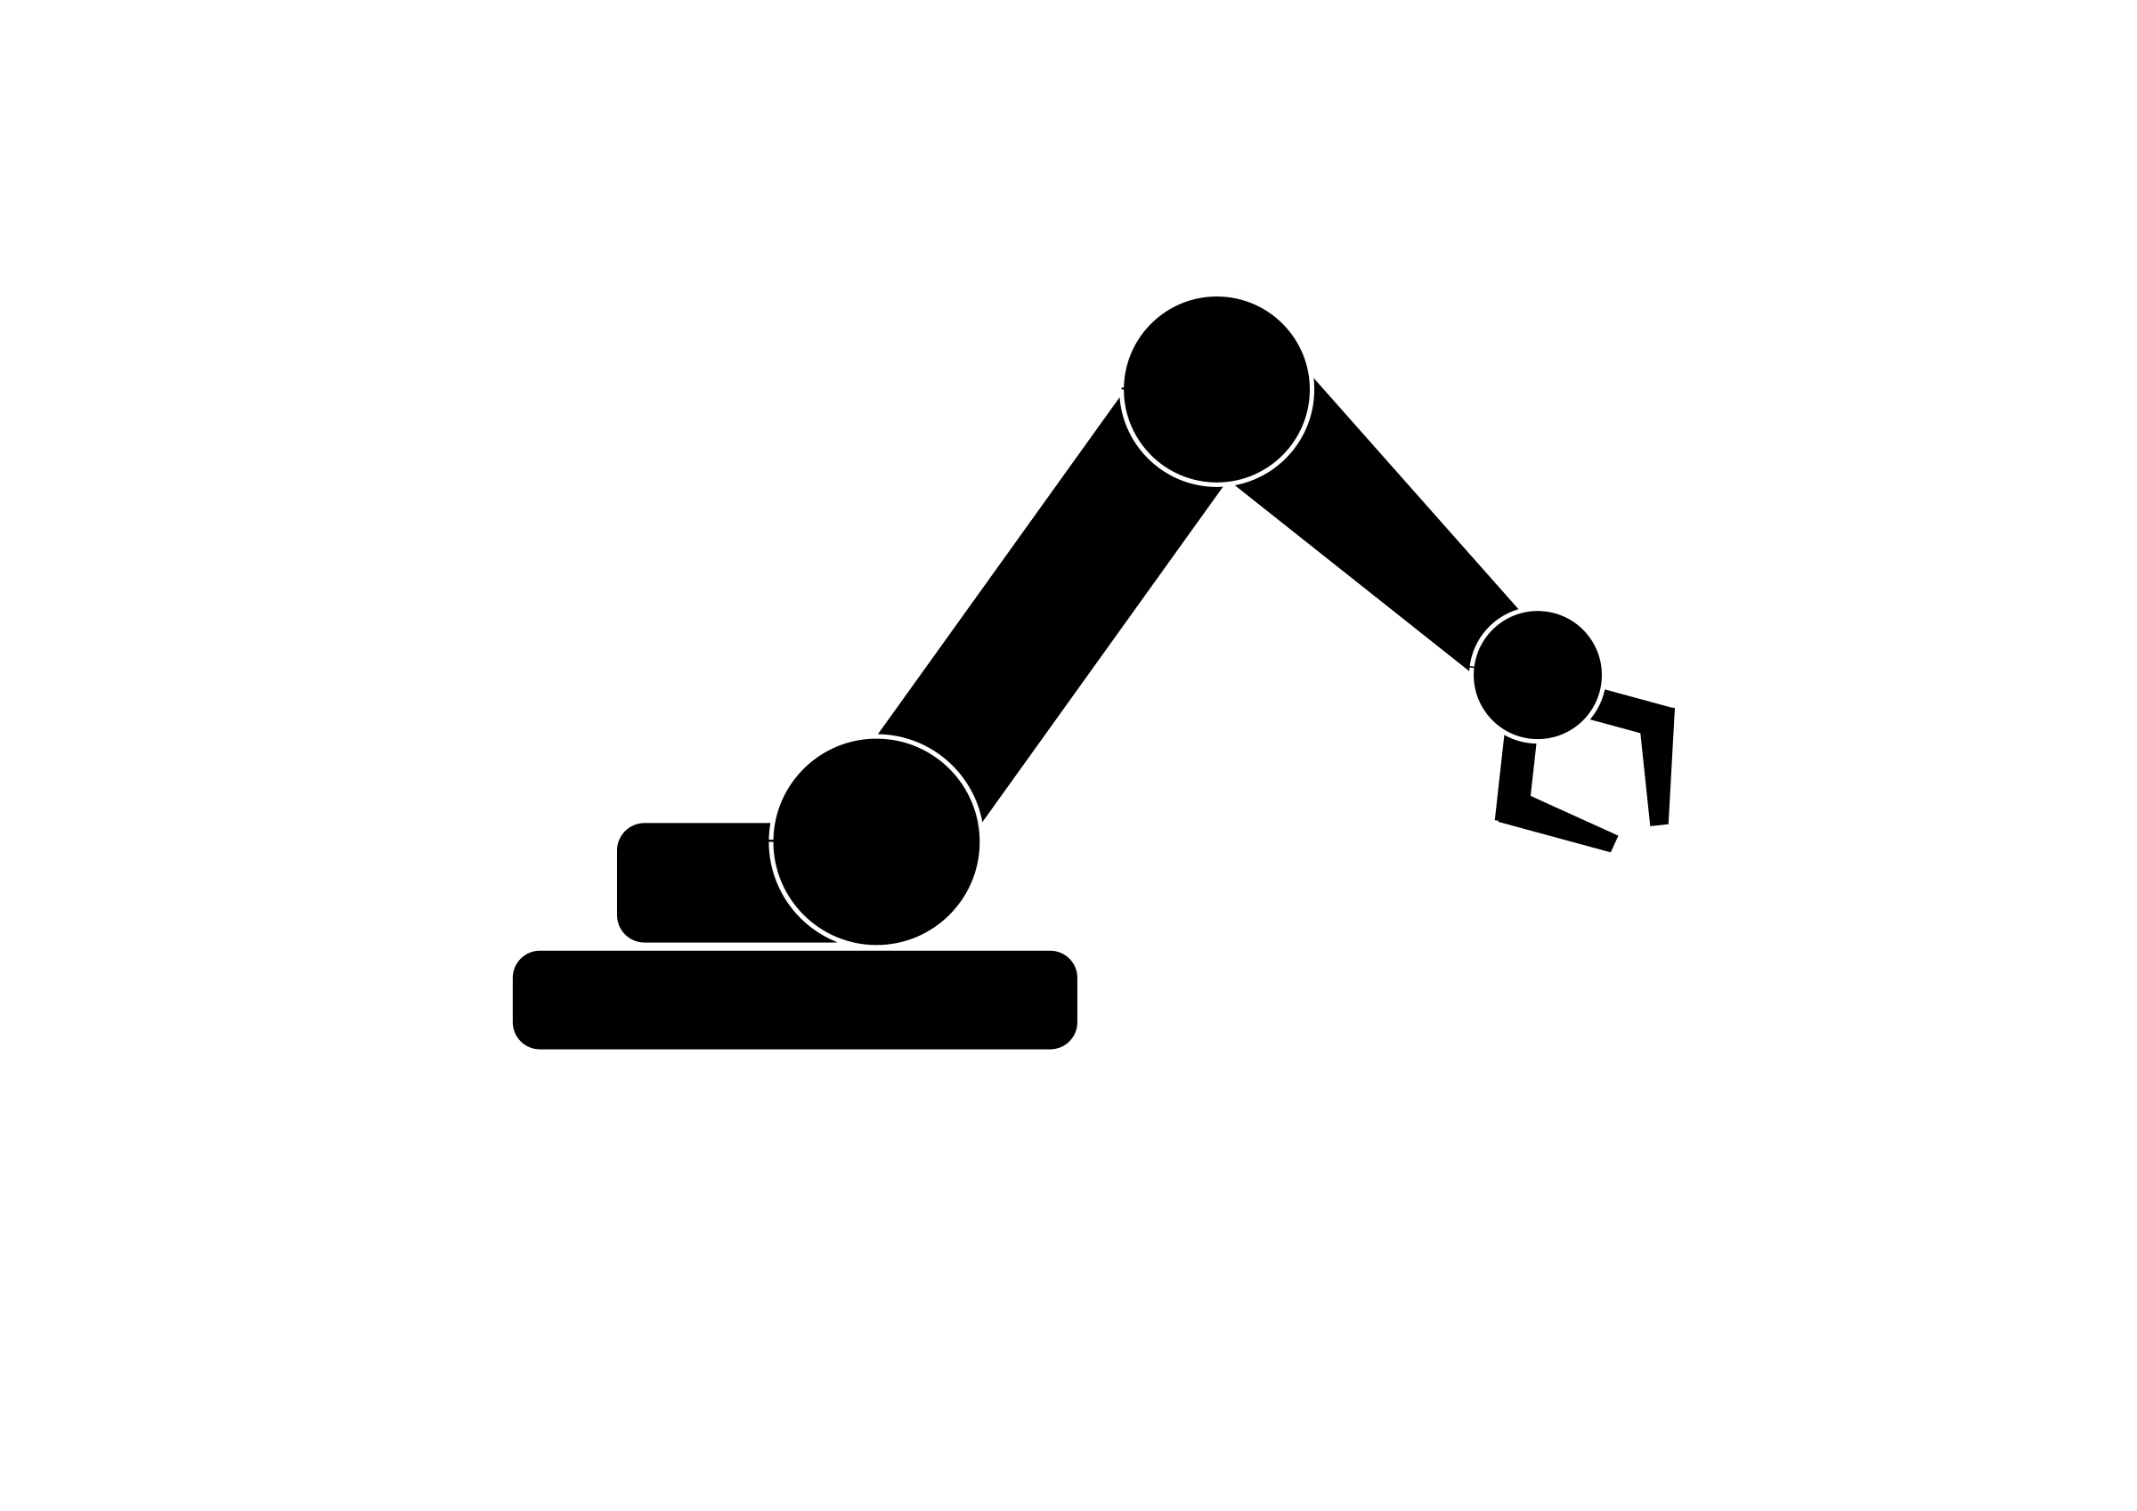

# Objective

To make an application on Windows which takes user voice as input and converts it into a text file which is mapped to its appropriate commands which further acts as input for the robotic arm.

In this project we operate the robotic arm present in lab using speech. For this purpose we have used inbuilt APIs of windows. The codes were written using C-Sharp in Visual Studio 2012.

# Algorithm

The aim of the project is to control a robotic arm through speech. For this we followed the following algorithm.

# Results

Currently the code recognizes the words stored in the code. We can store whatever words we want. But we have to train the visual studio with our voice for good enough recognition. Also the output is stored in the form of text file. Since the software operating the robotic arm accepts the the text file for operation.

The results come in the following format.

Initial Window:

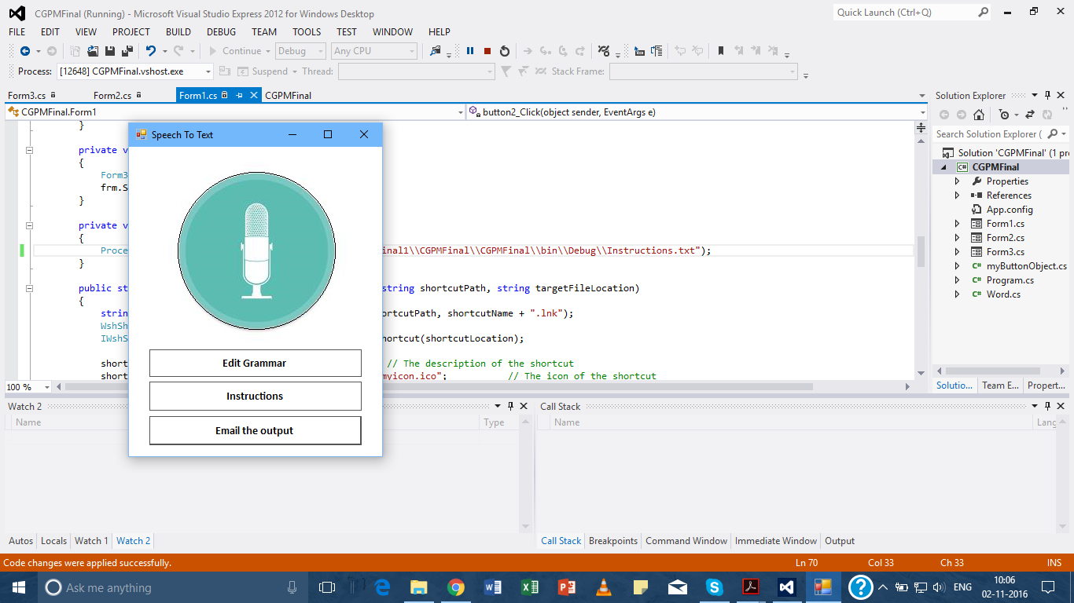

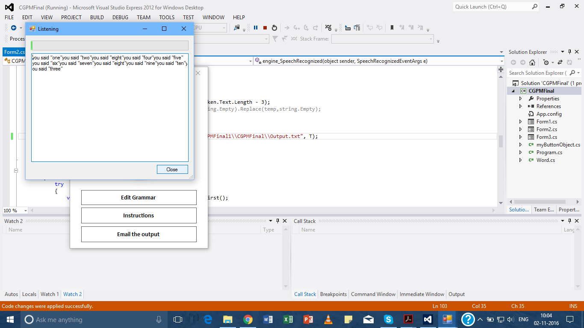

The Output text file:

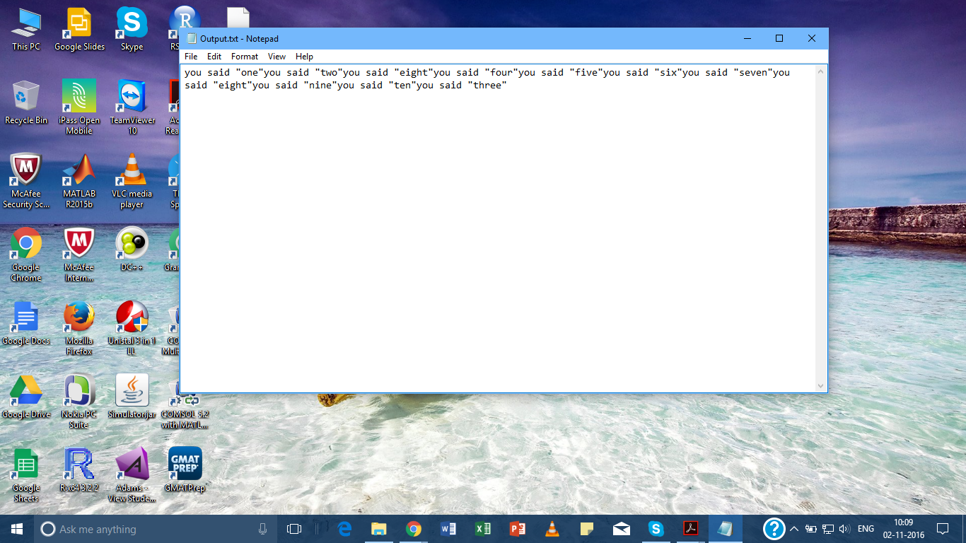

# Future Work

# 

# References