**Basic GitHub Commands**

1. How to clone a reposistory from github to local ?

**git clone** < url of repo >  
  
Above command will clone the default branch (i.e) master

2. How to clone a particular branch other than master ?

**git clon**e < url of repo > **-b** < branch to be cloned >

3. How to pull code from git reposistory ?

**git pull origin** <branch name >

4. How to push the local code to remote reposistory ?

**git push origin** < branch name >

5. How to check the status of your local reposistory ?

**git status**

6. How to add a new file to an existing reposistory ?

**git add** < file to be added >

Ex : git add hello.php

7. How to create a new branch in local reposistory ?

Always we have to create new branch from master only avoid creating new branch from other branches.

**Example**: If you’re currently working in a branch called as “Merge-tag” and if you like to switch to another task start with a new branch then first you need to switch to master branch.

Step 1: **git checkout** master

Step 2: Update your master branch -> **git pull origin** master

Step 3: Create a new branch -> **git checkout -b** <new_branch>

Note: When you start you’re day in github projects update your master and start your work.

8. How to switch between existing branches ?

git **checkout < branch name >**

**GIT COMMANDS WITH EXAMPLE**

Below command used to address the username and email address in git reposistory

**git config**

Usage: git config –global user.name “[name]”

Usage: git config –global user.email “[email address]”

This command sets the author name and email address respectively to be used with your commits.

Example:



### **git init**

Usage:git init [repository name]

This command is used to start a new repository.

Example:



### **git commit**

Usage:git commit -m “First Commit”

This command records or snapshots the file permanently in the version history.

Example:

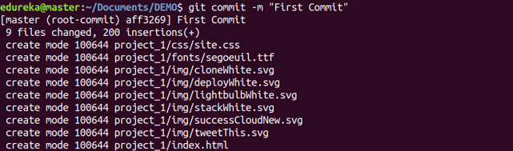

Usage: **git commit -a**

This command commits any files you’ve added with the git add command and also commits any files you’ve changed since then.



### **git diff**

Usage: git diff

This command shows the file differences which are not yet staged.

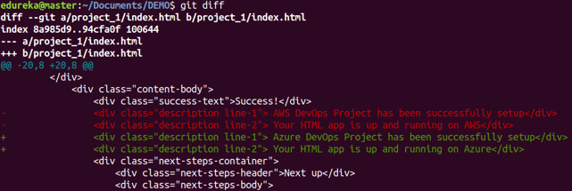

Usage: **git diff –staged**

This command shows the differences between the files in the staging area and the latest version present.

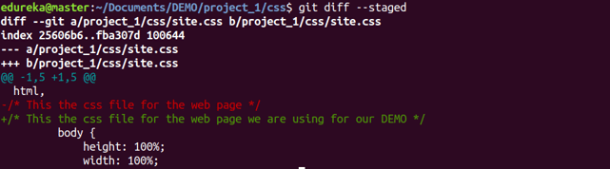

Usage: **git diff** [first branch] [second branch]

This command shows the differences between the two branches mentioned.

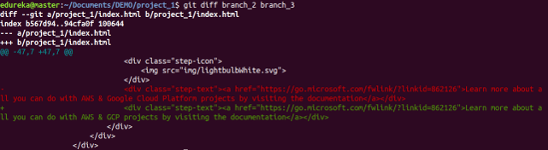

### **git reset**

Usage:git reset [file]

This command unstages the file, but it preserves the file contents.

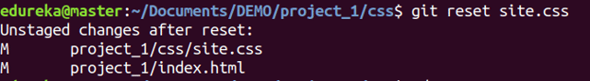

Usage: **git reset** [commit]

This command undoes all the commits after the specified commit and preserves the changes locally.



Usage: git reset –hard [commit]This command discards all history and goes back to the specified commit.



### **git status**

Usage: git status

This command lists all the files that have to be committed.

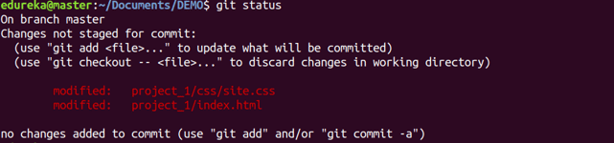

### **git rm**

Usage: git rm [file]

This command deletes the file from your working directory and stages the deletion.



### **git log**

Usage git log

This command is used to list the version history for the current branch.

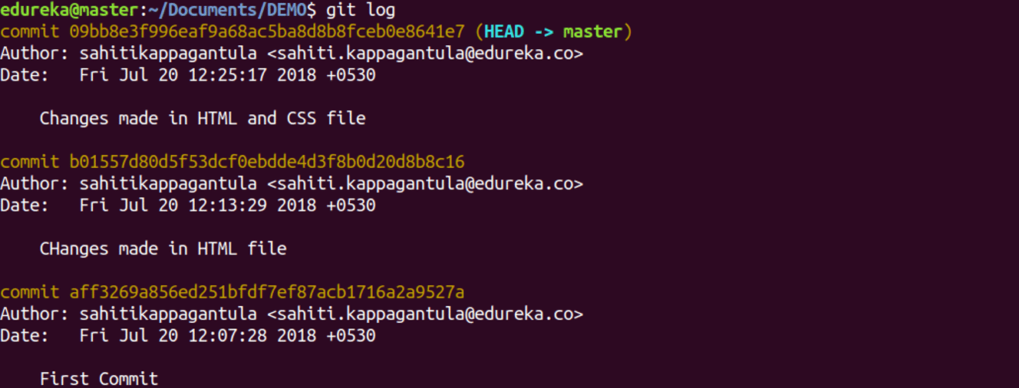

Usage: **git log –follow[file]**

This command lists version history for a file, including the renaming of files also.

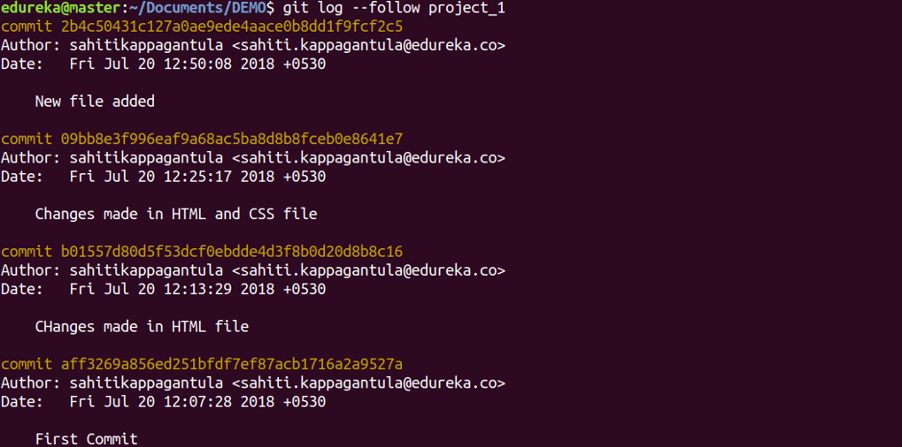

### **git show**

Usage: **git show** [commit]

This command shows the metadata and content changes of the specified commit.

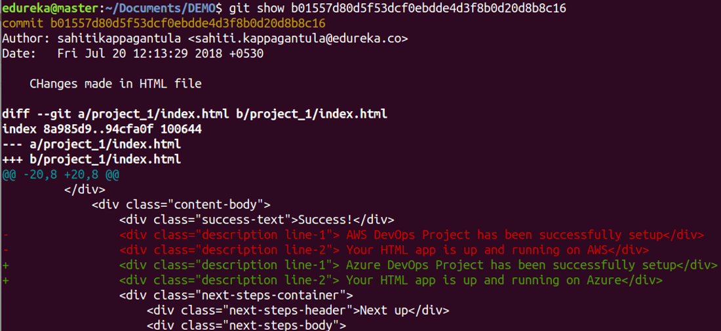

### **git tag**

Usage: **git tag** [commitID]

This command is used to give tags to the specified commit.

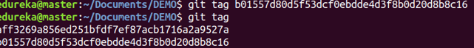

### **git branch**

Usage: **git branch**

This command lists all the local branches in the current repository.



Usage: **git branch** [branch name]

This command creates a new branch.



Usage: **git branch -d** [branch name]

This command deletes the feature branch.



### **git checkout**

Usage: **git checkout** [branch name]

This command is used to switch from one branch to another.



Usage: **git checkout -b** [branch name]

This command creates a new branch and also switches to it.



### **git merge**

Usage: **git merg**e [branch name]

This command merges the specified branch’s history into the current branch.



### **git remote**

Usage: git remote add [variable name] [Remote Server Link]

This command is used to connect your local repository to the remote server.



### **git push**

Usage: git push [variable name] master

This command sends the committed changes of master branch to your remote repository.

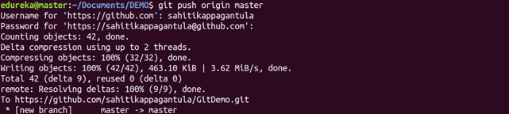

Usage: **git push** [variable name] [branch]

This command sends the branch commits to your remote repository.

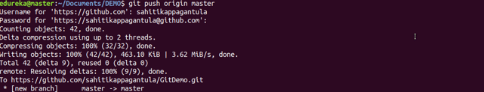

Usage: **git push –all [variable name]**

This command pushes all branches to your remote repository.

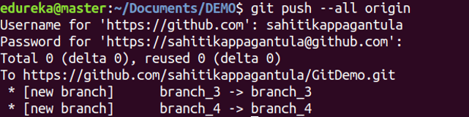

Usage: **git push [variable name] :[branch name]**

**Example: git push origin < Branch Name >**

This command deletes a branch on your remote repository.

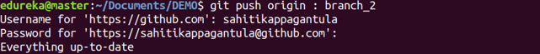

### **git pull**

Usage: **git pull** **origin < Branch Name >**

This command fetches and merges changes on the remote server to your working directory.

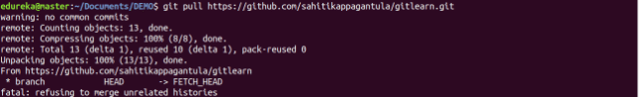

### **git stash**

Usage: **git stash save**

This command temporarily stores all the modified tracked files.



Usage: **git stash pop**

This command restores the most recently stashed files.

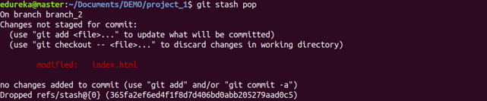

Usage:**git stash list**

This command lists all stashed changesets.



Usage: **git stash dro****p**

This command discards the most recently stashed changeset.

