Exp.no: 02 | Interaction with GitHub with Git commands
Date:

AIM:
To learn git commands, facilitating effective version control in projects.

COMMANDS:
- Clone a Repository:
To copy a repository from GitHub to your local machine:
git clone https://github.com/username/repository.git

- Add Changes:
To stage changes for the next commit:
git add .

- Commit Changes:
To save the staged changes to the local repository:
git commit -m “your commit message”

- Push Changes to GitHub:
To upload committed changes to your GitHub repository:
git push origin branch-name

- Pull Changes from GitHub:
To retrieve changes from a GitHub repository to your local repository:
git pull origin branch-name

- Create a New Branch:
To create a new branch:
git checkout -b new-branch

- Switch Branches:
To switch between branches:
git checkout branch-name

- Merge Branches:
To merge changes from one branch into another:
git merge branch-name

- Fetch Remote Changes:
To fetch changes from the remote repository without merging:
git fetch origin

- View Remote Repositories:
To see the list of remote repositories:
git remote -v

- Git Log:
To view a detailed commit history:
git log

SCREENSHOTS:

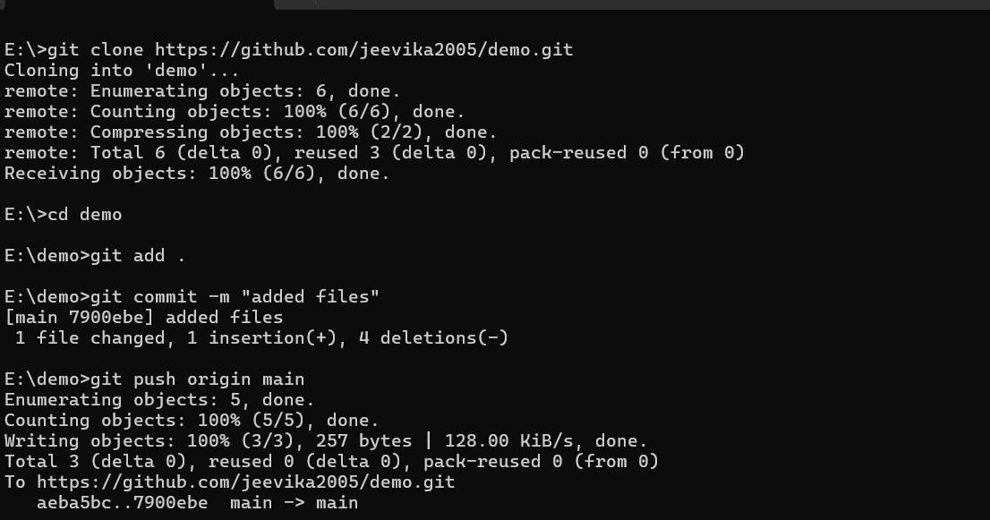

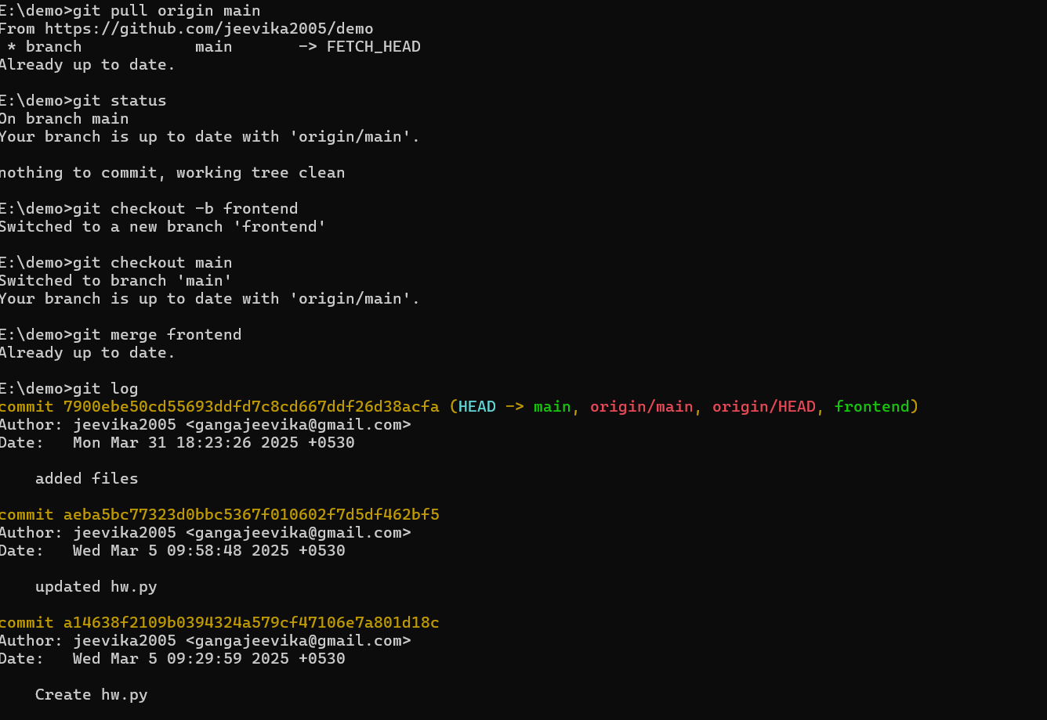

RESULT:
Thus, the interaction with GitHub using git commands were executed successfully.

