
One Page Abstract
S.NO | Register Number | Name
01 | 812022205031 | Mohemmad Arsal A
02 | 812022205045 | Sharan S
03 | 812022205052 | Suriya PB

Project Title | DRONE BASED THERMAL IMAGING FOR FOREST FIRE DETECTION
Details of Guide:
Name | Ms.M.Mathumitha
Department | B.Tech.IT
Designation | Assistant Professor

ABSTRACT:
Forest fires pose an escalating threat to global ecosystems, biodiversity, and human safety, necessitating rapid-response detection systems. This project proposes an autonomous Drone-based Thermal Imaging system designed for the early identification and real-time monitoring of wildfires. Traditional surveillance methods, such as satellite imagery or ground-based watchtowers, often struggle with low spatial resolution or visibility issues caused by dense smoke and rugged terrain.
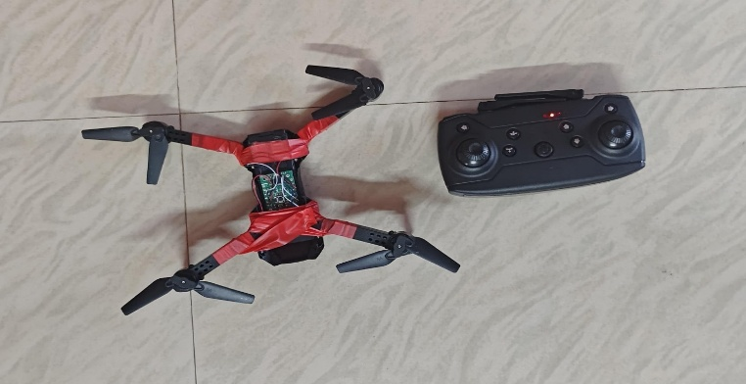
By deploying Unmanned Aerial Vehicles (UAVs) equipped with high-sensitivity Thermal Infrared (TIR) sensors, this system can pinpoint localized “hotspots” and heat signatures that remain invisible to conventional optical cameras. The methodology focuses on real-time data processing and autonomous flight path optimization to ensure maximum coverage with minimal latency. Experimental results demonstrate that thermal-equipped drones can effectively penetrate smoke screens to provide accurate heat maps, significantly reducing the time between ignition and emergency intervention. This project offers a scalable, cost-effective solution for proactive forest management, ultimately enhancing disaster mitigation strategies through advanced aerial intelligence. this allows for real-time “hotspot” detection, effectively filtering out false positives like sun-bleached rocks or reflection from water bodies. By focusing on these automated elements, the project moves beyond a simple remote-controlled camera and becomes a sophisticated, autonomous sentinel capable of providing first responders with high-fidelity heat maps and predicted fire-spread vectors within seconds of detection

