Course Code: CSA1557

Course Name: Cloud Computing and Big Data Analytics

R.Kishore 192224280

5) Create a simple cloud software application for Mark Sheet Processing System using any Cloud Service Provider to demonstrate SaaS include the necessary fields such as name of the student, Reg no of the student, Subjects , Marks, Average, percentage, rank, overall performance etc.

AIMS:

**KIPSTA CAR BOOKING**

Enter application name as kipsta car booking.

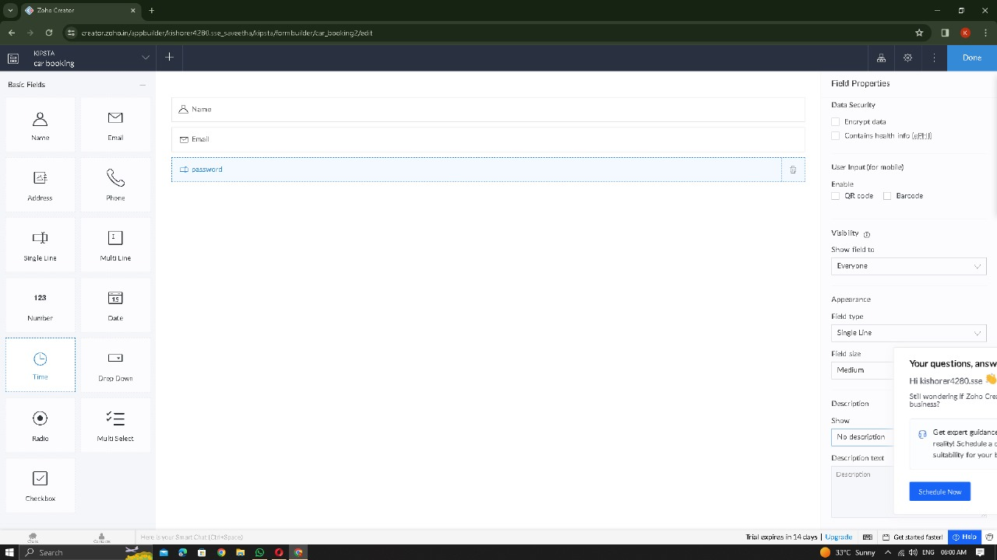

To create a simple cloud software application for Mark Sheet Processing System using any Cloud Service Provider to demonstrate SaaS.

PROCEDURE:

Step1: Go to zoho.com.

Step 2: Log into the zoho.com.

Step 3: Select one application step.

Step4: Enter application name as kipsta car booking.

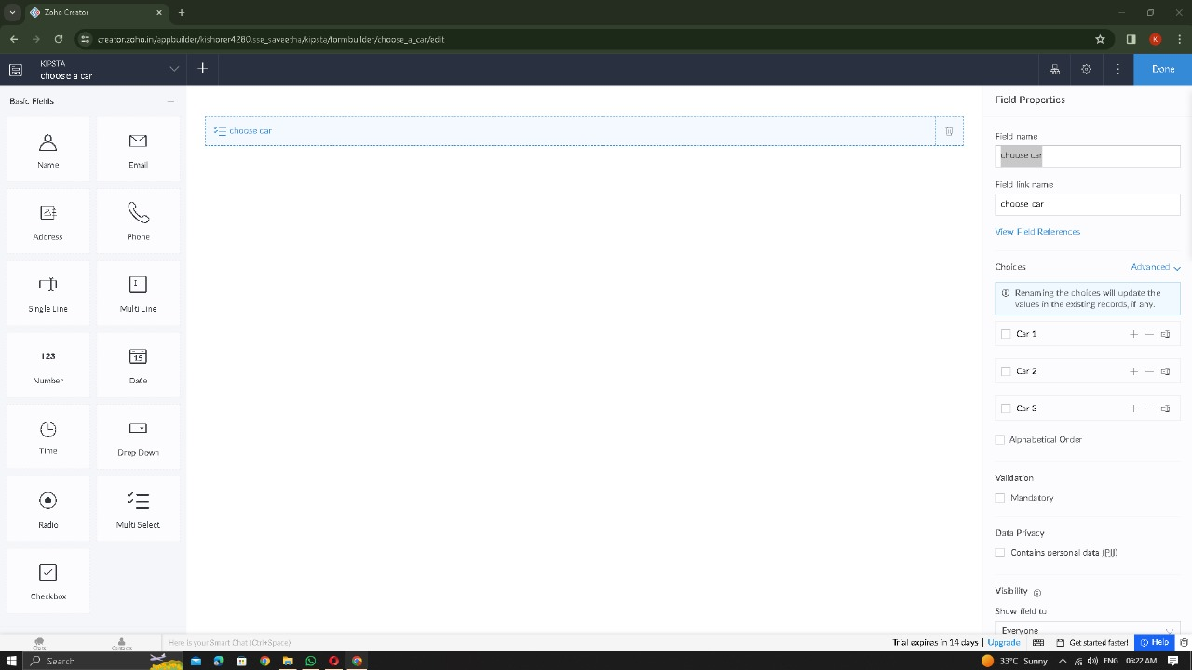

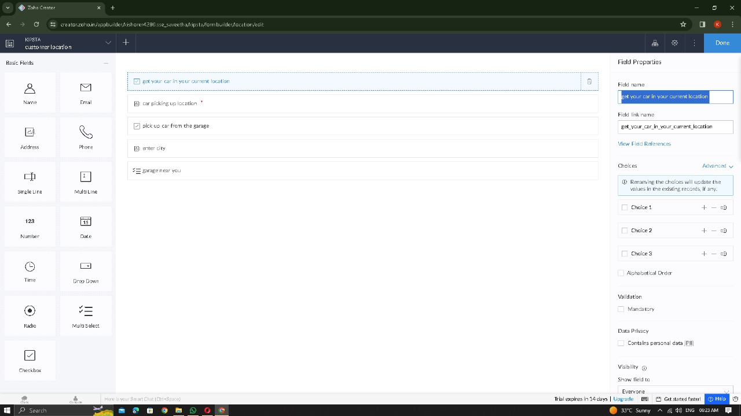

Step 5: Created new application kipsta car booking with location.

STEP 6: GET THE id PROOF AND THE SIGNATURE

STEP 7: ENTER THE LOCATION TO PICKUP

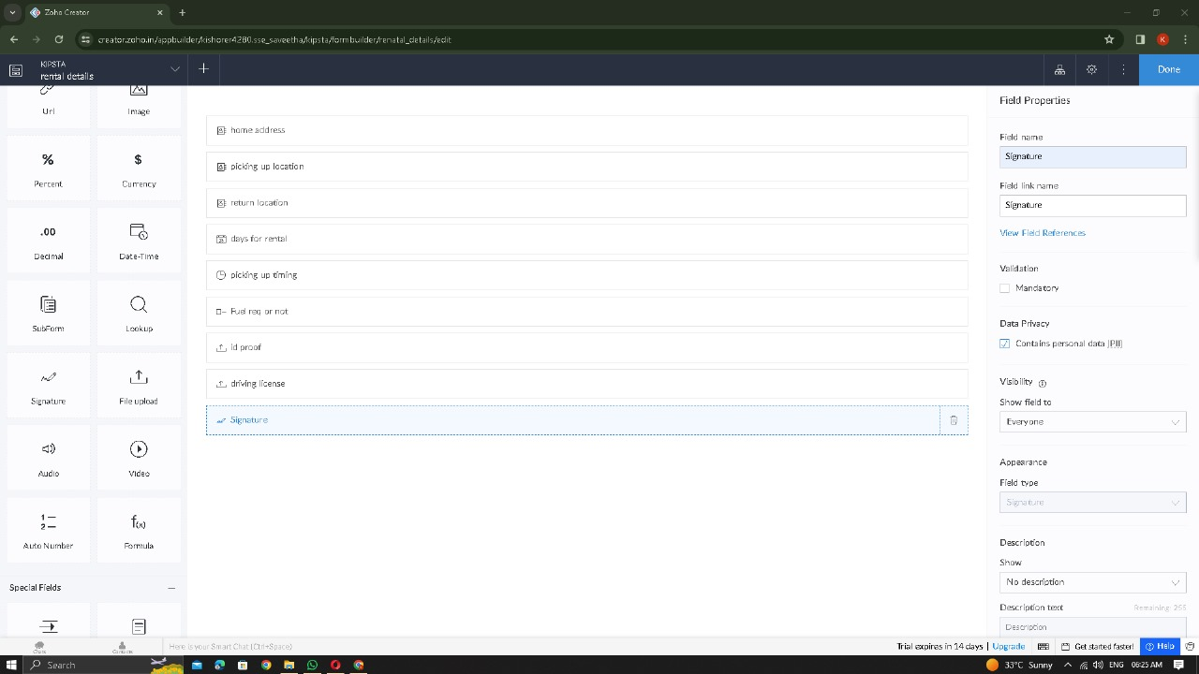

STEP 8: Click Access Development Live

STEP 9: Enter the details of the CAR BOOKING.

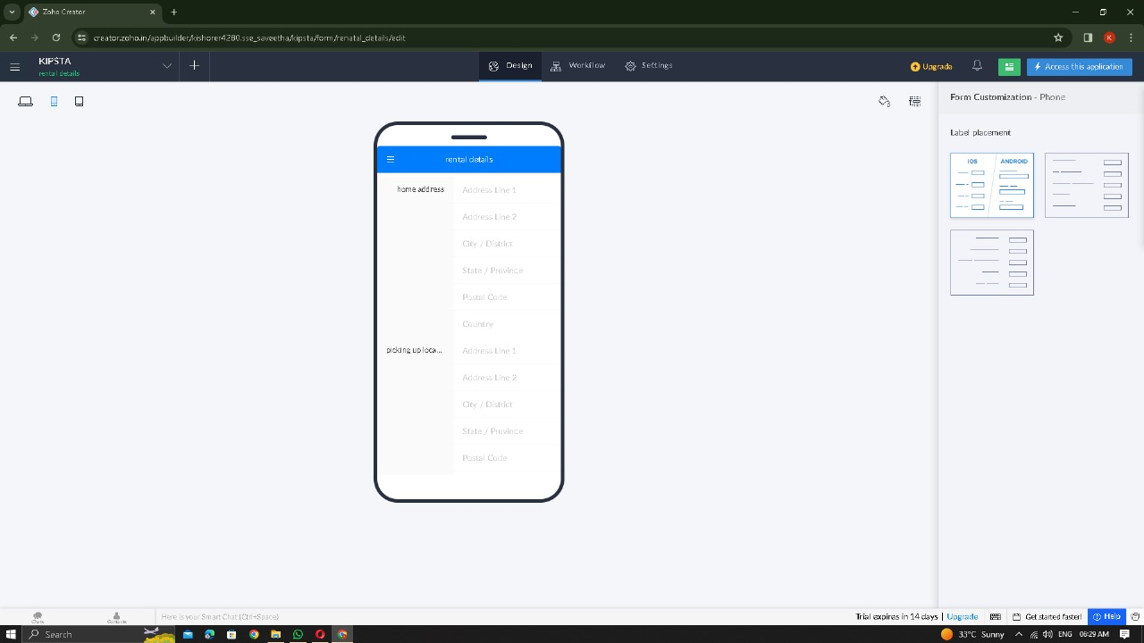

STEP 10: The report has been entered in the CAR BOOKING report.

STEP 12: ENTER THE DETAILS AND SAVE IT IN THE REPOSITORY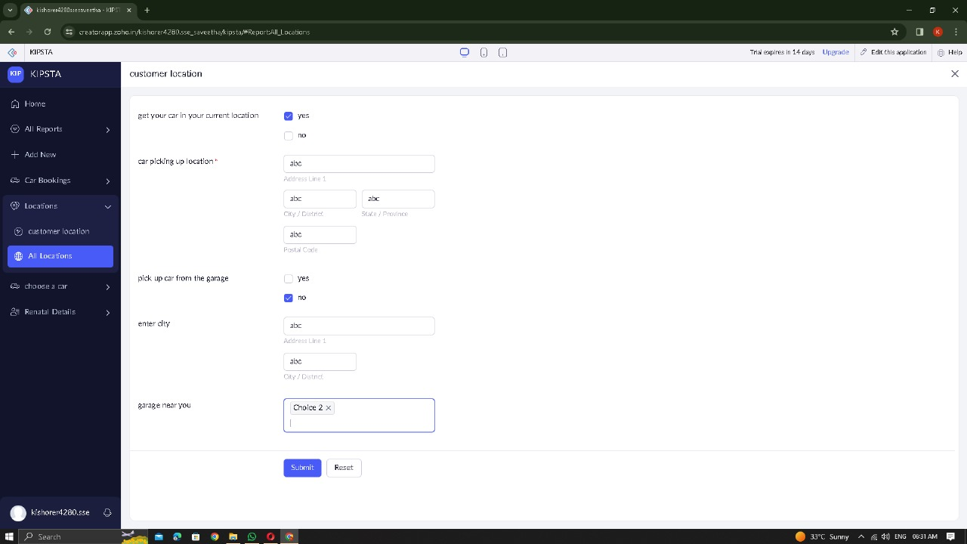

STEP 11: THE PROPERTY HAS BEEN REGISTERED IN THE ZOHO.COM.

STEP 12: THE PROPERTY HAS BEEN REGISTERED