Course Code: CSA1557

Course Name: Cloud Computing and Big Data Analytics

R.kishore 192224280

5) Create a simple cloud software application for Mark Sheet Processing System using any Cloud Service Provider to demonstrate SaaS include the necessary fields such as name of the student, Reg no of the student, Subjects, Marks, Average, percentage, rank, overall performance etc.

AIMS:

To create a simple cloud software application for Mark Sheet Processing System using any Cloud Service Provider to demonstrate SaaS.

PROCEDURE:

Step1: Go to zoho.com.

Step 2: Log into the zoho.com.

Step 3: Select one application step.

Step4: Enter application name as mark sheet processing system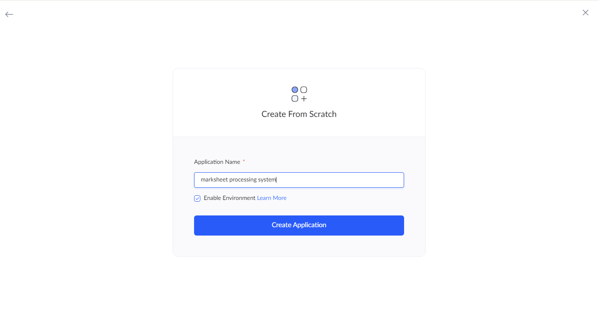.

Step 5: Created new application as marksheet processing system.

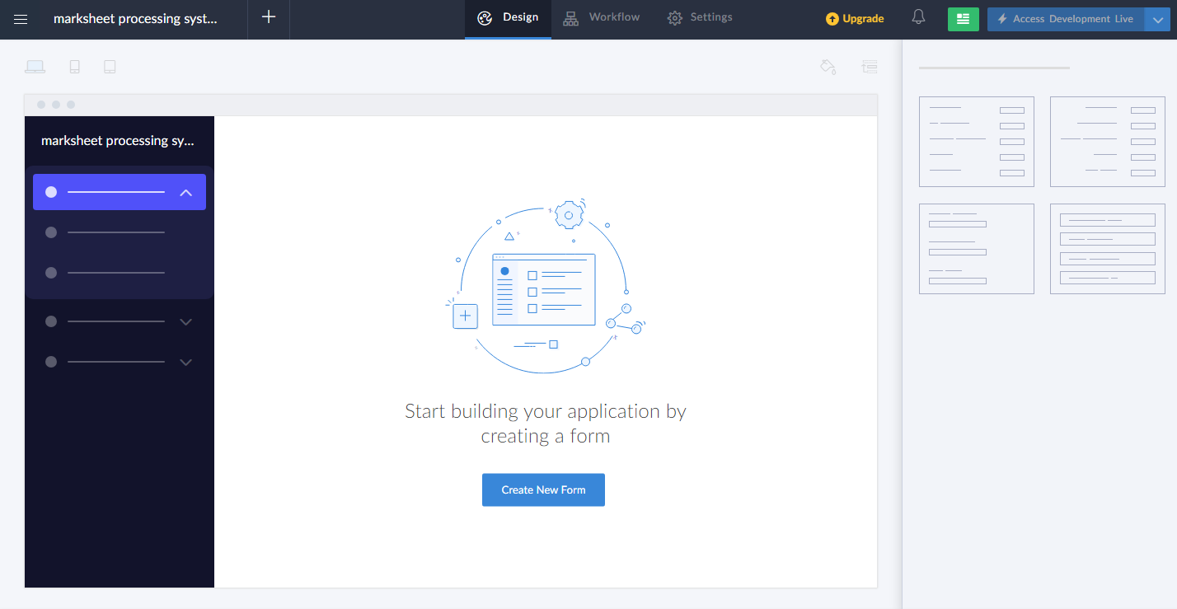

STEP 6: Select from Scratch and Create form as login.

STEP 7: The form has been created as Book

Choose the fields.

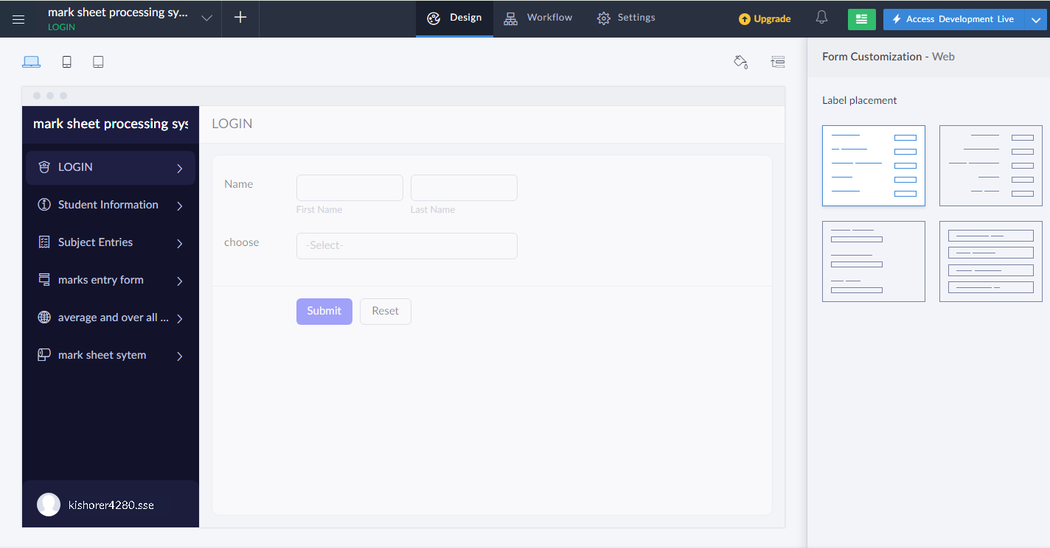

STEP 8: Click Access Development Live

STEP 9: Enter the details of the login.

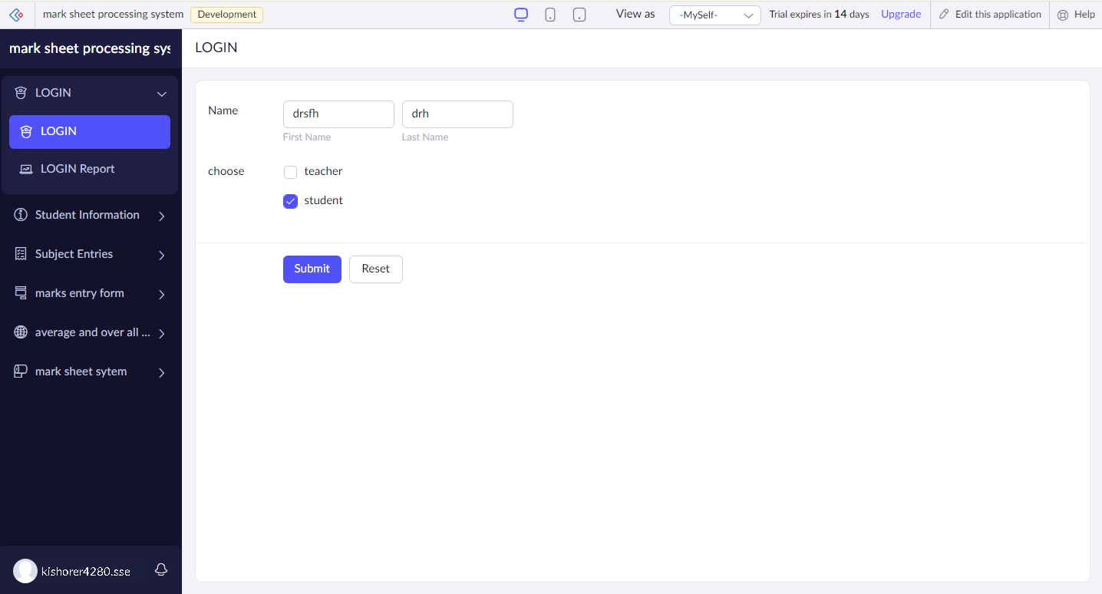

STEP 10: The report has been entered in the login report.

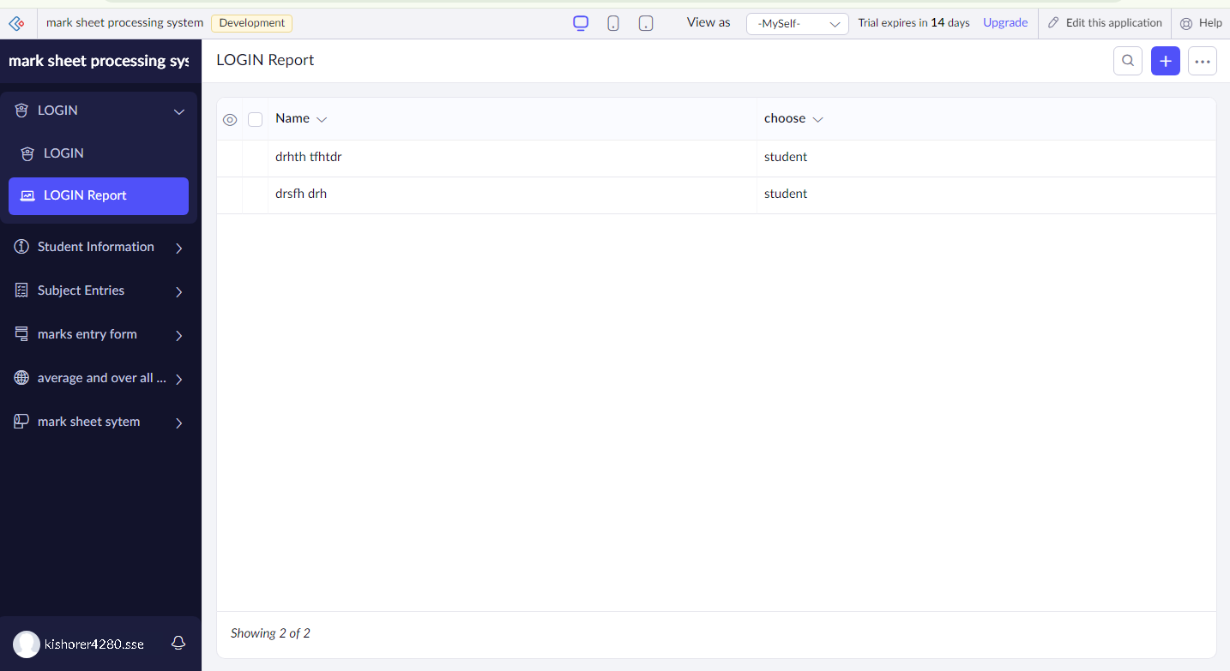

STEP 11: Enter the details of the login

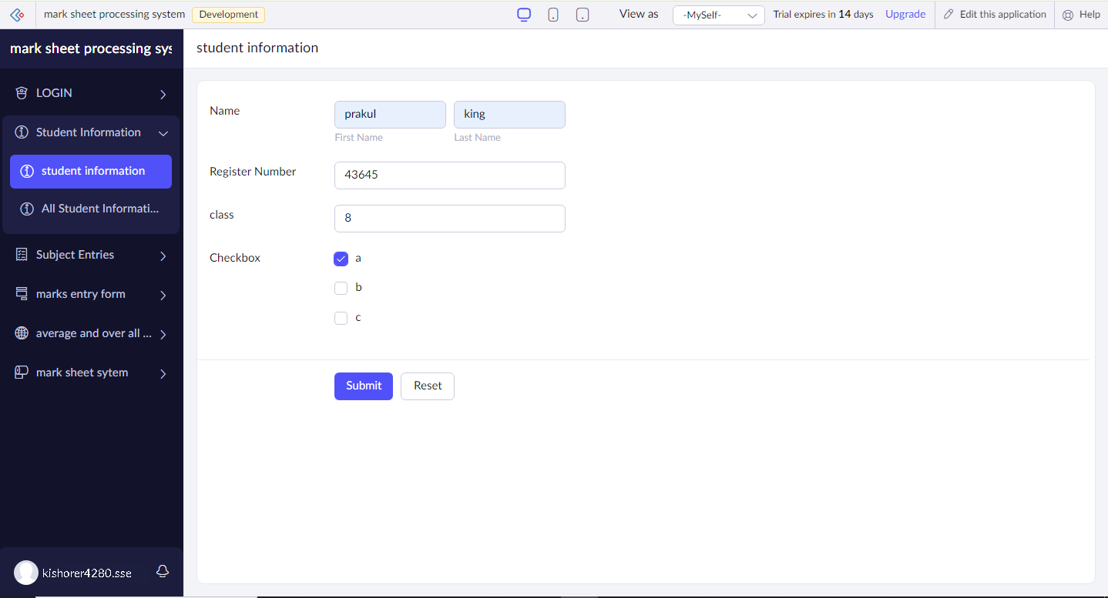

STEP 12: The report has been entered in the student information report.

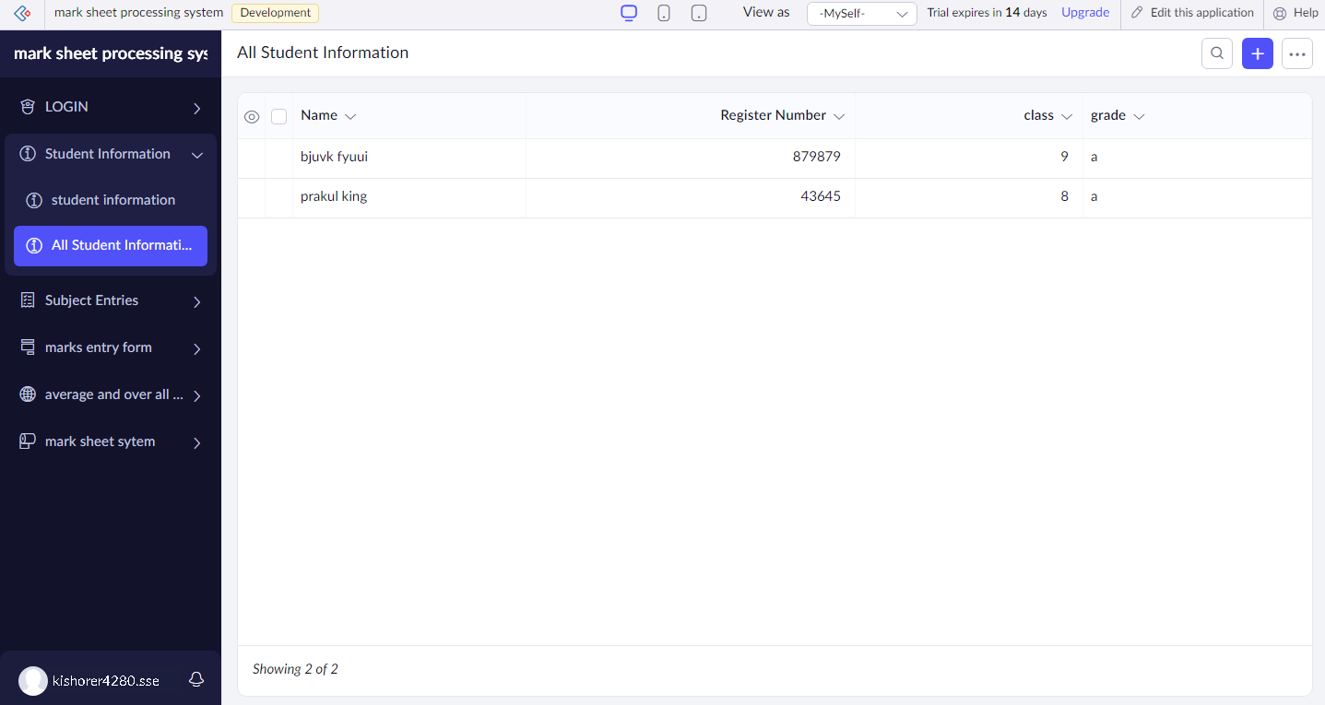

STEP 13: Enter the details of the login.

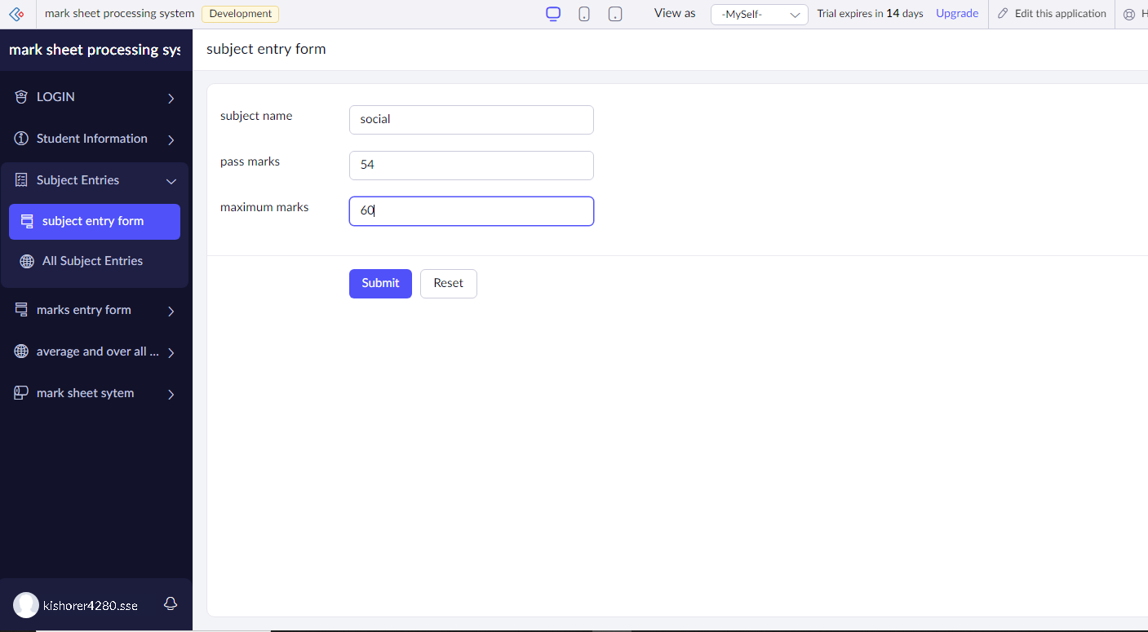

STEP 14: The report has been entered in the subject entries report.

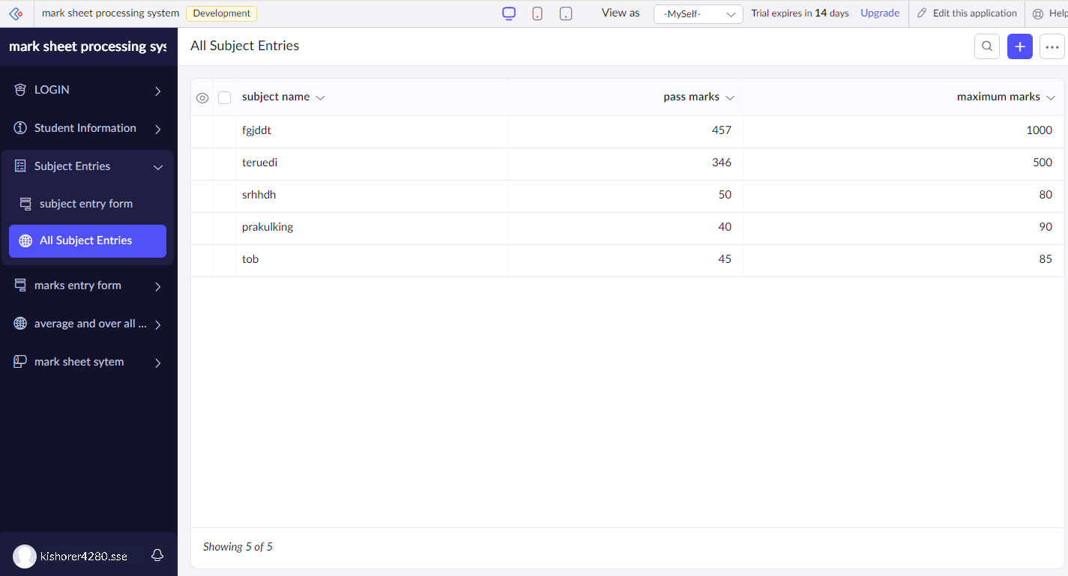

STEP 15: Enter the details of the login.

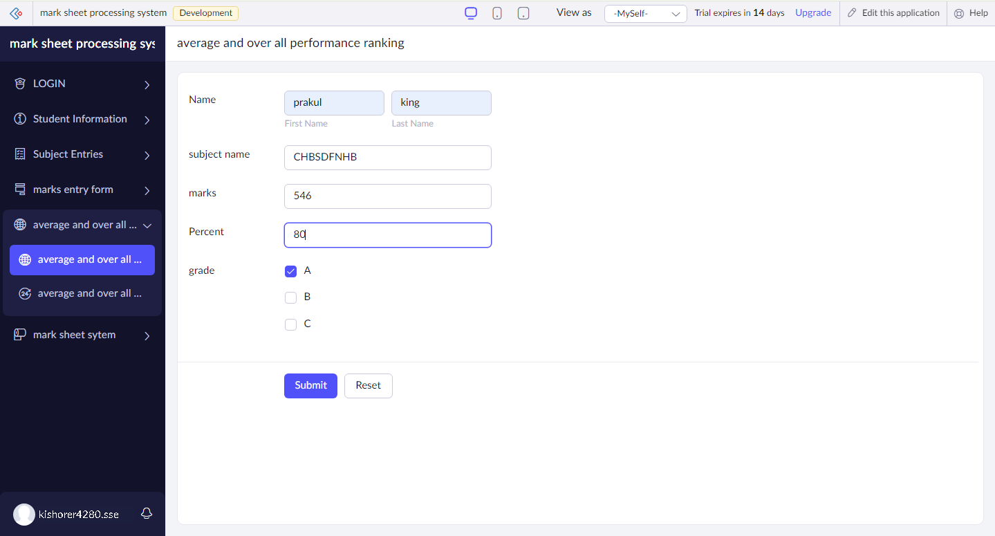

STEP 16: The report has been entered in the average and overall subject report.

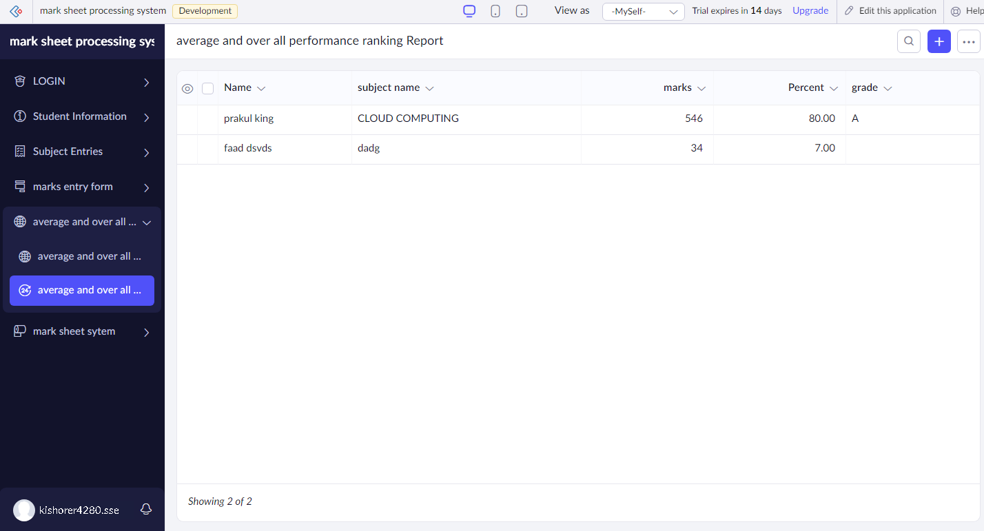

STEP 17: Enter the details of the login.

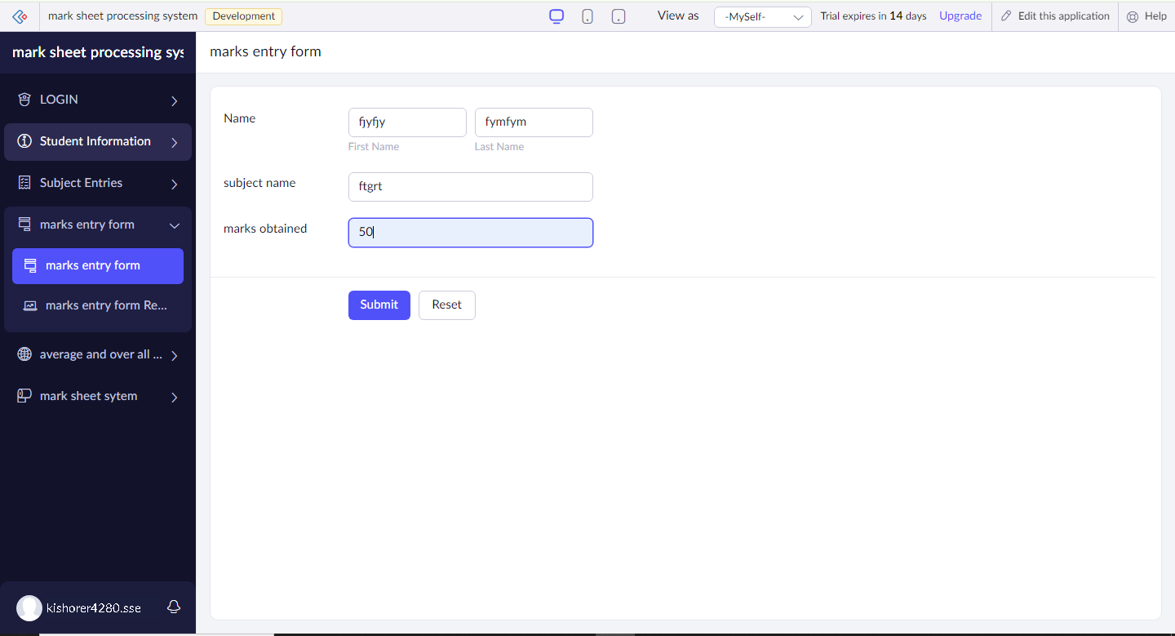

STEP 18: The report has been entered in the marks entry report.

