Course Code: CSA1557

Course Name: Cloud Computing and Big Data Analytics

R. KISHORE 192224280

2) Create a simple cloud software application for Property Buying & Rental process (In Chennai city) using any Cloud Service Provider to demonstrate SaaS include the necessary fields such as Buy, Rent, commercial, Rental Agreement, Rental Agreement, Area, place, Range, property value etc.

AIM: To Create a simple cloud software application for Property Buying & Rental process (In Chennai city) using any Cloud Service Provider to demonstrate SaaS.

PROCEDURE:

Step1: Go to zoho.com.

Step 2: Log into the zoho.com.

Step 3: Select one application step.

Step4: Enter application name as property buying & rental.

Step 5: Created new application as property buying & rental.

Step 6: Select one form

Step 7: The software has been created.

IMPLEMENTATION:

STEP1: GOTO ZOHO.COM

STEP1: GOTO ZOHO.COM

STEP 2: LOGINTOTHE ZOHO.COM

STEP 3: SELECT ONE APPLICATION

STEP 4: ENTER APPLICATION NAME

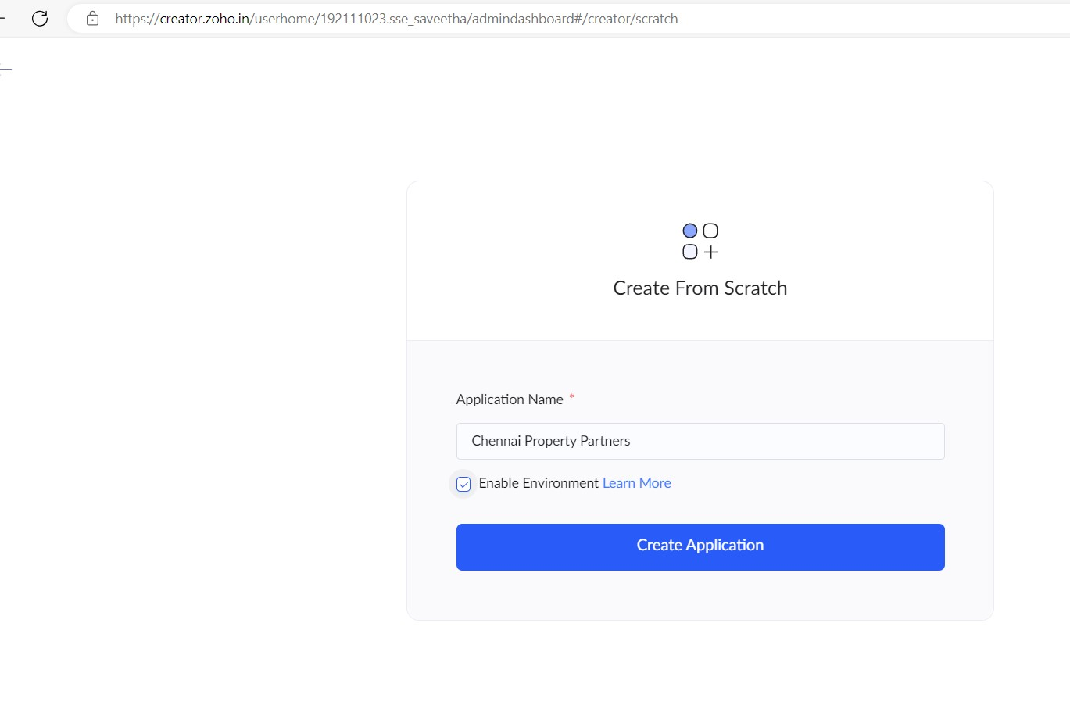

STEP 5: Created New Application

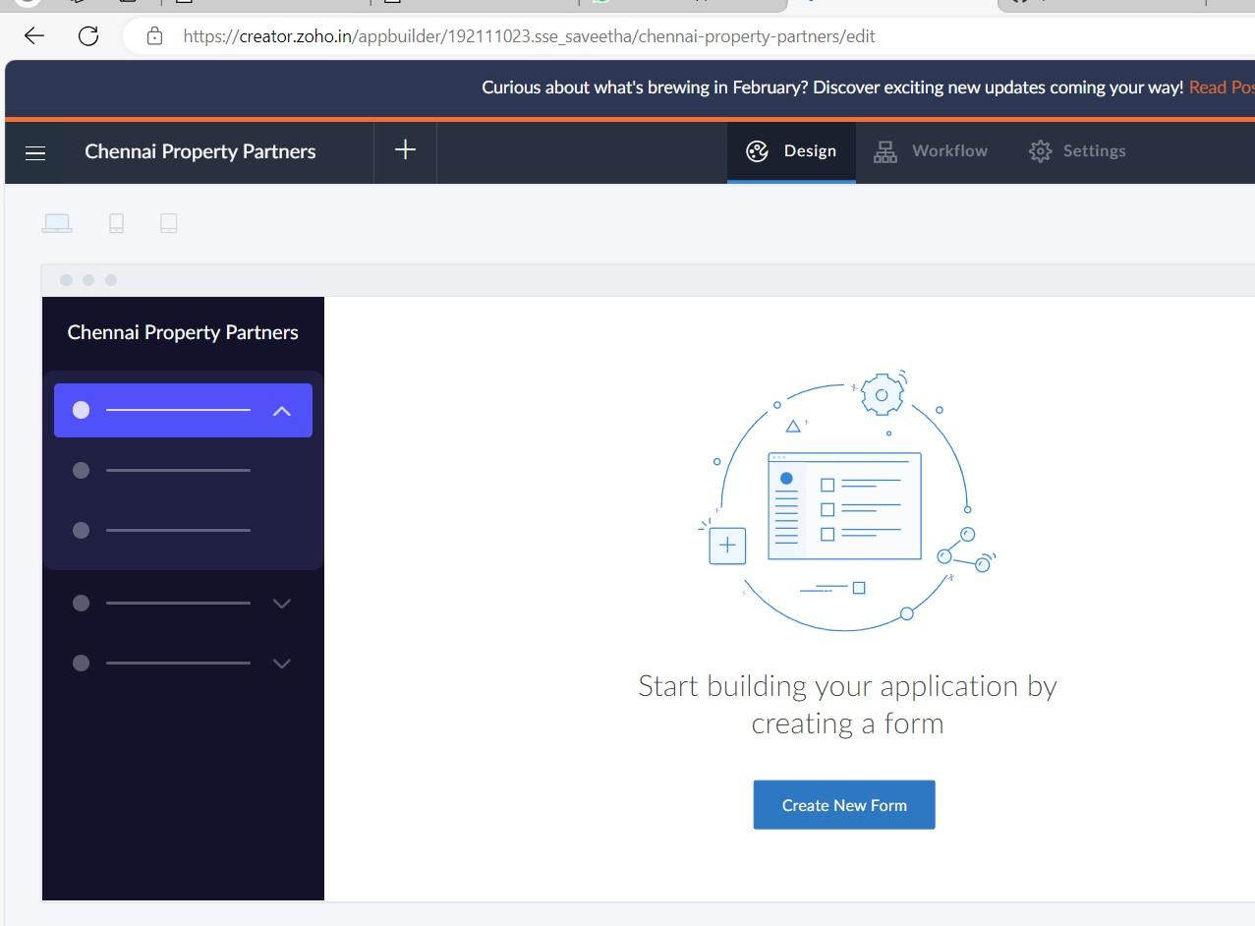

STEP 6: Select from Scratch and Create form as Property Description.

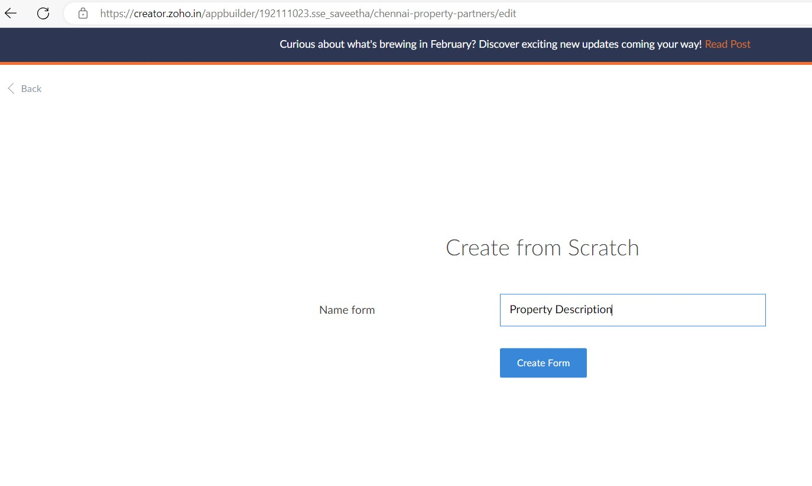

STEP 7: The form has been created as Property Details

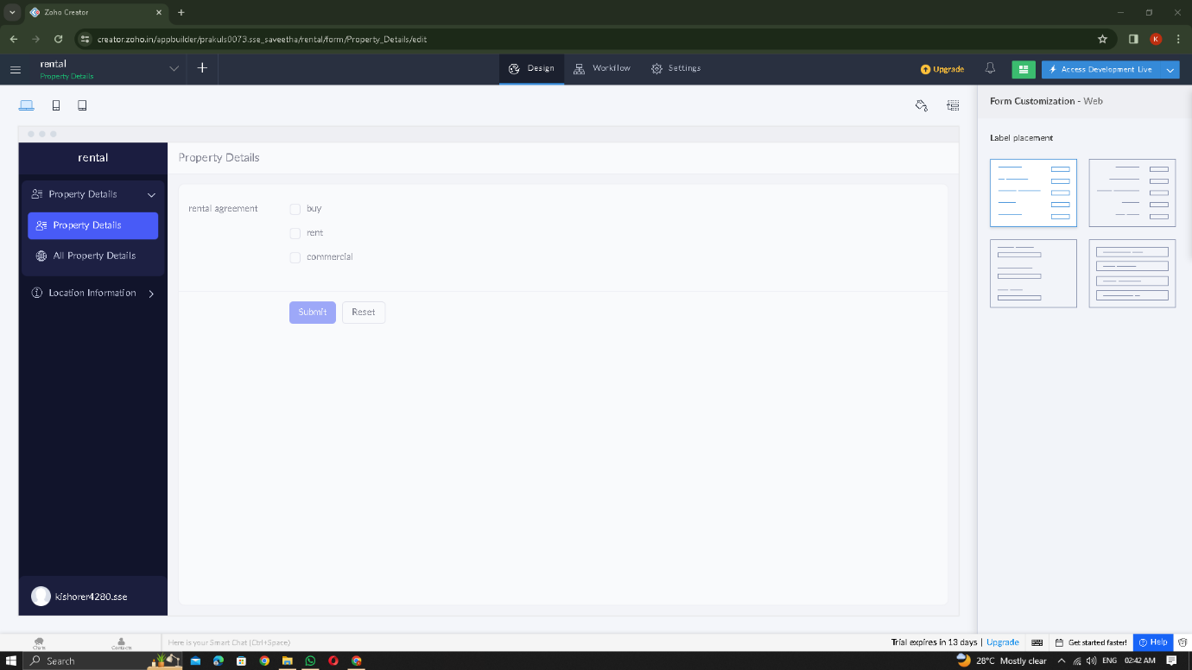

Choose the fields.

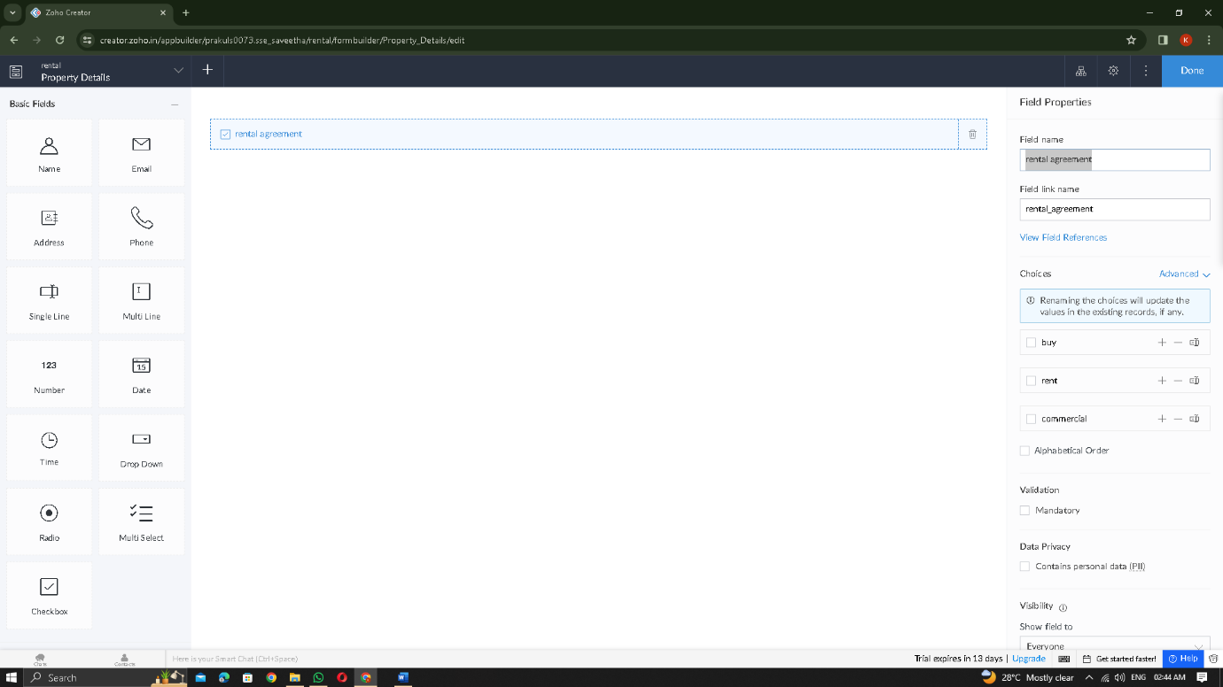

STEP 9: Click Access Development Live and enter the details to access

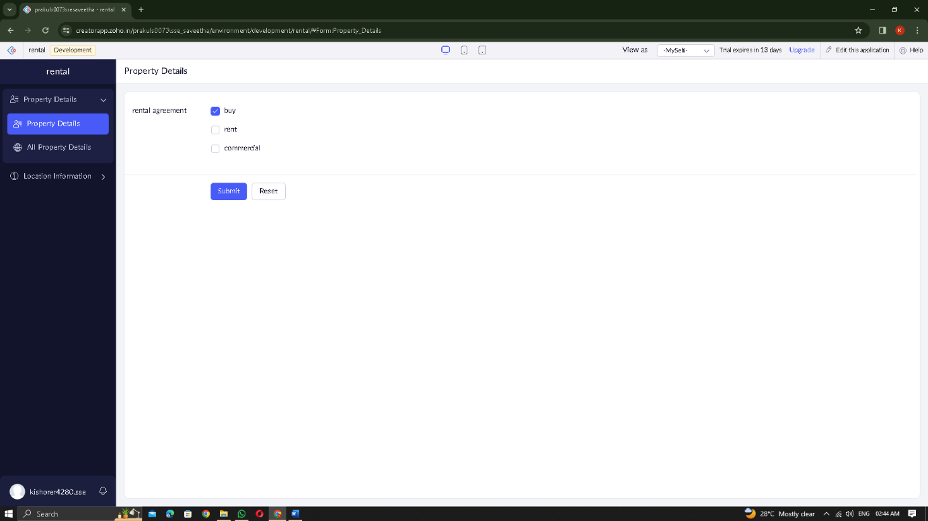

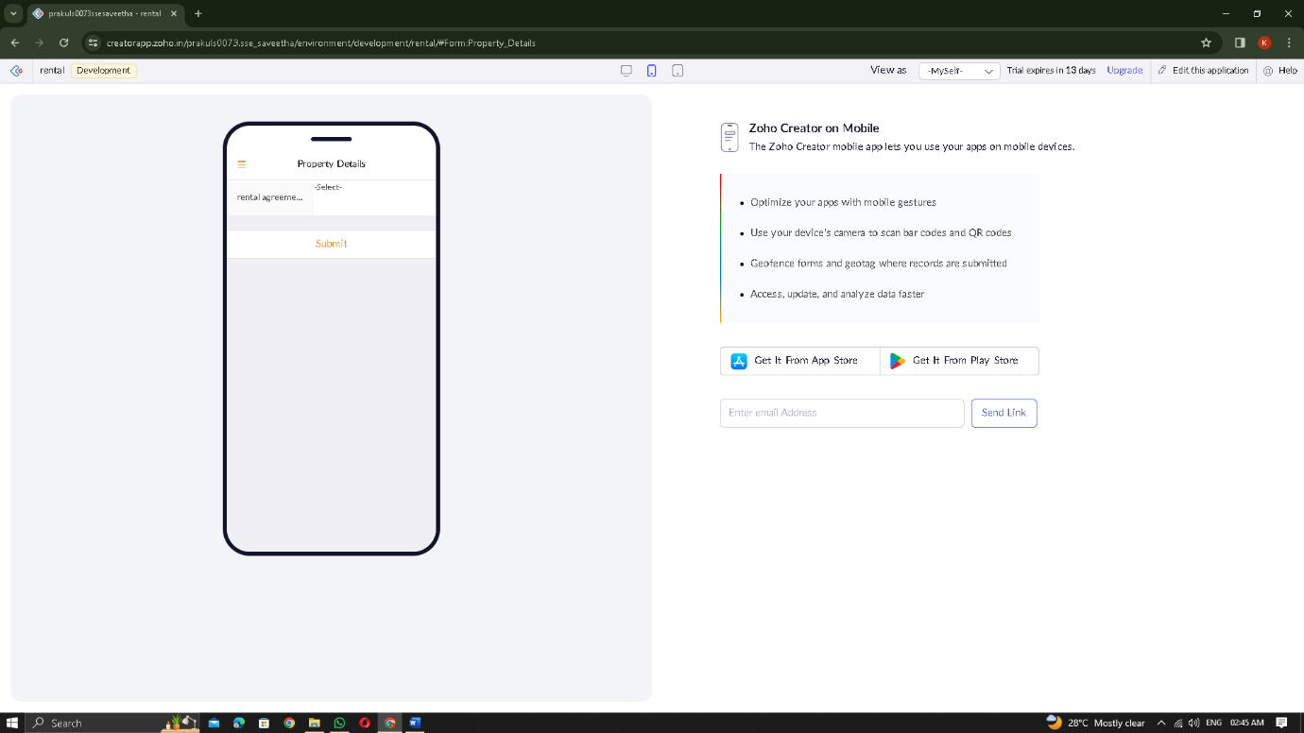

STEP 10: The report has been registered in the Property Description report.

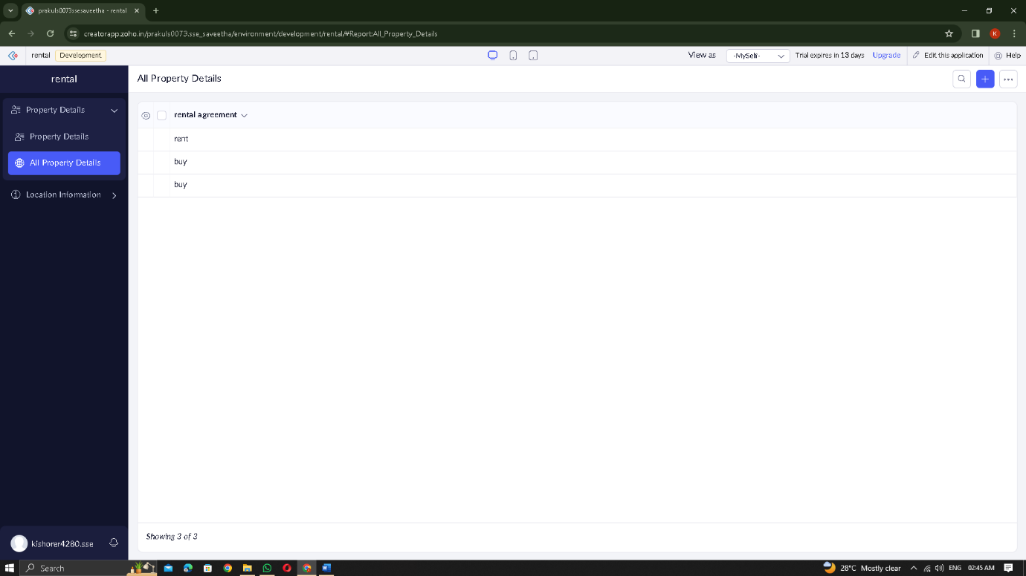

STEP 11: Select from Scratch and Create form as location information

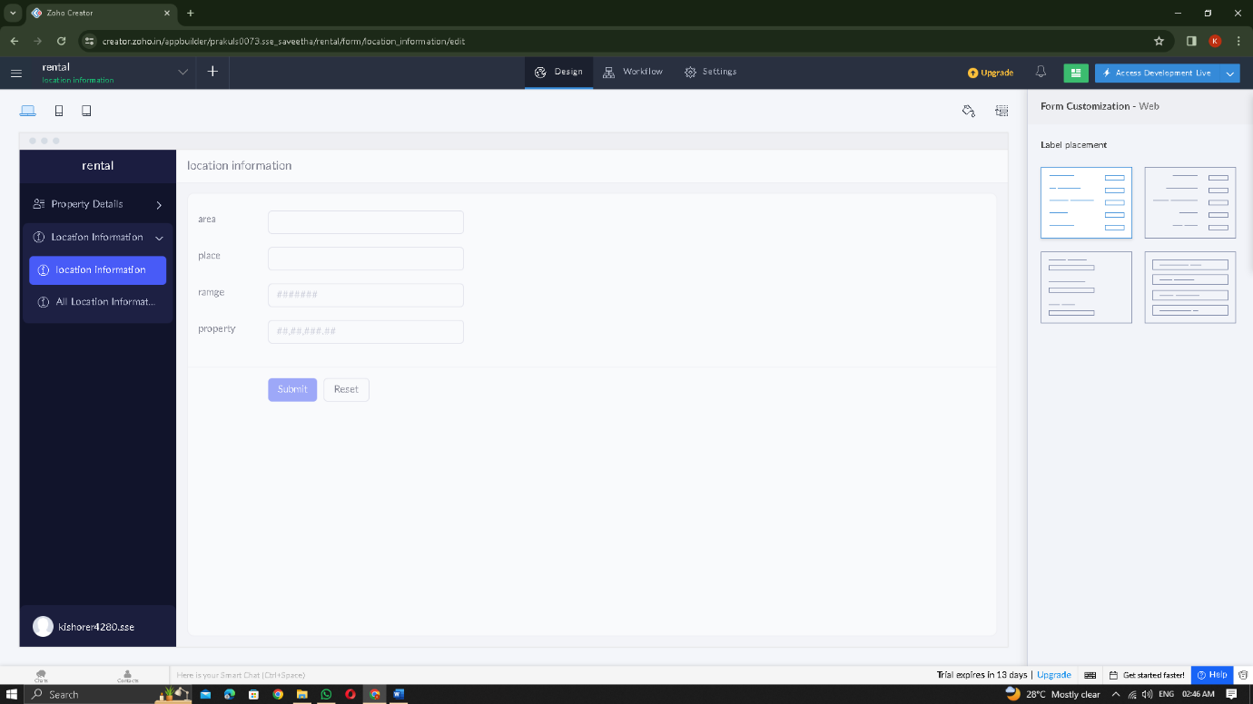

Choose the fields.

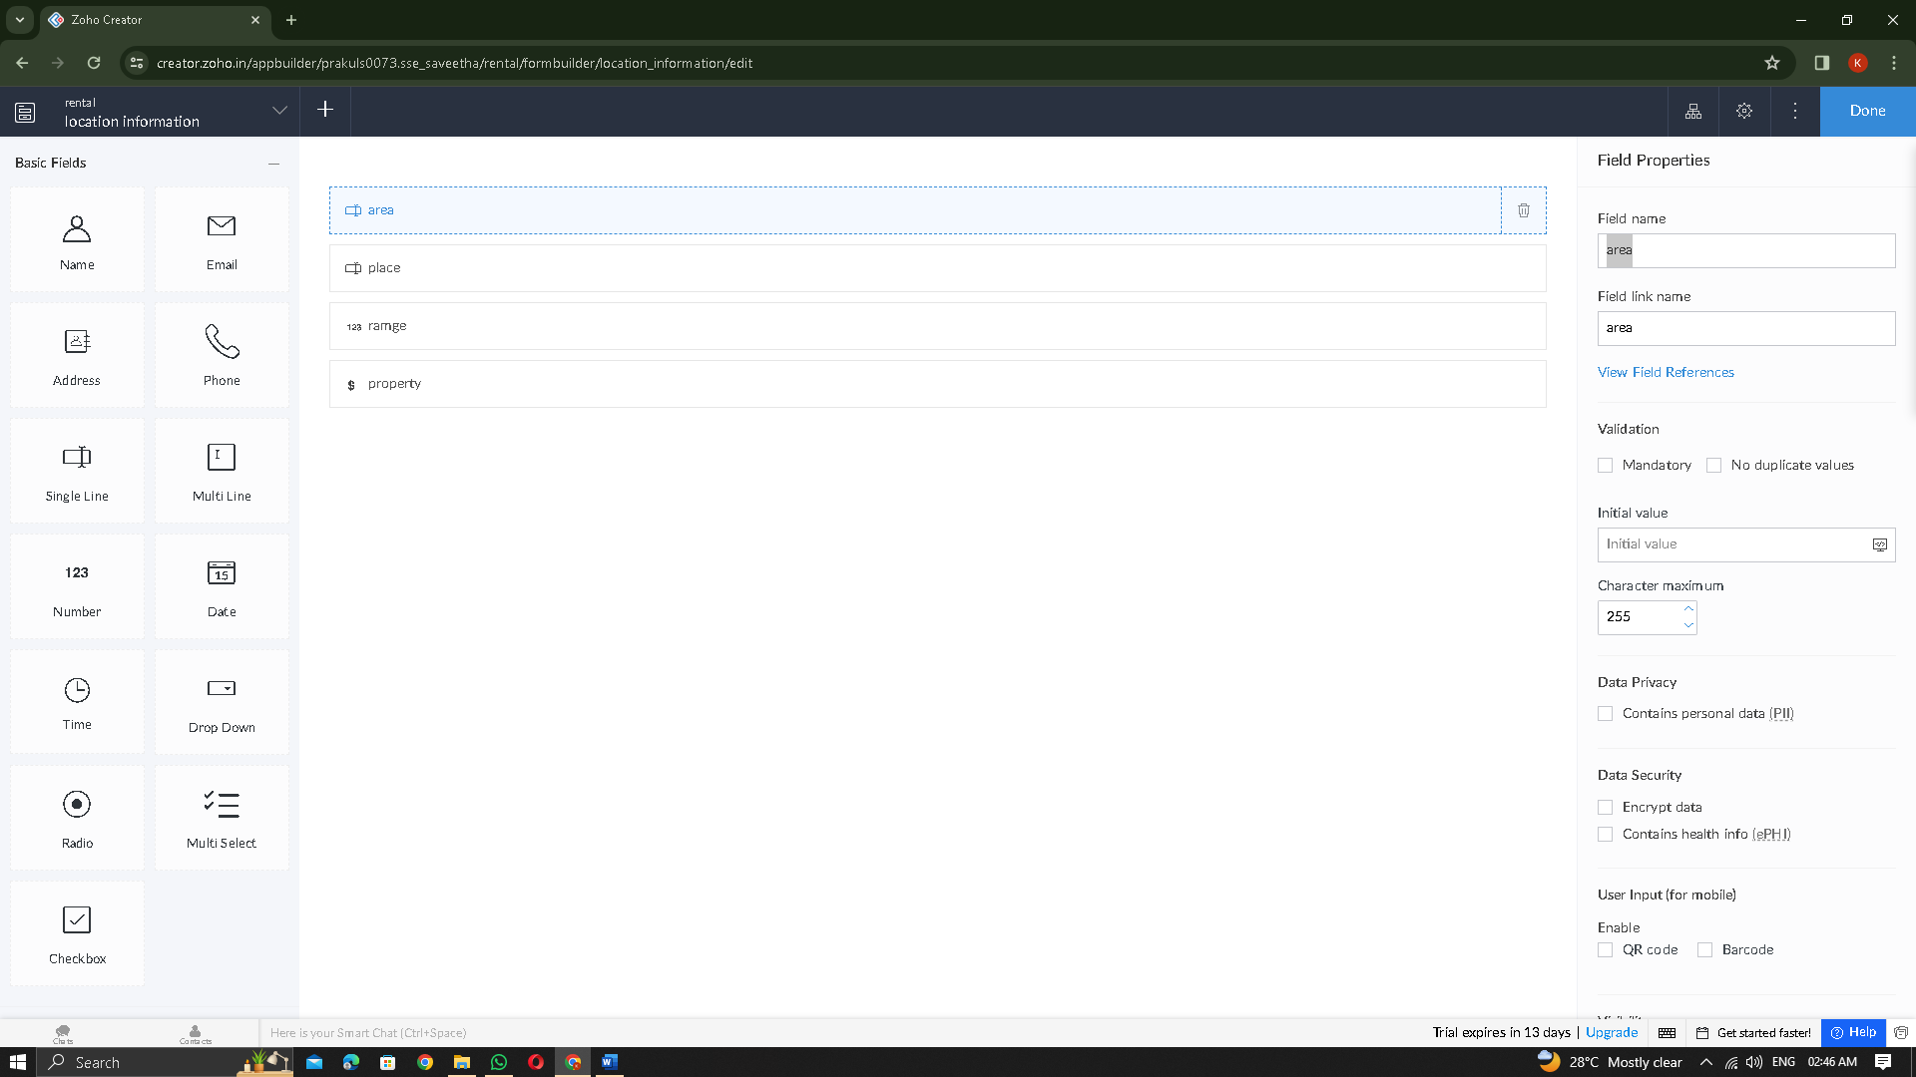

STEP 7: The form has been created as location information

STEP 12: Click Access Development Live and enter the details to access

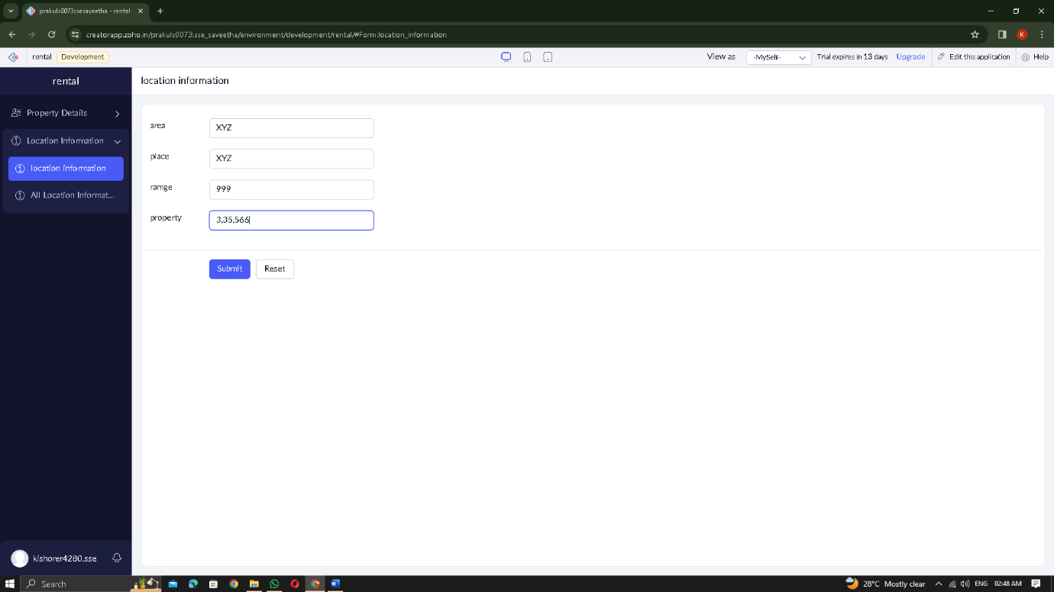

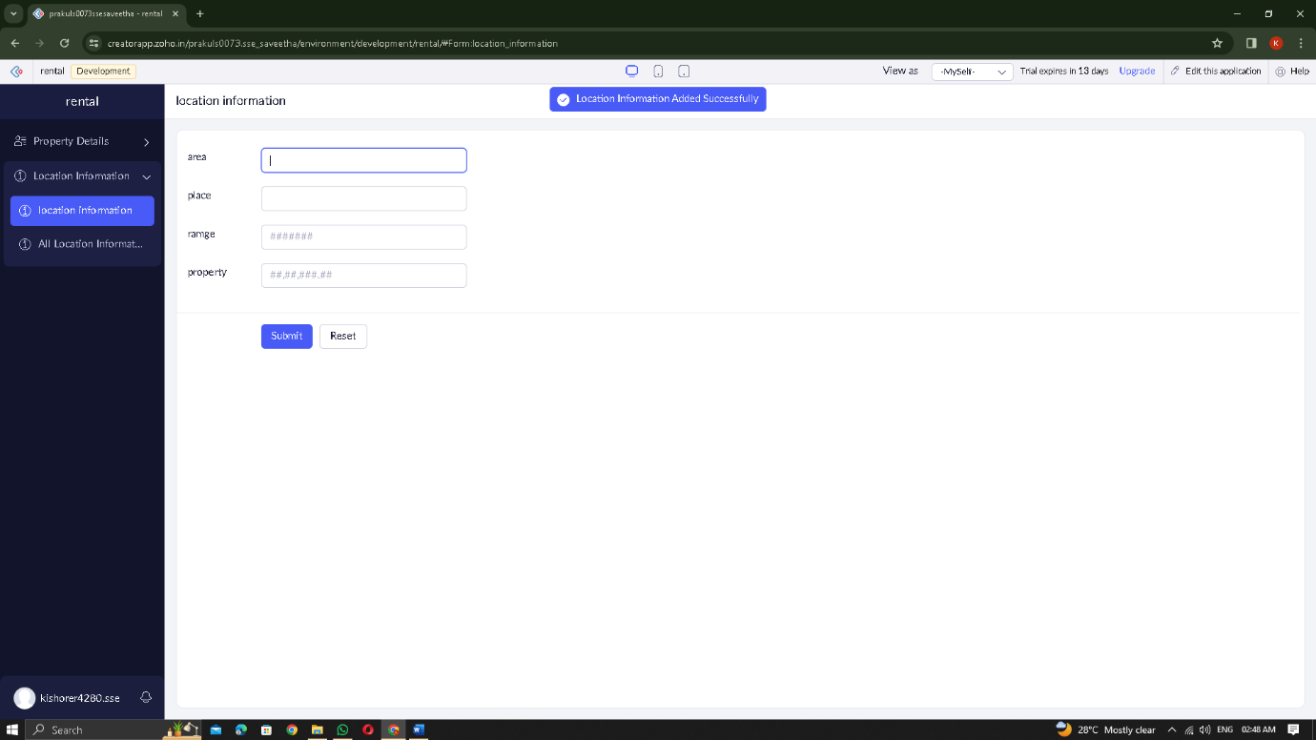

STEP 13: The report has been registered in the location information report.

