TEST-2

K. Varshini

192111556

1.print the pattern?

Program:

#include <iostream>

using namespace std;

int main() {

int rows = 5;

for (int i = 1; i <= rows; ++i) {

for (int j = 1; j <= i; ++j) {

cout << i;

}

cout << endl;

}

return 0;

}

OUTPUT:

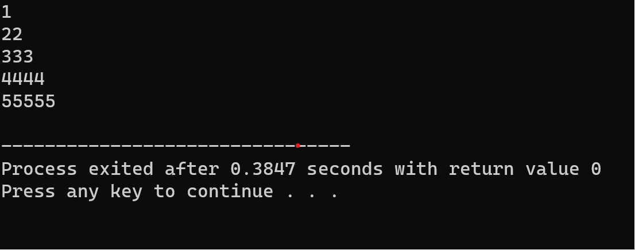

2.find the average of all elements in an array?

Program :

#include <iostream>

int main() {

const int maxSize = 100;

int arr[maxSize];

int size;

double sum = 0, average;

std::cout << "Enter the size of the array: ";

std::cin >> size;

std::cout << "Enter " << size << " elements:\n";

for (int i = 0; i < size; ++i) {

std::cin >> arr[i];

sum += arr[i];

}

if (size > 0) {

average = sum / size;

std::cout << "Average of array elements: " << average << std::endl;

} else {

std::cout << "Cannot calculate average for an empty array." << std::endl;

}

return 0;

}

OUTPUT:

