Project Initialization and Planning Phase

Date | 29 September 2026
Team ID | 6ab4cc32a238dc999eb580a8
Project Name | AI FAQ Assistant API
Maximum Marks | 3 Marks

Define Problem Statements (Customer Problem Statement Template):



Create a problem statement to understand your customer's point of view. The Customer Problem Statement template helps you focus on what matters to create experiences people will love. A well-articulated customer problem statement allows you and your team to find the ideal solution for your customers' challenges. Throughout the process, you’ll also be able to empathize with your customers, which helps you better understand how they perceive your product or service.

Example:
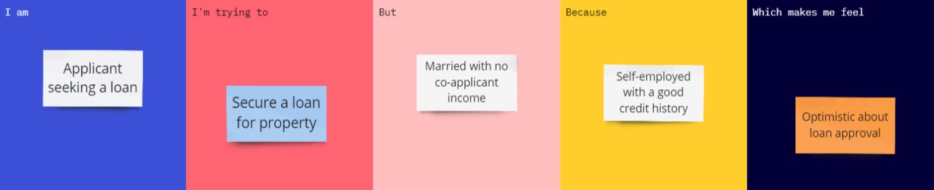

Problem  Statement  (PS) | I am (Customer) | I’m trying  to | But | Because | Which makes me feel
PS-1 | A male applicant  seeking a loan.  FAQ answers. | Secure a loan  for the  AI answers.  property | Married with  No co-applicant search and manage. income. | Self-employe  with a good with AI assistance. credit history. | Optimistic about  loan approval. are hard to find.

