Student Performance Factors Analysis
& Predictive Modeling
Capstone Data Analytics Project

Author: Kishore Arundhatiyar
Date: September 24, 2026

Executive Summary
This project analyzes 6,607 student records to identify factors associated with exam performance and to compare two predictive modeling approaches. The workflow combines data cleaning, exploratory visualization, categorical encoding, regression modeling, and automated reporting. On the held-out test set, Linear Regression outperformed the Random Forest Regressor, while Attendance, Hours_Studied, and Previous_Scores emerged as the strongest numeric factors linked to Exam_Score.

Problem Statement
Educators and academic support teams need practical evidence about the factors connected to student outcomes so they can prioritize monitoring and early intervention. This analysis provides a reproducible baseline for understanding how study behavior, attendance, prior achievement, family context, and school conditions relate to exam performance.

Dataset Overview
The source file, StudentPerformanceFactors.csv, contains 6,607 rows and 20 features. Exam_Score is the prediction target. The predictors cover academic behavior, attendance, resources, parental involvement, motivation, tutoring, school type, peer influence, learning needs, and demographic context. The raw file contained missing values in 3 columns; missing categorical values were filled with the most frequent category, and missing numeric values were filled with the median.
Records | 6,607
Predictor columns | 19
Target | Exam_Score
Average target score | 67.24
Observed target range | 55 to 101
Raw missing-value columns | Teacher_Quality, Parental_Education_Level, Distance_from_Home

Methodology
Text fields were trimmed and standardized before imputation. Numeric variables were passed through a median imputer. Ordered categorical variables were imputed with the most frequent level and ordinal-encoded using explicit category order, while nominal categorical variables were imputed and one-hot encoded. The data was split into 80% training and 20% test observations with random_state=42. Linear Regression served as an interpretable baseline, and a 300-tree Random Forest Regressor represented a nonlinear alternative.

Exploratory Analysis
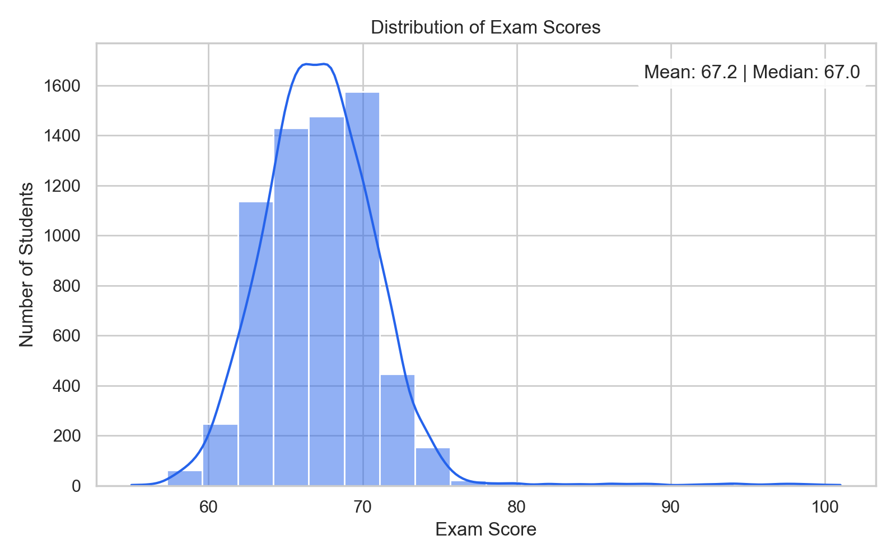
Figure 1. Distribution of Exam Score
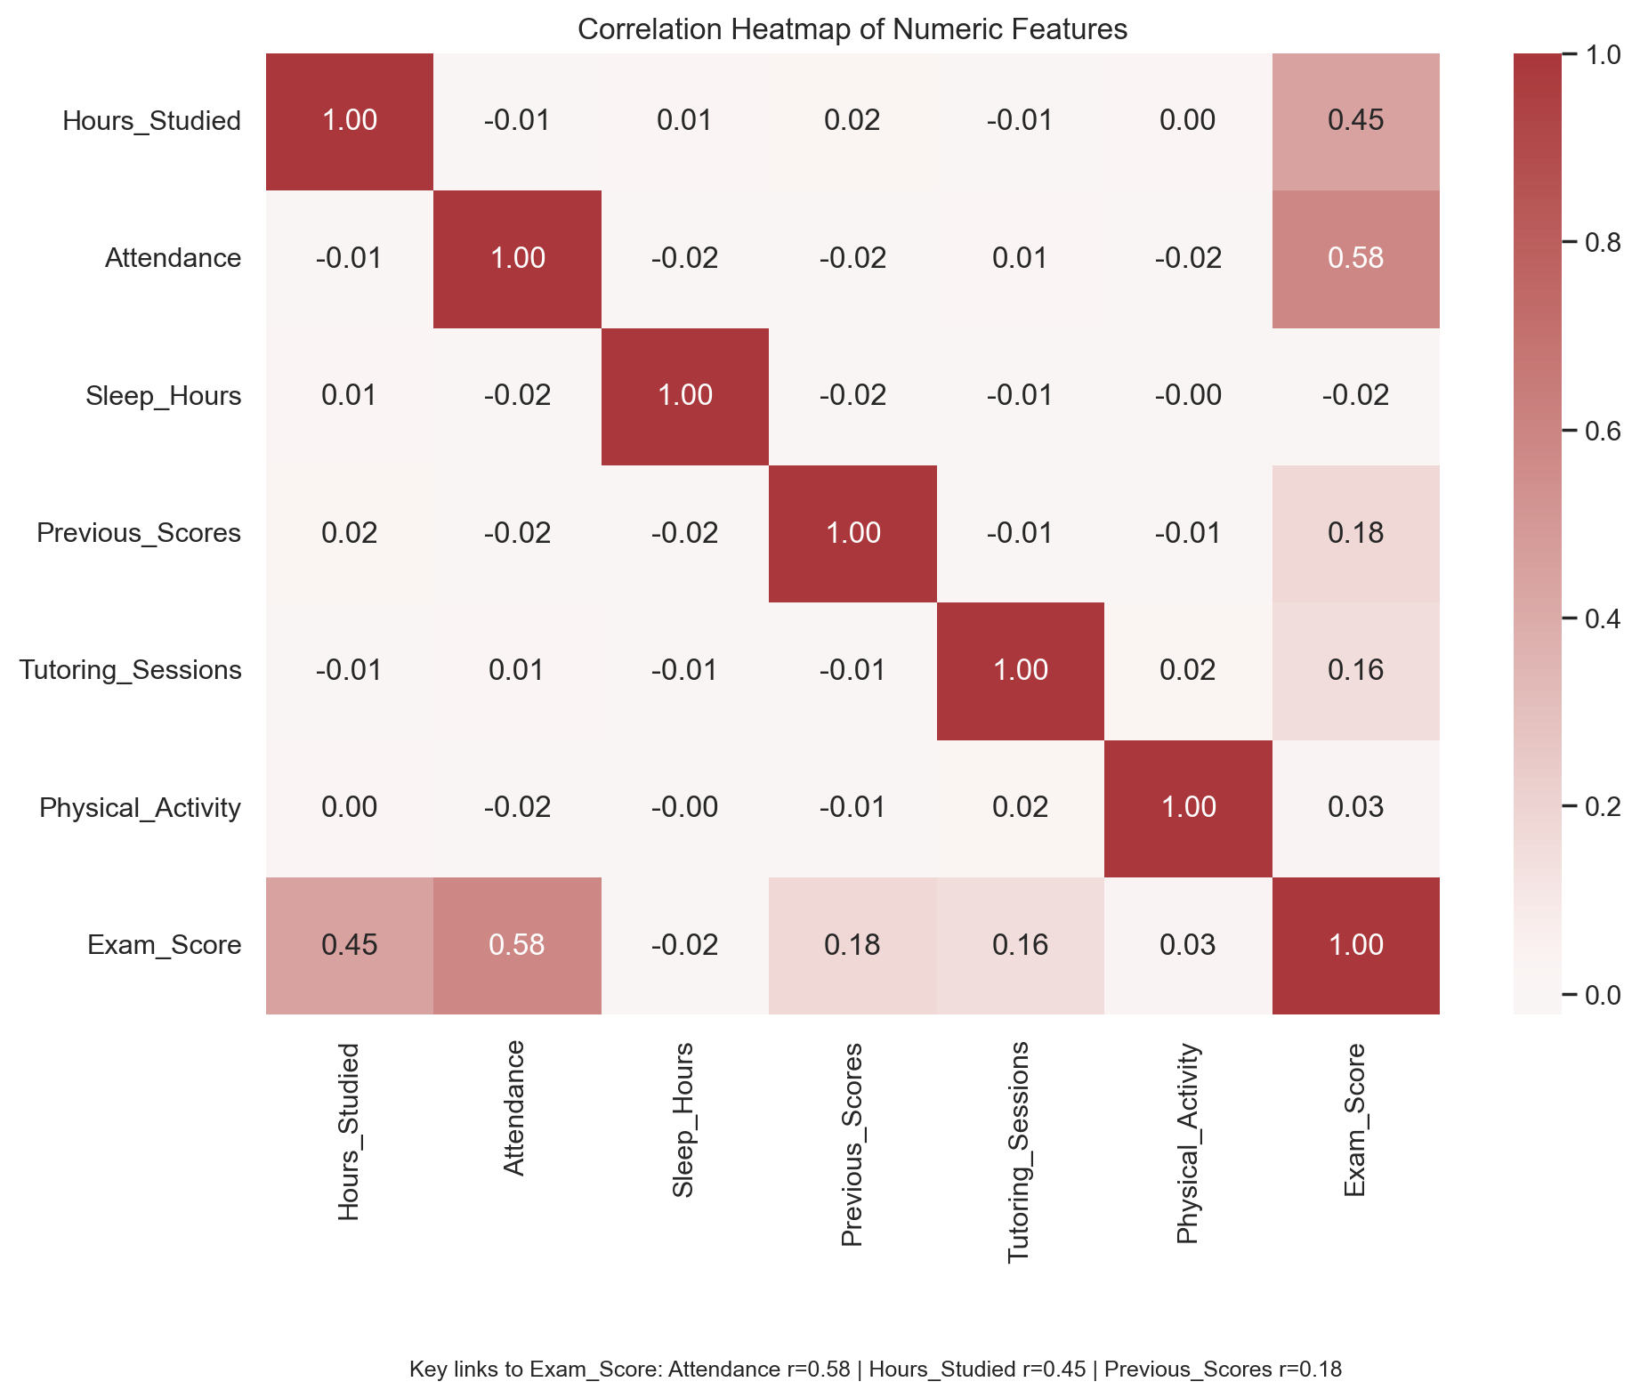
Figure 2. Correlation Heatmap of Numeric Features
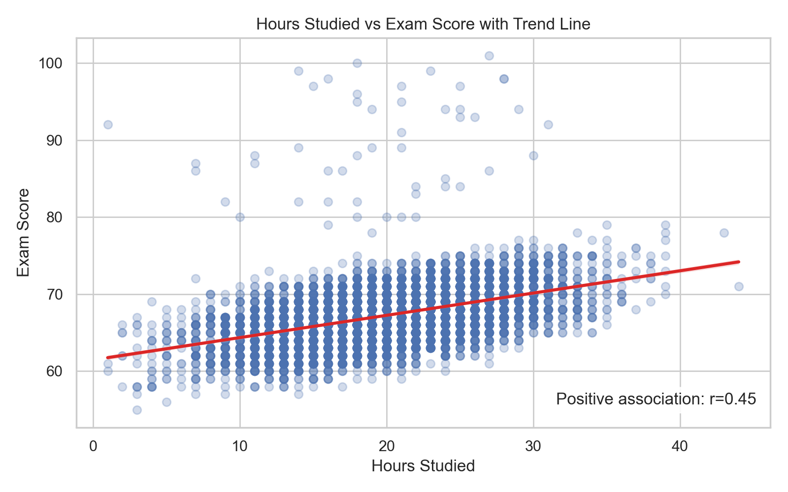
Figure 3. Hours Studied vs Exam Score with Trend Line
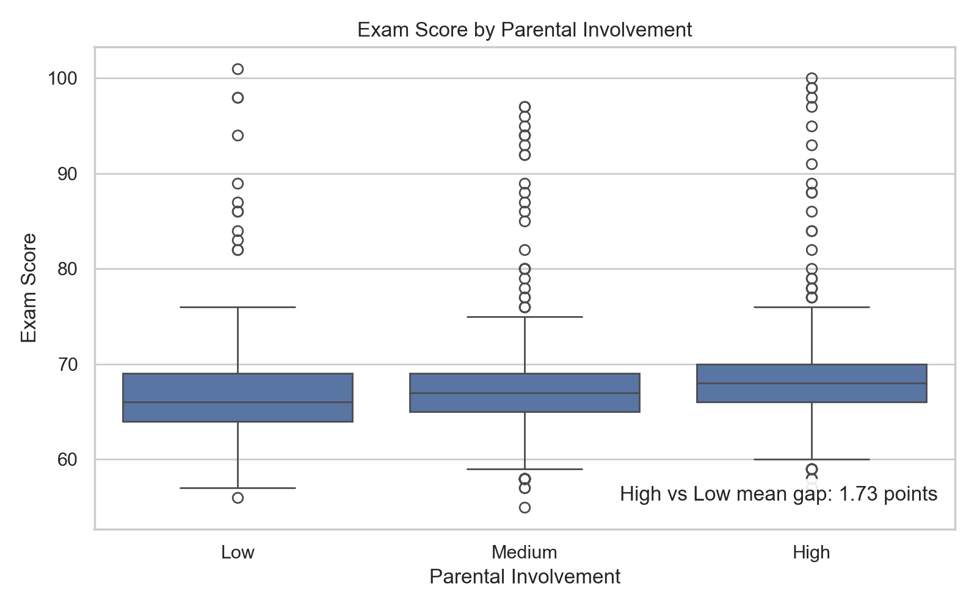
Figure 4. Exam Score by Parental Involvement
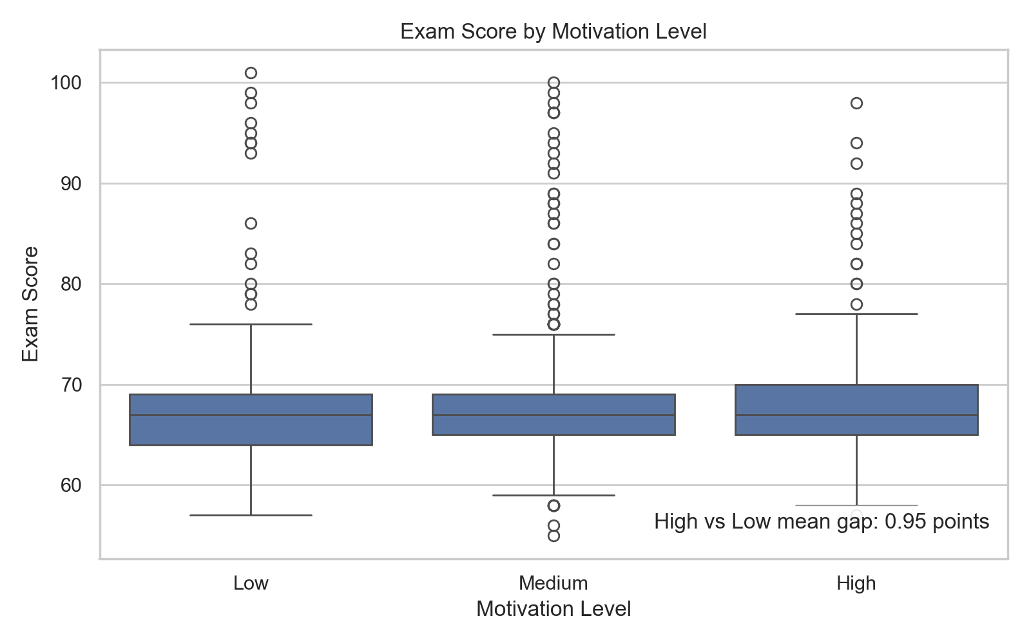
Figure 5. Exam Score by Motivation Level
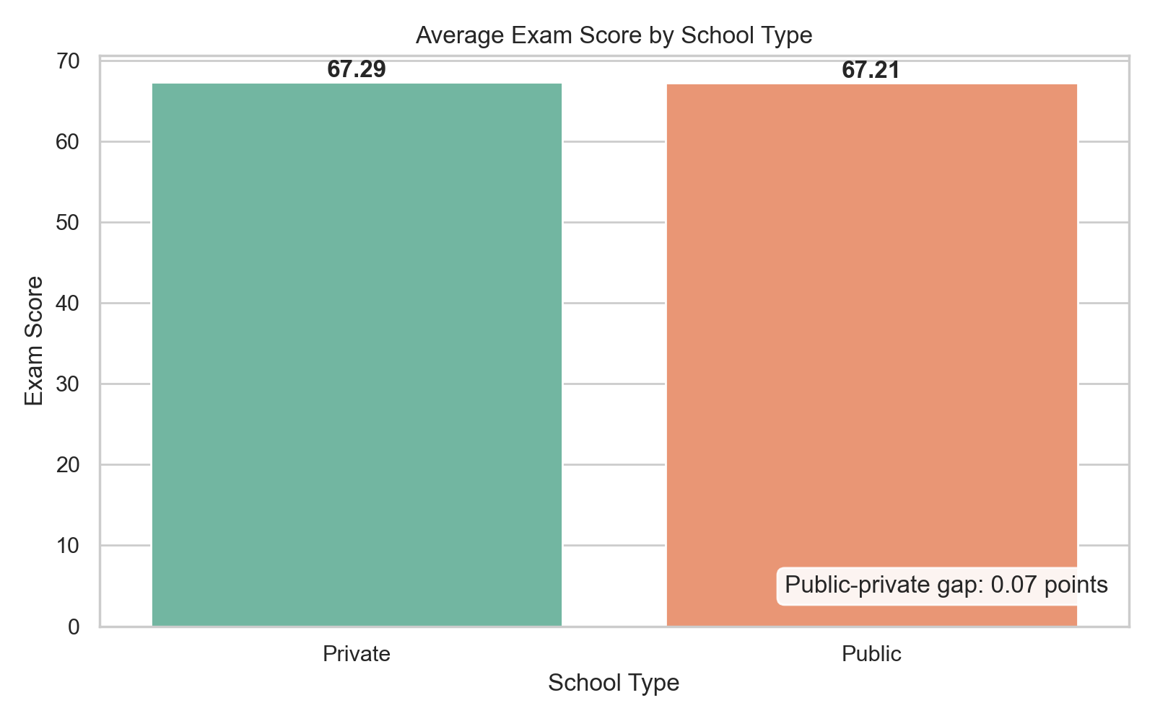
Figure 6. Average Exam Score by School Type

Chart Insights
- The score distribution is centered near 67.2, with an observed range of 55 to 101. This suggests a concentrated target with limited room for very large improvements in absolute score.
- Exam_Score reaches a maximum of 101 even though scores are presumably out of 100; this minor source-data quirk was kept as-is rather than silently altered.
- Attendance has the strongest numeric relationship with Exam_Score in the correlation analysis, making it a practical monitoring signal for student-support teams.
- The Hours_Studied scatter plot shows a positive trend: students who report more study hours generally have higher exam scores, although the spread indicates that study time is not the only driver.
- Average Exam_Score increases from 66.36 for low parental involvement to 68.09 for high involvement, a 1.73-point difference.
- Average Exam_Score increases from 66.75 at low motivation to 67.70 at high motivation, a 0.95-point difference.
- Public and private school averages are nearly identical (67.21 vs 67.29), so school type alone does not appear to explain much variation in this sample.

Business and Operational Recommendations
A real-world education analytics workflow would translate these findings into testable actions rather than using them as automatic decisions:
- Build an attendance-risk monitoring view that flags sustained declines early and routes students to an advisor or support program.
- Use study-hours and prior-score patterns to prioritize tutoring outreach, while avoiding one-size-fits-all recommendations.
- Treat parental involvement and motivation as context for supportive engagement, never as labels that restrict student opportunity.
- Track intervention uptake and later outcomes so the team can measure whether support changes performance over time.

Limitations and Responsible Use
- The dataset appears cross-sectional, so the analysis identifies association rather than causation.
- The model evaluation uses one random train-test split; cross-validation and an external holdout set would provide stronger evidence of generalization.
- The target includes values above 100, which should be verified with the data owner before deployment or public-facing interpretation.
- Predictions should support human review, not determine student access to resources, placement, or disciplinary action.

Modeling Results
The table below reports performance on unseen test data. Higher R² indicates more explained variance, while lower MAE and RMSE indicate smaller prediction errors.
Model | R² | MAE | RMSE
Linear Regression | 0.771 | 0.444 | 1.799
Random Forest | 0.673 | 1.068 | 2.151

The strongest model by R² was Linear Regression. Its results should be treated as a project baseline because no hyperparameter tuning or external validation was performed.

Conclusion
Attendance, Hours_Studied, and Previous_Scores are the three clearest numeric factors associated with higher exam scores. These relationships can help guide questions for academic support teams, but they are observational associations rather than causal estimates. Linear Regression outperformed Random Forest, with higher R² and lower MAE and RMSE. This suggests the relationships between these factors and Exam_Score are mostly linear/additive rather than needing the added complexity Random Forest offers. Future work should validate the findings across time and across additional student populations before operational decisions are made.

Recommended Next Iteration
The next production-oriented iteration should add cross-validation, hyperparameter tuning, feature importance or SHAP explanations, subgroup performance checks, and a small Streamlit dashboard. A deployment pipeline should also log predictions, monitor drift, and require periodic review with educators and data-governance stakeholders.

