1. While Transferring Split invoice as Total & add payment to that invoice in the Transfer payments   
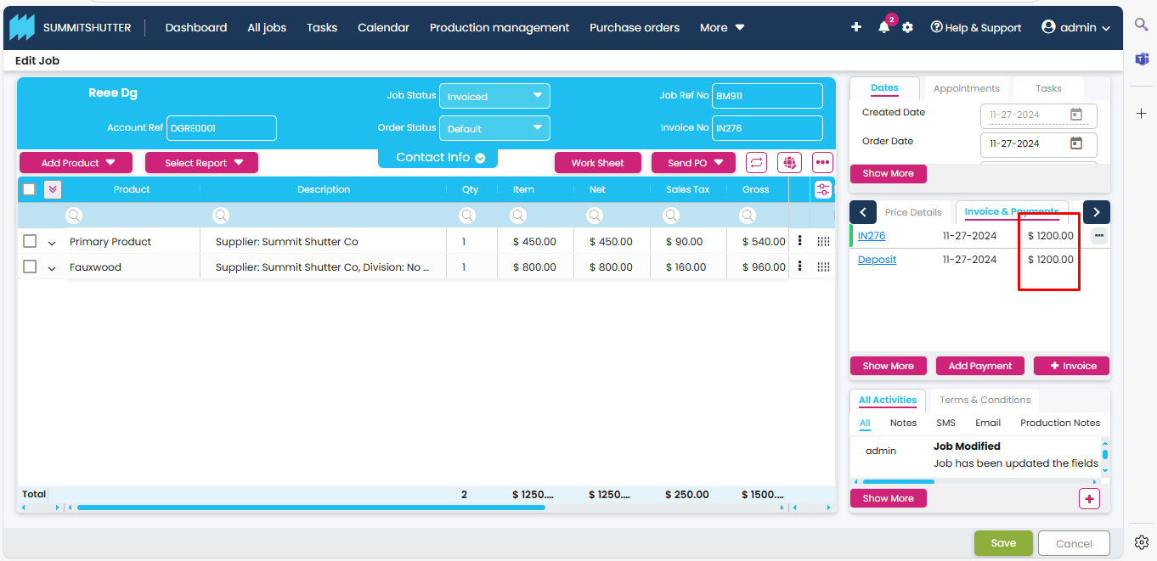

It shows the incorrect value in the Xero application

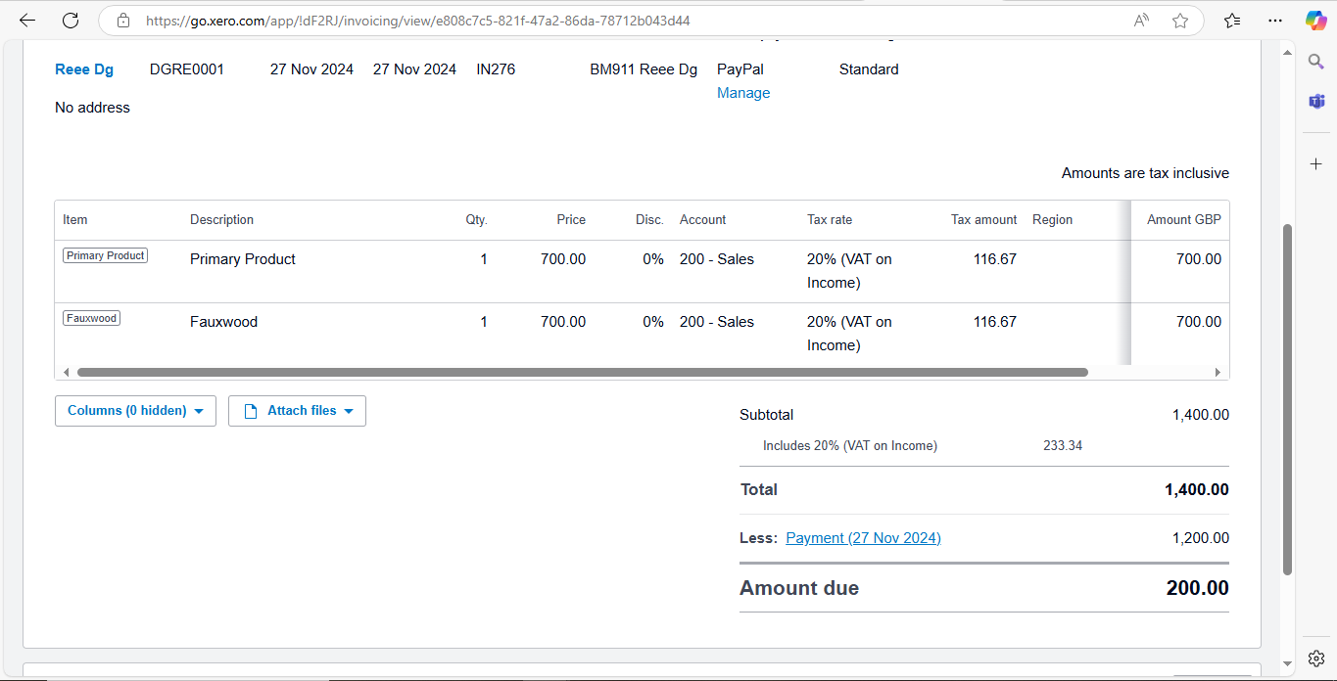

2.In integration settings when we select the Multi sales code for the first time, it is always loading

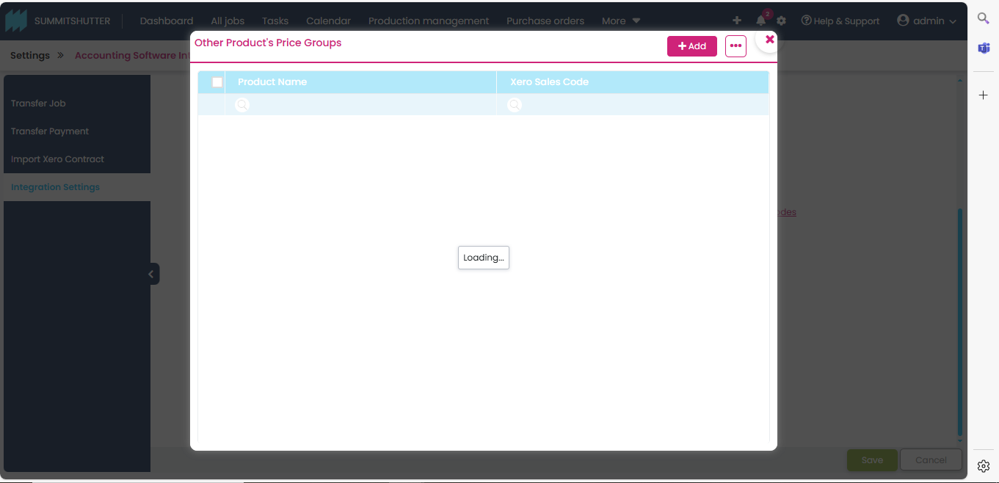

3. In Multi sales code when we configure the product and save it means configured product is not showing,

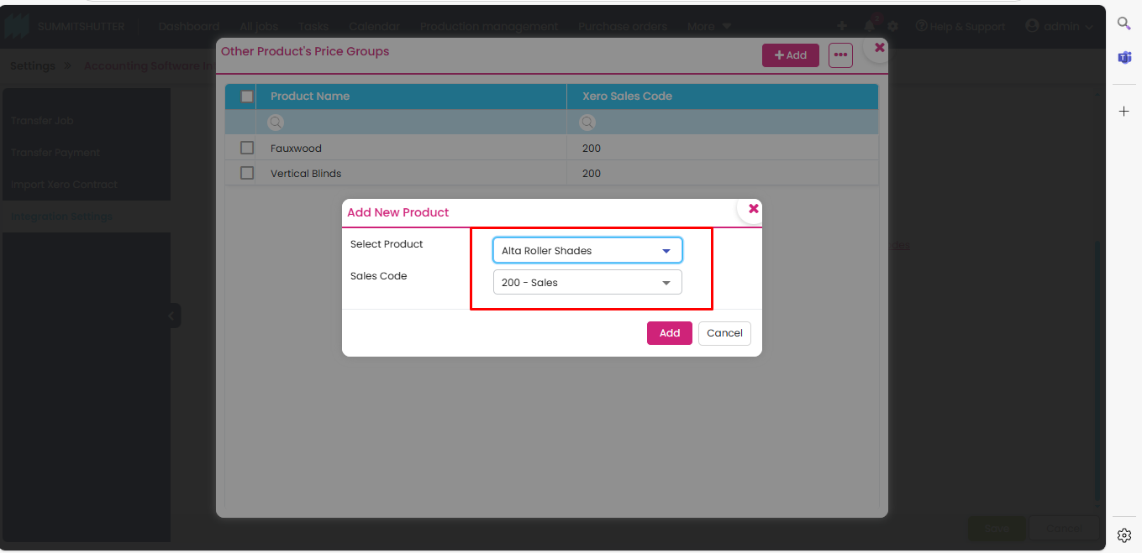

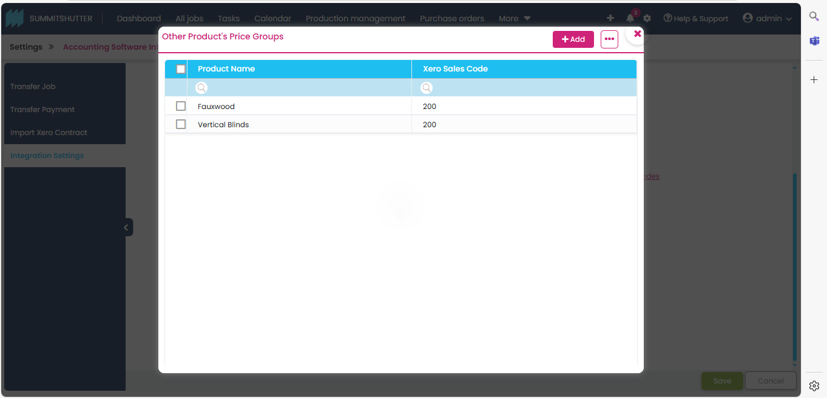

it shows after the refresh or configure the next product.

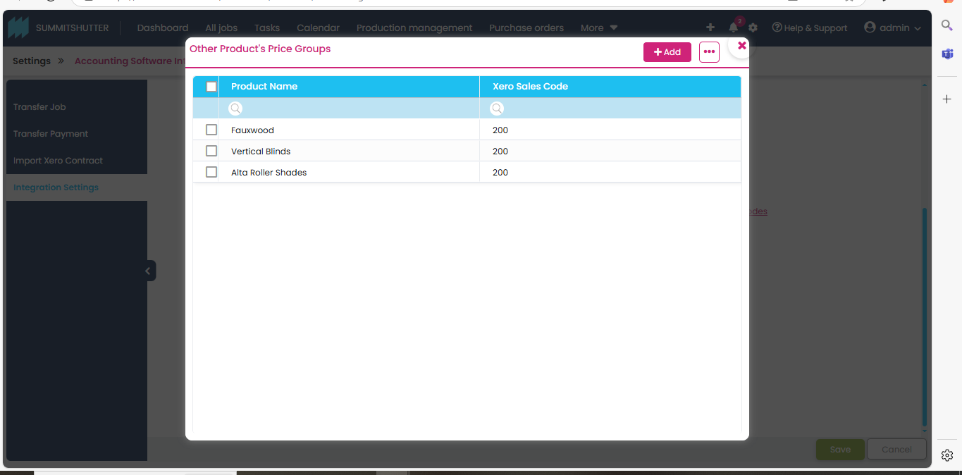

4. When we delete configured product it is not disappearing

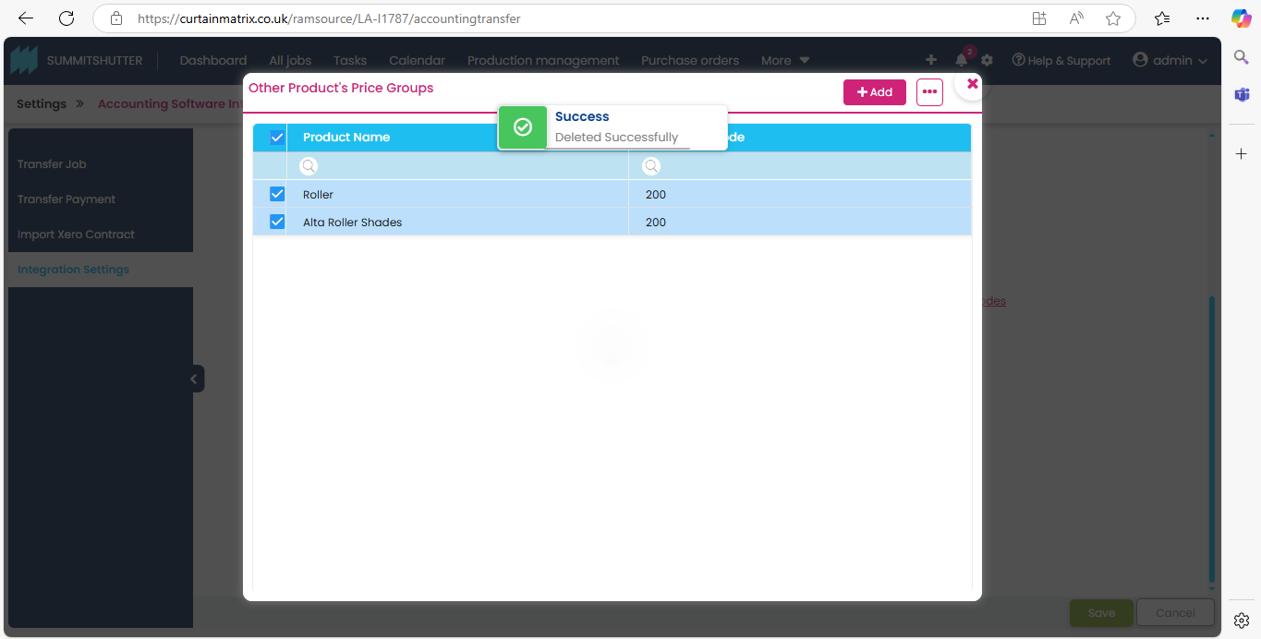

When we delete for the second time It will disappear.

