AllInOne Architecture: High Level
Think of AllInOne as one platform from the customer's perspective, but several independent bounded contexts from the backend perspective.
High-level: business domains, microservices, clients, gateway, event bus, databases.

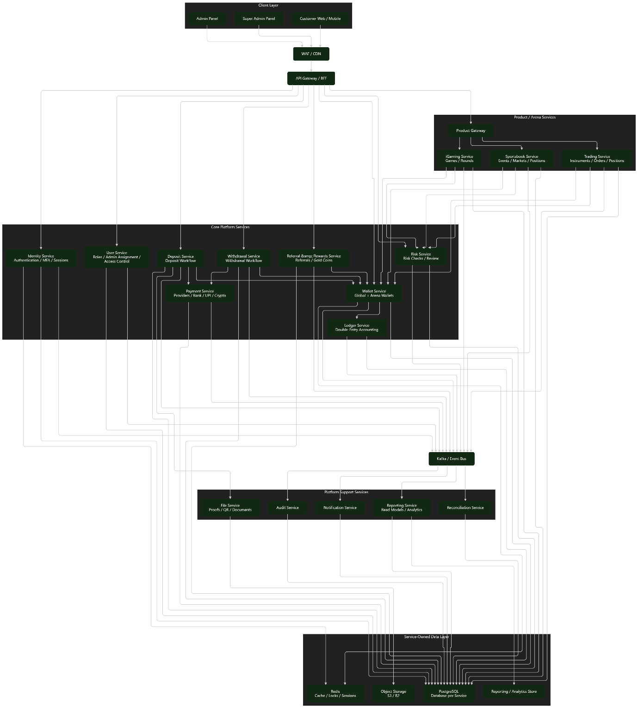

There are five major layers.
Layer 1 — Clients
There are three primary experiences:
Super Admin: having final authority
Admin: handling assigned customers and first-line checks
Customer: being the default platform user.

Layer 2 — API Gateway
Nobody talks directly to microservices.

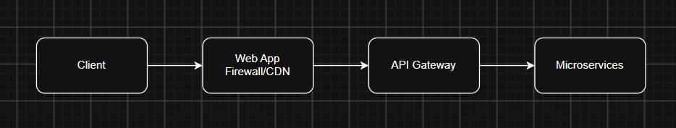

The Gateway handles:
- authentication token validation
- rate limiting
- routing
- API versioning
- request correlation ID
- authorization checks
- throttling
- common response/error handling

Layer 3 — Core Services
These are the most important business services:
- Identity
- User
- Wallet
- Ledger
- Deposit
- Withdrawal
- Payment
- Referral & Rewards
- Risk

The important architectural rule is: Wallet and Ledger are foundational services.
Products shouldn't directly modify financial balances.

Layer 4 — Product Services
The platform has three independent arenas:
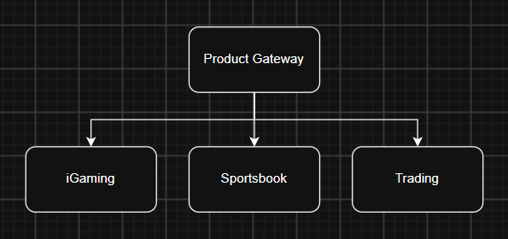
This enables independent scaling of services.

Layer 5 — Event / Support Layer
Kafka sits between the transactional services and supporting systems.
e.g.
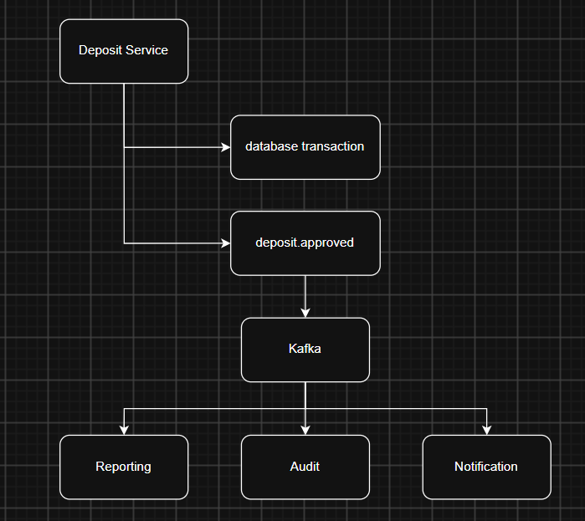
This is extremely useful because Reporting, Audit and Notification shouldn't make the deposit transaction slow.

Global Wallet: The Global Wallet is the financial hub; Arena Wallets are isolated product balances.

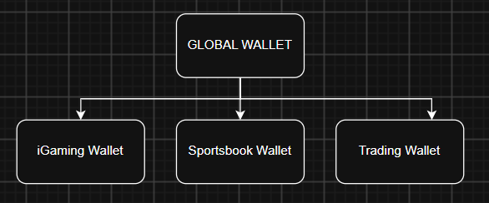
Money enters/exits only through Global Wallet. Transfers between Global and Arena wallets are instant and require no approval.

