ALLINONE
Final Backend Architecture, Microservices & PostgreSQL Design
Version 2.0 consolidated design • Prepared for engineering implementation

1. Executive Summary
This document consolidates the earlier Super Admin design and the v2.0 full-platform design into an implementation-oriented backend architecture. The v2.0 source defines three roles—Super Admin, Admin and Customer—and a shared global wallet feeding iGaming, sportsbook and trading arenas. It also establishes the control chain: Admin performs the first check and Super Admin has the final decision on money movement and user blocking/suspension.
The architecture below uses domain-driven microservices with database ownership per service, synchronous REST/gRPC for commands that require an immediate answer, Kafka for domain events, a separate reporting read model, centralized audit consumption, and object storage for uploaded proofs.

2. Source Requirements Incorporated
Requirement | Architecture implication
Roles & control | Super Admin has final authority; Admin manages assigned customers and first-line checks; Customer is the default role.
Wallet model | One Global Wallet plus three Arena Wallets: iGaming, Sportsbook and Trading.
Money boundaries | Deposits and withdrawals use the Global Wallet only; arena wallets do not receive external deposits or make external payouts.
Internal movement | Global ↔ Arena movement is instant and does not require approval.
Deposits | Customer submits proof; Admin reviews first; Super Admin makes final decision; only then is Global Wallet credited.
Withdrawals | Customer requests from Global Wallet; Admin reviews first; Super Admin approves; payout is completed only after payment is actually sent.
User restriction | Admin requests block/suspension with a mandatory reason; Super Admin takes or declines the action.
Identity restriction | Blocked/suspended users cannot sign in or bypass the restriction by re-registering with the same identity.
Referrals | Admins and Customers can create referral codes; rewards are tied to real activity, not signup.
Gold Coins | Coins convert to real money in the referrer's wallet and can subsequently be withdrawn.
Sportsbook | Buy/sell positions and full position history are required.
Trading | Live rates, multiple instrument classes, buy/sell activity, positions and P&L are required.
Audit/security | Important actions, approvals, wallet releases, referral payouts and payment-setting changes must be auditable.
Wallet integrity | Global and arena balances must always add up.
Source basis: AllInOne Platform Design Document v2.0, especially sections 2, 4–12. The earlier v1 Super Admin document remains relevant for the original control-plane dashboard and administrative workflows.

3. End-to-End Microservice Architecture
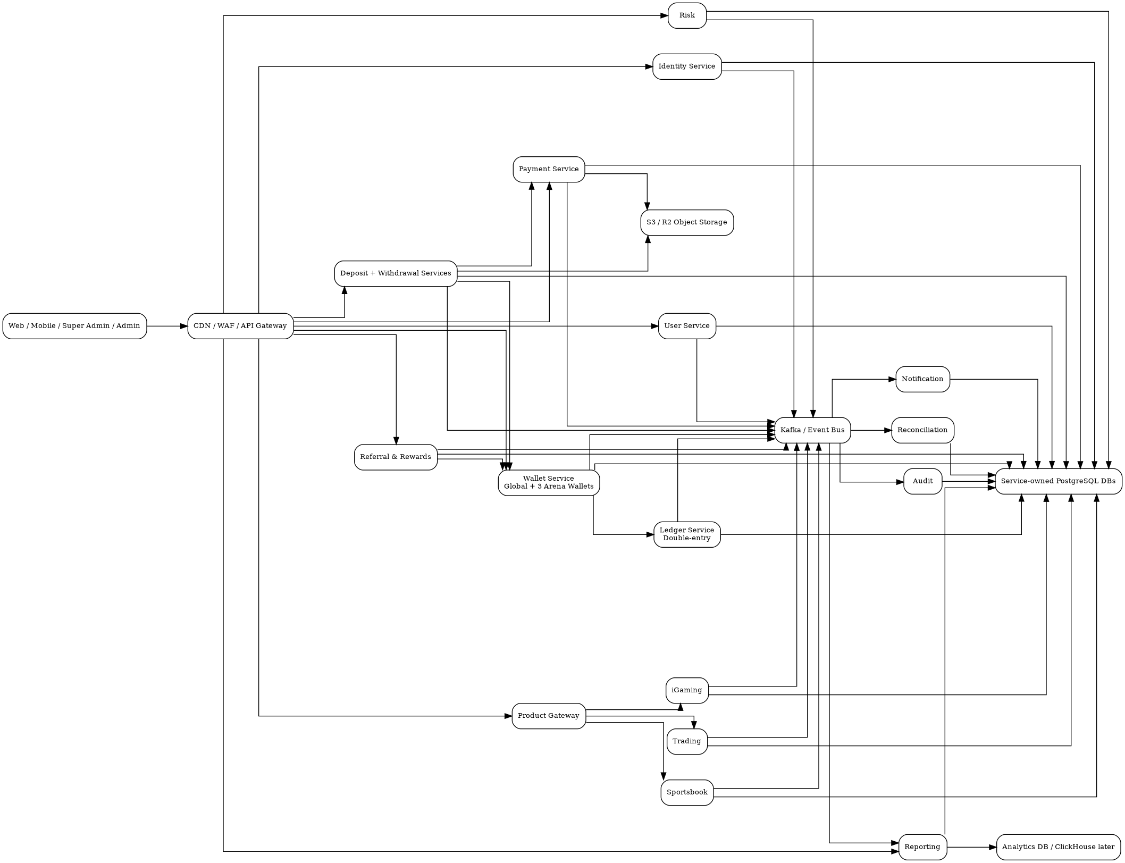
Figure 1 — End-to-end service architecture and event flow.

4. Service Catalogue & Ownership
Service | Owns
Identity Service | Authentication, sessions, MFA, identity restriction and token lifecycle.
User Service | User profiles, roles, admin/customer assignment and block/suspension request workflow.
Wallet Service | Global and arena wallets, balances, holds, internal transfers and releases.
Ledger Service | Immutable double-entry accounting for every financial movement.
Deposit Service | Deposit request, proof reference, Admin review and Super Admin review.
Withdrawal Service | Withdrawal request, payout account, two-step approval and payout lifecycle.
Payment Service | Payment providers, QR/bank/crypto destinations, provider execution and sensitive-setting versioning.
Referral & Rewards Service | Referral codes, qualifying events, Gold Coin accounting and conversion.
Product Gateway | Common API boundary routing customers to the three product services.
iGaming Service | Games, rounds and iGaming transactions.
Sportsbook Service | Events, markets, bets, buy/sell positions and settlement.
Trading Service | Instruments, market quotes, orders, executions, positions and P&L.
Risk Service | Risk cases/evaluations and review decisions.
Reporting Service | Event-driven read models for platform/admin/customer/arena metrics.
Audit Service | Append-only business/security audit stream.
Notification Service | In-app/email/SMS/push delivery.
File Service | File metadata and object storage integration.
Reconciliation Service | Payment-provider reconciliation and exceptions.

5. Database Architecture
Each microservice owns its data. No service should directly query another service's tables and no cross-service foreign keys should be used. A UUID from another service is an external reference, not a database FK.
Service | Database | Primary tables
Identity | identity_db | users, sessions, MFA
User | user_db | assignments, access requests, status history
Wallet | wallet_db | wallets, transfers, holds, wallet operations
Ledger | ledger_db | ledger accounts, transactions, entries
Deposit | deposit_db | deposits, reviews
Withdrawal | withdrawal_db | withdrawals, payout accounts, reviews
Payment | payment_db | providers, payment destinations, versions, attempts
Referral & Rewards | referral_db | codes, referrals, qualifying events, coins, conversions
iGaming | igaming_db | games, rounds, transactions
Sportsbook | sportsbook_db | events, markets, bets, positions, trades
Trading | trading_db | instruments, quotes, orders, executions, positions
Risk | risk_db | risk cases and events
Reporting | reporting_db | daily metrics/read models; ClickHouse later if required
Audit | audit_db | append-only audit events
Notification | notification_db | notification lifecycle
Reconciliation | reconciliation_db | runs and exception items
Deployment recommendation: initially place multiple logical service databases on one PostgreSQL cluster to reduce operational cost. Preserve strict ownership and separate credentials. Split high-volume services to dedicated PostgreSQL clusters later without changing service contracts.

6. Wallet & Ledger Design
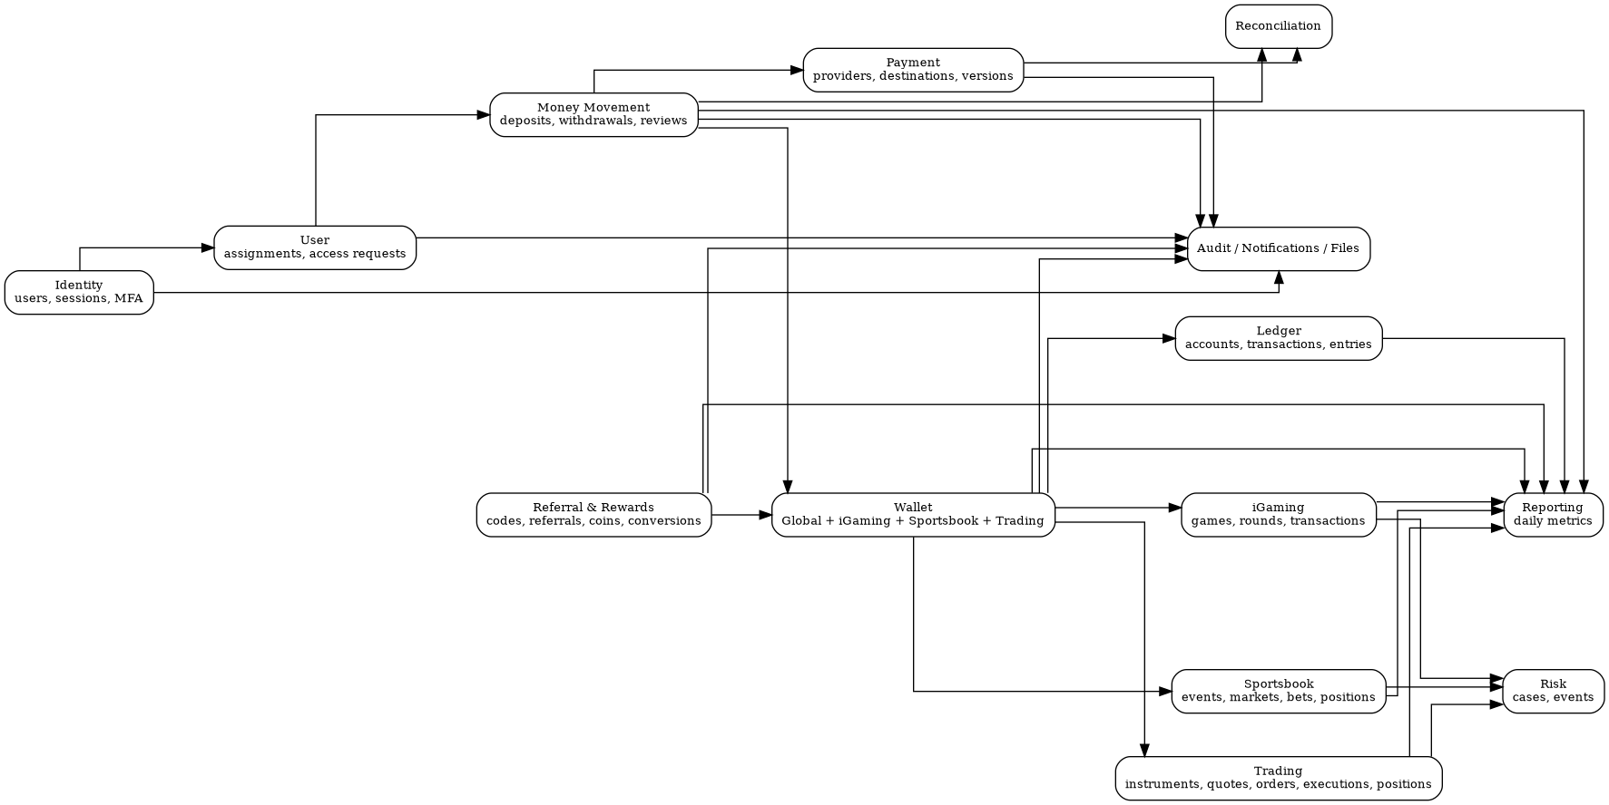
Figure 2 — Domain-level ERD overview. The complete Mermaid ERD is delivered separately.
The Global Wallet is the only wallet that receives approved deposits and funds withdrawals. Each customer also has one Arena Wallet for iGaming, one for Sportsbook and one for Trading. Arena activity uses the relevant arena wallet; releases return funds to the Global Wallet. This directly reflects the v2.0 wallet model.
The Wallet Service is the operational balance authority. The Ledger Service is the accounting authority. Every balance-changing operation must have an idempotency key, use row/version locking or an equivalent concurrency strategy, and result in balanced debit/credit ledger entries.

7. Money Movement Flows
Flow | End-to-end path
Deposit | Customer → Deposit Service → Admin Review → Super Admin Review → Wallet Service → Ledger Service → Global Wallet
Withdrawal | Customer → Withdrawal Service → Admin Review → Super Admin Review → Wallet Hold → Payment Service → completion → hold release/settlement
Global to Arena | Customer → Wallet Service → debit Global → credit selected Arena → ledger/event
Arena to Global | Customer → Wallet Service → debit Arena → credit Global → ledger/event
Reward conversion | Referral & Rewards → validate coins → create conversion → Wallet/Ledger credit → audit/report event

8. Approval State Models
Deposit:
PENDING_ADMIN → ADMIN_APPROVED → PENDING_SUPER_ADMIN → APPROVED → CREDITED
Alternative terminal paths: PENDING_ADMIN → ADMIN_REJECTED; PENDING_SUPER_ADMIN → SUPER_ADMIN_REJECTED.
Withdrawal:
PENDING_ADMIN → ADMIN_APPROVED → PENDING_SUPER_ADMIN → APPROVED → PROCESSING → COMPLETED
Alternative paths: ADMIN_REJECTED, SUPER_ADMIN_REJECTED, or PROCESSING → FAILED.

9. Referral & Gold Coin Architecture
The v2.0 specification allows both Admins and Customers to create referral codes. A referral reward is earned only after the referred person performs qualifying real activity. Customer referral codes have a set validity period. Gold Coins then convert into real money and that money can be withdrawn.
Recommended integrity chain:
Referral Code → Referral → Qualifying Activity → Gold Coin Transaction → Coin Balance → Conversion → Wallet/Ledger

10. Product Services
iGaming owns games, rounds and game transactions. Sportsbook owns events, markets, bets and buy/sell positions. Trading owns instruments, market quotes, orders, executions and positions. Product services must not directly mutate Global Wallet balances; they call the Wallet Service for debits/holds/credits and emit business events for reporting.

11. Event-Driven Integration
Recommended Kafka topic/event names:
user.created, user.status.changed, admin.customer.assigned, deposit.created, deposit.admin.approved, deposit.admin.rejected, deposit.superadmin.approved, deposit.superadmin.rejected, withdrawal.created, withdrawal.admin.approved, withdrawal.admin.rejected, withdrawal.superadmin.approved, withdrawal.superadmin.rejected, withdrawal.processing, withdrawal.completed, withdrawal.failed, wallet.transfer.completed, wallet.hold.created, wallet.hold.released, ledger.transaction.posted, referral.created, referral.qualifying.activity, reward.gold_coin.earned, reward.gold_coin.converted, payment.settings.changed, payment.completed, payment.failed, risk.review.required, sportsbook.bet.created, sportsbook.position.changed, sportsbook.bet.settled, igaming.round.completed, trading.order.created, trading.order.executed, trading.position.updated, audit.event, notification.requested

12. API & Communication Rules
- External clients use REST through an API Gateway/BFF.
- Internal synchronous commands may use REST or gRPC.
- Kafka carries facts/events and decouples Reporting, Risk, Audit, Notification and Reconciliation.
- Money-moving commands require idempotency keys.
- Services use the Outbox Pattern so database changes and emitted events cannot silently diverge.
- Consumers use the Inbox/idempotent-consumer pattern where duplicate event delivery is possible.
- Never expose internal databases or Kafka directly to browser/mobile clients.

13. Security & Reliability Controls
- Privileged roles require MFA.
- Super Admin cannot be granted to self from the application.
- Blocked/suspended identity must be rejected during authentication and registration checks.
- Payment destination credentials are encrypted; raw secrets are never logged.
- Payment-setting changes are versioned, confirmed and audited; a second approval can be enabled as a policy.
- Audit events are append-only.
- Wallet writes use database transactions plus optimistic/pessimistic concurrency control.
- Ledger entries are immutable after posting; corrections are compensating transactions.
- All money-moving endpoints require idempotency keys.
- Financial services require reconciliation and operational alerts.
- Use UTC timestamps in storage; render using user/account timezone at the edge.
- Use object storage for payment proofs and QR/document files; store metadata in PostgreSQL.

14. Reporting Architecture
Reporting must be a read model, not a cross-service SQL reporting query. Domain services publish events; Reporting consumes them and maintains daily/customer/admin/arena aggregates. This supports the system-wide dashboard, admin dashboards and customer performance views described in the source.
Recommended dimensions: date, customer, admin, arena, product, transaction type, volume, deposits, withdrawals, invested amount and P&L.

15. PostgreSQL Schema Package
The accompanying PostgreSQL directory contains service-specific migrations. These are deliberately separated rather than being one shared database migration.
- 00_extensions.sql
- 01_identity_service.sql
- 02_user_service.sql
- 03_wallet_service.sql
- 04_ledger_service.sql
- 05_deposit_service.sql
- 06_withdrawal_service.sql
- 07_payment_service.sql
- 08_referral_rewards_service.sql
- 09_product_common_service.sql
- 10_sportsbook_service.sql
- 11_trading_service.sql
- 12_igaming_service.sql
- 13_risk_service.sql
- 14_reporting_service.sql
- 15_audit_notification_file_reconciliation.sql
Execution rule: provision one database per service (or isolated schema initially), create a service-specific DB user, and run only that service's migration set.

16. V1 → V2 Architecture Changes
Earlier design | Final design
Single wallet model | Global Wallet + iGaming, Sportsbook and Trading Arena Wallets.
Single approval | Two-step Admin → Super Admin approval for every deposit and withdrawal.
Direct admin restriction | Admin raises block/suspension request; Super Admin executes.
Admin-only referrals | Admin + Customer referrals, with expiring customer codes.
Simple rewards | Qualifying activity → Gold Coins → real-money conversion.
Generic sportsbook transactions | Sportsbook positions and buy/sell history.
Generic trading model | Dedicated instruments, quotes, orders, executions and positions.
Basic payment configuration | Versioned sensitive payment destinations and change-request workflow.
Generic reporting | Event-driven reporting by customer, admin, arena and platform.

17. Implementation Roadmap
Phase | Scope
Phase 1 — Foundation | Identity, User, API Gateway, Kafka, Wallet, Ledger, Audit, File Service
Phase 2 — Money | Deposit, Withdrawal, Payment, Reconciliation, Notification
Phase 3 — Rewards | Referral & Rewards with tamper-proof qualifying-event flow
Phase 4 — Products | Product Gateway, iGaming, Sportsbook, Trading
Phase 5 — Intelligence | Risk rules, reporting read models, dashboards and operational monitoring
Phase 6 — Scale | Load testing, partitioning, read replicas, ClickHouse if reporting volume justifies it, dedicated DB clusters for hot services

18. Explicitly Unspecified by the Source
The v2.0 document does not define exact Gold Coin earning rates, coin-to-money conversion rates, referral-code format, qualifying transaction thresholds, KYC field sets, payment-provider names, sportsbook data/odds providers, trading execution venues, or retention periods. These should remain configuration/business decisions and should not be hard-coded into the schema.

19. Deliverables
This package contains:
- ALLINONE_Final_Backend_Architecture_and_DB_Design.docx
- ALLINONE_V2_COMPLETE_ERD.mmd
- ALLINONE_END_TO_END_ARCHITECTURE.png
- ALLINONE_ERD_DOMAIN_OVERVIEW.png
- postgresql/*.sql
- README.md

